SSWG Case Building Procedure Supplement
This supplement is an addition to Section Two of ERCOT Steady State Working Group (SSWG) Procedure Manual. It will be used to guide and direct the Option Two Case Building Process as Approved by Reliability and Operations Subcommittee (ROS) at their January 13, 2011 meeting and modified at the Feb 18, 2011 meeting.

Revision History
Version | Comments | Date | Author
0.1 | Initial Version | 3/1/2011 | SSWG
0.2 | ERCOT Comments | 3/7/2011 | ERCOT
0.3 | SSWG/ERCOT Agreed Comments | 3/9/2011 | ERCOT/SSWG

The following color coding is used through the document to differentiate between wording, process, and significant changes. The wording and process changes have been accepted and not included as tracked changes. The color of these changes may vary on each PC.

- Changes in Gray are wording changes that were not substantive to the meaning of the section

- Changes in Blue bring the document in line with the PLWG process described at the 2/25 meeting

- Tracked Changes have been agreed upon by ERCOT and SSWG.

Table of Contents
2.1. Overview 4
2.2. Definitions and Acronyms 4
2.2.1. Definitions 4
2.2.2. Acronyms 5
2.3. TP-Mirror Case Development 6
2.4. Consistency Validation 7
2.4.1. Reporting Metrics 7
2.4.2. Consistency Validation Process 8
2.4.3. Consistency Validation Spreadsheet 9
2.4.4. Explanation of Differences 10
2.5. Case Building Process: 10
2.5.1. Case Definitions 10
2.5.2. Entity Responsibilities 11
2.5.3. Data Set A 14
2.5.4. Data Set B 16
2.5.5. Transition from Completed Build to Next Case Build 18
2.5.6. TPIT Updates to Cases Created Outside MOD 19

SECTION 2.0 – SSWG Case Building Procedures and Schedules

Overview
SSWG will create a seed-case for the April 2011 case building process called the Topology Processor Mirror Case and named and defined as the “TP-Mirror Case”. The initial TP-Mirror Case will be created by modifying line impedances, ratings, bus and branches in the 11DSA Spring SSWG base case. These are the majority of the items that are expected to be modified, but modification of the SSWG base case is not limited to these items. The purpose of these modifications is to reconcile the modeling differences that exist between the Topology Processor (TP) case and the SSWG base cases.
A Consistency Validation Process will be defined in this supplement and implemented by SSWG and ERCOT staff. This validation process will help to maintain consistency between the TP-Mirror case and the TP case. SSWG members will have the opportunity to use this process to view and resolve differences between the cases. Once modifications are completed, the TP-Mirror case will become the seed-case and continue to be the seed-case for future case builds until the process described in this supplement is superseded.
This supplement also defines a Case Building Process for Data Set A, Data Set B, and TPIT case updates. The role and usefulness of the TP Mirror case in the case creation process will be described. The handling of differences caused by interim-update NOMCRS and the period of time between the TP-Mirror Case creation and Data Set A posting will also be addressed. Lastly, the transitioning from Data Set A to Data Set B case creation and the transitioning from Data Set B to TPIT update case build will be described in this supplement.
The primary tools/software that will be used by this supplement will be Model on Demand (MOD), MODFileBuilder and PSS/E. MOD is a web based application maintained by ERCOT. TSPs will use this tool to build and update the TP-Mirror case and Data Set A and B cases. The modifications will be put into project file (PRJ) format using MODFileBuilder, a text editor, or by manual entry using the MOD interface. SSWG members will need to consult the ERCOT Planning Model Design Guidelines & Expectations manual for further information.

Definitions and Acronyms

Definitions
TP-Mirror: Topology Processor Mirror case. The TP-Mirror case will be developed by SSWG by modifying the 11DSA Spring case to meet the consistency requirements being developed by the Planning PLWG, when compared to the topology, ratings, and impedance of the Topology Processor output case. The TP-Mirror case will be the seed case for all MOD work using the Option 2 method. This case will not include any generation, load or device control profiles.
Consistency PMCR: A planning model change submitted through MOD that is to be applied to the TP-Mirror case to improve the consistency of the TP-Mirror case versus the Topology Processor case.
ERCOT MOD Manual: Also known as Planning Mode Design Guidelines & Expectations. Manual that describes Model on Demand (MOD), MODFileBuilder and naming conventions for cases.
PROFILE: Information submitted by TSPs in a RAWD format in order to build cases. Such profiles include “Load Generation” and “Device Control” and are described more fully in the ERCOT MOD Manual.
STD_PMCR: PMCRs created to add elements or modify attributes that are not available in the NMMS database and exported by the TP to build a planning case.
TOPOLOGY: The arrangement of the network, such as busses and lines.
TPMCR: A planning model change submitted through MOD that is to be applied to the 11DSA Spring case to create the TP-Mirror case.
TP CASE (TP): Topology Processor case. A Bus/Branch representation of ERCOT system based on the NMMS database that models energized equipment for a designated point in time.
TRANSMISSION IN-SERVICE DATE: The date used to create the TP Case from NMMS and used in MOD to incorporate projects that will be included in the MOD case build through submission of a PMCR.

Acronyms
ALDR Annual Load Data Request
CPMCR Consistency PMCR
DSA Data Set A
DSB Data Set B
GR Generation Resource
IMM Information Model Manager
MOD Model on Demand
NERC North American Electric Reliability Corporation
NMMS Network Model Management System
NOIE Non Opt In Entity
NOMCR Network Operations Model Change Request
PLWG Planning Working Group
PMCR Planning Model Change Request
PSS/E Power System Simulator for Engineering
PUN Private Utility Network
RARF Resource Asset Registration Form
RAWD Raw Data
SSWG Steady-State Working Group
TP Topology Processor
TPMCR Topology Processor Mirror Change Request
TSP Transmission Service Provider
WGR Wind Generation Resource

TP-Mirror Case Development
The TP-Mirror case will initially be created by SSWG by modifying the 11SPG1 case posted 2/7/2011, which contains all future planned projects to be energized by April 1, 2011. The TP case contains all existing NOMCRs with an energization date of April 1, 2011 or earlier. Any NOMCR submitted after TP case download, but with an energization date prior to April 1, 2011 is not included in the TP case. The timing of these NOMCRs could cause modeling differences between the 11DSA spring case and the TP case. These differences will need to be corrected during the case building process.
The TP-Mirror Case is created by having the TSPs modify the existing 11SPG1 case with TP-Mirror Change Requests (TPMCR). These TPMCR applied to the 11SPG1 case are the modifications that create the TP-Mirror case. The following changes, some of which require TPMCRs, only need to be done once in the initial TP-Mirror build.
- Convert 11DSA SPG1 case and TP case to PSS/E v32.
- TSPs add in extra busses that are in the TP case due to ownership and other issues.
- TSPs resolve Load ID mismatches by producing TPMCRs to match the TP case or by submitting NOMCRs to match the SSWG seed case.
- TSPs resolve Transformer model and ID mismatches by producing TPMCRs to match the TP case or by submitting NOMCRs to match the SSWG seed case.
- TSPs resolve ratings / impedances mismatches, using approved tolerances, by producing TPMCRs to match the TP case or by submitting NOMCRs to match the SSWG seed case. The TSP can specify to use a different rating set in planning studies (i.e. – TSP can specify to use Rate A instead of Rate B for specific facilities or contingency types).
- TSPs resolve circuit IDs mismatches by producing TPMCRs to match the TP case or by submitting NOMCRs to match the SSWG seed case.
- TSPs do not need to model BC/BO branch IDs in TP-Mirror case.
- ERCOT staff will resolve any GR data discrepancies identified and notify the connected TSP of the changes.
- ERCOT staff will investigate any PUN data discrepancies identified and notify the connected TSP if any changes are required. PUN owned facilities will be identified by the connected TSP adding 600,000 to the existing bus number used in the SSWG Case.
- All the TPMCRs will be applied and the case output to a raw file. This is the TP-Mirror case.
- Once the TP-Mirror Case is created, it will be the seed case for 12DSA case building.

Consistency Validation
A comparison will be made of the topology, impedance, and ratings of the TP-Mirror case vs. the TP case developed by the SSWG.

Reporting Metrics

Topology
- Buses and branches in the TP-Mirror case that do not have corresponding buses and branches in the TP case will be reported.
- Buses and branches in the TP case that do not have corresponding buses and branches in the TP-Mirror case will be noted but not reported as part of the consistency validation process. TSPs will work with ERCOT staff to resolve these differences.

Impedances
For branches that match in both cases, the following metrics will be used for reporting as part of the consistency validation process.
- Exclude zero impendence/short branches, reactance less than or equal to 0.0005 per unit.
- Match to tolerance specified by PLWG.

Ratings
- For branches that match in both cases, the following metrics will be used for reporting as part of the consistency validation process. Match static ratings from IMM with tolerance specified by PLWG.
- Exclude Rate C from comparison.

Exceptions
- As specified by PLWG.

Consistency Validation Process
The results from comparing the metrics in 2.4.1 will be recorded on worksheets which will be combined into a workbook by ERCOT staff. Each TSP will enter their data onto worksheets using an agreed on format by TSP and ERCOT staff. Each TSP will submit their completed worksheet to ERCOT staff. ERCOT staff will combine all worksheets into a workbook and post in its final form. ERCOT staff will also maintain the workbook.

Consistency Validation Intervals
- Pass 0 Comparison:
  - TP mirror case
  - TP case with energization date corresponding to the scheduled start of the case creation or update. (Example: 12DSA work begins approximately April 1, 2011, create TP case with project energization date of April 1, 2011.)
  - Comparison will not be posted by ERCOT
- Pass 3 Comparison:
  - TP mirror case with Consistency PMCRs applied and future PMCRs with energization date that matches the TP case.
  - TP case with energization date corresponding to the scheduled start of the case creation or update plus 4 months. (Example: 12DSA work begins approximately April 1, 2011. Create TP case with energization date of August 1, 2011. TP-Mirror case will include all projects with energization by August 1, 2011)
  - Comparison will not be posted by ERCOT.
- Final case comparison:
  - TP mirror case with Consistency PMCRs applied and future PMCRs with energization date that matches the TP case
  - TP case from Pass 3
  - Comparison will be posted by ERCOT.

Consistency Validation Spreadsheet
The consistency validation spreadsheets will consist of the following comparisons of the TP-Mirror case and a TP case.

Topology comparison for branches
A topology comparison spreadsheet will be created by comparing the branch topology data (To Bus, From Bus, and Circuit ID) and the transformer topology data (Winding1 Bus, Winding2 Bus, Winding3 Bus, and ID). If the branch or transformer topology exists in the TP - Mirror case, but not the TP case, the topological element will be listed in the spreadsheet along with a column for the TSPs and ERCOT to include comments. An example of the topology comparison spreadsheet is shown below. The spreadsheet will include a flag identifying RARF submitted data that ERCOT staff shall address.
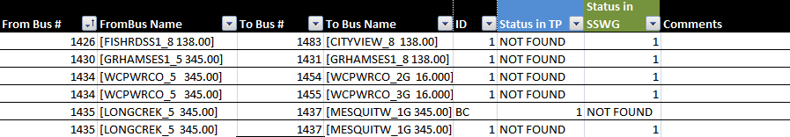

Ratings comparison for branches
A ratings comparison spreadsheet will be created by performing the Compare>Line Ratings function in PSS/E with the TP-Mirror case as the working case and the TP case as the comparison case. The output from the Compare output will be filtered using an Excel macro within tolerances defined by PLWG. A comment column will be updated by TSPs and ERCOT staff to explain the differences shown. An example of the ratings comparison spreadsheet is shown below. The spreadsheet will include a flag identifying RARF submitted data that ERCOT staff shall address.
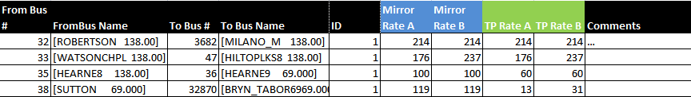

Impedance comparison for branches
Impedance comparison spreadsheet will be created by performing the Compare>Line R, X, B function in PSS/E with the TP-Mirror case as the working case and the TP case as the comparison case. The output from the Compare output will be filtered using an Excel macro within tolerances defined by PLWG. A comment column will be updated by TSPs and ERCOT staff to explain the differences shown. An example of the impedance comparison spreadsheet is shown below. The spreadsheet will include a flag identifying RARF submitted data that ERCOT staff shall address.
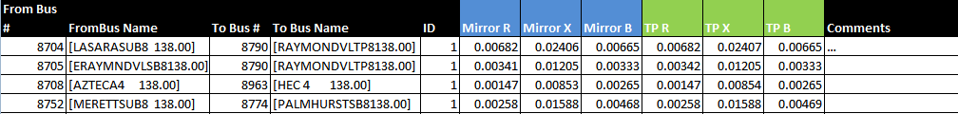

Explanation of Differences
TSPs and ERCOT will be asked to check the data in the spreadsheet and mark each of the differences in the comments column which will be a drop down consisting of the following:
- Change in IMM : NOMCR pending – SSWG case data is correct, a NOMCR will be created in the future that makes a change to IMM.
- Change in SSWG TP-Mirror: Consistency PMCR – A PMCR that will be applied to the TP-Mirror case (during case building process) that will match the data from the TP-Case.
- Necessary difference (explain) – No change will be made to the TP-Mirror case or IMM. Examples: A difference that is caused by a TP deficiency that cannot be fixed by a NOMCR, questionable RARF data, etc. An additional column will be provided to contain the explanation.

Case Building Process:

Case Definitions
Load-flow cases produced by SSWG are to be divided into two groups. The first group, “Data Set A,” models expected conditions for the following year’s four seasons, on peak and off peak for a total of eight cases. The second group, “Data Set B,” models cases for the five-year planning horizon. The schedule for Data Set A and Data Set B should be consulted for the appropriate project transmission in-service date.
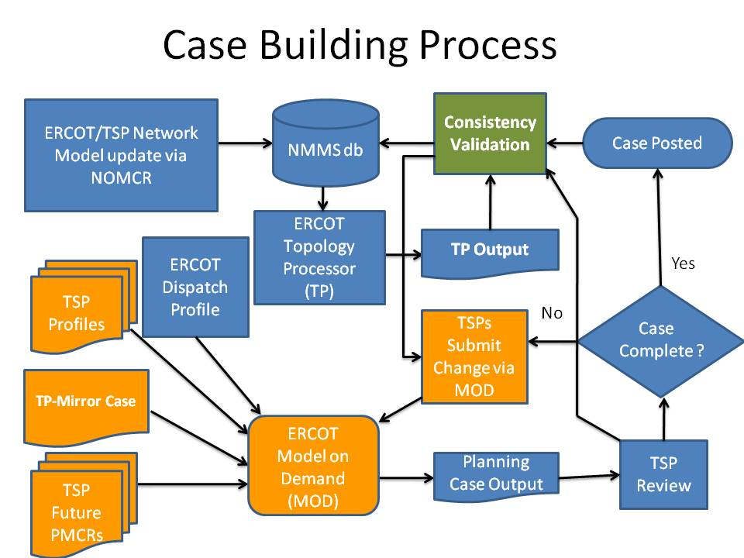

Entity Responsibilities
The Data Set A and Data Set B load-flow cases are assembled and produced as a collaborative effort by members of SSWG and ERCOT. The responsibilities for providing this data are divided among the various market participants and ERCOT. These data provision responsibilities may overlap among the various market participants because participants may designate their representative or a participant may be a member of more than one market participant group. The market participants can generally be divided into four groups: TSPs, Load Serving Entities (LSEs), Power Generation Companies, and Market Entities. ERCOT staff is included as a fifth entity with data provision responsibilities. The data responsibilities of each group are as follows:

TSPs
- It is the responsibility of the TSPs to provide accurate modeling information for all ERCOT Transmission Facilities owned or planned by the TSP. Submission requirements and naming conventions described in the ERCOT Planning Model Design & Expectations document shall be followed.
    - Future transmission facility changes will be submitted as Planning Model Change Requests (PMCRs). PMCRs phase date should correspond to the transmission in-service date. PMCRs should be submitted as far out into the future as possible. This technique will make the case building process more efficient when transitioning to a new case builds.
    - To maintain consistency with the TP case created from the Network Operations Model, TSPs shall submit Consistency PMCRs when necessary. Consistency PMCRS also may rectify the modeling differences caused by interim-update NOMCRs and the time periods between TP case and Data Set Case Postings. This is a period when possible network operations model changes may occur and not show up in the cases.
  - TSPs shall model the load data if they are the designated representatives for load entities. Loads for the cases will be submitted through Load Generation Profiles.
  - TSPs will provide all loads that it has accepted responsibility for modeling. TSPs shall change the ID of the load to ‘ER’ or ‘E1’, ‘E2’, etc for loads for which it historically has submitted data but no longer accepts responsibility. ERCOT will determine the owner of the load and ensure they are part of the ALDR or SSWG process.
  - PUN loads will be provided by TSPs.
  - NOIEs have the option of submitting generation dispatch or deferring to ERCOT staff.
  - Proper transmission system voltages will be maintained by submitting Device Control Profiles and Load and Generation Profiles. This will include accurate data for static and dynamic reactive resources and transformer settings in a Device Control Profile for each case. TSPs can suggest different generator reactive limits Qmax and Qmin for ERCOT to submit in the Load Generation Profiles and should submit data to collaborate the need for the change such as historical unit operation and biennial reactive tests. ERCOT will submit the change and follow-up with RE and TSP to determine RARF submission.
  - If the TSPs identify errors with generator data or PUN topology, the TSPs will notify ERCOT staff in accordance with the identified NMMS process. This process entails email notification to TSP of RARF change in their footprint and posting of RARF data entered into NMMS on Citrix NMMS_POSTINGS.
  - It is the responsibility of the TSPs to participate in the Consistency Validation Process.
    - TSPs will review the list of topology, ratings, and impedance differences produced by SSWG.
    - Any differences in topology, ratings, or impedances that are not resolved will be explained and documented by each TSP and reviewed by PLWG. If PLWG is unable to resolve then ROS will review and approve.

Load Serving Entities
- Each ERCOT Distribution Service Provider (DSP) directly interconnected with the transmission system (or its agent so designated to ERCOT) shall provide annual load forecasts to ERCOT staff as outlined in the ERCOT Annual Load Data Request (ALDR) Procedures.
- For each substation not owned by either a TSP or a DSP, the owner shall provide a substation load forecast to the directly connected TSP sufficient to allow it to adequately include that substation in its ALDR response.
- Entities not having representation on SSWG shall submit the data to ERCOT staff or to the directly connected TSP, if the TSP has agreed to be the agent on SSWG for that entity.
- See Nodal Operating Guides section 5.1.3.

Power Generating Companies
- It is the responsibility of the generation entities to provide all data required to model the generators in all the SSWG created cases via RARF and NMMS. (See Appendix A) Section 1.4. This data should be coordinated with ERCOT staff and should include but is not limited to unit capabilities.

Resource Entities
- It is the responsibility of Resource Entities to supply the load and/or generation data if they are the designated representatives for either a load or generating entity or both. See section 5.5 of the Nodal Operating Guides.

ERCOT
- It is the responsibility of ERCOT staff to maintain the ERCOT MOD production environment that allows SSWG members to provide appropriate equipment characteristics and system data as stated in this procedure.
- It is the responsibility of ERCOT staff to provide an initial generation dispatch for Pass 0 but this dispatch does not have to be economic or security constrained.
- It is the responsibility of ERCOT staff to provide the revised generation dispatch based on the latest topology and loads by submitting the Load Generation Profile by Pass 2 in the case building process. This dispatch will be security constrained (N-1) for Data Set A and economically dispatched for Data Set B and will be provided at next Pass after the case reaches an acceptable AC solution and no islands exist not related to an asynchronous tie or normally open equipment.
- ERCOT staff shall revise the generation dispatch as needed throughout the case building process.
- ERCOT staff shall review submitted PMCRs and notify TSPs of any PMCRs which appear to modify topology, ratings, or impedances from the Network Operations Model.
- Based on the TSPs NERC responsibilities of providing appropriate equipment characteristics and system data, ERCOT staff shall not reject any PMCR that TSPs ultimately determine should be applied to case after appropriate reviews have occurred. These changes will also be documented in comparison spreadsheet.
- ERCOT staff shall provide and review all generator models and updates including generator step-up transformers and associated GR-owned transmission facilities. ERCOT staff will use a Bus Number range assigned to it and modify equipment IDs as necessary. Future units will be modeled in accordance with data provided by GRs as required in the Generation Interconnection Or Change Request Procedure.
- ERCOT staff shall provide and review all PUN topology, ratings, and impedances.
- If load data is not submitted by pass 1 for loads not provided by TSPs and marked as such in accordance with section 2.5.2.1 above. ERCOT staff shall retrieve loads from most recent ALDR and insert these loads into the power flow cases during Data Set A and Data Set B annual updates.
- ERCOT staff shall provide case checking files after each pass as historically provided.

Data Set A

Summary of Cases
Data Set A seasons are as follows:
SPG March, April, May
SUM June, July, August, September
FAL October, November
WIN December, January, February

ERCOT DATA SET A BASECASES
(YR) = FOLLOWING YEAR
BASE CASE | NOTES | TRANSMISSION IN-SERVICE DATE
(YR) SPG1 | 2 | April 1, (YR)
(YR) SPG2 | 3 | April 1, (YR)
(YR) SUM1 | 1 | July 1, (YR)
(YR) SUM2 | 3 | July 1, (YR)
(YR) FAL1 | 2 | October 1, (YR)
(YR) FAL2 | 3 | October 1, (YR)
(YR+1) WIN1 | 1 | January 1, (YR+1)
(YR+1) WIN2 | 3 | January 1, (YR+1)
Notes
- Cases to represent the maximum expected load during the season.
- Cases to represent maximum expected load during month of transmission in-service date.
- Cases to represent lowest load on same day as the corresponding seasonal case (not a minimum case). For example, (YR) FAL2 case represents the lowest load on the same day as the (YR) FAL1 case.

Data Set A Generation Dispatch
Data Set A will contain a security constrained (N-1) economic dispatch. ERCOT will provide the dispatch using security constrained economic dispatch software to simulate the system load for two weeks leading up to the peak hour of each season. ERCOT will use Credible Single Contingencies applicable to Transmission Planning as defined in Nodal Operating Guides and monitor Rate A pre-contingency and Rate B post-contingency.

Procedure for Building Data Set A Cases
- Pass 0
  - Load TP-Mirror
  - Submit Profiles
  - Submit PMCRs
  - Load Initial Dispatch
  - Review Voltage Schedule and suggest changes
  - Review Reactive Curve and suggest changes
  - Consistency Validation Spreadsheet
  - Output Pass 1 Cases
- Pass 1
  - Begin Submitting Consistency PMCRs
  - Continue Submitting PMCRs
  - Updates to Profiles
  - Load Revised Generation Dispatch
  - Output Pass 2 Cases
- Pass 2
  - Continue Submitting Consistency PMCRs
  - Continue Submitting PMCRs
  - Updates to Profiles
  - Load Revised Generation Dispatch
  - Output Pass 3 Cases
- Pass 3
  - Continue Submitting Consistency PMCRs
  - Continue Submitting PMCRs
  - Updates to Profiles
  - Load Revised Generation Dispatch
  - Consistency Validation Spreadsheet using updated TP case
  - Output Pass 4 Cases
- Pass 4 – Pass N
  - Continue Submitting Consistency PMCRs
  - Continue Submitting PMCRs
  - Updates to Profiles
  - Load Revised Generation Dispatch
  - Output Pass N+1 Cases
- Final Pass
  - Consistency Validation Spreadsheet using Pass 3 TP case
  - SSWG approves cases
  - Cases, Generation Dispatch Spreadsheet and Consistency Validation Spreadsheet finalized by SSWG Posted
Any changes required after cases are posted will be submitted to ERCOT staff in the form of idevs and posted.

Data Set A Uses
Data Set A cases are generally used for short-term planning studies, systems operational studies, transmission loss calculations and are posted on ERCOT web site for general use.
Data Set B

Data Set B

Summary of Cases
ERCOT DATA SET B BASECASES
(YR) = FOLLOWING YEAR

BASE CASE | NOTES | TRANSMISSION IN-SERVICE DATE
(YR+1) SUM1 | 1 | JULY 1, (YR+1)
(YR+2) SUM1 | 1 | JULY 1, (YR+2)
(YR+3) MIN | 2 | JANUARY 1, (YR+3)
(YR+3) SUM1 | 1 | JULY 1, (YR+3)
(YR+4) SUM1 | 1 | JULY 1, (YR+4)
(YR+5) SUM1 | 1 | JULY 1, (YR+5)
Notes
- Cases to represent the maximum expected load during the season.
- Cases to represent the absolute minimum load expected for (YR+3).

Data Set B Generation Dispatch
Data Set B will contain economically dispatched generation (ECO). ERCOT will provide the dispatch using security constrained economic dispatch software to simulate the system load for two weeks leading up to the peak hour of each season but will not include contingencies and will monitor Rate A.

Procedure for Building Data Set B Cases
- Pass 0
  - Load updated TP-Mirror case
  - Submit Profiles
  - Submit PMCRs
  - Load Initial Dispatch
  - Review Voltage Schedule and suggest changes
  - Review Reactive Curve and suggest changes
  - Consistency Validation Spreadsheet
  - Output Pass 1 Cases
- Pass 1
  - Begin Submitting Consistency PMCRs
  - Continue Submitting PMCRs
  - Updates to Profiles
  - Load Revised Generation Dispatch
  - Output Pass 2 Cases
- Pass 2
  - Continue Submitting Consistency PMCRs
  - Continue Submitting PMCRs
  - Updates to Profiles
  - Load Revised Generation Dispatch
  - Output Pass 3 Cases
- Pass 3
  - Continue Submitting Consistency PMCRs
  - Continue Submitting PMCRs
  - Updates to Profiles
  - Load Revised Generation Dispatch
  - Consistency Validation Spreadsheet
  - Output Pass 4 Cases
- Pass 4 – Pass N
  - Continue Submitting Consistency PMCRs
  - Continue Submitting PMCRs
  - Updates to Profiles
  - Load Revised Generation Dispatch
  - Output Pass N+1 Cases
- Final Pass
  - Consistency Validation Spreadsheet using Pass 3 TP case
  - SSWG approves cases
  - Cases, Generation Dispatch Spreadsheet and Consistency Validation Spreadsheet finalized by SSWG Posted
Any changes required after cases are posted will be submitted to ERCOT staff in the form of idevs and posted.

Transition from Completed Build to Next Case Build
- At the start of the next case build process; all the Consistency PMCRs submitted during the previous case build will be applied to the previous MOD seed case along with the PMCRs representing completed projects. This will be the new MOD seed case for the next case build.
- Project files representing planned projects and profiles will be retained from the previous case update.
- This process will continue not only for the DSA and DSB case builds, but for each TPIT update.
- Consistency Validation occurs at the same points each update, Pass 0, Pass 3, and Final posting. For TPIT updates, Consistency Validation will occur only twice, at Pass 0 and the Final posting. The TP Case download at Pass 0 will be the TP Case used for the Final posting comparison.

TPIT Updates to Cases Created Outside MOD
- Since load, generation, and device control profiles do not exist for cases created outside MOD environment, these cases will continue to be updated through IDEVs outside of MOD.

