SSWG Case Building Procedure Supplement
This supplement is an addition to Section Two of ERCOT Steady State Working Group (SSWG) Procedure Manual. It will be used to guide and direct the Option Two Case Building Process as Approved by Reliability and Operations Subcommittee (ROS) at their January 13, 2011 meeting and modified at the Feb 18, 2011 meeting.

Revision History
Version | Comments | Date | Author
1.0 | Initial Version | 3/1/2011 | SSWG

Table of Contents
2.1. Overview 4
2.2. Definitions and Acronyms 4
2.2.1. Definitions 4
2.2.2. Acronyms 5
2.3. TP-Mirror Case Development 6
2.4. Consistency Validation 7
2.4.1. Reporting Metrics 7
2.4.2. Consistency Validation Process 8
2.4.3. Consistency Validation Spreadsheet 9
2.4.4. Explanation of Differences 10
2.5. Case Building Process: 10
2.5.1. Case Definitions 10
2.5.2. Entity Responsibilities 11
2.5.3. Data Set A 14
2.5.4. Data Set B 16
2.5.5. Transition from Completed Build to Next Case Build 18
2.5.6. TPIT Updates to Cases Created Outside MOD 19

SECTION 2.0 – SSWG Case Building Procedures and Schedules

Overview
SSWG will create a seed-case for the April 2011 case building process called the Topology Processor Mirror Case and named and defined as the “TP-Mirror Case”. The initial TP-Mirror Case will be created by modifying line impedances, ratings, bus and branches in the 11DSA Spring SSWG basecase. These are the majority of the items that are expected to be modified, but modification of the SSWG basecase is not limited to these items. These modifications should help to reconcile the modeling differences that are expected to exist between the Topology Processor (TP) case and the SSWG base cases.
A Consistency Validation Process will be defined in this supplement and implemented by SSWG and ERCOT staff. This validation process will help to maintain consistency between the TP-Mirror case and the TP case. SSWG members will have the opportunity to use this process to view and resolve differences between the cases. Once modifications are completed, the TP-Mirror case will then become the seed-case and continue to be the seed-case for future case builds until this process as described in this supplement is superseded.
This supplement also defines a Case Building Process for Data Set A, Data Set B, and TPIT case updates. The role and usefulness of the TP Mirror case in the case creation process will be described. The handling of differences caused by interim-update NOMCRS and the period of time between the TP-Mirror Case creation and Data Set A posting will also be addressed. Lastly, the transitioning from Data Set A to Data Set B case creation and the transitioning from Data Set B to TPIT update case build will be described in this supplement.
The primary tools/software that will be used by this supplement will be Model on Demand (MOD), MODFileBuilder and PSS/E. MOD is a web base application maintained by ERCOT. TDSPs will use this tool to access the TP-Mirror case and to submit modifications to the case(s). The modifications will be put into a project file format using MODFileBuilder which is a new tool to most SSWG members. SSWG members will need to consult the ERCOT MOD Procedures Manual for further information. PSS/E will continue to be used in the same manner SSWG members are familiar with.

Definitions and Acronyms

Definitions
TP-Mirror: Topology Processor Mirror case. The TP-Mirror case will be developed by SSWG by modifying the 11DSA Spring case to, where reasonable, resembles the topology, ratings, and impedance of the Topology Processor output case. The TP-Mirror case will be the seed case for all MOD work using the Option 2 method. This case will not include any generation, load or device control profiles.
Consistency PMCR: A planning model change submitted through MOD that is to be applied to the TP-Mirror case to improve the consistency of the TP-Mirror case versus the Topology Processor case.
ERCOT MOD Manual: Also known as Planning Mode Design Guidelines & Expectations. Manual that describes Model on Demand (MOD), MODFileBuilder and naming conventions for cases.
PROFILE: Information submitted by TSPs in a RAWD format in order to build cases. Such profiles include “Load Generation” and “Device Control” and are described more fully in the ERCOT MOD Manual.
STD_PMCR: PMCRs created to add elements that are not being processed correctly through the Topology Processor.
TOPOLOGY: The arrangement of the network, such as busses and lines.
TPMCR: A planning model change submitted through MOD that is to be applied to the 11DSA Spring case to create the TP-Mirror case.
TP CASE (TP): Topology Processor case. Case that is produced by ERCOT staff which contains data that represents the ERCOT network operations model
TRANSMISSION IN-SERVICE DATE: Date project will be energized will be used as the phase date when creating PMCRs.

Acronyms
ALDR Annual Load Data Request
CPMCR Consistency PMCR
DSA Data Set A
DSB Data Set B
GR Generation Resource
IMM Information Model Manager
MOD Model on Demand
NERC North American Electric Reliability Corporation
NMMS Network Model Management System
NOIE Non Opt In Entity
NOMCR Network Operations Model Change Request
PLWG Planning Working Group
PMCR Planning Model Change Request
PSS/E Power System Simulator for Engineering
PUN Private Utility Network
RARF Resource Asset Registration Form
RAWD Raw Data
SSWG Steady-State Working Group
TP Topology Processor
TPMCR Topology Processor Mirror Change Request
TSP Transmission Service Provider
WGR Wind Generation Resource

TP-Mirror Case Development
The TP-Mirror case will initially be created by SSWG by modifying the 11SPG1 case posted 2/7/2011, which contains all future planned projects to be energized by April 1, 2011. The TP case contains all projects with an energization date of April 1, 2011. Any NOMCR submitted after TP case download, but with an energization date prior to April 1, 2011 is not included in the TP case. The timing of these NOMCRs could cause modeling differences between the 11DSA spring case and the TP case. These differences will need to be corrected during the case building process.
The TP-Mirror Case is created by having the TSPs modify the existing 11SPG1 case with TP-Mirror Change Requests (TPMCR). These TPMCR applied to the 11SPG1 case are the modifications that create the TP-Mirror case. The following changes, some of which require TPMCRs, only need to be done once in the initial TP-Mirror build.
- Convert 11DSA SPG1 case and TP case to PSS/E v32.
- TSPs add in extra busses that are in the TP case due to ownership and other issues.
- TSPs resolve Load ID mismatches by producing TPMCRs to match the TP case or by submitting NOMCRs to match the SSWG seed case.
- TSPs resolve Transformer model and ID mismatches by producing TPMCRs to match the TP case or by submitting NOMCRs to match the SSWG seed case.
- TSPs resolve ratings / impedances mismatches, using approved tolerances, by producing TPMCRs to match the TP case or by submitting NOMCRs to match the SSWG seed case. Lower ratings can be used in planning as documented.
- TSPs resolve circuit IDs mismatches by producing TPMCRs to match the TP case or by submitting NOMCRs to match the SSWG seed case.
- TSPs do not need to model BC/BO branch IDs in TP-Mirror case.
- ERCOT staff will resolve any GR data discrepancies identified and notify the connected TSP of the changes.
- ERCOT staff will resolve any PUN data discrepancies identified and notify the connected TSP of the changes.
- All the TPMCRs will be applied and the case output to a raw file. This is the TP-Mirror case.
- Once the TP-Mirror Case is created, it will be the seed case for 12DSA case building.

Consistency Validation
A comparison will be made of the topology, impedance, and ratings of the TP-Mirror case vs. the TP case developed by the SSWG.

Reporting Metrics

Topology
- Buses and branches in the TP-Mirror case that do not have corresponding buses and branches in the TP case will be reported.
- Buses and branches in the TP case that do not have corresponding buses and branches in the TP-Mirror case will be noted but not reported as part of the consistency validation process. TSPs will work with ERCOT staff to resolve these differences.

Impedances
For branches that match in both cases, the following metrics will be used for reporting as part of the consistency validation process.
- Exclude zero impendence/short branches, reactance less than or equal to 0.0005 per unit.
- Match to +/- 0.0002 per unit for R, X, and B.

Ratings
- For branches that match in both cases, the following metrics will be used for reporting as part of the consistency validation process. Match (+/- 1 MVA) Rate A and Rate B to static ratings from IMM.
- Exclude Rate C from comparison.

Exceptions
Modeling differences between the TP case and the TP-Mirror are expected for the North DC-Tie (identified as Area 14), East DC-Tie (identified as Area 16), and interconnections to Mexico (CFE System identified as Area 24). The DC-Tie and CFE system modeling differences will be identified and explained in the Consistency Validation Spreadsheet, but shall be excluded from the Reporting Metrics.

Consistency Validation Process
The results from comparing the metrics in 2.4.1 will be recorded on worksheets which will be combined into a workbook by ERCOT staff. Each TSP will enter their data onto worksheets using an agreed on format by TSP and ERCOT staff. Each TSP will submit their completed worksheet to ERCOT staff. ERCOT staff will combine all worksheets into a workbook and post in its final form. ERCOT staff will also maintain the workbook.

Consistency Validation Intervals
- Pass 0 Comparison:
  - TP mirror case
  - TP case with energization date corresponding to the scheduled start of the case creation or update. (Example: 12DSA work begins approximately April 1, 2011, create TP case with project energization date of April 1, 2011.)
  - Comparison will not be posted by ERCOT
- Pass 3 Comparison:
  - TP mirror case with Consistency PMCRs applied and future PMCRs with energization date that matches the TP case.
  - TP case with energization date corresponding to the scheduled start of the case creation or update plus 4 months. (Example: 12DSA work begins approximately April 1, 2011. Create TP case with energization date of August 1, 2011. TP-Mirror case will include all projects with energization by August 1, 2011)
  - Comparison will not be posted by ERCOT.
- Final case comparison:
  - TP mirror case with Consistency PMCRs applied and future PMCRs with energization date that matches the TP case
  - TP case from Pass 3
  - Comparison will be posted by ERCOT.

Consistency Validation Spreadsheet
The consistency validation spreadsheets will consist of the following comparisons of the TP-Mirror case and a TP case.

Topology comparison for branches
A topology comparison spreadsheet will be created by comparing the branch topology data (To Bus, From Bus, and Circuit ID) and the transformer topology data (Winding1 Bus, Winding2 Bus, Winding3 Bus, and ID). If the branch or transformer topology exists in the TP - Mirror case, but not the TP case, the topological element will be listed in the spreadsheet along with a column for the TSPs and ERCOT to include comments. An example of the topology comparison spreadsheet is shown below. The spreadsheet will include a flag identifying RARF submitted data that ERCOT staff shall address.
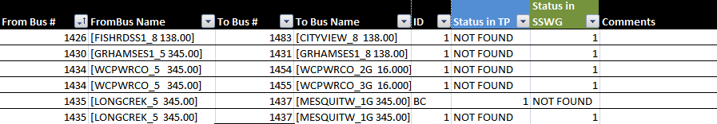

Ratings comparison for branches
A ratings comparison spreadsheet will be created by performing the Compare>Line Ratings function in PSS/E with the TP-Mirror case as the working case and the TP case as the comparison case. The output from the Compare output will be filtered using an Excel macro with tolerances defined in section 2.4.2 above. A comment column will be updated by TSPs and ERCOT staff to explain the differences shown. An example of the ratings comparison spreadsheet is shown below. The spreadsheet will include a flag identifying RARF submitted data that ERCOT staff shall address.
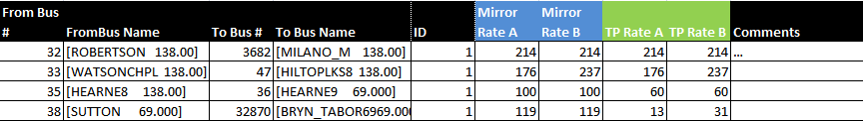

Impedance comparison for branches
Impedance comparison spreadsheet will be created by performing the Compare>Line R, X, B function in PSS/E with the TP-Mirror case as the working case and the TP case as the comparison case. The output from the Compare output will be filtered using an Excel macro with tolerances defined in section 2.4.2 above. A comment column will be updated by TSPs and ERCOT staff to explain the differences shown. An example of the impedance comparison spreadsheet is shown below. The spreadsheet will include a flag identifying RARF submitted data that ERCOT staff shall address.
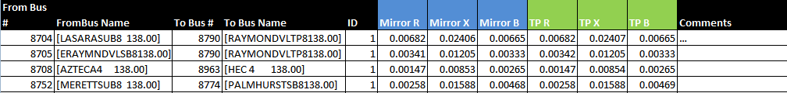

Explanation of Differences
TSPs and ERCOT will be asked to check the data in the spreadsheet and mark each of the differences as follows:
- Change in IMM : NOMCR pending – SSWG case data is correct, a NOMCR will be created in the future that makes a change to IMM.
- Change in SSWG TP-Mirror: Consistency PMCR – A PMCR that will be applied to the TP-Mirror case (during case building process) that will match the data from the TP-Case.
- Necessary difference (explain) – No change will be made to the TP-Mirror case or IMM. Examples: A difference that is caused by a TP deficiency that cannot be fixed by a NOMCR, incorrect RARF data, etc.

Case Building Process:

Case Definitions
Load-flow cases produced by SSWG are to be divided into two groups. The first group, “Data Set A,” models expected conditions for the following year’s four seasons, on peak and off peak for a total of eight cases. The second group, “Data Set B,” models cases for the five-year planning horizon. The schedule for Data Set A and Data Set B should be consulted for the appropriate project transmission in-service date.
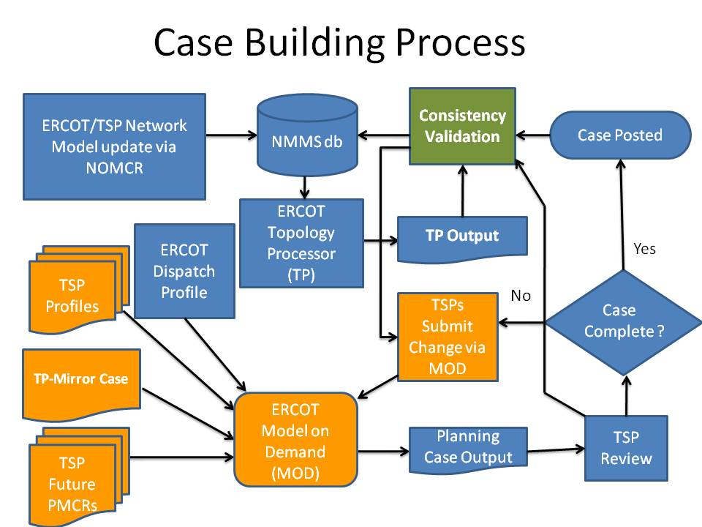

Entity Responsibilities
The Data Set A and Data Set B load-flow cases are assembled and produced as a collaborative effort by members of SSWG. The responsibilities for providing this data are divided among the various market participants and ERCOT. These data provision responsibilities may overlap among the various market participants because participants may designate their representative or a participant may be a member of more than one market participant group. The market participants can generally be divided into four groups: TSPs, Load Serving Entities (LSEs), Power Generation Companies, and Market Entities. ERCOT staff is included as a fifth entity with data provision responsibilities. The data responsibilities of each group are as follows:

TSPs
- It is the responsibility of the TSPs to provide accurate modeling information for all ERCOT Transmission Facilities owned or planned by the TSP.
    - Future transmission facility changes will be submitted as Planning Model Change Requests (PMCRs). PMCRs phase date should correspond to the transmission in-service date. PMCRs should be submitted as far out into the future as possible. This technique will make the case building process more efficient when transitioning to a new case builds.
    - To maintain consistency with the TP case created from the Network Operations Model, TSPs shall submit Consistency PMCRs when necessary. Consistency PMCRS also may rectify the modeling differences caused by interim-update NOMCRs and the time periods between TP case and Data Set Case Postings. This is a period when possible network operations model changes may occur and not show up in the cases.
  - TSPs shall model the load data if they are the designated representatives for load entities. Loads for the cases will be submitted through Load Generation Profiles.
  - TSPs will provide all loads that it has accepted responsibility for modeling.
  - PUN loads will be provided by TSPs.
  - NOIEs have the option of submitting generation dispatch or deferring to ERCOT staff.
  - Proper transmission system voltages will be maintained by submitting Device Control Profiles and Load and Generation Profiles. This will include accurate data for static and dynamic reactive resources and transformer settings in a Device Control Profile for each case. Also, generator characteristics Vsched, remotely controlled bus number, and RMPCT will be submitted by TSPs in Device Control Profiles. TSPs in voltage stability limited regions will be allowed to set generator reactive limits Qmax and Qmin in Load Generation Profiles based on their experience monitoring historical unit operation and reviewing biennial reactive tests.
  - If the TSPs identify errors with generator data or PUN topology, the TSPs will notify ERCOT staff in accordance with Nodal Protocols.
  - It is the responsibility of the TSPs to participate in the Consistency Validation Process.
    - TSPs will review the list of topology, ratings, and impedance differences produced by SSWG.
    - Any differences in topology, ratings, or impedances that are not resolved will be explained and documented by each TSP.

Load Serving Entities
- Each ERCOT Distribution Service Provider (DSP) directly interconnected with the transmission system (or its agent so designated to ERCOT) shall provide annual load forecasts to ERCOT staff as outlined in the ERCOT Annual Load Data Request (ALDR) Procedures.
- For each substation not owned by either a TSP or a DSP, the owner shall provide a substation load forecast to the directly connected TSP sufficient to allow it to adequately include that substation in its ALDR response.
- Entities not having representation on SSWG shall submit the data to ERCOT staff or to the directly connected TSP, if the TSP has agreed to be the agent on SSWG for that entity.

Power Generating Companies
- It is the responsibility of the generation entities to provide all data required to model the generators in all the SSWG created cases. (See Appendix A) Section 1.4. This data should be coordinated with ERCOT staff and should include but is not limited to unit capabilities.

Marketing Entities
- It is the responsibility of marketers to supply the load and/or generation data if they are the designated representatives for either a load or generating entity or both.

ERCOT
- It is the responsibility of ERCOT staff to maintain the ERCOT MOD production environment that allows SSWG members to provide appropriate equipment characteristics and system data as stated in this procedure.
- It is the responsibility of ERCOT staff to provide an initial generation dispatch for Pass 0.
- It is the responsibility of ERCOT staff to provide the revised generation dispatch based on the latest topology and loads by submitting the Load Generation Profile by Pass 2 in the case building process.
- ERCOT staff shall revise the generation dispatch as needed throughout the case building process.
- ERCOT staff shall review submitted PMCRs and notify TSPs of any PMCRs which appear to modify topology, ratings, or impedances from the Network Operations Model.
- Based on the TSPs NERC responsibilities of providing appropriate equipment characteristics and system data, ERCOT staff shall not reject any PMCR that TSPs ultimately determine should be applied to case after appropriate reviews have occurred.
- ERCOT staff shall provide and review all generator models and updates including generator step-up transformers and associated GR-owned transmission facilities.
- ERCOT staff shall provide and review all PUN topology, ratings, and impedances.
- If load data is not submitted by pass 1, then ERCOT staff shall calculate loads based on historical data and insert these loads into the power flow cases during Data Set A and Data Set B annual updates.
- ERCOT staff shall provide case checking files after each pass as historically provided.

Data Set A

Summary of Cases
Data Set A seasons are as follows:
SPG March, April, May
SUM June, July, August, September
FAL October, November
WIN December, January, February

ERCOT DATA SET A BASECASES
(YR) = FOLLOWING YEAR
BASE CASE | NOTES | TRANSMISSION IN-SERVICE DATE
(YR) SPG1 | 2 | April 1, (YR)
(YR) SPG2 | 3 | April 1, (YR)
(YR) SUM1 | 1 | July 1, (YR)
(YR) SUM2 | 3 | July 1, (YR)
(YR) FAL1 | 2 | October 1, (YR)
(YR) FAL2 | 3 | October 1, (YR)
(YR+1) WIN1 | 1 | January 1, (YR+1)
(YR+1) WIN2 | 3 | January 1, (YR+1)
Notes
- Cases to represent the maximum expected load during the season.
- Cases to represent maximum expected load during month of transmission in-service date.
- Cases to represent lowest load on same day as the corresponding seasonal case (not a minimum case). For example, (YR) FAL2 case represents the lowest load on the same day as the (YR) FAL1 case.

Data Set A Generation Dispatch
Data Set A will contain a security constrained economic dispatch.

Procedure for Building Data Set A Cases
- Pass 0
  - Load TP-Mirror
  - Submit Profiles
  - Submit PMCRs
  - Load Initial Dispatch
  - Consistency Validation Spreadsheet
  - Output Pass 1 Cases
- Pass 1
  - Begin Submitting Consistency PMCRs
  - Continue Submitting PMCRs
  - Updates to Profiles
  - Load Revised Generation Dispatch
  - Output Pass 2 Cases
- Pass 2
  - Continue Submitting Consistency PMCRs
  - Continue Submitting PMCRs
  - Updates to Profiles
  - Load Revised Generation Dispatch
  - Output Pass 3 Cases
- Pass 3
  - Continue Submitting Consistency PMCRs
  - Continue Submitting PMCRs
  - Updates to Profiles
  - Load Revised Generation Dispatch
  - Consistency Validation Spreadsheet using updated TP case
  - Output Pass 4 Cases
- Pass 4 – Pass N
  - Continue Submitting Consistency PMCRs
  - Continue Submitting PMCRs
  - Updates to Profiles
  - Load Revised Generation Dispatch
  - Output Pass N+1 Cases
- Final Pass
  - Consistency Validation Spreadsheet using Pass 3 TP case
  - SSWG approves cases
  - Cases, Generation Dispatch Spreadsheet and Consistency Validation Spreadsheet finalized by SSWG Posted
Any changes required after cases are posted will be submitted to ERCOT staff in the form of idevs and posted.

Data Set A Uses
Data Set A cases are generally used as operational cases, for loss calculations and are posted on ERCOT web site for general use.
Data Set B

Data Set B

Summary of Cases
ERCOT DATA SET B BASECASES
(YR) = FOLLOWING YEAR

BASE CASE | NOTES | TRANSMISSION IN-SERVICE DATE
(YR+1) SUM1 | 1 | JULY 1, (YR+1)
(YR+2) SUM1 | 1 | JULY 1, (YR+2)
(YR+3) MIN | 2 | JANUARY 1, (YR+3)
(YR+3) SUM1 | 1 | JULY 1, (YR+3)
(YR+4) SUM1 | 1 | JULY 1, (YR+4)
(YR+5) SUM1 | 1 | JULY 1, (YR+5)
Notes
- Cases to represent the maximum expected load during the season.
- Cases to represent the absolute minimum load expected for (YR+3).

Data Set B Generation Dispatch
Data Set B will contain economically dispatched generation (ECO).

Procedure for Building Data Set B Cases
- Pass 0
  - Load updated TP-Mirror case
  - Submit Profiles
  - Submit PMCRs
  - Load Initial Dispatch
  - Consistency Validation Spreadsheet
  - Output Pass 1 Cases
- Pass 1
  - Begin Submitting Consistency PMCRs
  - Continue Submitting PMCRs
  - Updates to Profiles
  - Load Revised Generation Dispatch
  - Output Pass 2 Cases
- Pass 2
  - Continue Submitting Consistency PMCRs
  - Continue Submitting PMCRs
  - Updates to Profiles
  - Load Revised Generation Dispatch
  - Output Pass 3 Cases
- Pass 3
  - Continue Submitting Consistency PMCRs
  - Continue Submitting PMCRs
  - Updates to Profiles
  - Load Revised Generation Dispatch
  - Consistency Validation Spreadsheet
  - Output Pass 4 Cases
- Pass 4 – Pass N
  - Continue Submitting Consistency PMCRs
  - Continue Submitting PMCRs
  - Updates to Profiles
  - Load Revised Generation Dispatch
  - Output Pass N+1 Cases
- Final Pass
  - Consistency Validation Spreadsheet using Pass 3 TP case
  - SSWG approves cases
  - Cases, Generation Dispatch Spreadsheet and Consistency Validation Spreadsheet finalized by SSWG Posted
Any changes required after cases are posted will be submitted to ERCOT staff in the form of idevs and posted.

Transition from Completed Build to Next Case Build
- At the start of the next case build process, all the Consistency PMCRs submitted during the previous case build will be applied to the previous MOD seed case along with the PMCRs representing completed projects. This will be the new MOD seed case for the next case build.
- Project files representing planned projects and profiles will be retained from the previous case update.
- This process will continue not only for the DSA and DSB case builds, but for each TPIT update.
- Consistency Validation occurs at the same points each update, Pass 0, Pass 3, and Final posting. For TPIT updates, Consistency Validation will occur only twice, at Pass 0 and the Final posting. The TP Case download at Pass 0 will be the TP Case used for the Final posting comparison.

TPIT Updates to Cases Created Outside MOD
- Since load, generation, and device control profiles do not exist for cases created outside MOD environment, these cases will continue to be updated through IDEVs outside of MOD.

