ERCOT Operations Report
Feb 2011 ROS & OWG

Frequency Control
Time | Freq(Hz) | Duration (s)
2/1/2011 22:27 | 59.875 | 52 | Unit trip with 460 MW
2/2/2011 2:18 | 59.847 | 184 | Unit trip with 730 MW; out of URS
2/2/2011 5:14 | 59.829 | 344 | Gen Deviation -1000 in 3 mins; out of URS
2/2/2011 5:39 | 59.576 | 1327 | Gen Deviation -3300 in 9 mins
2/2/2011 8:24 | 59.811 | 405 | Multiple Unit trips with 930 MW
2/2/2011 10:55 | 59.801 | 308 | Multiple Unit trips with 1170 MW
2/12/2011 18:02 | 59.899 | 4 | Unit trip with 390 MW
2/14/2011 18:56 | 60.107 | 8 | Gen Deviation +600 in 1 min
2/14/2011 19:00 | 60.119 | 54 | Gen Deviation +1000 MW in 4 min; out of DRS
2/15/2011 16:40 | 59.770 | 195 | Unit trip with 780 MW
2/16/2011 9:25 | 59.802 | 144 | Unit trip with 566 MW
2/17/2011 22:05 | 59.888 | 16 | Gen Deviation -1000 MW in 4 min; out of URS
2/18/2011 18:11 | 59.891 | 20 | Unit trip with 374 MW
2/19/2011 9:27 | 60.126 | 280 | Gen Deviation + 800 MW in 2 mins
2/21/2011 22:03 | 59.853 | 176 | Gen Deviation – 600 MW in 2 min; out of URS
2/22/2011 7:09 | 60.144 | 176 | Gen Deviation + 1400 MW in 2 mins
2/26/2011 8:15 | 59.899 | 12 | Unit trip with 275 MW
2/28/2011 7:50 | 59.864 | 32 | Multiple units run back with 446 MW
Note: Time of frequency excursions outside the range of +/- 0.1 Hz.

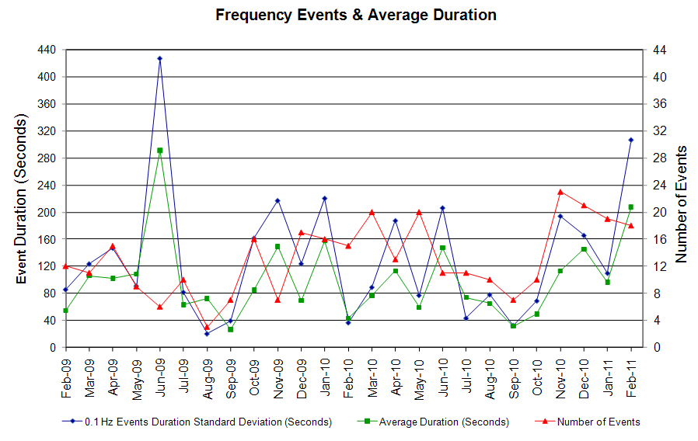
Deployed Responsive(Reported Above in Frequency Table)
Time deployed | Stop Time | Duration | Max | Details
2/2/11 5:03:25 | 2/2/11 5:25:39 | 0:22:14 | 738.00 | EEA event
2/2/11 5:39:20 | 2/2/11 5:49:25 | 0:10:05 | 1197
2/2/11 5:50:52 | 2/2/11 6:27:18 | 0:36:26 | 2300 | EEA event
2/2/11 7:19:25 | 2/2/11 7:23:41 | 0:04:16 | 620
2/2/11 8:25:30 | 2/2/11 8:47:12 | 0:21:42 | 704
2/2/11 10:55:44 | 2/2/11 11:02:28 | 0:06:44 | 1159
2/15/11 16:41:08 | 2/15/11 16:45:42 | 0:04:34 | 425
2/21/11 22:02:08 | 2/21/11 22:09:49 | 0:07:41 | 340

RUC Capacity Purchases
Weather Zone | Unit Days
COAST | 65
EAST | 12
FAR WEST | 37
NORTH CENTRAL | 75
SOUTH | 22
SOUTH CENTRAL | 66
WEST | 3
Grand Total | 280
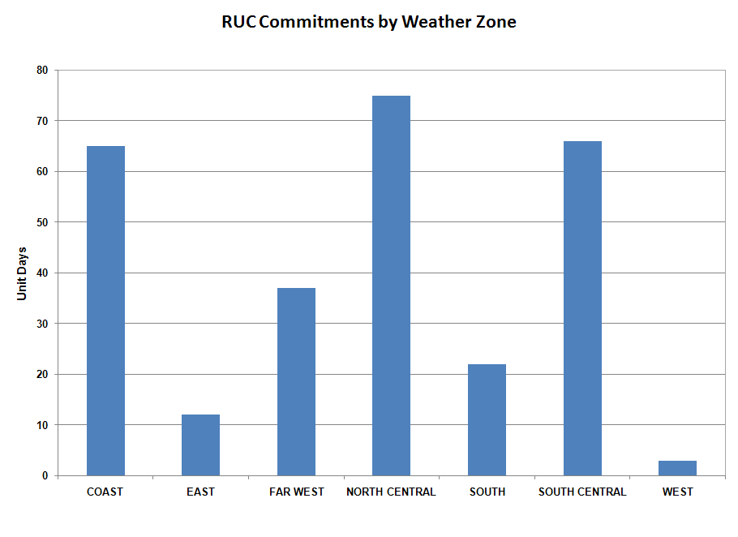
SCED Congestion Management Activity
Congestion affected by outages Remedial action plan has been developed for the element
Contingency | Overloaded Element | Days
Braunig - Toyota & Valley 138kV | West Side - Five Points 138kV | 6
Kendall 345/138kV AT2 | Kendall 345/138kV AT1 | 5
Odessa North - Odessa Basin Switch 69kV | Holt Switch - Ector Shell Tap 69kV | 5
DCKT WB Tuttle - Austin Road 138kV | West Side - Five Points 138kV | 4
Nueces Bay - Koch Upriver & Lon Hill 138kV | McKenzie - Westside 138kV | 3
Chamber - King & Cedar Bayou - Northbelt 345kV | Center - PH Robinson 345kV | 3
Chamber - Baytown Energy 345kV | Baytown Energy 345/138kV AT2 | 3
Lytton Springs - Zorn & Austrop 345kV | Turnersville - Buda 138kV | 3
DCKT Sandow Switch - Austrop 345kV | Sandow Switch 345/138kV AXFMR1 | 2
Aspermont - Spur 138kV | Spur 138/69kV AXFMR1 | 2
Aspermont - Spur 138kV | Spur - Girard Tap 69kV | 2
Fern Street - Ball Park 138kV | West Side - Five Points 138kV | 2
Odessa EHV Switch - Morgan Creek SES & Quail Switch 345kV | Ackerly Vealmoor Switch - Ackerly 69kV | 2
Twin Oak Switch - Gibbons Creek & Jack Creek 345kV | Twin Oak Switch - Jewet 345kV | 2
Denton - Argyle & West Denton 138kV | West Denton - Jim Christal Substation 138kV | 2
STP - Whitepoint 345kV | Blessing - Palacios 69kV | 2
Lobo - San Miguel 345kV | Freer - San Diego 69kV | 2
STP - Elm Creek 345kV | Blessing - Lolita 138kV | 2
Comanche Peak Unit 1 & 2 | Carrollton Northwest - Lakepointe 138 kV | 2
Sun Switch - Golden Switch 138kV | China Grove Switch - Bluff Creek Switch | 2
Lewisville West - Lewisville Highlands 138kV | Lewisville Switch - Lewisville Jones Street 138kV | 2
BASE CASE | Gold Switch - Brand TU 138kV | 1
BASE CASE | Notrees - Notrees Switch 138kV | 1
BASE CASE | Victoria - Thomaston 138kV | 1
BASE CASE | Bruni 138/69kV AT1 | 1
BASE CASE | Killeen Switch - Trimmier 138kV | 1
DCKT Sandow Switch - Austrop 345kV | Taylor West - Hutto 138kV | 1
Temple Creek - Tradinghouse SES & Temple Switch - Lake Creek SES 345kV | Lake Creek SES 345/138kV AT1 | 1
Lon Hill - Nelson Sharpe 345kV | Nelson Sharpe PS | 1
Willow Valley Switch - Bluff Creek Switch 138kV | Ackerly Vealmoor Switch - Ackerly 69kV | 1
Fort Stockton - Barilla 138kV | Fort Stockton Switch - Barilla 69kV | 1
Andrews North - Lamesa 138kV | Ackerly Vealmoor Switch - Ackerly 69kV | 1
Cagnon 345/138kV AXFMR3 | Cagnon 345/138kV AT4 | 1
Cagnon 345/138kV AT3 | Cagnon 345/138kV AT4 | 1
Graham SES - Long Creek & Cook Field 345kV | Cisco - Putnam 138kV | 1
Graham SES - Long Creek & Cook Field 345kV | Bomarton - Seymour 69kV | 1
Nueces Bay - Koch Upriver & Lon Hill 138kV | Citgo West - Weil Tract 138kV | 1
Bosque Switch - Whitney 138kV | Bosque Switch - Lake Whitney 138kV | 1
Pawnee - Lon Hill 345kV | Sinton - Skidmore 138kV | 1
Parker Switch - Eagle Mountain SES & Roanoke Switch 345kV | Carrollton Northwest - Lakepointe 138 kV | 1
Kiowa Switch - Kiamichi 345kV | Kiowa Switch - Kiamichi 345kV | 1
Sandy Creek - Ferguson 138kV | Coronado 138/69kV AT4 | 1
West Levee Switch 345/138kV AT1 | West Levee Switch 345/138kV AT2 | 1
Lytton Springs - Holman & Fayette 345kV | Fayette - Lost Pines 345kV | 1
Kiowa Switch - Kiamichi 345kV | Kiowa Switch - Kiamichi 345kV | 1
Trinidad SES - Watermill & Tricorner 345kV | Trinidad SES 345/138kV AT6 | 1
Nelson Sharpe - Ajo 345kV | Lon Hill - North Edinburg 345kV | 1
Lon Hill - Mathis Sub 69kV | Orange Grove - Orange Grove Sub 69kV | 1
Lobo - San Miguel 345kV | Big Foot 138/69kV | 1
Lobo - San Miguel 345kV | Asherton - North Laredo Switch 138kV | 1
Lobo - San Miguel 345kV | Big Foot 138/69kV | 1
Tradinghouse SES - Venus Switch 345kV | Jewet - Rattlesnake Road Switch 345kV | 1
Pawnee - Coleto Creek 345kV | Coleto - Kennedy Switch 138kV | 1
Carrolton NW - Plano Tennyson & Collin 345 345kV | Collin SES - Frisco A 138kV | 1
Comanche Peak Unit 1 & 2 | Sinton - Skidmore 138kV | 1
Nacogdoches Road - Skyline 138kV | West Side - Five Points 138kV | 1
Norwood Switch - Irving Norwood 138kV | DFW D1 - DFW C East 138kV | 1
Abilene Mulberry Creek - Bitter Creek & Long Creek - Sweetwater Cogen 345kV | Sterling County - Sterling City 69kV | 1
Lon Hill 138/69kV AT1 | Koch Up River 138_69A1 XFMR | 1
Holt Switch - Andrews North 138kV | Ackerly Vealmoor Switch - Ackerly 69kV | 1

Generic Transmission Limits (GTL’s)
GTL | Days
West – North | 25
Valley Import | 8
Note: This table lists out how many times a constraint has been activated to avoid exceeding this limit, it does not always imply an exceedance occurred.

New RAP, PCAP (Date indicates last update of RAP, PCAP not implementation date.)
None

SPS (RAS) (New, Modified, Removed)
None

New Procedures/Forms/Operations Bulletins
None

Load Shed Incidences
02/02 05:44 ERCOT requested a firm load shed of 1,000 MW.

02/02 06:04 ERCOT requested an additional 1,000 MW firm load. (2,000 MW total)

02/02 06:23 ERCOT requested an additional 2,000 MW firm load. (4,000 MW total)

02/03 22:06 Firm load shed based on existing mitigation plan for the Rio Grande Valley.

EEA
02/02 05:20 ERCOT issued an EEA Level 2A.

02/02 05:43 ERCOT issued an EEA Level 3. (At 14:01 ERCOT moved from EEA Level 3 to EEA Level 2B and at 15:14 EEA Level 2B to EEA Level 2A.)

02/03 10:00 ERCOT ended EEA.

System Voltage Problems
02/03 22:01 Voltage in the Rio Grande Valley reached 0.91 pu or 125 kV.

Application Issues
02/08 20:30 ERCOT issued an Emergency Notice due to EMS and SCED failure.

Communication Issues
None

ERCOT peak (Unofficial)
02/10 08:00 57,283 MW
Yearly MTLF Error Comparison
Yearly Mid-Term (Hourly) Load Forecast Error Comparison for the ERCOT Forecast
Month | MAPE for MTLF at 16:00 Day-Ahead
Month | 2008 | 2009 | 2010 | 2011
January | 3.30 | 4.11 | 3.78 | 2.91
February | 3.59 | 3.49 | 3.79 | 3.46
March | 3.29 | 3.24 | 2.24 | NA
April | 2.45 | 2.66 | 2.47 | NA
May | 3.01 | 2.90 | 2.63 | NA
June | 2.81 | 2.89 | 2.84 | NA
July | 2.55 | 2.83 | 2.39 | NA
August | 3.66 | 3.07 | 2.29 | NA
September | 4.99 | 3.68 | 3.14 | NA
October | 2.79 | 2.92 | 2.37 | NA
November | 2.60 | 1.93 | 3.46 | NA
December | 4.54 | 3.70 | 2.60 | NA
Annual Average | 3.29 | 3.11 | 2.83 | 3.19

OCN, Advisory, Watch & Emergency Notices
Capacity
Date | Start | Event
2/2/2011 | 2:47 | ERCOT issued an Advisory for PRC below 3000 MW.
2/2/2011 | 3:00 | ERCOT issued an OCN for Projected Reserve Capacity Shortage for HE 08:00 to 13:00
2/2/2011 | 2:49 | ERCOT issued an Advisory for PRC has fallen below 3000.
2/2/2011 | 3:01 | ERCOT issued an OCN for Projected Reserve Capacity Shortage for HE 08:00 to 13:00.
2/2/2011 | 5:08 | ERCOT issued a watch due to PRC below 2500 MW.
2/12/2011 | 19:15 | ERCOT issued an OCN for Projected Reserve Capacity Shortage for HE 01:00 to 06:00.
2/15/2011 | 6:30 | ERCOT issued an OCN for Projected Reserve Capacity Shortage for HE 19:00 to 20:00.
2/15/2011 | 16:59 | ERCOT issued an OCN for Projected Reserve Capacity Shortage for HE 19:00 to 21:00.
2/15/2011 | 18:36 | ERCOT issued an Advisory for PRC below 3000 MW.
2/16/2011 | 6:40 | ERCOT issued an OCN for Projected Reserve Capacity Shortage for HE 11:00 to 17:00.
2/16/2011 | 6:40 | ERCOT issued an OCN for Projected Reserve Capacity Shortage for HE 11:00 to 17:00.
2/18/2011 | 9:33 | ERCOT issued an Advisory for PRC below 3000 MW.
2/19/2011 | 8:50 | ERCOT issued an Advisory for PRC below 3000 MW.
2/19/2011 | 15:20 | ERCOT issued an Advisory for PRC below 3000 MW.
2/19/2011 | 1:53 | ERCOT issued an OCN for Projected Reserve Capacity Shortage for HE 10:00 to 16:00.
2/20/2011 | 9:58 | ERCOT issued an OCN for Projected Capacity Shortage for HE 18:00 to 21:00.
2/21/2011 | 0:34 | ERCOT issued an OCN for Projected Reserve Capacity Shortage for HE 12:00 to 20:00.
2/21/2011 | 19:32 | ERCOT issued an Advisory for PRC below 3000 MW.
2/21/2011 | 22:08 | ERCOT issued an Advisory for PRC below 3000 MW.
2/22/2011 | 0:16 | ERCOT issued an OCN for Projected Reserve Capacity Shortage for HE 04:00 to13:00. Also for HE 19:00 to 20:00.
2/22/2011 | 2:08 | ERCOT issued an Advisory for PRC below 3000 MW.
2/22/2011 | 6:54 | ERCOT issued an Advisory for PRC below 3000 MW.
2/24/2011 | 20:25 | ERCOT issued an Advisory for PRC below 3000 MW.
2/25/2011 | 2:50 | ERCOT issued an OCN for Projected Reserve Capacity Shortage for HE 08:00 to 12:00.
2/25/2011 | 8:58 | ERCOT issued an Advisory for PRC below 3000 MW.
2/25/2011 | 0:00 | ERCOT issued an Advisory for PRC below 3000 MW.
2/25/2011 | 19:51 | ERCOT issued an Advisory for PRC below 3000 MW.
2/26/2011 | 8:53 | ERCOT issued an Advisory for PRC below 3000 MW.
2/26/2011 | 9:20 | ERCOT issued an OCN for Projected Reserve Capacity Shortage for HE 11:00 to 14:00.
2/27/2011 | 18:45 | Advisory issued effective 1845 via Hotline Call to all QSEs due to PRC falling below 3000 MW.
2/28/2011 | 2:05 | ERCOT issued an OCN for Projected Reserve Capacity Shortage for HE 14:00 to 16:00, 19:00 to 20:00, and 23:00 to 24:00.
2/28/2011 | 18:50 | ERCOT issued an Advisory for PRC below 3000 MW.

Weather
Date | Start | Event
1/31/2011 | 06:32 | ERCOT issued an OCN due to a cold front approaching with temperatures anticipated to be in mid to low teens F range, with maximum temperatures expected to remain near or below freezing impacting 50% of more of major metropolitan areas.
1/31/2011 | 08:55 | ERCOT issued an Advisory due to a cold front approaching with temperatures anticipated to be in mid to low teens F range, with maximum temperatures expected to remain near or below freezing impacting 50% of more of major metropolitan areas.
2/1/2011 | 09:05 | ERCOT issued an Advisory due to temperatures epxected to be in teens to low 20 F range, and max temperatures expected to remain near or below freezing, impacting 50% or more of major metro areas.
2/6/2011 | 12:30 | ERCOT issued an Advisory due to a cold front approaching with temperatures anticipated to be in mid to low 20 degree F range and maximum temperature expected to remain near or below freezing impacting 50% or more of major metropolitan areas.
2/7/2011 | 7:24 | ERCOT issued an Advisory effective 0730 due to severe cold weather approaching.

Transmission Watch
02/03 17:35 ERCOT issued transmission watch for the Rio Grande Valley due to current and forecasted weather conditions.

02/08 10:26 ERCOT issued transmission watch effective 1030 due to cold weather approaching with below freezing temperatures anticipated across most of state.

02/10 06:10 ERCOT issued a Transmission Watch for the Rio Grande Valley due to current weather conditions and Valley import levels.

Emergency Notice
02/03 22:29 ERCOT issued a Transmission Emergency Notice for the Rio Grande Valley area due to current and forecasted weather.

02/08 20:30 ERCOT issued an Emergency Notice due to EMS and SCED failure.

Texas RE Event Analysis
02/02 05:20 ERCOT declared Energy Emergency Alert (EEA) Level 2A for Physical Responsive Capability (PRC) dropped below 1,750 MW. At 05:43 ERCOT declared EEA Level 3 and issued a Verbal Dispatch Instructions (VDI) to drop 1,000 MW of firm load. At 06:04 additional 1,000 MW was curtailed. At 06:23 additional 2,000 MW was curtailed, total of 4,000 MW. All of which was restored by 13:07.

02/03 21:47 Approximately 21:47 on February 03, 2011, approximately 486 MW of generation was forced out due to extreme cold weather in the Rio Grande Valley. In conjunction with planned generation outages and high loads due to the weather, this caused voltage in the area to deteriorate to approximately 0.91 p.u. by 22:01. A Mitigation Plan was implemented in which up to 442.2 MW of firm load was shed by ERCOT Transmission Operators; American Electric Power (AEP), Public Utility Board of Brownsville (BPUB), and South Texas Electric Cooperative (STEC) to recover the voltage to acceptable levels. All shed load was restored by 23:28 on February 04, 2011.

