Overview
Feb 22, 2011 MIS USER GROUP FEEDBACK IN THIS HIGHLIGHT (SUMMARY AT END)
The Dashboard portlets are a graphical display of near-real-time data. Certain pricing and load dashboards are available from ERCOT.com. All MIS Dashboards are accessed from the Applications page. The links to each Dashboard open in a new browser window that will continue to update at the specified refresh rate until you close the window. Some Dashboards provide options that you can select to track, such as LMPs; others are real-time data but provide no user-selected options.
The pricing table displays provide an observation of key nodal prices without having to download incremental current day reports to build a view of the day’s prices. These Displays open in a new browser window. All Displays are accessed from www.ercot.com.

The ERCOT.com Dashboards include:
- Real-Time LMP Report
- Real-Time Settlement Point Prices at Resource Nodes, Hubs and Load Zones
- DAM Settlement Point Prices
- DAM Clearing Prices for Capacity
- Actual Loads of Weather Zones

The MIS Dashboards include:
- Day-Ahead and Real-Time LMPs
- LMP Contour Map (also displays on the Real-Time Market page)
- LMP Ticker
- Load Forecast vs. Actual (also displays on Forecasts landing page)
- Real-Time System Conditions (also displays on the Markets – Real-Time and Transmission landing page)
- SCED Up/Down
- System Ancillary Service Capacity Monitor

General Dashboard Behavior
- Most Dashboards have an Auto-Update check box which is selected by default. Removing the check from the checkbox causes the Dashboard to remain static and does not update until you reselect the Auto-Update check box.
- Each Dashboard has a Last Updated timestamp that shows the date and time the data was updated

MISUG general changes proposed on existing Dashboards

#5 Market = MEDIUM - Resolve timeouts and frequency of re-fresh issues

Response- ERCOT needs example of unexpected timeout issues (HelpDesk tickets)

#28 Market = LOW - Ability to rescale/resize graphics to enlarge or shrink
Response- HIGH IMPACT
Capability not in current platform- significant re-design effort
Workaround to zoom individual panes /portlets

#36 Market = HIGH “My page”/eData like functionality to open a pre-determined set of screens
Response- HIGH IMPACT
Capability not in current platform- significant re-design effort
Workaround to take 5 minutes to re-establish tiling of screens each day

#13 Market = HIGH – Create some or all dashboard to become public
Response- HIGH IMPACT
Feb 2/3 confirmed on large usage day, current displays just meet peak market demand
Likely need more hardware for Capability not in current platform- significant re-design effort
If any chart have hovering/show values functionality place in user guide?
2.1 Price graphs – Market Low
2.2 Contour map – Market Med-High (price separation)
2.3 Ticker – Market Low
2.4 Load Forecast – Market Med-High
2.5 Freq and Real-Time – Market High
2.6 SCED Up/Down – Market High
2.7 System AS Capacity Monitor – Market Very High
New wind graph and report – Market High
Business case based on lessons learned from Feb2

ERCOT.com (Public) Displays

Real-Time LMPs for Load Zones and Trading Hubs Display
This is a near real-time display of the report, LMPs by Resource Nodes, Load Zones and Trading Hubs, from the most recent SCED run. It contains no history but a rolling table of the most recent SCED runs.
CONSIDER README - FOR POINT MAPPING
CONSIDER ARCHIVAL OF HISTORICAL PRICES and Link to these display

URL | Available from ERCOT.com: Nodal Real-Time Market (http://www.ercot.com/mktinfo/rtm/)
Source Data/CDR | NP6-788, LMPs by Resource Nodes, Load Zones and Trading Hubs
Data | LMPs from Latest SCED run
History | None
Screen Refresh Rate | Every 10 Seconds
Data Refresh Rate | Every Five Minutes or every SCED run
Notes | Displays only the Trading Hub and Load Zone prices from the most recent SCED run

Sample – Real-Time LMPs for the Latest SCED Run
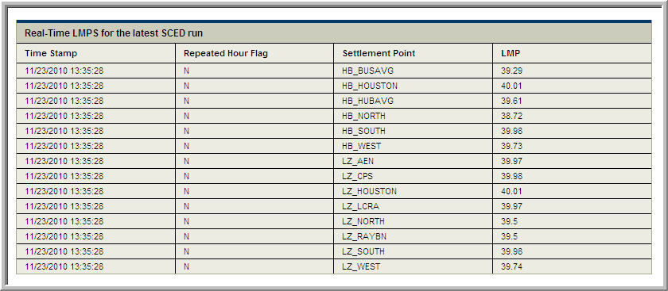

Real-Time LMPs for Latest SCED Run Display
This is a display of the LMPs by Resource Nodes, Load Zones and Trading Hubs (all settlement points) with no conversion.

URL | Available from ERCOT.com: Nodal Real-Time Market (http://www.ercot.com/mktinfo/rtm/)
Source Data/CDR | NP6-788, LMPs by Resource Nodes, Load Zones and Trading Hubs
Data | LMPs from Latest SCED run by all Resource Nodes, Load Zones and Trading Hubs
History | None
Screen Refresh Rate | None – user initiated
Data Refresh Rate | Every Five Minutes or every SCED run
Notes | Displays LMPs at every settlement point for the most recent SCED run only

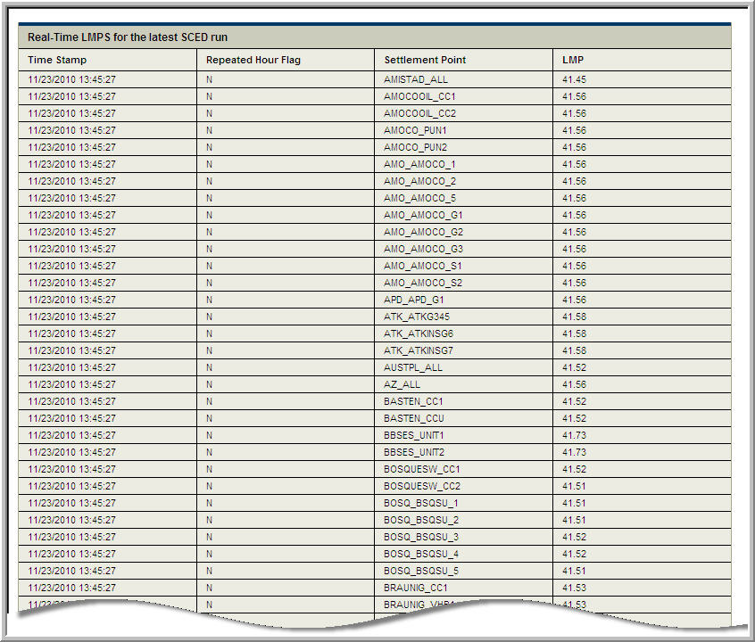

Real-Time Settlement Point Prices Display
This is a display of Real-Time Settlement Point Prices at Resource Nodes, Hubs and Load Zones.

URL | Available from ERCOT.com: Nodal Real-Time Market (http://www.ercot.com/mktinfo/rtm/)
Source Data/CDR | NP6-905, Settlement Point Prices at Resource Nodes, Hubs and Load Zones
Data | SPPs from Latest SCED run
History | Today’s date (default)  Yesterday’s date
Screen Refresh Rate | Every 60 Seconds
Data Refresh Rate | Every Fifteen minutes
Notes | There are 96 rows of 15-minute Real-Time price interval data: hours 0100 – 2400 for each day, displaying Trading Hubs and Load Zones only. Every fifteen minute interval throughout the Operating day, a new row is added.

Sample - Real Time Settlement Point Prices
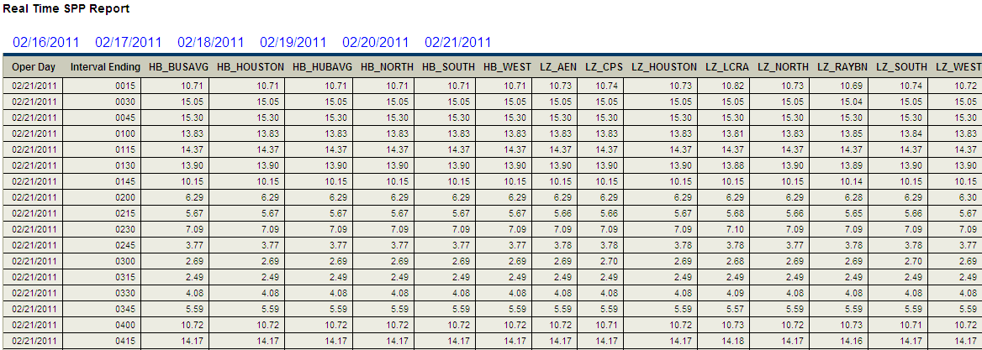

Day-Ahead Market Settlement Point Prices Display
This is a display of the DAM Settlement Point Prices for three Operating Days for Resource Nodes, Hubs and Load Zones.

URL | Available from ERCOT.com: Nodal Day-Ahead Market (http://www.ercot.com/mktinfo/dam/)
Source Data/CDR | NP4-190, DAM Settlement Point Prices
Data | Settlement Point Prices from the current operating day’s DAM run
History | Today’s date (default)  Yesterday  Tomorrow
Screen Refresh Rate | n/a
Data Refresh Rate | Daily (when DAM posts)
Notes | Click the link for a different day to see that day’s data. There are 24 rows of data for each hour ending of the day. This displays Trading Hub and Load Zone SPPs only.

Sample - Day Ahead Market Settlement Point Prices
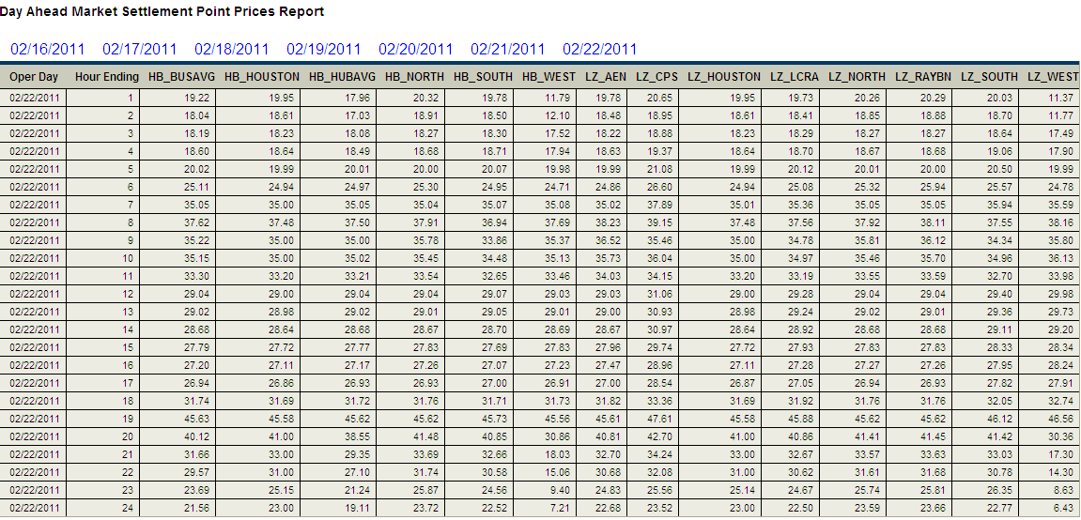

Day-Ahead Market Clearing Prices for Capacity Display
This is a display of the DAM Market Clearing Prices for Capacity for ancillary services.

URL | Available from ERCOT.com: Nodal Day-Ahead Market (http://www.ercot.com/mktinfo/dam/)
Source Data/CDR | NP4-188, DAM Clearing Prices for Capacity
Data | Market Clearing Prices for Capacity for ancillary services, defaulted to the current operating day from the DAM run
History | Today’s date (default)  Yesterday  Tomorrow
Screen Refresh Rate | n/a
Data Refresh Rate | Daily (when DAM posts)
Notes | Click the link for a different day to see that day’s data. Contains 24 rows of hourly data: 0100 – 2400

Sample - Day-Ahead Market Market Clearing Price for Capacity
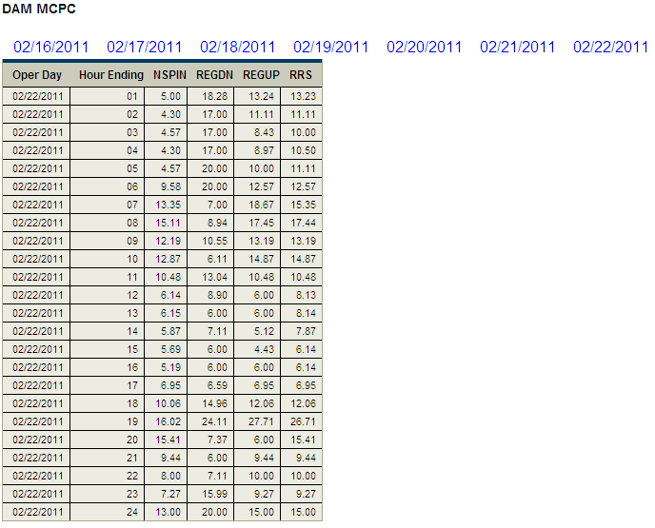

Nodal Control Area Historical Load Display
This is a display of the actual load values of Weather Zones up to the current hour.

URL | Available from ERCOT.com: Grid Information  Link: Nodal Control Area Historical Load (http://www.ercot.com/gridinfo/load/)
Source | There is no corresponding protocol requirement to post a report to MIS in support of this dashboard.
Data | Actual load of weather zones (integrated with 4 second values)
History | Today’s date (default)  Yesterday’s date
Screen Refresh Rate | n/a
Data Refresh Rate | Hourly
Notes | Click the link for a different day to see that day’s data. The previous day provides a 24-hour view of Load data and the current day will show up to the current beginning hour.

Create a downloadable report equivalent

Sample - Actual Loads of Weather Zones
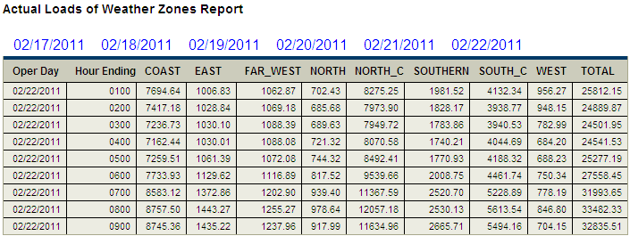

MIS Dashboard Descriptions

Day-Ahead and Real-Time LMPs
Day-Ahead and Real-Time LMPs Dashboard will initially take you to a setup screen where you choose the LMPs you wish to track. Those LMPs will continue to display in the Dashboard until you make different selections through the Edit function.

You can select up to four LMPs for which to track Real-Time and Day-Ahead Prices
Source Data/CDR | NP4-183, DAM Hourly LMPs  NP6-788, LMPs by Resource Nodes, Load Zones and Trading Hubs
Data | The current value for each LMP displays in the upper right section of the chart and the name displays above the chart. Both prices are for the current operating day, the DAM LMPs having been created by the DAM execution the day before. When you select the prior day’s date, the current value of the LMPs does not display.
Operating Day | Today’s date (default)  Yesterday’s date
Time Frame | 4 hours (default)  2 hours  24 hours
Screen Refresh Rate | Every 60 Seconds
Data Refresh Rate | Real-Time LMPs are updated every 5 minutes or after every SCED run  Day-Ahead LMPs are updated every hour
View Latest Details | Displays an LMP Details screen that shows the most current Day-Ahead (DA) and Real-Time (RT) prices, the difference between the RT and DA, and today’s RT Minimum and Maximum. The data in this window does not auto-refresh. Clicking on a different LMP, while the detail window is open, refreshes the window with the new data. The display of multiple detail windows is not supported.
Edit | Click the Edit button to change the LMPs you track on this Dashboard.
Notes | Day-Ahead and Real-Time LMPs will initially take you to a setup screen where you choose the LMPs you wish to track. Those LMPs will continue to display in the Dashboards until you make different selections through the Edit function. You cannot choose more than four LMPs to track in this Dashboard.
Sample – Day-Ahead and Real-Time LMPs
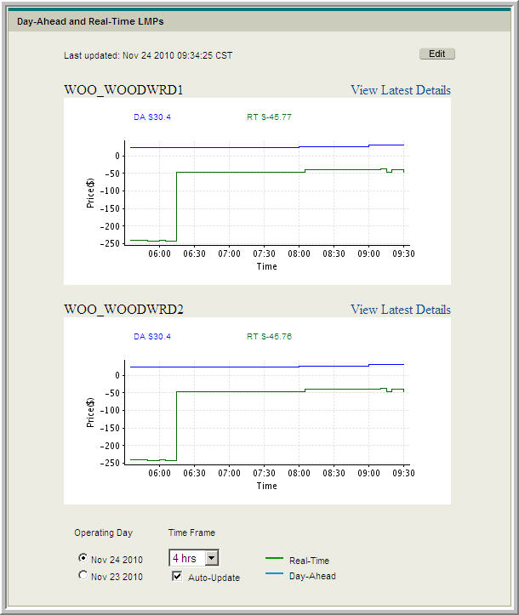

#43 – Market HIGH - LMP graphs- additional prices to allow more than one price per chart
Discuss how many LMPs desired on one chart.- Not specified- ERCOT will determine if 6-10 possible
Med-High System Impact

LMP Contour Map
The LMP Contour Map offers a dynamic view of Locational Marginal Prices for resource nodes and Settlement Point Prices against the ERCOT network.

A graphical display of LMPs price ranges throughout the ERCOT area
Source | There is no corresponding protocol requirement to post a report to MIS in support of this dashboard.
Data | The contour map has three data displays:  - Real-Time LMPs  - Real-Time SPPs  - Day-Ahead SPPs  Dots on the map representing each LMP/SPP are located at the resource node (dots may overlap).
Market | RTM (default)  DAM
Type | LMP (default)  SPP
Screen Refresh Rate | Every 60 seconds
Data Refresh Rate | Real-Time LMPs are updated every 5 minutes or after every SCED run  Real-Time SPP are updated every 15 minutes  Day-Ahead LMPs are updated hourly
Date | Date is inactive until you deselect the Auto-update check box. When you remove the Auto-update check mark, the date windows is activated. Click the dropdown to choose a different date.
Int. Ending | Interval Ending is inactive until you deselect the Auto-update check box. When you remove the Auto-update check mark, and select a date, the interval selection window is activated. Click the dropdown to choose a different interval.
Notes | The Contour map is titled according to the selections you made in the Dashboard options. The Market and Type displays the date and time of the data displaying on the screen along with Maximum and Minimum prices.
Sample – LMP Contour
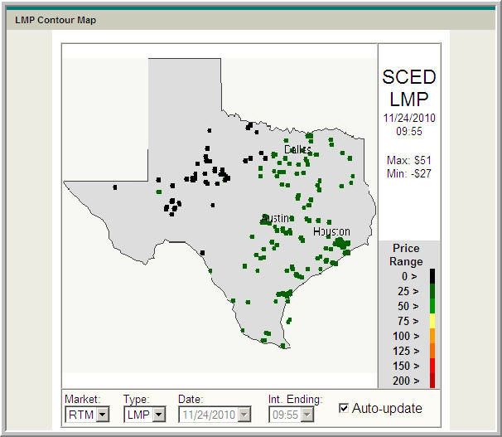

#38- LMP Contour Map improvements
HIGH impact- re-write and change software to create contour, ERCOT shares interest
HIGH impact- create ability to zoom into regions
LOW/free – modify colors/scaling
History- Changed polygons of previous version to dots, anchored contour scale (eg CAISO)
Easy to increase/decrease dot size
Easy to change scale bandwidth, and colors
Change labels to specify range
Hover-Settlement Point name revealed
Consider additional city names
Monitor congestion- find owner of protocol reqts- and consider map as possible artifact.

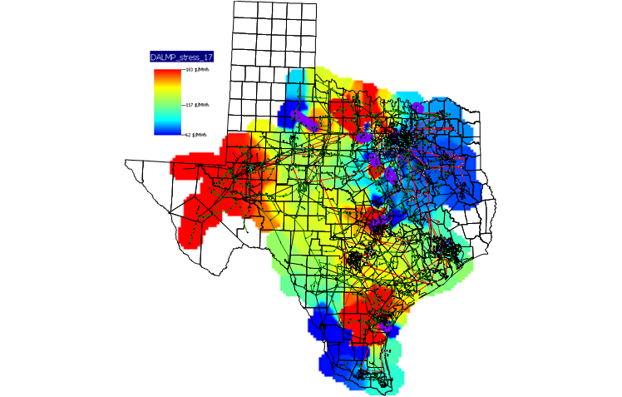
LMP Ticker
Provides real-time LMP values for the user-selected list of LMPs.

A scrolling display of user-selected LMPs
Source Data/CDR | NP4-183, DAM Hourly LMPs  NP6-788, LMPs by Resource Nodes, Load Zones and Trading Hubs
Data | Provides a scrolling display of all LMPS selected. You can choose up to 50 LMPs to track in the ticker. The Real-Time price displays, followed by the difference between the Real-Time and Day-Ahead price.  Position your cursor over the scrolling bar and click on a given LMP name to view details about the LMP. The data in the details window does not auto-refresh. Clicking on a different LMP, while the detail window is open, refreshes the window with the new data. The display of multiple detail windows is not supported.
Screen Refresh Rate | When the feed for the list of LMPs completes, the scroll begins again.
Edit | Click the Edit button to change the LMPs you track on this Dashboard.
Notes | LMP Ticker will initially take you to a setup screen where you choose the LMPs you wish to track. Those LMPs will continue to display in the Dashboard until you make different selections through the Edit function. You cannot choose more than 50 LMPs to track on the Ticker.

Sample – LMP Ticker

Sample – LMP Ticker Details
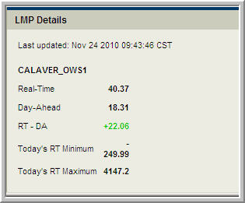

Load Forecast vs. Actual
This Dashboard provides load forecast data to compare with the actual load, as well as planned and actual online generation.

Displays system-wide load information
Source/CDR | NP3-560, Seven-Day Load Forecast by Forecast Zone (for both the load forecast and the actual load)
Data | System-wide load and generator COP information
Operating Day | Today’s date (default)  Yesterday’s date  Tomorrow’s date
Time Frame | 2 hours (Today’s date – current time minus one hour and plus one hour)  24 hours (Yesterday or Tomorrow)
Screen Refresh Rate | Every 60 Seconds
Data Refresh Rate | Forecast from the Day-Ahead uses data after DRUC is run the previous day.  Load Forecast is updated approximately every hour  Actual Load displays as a number for current load and line graph for historical and is updated every 60 seconds  Online Generation Actual uses COP information that was available at the end of the adjustment period and is calculated once every hour  Online Generation Planned uses the COP information that was available at the time that DRUC was executed and is calculated once a day
Notes | The load forecast information comes from the ERCOT Seven-Day Load Forecast. The online generation information is determined by summing the COP HSLs for all generators with an online COP resource status.
Sample – Load Forecast vs. Actual
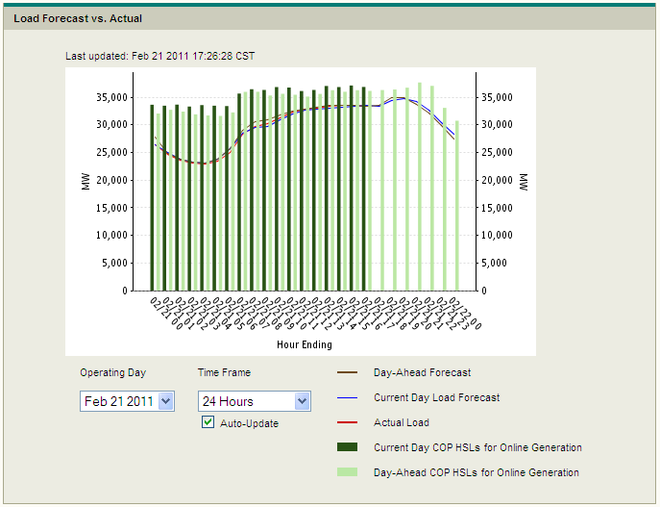

#40 Market = MEDIUM – Load Page Dashboard

“Currently have DAM, RTM and actual - could we include forecasts?

ERCOT doesn't have the RUC snapshots.

Looking for most recent HRUC snapshot looking at current load.”

ERCOT does not see a gap- see details of data re-fresh rate (above)

Hover capability to see value, or open a table

Add an additional reporting equivalent
Refine scale to within operating (instead 0-65,000MW)

Real-Time System Conditions
The Real-Time System Conditions dashboard displays the latest system conditions.

Displays the key real-time summary information
Source/CDR | NP4-732, Actual and Forecasted Regional Wind Production  NP6-626, State Estimator Load Report - DC Ties Flows  NP6-235, System-Wide Demand
Data | Displays:  - Frequency for the last 15 minutes (as a graph and as a number)  - Instantaneous Time Error  - Actual System Demand (Telemetered Load)  - Total System Capacity  - DC Tie MW values for actual flows  - Total Wind Output (an hourly average value)
Operating Day | Today’s date (default)  Yesterday’s date
Hour Ending | Can choose only one interval
Screen Refresh Rate | Every 60 Seconds
Data Refresh Rate | Total Wind Output updates hourly. Frequency and Instantaneous Time Error updates every 4 seconds. The other values update every 5 minutes. The Actual System Demand will be the current 5-minute snapshot.
Notes | Total System Capacity equals the Actual System Demand plus the capacity available to increase SCED Base Points  Total system capacity in Nodal is dependent on either the QSEs COPs or the QSEs telemetry. In either case, these submittals may not necessarily be in line exactly with what has been submitted by the QSEs in Zonal. In Zonal, the value is calculated using Resource Plans, telemetry, and seasonal limits.  For the total wind output, in Nodal the value is an hourly average value. This is not the case in Zonal. In Zonal, the value is a real-time snap shot.
Sample – Real-Time System Conditions
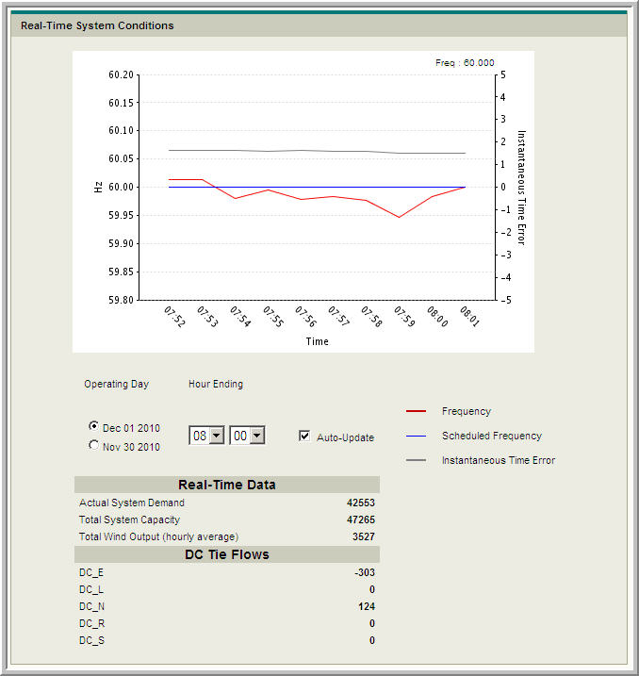

#39- Market = MEDIUM - Add CSC Flows
More requirements needed - Leverage old zonal CSCSs or show ValleyImport, W-N limits?
Want on this screen or new historical graphic?
Consider using new 5-minute SE report implementing this month: (all discreet elements that make up CSC and CRE except Valley Import and Laredo
Option 1- Add Interface and CSCs with DC Ties on this display
Option 2- Consider new display of all available CSC/CRE elements
Increase frequency on wind refresh (to align with DC tie frequency of 5 minutes)- new source, or change hourly wind report to 5minutes)
Add DC-Tie labels
Consider solar

SCED Up Down
SCED Up/Down dashboard displays the available capacity that can be used to increase/decrease base points

Displays the available capacity that can be used to increase or decrease base points
Source | There is no corresponding protocol requirement to post a report to MIS in support of this dashboard.
Data | Displays the available capacity in the ERCOT system that can be used to increase or decrease Base Points in SCED.
Operating Day | Today’s date (default)  Yesterday’s date
Time Frame | Past 90 minutes (default)  24 hours
Screen Refresh Rate | Every 60 Seconds
Data Refresh Rate | Every 10 seconds
Notes | These values are calculated as part of the ERCOT Ancillary Service Capacity Monitor described in 6.5.7.5 of the ERCOT Nodal Protocols

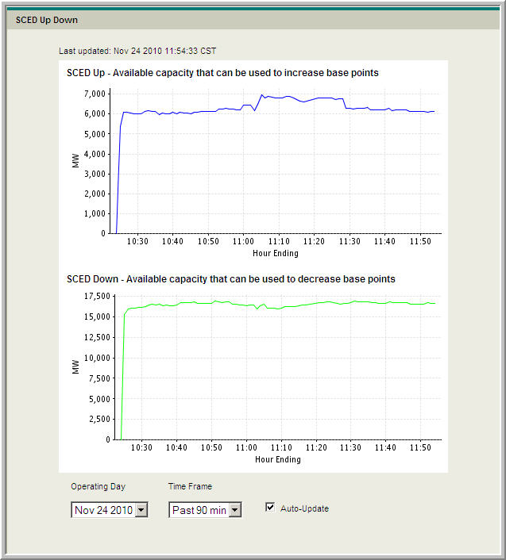

# Combine on single chart- SCED Up and Down on same chart (Market- MED-HIGH)

System Ancillary Service Capacity Monitor
The System Ancillary Service Capacity Monitor can be accessed from the Market – Real-Time Market page or the Applications page. All MW values are in whole numbers.

Displays the current System Ancillary Service values
Source/CDR | There is no corresponding report posted to MIS in support of this dashboard
Data | Displays:  - Responsive Reserve Capacity (MW)  - Non-Spin Reserve Capacity (MW)  - Regulation Up/Regulation Down Capacity (MW)  - System Capacity (MW)
Screen Refresh Rate | Every 60 seconds
Data Refresh Rate | Every 10 seconds
Notes | The values provided are listed in 6.5.7.5 of the ERCOT Nodal Protocols

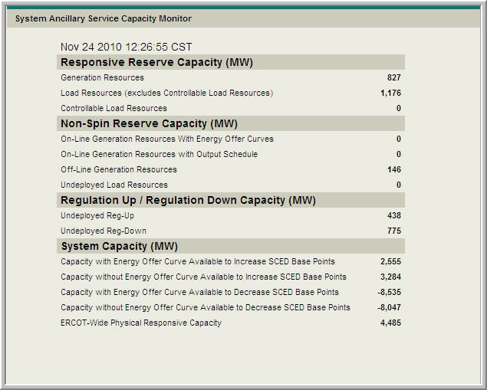
#24- MARKET MEDIUM - Create graphical version of seven days (similar to Forecast/Actual)
MEDIUM IMPACT
MARKET AGENDA DISCUSSION TO CONSIDER WHICH LINES TO TREND/GRAPH

********************************************************

MISUG New Displays

#37 MARKET HIGH - New Weather Assumption Graphic (Temperature Map of Texas)
MEDIUM IMPACT- New display can be created. This requirement was de-scoped from original requirements to deliver existing dashboards just-in-time for go-live, allowed bandwidth to develop pricing displays that were not in MIS specifications.
MAY NOT BE A HIGH PRIORITY FOR THE MARKET
NEED TO DEFINE FUNCTIONALITY- LOOK AHEAD, or just next hour

#41 – MARKET MEDIUM- Emergency tabs on dashboard
Response- ERCOT needs more detailed requirements (portlet, filters, etc)
Current ERCOT.com posting- http://www.ercot.com/services/comm/mkt_notices/opsmessages/index
THIS MAY MEET THE NEED – SUCH AS EAA
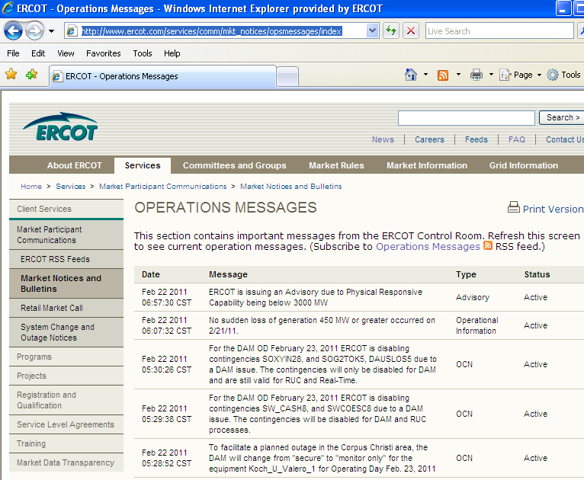

#42 MARKET MEDIUM– Constraint Dashboard
Need more requirements- current active RT constraints, RUC constraints, DAM constraint
Likely MEDIUM

#43 – MARKET HIGH - Wind Graph Dashboard
Need more requirements- current vs forecast
Create graph- Group of wind output
Aggregate values Day-Ahead or 48-hr, AdjustmentPeriod/Hourly, Actual
both sides of W-N constraint
coastal wind
more granular the better in regional without confidentiality
Consider solar (other renewable)
Likely MEDIUM ERCOT IMPACT
Recommend a report

#45 – MARKET HIGH - Area Control Error (ACE) Dashboard
Need more requirements
For ERCOT (single frequency control) – is ACE redundant with frequency (multiplier)?
Likely MEDIUM
MAY NOT BE A HIGH PRIORITY FOR THE MARKET SINCE FREQUENCY IS POSTED

Dashboard Enhancement Summary from Feb 22 MIS User group:

Phase 1:

#13- PUBLIC DASHBOARDS:
Estimate promotion of following dashboards to public domain considering costs and benefit in public communications of:
2.2 Contour map – Med-High ( observe price separation)
2.4 Load Forecast – Med-High
2.5 Freq and Real-Time – High
2.6 SCED Up/Down – High
2.7 System AS Capacity Monitor – Very High
New wind graph and report – High

#39- ENHANCE REAL-TIME SYSTEM CONDITIONS:
Investigate using new 5-minute SE report implementing this month: (all discreet element flows that make up CSCs and CREs except Valley Import and Laredo)
Item 1- Add Interface and CSCs with DC Ties on this display
Item 2- Consider new display of all available CSC/CRE elements
Increase frequency of wind refresh (to align with DC tie frequency of 5 minutes)-
Consider new data source, or change hourly wind report and protocols from
hourly to 5 minutes
Add DC-Tie labels

# NEW SCED UpDown Display
Merge to be on same axis so SCED Up is positive, and SCED down is negative

#43 –Wind Graph Dashboard
Create graph- Total and Groupings of wind output
Aggregate values Day-Ahead or 48-hr, AdjustmentPeriod/Hourly, Actual (similar to forecast v
actual)
Sub-total grouping for actual values
- both sides of W-N constraint
- coastal wind
- more granular the better in regional without confidentiality
Consider solar (other renewable)
Recommend a report

