 |  |  |  | System Planning Division
Monthly Status Report
to
Reliability and Operations Subcommittee
for
January 2011

 |  | Report Highlights
Item
1. | - ERCOT is currently tracking 191 active generation interconnection requests totaling almost 64,000 MW. This includes almost 37,000 MW of wind generation.
2. | - ERCOT is currently reviewing proposed transmission improvements with a total cost of $51.1 Million  - Transmission Projects endorsed in 2010 total $268.8 Million  - All projects (in engineering, routing, licensing and construction) total approximately $9.3 Billion  - Transmission Projects energized in 2010 total about $857.1 million

Table of Contents
1. Generation Interconnection 1
1.1 New Generation Registering for Commercial Operations 1
1.2 Publicly Disclosed Generation Interconnection Projects 4
1.3 Generation Projects Undergoing Full Interconnection Studies (not otherwise public) 6
1.4 Wind Generation 8
2. Regional Planning Group Project Reviews 10
3. Congestion Costs 11
4. Wind Generation as a Percent of Load 13
5. Planning Model Activities 14
6. Other Notable Activities 15

1. Generation Interconnection
Additional information regarding detailed generation interconnection and impact studies is contained in the “Generation Project Interconnection Information” folder in the “Operations and System Planning” area on the ERCOT website: http://planning.ercot.com/login/login.

New Generation Registering for Commercial Operations

The total installed wind capacity is reported as 9,400 MW by the resource owners through the registration process.

Summary of Active Generation Interconnection Requests

GENERATION INTERCONNECTION REQUESTS CURRENTLY BEING PROCESSED
Currently tracking 191 active generation interconnection or change requests
As of January 31, 2011 | North | South | West | Total
Security Screening Study | 3 | 2 | 9 | 14
SSS Completed | 1 | 2 | 14 | 17
Full Interconnect Study | 18 | 14 | 88 | 120
FIS Completed | 5 | 13 | 4 | 22
Interconnect Agreement Completed | 7 | 6 | 5 | 18
Capacity under Interconnection Agreements | 5,147 | 3,742 | 756 | 9,645
Capacity for Grid, MW | 18,815 | 12,796 | 32,127 | 63,738
Wind Capacity, MW | 3,507 | 4,093 | 29,226 | 36,826

Fuel Type | Confidential Projects (MW) | Projects Under Full Study (MW) | Projects w/ Interconnect Agreement/Public Letter (MW) | Grand Total (MW)
Gas-CombinedCycle |  |  | 5,352 | 12,043
Gas-All Other |  |  |  | 650
Total Gas | 11 | 7,330 | 5,352 | 12,693
Nuclear |  |  | 5,900 | 5,900
Coal |  | 1,740 | 3,210 | 4,950
Wind | 2,982 | 28,291 | 5,553 | 36,826
Solar | 420 | 819 |  | 1,239
Biomass |  | 50 | 100 | 150
Other |  | 740 | 1,240 | 1,980
Grand Total | 3,413 | 38,970 | 21,355 | 63,738

Publicly Disclosed Generation Interconnection Projects
The table below summarizes the publicly disclosed generation projects for the ERCOT region.
(Status: IA=Interconnect Agreement, PL=Public Letter, XX= cancelled)
Generation Interconnections as of January 31, 2011
INR | SiteName | Status | County | Region | COD | Fuel Type |  | MW For Grid | Change from Last Report
08INR0065 | Buffalo Gap 4 and 5 | PL | Nolan | West | Mar-11 |  | Wind | 465
09INR0029 | CFB Power Plant Units 11&12 | IA | Calhoun | South | Mar-11 |  | Coal | 260
10INR0010 | Jack County 2 | IA | Jack | North | Jun-11 |  | Gas-CC | 620
08INR0038 | M Bar Wind | PL | Andrews | West | Dec-11 |  | Wind | 194
09INR0034 | Gatesville Wind Farm | PL | Coryell | North | Dec-11 |  | Wind | 200
12INR0003 | Throckmorton Wind Farm | PL | Throckmorton | West | Dec-11 |  | Wind | 400
08INR0025 | Pistol Hill Energy Center | PL | Ector | West | Dec-11 |  | Wind | 300
06INR0012b | Sherbino Mesa Wind Farm 2 | IA | Pecos | West | Jan-12 |  | Wind | 150
09INR0001 | Sandy Creek 1 | IA | McLennan | North | Feb-12 |  | Coal | 925
08INR0062 | Archer-Young | IA | Young | West | Mar-12 |  | Wind | 250
11INR0084 | 2W Whatley Phase 1 | PL | Ector | West | Mar-12 |  | Wind | 45
09INR0007 | Nacogdoches Project | IA | Nacogdoches | North | Apr-12 |  | Biomass | 100
07INR0004 | Pampa Energy Center | PL | Gray | West | May-12 |  | Coal | 165
09INR0024 | B&B Panhandle Wind | PL | Carson | West | Jun-12 |  | Wind | 1001
09INR0037 | Scurry County Wind III | PL | Scurry | West | Jun-12 |  | Wind | 350
05INR0015b | Gulf Wind 2 | PL | Kenedy | South | Jul-12 |  | Wind | 400 | Date
12INR0004 | Fort Concho Wind Farm | PL | Tom Green | West | Jul-12 |  | Wind | 400
12INR0043 | 2W Whatley Phase 2 | PL | Ector | West | Aug-12 |  | Wind | 290
08INR0011 | Senate Wind Project | IA | Jack | North | Sep-12 |  | Wind | 150
08INR0018 | Gunsight Mountain | IA | Howard | West | Dec-12 |  | Wind | 120
06INR0022c | Penascal Wind Farm 3 | IA | Kenedy | South | Dec-12 |  | Wind | 202
05INR0015c | Gulf Wind 3 | PL | Kenedy | South | Dec-13 |  | Wind | 400 | Date
10INR0020a | Panda Temple Power | IA | Bell | North | Feb-14 |  | Gas-CC | 780
06INR0006 | Cobisa-Greenville | IA | Hunt | North | May-14 |  | Gas-CC | 1792
10INR0022 | Pondera King Power Project | IA | Harris | South | Jun-14 |  | Gas-CC | 1380
04INR0011b | Cedar Elm | IA | Shackelford | West | Jun-14 |  | Wind | 136
04INR0011c | Cottonwood Wind | IA | Shackelford | West | Jun-14 |  | Wind | 100
14INR0005 | White Stallion Energy Center | PL | Matagorda | South | Jul-14 |  | Coal | 1200
10INR0020b | Panda Temple Power | IA | Bell | North | May-15 |  | Gas-CC | 780 | Date
12INR0016a | Las Brisas Energy Center | IA | Nueces | South | Jun-15 |  | Other | 620
14INR0002 | Coleto Creek Unit 2 | IA | Goliad | South | Jan-16 |  | Coal | 660 | Date
12INR0016b | Las Brisas Energy Center | IA | Nueces | South | Jun-16 |  | Other | 620
15INR0008 | STP 3 and 4 | PL | Matagorda | South | Jun-16 |  | Nuclear | 2700
15INR0002 | Comanche Peak 3 and 4 | PL | Somervel | North | Dec-18 |  | Nuclear | 3200
 |  |  |  |  |  |  | TOTAL | 21,355

County Location of Installed Generation and Interconnection Requests (all fuels)

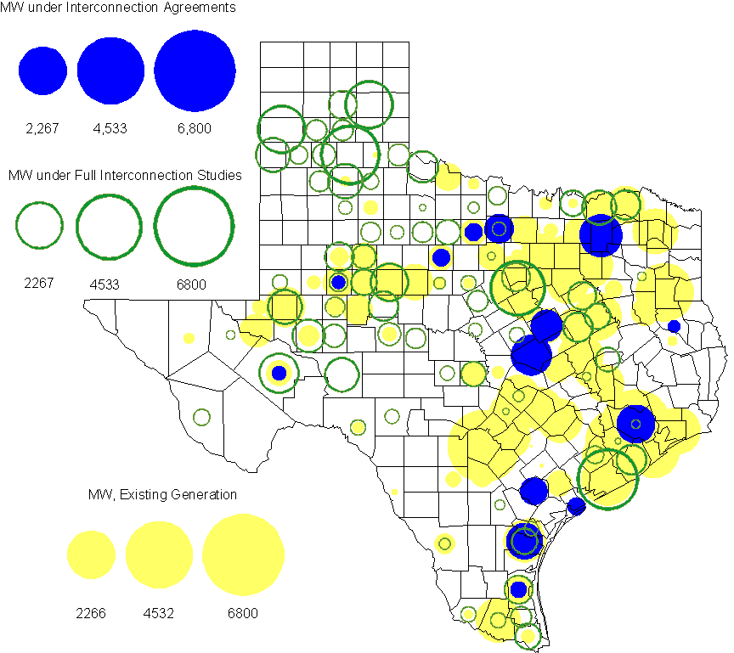

Generation Projects Undergoing Full Interconnection Studies (not otherwise public)

INR | County | Capacity | COD | Fuel |  | INR | County | Capacity | COD | Fuel
09INR0054 | Stonewall | 149 | TBD | Wind |  | 10INR0048 | Hardeman | 1,000 | TBD | Wind
10INR0016 | Childress | 150 | TBD | Wind |  | 10INR0054 | Palo Pinto | 36 | TBD | Wind
10INR0079 | Nolan | 60 | TBD | Wind |  | 10INR0029 | Hood | 810 | TBD | Gas
10INR0013 | Upton | 400 | TBD | Wind |  | 10INR0052a | Knox | 21 | TBD | Wind
09INR0074 | Motley | 70 | TBD | Wind |  | 10INR0041 | Floyd | 135 | TBD | Wind
11INR0029 | Throckmorton | 200 | TBD | Wind |  | 10INR0008 | Pecos | 500 | TBD | Wind
07INR0013 | Coke | 200 | TBD | Wind |  | 10INR0019 | Deaf Smith | 609 | TBD | Wind
10INR0032 | Navarro | 775 | TBD | Gas |  | 10INR0033 | Armstrong | 399 | TBD | Wind
10INR0042 | Mason | 170 | TBD | Wind |  | 10INR0077 | Callahan | 101 | TBD | Wind
10INR0051 | Brazoria | 200 | TBD | Wind |  | 11INR0076 | Archer | 94 | TBD | Wind
11INR0050 | Crosby | 149 | Mar-11 | Wind |  | 11INR0081 | Live Oak | 72 | Mar-11 | Wind
11INR0082A | Val Verde | 50 | Mar-11 | Wind |  | 11INR0083A | Crockett | 50 | Mar-11 | Wind
11INR0085 | Nolan | 106 | Mar-11 | Wind |  | 11INR0088 | Brazos | 45 | Mar-11 | Gas
11INR0071 | Harris | 7 | Apr-11 | Gas |  | 11INR0037 | Smith | 50 | May-11 | Biomass
11INR0058 | Pecos | 135 | May-11 | Solar |  | 11INR0060 | Tom Green | 90 | May-11 | Solar
11INR0061 | Presidio | 90 | May-11 | Solar |  | 11INR0062 | Nueces | 149 | May-11 | Wind
08INR0020 | Eastland | 200 | Jun-11 | Wind |  | 09INR0050 | Fannin | 1,200 | Jun-11 | Gas
10INR0023 | Haskell | 386 | Jun-11 | Wind |  | 11INR0054 | San Patricio | 161 | Jun-11 | Wind
10INR0089 | Harris | 40 | Jun-11 | Other |  | 11INR0019 | Upton | 200 | Jun-11 | Wind
11INR0091 | Webb | 92 | Jun-11 | Wind |  | 11INR0006 | Lamar | 579 | Jul-11 | Gas
11INR0040 | freestone | 640 | Aug-11 | Gas |  | 11INR0047 | Deaf Smith | 600 | Sep-11 | Wind
11INR0079a | Clay | 200 | Sep-11 | Wind |  | 10INR0062a | Pecos | 80 | Oct-11 | Wind
10INR0081b | Clay | 19 | Oct-11 | Wind |  | 11INR0090 | Howard | 60 | Nov-11 | Solar
11INR0094 | Kent | 100 | Nov-11 | Solar |  | 11INR0013 | Mills | 150 | Dec-11 | Wind
11INR0025 | Crockett | 400 | Dec-11 | Wind |  | 11INR0043 | Coke | 300 | Dec-11 | Wind
11INR0070 | Reeves | 50 | Dec-11 | Solar |  | 11INR0005 | Upton | 500 | Dec-11 | Wind
11INR0089 | Hays | 20 | Dec-11 | Solar |  | 09INR0048 | Jack | 150 | Dec-11 | Wind
12INR0033 | Motley | 150 | Jan-12 | Wind |  | 10INR0085 | Ector | 40 | Jan-12 | Solar
10INR0018 | Madison | 550 | Mar-12 | Gas |  | 12INR0042 | Deaf Smith | 400 | Mar-12 | Wind
09INR0031 | Ector | 275 | May-12 | Gas |  | 12INR0007 | Lamar | 296 | May-12 | Gas
10INR0081a | Clay | 30 | May-12 | Wind |  | 08INR0031 | Childress | 100 | Jun-12 | Wind
12INR0053 | Crockett | 615 | Jun-12 | Wind |  | 08INR0041 | Coke | 200 | Oct-12 | Wind
12INR0026 | Randall | 400 | Oct-12 | Wind |  | 08INR0044 | Concho | 200 | Nov-12 | Wind
08INR0042 | Coke | 200 | Dec-12 | Wind |  | 09INR0025 | Concho | 180 | Dec-12 | Wind
12INR0005 | Floyd | 1,100 | Dec-12 | Wind |  | 12INR0029 | Swisher | 500 | Dec-12 | Wind
10INR0024 | Briscoe | 2,940 | Jan-13 | Wind |  | 12INR0027 | Gray | 200 | Jan-13 | Wind
09INR0058 | Howard | 250 | Mar-13 | Wind |  | 10INR0056 | Borden | 249 | Mar-13 | Wind
12INR0034 | Borden | 342 | Mar-13 | Wind |  | 11INR0082B | Val Verde | 150 | Mar-13 | Wind
11INR0083B | Crockett | 100 | Mar-13 | Wind |  | 12INR0018 | Gray | 500 | Apr-13 | Wind
10INR0062b | Pecos | 220 | May-13 | Wind |  | 13INR0020a | Glasscock | 200 | May-13 | Wind
09INR0051 | Borden | 249 | Jun-13 | Wind |  | 13INR0023 | Ector | 240 | Jul-13 | Gas
13INR0016 | Deaf Smith | 251 | Aug-13 | Wind |  | 13INR0004 | Deaf Smith | 500 | Oct-13 | Wind
13INR0005 | Carson | 600 | Oct-13 | Wind |  | 13INR0028 | Hale | 392 | Nov-13 | Gas
12INR0002a | Briscoe | 200 | Dec-13 | Wind |  | 09INR0077 | Reagan | 500 | Dec-13 | Wind
13INR0007 | Pecos | 200 | Dec-13 | Wind |  | 13INR0017 | Childress | 200 | Dec-13 | Wind
10INR0009 | Castro | 300 | Dec-13 | Wind |  | 09INR0073 | Scurry | 200 | Dec-13 | Wind
13INR0010 | Parmer | 1,200 | Dec-13 | Wind |  | 08INR0019a | Gray | 250 | Jan-14 | Wind
08INR0019b | Gray | 250 | Jan-14 | Wind |  | 08INR0019c | Gray | 250 | Jan-14 | Wind
13INR0006 | Gray | 750 | Jan-14 | Wind |  | 10INR0015 | Mitchell | 350 | May-14 | Wind
13INR0020b | Glasscock | 150 | May-14 | Wind |  | 14INR0003 | Nolan | 850 | Jun-14 | Coal
14INR0001 | Pecos | 500 | Dec-14 | Wind |  | 13INR0021 | Llano | 600 | Dec-14 | Gas
12INR0002b | Briscoe | 200 | Dec-14 | Wind |  | 12INR0002c | Briscoe | 350 | Dec-15 | Wind
16INR0002 | Brazoria | 700 | Jun-17 | Other

Wind Generation
Wind Capacity Installed by Year

County Location of Installed Capacity and Interconnection Requests (Wind only)

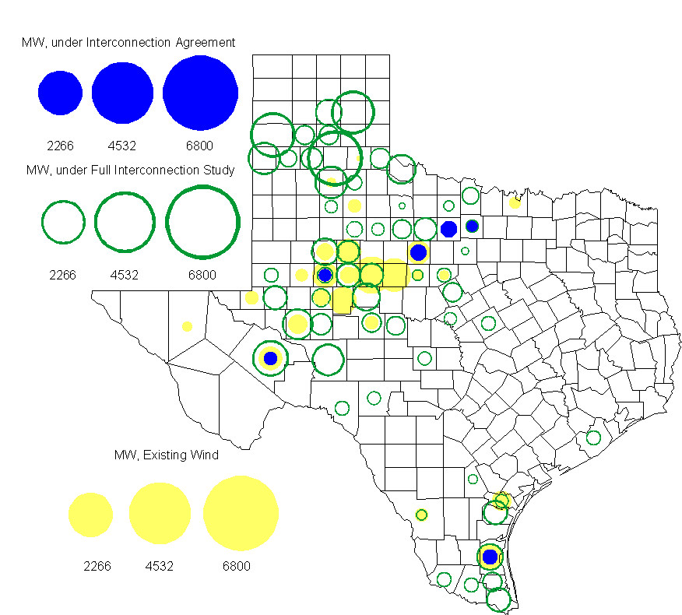

Regional Planning Group Project Reviews

- Brazos Electric Cooperative has submitted a project to move some load that is currently being served by the Entergy Texas system into the ERCOT system. The project would involve disconnecting the subject load from the Entergy Texas system, constructing a new 345/ 138 kV substation in ERCOT, upgrading an existing 69 kV line in the ERCOT system and constructing two new 138 kV lines to serve the load from the ERCOT system. The estimated cost of this project is $51.1 M. The project is currently undergoing ERCOT Independent Review.

Congestion Costs
Dollars shown in graphs are settlement quality.

OOMC and RUC net Make Whole payment in million$

Monthly Average MCPE and LMP
Binding Constraints - December 2010
Contingency | Binding Element | Number of 5-min intervals | Shadow Price Range $/MWh | Estimated Congestion Cost $ (Shadow Price*Limit) | Transmission Project | Clearance
BASE CASE | West to North Stability Limit | 3865 | 0 - 612 | 11,923,923 | CREZ
W.A. Parish - Obrien 345kV | Garrott - Midtown 138kV | 1313 | 0 - 3500 | 3,200,445 | Upgrade 138 kV underground Ckt. 90 Garrott to Midtown to Polk [11TPIT0072]
Anctp - Ncwam 138kV | Odessa North 138/69KV autotransformer | 1362 | 0 - 2800 | 3,108,366 | 5YTP [2009-R4] | Outage on Moss Switch - Permian Basin SES 138kV
Cabaniss To Airline 138kV | Naval Base - North Padre 69kV | 173 | 0 - 2800 | 856,227 | Rebuild Airline to Naval Base 69 kV line [06TPIT0015] | Outage on Holly - Rodd Field 138 kV
BASE CASE,  Cabaniss - Airline 138kV | Nelson Sharpe 138KV phase shifting transformer | 383 | 0 - 3500 | 757,303 | Barney Davis to Nelson Sharpe 138 kV line rebuild  [12TPIT0069] | Outage on Holly - Rodd Field 138 kV
Austrop - Lost Pines 345kV | SALEM LCRA 345/138kV autotransformer | 95 | 0 - 4500 | 645,328 | Fayetteville Power Project  [15TPIT0009]
Cagnon - Marbach 138kV | Five Points - Westside CPS 138kV | 320 | 0 - 940 | 439,002 | Westside substation equipment upgrade [12TPIT0054] | Outage on Cagnon 345/138kV autotransformer
Garfield-Hicross and Onion-Pilot 138kV | Garfield - Onion Creek 138kV | 193 | 0 - 3500 | 403,271
Watermill - Tricorner -Tylergnd 345kV | Trinidad 345kV step-up transformer | 2 | 4500 - 4500 | 256,725
Morgan Creek SES - China Grove 138kV | Morgan Creek SES - China Grove 138kV | 4 | 3500 - 3500 | 215,221

Wind Generation as a Percent of Load
One-hour average Settlement quality data shown.

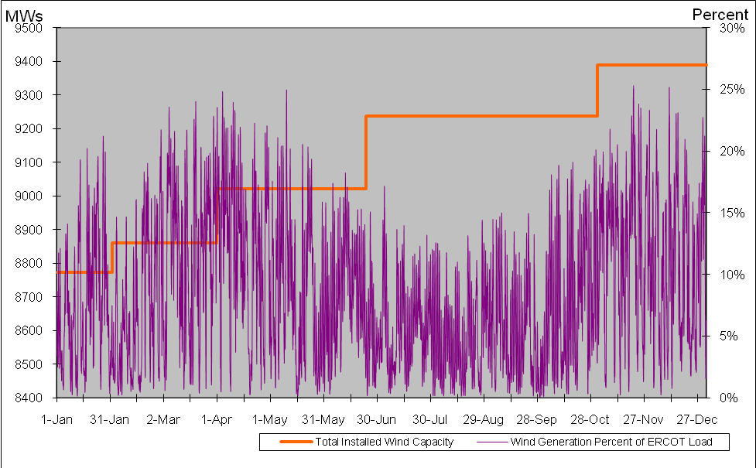

Planning Model Activities
- ERCOT and SSWG continued work to create a 2012 case using PSSE version 32 format starting Dec. 3, 2010. All standard PMCR’s will be applied to this case and the case will be completed using PMCR’s to model transmission projects expected to by complete by July 1, 2012. This case will be compared to the current DSB 2012SUM1 case completed in Nov. 2010.
- ERCOT and the TSP are working to complete Cost Benefit Analysis for SCR760 based on the ROS approved comments from the January meeting.

Other Notable Activities
- Work on the 2010 Five-Year Transmission Plan (5YTP) is wrapping up. All studies have been completed to identify the projects needed to reliably serve load and reduce congestion for years 2011 through 2015. The study is currently in the report writing phase.

- Transient Stability Study for 2011 Winter off-peak conditions: As part of the annual reliability assessment of the network, a transient stability study study is been performed on an ERCOT 2011 Winter off-peak case.

