ERCOT Operations Report
Jan 2011 ROS & OWG

Frequency Control
Time | Freq(Hz) | Duration (s)
1/4/2011 0:12 | 59.899 | 4 | Out of URS
1/7/2011 6:01 | 59.790 | 388 | Expected Gen Deviation -2200 in 3 mins; out of URS
1/9/2011 3:49 | 59.884 | 32 | Units coming offline with 665 MW due to weather condition and line outages
1/9/2011 18:52 | 59.842 | 76 | Unit trip with 540 MW
1/11/2011 6:50 | 59.871 | 52 | Unit trip with 522 MW
1/14/2011 7:47 | 59.894 | 16 | Unit trip with 465 MW
1/15/2011 7:04 | 59.841 | 248 | Expected Gen Deviation -1250 in 3 mins; out of URS
1/18/2011 6:01 | 60.111 | 11 | Expected Gen Deviation +800 MW in 3 mins due to combined cycle units on TEST mode ramping up fast; out of DRS
1/19/2011 4:58 | 60.102 | 13 | Expected Gen Deviation +800 MW in 2 min; out of DRS
1/19/2011 6:05 | 59.899 | 16 | Expected Gen Deviation -1100 MW in 3 mins; slow URS response
1/20/2011 0:01 | 59.769 | 209 | Unit trip with 890 MW
1/20/2011 7:01 | 59.857 | 224 | Expected Gen Deviation -1200 MW in 2 mins; out of URS
1/21/2011 3:46 | 59.852 | 148 | Unit trip with 650 MW
1/21/2011 10:01 | 59.870 | 172 | Unit trip with 180 MW; out of URS
1/23/2011 14:53 | 59.846 | 160 | Unit trip with 400 MW
1/28/2011 5:21 | 59.875 | 8 | Unit trip with 370 MW
1/29/2011 22:29 | 59.840 | 36 | Unit output reduced by 450 MW due to valve problems
1/30/2011 16:01 | 60.101 | 8 | Expected Gen Deviation +670 MW in 2.5 mins; out of DRS
1/31/2011 0:01 | 59.895 | 12 | Expected Gen Deviation -1200 in 4 mins; out of URS
Note: Time of frequency excursions outside the range of +/- 0.1 Hz.

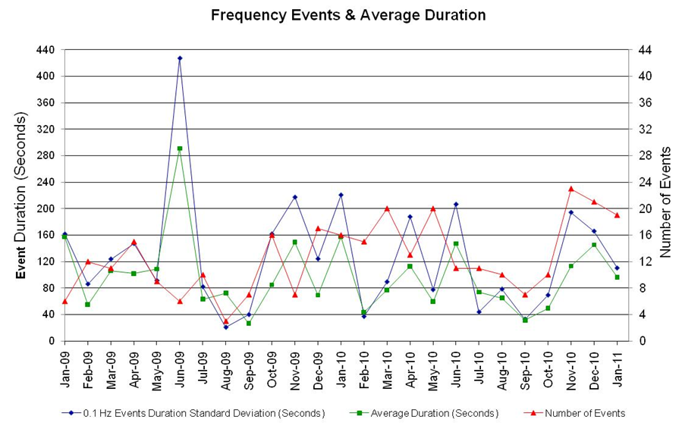

Deployed Responsive (Reported Above)
Time deployed | Stop Time | Duration | Max | Details
1/23/11 14:56:10 | 1/23/11 15:12:10 | 0:16:00 | 400

RUC Capacity Purchases
Details | Unit Days
Coast | 5
East | 4
Far West | 10
North Central | 9
South | 31
South Central | 25
Grand Total | 84

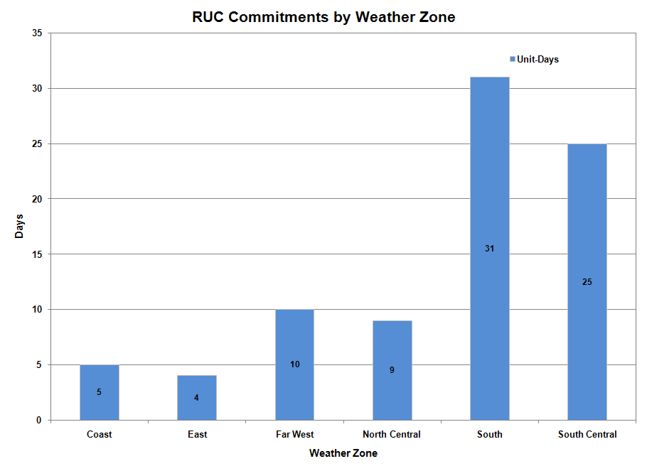

SCED Congestion Management Activity
Congestion affected by outages Remedial action plan has been developed for the element
Contingency | Overloaded Element | Days
Aspermont - Spur 138kV | Spur 138/69kV AXFMR1 | 4
Lewisville Switch 345/138kV AT1 | Lewisville Switch - Lewisville Jones Street 138kV | 4
BASE CASE | Syntex - Syntex Tap 69kV | 3
BASE CASE | Victoria - Thomaston 138kV | 3
Singleton - Tomball & Roans Prairie 345kV | Garrott - Midtown 138kV | 3
Singleton - Tomball & Roans Prairie 345kV | Jewett - Rattlesnake Road Switch 345kV | 3
Calaveras - Streich 138kV | West Side - Five Points 138kV | 3
Braunig - Streich 138kV | West Side - Five Points 138kV | 3
BASE CASE | Matador - Paducah 69kV | 2
BASE CASE | Notrees - Notrees Switch 138kV | 2
Fern Street - Ball Park 138kV | West Side - Five Points 138kV | 2
Willow Valley Switch - Lamesa 138kV | Ackerly Vealmoor Sw - Ackerly 69kV | 2
Nueces Bay - Koch Upriver & Lon Hill 138kV | Hiway 9 - Air Liquid AEP 69kV | 2
Parker Switch - Eagle Mountain SES & Roanoke Switch 345kV | Lewisville Switch - Lewisville Jones Street 138kV | 2
Lewisville Switch - Carrolton Northwest 345kV | Lewisville Switch - Lewisville Jones Street 138kV | 2
Air Liquid AEP - Valero East 69 kV | Koch Up River 138_69A1 XFMR | 2
BASE CASE | TH Wharton 138kV/13.2kV Transformer 4A | 1
Singleton - Tomball & Roans Prairie 345kV | Singleton - O'brien 345kV | 1
Singleton - Tomball & Roans Prairie 345kV | Singleton - TH Wharton 345 kV | 1
Singleton - Tomball & Roans Prairie 345kV | Singleton - O'brien 345kV | 1
Lon Hill - Nelson Sharpe 345kV | Nelson Sharpe - Celanese Bishop 138kV | 1
Braunig - Toyota & Valley 138kV | West Side - Five Points 138kV | 1
North Edinburg - Lon Hill 345kV | Rio Hondo 345kV Series Capacitor 1 | 1
Moss Switch - Holt Switch 138kV | Odessa North 138/69kV AXFMR1 | 1
Austrop - Lost Pines 345kV | Austrop 345/138kV AT1 | 1
Farmersville - Monticello SES 345kV | Monticello SES - Sulphur Springs Switch 345kV | 1
Tonkawa Switch - Gibbons Creek & Jack Creek 345kV | Jewet - Singleton 345kV | 1
Tonkawa Switch - Gibbons Creek & Jack Creek 345kV | Jewett - Singleton 345kV | 1
Tonkawa Switch - Gibbons Creek & Jack Creek 345kV | Jewett - Limestone Plant 345kV | 1
Tonkawa Switch - Gibbons Creek & Jack Creek 345kV | Jewett - Singleton 345kV | 1
Ingleside Cogen Switch - Oxychem Corpus Christi 138kV | Dupont PP1 Ingleside - Dupont Switch Ingleside 138kV | 1
Bosque Switch - Whitney 138kV | Bosque Switch - Lake Whitney 138kV | 1
Zorn 345/138kV 23AT1 | Zorn 345/138kV 72AT2 | 1
Lytton Springs 345/138kV AT2 | Lytton Springs 345/138kV AT1 | 1
Garfield - Lytton Springs & Austrop - Zorn 345kV | Austrop 345/138kV AT1 | 1
Base Case | Gold Switch - Brand TU 138kV | 1
DCKT Sandow - Temple Switch 345kV | Hearne 138/69kV AT1 | 1
Oklaunion - Fisher Road 345kV | Liberta REA - Pauline 69kV | 1
Pawnee - Lon Hill 345kV | Sinton - Skidmore 138kV | 1
Santa Anna - Ballinger 138kV | Ballinger - Humble 69kV | 1
Fort Worth - West Denton 138kV | West Denton - Jim Christal Substation 138kV | 1
Graham SES - Breckenridge 138kV | Graham SES - Breckenridge Tap 138kV | 1
Ballinger 138/69kV AT1 | Abilene South - Cedar Gap TEC 69kV | 1
Watermill Switch - Desoto Switch & Cedar Hill Switch 345kV | West Levee Switch 345/138kV AT1 | 1
Parker Switch - Eagle Mountain SES & Roanoke Switch 345kV | Carrollton Northwest - LKPNT 138 kV | 1
Denton - Argyle & West Denton 138kV | West Denton - Jim Christal Substation 138kV | 1
Jewett - Lake Creek SES 138kV | Navarro - Richland 69kV | 1

Generic Transmission Limits (GTL’s)
GTL | Days
West – North | 18
Valley Import | 3

New RAP, PCAP (Date indicates last update of RAP, PCAP not implementation date.)
None

SPS (RAS) (New, Modified, Removed)
None

New Procedures/Forms/Operations Bulletins
Date | Subject | Bulletin No.
01/31/2011 | Nodal Transmission and Security Desk V1 Rev4 | 521
01/31/2011 | Nodal Resource Desk V1 Rev3 | 520
01/31/2011 | Nodal Reliability Unit Commitment V1 Rev3 | 519
01/31/2011 | Nodal Real Time Desk V1 Rev4 | 518
01/31/2011 | Nodal DC Tie Desk V1 Rev2 | 517
01/31/2011 | Nodal Shift Supervisor Desk V1 Rev2 | 516
01/05/2011 | Nodal Transmission and Security Desk V1 Rev3 | 515
01/05/2011 | Nodal Real Time Desk V1 Rev3 | 514

Load Shed Incidences
None

EEA
None

System Voltage Problems
None

Application Issues
01/15 01:00 ERCOT issued an Emergency Notice for the loss of EMS.

01/15 07:15 ERCOT issued an Emergency Notice for the loss of RLC.

01/15 07:17 ERCOT issued an Emergency Notice for the loss of EMS.

Communication Issues
None

ERCOT peak (Unofficial)
01/21 08:00 50,715 MW

Yearly MTLF Error Comparison
Yearly Mid-Term (Hourly) Load Forecast Error Comparison for the ERCOT Forecast
Month | MAPE for MTLF at 16:00 Day-Ahead
Month | 2008 | 2009 | 2010 | 2011
January | 3.30 | 4.11 | 3.78 | 2.91
February | 3.59 | 3.49 | 3.79 | NA
March | 3.29 | 3.24 | 2.24 | NA
April | 2.45 | 2.66 | 2.47 | NA
May | 3.01 | 2.90 | 2.63 | NA
June | 2.81 | 2.89 | 2.84 | NA
July | 2.55 | 2.83 | 2.39 | NA
August | 3.66 | 3.07 | 2.29 | NA
September | 4.99 | 3.68 | 3.14 | NA
October | 2.79 | 2.92 | 2.37 | NA
November | 2.60 | 1.93 | 3.46 | NA
December | 4.54 | 3.70 | 2.60 | NA
Annual Average | 3.29 | 3.11 | 2.83 | 2.91

OCN, Advisory, Watch & Emergency Notices
Capacity
Date | Start | Event
1/1/2011 | 20:05 | Advisory issued to all QSE PRC below 3000 MW.
1/2/2011 | 8:11 | ERCOT is issuing an Advisory due to PRC being below 3000 MW. Real Time Desk Operator made hotline call.
1/2/2011 | 6:44 | ERCOT issued an OCN for Projected Reserve Capacity Shortage for HE 10-12.
1/4/2011 | 7:11 | ERCOT issued advisory for PRC below 3000 MW.
1/4/2011 | 9:43 | ERCOT issued Advisory for PRC below 3000 MW.
1/4/2011 | 7:10 | ERCOT issued an Advisory due to PRC has fallen below 3000 MW.
1/4/2011 | 9:43 | ERCOT issued an Advisory due to PRC has fallen below 3000 MW.
1/5/2011 | 7:11 | ERCOT issued advisory for PRC below 3000 MW.
1/5/2011 | 10:08 | ERCOT issued an Advisory due to PRC being below 3000 MW.
1/5/2011 | 2:08 | ERCOT issued an OCN for Projected Reserve Capacity Shortage for HE 19-21.
1/5/2011 | 7:12 | ERCOT issued an Advisory for PRC below 3000 MW.
1/5/2011 | 10:08 | ERCOT issued an Advisory for PRC below 3000 MW.
1/5/2011 | 18:03 | ERCOT issued an Advisory for PRC below 3000 MW.
1/6/2011 | 4:07 | ERCOT issued an Advisory for PRC below 3000 MW.
1/7/2011 | 6:38 | ERCOT issued an Advisory for PRC below 3000 MW.
1/15/2011 | 22:13 | ERCOT issued an Advisory for PRC below 3000 MW.
1/15/2011 | 9:05 | ERCOT issued an Advisory for PRC below 3000 MW.
1/16/2011 | 10:20 | ERCOT issued an advisory for PRC below 3000 MW.
1/17/2011 | 10:27 | ERCOT issued an Advisory for PRC below 3000 MW.
1/17/2011 | 10:28 | ERCOT issued an Advisory for PRC below 3000 MW.
1/20/2011 | 19:20 | ERCOT issued an Advisory for PRC below 3000 MW.
1/21/2011 | 22:45 | ERCOT issued an Advisory for PRC below 3000 MW.
1/21/2011 | 22:45 | ERCOT issued an OCN for projected reserve capacity shortage for H.E. 0100, 0200 and 0300 tomorrow.
1/22/2011 | 2:55 | ERCOT is extending the OCN for projected reserve capacity shortage for H.E. 0400 through 1200.
1/23/2011 | 18:30 | ERCOT issued an Advisory for PRC below 3000 MW.
1/23/2011 | 13:24 | ERCOT issued an OCN for Projected Reserve Capacity Shortfall for hours 19-22.
1/23/2011 | 18:31 | ERCOT issued an Advisory for PRC has fallen below 3000 MW.
1/29/2011 | 9:26 | ERCOT issued an Advisory for PRC below 3000 MW.
1/29/2011 | 9:26 | ERCOT issued an Advisory for PRC has fallen below 3000 MW.
1/30/2011 | 11:22 | ERCOT issued an Advisory for PRC being below 3000 MW.
1/30/2011 | 8:51 | ERCOT issued an OCN for projected reserve capacity shortage for H.E. 1200 through 1500.
1/30/2011 | 11:23 | ERCOT issued an Advisory for PRC has fallen below 3000 MW.
1/31/2011 | 18:16 | ERCOT issued an OCN for Projected Reserve Capacity shortage HE11-HE22 on 2-1-11.

Transmission Watch
None

Emergency Notice
01/15 01:00 ERCOT issued an Emergency notice for the loss of EMS.

01/15 07:15 ERCOT issued an Emergency notice for the loss of RLC.

01/15 07:17 ERCOT issued an Emergency notice for the loss of EMS.

Texas RE Event Analysis
01/09 03:38 Simultaneous loss of three 345kV lines, two 138kV lines, one 69kV line, one 345/138kV Autotransformer, one 138/69kV Autotransformer, one 138kV Bus and loss of multiple units for a total of 654 MW of generation in the Corpus Christi area. Effects of severe storm being experienced in the area at the time.

Others
None

