SCR Number | 760 | SCR Title | Recommended Changes Needed for Information Model Manager and Topology Processor for Planning Models
Timeline | Urgent | Action |  | Tabled
Date of Decision |  | January 6, 2011
Proposed Effective Date |  | To be determined.
Priority and Rank Assigned |  | Priority - Critical
Supporting Protocol or Guide Section(s) |  | Not applicable.
Other Document Reference/Source |  | Not applicable.
System Change Description |  | This System Change Request (SCR) proposes changes to the Information Model Manager and Topology Processor to fix a number of deficiencies with the proposed Annual Planning Model creation process.
Reason for System Change |  | ERCOT decided that system modeling information feeding downstream applications, market apps, operations systems, and planning models would reside in one database, which is the Information Model Manager. The Topology Processor is a piece of software that takes the Information Model Manager database (a breaker/switch model) and modifies the data into a planning model (a bus/branch model). This model will then be input into the Model On Demand (MOD) software which will be used to create future planning cases. Since 2009, the Steady State Working Group (SSWG) began a detailed review of the Topology Processor output and has noted a number of deficiencies in the Information Model Manager and/or Topology Processor. These deficiencies have to be corrected to produce usable cases for planning analyses; therefore, rather than make these corrections on the back end of the process through MOD each time a case is created, we strongly urge the adoption of the changes suggested in this SCR.  The deficiencies with the current output of the Topology Processor are listed in a ranked order of importance to the SSWG. Potential resolutions have been offered; however, further discussion with ERCOT and its vendors will be needed before finalizing.
Overall Market Benefit |  | Improved quality of Annual Planning Models and reduce the time and effort required to develop these models.
Overall Market Impact |  | Project cost to make Information Model Manager and Topology Processor system changes by ERCOT and/or vendors.
Consumer Impact |  | None.
Relevance to Nodal Market |  | No known market impact. However, this change will facilitate the accurate creation of the Annual Planning Models from the Network Model Management System (NMMS) after the Texas Nodal Market Implementation Date.
Procedural History |  | - On 11/4/10, SCR760 and the associated CEO Revision Request Review were posted.  - On 11/10/10, ERCOT comments were posted.  - On 11/11/10, ROS considered SCR760.  - On 11/15/10, Oncor comments were posted.  - On 11/16/10, CenterPoint Energy comments were posted.  - On 11/16/10, STEC comments were posted.  - On 11/17/10, Austin Energy comments were posted.  - On 11/18/10, PRS considered SCR760.  - On 11/22/10, CPS Energy comments were posted.  - On 11/29/10, AEP comments were posted.  - On 12/5/10, a preliminary Impact Analysis was posted.  - On 12/6/10, TAC considered SCR760.  - On 12/13/10, a second set of ERCOT comments were posted.  - On 1/6/11, TAC again considered SCR760.
ROS Decision |  | On 11/11/10, ROS unanimously voted to grant Urgent status to SCR760. ROS then voted to recommend approval of SCR760 as submitted. There was one abstention from the Independent Power Marketer (IPM) Market Segment. All Market Segments were present for the votes.
Summary of ROS Discussion |  | On 11/11/10, there was discussion regarding deficiencies identified in the Topology Processor and the Information Model Manager that must be corrected in order to produce usable cases for planning analyses. ERCOT Staff noted that the MOD, used by ERCOT in producing cases, includes all functionalities and features proposed by this SCR. Concern was expressed that implementing SCR760 would result in inconsistencies between the planning model and the operational model and possible conflicts with the Nodal Protocols. ERCOT Staff also noted that at a minimum, some deficiencies identified in SCR760 could be resolved prior to planning Go-live; however, others that would require a schema change would have to be corrected post planning Nodal Go-live to avoid significant impacts to Nodal systems. ROS noted that SCR760 should be assigned a priority of Critical so that these deficiencies are resolved as soon as possible after Nodal Go-live.
PRS Decision |  | On 11/18/10, PRS voted to recommend a priority of Critical and to endorse and forward the 11/11/10 ROS Report for SCR760 to TAC. There were three abstentions from the Independent Generator, Consumer and IPM Market Segments. All Market Segments were present for the vote.
Summary of PRS Discussion |  | On 11/18/10, ERCOT Staff noted that an Impact Analysis is in development. Some participants expressed concerns regarding the implementation of SCR760.
TAC Decision |  | On 12/6/10, TAC unanimously voted to table SCR760 for one month. All Market Segments were present for the vote.  On 1/6/11, TAC unanimously voted to table SCR760 for one month. All Market Segments were present for the vote.
Summary of TAC Discussion |  | On 12/6/10, it was requested that TAC table SCR760 to allow SSWG and Market Participants additional time to review the preliminary Impact Analysis. It was noted that a SSWG/Nodal Planning Go-Live Workshop would be held to discuss the preliminary Impact Analysis, proposed alternatives and Planning Go-live. ERCOT Staff requested that interested parties provide the benefit detail to complete the value proposition for evaluating SCR760.  On 1/6/11, it was noted that ROS would review the 12/13/10 ERCOT comments at its January meeting.

Comments Received
Comment Author | Comment Summary
ERCOT 111010 | Addressed the deficiencies as listed in SCR760.
Oncor 111510 | Supported SCR760 in its entirety.
CenterPoint Energy 111610 | Supported SCR760 as submitted.
STEC 111610 | Supported SCR760 as submitted.
Austin Energy 111710 | Supported SCR760 as submitted with a priority of Critical.
CPS Energy 112210 | Supported SCR760 as submitted.
AEP 112910 | Supported SCR760 as submitted with a priority of Critical.
ERCOT 121310 | Provided ERCOT’s position on SCR760.

Business Case for Proposed System Change

Deficiency #1
Upgrade to PSS/E v32  Topology Processor was written for PSS/E v30 | Planning Requirements
 | 1 | Revise Information Model Manager and Topology Processor in a timely manner after a major PSS/E release and include all new available data types and new data parameters to existing data types.
 | Proposed Solution
 |  | Modify Information Model Manager and Topology Processor to allow outputting of the latest version of PSS/E. This should be done within three months of any and all PSS/E version updates in the future.

Deficiency #2
Distribution Capacitor banks  Capacitor Banks not modeled for distribution side, therefore not shown in the Topology Processor case. | Planning Requirements
 | 1 | Represent Distribution Capacitor Banks on the proper bus in Topology Processor PSS/E case
 | 2 | Provide Capacitor Bank parameters necessary for PSS/E (MVAR, ID, fixed/switch shunt, number of blocks)
 | 3 | Allow for multiple capacitor banks on the same bus
 | Proposed Solution – Option 1
 | OPT1 | In Information Model Manager, define new Class called DistributionCapBank that can store the PSS/E data in its attributes. This Class would not be modeled like a ShuntCompensator with a Terminal connected to a node. Instead, a DistributionCapBank would be a “child” of BusbarSection.  Example of similar Class: A LoadResource is instantiated as a “child” of a CustomerLoad to allow the RE to store their data.  Advantages: The DistributionCapBank can be placed directly on the proper bus eliminating Topology Processor problems with collapsing to the proper bus. Also, not visible on one-line.  Disadvantages: Confusing because of unexpected location for a distribution cap bank.
 | Proposed Solution – Option 2
 | OPT2 | In Information Model Manager, define new Class called DistributionCapBank that can store the PSS/E data in its attributes. This Class would not be modeled like a ShuntCompensator with a Terminal connected to a node. Instead, a DistributionCapBank would be a child of CustomerLoad or NonConformLoad.  Example of similar Class: A LoadResource is instantiated as a child of a CustomerLoad to allow the RE to store their data.  Advantages: The DistributionCapBank can be placed on a Load nearest the actual cap bank. Also, not visible on one-line.  Disadvantages: Topology Processor has to have capability to collapse to the proper bus.
 | Proposed Solution – Option 3
 | OPT3 | In Information Model Manager, define new Class called DistributionCapBank and create it in a new directory outside of the substations (similar to TransformerKluges). Then have a new link in a Class, such as the BusbarSection, that can be associated with the DistributionCapBank.  Advantages: No objects defined in the substations. Also, not visible on the one-line.  Disadvantages: New link field in a Class that modelers will question why is there a distribution link requirement on an object defined in transmission voltage.

Distribution Capacitor Bank Example Substation AF

This is just to set up a frame of reference for the next page.

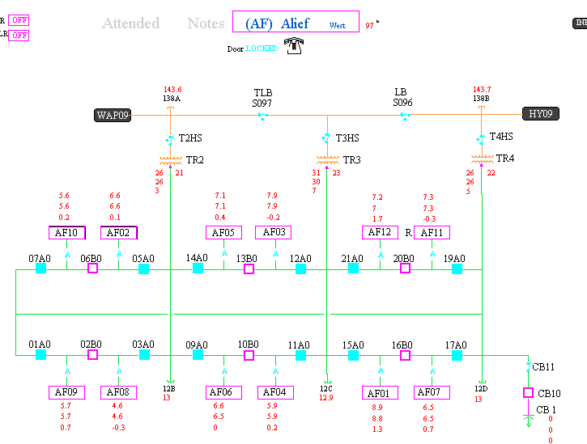

Notice CB 1 is closest to TR4. The BB138B busbar is closest to TR4.

DistributionCapBank – Proposed Solution Option 1

Example of how a DistributionCapBank object would be located as a child of the BusbarSection. Planning could store their PSS/E data in the object’s attributes. Would a regulation schedule be required? No.

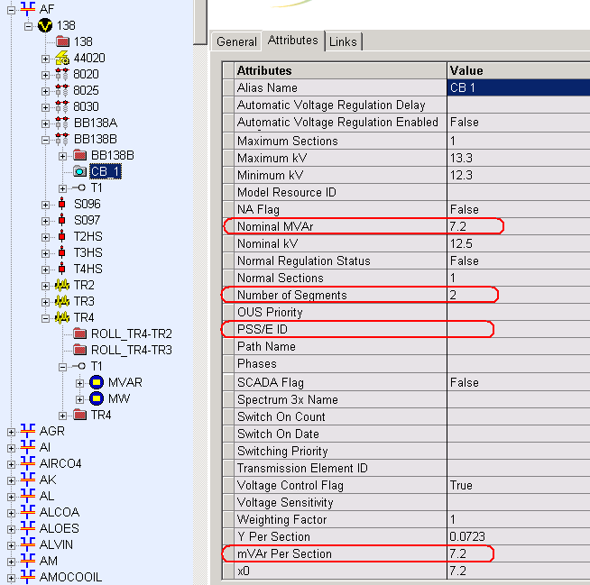

DistributionCapBank – Proposed Solution Option 2

Allow a DistributionCapBank object to reside under a CustomerLoad closest to the actual cap bank. Example of how ERCOT implements a similar example, in which a LoadResource (AK_LD2) under a CustomerLoad with multiple measurements under the terminal.

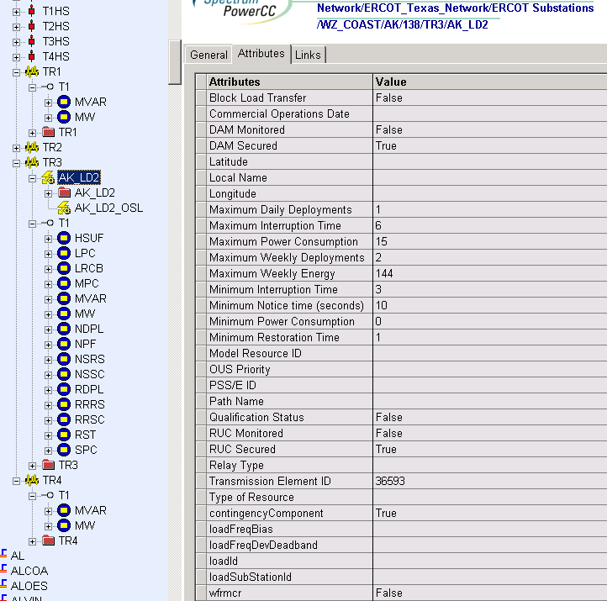

DistributionCapBank – Proposed Solution Option 3

Store the DistributionCapBank objects outside of the ERCOT_Texas_Network directory similar to Transformer Kluges, and have some object link to them.

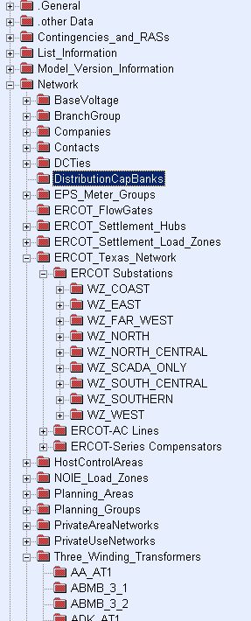
Transformer Kluges

Deficiency #3
Zero Impedance Line Ratings  Zero impedance lines in the Topology Processor cases default with 9999 MVA rating | Planning Requirements
 | 1 | Represent the proper ratings on zero impedance lines in the Topology Processor PSS/E cases
 | Proposed Solution – Option 1
 | OPT1 | In Information Model Manager, add new attributes for Breakers and Disconnectors to allow planning to enter ratings on devices converted by Topology Processor to zero impedance lines. Recommend no validation rule requiring this data to be populated.
 | Proposed Solution – Option 2
 | OPT2 | In Information Model Manager, add static ratings to the Breaker or Disconnector converted by Topology Processor to a zero impedance line. Recommend no validation rule requiring this data to be populated.

Zero Impedance Line Ratings – Proposed Solution Option 1
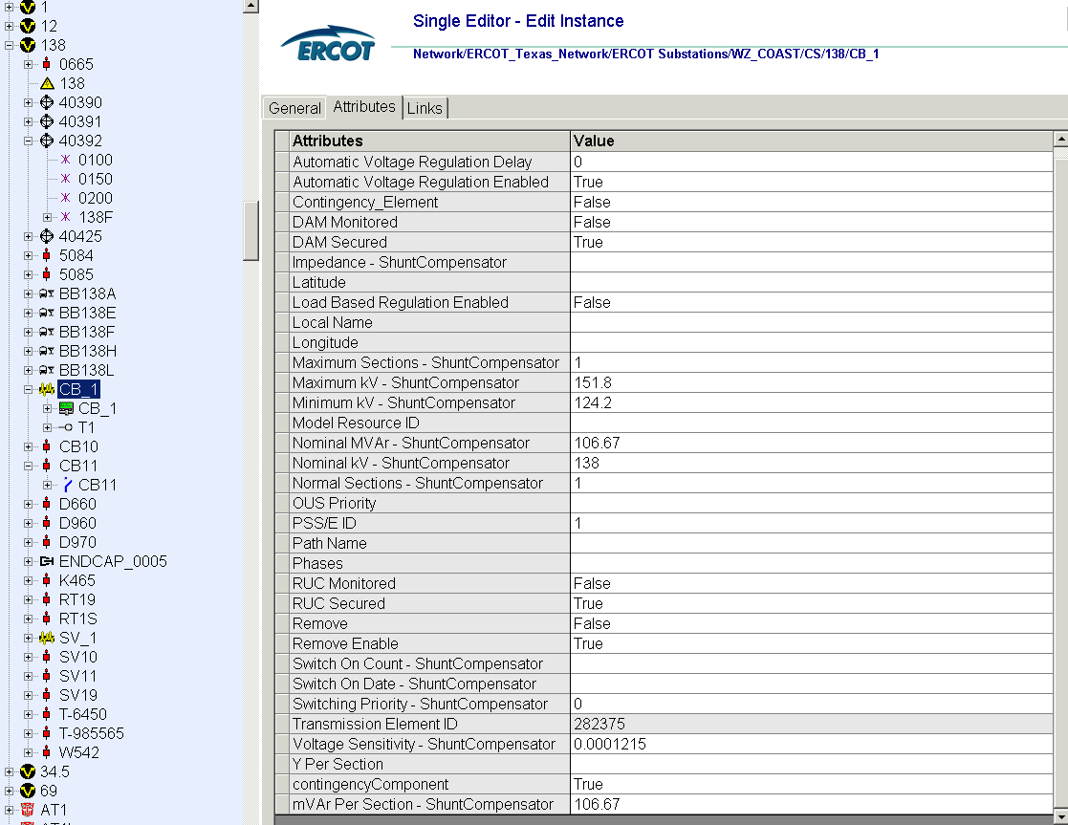
Add a new rating attribute

Zero Impedance Line Ratings – Proposed Solution Option 2
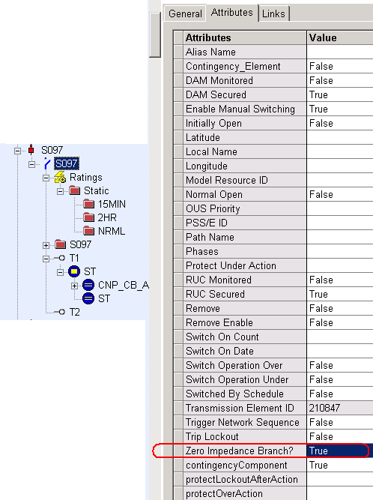
Example: Ratings assigned to a Disconnector

Deficiency #4
Associate Loads and Capacitor banks with the correct CNG  Some loads and cap banks cannot be modeled on the correct CNG. | Planning Requirements
 | 1 | Planning should be able to model loads and capacitor banks on the correct PSS/E busses.
 | Proposed Solution – Option 1
 | OPT1 | In Information Model Manager, allow capability to create a Jumper and be able to associate ratings to the Jumper. Jumpers could be utilized by Planning to associate capacitor banks and loads on the right CNG and model CAPE mutual buses.  Remove restriction from using the existing Jumper Class. The Jumper inherits from the Switch Class. Therefore, attributes and links are similar to the Disconnector and Breaker Class.
 | OPT2 | Proposed Solution – Option 2
 | OPT2 | In Information Model Manager, create a new attribute that would enable the user to select the PSS/E bus where the capacitor bank should appear in the Topology Processor case.
 | OPT3 | Proposed Solution – Option 3
 | OPT3 | In Information Model Manager, create a new attribute that would enable the user to select the PSS/E bus where the load should appear in the Topology Processor case.

Load and Capacitor bank bus correction – Proposed Solution Option 1

The Jumper Class is currently “Not Allowed” by ERCOT, yet it is already defined in NMMS. Here is an example of creating a Jumper under a Bay with Normal, 2hr, 15min, Conductor ratings, and two Terminals.

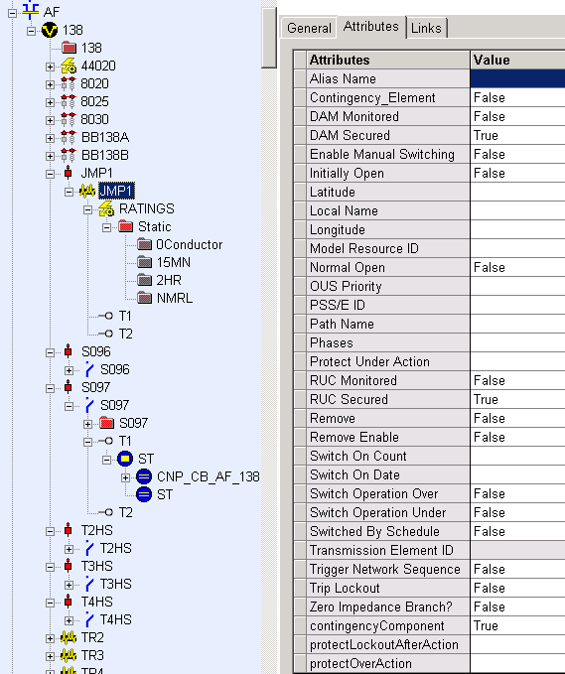
Jumper

Figure shows a Jumper Class being defined under a Bay.

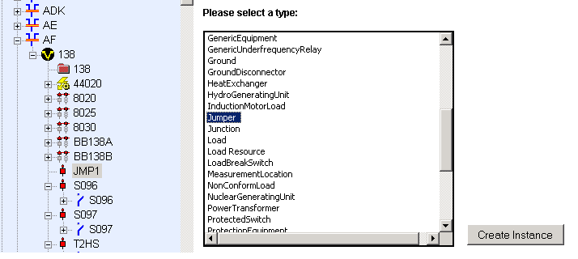

Figure below shows a Jumper across BB138A and BB138B just for demonstration purposes.

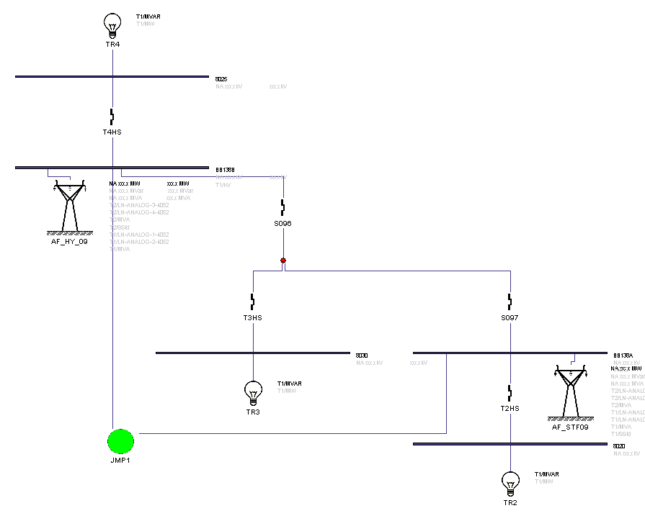
Jumper

Load and Capacitor bank bus correction - Proposed Solution Option 2

Assign a PSS/E bus where a capacitor bank should be located

Load and Capacitor bank bus correction - Proposed Solution Option 3

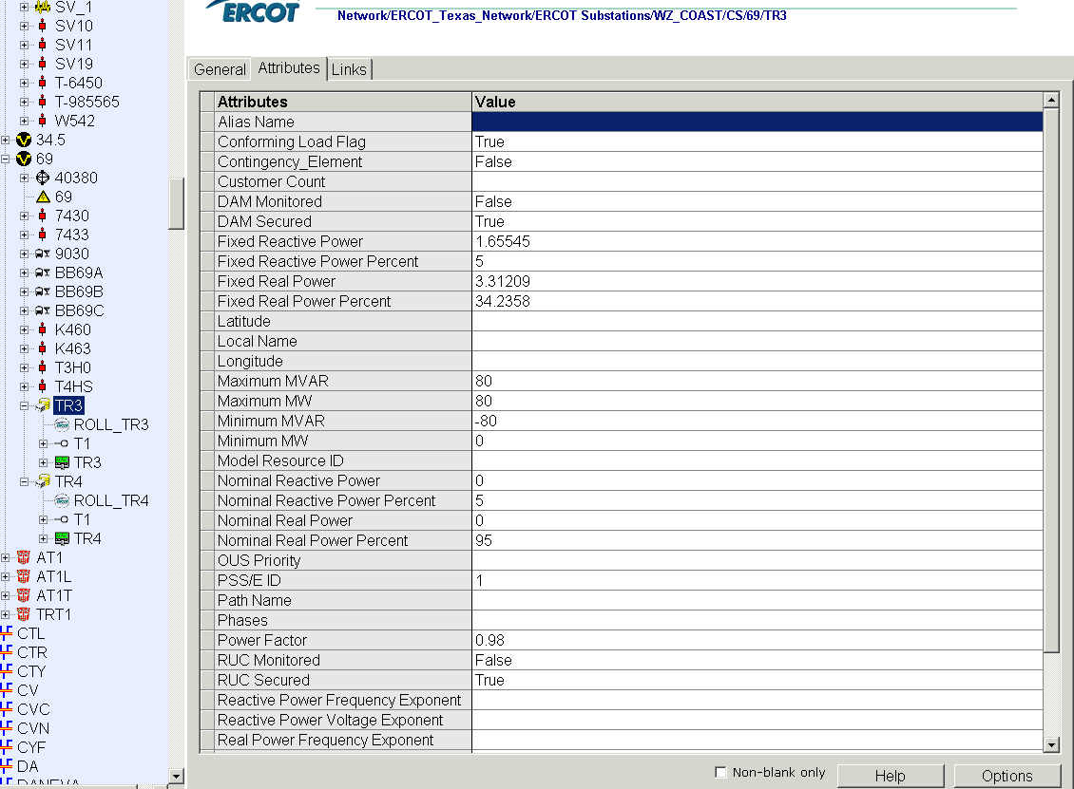
Assign a PSS/E bus where a load should be located

Deficiency #5
Additional Transformer Data for Planning  Operations Transformer model may differ from Planning model. | Planning Requirements
 | 1 | Represent the actual transformer models in the PSS/E cases. The planning transformer model is an appropriate model for the transformer to ensure stakeholders the power flow results will be accurate. Additional data attributes such as the number of taps, location of tapped winding, maximum and minimum tap ratios.
 | Proposed Solution
 |  | In Information Model Manager, store Planning transformer data in a separate file (or in a new Class outside of the ERCOT Texas Network directory similar to Transformer Kluges). The Topology Processor will select the Planning transformer data to generate the Topology Processor PSS/E case. Necessary data includes number of taps, location of tapped winding, maximum and minimum tap ratios, and specifying the voltage control bus.

Create a new class similar to transformer kluge or create a data file under the transformer kluge folder.

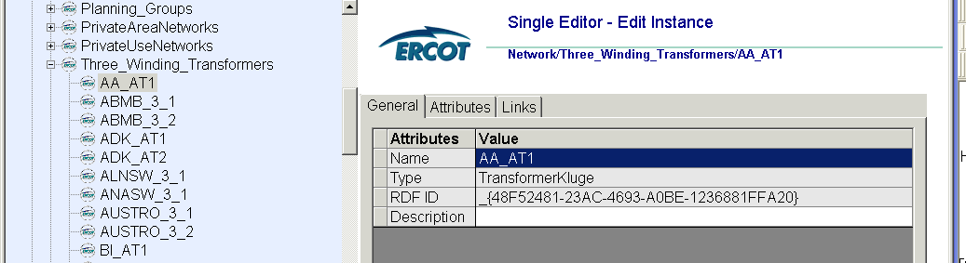

Deficiency #6
FACTS Devices  FACTS devices are modeled only as generators in Topology Processor Case, although they may be modeled in a number of ways in PSSE | Planning Requirements
 | 1 | Allow capability to convert a FACTS device model in Information Model Manager to any possible FACTS device model allowed in PSS/E version 32.
 | Proposed Solution
 |  | In Information Model Manager, Add an attribute to allow the TSP to be able to select for each object (generator, switch shunt, or FACTS Device). The TSP should be able to select the object it would like to see as a FACTS Device appear in the Topology Processor case as opposed to all FACTS Devices be modeled as generators. Any additional data parameters needed should be included as attributes, so that the Topology Processor can convert to the appropriate PSS/E model

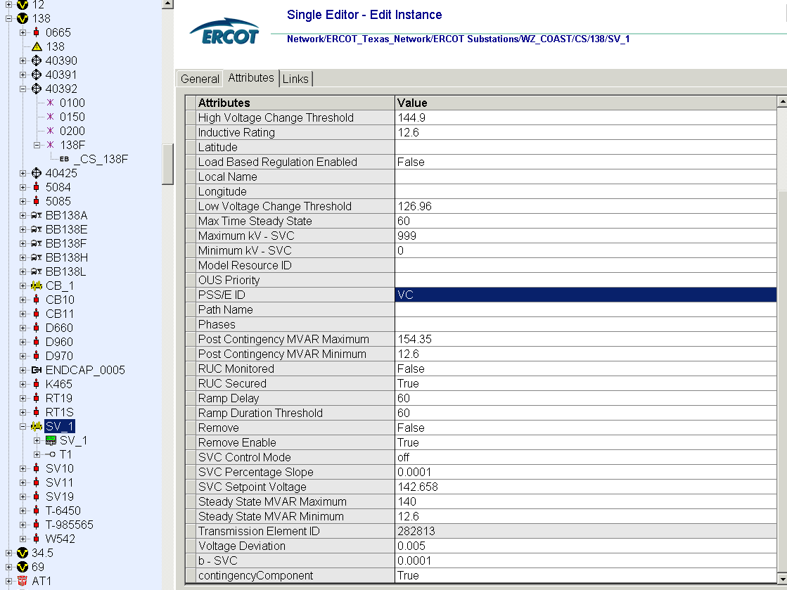

Deficiency #7
Assign valid PSSE IDs to Breakers/  Switches/ Series Devices  Topology Processor is creating lines with ID of BO/BC. | Planning Requirements
 | 1 | Allow any valid PSS/E ID’s to be assigned, in particular where breakers and switches are used to split up branches. Current SSWG cases allow zero impedance branches to have any valid two character PSS/E ID. Simply maintain this ability for SSWG members because circuit IDs have already been assigned for particular reasons.
 | Proposed Solution
 |  | In Information Model Manager, allow the capability to assign any valid PSS/E ID to Breakers and Switches by including an additional attribute. Also, remove validation rules that limit the PSS/E ID on series devices to Sx.

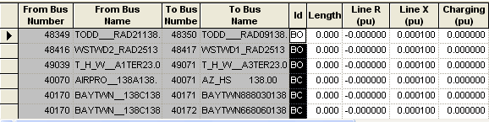
Line IDs with BO/BC ID
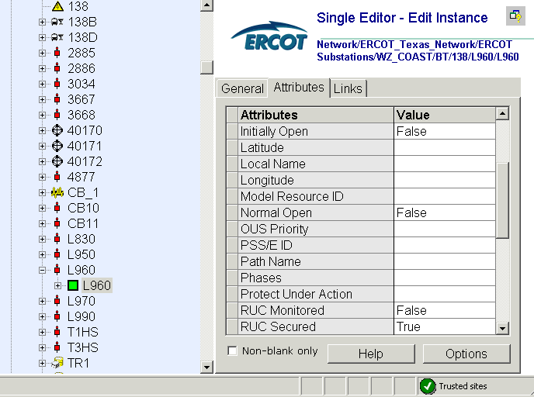
Allow a PSS/E ID to be assigned to switches and breakers to represent the line ID

Deficiency #8
Phase shift of Autos for short circuit studies  Missing 30 deg phase shift on tertiary. | Planning Requirements
 | 1 | Allow representation of a phase shift for an autotransformer winding in the Topology Processor PSS/E cases
 | Proposed Solution – Option 1
 | OPT1 | In Information Model Manager, store Planning transformer data in a separate file (or in a new Class outside of the ERCOT Texas Network directory similar to Transformer Kluges). After the first Topology Processor PSS/E output, recompile with the Planning transformer data to generate a Topology Processor PSS/E case.
 | Proposed Solution – Option 2
 | OPT2 | Topology Processor should check the value in the “Connection Type” attribute between TransformerWindings objects. If two windings are Y-Δ, then process as a 30 degree phase shift.

Phase Shift – Proposed Solution Option 1

Create a new class similar to transformer kluge or create a data file under the transformer kluge folder.

Phase Shift – Proposed Solution Option 2
Currently, TSP’s are not required to fill in the correct Connection Type attribute because it’s not being used by any of ERCOT’s downstream systems. If TSPs inserted the proper Wye or Delta designations for transformer windings in the Nodal model, then the Topology Processor could apply the phase shift in the case where appropriate.

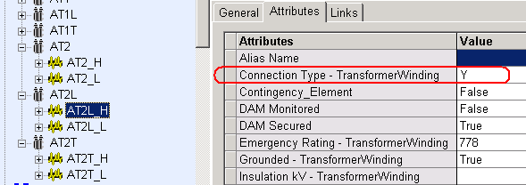
Y
Y
Δ

