SCR Number | 760 | SCR Title | Recommended Changes Needed for Information Model Manager and Topology Processor for Planning Models

Date | January 7, 2011

Submitter’s Information
Name | Wesley Woitt on behalf of the Steady State Working Group (SSWG)
E-mail Address | wesley.woitt@centerpointenergy.com
Company | CenterPoint Energy
Phone Number | 713-207-2760
Cell Number
Market Segment | Investor Owned Utility (IOU)

Comments

SSWG has reviewed ERCOT’s Dec 5, 2010 Impact Analysis for SCR760 and the Revised Impact Analysis for SCR759. ERCOT commented that several of the items in SCR760, Items 1, 3, and 6, had significantly higher costs to implement than the other items in SCR760. Also, the change proposed in SCR759 had a high cost to implement. The common theme throughout these high cost items is that each of these requires additional work on downstream applications from NMMS, such as the EMS and MMS.
In an effort to reduce costs and impact to downstream applications, but still outputting a Topology Processed case containing the data needed in planning cases, the SSWG offers the following proposed changes to three items in SCR760 and adds an additional item #9 which is effectively a substitution for the changes proposed in SCR759.

Revised Business Case for Proposed System Change

Deficiency #1
Upgrade to PSS/E v32  Topology Processor was written for PSS/E v30 | Planning Requirements
 | 1 | Revise Information Model Manager and Topology Processor in a timely manner after a major PSS/E release and include new available data types and new data parameters to existing data types that are needed and recommended by SSWG and approved by ROS.
 | Proposed Solution
 |  | Modify Information Model Manager and Topology Processor to allow outputting of the latest version of PSS/E. This should be done within one year of any and all PSS/E version updates in the future. Implement an evaluation process where SSWG recommends to ROS and ROS approves which new PSS/E data models should be evaluated for implementation into the IMM. The evaluation would be done on an annual basis and timed so that new data types could be used for SSWG case-building the following year.

Deficiency #2
Distribution Capacitor banks  Capacitor Banks not modeled for distribution side, therefore not shown in the Topology Processor case. | Planning Requirements
 | 1 | Represent Distribution Capacitor Banks on the proper bus in Topology Processor PSS/E case
 | 2 | Provide Capacitor Bank parameters necessary for PSS/E (MVAR, ID, fixed/switch shunt, number of blocks)
 | 3 | Allow for multiple capacitor banks on the same bus
 | Proposed Solution – Option 1
 | OPT1 | In Information Model Manager, define new Class called DistributionCapBank that can store the PSS/E data in its attributes. This Class would not be modeled like a ShuntCompensator with a Terminal connected to a node. Instead, a DistributionCapBank would be a “child” of BusbarSection.  Example of similar Class: A LoadResource is instantiated as a “child” of a CustomerLoad to allow the RE to store their data.  Advantages: The DistributionCapBank can be placed directly on the proper bus eliminating Topology Processor problems with collapsing to the proper bus. Also, not visible on one-line.  Disadvantages: Confusing because of unexpected location for a distribution cap bank.
 | Proposed Solution – Option 2
 | OPT2 | In Information Model Manager, define new Class called DistributionCapBank that can store the PSS/E data in its attributes. This Class would not be modeled like a ShuntCompensator with a Terminal connected to a node. Instead, a DistributionCapBank would be a child of CustomerLoad or NonConformLoad.  Example of similar Class: A LoadResource is instantiated as a child of a CustomerLoad to allow the RE to store their data.  Advantages: The DistributionCapBank can be placed on a Load nearest the actual cap bank. Also, not visible on one-line.  Disadvantages: Topology Processor has to have capability to collapse to the proper bus.
 | Proposed Solution – Option 3
 | OPT3 | In Information Model Manager, define new Class called DistributionCapBank and create it in a new directory outside of the substations (similar to TransformerKluges). Then have a new link in a Class, such as the BusbarSection, that can be associated with the DistributionCapBank.  Advantages: No objects defined in the substations. Also, not visible on the one-line.  Disadvantages: New link field in a Class that modelers will question why is there a distribution link requirement on an object defined in transmission voltage.

Distribution Capacitor Bank Example Substation AF

This is just to set up a frame of reference for the next page.

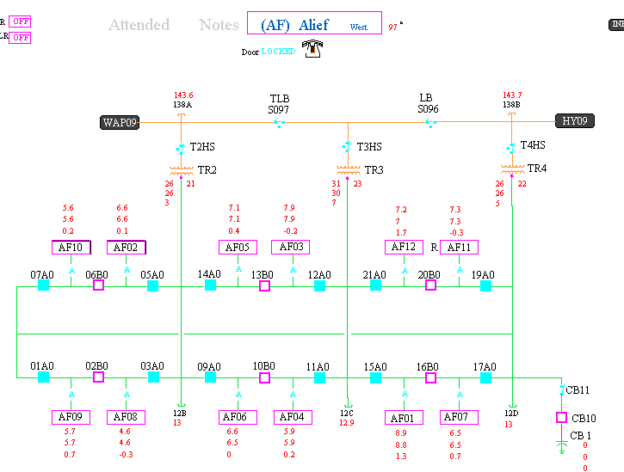

Notice CB 1 is closest to TR4. The BB138B busbar is closest to TR4.

DistributionCapBank – Proposed Solution Option 1

Example of how a DistributionCapBank object would be located as a child of the BusbarSection. Planning could store their PSS/E data in the object’s attributes. Would a regulation schedule be required? No.

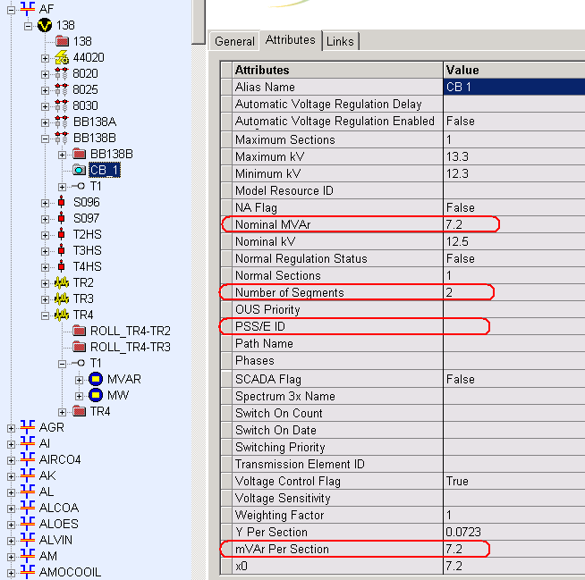

DistributionCapBank – Proposed Solution Option 2

Allow a DistributionCapBank object to reside under a CustomerLoad closest to the actual cap bank. Example of how ERCOT implements a similar example, in which a LoadResource (AK_LD2) under a CustomerLoad with multiple measurements under the terminal.

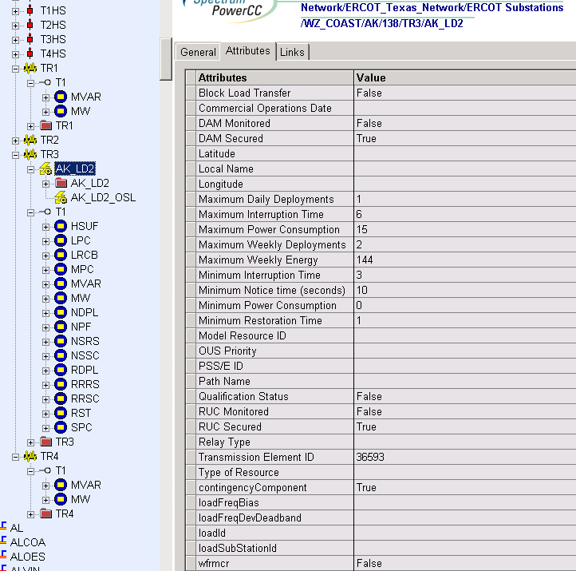

DistributionCapBank – Proposed Solution Option 3

Store the DistributionCapBank objects outside of the ERCOT_Texas_Network directory similar to Transformer Kluges, and have some object link to them.

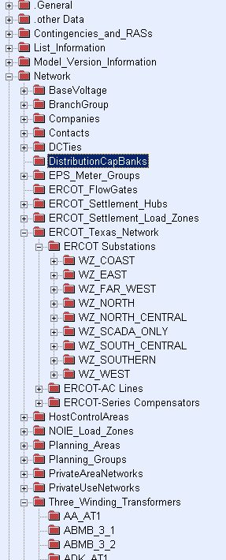
Transformer Kluges

Deficiency #3
Zero Impedance Line Ratings  Zero impedance lines in the Topology Processor cases default with 9999 MVA rating | Planning Requirements
 | 1 | Represent the proper ratings on zero impedance lines in the Topology Processor PSS/E cases
 | Proposed Solution – Option 1
 | OPT1 | In Information Model Manager, add new attributes for Breakers and Disconnectors to allow planning to enter ratings on devices converted by Topology Processor to zero impedance lines. Recommend no validation rule requiring this data to be populated. These ratings are intended to be strictly used for planning purposes and should not change the ratings that are currently applied to series devices or AC Line Segments. These new ratings should not affect the downstream Operational (EMS, MMS, CRR) systems.
 | Proposed Solution – Option 2
 | OPT2 | In Information Model Manager, add static ratings to the Breaker or Disconnector converted by Topology Processor to a zero impedance line. Recommend no validation rule requiring this data to be populated. These ratings are intended to be strictly used for planning purposes and should not change the ratings that are currently applied to series devices or AC Line Segments. These new ratings should not affect any current application besides the topology processor.

Zero Impedance Line Ratings – Proposed Solution Option 1
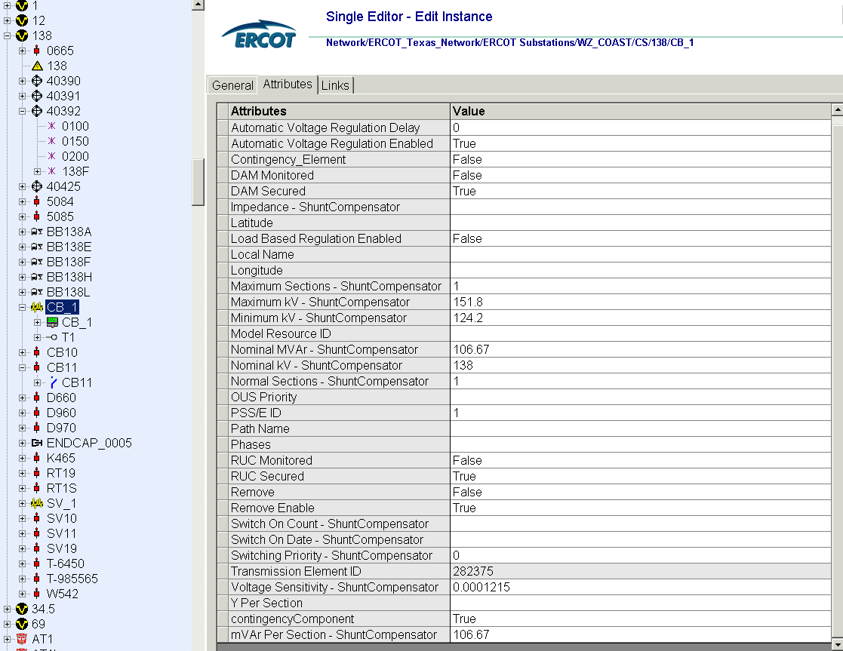
Add a new rating attribute

Zero Impedance Line Ratings – Proposed Solution Option 2
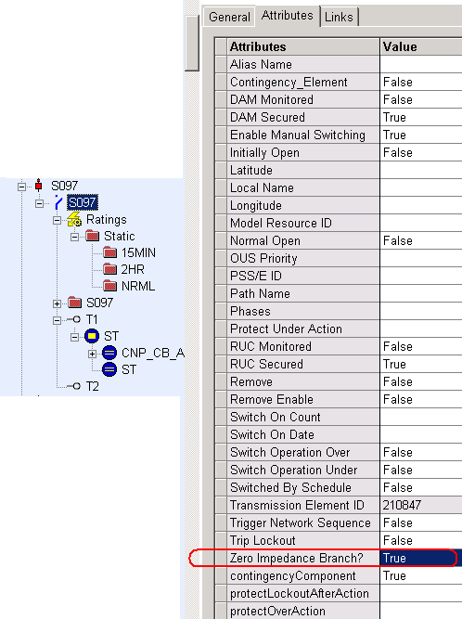
Example: Ratings assigned to a Disconnector

Deficiency #4
Associate Loads and Capacitor banks with the correct CNG  Some loads and cap banks cannot be modeled on the correct CNG. | Planning Requirements
 | 1 | Planning should be able to model loads and capacitor banks on the correct PSS/E busses.
 | Proposed Solution – Option 1
 | OPT1 | In Information Model Manager, allow capability to create a Jumper and be able to associate ratings to the Jumper. Jumpers could be utilized by Planning to associate capacitor banks and loads on the right CNG and model CAPE mutual buses.  Remove restriction from using the existing Jumper Class. The Jumper inherits from the Switch Class. Therefore, attributes and links are similar to the Disconnector and Breaker Class.
 | OPT2 | Proposed Solution – Option 2
 | OPT2 | In Information Model Manager, create a new attribute that would enable the user to select the PSS/E bus where the capacitor bank should appear in the Topology Processor case.
 | OPT3 | Proposed Solution – Option 3
 | OPT3 | In Information Model Manager, create a new attribute that would enable the user to select the PSS/E bus where the load should appear in the Topology Processor case.

Load and Capacitor bank bus correction – Proposed Solution Option 1

The Jumper Class is currently “Not Allowed” by ERCOT, yet it is already defined in NMMS. Here is an example of creating a Jumper under a Bay with Normal, 2hr, 15min, Conductor ratings, and two Terminals.

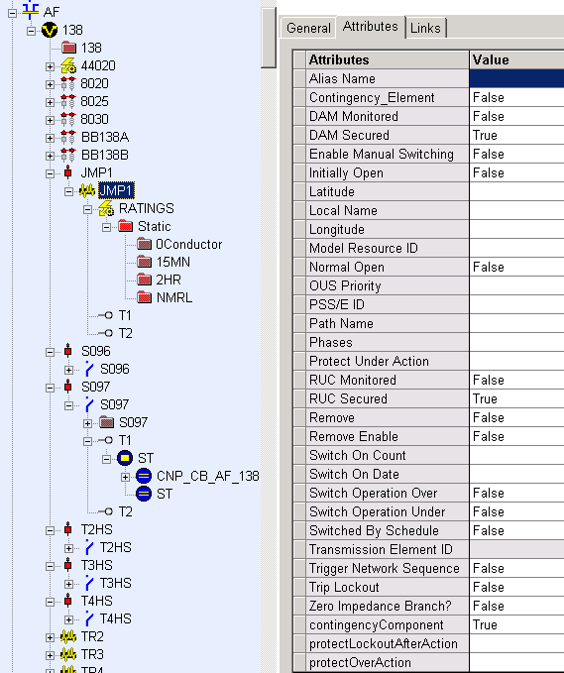
Jumper

Figure shows a Jumper Class being defined under a Bay.

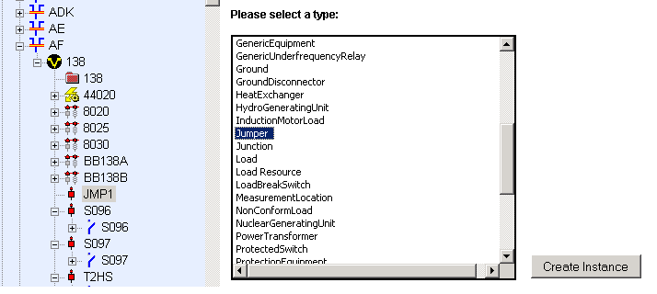

Figure below shows a Jumper across BB138A and BB138B just for demonstration purposes.

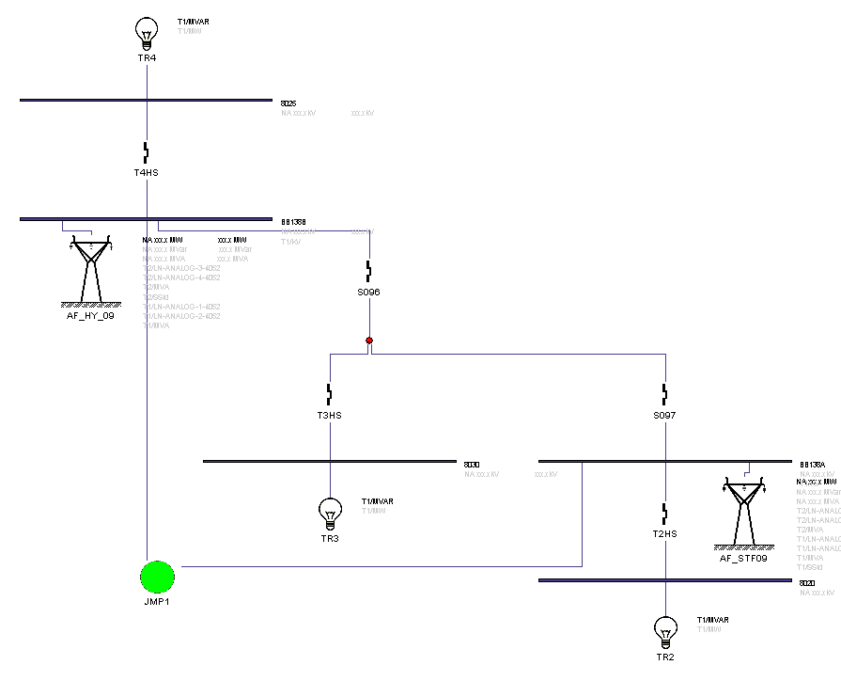
Jumper

Load and Capacitor bank bus correction - Proposed Solution Option 2

Assign a PSS/E bus where a capacitor bank should be located

Load and Capacitor bank bus correction - Proposed Solution Option 3

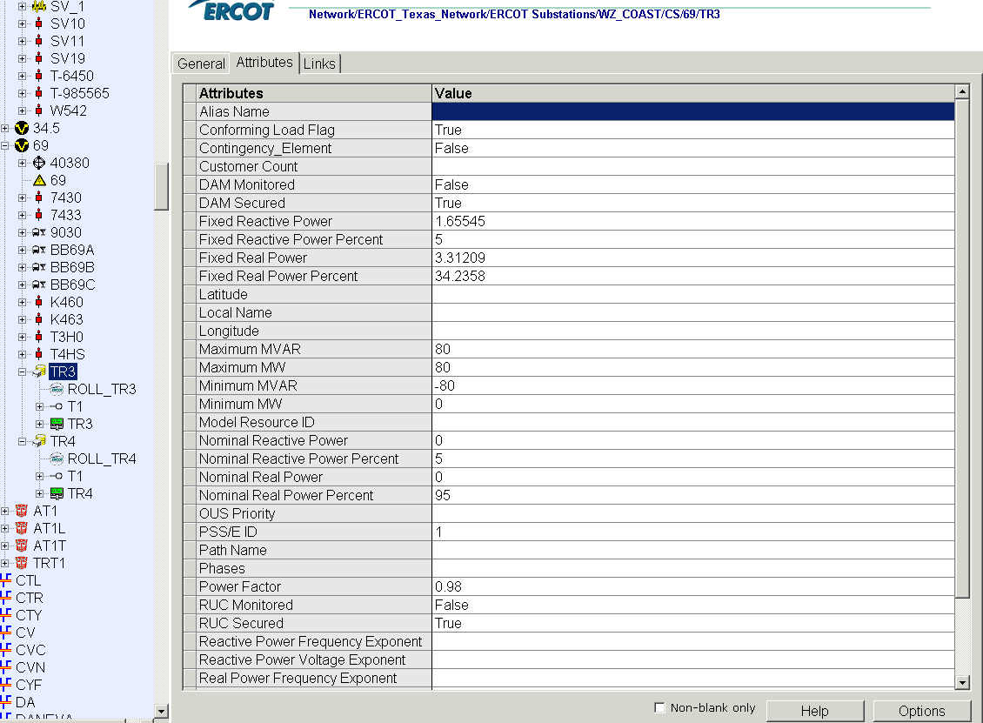
Assign a PSS/E bus where a load should be located

Deficiency #5
Additional Transformer Data for Planning  Operations Transformer model may differ from Planning model. | Planning Requirements
 | 1 | Represent the actual transformer models in the PSS/E cases. The planning transformer model is an appropriate model for the transformer to ensure stakeholders the power flow results will be accurate. Additional data attributes such as the number of taps, location of tapped winding, maximum and minimum tap ratios.
 | Proposed Solution
 |  | In Information Model Manager, store Planning transformer data in a separate file (or in a new Class outside of the ERCOT Texas Network directory similar to Transformer Kluges). The Topology Processor will select the Planning transformer data to generate the Topology Processor PSS/E case. Necessary data includes number of taps, location of tapped winding, maximum and minimum tap ratios, and specifying the voltage control bus.

Create a new class similar to transformer kluge or create a data file under the transformer kluge folder.

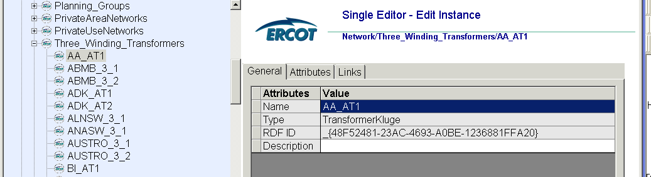

Deficiency #6
FACTS Devices  FACTS devices are modeled only as generators in Topology Processor Case, although they may be modeled in a number of ways in PSSE | Planning Requirements
 | 1 | Allow capability to convert a FACTS device model in Information Model Manager to one of several FACTS device models allowed in PSS/E version 32 to be decided based on the recommendation of SSWG and approved by ROS.
 | Proposed Solution
 |  | In Information Model Manager, Add an attribute to allow the TSP to be able to select for each object (generator, switch shunt, or FACTS Device). The TSP should be able to select the object it would like to see as a FACTS Device appear in the Topology Processor case as opposed to all FACTS Devices be modeled as generators. Any additional data parameters needed should be included as attributes, so that the Topology Processor can convert to the appropriate PSS/E model

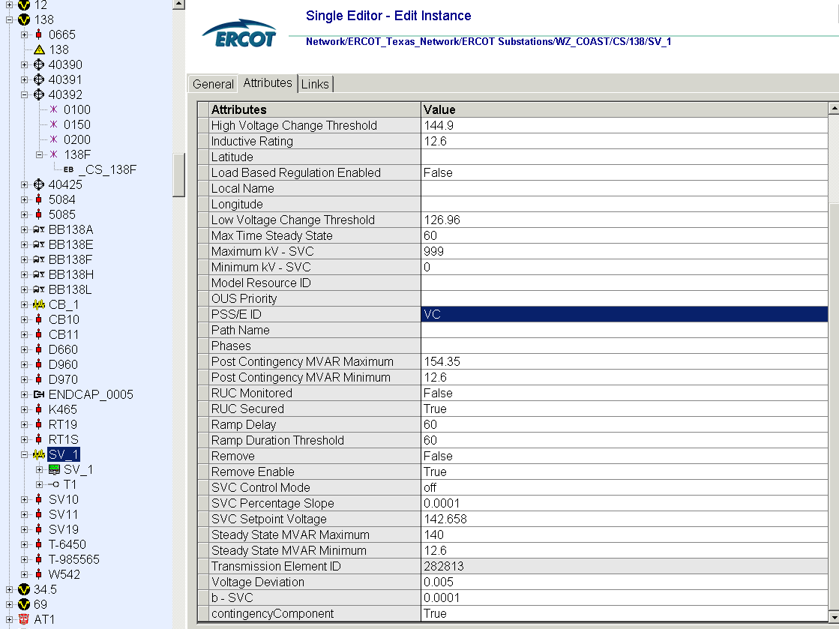

Deficiency #7
Assign valid PSSE IDs to Breakers/  Switches/ Series Devices  Topology Processor is creating lines with ID of BO/BC. | Planning Requirements
 | 1 | Allow any valid PSS/E ID’s to be assigned, in particular where breakers and switches are used to split up branches. Current SSWG cases allow zero impedance branches to have any valid two character PSS/E ID. Simply maintain this ability for SSWG members because circuit IDs have already been assigned for particular reasons.
 | Proposed Solution
 |  | In Information Model Manager, allow the capability to assign any valid PSS/E ID to Breakers and Switches by including an additional attribute. Also, remove validation rules that limit the PSS/E ID on series devices to Sx.

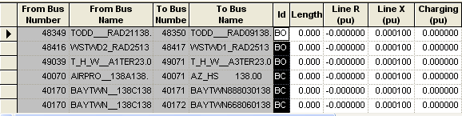
Line IDs with BO/BC ID
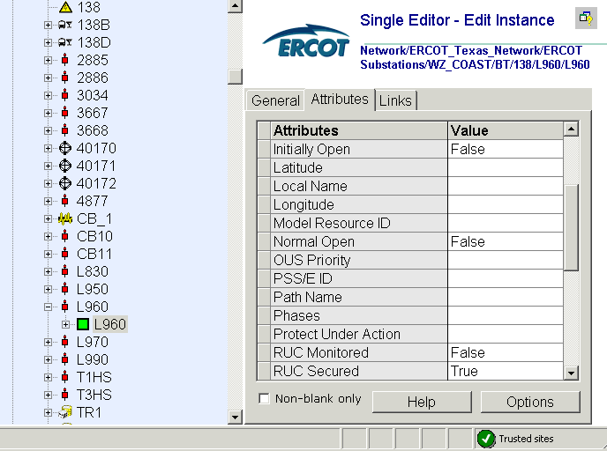
Allow a PSS/E ID to be assigned to switches and breakers to represent the line ID

Deficiency #8
Phase shift of Autos for short circuit studies  Missing 30 deg phase shift on tertiary. | Planning Requirements
 | 1 | Allow representation of a phase shift for an autotransformer winding in the Topology Processor PSS/E cases
 | Proposed Solution – Option 1
 | OPT1 | In Information Model Manager, store Planning transformer data in a separate file (or in a new Class outside of the ERCOT Texas Network directory similar to Transformer Kluges). After the first Topology Processor PSS/E output, recompile with the Planning transformer data to generate a Topology Processor PSS/E case.
 | Proposed Solution – Option 2
 | OPT2 | Topology Processor should check the value in the “Connection Type” attribute between TransformerWindings objects. If two windings are Y-Δ, then process as a 30 degree phase shift.

Phase Shift – Proposed Solution Option 1

Create a new class similar to transformer kluge or create a data file under the transformer kluge folder.

Phase Shift – Proposed Solution Option 2
Currently, TSP’s are not required to fill in the correct Connection Type attribute because it’s not being used by any of ERCOT’s downstream systems. If TSPs inserted the proper Wye or Delta designations for transformer windings in the Nodal model, then the Topology Processor could apply the phase shift in the case where appropriate.

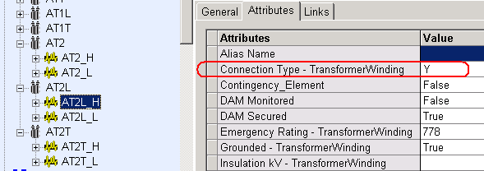
Y
Y
Δ
Deficiency #9
Multisection Line Grouping  Currently there is a 2 character restriction for ACLineSegment names. This doesn’t allow a majority of the TSPs the ability to create multisection line groupings when they have longer than 2 character ACLineSegment names. | Planning Requirements
 | 1 | Represent multisection line groupings properly in TP PSSE cases
 | 2 | Allow capability to mark unique Line Id.
 | 3 | Show “&X” line identifier properly in the TP data records. Currently the output leaves the field blank.
 | Proposed Solution
Define new Class called MultisectionLineGroup and create it in a new directory outside of the substations (see Fig. 1). MultisectionLineGroup attributes will include string “Line Id” and Boolean “Metered”. Then add a new link in the ACLineSegment objects that can be associated with a MultisectionLineGroup. An ACLineSegment cannot be linked to more than one MultisectionLineGroup.

Advantages: No modification needed to the 2 character rule. Doesn’t change the current hierarchical model structure and doesn’t require renaming ACLineSegments. Also, modeling these MultisectionLineGroup objects doesn’t become a requirement in NMMS for those TSPs that don’t use the feature in PSSE (Independent option).

Disadvantages: Unable to easily view the model tree to see which lines are associated to a MultisectionLineGroup. More difficult to programmatically determine which lines are associated to a MultisectionLineGroup. If not all TSPs model multisection lines in IMM, then ERCOT cannot create a validation rule to check that the ACLineSegment link to a MultisectionLineGroup is filled out.

Proposed Solution:
Figure 1 below shows MultisectionLineGroup objects defined under sub-directories named for each TSP owner, with sub-directories defined under main directory called MultisectionLineGroups. The sub-directories should have an Ownership field to restrict access to the proper TSP.

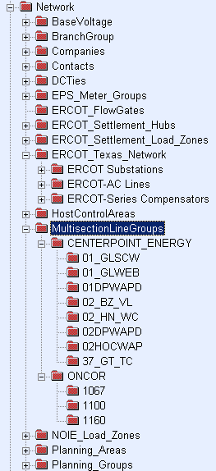

Main directory
Sub directory with Ownership Link
MultisectionLineGroup objects

Figure 1

Attributes of a MultisectionLineGroup

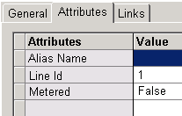

Figure 1

Figure 2 below shows a new link field in the ACLineSegment object to associate to a MultisectionLineGroup. The field is not required to fill out if a TSP chooses not to incorporate multisection lines.

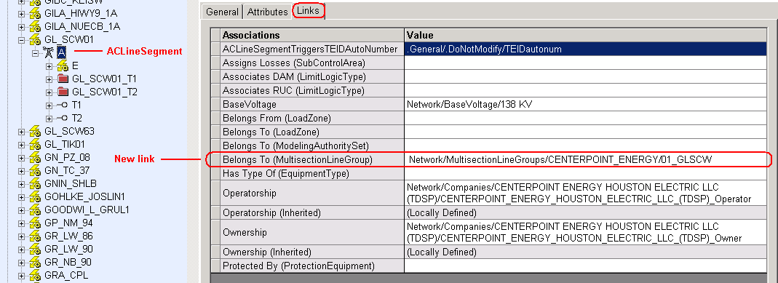
Figure 2

