 |  |  |  | System Planning Division
Monthly Status Report
to
Reliability and Operations Subcommittee
for
December 2010

 |  | Report Highlights
Item
1. | - ERCOT is currently tracking 193 active generation interconnection requests totaling almost 65,000 MW. This includes almost 38,000 MW of wind generation.
2. | - ERCOT is currently reviewing proposed transmission improvements with a total cost of $51.1 Million  - Transmission Projects endorsed in 2010 total $268.8 Million  - All projects (in engineering, routing, licensing and construction) total approximately $9.3 Billion  - Transmission Projects energized in 2010 total about $857.1 million

Table of Contents
1. Generation Interconnection 1
1.1 New Generation Registering for Commercial Operations 1
1.2 Publicly Disclosed Generation Interconnection Projects 4
1.3 Generation Projects Undergoing Full Interconnection Studies (not otherwise public) 6
1.4 Wind Generation 7
Wind Capacity Installed by Year 7
2. Regional Planning Group Project Reviews 9
3. Congestion Costs 10
4. Wind Generation as a Percent of Load 16
5. Other Notable Activities 17

1. Generation Interconnection
Additional information regarding detailed generation interconnection and impact studies is contained in the “Generation Project Interconnection Information” folder in the “Operations and System Planning” area on the ERCOT website: http://planning.ercot.com/login/login.

New Generation Registering for Commercial Operations

Lufkin Biomass (08INR0033), 45 MW in Angelina County
The total installed wind capacity remains at 9,467 MW.

Summary of Active Generation Interconnection Requests

GENERATION INTERCONNECTION REQUESTS CURRENTLY BEING PROCESSED
Currently tracking 193 active generation interconnection or change requests
As of December 31, 2010 | North | South | West | Total
Security Screening Study | 2 | 3 | 10 | 11
SSS Completed | 2 | 3 | 11 | 16
Full Interconnect Study | 23 | 28 | 93 | 125
FIS Completed | 4 | 14 | 4 | 23
Interconnect Agreement Completed | 7 | 6 | 5 | 18
Capacity under Interconnection Agreements | 5,147 | 3,742 | 756 | 9,645
Capacity for Grid, MW | 19,195 | 13,235 | 32,279 | 64,708
Wind Capacity, MW | 3,907 | 4,491 | 29,379 | 37,776

Fuel Type | Confidential Projects (MW) | Projects Under Full Study (MW) | Projects w/ Interconnect Agreement/Public Letter (MW) | Grand Total (MW)
Gas-CC |  |  | 5,352 | 12,043
Gas-CT |  |  |  | 650
Total Gas | 11 | 7,330 | 5,352 | 12,693
Nuclear |  |  | 5,900 | 5,900
Coal |  | 1,740 | 3,210 | 4,950
Wind | 3,184 | 28,539 | 6,053 | 37,776
Solar | 440 | 819 |  | 1,259
Biomass |  | 50 | 100 | 150
Other |  | 740 | 1,240 | 1,980
Grand Total | 3,635 | 39,218 | 21,900 | 64,708

Publicly Disclosed Generation Interconnection Projects
The table below summarizes the publicly disclosed generation projects for the ERCOT region.
(Status: IA=Interconnect Agreement, PL=Public Letter, XX= cancelled)
Generation Interconnections as of December 31, 2010
INR | SiteName | Status | County | Region | COD | Fuel Type |  | MW For Grid | Change from Last Report
05INR0015b | Gulf Wind 2 | PL | Kenedy | South | Jan-11 |  | Wind | 400
05INR0015c | Gulf Wind 3 | PL | Kenedy | South | Jan-11 |  | Wind | 400
08INR0065 | Buffalo Gap 4 and 5 | PL | Nolan | West | Mar-11 |  | Wind | 465
09INR0029 | CFB Power Plant Units 11&12 | IA | Calhoun | South | Mar-11 |  | Coal | 260
10INR0010 | Jack County 2 | IA | Jack | North | Jun-11 |  | Gas-CC | 620
08INR0038 | M Bar Wind | PL | Andrews | West | Dec-11 |  | Wind | 194
09INR0034 | Gatesville Wind Farm | PL | Coryell | North | Dec-11 |  | Wind | 200
12INR0003 | Throckmorton Wind Farm | PL | Throckmorton | West | Dec-11 |  | Wind | 400 | Date
08INR0025 | Pistol Hill Energy Center | PL | Ector | West | Dec-11 |  | Wind | 300
06INR0012b | Sherbino Mesa Wind Farm 2 | IA | Pecos | West | Jan-12 |  | Wind | 150
09INR0001 | Sandy Creek 1 | IA | McLennan | North | Feb-12 |  | Coal | 925
08INR0062 | Archer-Young | IA | Young | West | Mar-12 |  | Wind | 250
11INR0084 | 2W Whatley Phase 1 | PL | Ector | West | Mar-12 |  | Wind | 45
09INR0007 | Nacogdoches Project | IA | Nacogdoches | North | Apr-12 |  | Biomass | 100
07INR0004 | Pampa Energy Center | PL | Gray | West | May-12 |  | Coal | 165
09INR0024 | B&B Panhandle Wind | PL | Carson | West | Jun-12 |  | Wind | 1001
09INR0037 | Scurry County Wind III | PL | Scurry | West | Jun-12 |  | Wind | 350
12INR0004 | Fort Concho Wind Farm | PL | Tom Green | West | Jul-12 |  | Wind | 400
12INR0043 | 2W Whatley Phase 2 | PL | Ector | West | Aug-12 |  | Wind | 290
08INR0011 | Senate Wind Project | IA | Jack | North | Sep-12 |  | Wind | 150 | Date
09INR0036 | McAdoo Energy Center II | PL | Dickens | West | Dec-12 |  | Wind | 500
08INR0018 | Gunsight Mountain | IA | Howard | West | Dec-12 |  | Wind | 120
06INR0022c | Penascal Wind Farm 3 | IA | Kenedy | South | Dec-12 |  | Wind | 202
10INR0020a | Panda Temple Power | IA | Bell | North | Feb-14 |  | Gas-CC | 780
06INR0006 | Cobisa-Greenville | IA | Hunt | North | May-14 |  | Gas-CC | 1792
10INR0022 | Pondera King Power Project | IA | Harris | South | Jun-14 |  | Gas-CC | 1380
04INR0011b | Cedar Elm | IA | Shackelford | West | Jun-14 |  | Wind | 136
04INR0011c | Cottonwood Wind | IA | Shackelford | West | Jun-14 |  | Wind | 100
14INR0005 | White Stallion Energy Center | PL | Matagorda | South | Jul-14 |  | Coal | 1200
14INR0002 | Coleto Creek Unit 2 | IA | Goliad | South | Nov-14 |  | Coal | 660
10INR0020b | Panda Temple Power | IA | Bell | North | Jan-16 |  | Gas-CC | 780
12INR0016a | Las Brisas Energy Center | IA | Nueces | South | Jun-15 |  | Other | 620
12INR0016b | Las Brisas Energy Center | IA | Nueces | South | Jun-16 |  | Other | 620
15INR0008 | STP 3 and 4 | PL | Matagorda | South | Jun-16 |  | Nuclear | 2700
15INR0002 | Comanche Peak 3 and 4 | PL | Somervel | North | Dec-18 |  | Nuclear | 3200
 |  |  |  |  |  |  | TOTAL | 21,900

County Location of Installed Generation and Interconnection Requests (all fuels)

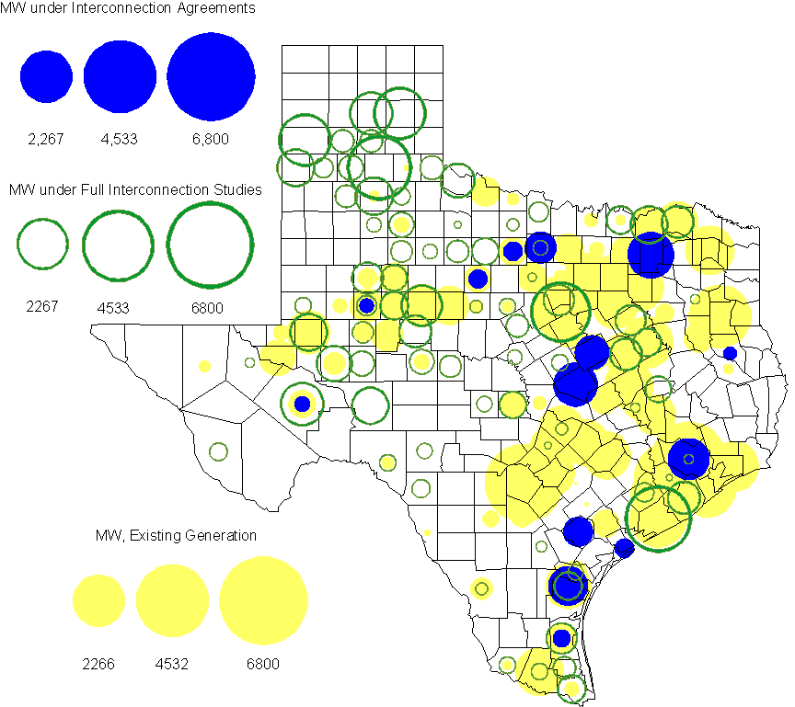

Generation Projects Undergoing Full Interconnection Studies (not otherwise public)
INR | County | Capacity | COD | Fuel |  | INR | County | Capacity | COD | Fuel
09INR0054 | Stonewall | 149 | TBD | Wind |  | 09INR0061 | Kent | 258 | TBD | Wind
10INR0048 | Hardeman | 1,000 | TBD | Wind |  | 10INR0054 | Palo Pinto | 36 | TBD | Wind
10INR0016 | Childress | 150 | TBD | Wind |  | 10INR0079 | Nolan | 60 | TBD | Wind
10INR0029 | Hood | 810 | TBD | Gas |  | 10INR0013 | Upton | 400 | TBD | Wind
10INR0052a | Knox | 21 | TBD | Wind |  | 09INR0074 | Motley | 70 | TBD | Wind
10INR0041 | Floyd | 135 | TBD | Wind |  | 11INR0029 | Throckmorton | 200 | TBD | Wind
10INR0032 | Navarro | 775 | TBD | Gas |  | 10INR0042 | Mason | 170 | TBD | Wind
10INR0082 | Travis | 30 | TBD | Solar |  | 10INR0051 | Brazoria | 200 | TBD | Wind
10INR0060 | Willacy | 401 | TBD | Wind |  | 07INR0013 | Coke | 200 | TBD | Wind
10INR0008 | Pecos | 500 | TBD | Wind |  | 10INR0019 | Deaf Smith | 609 | TBD | Wind
10INR0033 | Armstrong | 399 | TBD | Wind |  | 10INR0056 | Borden | 249 | TBD | Wind
10INR0077 | Callahan | 101 | TBD | Wind |  | 10INR0080 | Presidio | 144 | TBD | Solar
12INR0003 | Throckmorton | 400 | TBD | Wind |  | 05INR0015b | Kenedy | 400 | TBD | Wind
11INR0076 | Archer | 94 | TBD | Wind |  | 05INR0015c | Kenedy | 400 | TBD | Wind
11INR0081 | Live Oak | 72 | Mar-11 | Wind |  | 11INR0088 | Brazos | 45 | Mar-11 | Gas
08INR0065 | Nolan | 465 | Mar-11 | Wind |  | 11INR0050 | Crosby | 149 | Mar-11 | Wind
11INR0082A | Val Verde | 50 | Mar-11 | Wind |  | 11INR0083A | Crockett | 50 | Mar-11 | Wind
11INR0085 | Nolan | 106 | Mar-11 | Wind |  | 11INR0071 | Harris | 7 | Apr-11 | Gas
11INR0075 | Fort Bend | 15 | Apr-11 | Coal |  | 11INR0086 | Travis | 60 | Apr-11 | Solar
11INR0037 | Smith | 50 | May-11 | Biomass |  | 11INR0062 | Nueces | 149 | May-11 | Wind
11INR0058 | Pecos | 135 | May-11 | Solar |  | 11INR0060 | Tom Green | 90 | May-11 | Solar
11INR0061 | Presidio | 90 | May-11 | Solar |  | 11INR0033a | Cameron | 200 | May-11 | Wind
11INR0033b | Cameron | 200 | May-11 | Wind |  | 09INR0050 | Fannin | 1,200 | Jun-11 | Gas
10INR0089 | Harris | 40 | Jun-11 | Other |  | 11INR0054 | San Patricio | 161 | Jun-11 | Wind
11INR0057 | Cameron | 165 | Jun-11 | Wind |  | 11INR0065 | Nueces | 240 | Jun-11 | Wind
11INR0091 | Webb | 92 | Jun-11 | Wind |  | 08INR0020 | Eastland | 200 | Jun-11 | Wind
10INR0023 | Haskell | 386 | Jun-11 | Wind |  | 11INR0019 | Upton | 200 | Jun-11 | Wind
11INR0006 | Lamar | 579 | Jul-11 | Gas |  | 11INR0040 | freestone | 640 | Aug-11 | Gas
11INR0039 | Starr | 201 | Sep-11 | Wind |  | 11INR0079a | Clay | 200 | Sep-11 | Wind
11INR0047 | Deaf Smith | 600 | Sep-11 | Wind |  | 10INR0062a | Pecos | 80 | Oct-11 | Wind
10INR0081b | Clay | 19 | Oct-11 | Wind |  | 10INR0021 | Grayson | 646 | Nov-11 | Gas
11INR0090 | Howard | 60 | Nov-11 | Solar |  | 11INR0094 | Kent | 100 | Nov-11 | Solar
08INR0049 | Clay | 50 | Dec-11 | Wind |  | 09INR0034 | Coryell | 200 | Dec-11 | Wind
11INR0013 | Mills | 150 | Dec-11 | Wind |  | 11INR0067 | Cameron | 78 | Dec-11 | Wind
11INR0089 | Hays | 20 | Dec-11 | Solar |  | 08INR0038 | Andrews | 194 | Dec-11 | Wind
11INR0005 | Upton | 500 | Dec-11 | Wind |  | 11INR0025 | Crockett | 400 | Dec-11 | Wind
11INR0043 | Coke | 300 | Dec-11 | Wind |  | 11INR0070 | Reeves | 50 | Dec-11 | Solar
08INR0025 | Ector | 300 | Dec-11 | Wind |  | 12INR0034 | Borden | 342 | Dec-11 | Wind
09INR0048 | Jack | 150 | Dec-11 | Wind |  | 09INR0075 | Kinney | 248 | Dec-11 | Wind
10INR0085 | Ector | 40 | Jan-12 | Solar |  | 12INR0021 | Edwards | 165 | Jan-12 | Wind
12INR0033 | Motley | 150 | Jan-12 | Wind |  | 10INR0018 | Madison | 550 | Mar-12 | Gas
11INR0084 | Ector | 45 | Mar-12 | Wind |  | 12INR0042 | Deaf Smith | 400 | Mar-12 | Wind
12INR0007 | Lamar | 296 | May-12 | Gas |  | 11INR0049 | Wharton | 275 | May-12 | Gas
07INR0004 | Gray | 165 | May-12 | Coal |  | 09INR0031 | Ector | 275 | May-12 | Gas
10INR0081a | Clay | 30 | May-12 | Wind |  | 12INR0006 | Limestone | 875 | Jun-12 | Coal
08INR0031 | Childress | 100 | Jun-12 | Wind |  | 09INR0024 | Carson | 1,001 | Jun-12 | Wind
09INR0037 | Scurry | 350 | Jun-12 | Wind |  | 12INR0053 | Crockett | 615 | Jun-12 | Wind
12INR0004 | Tom Green | 400 | Jul-12 | Wind |  | 12INR0043 | Ector | 290 | Aug-12 | Wind
08INR0041 | Coke | 200 | Oct-12 | Wind |  | 12INR0026 | Randall | 400 | Oct-12 | Wind
12INR0035 | Nueces | 249 | Nov-12 | Wind |  | 08INR0044 | Concho | 200 | Nov-12 | Wind
08INR0054 | Comanche | 401 | Dec-12 | Wind |  | 12INR0022 | Hidalgo | 200 | Dec-12 | Wind
08INR0042 | Coke | 200 | Dec-12 | Wind |  | 09INR0025 | Concho | 180 | Dec-12 | Wind
09INR0036 | Dickens | 500 | Dec-12 | Wind |  | 12INR0005 | Floyd | 1,100 | Dec-12 | Wind
12INR0029 | Swisher | 500 | Dec-12 | Wind |  | 10INR0024 | Briscoe | 2,940 | Jan-13 | Wind
12INR0027 | Gray | 200 | Jan-13 | Wind |  | 09INR0058 | Howard | 250 | Mar-13 | Wind
11INR0082B | Val Verde | 150 | Mar-13 | Wind |  | 11INR0083B | Crockett | 100 | Mar-13 | Wind
12INR0018 | Gray | 500 | Apr-13 | Wind |  | 10INR0062b | Pecos | 220 | May-13 | Wind
13INR0020a | Glasscock | 200 | May-13 | Wind |  | 09INR0041 | Mitchell | 300 | Jun-13 | Wind
09INR0051 | Borden | 249 | Jun-13 | Wind |  | 13INR0023 | Ector | 240 | Jul-13 | Gas
13INR0016 | Deaf Smith | 251 | Aug-13 | Wind |  | 13INR0005 | Carson | 600 | Oct-13 | Wind
13INR0004 | Deaf Smith | 500 | Oct-13 | Wind |  | 13INR0028 | Hale | 392 | Nov-13 | Gas
09INR0077 | Reagan | 500 | Dec-13 | Wind |  | 10INR0009 | Castro | 300 | Dec-13 | Wind
12INR0002a | Briscoe | 200 | Dec-13 | Wind |  | 13INR0007 | Pecos | 200 | Dec-13 | Wind
13INR0017 | Childress | 200 | Dec-13 | Wind |  | 13INR0010 | Parmer | 1,200 | Dec-13 | Wind
09INR0073 | Scurry | 200 | Dec-13 | Wind |  | 08INR0019a | Gray | 250 | Jan-14 | Wind
08INR0019b | Gray | 250 | Jan-14 | Wind |  | 08INR0019c | Gray | 250 | Jan-14 | Wind

Wind Generation

Wind Capacity Installed by Year

County Location of Installed Capacity and Interconnection Requests (Wind only)

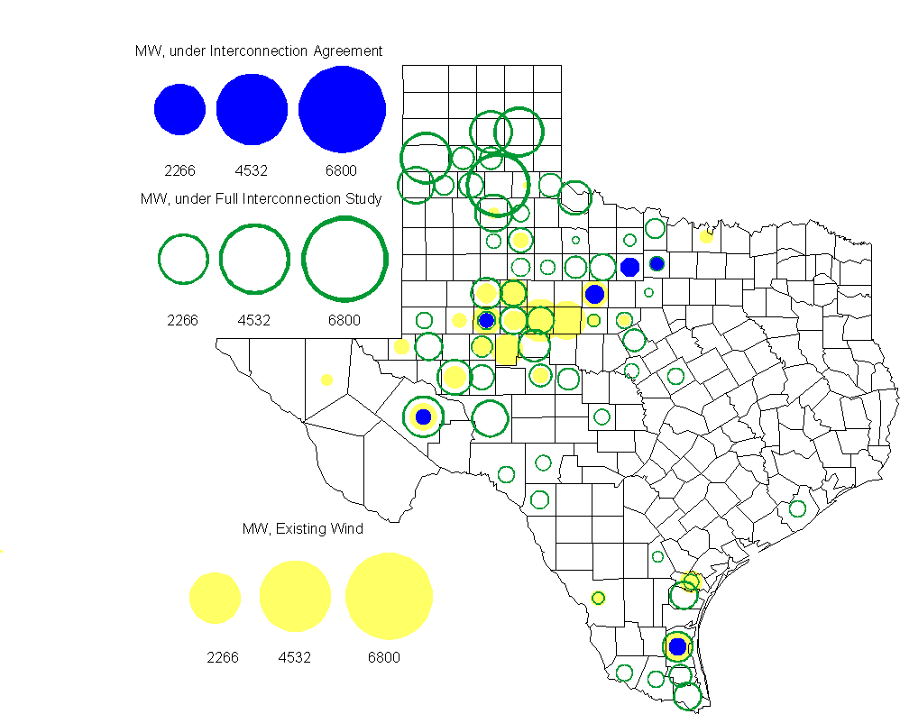

Regional Planning Group Project Reviews

- Brazos Electric Cooperative has submitted a project to move some load that is currently being served by the Entergy Texas system into the ERCOT system. The project would involve disconnecting the subject load from the Entergy Texas system, constructing a new 345/ 138 kV substation in ERCOT, upgrading an existing 69 kV line in the ERCOT system and constructing two new 138 kV lines to serve the load from the ERCOT system. The estimated cost of this project is $51.1 M. The project is currently undergoing ERCOT Independent Review.

Congestion Costs
Dollars shown in graphs are settlement quality.

OOMC – last 13 months in million$

OOM Down – last 13 months in million$

Local Balancing Energy Down – last 13 months in million$

OOM Up – last 13 months in million$

Local Balancing Energy Up – last 13 months in million$

Replacement Reserve – last 13 months in thousand$

Average MCPE

Binding Constraints & Capacity Shortages– September, 2010
Contingency | Binding Element | Estimated Costs | Transmission Project | Clearance
Planned Outage |  | $1,286,069.14
Brauning – Toyota – Valley 138 kV | Five Points – Westside 138 kV | $775,804.90 |  | Outage on Cagnon - Marbach and Cagnon to Anderson 138kV lines
Austrop – Sandow 345 kV | Hutto – Round Rock SE 138 kV | $426,869.56 | Hutto Switch - Round Rock NE - Round Rock 138 kV line  [08TPIT0009] | Outage on Round Rock - Round Rock North East 138kV
ODEHV Auto/ Voltage Support |  | $321,198.18
Temple Pecan Creek – Tradinghouse and Temple Switch – Lake Creek 345 kV | Lake Creek 345/138kV Autotransformer 1 | $258,650.27
Falcon Cal Energy – Morgan Creek 345 kV | Forsan Tap - CRMWD7 138KV | $173,010.83 |  | Outage on Odessa EVH Switch 138kV and 345kV bus and Odessa 345/138kV AT
Maring Lake – Elkton Outage |  | $145,821.76
Greens Bayou – Gable Street and Hardy – Crockett 138 kV | Garrott – Midtown 138 kV | $120,524.41 | Upgrade 138 kV underground Ckt. 90 Garrott to Midtown to Polk [11TPIT0072] | Outage on Oasis to Meadow 345kV line
Moss Switch – Holt Switch 138 kV | Odessa North 138/69kV Autotransformer | $113,836.86 |  | High Wind Generation/W-N flow
Valley Import |  | $112,412.83

Inter-zonal Congestion

Wind Generation as a Percent of Load
One-hour average Settlement quality data shown.

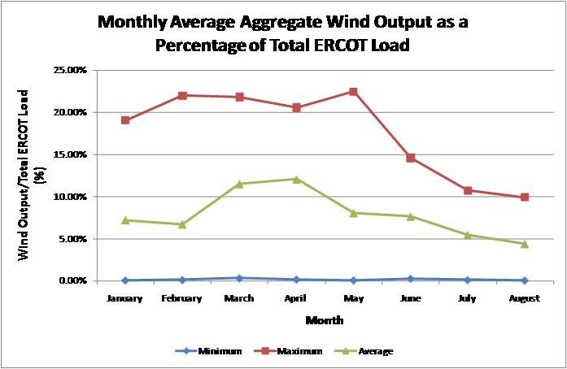

Planning Model Activities
- ERCOT and SSWG completed work to create a 2010 planning case after three passes. The case solves if islands are disconnected and generator MVar limits are ignored. By the time work had stopped, TSPs had not completed adding standard PMCRs in MOD that might have provided additional reactive capability.
- ERCOT and SSWG continued work to create a 2012 case using PSSE version 32 format starting Dec. 3, 2010. All standard PMCR’s will be applied to this case and the case will be completed using PMCR’s to model transmission projects expected to by complete by July 1, 2012. This case will be compared to the current DSB 2012SUM1 case completed in Nov. 2010.
- The projected testing schedule for the NMMS MOD application is as follows:
  - Dec. 3 – ERCOT creates Topology Processor case and loads into MOD
  - Dec. 17 – TSPs submit Pass 0 PMCR’s (standard PMCR’s only)
  - Jan. 7 - TSPs submit Pass 1 PMCR’s (standard PMCR’s and future project PMCR’s)
  - Jan. 21 - TSPs submit Pass 2 PMCR’s (standard PMCR’s and future project PMCR’s)
- A Nodal Planning Go-Live Workshop was held December 15, 2010. The use of the NMMS MOD application to build planning cases was debated. Three options were developed for building the 2012 Data Set A cases in April 2011:
  - Option 1 – Use the NMMS MOD application and implement Planning Go-Live (defined as using the NMMS Topology Processor output as the seed case for MOD to build the Annual Planning Cases) in April 2011. Consistency would be as defined in the TAC approved (but non-binding) “Principles of Consistency” document.
  - Option 2 – Use an already created (but still undetermined) SSWG case as input to MOD independent of the NMMS data being used for Operations models. Redefine Planning Go-Live as a commitment by TSPs to compare the resulting SSWG cases with a NMMS Topology Processed case and resolve or document differences using an as yet undefined process to achieve a higher level of consistency between planning and operations cases than seen in the past. The Planning Working Group will develop and document the tolerances that will be used to define consistency. Planning Go-Live will occur when the documentation is complete and tolerances have been met which is expected to be by August 1, 2011.
  - Option 3 – Do Nothing.

Other Notable Activities
- Work on the 2010 Five-Year Transmission Plan is wrapping up. The set of projects needed to reliably serve load and reduce congestion in the years 2011 through 2015 has been identified and comments have been received. The study is currently in the report writing phase.

- ABB has completed the CREZ Reactive Study. This study was conducted to optimize the reactive support equipment required to implement the CREZ plan. A final report will be available to market participants by mid-November.

- Work on the Long-Term System Assessment/DOE Study is ongoing.

- Transient Stability Study for 2011 Winter off-peak conditions: As part of the annual reliability assessment of the network, a transient stability study study is been performed on an ERCOT 2011 Winter off-peak case.

