ERCOT Operations Report
Dec 2010 ROS & OWG

Frequency Control
Time | Freq(Hz) | Duration (s)
12/3/2010 0:03 | 59.869 | 155 | Expected Gen Deviation -1970 MW in 12 mins; out of URS
12/5/2010 21:10 | 59.871 | 6 | Unit trip with 392 MW
12/6/2010 11:25 | 59.811 | 28 | Unit trip with 760 MW
12/9/2010 17:34 | 59.805 | 92 | Unit trip with 751 MW
12/11/2010 22:38 | 59.803 | 40 | Unit trip with 574 MW
12/11/2010 23:38 | 59.749 | 188 | Unit trip with 1071 MW
12/14/2010 4:57 | 60.103 | 84 | out of DRS
12/15/2010 18:08 | 60.144 | 181 | Non-spin units coming online, Expected Gen Deviation +1500 MW in 3 min
12/16/2010 6:15 | 59.780 | 364 | Unit trip with 775 MW
12/16/2010 15:16 | 59.822 | 36 | Unit trip with 818 MW
12/17/2010 17:27 | 59.852 | 40 | Unit trip with 646 MW
12/19/2010 2:39 | 59.823 | 96 | Unit trip with 810 MW
12/19/2010 15:56 | 59.843 | 8 | Unit trip with 586 MW
12/19/2010 20:18 | 59.781 | 108 | Unit trip with 983 MW
12/21/2010 22:02 | 59.753 | 474 | Expected Gen Deviation -2500 MW in 3 mins due to numerous units status change to ONTEST during shut-down process; out of URS
12/22/2010 4:44 | 60.175 | 630 | Expected Gen Deviation +1000 MW in 4 min. Out of DRS
12/23/2010 14:41 | 59.842 | 8 | Unit trip with 553 MW
12/24/2010 16:15 | 59.814 | 27 | Expected Gen Deviation -2000 in 2s
12/26/2010 8:32 | 59.827 | 32 | Unit trip with 820 MW
12/28/2010 4:56 | 60.122 | 240 | Expected Gen Deviation +800 MW in 3 min; out of DRS
12/29/2010 0:00 | 59.879 | 216 | Units coming offline across 2400, Expected Gen Deviation -1100 MW in 5 min; out of URS
Note: Time of frequency excursions outside the range of +/- 0.1 Hz.

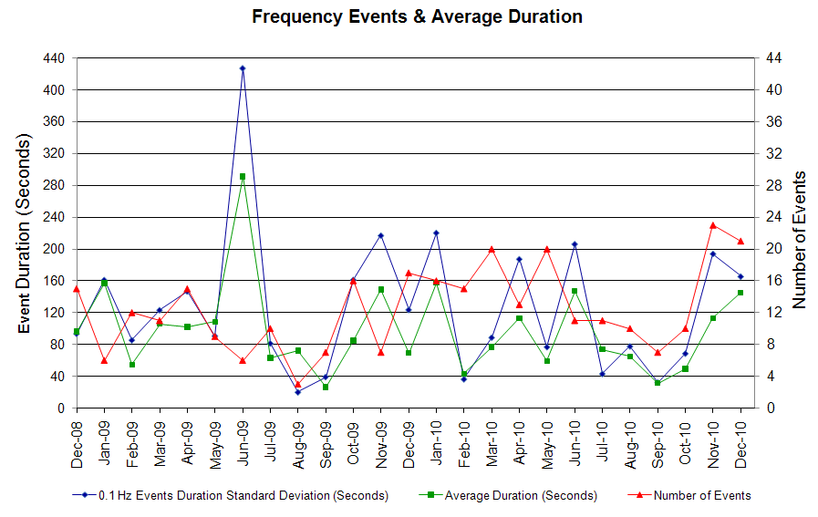

Deployed Responsive (Reported Above)
Time deployed | Stop Time | Duration | Max | Details
12/21/10 22:05:02 | 12/21/10 22:12:07 | 0:07:05 | 290.3

RUC Capacity Purchases
Details | Unit Days
COAST | 8
EAST | 3
FAR WEST | 56
NORTH CENTRAL | 4
SOUTH | 13
SOUTH CENTRAL | 13
WEST | 1
Grand Total | 98

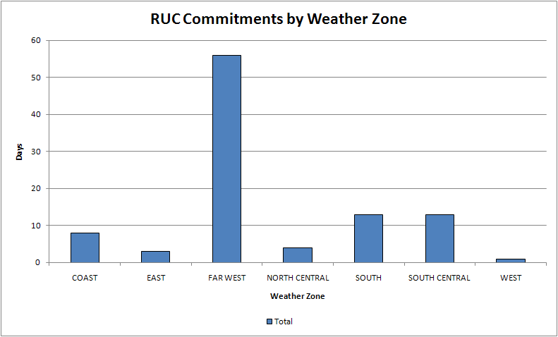

SCED Congestion Management Activity Congestion affected by outages
Remedial action plan has been developed for the element
Contingency | Overloaded Element | Days
Moss Switch - Holt Switch 138kV | Odessa North - Odessa Basin Switch 138kV | 14
W.A. Parish - O'brien 345kV | Garrott - Midtown 138kV | 6
Basecase | Syntex - Syntex Tap 69kV | 5
Basecase | Matador - Paducah 69kV | 4
Basecase | Naval Base - North Padre 69kV | 4
Basecase | Golden Switch - Brand TU 138kV | 3
Basecase | Spur 138/69kV AXFMR1 | 3
Willow Valley Switch - Bluff Creek Switch 138kV | Ackerly Vealmoor Sw - Ackerly 69kV | 3
Cagnon - Marbach 138kV | West Side - Five Points 138kV | 3
Basecase | Nelson Sharpe PS | 2
Basecase | Notrees - Notrees Switch 138kV | 2
Basecase | Victoria - Thomaston 138kV | 2
Basecase | Odessa North 138/69kV AXFMR1 | 2
Hearne 138/69kV AT1 | Hilltop Lakes 138/69kV AT1 | 2
Airline - Westside 138kV | Nelson Sharpe PS | 2
Cagnon 345/138kV AXFMR3 | Med Center - Hamilton Wolfe 138kV | 2
Willow Valley Switch - Lamesa 138kV | Ackerly Vealmoor Sw - Ackerly 69kV | 2
Garfield - Hicross & Onion - Pilot Knob 138kV | Garfield - Onion 138kV | 2
Basecase | Barney Davis - Woolridge 138kV | 1
Austrop - Sandow Switch 345kV | Gilleland - McNeil LCRA 138kV | 1
Basecase | Round Rock - Round Rock NE 138kV | 1
Aspermont - Spur 138kV | Matador - Paducah 69kV | 1
China Grove Switch - Snyder 138kV | Golden Switch - Brand TU 138kV | 1
Lamesa - Andrews North 138kV | Stanton Switch - Midland East 138kV | 1
Bell County - Temple Switch 138kV | Seaton 138/69kV AT1 | 1
Moss Switch - Odessa EHV Switch 138kV | Holt Switch - Ector Shell Tap 69kV | 1
China Grove Switch - Morgan SES 138kV | China Grove Switch - Morgan SES 138kV | 1
STP - Whitepoint & Hillje 345kV | Blessing - Lolita 138kV | 1
Austrop - Lost Pines 345kV | Salem 345/138kV AT3 | 1
Barney Davis - Airline & Rodd Field 138kV | Nelson Sharpe PS | 1
Graham SES - Long Creek & Cook Field 345kV | Murray - Paint Creek 138kV | 1
Nueces Bay - Koch Upriver & Lon Hill 138kV | Hiway 9 - Air Liquid AEP 69kV | 1
Basecase | McKenzie - Westside 138kV | 1
Watermill - Tricorner & Trinidad 345kV | Trinidad 345/138kV AXFMR6 | 1
Pearsall - San Miguel 138kV | Pearsall - Big Foot Sub 69kV | 1
Basecase | Pearsall 138/69kV AXFMR4 | 1
Cagnon - Calaveras & Braunig 345kV | Med Center - Hamilton Wolfe 138kV | 1
Garfield - Onion & Hicross 138kV | Lytton Springs - Pilot Knob 138kV | 1
Farmersville - Monticello SES 345kV | Monticello SES - Monticello Mining 138kV | 1
La Palma - Laureles 138KV | La Palma - Villa Cavazos 138KV | 1

Generic Transmission Limits (GTL’s)
GTL | Days
West – North | 25
Valley Import | 1

New RAP, PCAP (Date indicates last update of RAP, PCAP not implementation date.)
None

SPS (RAS) (New, Modified, Removed)
Stanton Modified
Mount Enterprise Energized (Dec 13)
Stryker Creek Approved not energized

New Procedures/Forms/Operations Bulletins
Date | Subject | Bulletin No.
12/15/2010 | Nodal Resource Desk V1 Rev2 | 513
12/15/2010 | Nodal Real Time Desk V1 Rev2 | 512
12/15/2010 | Nodal Transmission and Security Desk V1 Rev2 | 511
12/15/2010 | Nodal Reliability Unit Commitment Desk V1 Rev2 | 510
12/01/2010 | Nodal Transmission and Security Desk V1 Rev 1 | 509
12/01/2010 | Nodal Shift Supervisor Desk V Rev 1 | 508
12/01/2010 | Nodal Resource Desk V1 Rev 1 | 507
12/01/2010 | Nodal Reliability Unit Commitment Desk V1 Rev 1 | 506
12/01/2010 | Nodal Real Time Desk V1 Rev 1 | 505
12/01/2010 | Nodal DC Tie Desk V1 Rev 1 | 504

Load Shed Incidences
None

EEA
None

System Voltage Problems
None

Application Issues
12/10 19:39 ERCOT declared an Emergency due to the failure of the SCED process.

12/11 20:40 ERCOT declared an Emergency due to the failure of the SCED process.

12/27 05:45 ERCOT declared an Emergency due to the failure of the SCED process, starting at 16:55

Communication Issues
None

ERCOT peak (Unofficial)
12/13 08:00 44,376 MW

Yearly MTLF Error Comparison
Yearly Mid-Term (Hourly) Load Forecast Error Comparison for the ERCOT Forecast
Month | MAPE for MTLF at 16:00 Day-Ahead
Month | 2007 | 2008 | 2009 | 2010
January | 4.55 | 3.30 | 4.11 | 3.78
February | 3.75 | 3.59 | 3.49 | 3.79
March | 2.70 | 3.29 | 3.24 | 2.24
April | 3.00 | 2.45 | 2.66 | 2.47
May | 3.22 | 3.01 | 2.90 | 2.63
June | 4.46 | 2.81 | 2.89 | 2.84
July | 4.29 | 2.55 | 2.83 | 2.39
August | 3.11 | 3.66 | 3.07 | 2.29
September | 3.78 | 4.99 | 3.68 | 3.14
October | 3.08 | 2.79 | 2.92 | 2.37
November | 2.95 | 2.60 | 1.93 | 3.46
December | 3.74 | 4.54 | 3.70 | 2.60
Annual Average | 3.55 | 3.29 | 3.11 | 2.83

OCN, Advisory, Watch & Emergency Notices
Capacity
Date | Start | Event
12/4/2010 | 17:53 | ERCOT issued an Advisory due to Physical Reserve Capability (PRC) below 3000 MW.
12/5/2010 | 5:30 | ERCOT issued an Advisory due to PRC below 3000 MW.
12/6/2010 | 17:57 | ERCOT issued an Advisory due to PRC below 3000 MW.
12/9/2010 | 21:12 | ERCOT issued an Advisory due to PRC below 3000 MW.
12/10/2010 | 5:10 | ERCOT issued an Advisory due to PRC below 3000 MW.
12/12/2010 | 19:30 | ERCOT issued an Advisory for PRC below 3000 MW.
12/15/2010 | 16:44 | ERCOT issued an OCN for projected reserve capacity shortage for HE 1900-2100.
12/15/2010 | 17:44 | ERCOT issued an Advisory for PRC below 3000 MW.
12/16/2010 | 11:01 | ERCOT issued an Advisory for PRC below 3000 MW.
12/18/2010 | 5:10 | ERCOT issued an OCN for a projected reserve capacity shortage for HE 10:00 -13:00.
12/21/2010 | 2:11 | ERCOT issued an OCN for a projected reserve capacity shortage for H.E. 1200 - 1500 and 1800 - 2200
12/21/2010 | 9:45 | ERCOT issued an Advisory for PRC below 3000 MW.
12/22/2010 | 11:06 | ERCOT issued an Advisory for PRC below 3000 MW.
12/23/2010 | 2:46 | ERCOT issued an OCN issued for projected reserve capacity shortage for HE 11:00.
12/23/2010 | 4:20 | ERCOT issued an Advisory for PRC below 3000 MW.
12/25/2010 | 6:57 | ERCOT issued an OCN for projected reserve capacity shortage for H.E. 1100 and 1200 and 1900 through 2300.
12/25/2010 | 18:39 | ERCOT issued Advisory due to PRC below 3000 MW.
12/26/2010 | 0:07 | ERCOT issued an OCN for projected reserve capacity shortage for hrs 09:00 - 1400.
12/30/2010 | 9:30 | ERCOT issued an Advisory for PRC below 3000 MW.
12/31/2010 | 10:07 | ERCOT issued an Advisory due to PRC below 3000 MW.
12/31/2010 | 16:20 | ERCOT issued an OCN for projected reserve capacity shortage for HE 19-20.

Transmission Watch
None

Emergency Notice
12/10 19:39 ERCOT declared an Emergency due to the failure of the SCED process.

12/11 20:40 ERCOT declared an Emergency due to the failure of the SCED process.

12/27 05:45 ERCOT declared an Emergency due to the failure of the SCED process, starting at 16:55

Texas RE Event Analysis
12/11 23:38 Simultaneous loss of multiple units for a total of 1071 MW of generation caused a frequency deviation of 0.251 Hz (59.749 Hz) and the deployment of 203 MW of Hydro supplying Responsive Reserve. System frequency recovered to 60 Hz in approximately 6 minutes and 56 seconds.

12/14 06:17 Monticello Mining SPS #25 activated. There is no evidence that the Monticello Mining SPS #25 SPS failed to operate as designed.

12/19 08:06 Monticello Mining SPS #25 activated. Still under investigation.

12/30 07:07 Stanton Switch Station SPS #46 activated. Still under investigation.

Others
None

