
Texas Nodal Market Guide
Version 3.0
1-Dec-10

Document Revisions
Date | Version | Description
1/22/01 | V1.2 | A major revision that updates the Guide to current specifications and ERCOT Protocols. Updated sections on market operations, data aggregation, settlements.
11/25/02 | V2003.1 | Updated V1.2 to reflect current operations and changes in protocols to be in effect as of 1/1/2003.
7/26/04 | V2004.1 | Updated competitive metering language – Beginning in 2004, competitive metering is limited to meter ownership
1/1/05 | V2005.1 | Updated to reflect ERCOT market as of January 05
6/11/08 | V2.01 | Update market guide for nodal market.
12/1/2010 | V3.0 | Completion of upgrade for Nodal Market

Document Approvals
Date | Approved By | Approval Documented In (select)
 | <Name>  <Role> | ___ Approval email on file  ___ Signature

Table of Contents
1. Purpose 2
2. Introduction 2
2.1. Overview of ERCOT 2
2.2. History of Events Leading to Today’s Nodal Wholesale Market Design 3
2.3. Market Design Overview 5
2.4. Overview to This Guide 6
3. Current Market Design 7
3.1. Network Models 7
3.2. ERCOT Market Structure 8
3.3. ERCOT Market Participants 10
4. Important Concepts 12
4.1. Congestion, Locational Marginal Pricing (LMP), and Congestion Rent 12
4.2. Types of Congestion Revenue Rights (CRRs) 13
4.3. Settlement Points 14
4.4. Ancillary Services 14
5. ERCOT Key Processes 17
5.1. Registration and Compliance 17
5.2. Network Modeling 18
5.3. CRR Auction 18
5.4. Day-Ahead Market 19
5.5. Reliability Unit Commitment 21
5.6. Adjustment Period 22
5.7. Real-Time Operations 23
5.8. Data Acquisition, Load Profiling, and Aggregation 25
5.9. Settlements and Billing 27
6. Market Participant Qualification 29
6.1. Registration and Qualification Process Summaries 29
6.2. Interface Summary 31
6.3. Education 32
7. Appendices 33
7.1. Customer Switch Request processing 33
7.2. Definitions, Acronyms, and Abbreviations 34

Purpose
This document is intended as an overview of the ERCOT Nodal Market. AS such it is a high level description of the structure and components of the market and is not intended as a replacement for the Protocols and Guides that govern the operation of the Market Participants and ERCOT.

Introduction

Overview of ERCOT
The Electric Reliability Council of Texas (ERCOT) is one of 10 regional reliability councils in the North American Electric Reliability Council (NERC), as shown on the map below.

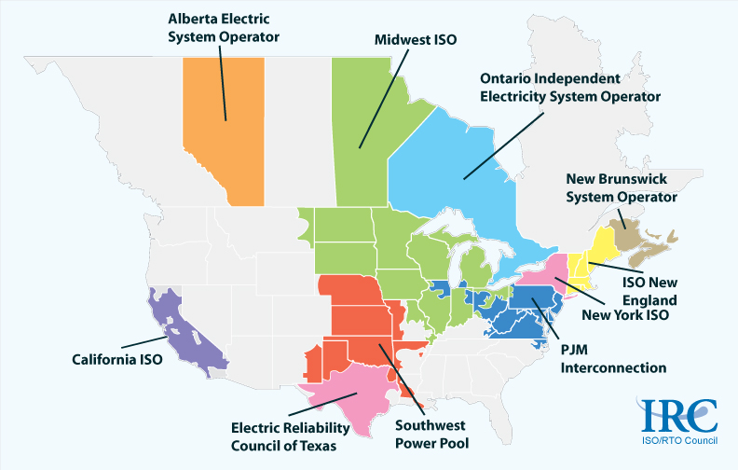

Figure 1 - ISO/RTO in North America

The ERCOT Independent System Operator (ISO) is the independent, not-for-profit 501(c)(4) organization responsible for the reliable transmission of electricity across Texas' interconnected 40,000+ mile power grid. The ERCOT grid is an electrical island because ERCOT is not synchronously connected to its neighboring grid systems; the only connection between the ERCOT grid and its neighboring electrical systems is via direct current (DC) ties.

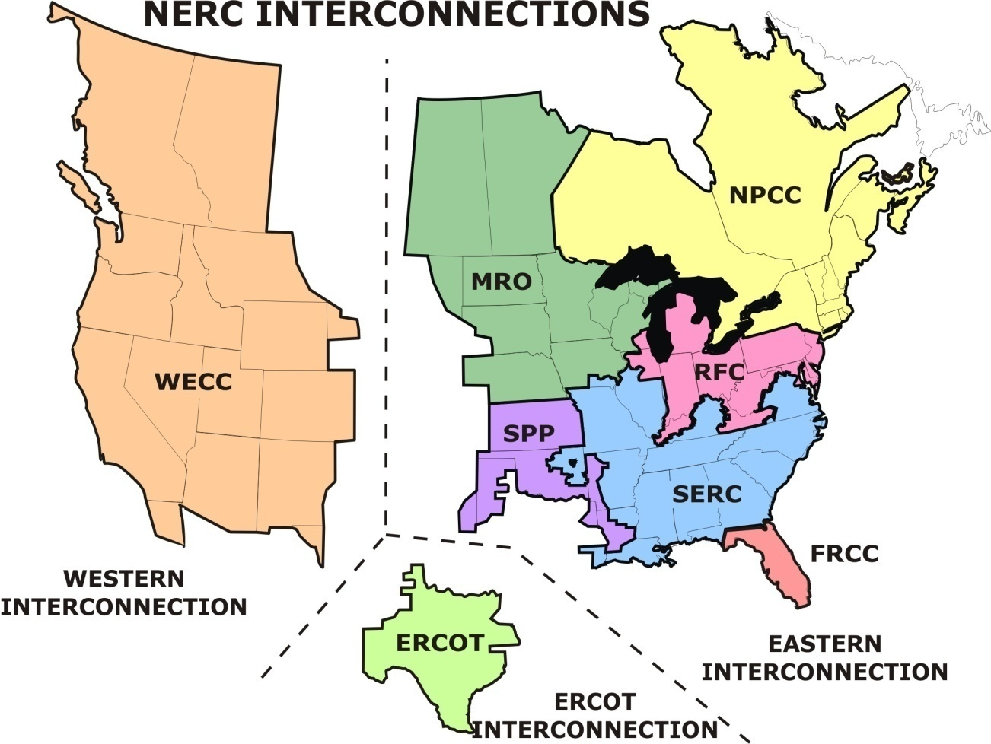

Figure 2 - North American Reliability Council (NERC) Interconnections

The ERCOT ISO shares responsibility for reliable power grid operations in the ERCOT region jointly with the electrical energy industry organizations that operate within that region. ERCOT ensures open access to transmission and distribution systems in areas that permit competition, the timely conveyance of market information to market participants, and accurate accounting of power produced and delivered. To do this, the ERCOT ISO focuses on the development, implementation, and ongoing management of reliable market and operating systems, transmission planning, retail mechanics supporting retail choice, accountable and reliable wholesale settlement and billing systems, and financial risk strategies.
ERCOT members serve about 85% of the electrical load in Texas, and have an overall generating capacity of approximately 77,000 Megawatts (MW) from more than 550 generators. Because ERCOT is located entirely within Texas, the Public Utility Commission of Texas (PUCT) is the principal regulatory authority. ERCOT's members include retail consumers, investor-owned utilities, municipally-owned utilities, rural electric cooperatives, river authorities, independent generators, power marketers and retail electric providers.

History of Events Leading to Today’s Nodal Wholesale Market Design
Since 1970, ERCOT's primary role has been to coordinate electric power transfers among members and ensure electricity transmission reliability. Several times since its origin, ERCOT's duties have grown to accommodate the changing needs of Texas' electricity industry.
ERCOT role expanded to include overseeing the transactions related to the restructuring of the electric industry, including the development and effective operation of the majority of Texas' competitive retail market. ERCOT is the central controller of the majority of the energy market's activities, including power scheduling, power operations, and retail market data transactions between retailers and wire companies.
In 1995, the market became more competitive when the Texas State Legislature amended the Public Utility Regulatory Act to deregulate the wholesale generation market. ERCOT enabled this change and increased electric transmission system efficiency for all market participants. ERCOT restructured its organization and initiated operations as a not-for-profit Independent System Operator (ISO) on September 11, 1996.
The Texas State Legislature passed Senate Bill 7 (SB7) in 1999, which initiated a series of events that changed how the electrical energy industry operates in the state. The objective of the bill was to make the price of energy more visible, provide more choice for customers, and create an environment that is conducive to innovation and new business opportunities. Major impacts of SB7 included:
- Functional unbundling of generation, transmission and/or distribution, and retail functions by creating a separate Power Generation Company (PGC), a Transmission and/or Distribution Service Provider (TDSP), and a Retail Electric Provider (REP)
- Continuing to regulate Transmission and/or Distribution Service Providers (TDSPs), although in 2004, some commercial and industrial customers in areas were opened to retail competition were eligible for competitive meter ownership
- Limiting PGC ownership of installed capacity to not more than 20% of the ERCOT or any other Texas power region
- Requiring REPs of an Investor Owned Utility (IOU) to offer residential and small commercial customers in its affiliated TDSP’s service area a “price to beat.” The “price to beat” is six percent lower than the rate charged by its affiliated electric utility on January 1, 1999 (excluding fuel).
- Making provisions for municipally owned utilities and electric cooperatives to opt out of retail competition and retain their existing service territories and bundled organizations.
On July 31, 2001, the ERCOT system was consolidated into a single control area from the former 10 control areas in the ERCOT region, and began operations of centralized power scheduling for wholesale electricity market transactions. ERCOT began procuring the necessary ancillary services to fulfill its reliability role.
Starting January 1, 2002, customers are allowed to choose their retail electric providers. Those served by investor owned utilities were automatically eligible to participate in the new market. Customers of Municipally Owned Utilities and Cooperatives were given the opportunity to also participate in retail competition if their governing bodies chose to do so.
In September 2003, as part of Project 26376, the Public Utility Commission of Texas (PUCT) ordered ERCOT to develop a nodal wholesale market design. The nodal market design introduces more precise assignment of congestion costs, resource-specific security-constrained economic dispatch, an energy and ancillary service capacity co-optimized day-ahead market, and increase transparency of energy prices from Locational Marginal Pricing (LMP) technology, thereby enhancing reliability and increasing market efficiency.

Market Design Overview
This section provides summaries of the wholesale and retail markets. Further details for this section are given in the body of this document.
The wholesale Nodal Market is built upon ERCOT’s function as an ISO and as a facilitator of open electricity markets. The market is based on management of congestion on the transmission grid consisting of more than 4000 nodes, or points of transmission system interconnection, which will result in over 4000 Locational Marginal Prices (LMPs). LMP is the offer-based marginal cost of serving the next increment of Load at a given network node. Because of this 4000 point granularity, the ERCOT LMP market provides a high level of market transparency, with directly observable consequences of market behaviors.
The Nodal Market also directly assigns local congestion costs and improves dispatch efficiencies by calculating resource-specific instructions. Congestion costs, or how much “extra” money was paid to generators due to congestion, are calculated by taking the difference between the payments made to generators with congestion (actual conditions) and what it would have cost if no congestion existed.
Because LMPs may be volatile due to changes in supply and demand, weather conditions, unanticipated outages or other changes in grid network topology, the nodal market offers financial instruments to mitigate risk. Congestion Revenue Rights (CRRs) entitle the CRR Owner to receive or be charged congestion rents that ERCOT collects. Participants in the CRR markets, who are not necessarily suppliers or purchasers of physical energy, may purchase CRRs through annual or monthly auctions, or through trading with other CRR holders.
ERCOT runs a Day-Ahead Market (DAM) to co-optimize supply and demand for energy, Ancillary Services (AS), and certain types of CRRs. This ensures energy and services for the following day and establishes prices. This market is financially binding, not physically binding.
During Real-Time Market (RTM) operations, ERCOT executes Load Frequency Control (LFC) and Security Constrained Economic Dispatch (SCED), issues resource-specific Base Points, and posts market information required by the protocols on the Market Information System (MIS).
The Congestion Revenue Right (CRR) Auction, the Day-Ahead Market (DAM), and the Real-Time Market (RTM) are settled separately in the Nodal Market using different settlement timelines.
The Retail Market is defined by areas served by transmission and distribution utilities. These areas are either open to retail competition or are “opted out”. The areas in competition require that end-user load be represented by independent identification that is accessible to competitive retailers who vie for providing the power across the local distribution utilities’ systems. The local distribution utility is the keeper of this independent identification or electric service identification (ESI ID). The ESI ID represents the location, ownership, type of electric service for a premise whether a residential dwelling, commercial or industrial business, or governmental institution or facilities. The local distribution utility must keep the ESI ID information current and available to competitive retailers. The ESI ID and the standard of data transaction across all distribution utilities in competitive areas are the basis for competitive retail market functions.

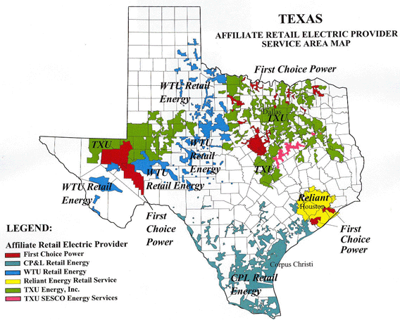
Figure 3 – Competitive Areas in Texas

Areas without competition remain as fully integrated utilities. These entities, such as electric cooperatives and municipals, can open their areas to competition upon the action of their governing boards.
For detailed information regarding the retail market, please read the current Retail Market Guide, found on the ERCOT website.

Overview to This Guide
This guide provides an overview of how the Electric Reliability Council of Texas (ERCOT) performs its role in the competitive wholesale and retail electricity market. It is not intended to be a detailed comprehensive market document. The guide aims to be a starting point to gain an understanding of how the Texas competitive electric market operates, including the roles and responsibilities of ERCOT and the various participants. For detailed information and rules on how the ERCOT market operates the guiding documents are the ERCOT Protocols and Guides (available on the ERCOT website). The entire list of binding documents is posted on the website. It is assumed that readers have a basic understanding of electrical energy industry operations. The remaining sections of this guide contain.
- Current Market Design: A detailed description of the nodal network model.
- Important Concepts: An overview of the ideas necessary for understanding the ERCOT markets.
- ERCOT Key Processes: A description of the core business processes that ERCOT follows.
- Participant Qualification: An overview of the key requirements for organizations planning to participate in the Texas power market.

Current Market Design

Network Models
The ERCOT market uses a Network Operations Model, which represents the complete transmission grid as a set of more than 4,000 network nodes. A ‘network node’, or point of interconnection with the system, may be an energy source, sink, or switching station. The network model contains the physical characteristics, ratings, and operational limits of all the transmission elements within the ERCOT Grid. The nodal network concept is illustrated below.
Figure 4 - Texas Nodal Network Model

An accurate Network Operations Model is necessary in order to calculate accurate base points (a resource’s MW output level) and prices, and to build the Congestion Revenue Right (CRR) Network Model and the Planning Model. The Network Operations Model is posted using a Common Information Model (CIM) compliant format for Market Participants to download.
ERCOT plans the operations of the network on both a long-term and short-term basis. Long term planning is needed to accommodate topology changes in the nodal network, including those due to planned maintenance outages, new generation interconnections, and new transmission units. Long term planning is also required to contract Black Start generators, which can be started and synchronized without the support of the power grid in the event of widespread power black out. Short term planning for system operations is needed to support network topology changes due to planned outages and load forecasts, unplanned events including weather, and voltage profiles postings (“normal” desired voltage for a generation interconnection). Market Participants update the network model by submitting a Network Operations Model Change Request (NOMCR).
For the purposes of settling load, the Nodal Market utilizes for Competitive Load Zones. Each zone could is considered a single settlement point. The picture below shows the four load zones in Texas. This is discussed further in the section about Settlement Points.

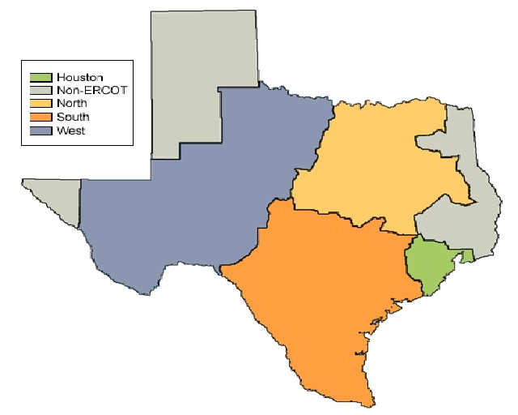
Figure 5 – Texas Zonal Model

ERCOT Market Structure
Congestion Revenue Rights (CRR) Market - ERCOT runs annual and monthly auctions to sell Congestion Revenue Rights (CRRs), which are financial instruments that hedge against congestion costs. CRRs can be acquired in several ways; through bidding in an auction, by direct allocation, or by trade either within or outside of the ERCOT system. Point-to-Point Obligations may also be purchased in the Day-Ahead Market.
The common way is through bidding in the monthly or annual auctions that offer available (unallocated) network transmission capacity. CRR Account Holders, who may be anyone except ERCOT, PUCT or TDSP staff, submit bid portfolios for CRRs by specifying the source and sink Settlement Points, MWs, and duration of the desired CRR. The auction is cleared by running a simultaneous combinatorial feasibility algorithm that uses the nodal network model and maximizes revenue with the constraint that all winners pay the same dollar amount per MW per hour for the same product.
Day-Ahead Market (DAM) ERCOT’s day-ahead operations run the day before the operating day; it is a financial, not a physical market that ensures reliability of the transmission grid. The Day-Ahead Market (DAM) allows Qualified Scheduling Entities (QSEs) to bid and/or offer energy and to offer Ancillary Services. Participants have an opportunity to purchase and/or sell energy even if they do not have resources or loads. Participation in the DAM is voluntary with the exception of election of ancillary service coverage of ERCOT allocation of obligations to QSE’s that represent load.
The DAM establishes the market value of the CRRs for CRR Account Holders who have CRRs. (NOIES may choose to offer certain types of CRRs for sale in the DAM.) Qualified Scheduling Entities (QSEs) can bid to purchase Point-to-Point Obligations in the DAM that settle in the Real-Time Market. Also during this period, ERCOT runs the Day-Ahead Reliability Unit Commitment (DRUC) study. This process ensures that there is sufficient generation capacity committed in the proper locations to reliably serve the forecasted load and forecasted transmission congestion by committing offline resources, if required.
Adjustments and Supplementary Ancillary Services Market (SASM) After day-ahead operations closes, an adjustment period begins to allow QSEs to submit new information, including energy offers and bids, output schedules and trades. Additionally, Transmission Service Providers (TSPs) may submit and/or update information related to forced outages.
During the Adjustment Period, ERCOT may execute a Supplemental Ancillary Services Market (SASM) to procure additional Ancillary Services. The SASM Market Clearing Prices for Capacity (MCPCs) are cleared in the real time market.
QSE proposed adjustment period changes that revoke commitment of resources will be evaluated and accepted or rejected by the Hourly Reliability Unit Commitment (HRUC) study, which uses the same algorithm as the DRUC but is run the hour before the operating period.
Real-Time Market (RTM) ERCOT controls the RTM by running a Security Constrained Economic Dispatch (SCED) at least every five minutes, using offers by individual resources and actual shift factors by each resource on each transmission element, while considering conditions on the transmission network. As the name implies, SCED determines the most economical dispatch of individual resources across the grid. The distinction between zonal and local congestion disappears as all congestion is managed using individual resources instead of portfolios.
There are several different algorithms used to settle the RTM depending on settlement point type. This is discussed in detail in the later sections of this document.
Competitive Retail Market A key feature of the ERCOT competitive retail electricity market is that it is based on “bilateral” transactions between buyers and sellers of energy. The picture below shows these market participants and their interactions.
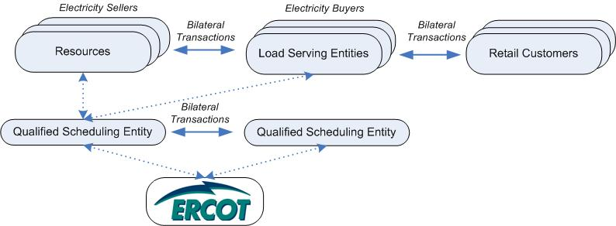

Figure 6 - Market Participant Bilateral Transaction and Information Exchanges

Load Serving Entities (LSEs) buying energy and Resources selling energy communicate operational information such as their bilaterally arranged schedules of loads and resources to ERCOT through their Qualified Scheduling Entities (QSEs). ERCOT ensures that the power grid can accommodate the schedules that were generated by the bilateral market.

ERCOT Market Participants
Any entity that engages in an activity described in the Nodal Protocols is a Market Participant, whether or not there is a signed ERCOT agreement. Market Participants (MPs) are required to demonstrate market readiness before participating in the market. To this end, ERCOT registers and communicates with the MPs, which include Qualified Scheduling Entities (QSEs) with and without resources, Resource Entities (REs), Load Serving Entities (LSEs), Transmission and Distribution Service Providers (TDSPs), and Congestion Revenue Rights Account Holders (CRR AHs). ERCOT also requires registration of Resource Assets belonging to the REs; but does not communicate with them directly, but through the QSE. Any of these roles can be held by either Non Opt-in Entities (NOIEs) or Opt-in Entities. The figure below illustrates the entities in the ERCOT region electricity market that must be registered to participate, other market entities, and the lines of communication between them.

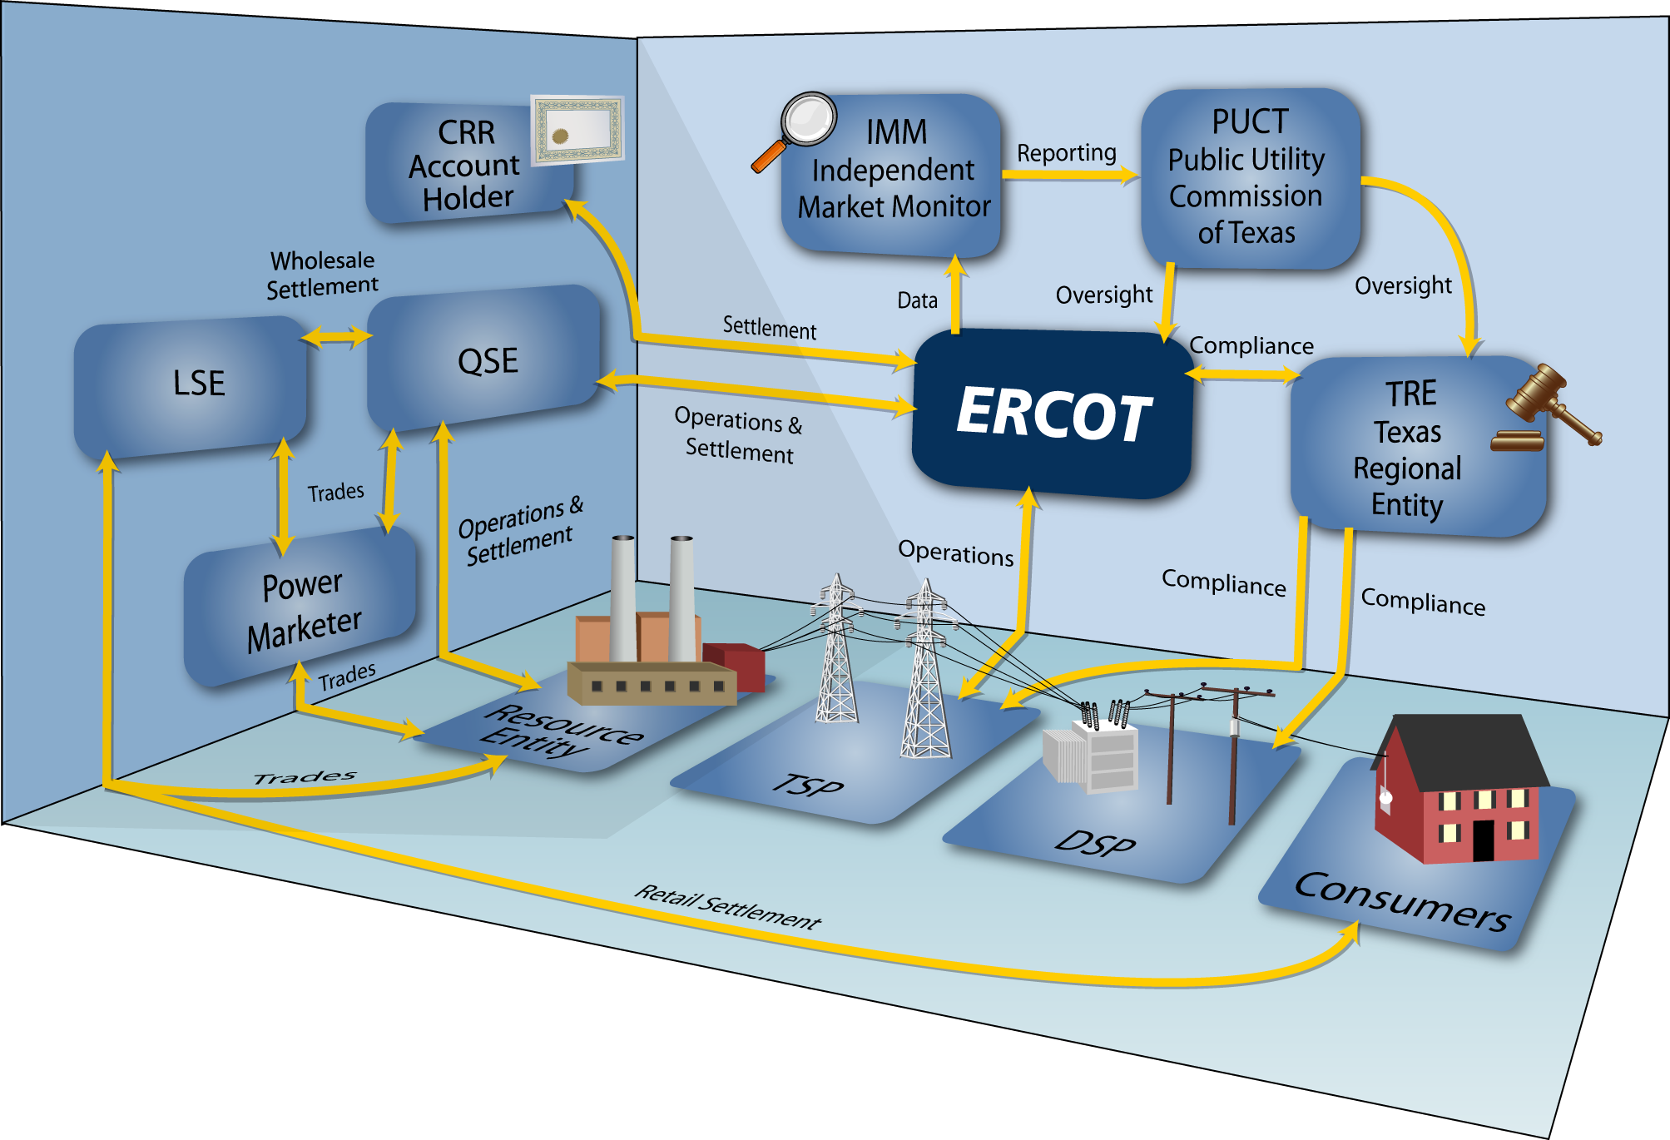
Figure 7 - ERCOT Competitive Market Participants and Their Interactions

The Market Participants represented in the diagram above are identified and described in the sections below.
Electric Reliability Council of Texas (ERCOT) performs the following major functions:
- Manages the flow of electric power to 22 million Texas customers – representing 85 percent of the state’s electric load and 75 percent of the Texas land area.
- As the independent system operator for the region, ERCOT schedules power on an electric grid that connects 40,000 miles of transmission lines and more than 550 generation units.
- Helps market participants plan and manage their competitive market operations effectively by giving them timely information like forecasts of weather, load, losses, and ancillary services requirements.
- Runs the CRR auctions, DAM, SASM, and Real Time markets, and works with QSEs to procure ancillary services in these markets, settles the markets and handles the billing.
- ERCOT also manages financial settlement for the competitive wholesale bulk-power market and administers customer switching for 6.5 million Texans in competitive choice areas.
- Works with TDSPs to manage the transmission system. TDSPs are also responsible for load and resource meters installation as well as submitting meter data for all loads and resource meters not directly polled by ERCOT.
- Runs the central premise registration system that facilitates the retail customer switching process by transmitting switch requests and meter consumption data between Competitive Retailers (CRs) and TDSPs and keeping track of the association between premises and load serving entities in the ERCOT centralized statewide registration system.
Counter Parties (CPs) - are legal business entities that sign the Standard Form Agreement (SFA) with ERCOT. A CP may register with ERCOT as any type of Market Participant (QSE, CRRAH, LSE, RE, TSP/DSP). A CP may have both QSEs and CPs registered with ERCOT. ERCOT calculates credit requirements at the CP level, therefore all credit requirements for all QSEs, sub-QSEs and CRRAHs under the CP will be aggregated at the CP level.
Qualified Scheduling Entities (QSEs) - are qualified by ERCOT to participate in the Day-Ahead and Real-Time Markets. QSEs may represent Load Serving Entities (LSEs), Resource Entities (REs), both or neither. Two levels of qualification exist for a QSE; (1) QSE with Resources and (2) QSE without Resources. QSEs are one of two entities that perform financial settlements with ERCOT. QSEs are responsible for submitting schedules to ERCOT on behalf of the entities they represent or any trades are accomplishing with another QSE. QSEs may also offer to sell energy, bid to buy energy or offer Ancillary Services to ERCOT.
During the real-time market, ERCOT procures and deploys energy from resource specific offers submitted by QSE’s for each 5 minute SCED interval. If ERCOT accepts an offer by a QSE, ERCOT pays the QSE as appropriate at the associated Settlement Point Price (SPP). QSEs can also offer into ancillary services markets from the resources in their portfolio. ERCOT reimburses the QSE at the associated Market Clearing Price for Capacity (MCPC) if ERCOT selects the offer. After the real-time market for energy is run, the financial settlement takes place between QSEs and ERCOT.
Load Serving Entities (LSEs) represent either Non Opt-in entities (NOIE) which are represented by wholesale delivery points or Competitive Retailers (CRs), which are the only organizations authorized to sell electricity to retail customers who have customer choice. CRs may be Retail Electric Providers (REPs) or Opt-in Municipally Owned Utilities or Cooperatives and are also registered with the Public Utility Commission of Texas (PUCT). The following picture describes the relationship between types of LSEs.

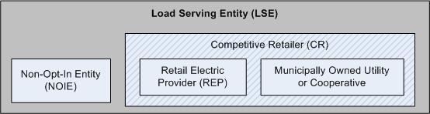

Figure 8 - Load Serving Entity Constituents

LSEs forecast their customer load and negotiate privately with other market participants, like resources or power marketers, to buy energy. LSEs communicate the resulting schedules to ERCOT through a QSE.
CRs interact directly with ERCOT when submitting switching requests, where customers choose a new CR. ERCOT processes the switching requests by working with TDSPs to obtain the initial and final meter reads, confirming switches with customers, and confirming the switch with the relevant CRs once the switch is approved. ERCOT also sends switch confirmation notices to consumers to help control “slamming” or unauthorized switching.
Transmission and/or Distribution Service Providers (TDSPs) provide the electricity transmission infrastructure and work with ERCOT to jointly manage the reliability of the transmission system. TDSPs are also charged with management of metering functions including meter reading activities. As of 2004, some commercial and industrial customers in areas open to retail competition are eligible for competitive meter ownership. ERCOT needs TDSPs to provide meter reading and consumption information in order to correctly settle energy and ancillary service markets.
Resource Entities (REs) negotiate privately with other market participants to sell their energy, and communicate the resulting schedules to ERCOT through their QSEs. These entities also own and/or operate generation or loads that provide ancillary services ERCOT needs to manage system reliability. The RE must register applicable Resource Assets with ERCOT in order to properly model, plan, dispatch, and settle wholesale transactions from these Resources.

Non Opt-In Entities (NOIEs) are Municipalities and Cooperatives. Municipally owned utilities and electric cooperatives have the right not to opt into retail competition and retain their existing service territories. Also, they are not required to functionally unbundle their organizations if they choose to opt in and participate as a Competitive Retailer (CR). They are allowed to continue bundled operations regardless of their choice to open their service areas to retail competition. While they remain opted-out, they do not need to submit switching requests to ERCOT because their customers do not have a choice of electric retailer.
However, these utilities participate in all the wholesale competitive market transactions, including acquiring energy through private bilateral transactions, and submitting balanced schedules for energy to ERCOT. NOIEs participate in the ERCOT market as any combination of QSE, LSE, RE and TSP/DSP as appropriate for their operations.
Congestion Revenue Rights Account Holders (CRRAH) are entities that are registered and qualified to become the owner of record of CRRs in the nodal market. A CRRAH is the only entity other than QSEs that financially settles with ERCOT. The CRR is a financial instrument that entitles the CRR owner to be charged or to receive compensation for congestion rents that arise when the ERCOT transmission grid is congested in the day-ahead market (DAM) or in certain circumstances, the Real Time Market (RTM). CRRs do not necessarily represent a physical energy resource or load.
CRRAHs bid for CRRs in annual and monthly auctions that ERCOT runs. They may also bilaterally trade awarded CRRs either within the ERCOT CRR system or outside it. Note that ERCOT does not track outside CRR trading and that the account holder of ERCOT record is still liable for the CRR.
Other Market Participants - Other participants may also operate in the ERCOT market.
- Power Marketers, who buy and sell blocks of energy, schedule that power with ERCOT through a QSE.
- Aggregators that acquire groups of retail customers may also operate in this market.
Note that these entities while recognized as players in the market, are not registered as ERCOT market participant perform no settlement or function directly with ERCOT.
Public Utility Commission of Texas (PUCT) oversees the entire market, including customer participation matters, and monitor market activity to deal with market abuses and gaming. The PUCT also hires the Independent Market Monitor (IMM) to oversee and review the functioning of the wholesale market.
Texas Reliability Entity (TRE) is charged with ensuring the reliability of the bulk power system in the Electric Reliability Council of Texas (ERCOT) region, Texas Reliability Entity, Inc. monitors and enforces compliance with reliability standards for the North American Electric Reliability Corporation; develops regional standards; and monitors and reports on compliance with the ERCOT Protocols.
For the market to operate reliably and efficiently, the various market participants need to work closely together and operate according to standard market rules or Protocols. A description of the ERCOT Protocols can be found on the ERCOT website.
NOTE: Not all processes needed to operate the competitive market are facilitated by ERCOT. For example, ERCOT does not provide a facility to bring buyers and sellers of energy together, and does not facilitate interactions between TDSPs and other market participants to support processes such as distribution outage management or TDSP retail meter services
ERCOT will continue to evolve as it modifies and refines its active role in the operation of the competitive retail market. The rest of the Market Guide is focused on how the ERCOT power market processes work, as well as the requirements for organizations wishing to participate through one or more of the roles described above.

Important Concepts

Congestion, Locational Marginal Pricing (LMP), and Congestion Rent
Congestion occurs in the transmission network when the transmission capacities at one or more facilities become fully utilized. (Note that capacity is based on operational security criteria “N-1”.) Congestive elements tend to interact with each other, so their costs must be analyzed in combination, which Locational Marginal Pricing (LMP) achieves.
The LMP calculation establishes a price per MW at a given network node based on the cost of delivering the next MW of energy to that node. For example, if there is a need for 10 MW at a network node, the LMP would be determined by the cost of delivering the 11th MW. LMPs will be the same throughout the system if no congestion exists. However, if congestion does exist, LMPs will differ from node to node. LMPs can be the same, higher or lower than a specific offer price at a given node.
Congestion Rent is the difference between the charges to the loads for the energy they use minus the payments to the generators for the energy they provide.
The following diagrams show examples of LMP calculations with and without congestion, and the associated rents that would be charged. Note that the actual paths between the generators and the load are unknown (represented by the star blotting the connecting paths for the nodes).

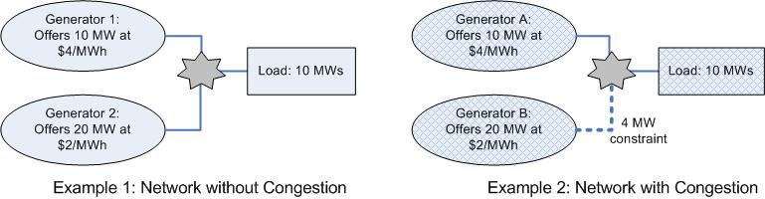

Figure 9 - Networks with and without Congestion

In example 1 (diagram on left), no congestion exists and Generator 2 has the lowest offer and can serve the entire load. Since LMP is calculated as the cost of the next MW needed and generator 2 can supply the next MW at $2, the LMP is $2/MWh. Because there’s no congestion on the network, the cheaper LMP of $2/MWh applies to all the nodes, and the 10 MW load costs $20.
In example 2 (diagram on right), congestion exists and Generator B is not fully utilized; there’s a constraint from Generator B and it can only serve 4 MWs. Now using MWs from the lowest priced generator cannot serve the entire load; 6 MWs must come from elsewhere, such as Generator A.
The LMP at Generator B is still $2/MWh, so for the 4MWs it supplies, $8 will be paid to Generator B. Generator A will supply 6 MW at $4/MWh, so it should receive a payment of $24. Because congestion exists between Generator B and the load, the two LMPs are different, and the more expensive generation cost of $4/MWh is used when charging the load for the 10MW; $40 is owed for the 10 MWs it used for an hour.
ERCOT will collect $40 from the load and distribute $32 to the generators; the remaining $8 would be paid to eligible CRR Owners as Congestion Rent.
Congestion Cost is defined as the difference between Congestion Rent and what would have been paid in an uncongested system (i.e., all the MWhs bought at the lowest rate). In the above example, it’s $32 (as calculated in example 2) - $20 (what was calculated in example 1) = $12. Congestion cost isn’t used in settlements; it’s used to determine how much ‘extra’ money is being paid due to congestion.

Types of Congestion Revenue Rights (CRRs)
ERCOT offers different types of CRRs as hedges against congestion costs, which are fully tradable with a few exceptions. CRRs are measured in tenths of MWs and in hour durations, and are either defined from nodal network source point to sink point (“Point-to-Point, or PTP”) or as a flowgate, which is a directional bundle of network elements. There are currently no flowgates defined .
Account holders can bid for PTP Options, which will only generate payments to the holder, or PTP Obligations, which can result in either a payment or a charge. NOIEs may choose receive PTP options and obligations with refunds, which they may not trade bilaterally.
Point to Point CRRs generate hourly revenue to the holder, calculated as the number of MW hours held times the difference between the LMPS at the sink and source nodes: Revenue = P_{crr} x [LMP_{sink} – LMP_{source}]. For option CRRs, if this number is negative, nothing is owed or paid. For obligations, a negative number means that the CRR holder owes the revenue to ERCOT. Because of this, obligation CRRs are generally expected to be less expensive to purchase than options.
To illustrate the benefits of owning CRRs, review example 2 of the network with congestion in the section above. Supposed a CRR had been purchased for 2MWs between generator B (the source) and the load (the sink). Using the formula above, the LMP_{sink} - LMP_{source} x MW of CRR = ($4 - $2) x 2 = $4 owed to the CRR holder. Remember $8 of congestion rent was collected, with covers the $4 due. If the load in the example owned that CRR, the income from it would help offset the ‘extra’ $20 paid because of congestion.

Settlement Points
There are three types of settlement points in the nodal market; Resource Nodes, Load Zones, and Hubs. Locational Marginal Pricing, explained above, is used to calculate the settlement point prices at every node. Fundamental difference in LMP’s between Day-Ahead Market and Real-Time Market is interval of calculation; DAM performed on an Hourly basis and RTM on approximately 5 minute basis and weighted to a 15-minute settlement price.
A Resource Node’s settlement point price is based on the LMP at a specific bus location associated with the measured output of a Resource. Real-time Settlement Point Prices are calculated for each 15 minute settlement interval. Since LMPs are calculated for every SCED execution (at least every 5 minutes), the Real-Time Settlement Point Price for a Resource node is the base-point time-weighted average of the Real-Time LMPs within the settlement interval.
A Load Zone’s settlement point price is calculated using the Load-weighted average of the LMPs at all nodes assigned to that Zone. In Real-Time Settlements, the LMPs will also be time-weighted. This applies to all three types of load zones: competitive load zones, NOIE load zones, and DC tie load zones.
A Hub’s settlement point price is the simple average of the hub buses LMPs. In Real-Time, the LMPs will also be time-weighted. Hubs consist of Hub Buses, which are one or more electrical buses within a single substation. They are defined by the zonal protocols, may only be changed by amending the protocols, and are used for trading purposes.

Ancillary Services
As operator of the single control area, ERCOT is responsible for ensuring that the right amount of generation is available to service the system load and that there is sufficient transmission capacity to deliver the power to where it is needed.
ERCOT relies on the availability of generation capacity to provide energy to maintain the electric system within allowable reliability limits. Capacity and energy procurement, needed by ERCOT to perform reliability role, are competitively procured from Qualified Scheduling Entities (QSEs) on a Resource specific basis. Generation units that can be on standby and available to be called upon to provide energy or loads that are available to be interrupted to relieve the need for additional energy may provide these services upon meeting ERCOT qualification requirements. These services sourced from generation or load resources and provided to ERCOT to ensure reliability are called “ancillary services”. Types of ancillary services are discussed in more detail below.

Market supplied Ancillary Services
ERCOT publishes a Day-Ahead requirement for each of these ancillary services and allocates the requirement among all QSEs in the market, based on their historical load share. This is how ERCOT determines each QSE’s obligation to either self-provide or provide through the Day-Ahead AS Market.
QSEs indicate the amounts of ancillary services that they intend to self-arrange through their own resources and/or through a bilateral trade. When ERCOT has validated and processed these schedules, the aggregate amount of self-provision is calculated. Hence the remainder, which ERCOT must procure, can be determined. ERCOT notifies the market of this shortfall in ancillary services.
ERCOT then receives offers from QSEs, qualified to provide ancillary services, for one to all four of the services. ERCOT’s market operations system “stacks” these bids in merit order and establishes a Market Clearing Price at the bid price of the last bidder needed to purchase the required amount of each ancillary service. The Day-Ahead market process clears offers for Ancillary Services simultaneously with Energy Offers. This process is called co-optimization.
QSEs can submit offers in which the same capacity is offered into more than one of these markets. Capacity which is not selected for one service is then assumed by ERCOT to be available for another
Regulation Reserve This is generating capacity that can follow instantaneous load changes to maintain system frequency, providing energy in response to electronic signals sent by ERCOT within predetermined limits according to the Operating Guides. ERCOT is required to evaluate normal requirements for Regulation Service – Up (regulation up) and Regulation Service – Down (regulation down) on an annual basis. It is ERCOT’s intent to use historical rates of Regulation Service usage to perform this evaluation. Regulation Service is deployed in order to correct actual frequency to scheduled frequency. This normal Regulation Service requirement may be increased by a multiple of two (2) during projected severe stress conditions such as forecasted extreme weather days.
To evaluate Regulation Service requirements, ERCOT collects monthly historic deployed Regulation Service data. This data is used to calculate average historically deployed Regulation Service for one-minute periods. By calculating the 98.8 percentile of the amounts of deployed regulation up and deployed regulation down by hour, ERCOT will estimate the expected needs for similar months.
ERCOT provides the mathematical expectation that sufficient Regulation Service will be available 98.8% of all periods. This implies that 1.2% of every month, or 35 intervals/month; ERCOT expects to exhaust available Regulation Service and will perform a back-cast of last month’s actual exhaustion rate. If the exhaustion rate exceeded 1.2% in any given hour, ERCOT will determine the amount of increase necessary to achieve an exhaustion rate of 1.2 % for that hour.
Responsive Reserve (RRS) This is generating capacity or interruptible load that will automatically produce or stop producing energy when frequency drops due to a system disturbance such as a unit trip. The ERCOT Operating Guides set the minimum RRS requirement at 2300 MW for all hours under normal conditions. The Operating Guides allow ERCOT to increase that requirement under extreme conditions. ERCOT will increase the amount of RRS purchased for Hour Ending 0700 through Hour Ending 2200 by linking the amount of RRS to a day-ahead forecast of the RDF. ERCOT will use the higher of the hourly forecast temperature for North Central or the Coastal weather zone to predict the amount of RDF to apply in real-time. For each hour in which the RDF is projected to be greater than 2%, ERCOT will adjust the Day-Ahead hourly RRS obligation upward by 100 MW per percentage point. ERCOT will not adjust the RRS requirement below the minimum RRS requirement set forth in the ERCOT Operating Guides nor greater than 500 MW more than the minimum RRS requirement in the ERCOT Operating Guides. The 2300 MW requirement was derived based on studies done in the past to determine the amount of Responsive Reserve that might be required to prevent the shedding of firm load upon the simultaneous loss of the two largest Generation Resources in the ERCOT Region.
One type of Responsive Reserve is Interruptible Responsive Reserve. Interruptible Responsive Reserve is Load Acting as a Resource (LaaR) that is automatically interrupted when system frequency decreases to 59.7 Hz. The total amount of LaaR procured for RRS during any given hour will be limited to 50% of the RRS requirement for that hour. The limit therefore will range between 1150 MW and 1400 MW. The ERCOT Protocols state, “The amount of Load Resources on high-set under-frequency relays providing RRS is limited to 50% of the total ERCOT RRS requirement. ERCOT may reduce this limit if it believes that this amount will have a negative impact on reliability or if this limit would require additional Regulation to be deployed”, as prescribed in section 3.16, Standards for Determining Ancillary Services Quantities.
Non-Spinning Reserve Non-Spinning Reserve Service (NSRS) consists of off-line resources capable of being ramped to a specified output level within thirty (30) minutes or Loads acting as a Resource that are capable of being interrupted within thirty (30) minutes and that are capable of running (or being interrupted) at a specified output level for at least one (1) hour. NSRS may be deployed to replace loss of generating capacity, to compensate for load forecast and/or wind forecast uncertainty on days in which large amounts of reserve are not available online or when 95% or more of Real-Time Capacity Sufficiency available to the market is projected to be used.

ERCOT Procured Services
These services deployed by ERCOT as the result of contracts with the specific resource or direct deployment at the request of a TDSP.
Black Start units are generators that are capable of being started and synchronized without the support of the power grid. They are needed in the event of widespread power black out. Procurement of Black Start service occurs on a two year basis. Bidders respond to a Black Start request for proposal posted by ERCOT. The bids are evaluated and awarded according to location on the transmission grid and price. The awarded entities then must complete a 24-month contract and complete black start testing prior to the start of the next contract period. Black start readiness monitored on a daily basis and the payment to the providers is based on the availability of the contracted resources. Black start training is also integrated on an annual basis.
Reliability Must-Run (RMR) Units are those generators that ERCOT retains to dispatch power for the purpose of voltage support or for stability or reliability, which would otherwise not be an active resource in the ERCOT market. These generators are called on to resolve local system reliability issues due to lack of primary market resources in their area. The Reliability Must-Run (RMR) resource is contracted either through an action by ERCOT to petition a resource owner of the idle generator or the resource owner petitions ERCOT to consider an idled resource to provide RMR service. The RMR contract is for 12-months with a 90-day notice of termination at which point ERCOT re-assesses the need for the idled resource if required.
Voltage Support Service (VSS) is provided by specific units to maintain transmission and distribution voltages on the power grid within acceptable limits. Currently, resource providers are deployed to provide voltage support via an out-of-merit capacity deployment and compensated only for service over and above what the Resource is required to provide at nominal operations.
Emergency Interruptible Load Service (EILS) is provided by qualified loads that make themselves available to be interrupted in the case of an electric grid emergency. This service is designed to reduce the likelihood of the need for firm load shedding (a.k.a. “rolling blackouts”). Loads that are qualified are bid into a Request for Proposal process run by ERCOT to procure EILS.

ERCOT Key Processes
ERCOT is continuously performing key processes that support the wholesale and retail markets, which are ensuring Registration and Compliance, Network Modeling, Operations Systems Planning, CRR Auctions, Day Ahead Market, Adjustment Period, Operating Period, Data Acquisition and Aggregation, and Settlements and Billing. These processes are executing almost continuously, but they can be viewed in a linear fashion. The picture below lists the key processes in approximately time order.

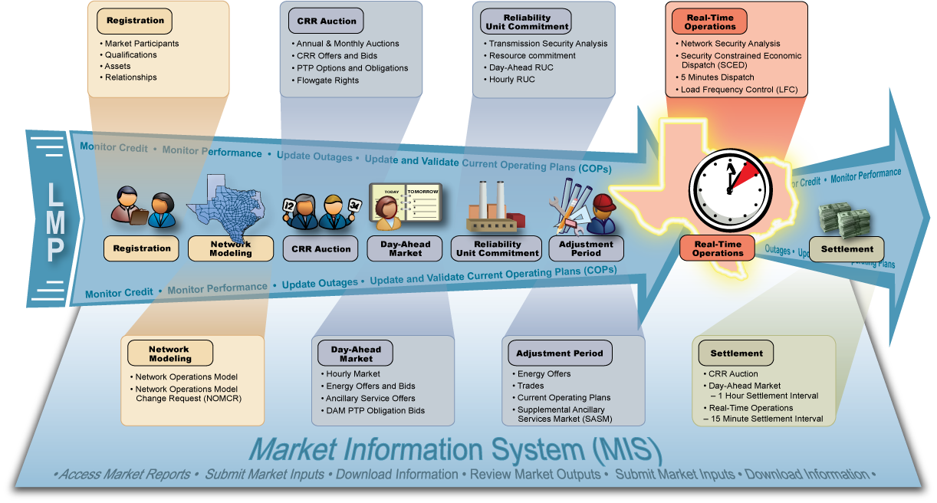

Figure 10 - ERCOT Key Processes Flow Diagram

Each of the processes above is described in the following sections.

Registration and Compliance
The ERCOT protocols outline registration and qualification requirements that must be completed prior to participation in the market. In addition, Resource Entities must also register any generation and load resource assets they intend to operate in the market. ERCOT collects important operational parameters for assets such as generators and load resources needed for reliable operations and economic evaluation. During the registration process, ERCOT also captures relationships between market participants required for market participation. For example, all Load Serving Entities and Resource Entities are required to designate a Qualified Scheduling Entity that will represent them for operations and financial settlement. Please refer to the section above on market participants for details about the roles ERCOT recognizes.
The ERCOT centralized registration database also contains the information that ERCOT needs to facilitate the process of a customer switching CRs in support of retail competition. Please see the appendix for a description of how switching is performed.
Potential market participants must register well in advance of a market activity in which they wish to take part, may vary from 15 to 120 days depending on level of participation. This is because the registration process includes a rigorous qualification process that ensures that the candidate’s market systems interact properly with ERCOT’s, checking applicant’s credit, and verifying the potential MP can perform protocol required functions.
After registration, ERCOT and Market Participants will continue to be monitored in the Nodal Market. The Nodal Protocols have a dedicated section to compliance: Section 8: Performance Monitoring and Compliance.

Network Modeling
The Network Operation Model is another critical component of the ERCOT nodal market design. The Network Operation Model is representation of the ERCOT System that will provide ERCOT’s systems with critical information on the complete physical network definition, characteristics, ratings, and operational limits of all elements of the Transmission Grid. Network Modeling includes both long and short-term planning. Long-term planning focuses on Black Start contracts, topology changes, planned maintenance Outages, new generation interconnections, and planned transmission additions. Short-term planning focuses on Planned Outages, Voltage Profiles, unplanned events, short-term topology changes, current weather and Load forecasts.
ERCOT, Transmission Service Providers, Resource Entities and their QSEs will use a change management process called the Network Operations Model Change Request to submit, track and implement changes to the Network Model for use in activities ranging from planning to Day-Ahead and Real-Time Operations.

CRR Auction
By definition, the ERCOT nodal market provides more granularity into energy pricing through energy prices at each network node. The nodal market also features direct assignment of congestion costs to market participants. This means that each market participant‘s congestion costs are more directly proportional to the impact of each entity’s energy transactions on congestion. Along with direct assignment of congestion costs, the nodal market features Congestion Revenue Rights or CRRs, which are financial instruments that can be used as a hedge against congestion costs. ERCOT conducts annual and monthly CRR Auctions to offer market participants the opportunity buy and sell these financial instruments.
Before an auction is run, ERCOT allocates Pre-assigned CRRs and Flowgate rights. (Please see the Key Concepts section for details about the types of CRRs that are offered in the auctions.) Certain NOIES apply for eligibility to receive PCRRs from their lists of resource and load pairings that are eligible for PCRRs. They may nominate up to 100% of their contractual amount or net unit capacity (whichever is less) for refund type CRR, or up to 40% of the capacity factor for a capacity CRR. There is a published timeline for PCRR allocation activities, and a timeline for the percentage of allocated PCRRs that are released to the NOIEs prior to the corresponding monthly auction or daily market. When the PCRR clears, a percentage of the clearing price will be applied, depending on the type of CRR (option or obligation) and the type of resource (coal, gas, hydro, etc).
After the PCRRs and Flowgates are allocated, the annual or monthly CRR auctions are conducted as method of auctioning some of the remaining network capacity of the ERCOT Transmission System. The auction also allows CRR Holders an opportunity to offer for sale any CRRs that they currently hold. In an auction, a bid to buy represents a willingness to purchase a CRR at a “not to exceed” price. An offer represents a willingness to sell a CRR (or portion of CRR) at a ‘minimum reserve’ price.
There is a published timeline of activities for every auction. The activities include setting up the allocation market, accepting nominations, running the allocation market, allocating the Flowgates, posting the auction model, setting up the auction market, posting the notice, receiving bids and offers, optimizing the market and validating the results, then posting the market results and sending invoices to the winners.
In an auction, participants bid for the available pool of system CRR capacity, bidding for week day Times of Use (TOUs), weekends, or off-peak TOUs. For annual auctions where two years’ worth of capacity may be bid on, 55% of the network topology is released to the pool for the first year, and 15% for the second year. For monthly auctions, 90% of the network topology is made available. The size of the pool also reflects the amount of existing CRRs that were previously awarded in earlier auctions.
When optimizing an auction, ERCOT attempts to achieve simultaneous feasibility for the bids, and curtail the nominated CRRs as little as possible in proportion to their contributions to congestion. The optimization algorithm uses many inputs, including:
- The bids and offers for the current market,
- All previously awarded or allocated CRRs for market period,
- Expected configuration of Transmission Facilities including scheduled outages,
- Increased capacity of each element that has been oversold in prior CRR Auctions and CRR allocations to exactly match the amount of CRRs that have been sold or allocated on that element,
- Thermal operating limits (including estimates for Dynamic Ratings) for transmission lines,
- Voltage and stability limits that are valid for the study period converted to thermal limits represented as non-thermal/generic constraints
- ERCOT Transmission Grid pre-and post-contingency ratings
- List of transmission element contingencies expected to be enforced by ERCOT in Real-Time Operations
- Assumptions for selected RAPs (Remedial Action Plans) and SPSs (Special Protection Systems)
The CRR markets are based on the assumption that the Day Head Market’s net congestion revenue will be adequate to meet the payouts due to the CRR holders. For the first three years after the nodal market is implemented, CRR auction revenue will be distributed based on the location of the source and sink of each CRR. If the source and sink are in the same Load Zone, then the revenues will be distributed on a zonal Load Ratio Share. If the source and sink are in different Load Zones, then the revenues will be distributed on an ERCOT-wide Load Ratio Share.

Day-Ahead Market
The nodal market design includes a voluntary forward energy market conducted the morning of day before each Operating Day. Market Participants may submit bids to buy energy by specifying the amount, location and the maximum price they are willing to pay. On the other hand, they may also submit offers to sell energy at a specific location along with the minimum price they are willing to take. The day-ahead energy market is an hourly market and bids and offers may be submitted for one or more hours of the Operating Day. The Day-Ahead Market will also allow ERCOT to purchase Ancillary Services from QSEs representing Resources who may submit offers to sell. The ERCOT nodal market will also feature point-to-point obligations that may be purchased to hedge differences in congestion costs between the Day-Ahead Market and Real-Time Operations.

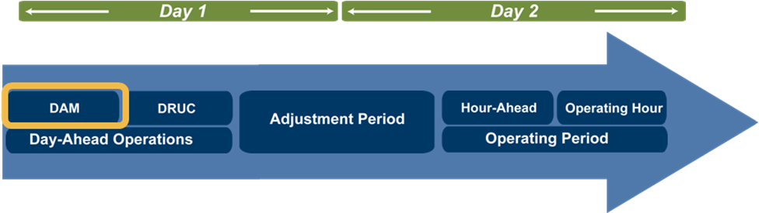
Figure 11 – DAM Timeline

The Day-Ahead Period occurs from 6:00AM to 6:00PM on the day prior to the operating day or actual power flow. This period consists of executing the Day-Ahead Market (DAM) and the Day-Ahead Reliability Unit Commitment (DRUC). DAM co-optimizes Energy Offers and Bids, PTP Obligation bids, and AS Offers. The daily RUC uses the same security sequence as the hourly RUC executed during real-time operations; however, the inputs and the study period are different.
By 6:00am, ERCOT must notify each QSE of its Ancillary Service Obligation for each service for each hour and post the following on the secure Market Information System (MIS):
- Network Operations Model that includes outages for the minimum Load hour and the peak Load hour
- Weather assumptions
- Any weather-related changes to transmission contingency list
- Load forecasts for the next seven days, by hour
- Load forecast distribution factors
- Load Profiles
- Distribution Loss Factors
- Current list of all Settlement Points

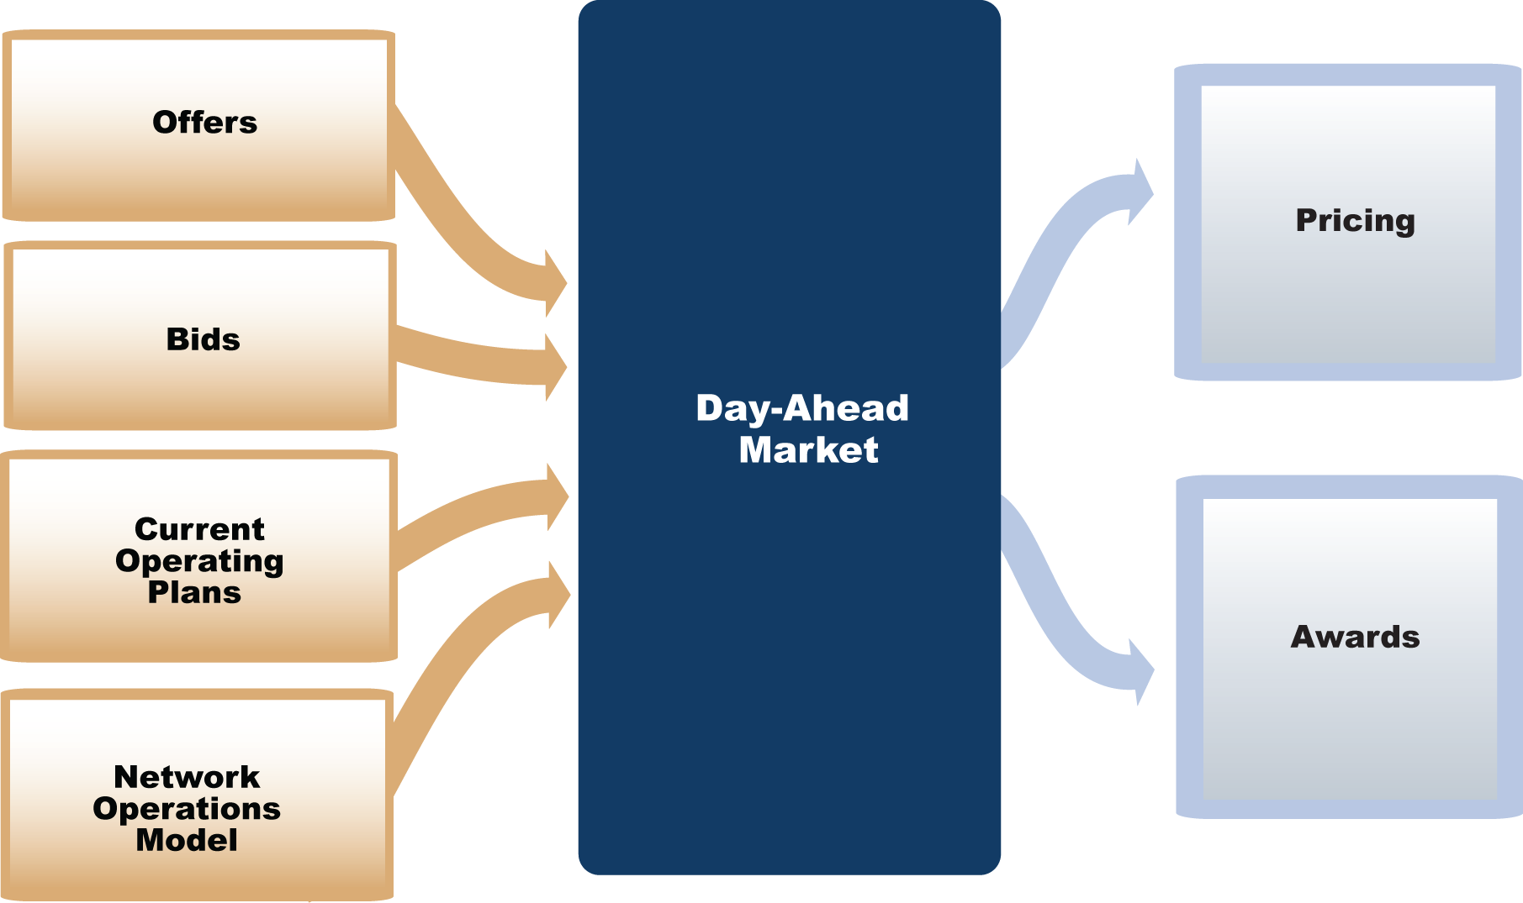

Figure 12 – DAM Processes

Day-Ahead Market (DAM) – This program runs at 10:00. Bids and offers must be submitted prior to the start of the process.
The offers that may be submitted for DAM or DRUC consideration are:
Three-Part Supply Offers - If a Three-Part Supply Offer for a Resource is awarded in DAM, the commitment is only financial and there is no physical obligation for the Resource to be On-Line in Real-Time. (However, whether or not the Resource is eligible for a Day-Ahead Make-Whole payment is partially dependant on whether the Resource ran during the Operating Day.)A QSE may not submit a Three-Part Supply Offer to be considered in the DRUC unless the offer was also submitted for consideration in the DAM.
Energy Offer Curves - A QSE submitting only an Energy Offer Curve is said not be offering the Resource into RUC, but may be committed depending on Resource status in the COP.
DAM Energy-Only Offers - Offer represents energy offered for sale at a specific Settlement Point and is not Resource-specific.
Ancillary Service Offers – The capacity of a single Resource may be offered for multiple Ancillary Services. Resource specific offers may be for Regulation Service, Non-Spinning Reserve Service or Responsive Reserve Service. Offers must include specific Resources, quantities, schedules including an expiration time and date, and no offer may exceed the system-wide offer cap.
CRR Offers - Only Non-Opt-In Entities (NOIEs) can offer CRRs in the DAM. NOIEs can only offer PTP Options and PTP Options with Refund. For a given offer, all CRRs offered must be of the same type, have the same source and sink, blocks must have the same number of CRRs in each hour, and blocks must consist of contiguous hours
RMR Must-Run Offers – These offers are submitted by ERCOT if deemed necessary and are based on the current RMR Contracts. ERCOT submits Three-Part Supply Offers based on RMR Agreement rates and other relevant information. ERCOT may submit Energy Offer Curves based on RMR Agreement rates and other relevant information.
The bids that can be submitted include:
DAM Energy Bids – Bids represent willingness to buy energy at or below a certain price and at a certain quantity at a specific Settlement Point in the DAM. These are only valid in the DAM.
Point-to-Point (PTP) Obligation Bid - PTP Obligations are a hedge against congestion in which QSEs who are also CRR Account Holders may bid for in the DAM and pay for at Real-Time Settlement Point Prices.
Self-Arranged Ancillary Service Quantities – these must be reported to ERCOT before the execution of the DAM at 10:00. The Self-Arranged Quantities must be backed by physical capacity or Trades prior to the execution of DRUC at 14:30.
DAM execution results in awards for these offers and bids, which ERCOT communicates no later than 13:30.

Reliability Unit Commitment
After the completion of the Day-Ahead Market and in the afternoon of the day-ahead period, ERCOT executes a reliability centered process to ensure that it has enough capacity committed to serve the forecasted load for the Operating Day. In the Reliability Unit Commitment or RUC process, ERCOT performs a security analysis of the transmission grid using the most updated network operations model and resource commitments already made by QSEs. ERCOT will then determine if any additional Resources commitments are needed for reliable operations during the Operating Day. A RUC process is the only market process that will physically commit a resource to come on-line. A Day-Ahead RUC process is executed in the afternoon of the Day-Ahead Period to determine Resource commitment needs for all hours of the next Operating Day. As we get closer to real-time operations, a similar process, the Hourly RUC, is executed using updated system conditions to determine if any additional Resource commitments are needed.
Current Operating Plan (COP) - Any QSE that represents a Resource will be required to submit a COP. QSEs representing combined-cycle Resources will be required to submit a COP for each operating configuration. The COP contains data for the next seven Operating Days and will not be used in SCED or in Real-Time Operations. The COP is only used in the Day-Ahead Market (DAM) and the Reliability Unit Commitment (RUC) Processes. Because the COP is not being utilized by SCED, it may be modified up to the point of dispatch.
Three-Part Supply Offer (TPO) - In addition to submitting a COP, a QSE may submit a Three-Part Supply Offer, which consists of three parts: the Startup Offer, the Minimum-Energy Offer and the Energy Offer Curve. The Startup Offer represents all costs incurred upon starting a generator, synchronizing to the grid and closing the breaker that connects it to the grid. The Minimum-Energy Offer represents all costs incurred from breaker close to operating at the Low Sustained Limit (LSL). The Energy Offer Curve represents a proposal to sell energy at a Settlement Point at a monotonically increasing price with increasing quantity, and has a different purpose in the Day-Ahead Market than it does in Real-Time Operations. It may also be submitted by itself.
Three-Part Supply Offers are used in the Day-Ahead Market (DAM) and in the Reliability Unit Commitment (RUC) processes to determine awards and commitments. In Real-Time Operations, Security Constrained Economic Dispatch (SCED) will utilize the Energy Offer Curve to dispatch the Resource. Energy Offer Curves are utilized by the Day-Ahead Market (DAM) to determine awards and by Security Constrained Economic Dispatch (SCED) to dispatch a Resource. The Reliability Unit Commitment (RUC) will not consider Energy Offer Curves submitted alone as offering the Resource into RUC.
The Energy Offer Curve may be submitted alone, without the other two parts. This curve is intended to be the marginal cost curve for the resource to operate at any given output level. The submission of only the Energy Offer Curve implies that the Resource has been QSE committed and is already on-line.
Output Schedules allow a QSE to inform ERCOT of the desired MW level for every five minute interval for a specific Resource. A QSE submitting an Output Schedule is said to be a “price-taker” since the Output Schedule does not have an Offer price associated with it. If the Output Schedule is for a Resource that is not dynamically scheduled, it may be updated in the Adjustment Period. If the Output Schedule is for a Dynamically Scheduled Resource (DSR), it may be updated up to the point of SCED execution. If Security Constrained Economic Dispatch (SCED) detects that a Resource is On-Line and neither an Energy Offer Curve nor an Output Schedule exists for that Resource, SCED will create an Output Schedule equal to the Resource’s telemetered output. If both an Energy Offer Curve and an Output Schedule are submitted for the same interval, SCED will only recognize the Energy Offer Curve; the Output Schedule will be nullified.
Trades transfer either financial or capacity obligations between two QSEs or between two CRR Owners. In the Nodal Market, in order for a trade to be recognized by ERCOT both parties will need to confirm the trade. Trades can be entered until 14:30 of the day after the Operating Day.
Self-Schedules are submitted to inform ERCOT that a QSE is using energy from a specific source Settlement Point to meet its energy obligation at a specified sink Settlement Point. The QSE will still be responsible for any congestion charges that may occur between these two points.

Day-Ahead Reliability Unit Commitment (DRUC) - Prior to DRUC execution at 1430, these activities occur:
- MPs must have Self-Arranged Ancillary Services Quantities represented by physical capacity or backed by Ancillary Service Trades
- MPs may update their COP
- MPs may submit Trades
- ERCOT posts prices, Ancillary Service and Energy quantities, and aggregated Ancillary Offer Curves on the MIS public area no later than 1330.
The DRUC studies all hours in the next operating day to ensure system reliability. DRUC uses Three-Part Supply Offers submitted before the DAM by QSEs that were considered in the DAM, but not awarded in the DAM. Any Resources that do not have Three-Part Supply Offers but are designated as available in the COP may still be committed by DRUC. All RUC-Committed Resources are subject to Make-Whole and Clawback Settlements. Make-Whole payments make up the difference when the revenues of a RUC-Committed Resource receive is less than the guaranteed costs. A Clawback is charged to the QSE representing a RUC-Committed Resource when the energy revenue is greater than the amount required to make the Resource whole.
Hourly Reliability Unit Commitment (DRUC) – HRUC is essentially the same process as the DRUC but runs hourly. The HRUC will study every hour forward as long as DRUC has had an opportunity to study that hour first. For example, prior to DRUC running, an HRUC in the morning will only study the current day until midnight (DRUC has not run for the next day). An HRUC run anytime after the DRUC has run will study the remaining hours of the current day, and all the hours of the next day. The HRUC will approve or reject any resource decommitments that were requested during the Adjustment Period.

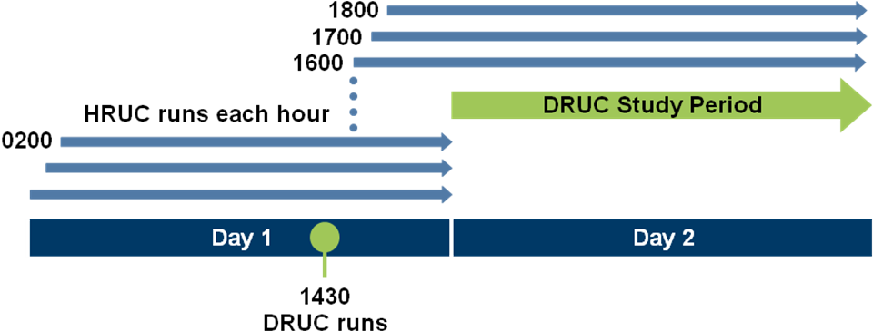
Figure 13 – RUC Processes

Adjustment Period
The end of the day-ahead period brings us to the Adjustment Period. As the name implies, this is a period of preparations and adjustments for ERCOT and Market Participants in anticipation of real-time operations. Market Participants may submit or modify energy offers for use by ERCOT during real-time. They may also report their bilateral trades to ERCOT as they finalize their requirements to meet their real-time obligations. QSEs with Resources also submit their Current Operating Plans for each of their Generation or Load Resources. These plans reflect anticipated operating conditions of each Resource including status, operational data and amount of capacity reserved for Ancillary Services. ERCOT may also execute a Supplementary Ancillary Services Market if it determines a need for additional Ancillary Services over what was procured in the Day-Ahead Market.
The Adjustment Period begins at the end of Day Ahead Operations and ends at the beginning of the Operating Period. The Adjustment Period allows Qualified Scheduling Entities (QSEs) can submit and / or update information such as Energy Offers and Bids, Output Schedules and Trades. On the other hand, Transmission Service Providers may submit and/or update information related to forced outages. The activities that can occur in the adjustment period include the following items, which are explained below:
- Current Operating Plans (COPs) may be updated
- Energy offers may be submitted and / or updated
- Output Schedules may be submitted and / or updated
- Trades may be submitted and / or updated
- Self-Schedules may be submitted
- Communication of Forced Outages
- A Supplemental Ancillary Service Market (SASM) may be executed if necessary

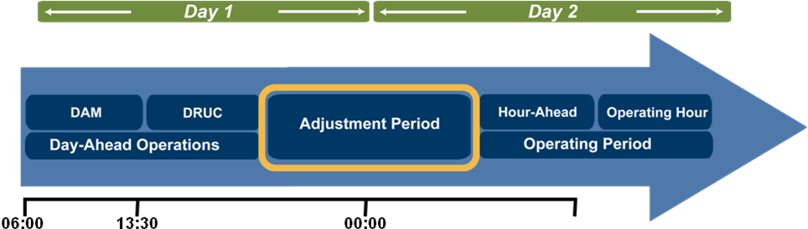
Figure 14 – Adjustment Period

Forced Outage - In the event of a Forced Outage or de-rating of a Resource, the QSE must provide ERCOT with information pertaining to the duration, schedule and nature of the event.
Supplemental Ancillary Service Market (SASM) – this may be executed, if necessary, to procure additional Ancillary Services. A SASM may be run for several reasons, including undeliverable Ancillary Services, a failure to provide, or an sudden change in the required Ancillary Services system wide.

Real-Time Operations
Following the Adjustment Period is Real-Time Operations. The time for financial and operational adjustments is over and it is time for ERCOT to monitor the real-time status of the grid and dispatch resources to serve the real-time system load. ERCOT will analyze the security of the grid as it did in the Reliability Unit Commitment process; but this time, its goal is to serve the actual system load instead of load forecasts. Even in real-time, ERCOT will determine the most economic solution to resolve system security issues by dispatching resources using energy offers submitted by QSEs. A Security Constrained Economic Dispatch or SCED process is executed at least every 5 minutes to determine the required operating levels of all Resources for reliable operation of the grid in real-time.
While SCED determines the economic dispatch of Resources every 5 minutes, an even more frequent process is charged with regulation of system frequency and dispatch of resources as needed to maintain reliable operations. The Load Frequency Control or LFC is executed every few seconds to dispatch Resources providing Regulation Reserve as needed to maintain system frequency at 60 hertz.
Real-Time Operations, also referred to as the Operating Hour, is part of the Operating Period. Real-Time Operations consists of a sequence of programs, processes and interactions between ERCOT and Market Participants. During Real Time Operations, the following activities occur:
- QSEs may update and / or submit Output Schedules for DSRs
- Real-Time data is provided by QSEs and TSPs
- Network Security Analysis is performed
- Security Constrained Economic Dispatch (SCED) is executed
- Load Frequency Control (LFC) is executed
- Ancillary Service capacities are monitored
- Instructions and prices are communicated

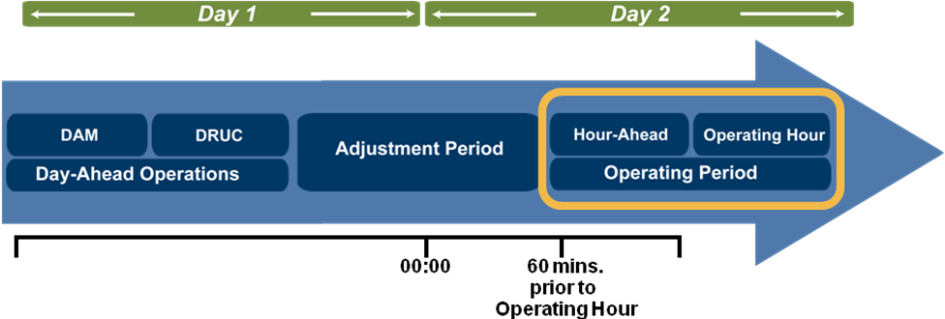
Figure 15 – Real-Time and Hour-Ahead Operations

Hour-Ahead Operations
Hourly Reliability Unit Commitment (HRUC) is one instance of Reliability Unit Commitment (RUC). ERCOT will execute HRUC at least one hour before every Operating Hour and it may be executed at any time to evaluate and resolve reliability issues. HRUC will assess the need for Resource commitments and decommitments for the remaining hours of the Operating Day unless the Day-Ahead Reliability Unit Commitment (DRUC) has solved. If DRUC has solved, HRUC will assess the system needs for the remaining hours of the Operating Day and all the hours for the next Operating Day. If a Resource is offline and available, regardless if a Three-Part Supply offer has been submitted, the Resource may be considered for RUC-Commitment.

Real-Time Operations
Real-Time Operations balances reliability and economics. ERCOT uses telemetry and forecasts to maintain the security of the Transmission Grid. Energy Offer Curves of the On-Line Resources are used in the calculation of approximately 4,000 LMPs. Security Constrained Economic Dispatch (SCED) uses the results of the Network Security Analysis and the applicable Energy Offer Curves to determine the least-cost dispatch to ensure system reliability.
ERCOT requires SCADA telemetered data to assess the reliability of the Transmission Grid in Real-Time. The Network Security Analysis (NSA) needs accurate data and an accurate Network Operations Model to determine the issues that will be resolved by SCED. Some of the needed data is provided by TSPs, QSEs, and weather stations. The remaining data, such as Load forecasts and the Contingency List, is provided by ERCOT.
Network Operations Model Creation - The telemetered data is used to update the Network Operations Model so it will mimic the Real-Time conditions of the Transmission Grid. This is done by updating that model with telemetered data and then checking against the State Estimator solution. The NSA processor uses this updated model to determine the limit violations. The contingencies are then checked before activating them in SCED. Therefore, SCED has the most accurate Network Operations Model that reflects the ERCOT Transmission Grid under normal operating conditions. It also contains the operational limits of all the Transmission Elements and the list of the possible contingencies.
Security Constrained Economic Dispatch (SCED) – This program is executed every five minutes, but ERCOT may execute SCED at anytime to determine least-cost dispatch. Each time SCED is executed LMPs, Shadow Prices, and Resource-specific Base Points will be calculated.
Because SCED operation is vital to the Nodal Market, ERCOT has developed an action plan should it fail. In case of failure to execute, ERCOT will declare an Emergency Condition, notifying the market through the ERCOT-to-QSE real-time communications system and by posting to the secure Market Information System (MIS). Since LMPs will not be created, prices will be set equal to the LMPs in the most recently solved interval. Once ERCOT has declared the Emergency Condition, the following measures may be used to remedy the SCED failure:
- ERCOT may direct the SCED process to relax the active transmission constraints. (These were the constraints that were verified prior to being an input to SCED, not the actual limits of the transmission elements in Real-Time.)
- ERCOT may also reduce Ancillary Service Schedules as a means to return to normal operations.
- ERCOT may give Emergency Base Points verbally and / or hold the instructions from the most recently solved interval The Emergency Condition remains until the SCED process can reach a solution.
Load Frequency Control (LFC) – This program is executed every four seconds and is intended to maintain system frequency. It uses the Area Control Error (ACE) equation, Frequency Bias, and Participation Factors to determine Regulation and / or Responsive Reserve deployment. Participation Factors notify ERCOT how regulation energy is planned to be distributed among the QSEs resources. The Resource Limit Calculator that was used in the SCED process is used in LFC to ensure the LFC deployments will respect the limits of the Resource.
Ancillary Service Capacity Monitor - This program updates every ten seconds and the results are made available on the MIS Secure Area and via real-time telemetry. The quantities represent Real-Time total system amounts of:
- Available Responsive Reserve Capacity
- Non Spinning Reserve Services available from On-Line Generation Resources with Energy Offer Curves, undeployed Load Resources, Off Line Generation Resources and Resources with Output Schedules
- Undeployed Reg-Up and undeployed Reg-Down
- Available capacity with Energy Offer Curves
- Available capacity without Energy Offer Curves.
These two quantities are listed separately because an Energy Offer Curve from an On-Line Resource represents the Resource’s willingness to be dispatched in Real-Time; therefore, this capacity is available under all system conditions. Also, if an On-Line Resource submits an Output Schedule, SCED will only deviate from it under Emergency Conditions. Therefore, each Resource’s capacity with Energy Offer Curves is available under any system conditions and the capacity without Energy Offer Curves is only available in emergencies.

Data Acquisition, Load Profiling, and Aggregation
The diagram below shows the relationships between the processes of gathering meter data, profiling, and aggregating the data before sending it to the settlements process. These activities are explained in the following text.
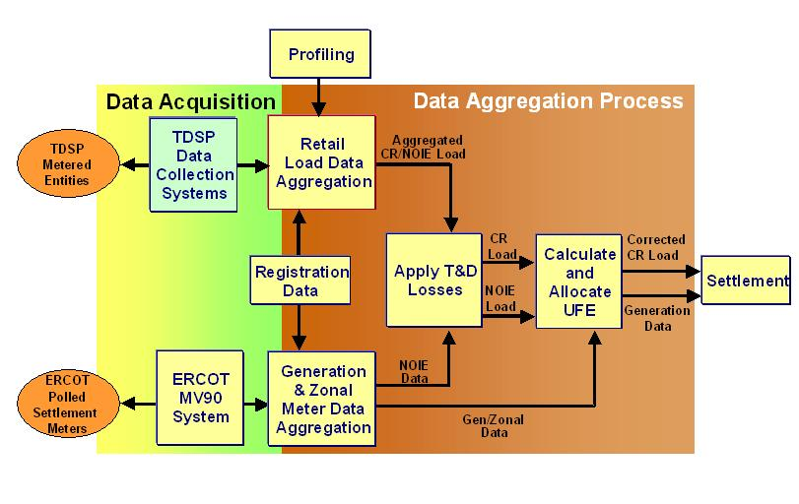
Figure 16 - Data Acquisition and Aggregation Diagram

Data Acquisition
Data acquisition is the process of receiving and processing energy consumption and production data from TDSPs. It also supports the retrieving, validating, editing and estimating of energy production and consumption data from ERCOT polled settlement meter points. This process provides the necessary meter data for the ERCOT data aggregation process.
ERCOT determines the load obligations of each QSE in 15 minute intervals. Interval Data Recorders (IDRs) must be installed at commercial and industrial loads exceeding 1000 kW of demand, and at some utilities below the 1000 kW level. Cumulative (non-IDR) meters continue to be used at most residential and small commercial loads, and some loads such as streetlights continue to be un-metered.

Load Profiling
The meter data from cumulative meters and estimated consumption from un-metered loads are allocated into 15-minute intervals through the process of Load Profiling.
ERCOT develops and maintains “static” (pre-determined) load profile models for residential, small commercial and un-metered loads in the ERCOT region. Load profiles are patterns of energy consumption at various hours of each day that are developed by studying groups of loads with similar consumption patterns. These profile models are adjusted daily using actual weather and calendar data; Competitive Retailers participate in the establishment of load profiles and their assignments. These models are assigned to groups of loads with similar consumption patterns prior to the day of actual energy consumption. ERCOT gives market participants a description of the profile models so they can forecast their own loads.
Proper allocation of load obligations at different times during the day using Load Profiling is important to market participants because energy prices are more costly during periods of high demand. Load profiling has been used in many markets to enable the participation of residential and small commercial loads without incurring the higher cost of IDRs. The process of estimating interval consumption data from cumulative meter data through Load Profiling can introduce inaccuracies for premises whose energy consumption patterns may not be adequately represented by the profile models.

Data Aggregation
Data Aggregation is the process of creating generation and load billing determinants that are required inputs to the settlement system. Data aggregation is done in a series of calculations to consolidate estimated and actual load and generation for each 15-minute settlement interval into a series of categories. There are a number of categories into which load and generation are aggregated, the most important being:
- Physical Interconnectivity to the ERCOT Grid – for aggregation purposes, load and generation are assigned to nodal areas that are primarily used to facilitate the accurate allocation of the costs of congestion and UFE.
- Market participant – load within each nodal area is aggregated by QSE and LSE, while generation is aggregated by QSE and Resource Entity. These aggregations provide the data that is required for input to settlement calculations.
Before settlement calculations can be performed, the load has to be adjusted to account for distribution losses, transmission losses and UFE. These adjustments are described in the next two sections.
Losses - Transmission Loss Factors are forecasted by ERCOT and posted to the market by 06:00AM of the Day-Ahead period. On the day following the Operating Day, ERCOT calculates Transmission Loss Factors for each settlement interval using actual system Load for that Settlement Interval and posts the results to the market and to the ERCOT settlement system.
Similarly, distribution companies (TDSP) furnish distribution loss factors (DLFs) to ERCOT to be applied to load in the TDSP’s distribution areas.
Unaccounted For Energy (UFE) - After allowing for losses, metered resource output in a given interval will not exactly equal metered load for several reasons, including the following:
- Profiles are estimates, and are thus not 100% accurate.
- Meters are not 100% accurate.
- Energy may be diverted due to theft
- Loss calculations are estimates, and are thus not 100% accurate.
The difference between metered resource output and the aggregated load, derived from the sum of profiled and interval usage, plus transmission and distribution losses, is called unaccounted-for-energy or UFE.
As the next diagram shows for each Settlement Interval, metered resource output has to be allocated to an equal amount of load in order to compensate the resources for all the energy injected into the ERCOT grid. Because of the reasons stated above, there will likely always be a certain amount of UFE.
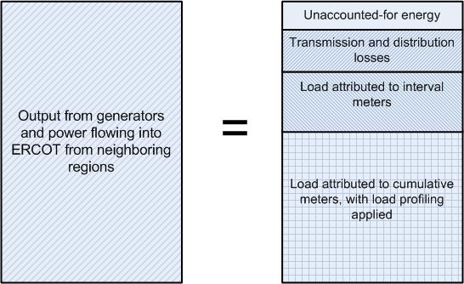

Figure 17 - 15 Minute Settlement Interval

UFE may be positive or negative based on whether the aggregated load quantity in a given interval, after accounting for losses, is either short of or exceeds the amount of metered resource output in the same interval. ERCOT aims to keep UFE as small as possible by investigating the causes of UFE and recommending remediation measures.
The costs or credits due to UFE are allocated across all loads in ERCOT based on premise type. The ERCOT protocols specify a methodology by which UFE is allocated to Load Serving Entities. The methodology attempts to allocate UFE based on the degree to which the type of premises represented by the LSE may cause UFE. For example, Profiled loads are allocated more UFE than those metered by Interval Data Recorders (IDRs) since errors in the application of profiles contribute more to UFE.

Settlements and Billing
Finally, the settlement process reconciles financial credits and obligations from all the processes that were executed. ERCOT will issue settlement statements and invoices for CRR Auctions to CRR Account Holders after every annual and monthly auction. QSEs are the recipients of statements and invoices for the Day-Ahead and Real-Time markets.
Recall that the Day-Ahead Market is an Hourly Market. Prices for energy, ancillary services and point-to-point obligations are determined for each hour of the Operating Day. Financial settlement is also calculated for each hour.
In real-time operations, ERCOT’s will dispatch of Resources and determine prices every 5 minutes or even more frequently while financial settlement is performed in 15 minute settlement intervals. In the next module, we will discuss how prices for 15 minute settlement intervals are determined using the 5 minute prices generated in Real-Time Operations.
The Real-Time Market, the Day-Ahead Market and the Congestion Revenue Right (CRR) Auction are settled separately. This means that there will be three different statements, three different invoices, and the potential for three different settlement times - initial, final, and true-up. The Settlements Calendar and QSE Settlement Statements will be available on the MIS. The Calendar is located in the Public Area for anyone to access it and each QSE’s Settlement Statements will be in the Secure Area for access by the QSE. Any settlement statement can be disputed.

Settlements
Congestion Revenue Rights - CRRs may be Settled using the CRR Auction clearing price, Day-Ahead Settlement Point Prices and/or Real- Time Settlement Point Prices. The CRRs do not actually become property of the new owner until the CRR Invoices have been paid in full.
CRR Auction Revenue will be distributed based on the location of the source and sink of each CRR and PCRR. If the source and sink are in the same Load Zone, then the revenues will be distributed on a zonal Load Ratio Share. If the source and sink are in different Load Zones, then the revenues will be distributed on an ERCOT-wide Load Ratio Share.
A Balancing Account is maintained for CRRs, and is used for any surplus from CRRs settled in the DAM. Basically, if the Congestion Rent is greater than the total payments to all CRR Owners for the CRRs settled in the DAM for any Operating Hour, then a credit is put in to the CRR Balancing Account for that Operating Hour. Any funds in the Balancing Account will be dispersed at the end of the month in two possible ways. If, for each Operating Hour, the Day-Ahead Congestion Rent is less than the total payments to all CRR Owners then those CRR Owners will be charged a shortfall. At the end of the month, the Balancing Account will be distributed to these CRR Owners on a CRR Credit Ratio Share. If there is still a surplus in the Balancing Account, then the money will be paid to QSE’s representing LSEs based on a monthly Load Ratio Share. At the end of each month, ERCOT will ensure that the Balancing Account is emptied of all funds.
CRR Settlements can be categorized into CRR Auction Settlements, CRR Day-Ahead Market Settlements, and CRR Real-Time Settlements. ERCOT will issue CRR statements on the first Business Day after a CRR Auction. A CRR Account Holder who purchased CRRs during the CRR Auction will pay ERCOT for those CRRs purchased on the third Business Day. On the fourth Business day following the CRR Auction and after ERCOT receives payment from the purchasing CRR Account Holders, ERCOT pays the selling CRR Account Holder. If a Statement or payment date occurs on a day that is not a bank Business Day, the statements or payments will be issued on the next bank Business Day.
Day-Ahead Market – Day-Ahead Settlements are done in one-hour intervals, with no time weighting involved. The Day-Ahead Market calculates Day-Ahead LMPs and Market Clearing Prices for Capacity (MCPCs). The LMPs will be used to calculate Settlement Point Prices and the MCPCs are used for Ancillary Service Settlements. All Day-Ahead prices are final at 1000 of the next Business Day after the Operating Day.
The DAM statements and invoices are issued on the same day and rolling payments are anticipated. They are issued two days after the operating day. Payments due to ERCOT shall occur on the 4th Business Day from receipt of invoice, which equals the Operating Day +6. On day seven ERCOT pays those QSEs who are entitled to money from their participation in the Day-Ahead Market.
Day-Ahead Settlements include energy, Ancillary Services, and some CRR Settlements.
Real-Time Settlements - Market Participants receive Initial Statements 10 days after the Operating Day, the Final Statement 59 days after the Operating Day, and the True-Up Settlement180 days after the Operating Day. Invoices are issued on a weekly basis. The invoice will have seven initials, seven finals, and seven true-ups listed on it weekly. All invoices are to be paid once a week. ERCOT collects money from all QSEs that have invoices with amounts due to ERCOT on one day and makes payments to QSEs that have invoices with payments from ERCOT on the next day. If ERCOT finds an error or a dispute is slated for resettlement, additional re-runs could occur at any point within this timeline.
The Real-Time Market includes Day-Ahead Reliability Unit Commitment (DRUC), Adjustment Period, and Real-Time Operations Settlements. If a Supplemental Ancillary Service Market is executed in the Adjustment Period, the Market Clearing Prices for Capacity (MCPCs) are calculated hourly. Both DRUC and HRUC activities are settled using both one hour and 15-minute intervals. Real-Time operations are settled using 15-minute intervals. Real-Time operations are settled in 15-minute intervals and SCED is executed at least every five minutes. SCED is responsible for calculating LMPs which are used to calculate Settlement Point Prices. Because SCED may be executed multiple times for a Real-Time Settlement Interval, the Real-Time Settlement Point Prices must be time-weighted. All Real-Time prices are final at 1600 of the next Business Day after the Operating Day.
Real-Time Settlements include: RUC, Energy Imbalance, Base-Point Deviations, RMR, Voltage Support, Black Start, Emergency Power, Supplemental Ancillary Service Market, and some CRR Settlements.

Billing
ERCOT produces daily settlement statements reflecting a breakdown of market charges for hourly and 15-minute interval market services. The statements also reflect administrative and miscellaneous charges.
A Settlement Statement includes the following information:
- A Summary Page, listing the type of market service, the billable quantity, the net amount payable to or receivable from the QSE for each of the services in that operating day after the amounts payable and the amounts receivable have been offset, and the total charge or credit for the QSE after the amounts payable and the amounts receivable have been offset for all charge types combined.
- A Detail Section, listing the total net amount payable to or receivable from the statement recipient for each settlement interval, the type of market service unit price, and the summary of charges for each settlement interval over the operating day, including a grand total for the day.
Note that the billed quantity may be either positive or negative; a positive number reflects what is owed to ERCOT, and a negative number is what is due from ERCOT. ERCOT uses all available Initial, Final and Resettlement data to produce the True-Up Statement for each statement recipient for the given operating period.
ERCOT provides invoices to QSEs every seven days, covering settlement payments and charges, which are paid using electronic funds transfer. ERCOT requires payment in full of each Invoice, regardless of any outstanding disputes.
Disputes Process – It is expected that every Market Participant is examining the settlements and in many cases shadowing the calculations. If a dispute is discovered, Market Participants must submit it within 10 business days after the statement is posted. ERCOT maintains staff to support dispute resolution within the 10 day time frame.
If a condition that causes a dispute affects multiple Operating Days or Charge Types, the recipient of the settlement statement or invoice may file a dispute form for each charge type for one or more operating days affected on a single dispute that are all in the same calendar month. If an agreement on the resolution can not be reached, the next step is the Alternative Dispute Resolution process. Finally, a Market Participant may appeal the outcome of a dispute with the PUCT. All communications regarding disputes and their status will be available electronically. When settling a dispute, a QSE must normally wait for the re-run of a particular settlement date and then the payment will automatically appear on the relevant statement and invoice. There is a specific condition in which a dispute in a material market settlement error may result in an immediate re-settlement of a particular day.

Market Participant Qualification
This section provides an overview of how entities must register and qualify to participant in ERCOT energy markets. Section 16 of the ERCOT Protocols contains the specific requirements for market participation. Access the ERCOT www.ERCOT.com website for more information, including copies of the registration materials.
Note: Registration requirements and qualification tests listed in this section pertain to interfaces between market participants and ERCOT and do not include tests that may be recommended by the Texas SET Test Planning Team to support testing of commercial transactions between TDSPs and CRs.

Registration and Qualification Process Summaries
Different types of entities must register and qualify for specific roles. The high level steps required and given below by MP type:
Load Serving Entities (LSEs) - Includes Competitive Retailer (CR): Retail Electric Providers (REPs)/Opt-In MOUs /Coops. Required steps are:
- Submit a LSE Application
- Execute an Standard Agreement Form
- Designate a QSE
- Complete the requirements of Texas SET and the Texas Test Plan Team (CR/REP)
- Complete PUCT certification (REPs only)
- Execute an LSE Agreement
- Receive a digital certificate for access to ERCOT Web Portal
- Complete ERCOT Programmatic Interface functional testing
- Complete Market Participant training on ERCOT business systems (as needed).
Congestion Revenue Rights Account Holders (CRR AHs) - Required steps are:
- Submit an CRR AH registration application
- Execute an Standard Agreement Form
- Satisfy credit requirements
- Receive a digital certificate for access to ERCOT Web Portal
- Establish communications with the Market Operations Systems
- Complete the qualification process for CRR AHs
Non Opt-In Entities (NOIEs) - See the other applicable categories for additional requirements. Required steps are:
- Submit an LSE Application
- Execute an Standard Agreement Form
- Designate a QSE
- Complete a NOIE wholesale point registration
- Execute an LSE Agreement
- Receive a digital certificate for access to ERCOT Web Portal
- Complete Market Participant training on ERCOT business systems (as needed)
Qualified Scheduling Entities (QSEs) – Required steps are:
- Submit a QSE Application
- Execute an Standard Agreement Form
- Execute a QSE acknowledgement form
- Submit Service Filings
- Declare intent to provide ancillary services
- Complete the credit application
- Submit a telecommunication requirements survey (WAN users)
- Complete the ERCOT WAN Agreement
- Establish and test ability to access ERCOT private network
- Test real-time data exchange and ability to send/receive control signals (ICCP)
- Complete ERCOT programmatic interface functional testing
- Receive a digital certificate for access to ERCOT Web Portal
- Complete Market Participant training on ERCOT business systems (as needed)
- Complete ancillary service tests
- Post financial security
Resources – including Power Generating Companies (PGCs) and Loads Acting as Resources. Required steps are:
- Submit an application to be a Resource Entity
- Execute an Standard Agreement Form
- Designate a QSE
- Complete the Resource Asset Registration Form
- Execute the Resource agreement
- Register with PUCT
- Establish control and data interfaces with QSE
- Complete Market Participant training on ERCOT business systems
- Receive a digital certificate for access to ERCOT Web Portal
Transmission and/or Distribution Service Provider (TDSP) - Note that the steps marked by an asterisk apply to those TDSPs that operate in the ERCOT region. Required steps include:
- Perform Data Conversion of premise, historic, and ongoing retail usage data (ESI-ID) via EDI/XML (If Applicable)
- Submit an application as a TSP, DSP, or both
- Submit an application
- Execute an Standard Agreement Form
- Register company and users
- Execute a TDSP agreement
- Provide annual distribution loss factors or alternate methodology *
- Provide annual transmission losses within NOIE ties (NOIEs only) *
- Receive a digital certificate for access to ERCOT Web Portal
- Install ERCOT polled settlement metering (if applicable) *
- Meet mandatory IDR meter installation requirements *
- Complete Market Participant training on ERCOT business systems (as required or needed)
* Applies to those that operate in the ERCOT region only.

Interface Summary
Market participants have specific requirements to interface effectively with ERCOT. There are five main technical interfaces between market participants and ERCOT. In general, most QSEs and Transmission Service Providers interact with ERCOT over a private wide area network. Other market participants perform their market transactions over the internet. The types of interfaces and the MP interfaces requirements are given in the sections below.

ERCOT Interfaces
Portal – the portal is a browser-based interface which allows both public and private information transfers between ERCOT and participants. However, only active market participants with digital certificates can access the Portal for either public market information or data specific to the market participant.
ERCOT acts as the Certificate Authority and generates a digital certificate on behalf of each Market Participant. The Market Participant must be identified uniquely within the ERCOT system.
Transaction Clearinghouse – the transaction clearinghouse manages the Electronic Data Interchange (EDI) transactions between ERCOT and participants, including supporting an XML implementation. The clearinghouse supports commercial transaction management for complex transactions, such as switching retail customers between competitive retailers, which require multiple organizations to perform the right sequence of steps to execute correctly. The encryption and digital certificate technology provided by ERCOT makes this information transfer secure.
Application Programmatic Interface (API) – the API is a custom interface developed by ERCOT to support integration between participant systems and ERCOT’s systems to reduce the need for manual interaction. This is particularly important for QSE operations in areas like scheduling and bidding, where manual interaction could be cumbersome.
Real Time Inter Control Center Communications (ICCP) Interface – this is a standard power industry interface supporting automated integration between QSE/TDSP control systems and ERCOT’s power control system.

Market Participant Interface Requirements
Qualified Service Provider - At a minimum, a QSE needs secure access to the Web Portal to process settlement statements and invoices and download extracts. It may also be used to access the market operation functions such as scheduling and bidding. The portal and the Programmatic Interface give access to specific QSE information, including selected bids, generation outage schedules, as well as market data. QSEs that represent resources also need ICCP/RTU for real-time signal communication with ERCOT. Interface requirements are:
- Access to Internet Explorer Web browser
- Internet connectivity
- Web Portal (digital certificate) for processing of settlement invoices and data extracts
- Programmatic Interface for market operation functions
- Private Wide Area Network Access (required for QSEs with deployable resources)
- ICCP (required for QSEs with deployable resources)
Load Serving Entity - An LSE’s interface requirements are:
- Access to Internet Explorer Web browser
- Internet connectivity
- Private Wide Area Network Access
All Other Market Participants – Interface requirements are:
- Access to Internet Explorer Web browser
- Internet connectivity

Education
Market participant education is offered via classroom sessions. A Training site on the www.ERCOT.com website provides access to currently scheduled classes. ERCOT courses include information on:
- Registration and Web Portal Functions
- Settlements and Billing
- Metering, Data Acquisition, Data Aggregation, and Load Profiling
- Systems Operations
- Market Operations System Interface
- Congestion Revenue Rights
ERCOT strives to provide education courses quarterly in the primary subject areas. Market participants are also encouraged to request education as needed.

Appendices

Customer Switch Request processing
The ability for customers to switch CRs is fundamental to supporting retail competition. The figure below shows how ERCOT processes a customer switch.
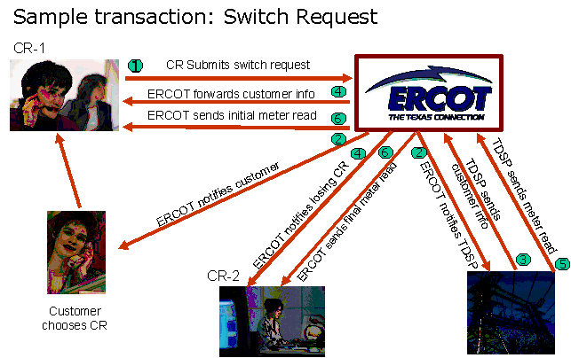


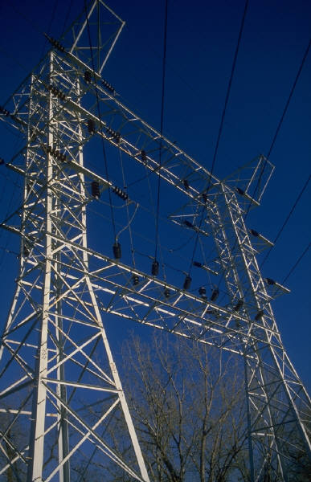


Figure 18 - Switch transaction request

When ERCOT receives a switch request from a customer’s New CR, it verifies that the New CR is certified by the PUCT, registered with ERCOT, and authorized to serve the customer’s premise area.
ERCOT notifies the customer and both CRs about the impending switch. ERCOT also notifies the TDSP so it can send detailed premise data, like historical usage, the rate class and meter type. This information is sent from the TDSP to ERCOT, which forwards it to the New CR. The New CR needs this data in order to prepare for the switch.
When the TDSP reads the customer’s meter, it sends the reading data to ERCOT, which forwards it to both CRs and finalizes the switch. The CRs need this meter reading information in order to determine when the customer stops being billed by the current CR and starts being billed by the new CR.
With millions of ESI-IDs in service in the Texas retail market there are understandably thousands of ESI-ID transactions for switching, moving in and out, etc. This presents the opportunity for a significant volume of data synchronization issues between competitive retailers, TDSPs, and ERCOT.
ERCOT and market participants implemented FasTrak – ERCOT Production Issue Resolution System, to work through data differences. The ERCOT FasTrak system is the primary tool and entry system used by CRs and TDSPs to communicate with ERCOT Registration Analyst regarding enrollment process issues.
Before a FasTrak issue is submitted the CR must validate the discrepancy with the use of ESI-ID status reports provided to market participants. These are the “Service Order Full Extract Report” and the “ERCOT Market Participant (MP) Transaction Report”.
The goal of this process is to resolve data exchange issues in order to make service changes to retail electric customers’ services quickly and efficiently.

Definitions, Acronyms, and Abbreviations
For a current list of definitions, acronyms, and abbreviations authorized by ERCOT Protocol refer to Section 2 of ERCOT protocols on ERCOT.com: http://www.ercot.com/mktrules/nprotocols/.

AP Adjustment Period The Adjustment Period for any given Operating Hour is the time period following the close of the Day-Ahead market and extending up to each Operating Period.
API Automated Programmatic Interface
AS Ancillary Service Those services necessary to support the transmission of energy from Resources to Loads while maintaining reliable operation of transmission provider’s transmission systems in accordance with Good Utility Practice.
Base Point The MW output level for a Resource produced by the SCED process.
Bid Stack Bids received for Ancillary Services organized from lowest price to highest price bid for the same service and time interval.
Bid a proposal to buy
Black Start Resource A single Resource capable of providing Black Start Service.
BSS Black Start Service A contracted Ancillary Service acquired by ERCOT for the benefit of all Loads, provided by Resource capable of starting without support of the ERCOT Transmission Grid.
Business Day Monday through Friday, excluding observed holidays: New Year’s Day, Memorial Day, Independence Day, Labor Day, Thanksgiving Thursday and Friday, 2 days at Christmas, as designated by the ERCOT CEO
Business Hours 8:00 A.M. to 5:00 P.M. Central Prevailing Time on Business Days.
Central Prevailing Time Either Central Standard Time or Central daylight time as established by national time standards.
CIM Common Information Model A format for network models.
Clawback A charge to the QSE representing a RUC-Committed Resource when the energy revenue is greater than the amount required to make the Resource whole.
Congestion The situation that exists when requests for power transfers across a Transmission Facility element or set of elements, when netted, exceed the transfer capability of such elements.
COP Current Operating Plan
CR Competitive Retailer A Municipally Owned Utility or an Electric Cooperative that offers Customer Choice and sells electric energy at retail in the restructured electric power market in Texas; or a Retail Electric Provider (REP) as defined in 25.5 of the PUCT Substantive rules.
CRR Invoice See Invoice
CRR Congestion Revenue Right A financial instrument, defined by a MW amount, settlement point of injection and settlement point of withdrawal. Conceptually, a CRR owner pays or gets paid the product of the CRR MW amount and the LMP difference between the CRR injection and withdrawal settlement points.
CRRAH Revenue Rights Account Holder

Customer Choice The freedom of a retail Customer to purchase electric services, either individually or on an aggregated basis with other retail Customers, from the provider or providers of the Customer’s choice and to choose among various fuel types, energy efficiency programs, and renewable power suppliers.
Customer Registration Database The database maintained by the Registration Agent containing information identifying each Premise, including current and previous Competitive Retailers serving the Premise.
Customer An Entity that purchases electricity for its own consumption.
DA Day Ahead The twenty-four hour period prior to the beginning of the Operating Day.
DAM Day Ahead Market
Data Aggregation The process of netting, grouping and summing Load consumption data, applying appropriate profiles, Transmission Loss Factors, and Distribution Loss Factors and calculating and allocating UFE to determine each QSE and/or Load Serving Entities responsibility by Settlement Interval by Congestion Zone and by other prescribed aggregation determinants.
Demand Instantaneous or integrated power consumption
Distribution Losses The difference between the energy delivered to the Distribution System and the energy consumed by Loads connected to the Distribution System.
Distribution System That portion of an electric delivery system operating at under 60 kilovolts (kV) that provides electric service to Customers or Wholesale Customers.
DLF Distribution Loss Factor The ratio of the Distribution Service Provider’s estimated Distribution Losses to the total amount of energy deemed consumed (IDR plus profiled consumption) on the Distribution Service Provider’s system.
DRUC Day-Ahead Reliability Unit Commitment
DSP Distribution Service Provider An Entity that owns and maintains a Distribution System for the delivery of energy from the ERCOT Transmission Grid to the Customer.
DSRs Dynamically Scheduled Resources
DUNS Number A unique nine-digit common company identifier used in electronic commerce transactions.
EC Electric Cooperative
EDI Electronic Data Interchange
Electric Cooperative A corporation organized under Chapter 161, Texas Utilities Code, or a predecessor statute to Chapter 161 and operating under that chapter; A corporation organized as an electric cooperative in a state other than Texas that has obtained a certificate of authority to conduct affairs in the State of Texas; or A successor to an electronic cooperative created before June 1, 1999, in accordance with a conversion plan approved by a vote of the members of the electric cooperative, regardless of whether the successor later purchases, acquires, merges with, or consolidates with other electric cooperatives.
Energy Offer Curve A proposal to sell energy at a Settlement Point at a monotonically increasing price with increasing quantity.
Entity Any natural person, partnership, municipal corporation, cooperative corporation, association, governmental subdivision, or public or private organization.
EPS ERCOT Polled Settlement Meter Any meter polled by ERCOT as defined in Section 10 for use in the financial settlement of the Market.
ERCOT Member Any member of ERCOT that is a member in good standing in accordance with the ERCOT Bylaws.
ERCOT Region The geographic area under the jurisdiction of the PUCT that is served by TDSPs that are not synchronously interconnected with electric utilities outside the state of Texas.
ERCOT Transmission Grid All of those Transmission Facilities which are within the ERCOT Region.
ERCOT Electric Reliability Council of Texas, Inc. A Texas nonprofit corporation that has been certified by the PUCT as the Independent Organization, as defined in §39.151 of PURA, for the ERCOT Region.
ESI ID Electric Service Identifier The basic identifier assigned to each Service Delivery Point used in the registration and settlement systems managed by ERCOT or another Independent Organization
Facilities Equipment situated for the purpose of conducting service and/or business through use of the ERCOT System
Final Day-Ahead Schedule Those schedules ERCOT deems valid following the close of the Day Ahead period.
Final Statement The statement issued at the end of the fifty-ninth (59th) calendar day following the Operating Day, as described in 9.2.4, Final Statements.
Forced Outage A component failure or other condition that requires that the equipment be removed from service immediately or up to and including the next weekend.
GR Generation Resources Facilities that produce energy and that are owned or operated by a Generation Entity.
HRUC Hourly Reliability Unit Commitment
IDR Interval Data Recorder Metering Device that is capable of recording Load usage in each Settlement Interval in accordance with Section 9, Settlement and Section 10, Metering.
Initial Statement The first iteration of a Settlement Statement issued for a particular Operating Day, as further described in Section 9.2.3, Initial Statements
Invoice Settlement Invoice: A notice for payment or credit due rendered by ERCOT based on data contained in Initial, Final, True-Up or any Resettlement Statements.
IOU Investor Owned Utilities
ISO Independent System Operator
KWH Kilowatt Hour
LFC Load Frequency Control
LMP Locational Marginal Price
Load Profile A representation of the energy usage of a group of Customers, showing the demand variation on an hourly or sub-hourly basis.
Load Profiling Methodology The fundamental basis on which Load Profiles are created. The implementation of a Load Profiling Methodology may require statistical sampling, engineering methods, econometric modeling, or other approaches.
Load Profiling The set of processes used for the development and creation of Load Profiles.
Load Ratio Share A QSE’s ratio of Adjusted Metered Load to total ERCOT Adjusted Metered Load related to the appropriate interval.
Load The amount of electric power delivered at any specified point or points on a system.
LSE Load Serving Entity An Entity that provides electric service to Customers and Wholesale Customers. Load Serving Entities include Retail Electric Providers, Competitive Retailers, and Non-Opt In Entities that serve Load.
Market Solution A Market Solution exists when at least three unaffiliated Resources, with capacity available, submit bids to ERCOT that can solve a circumstance of local Congestion and no one bidder is essential to solving the Congestion.
MCFRI McCamey Flowgate Right
MCP Market Clearing Price
MCPC Market Clearing Price for Capacity The highest price associated with a Congestion Zone for a Settlement Interval for Ancillary Service capacity awarded in each Ancillary Services capacity procurement run by ERCOT. There will be a separate Market Clearing Price for Capacity for each Ancillary Services capacity market.
Merit Order The ranking of Resources as a direct function of the monetary bid from those resources.
MIS Market Information System An electronic communications interface established and maintained by ERCOT that provides a communications link to Market Participants, including secure access by and communications to individual Market Participants regarding information linked to each individual Market Participant.
MOU Municipally Owned Utility A utility owned, operated, and controlled by a municipality or by a nonprofit corporation, the directors of which are appointed by one or more municipalities.
MP Market Participant An Entity that engages in any activity that is in whole or in part the subject of these Protocols, regardless of whether such Entity has executed an Agreement with ERCOT.
MRE Meter Reading Entity An Entity that is responsible for providing ERCOT with ESI ID level consumption data as defined in Texas SET and Protocols Section 19. This Entity must be a TDSP that is registered with ERCOT as prescribed in Protocols Section 10. In the case of an ERCOT Polled Settlement (EPS) Meter or ERCOT populated ESI ID data (such as generation site load), ERCOT will be identified as the MRE in ERCOT systems.
NERC North American Electric Reliability Council
NOIE Non-Opt In Entity An Electric Cooperative or Municipally Owned Utility that does not offer Customer Choice.
NOMCR Network Operations Model Change Request Form used by Market Participants to update the network model.
Non-Metered Load Load that is not required to be metered by applicable distribution or transmission tariff.
NSRS Non-Spinning Reserve Service A service that is provided through utilization of the portion of off-line generation capacity capable of being synchronized and ramped to a specified output level within thirty (30) minutes (or Load that is capable of being interrupted within thirty (30) minutes) and that is capable of running (or being interrupted) at a specified output level for at least one (1) hour. Non-Spinning Reserve Service (NSRS) may also be provided from unloaded on-line capacity that meets the above response requirements and that is not participating in any other activity, including ERCOT markets, self-generation and other energy transactions.
Obligation Total Obligations scheduled by a QSE that are comprised of energy Obligations and Ancillary Services Obligations where: Energy Obligations = Load + losses + energy sales + energy exports; and Ancillary Services Obligations = ERCOT allocated Ancillary Services Obligations (which may be self-arranged) + Ancillary Services sales (to ERCOT or to other QSEs)
OC Operational Constraint Anticipated or actual security violation or overload of a transmission element, based on actual network topology.
Offer a proposal to sell
Operating Day The actual day, including hours ending 0100 to 2400, during which energy is flowing.
Operating Hour The current clock hour.
Operating Period A two-hour period comprised of the Operating Hour and the hour preceding the Operating Hour.
Operational Model The transmission model based on actual network topology of the ERCOT System.
Outage Removal of a Facility from service to perform maintenance, construction or repair on the Facility for a specified duration.
PCRR Pre-assigned Congestion Revenue Right Congestion Right allocated prior to the annual CRR auctions to MOUs and ECs which own or have a long-term (greater than five years) contractual commitments, entered into prior to September 1, 1999, for annual capacity and energy from a specific remote Generation Resource.
PGC Power Generation Company
Premise A Service Delivery Point or combination of Service Delivery Points that are assigned a single Electric Service Identifier (ESI ID) for purposes of settlement and registration.
PTB Price-to-Beat The bundled rate a Retail Electric Provider that is affiliated with an Entity required to unbundle its electric services, and offer Customer Choice, must charge to residential and small commercial Customers upon initiation of Customer Choice, as further described in Section 39.202 of PURA and PUCT rules.
PTP Point-to-Point A type of CRR (the other type is ‘flowgate’).
PUCT Public Utility Commission of Texas
QSE Operator The person designated by the QSE to communicate with ERCOT on a 24-hour basis.
QSE Qualified Scheduling Entity A Market Participant that is qualified by ERCOT in accordance with Section 16, Registration and Qualification of Market Participants, to submit Balanced Schedules and Ancillary Services bids and settle payments with ERCOT.
RE Resource Entity A Market Participant that owns or controls a Resource.
Registered Market Participant Entity that is registered with ERCOT to participate in the competitive market administered by ERCOT within the ERCOT Region. Registered Market Participants include those using statewide systems administered by ERCOT and may be non-ERCOT participants.
Reliability Must Run (RMR) Unit A Generation Resource unit operated under the terms of an Agreement with ERCOT that would not otherwise be operated except that they are necessary to provide voltage support, stability or management of localized transmission constraints under first contingency criteria where Market Solutions do not exist.
REP Retail Electric Provider
Resource Category Generic Operational Cost A standard $/MWh price for running a unit selected out of merit order to provide energy or ancillary services. The RCGOC is defined by the generation unit category (Base-load, Gas Intermediate, Gas Cyclic, Gas Peaking and Renewable).
Resource Facilities capable of providing electrical energy or Load capable of reducing, or increasing the need for electrical energy or providing Ancillary Services to the ERCOT System, as described in Section 6, Ancillary Services. This includes Generation Resources and Loads acting as Resources.
Retail Electric Provider A person that sells electric energy to retail Customers in this state. As provided in PURA §31.002(17), a Retail Electric Provider may not own or operate generation assets. As provided in PURA §39.353(b), a Retail Electric Provider is not an Aggregator.
RID Resource ID A unique identifier assigned to each Resource used in the registration and settlements systems managed by ERCOT.
RIDR Representative IDR
RMR Reliability Must Run Service The provision of generation capacity and/or energy resources from a Reliability Must Run Unit or a Synchronous Condenser Unit.
RRS Responsive Reserve Service Responsive Reserve consists of the daily operating reserves that are intended to help restore the frequency of the interconnected transmission system within the first few minutes of an event that causes a significant deviation from the standard frequency.
RS Regulation Service A service that is used to control the power output of Resources in response to a change in system frequency so as to maintain the target system frequency within predetermined limits.
RT Real Time
RUC Reliability Unit Commitment
SCADA Supervisory Control And Data Acquisition
SCED Security Constrained Economic Dispatch
SCF System Congestion Fund
Scheduling Process The process through which schedules for energy and Ancillary Services are submitted by QSEs to ERCOT as further described in Section 4, Scheduling.
SDP Service Delivery Point
Season Winter months are December, January, and February; Spring months are March, April, and May; Summer months are June, July, and August; Fall months are September, October, and November.
Self-Arranged Ancillary Service Resources used for Ancillary Services designated by a QSE for use by ERCOT for meeting the ERCOT allocated portion of the Ancillary Services Obligations of a QSE. These Resources may not be included in the ERCOT Ancillary Services market.
SET Standard Electronic Transaction
Settlement Calendar As defined in Section 9.1.2, Settlement Calendar.
Settlement Interval The time period for which a Market Service is deployed and financially settled. For example, the currently defined settlement interval for the Real –Time Energy is 15 minutes.
Settlement Meter Generation and end-use consumption meters used for allocation of ERCOT charges and wholesale and retail settlements.
Settlement Statement A statement issued by ERCOT reflecting a breakdown of administrative, miscellaneous, and market charges for the applicable Market Services, as further described in Section 9.2, Settlement Statements.
Shadow Price The cost of an operation to effect a one (1) MW change in a constraint.
Shift Factor A measure of the flow of a unit injection of the power on the transmission element from a particular bus to a fixed reference bus.
Supply Total supply scheduled by a QSE that is comprised of Energy Supply and Ancillary Services Supply where: Energy Supply = Resources + energy purchases + energy imports; and Ancillary Services Supply = Resources + Ancillary Services purchases (including purchases through ERCOT) + Ancillary Services imports
System Operator A person supervising the collective Transmission Facilities of a power region that is charged with coordination of market transactions, system-wide transmission planning, and network reliability.
TDSP Transmission and/or Distribution Service Provider An Entity that owns or operates for compensation in this state equipment or Facilities to transmit and/or distribute electricity, and whose rates for Transmission Service, distribution service, or both is set by a Governmental Authority.
Texas SET Texas Standard Electronic Transaction procedures, set forth in Section 19, Texas SET, used to transmit information pertaining to the Customer Registration Database. Record and Data Element Definitions are provided in the data dictionary in Protocols Section 19.
TLF Transmission Loss Factors The fraction of ERCOT Load (forecast or actual) that is considered to constitute the ERCOT Transmission Grid losses in the Settlement Interval. Transmission Loss Factors are computed by ERCOT and are based on a linear interpolation (extrapolation) of the calculated losses in the off-peak and on-peak seasonal ERCOT base cases.
TPO Three-Part Supply Offer Consists of the Startup Offer, the Minimum-Energy Offer and the Energy Offer Curve.
TOUS Time of Use Schedule A schedule identifying the Time of Use period associated with each Settlement Interval. These schedules may include on-peak, off-peak, and shoulder periods.
Transaction Clearinghouse A batch, transactional interface intended to provide reliable exchange of high volume, standardized transactions between Market Participants and ERCOT using the Texas SET procedures in Section 19, Texas SET.
Transmission Facilities The following Facilities are deemed to be Transmission Facilities: Power lines, substation, and associated Facilities, operated at 60 kV or above, including radial lines operated at or above 60 kV. Substation Facilities on the high side of the transformer, in a substation where power is transformed from a voltage higher than 60 kV to a voltage lower than 60 kV or is transformed from a voltage lower than 60 kV to a voltage higher than 60 kV. The direct current interconnections with the Southwest Power Pool (SPP), Western System Coordinating Council (WSCC), Comision Federal de Electricidad, or other interconnections.
Transmission Losses Difference between energy input into the ERCOT Transmission Grid and the energy taken out of the ERCOT Transmission Grid.
True-Up Statement The statement issued six (6) months following the Operating Day, as further described in Section 9.5.8, RTM True-Up Statement.
TSP Transmission Service Provider An Entity under the jurisdiction of the PUCT that owns or operates Transmission Facilities used for the transmission of electricity and provides transmission service in the ERCOT Transmission Grid.
TX SET Texas Standard Electronic Transaction – see Texas SET
UFE Unaccounted for Energy The difference between total metered Load each Settlement Period, adjusted for applicable Distribution Losses and Transmission Losses, and total ERCOT System net generation.
USTR Uninitiated Service Termination Request
WPGR Wind Powered Generation Resource

A REP is a type of Competitive Retailer that is certified by the PUCT.
Residential and small commercial customers are defined to be those with less than 1000 kW demand in SB7
The “price to beat” is under the jurisdiction of the PUCT.
The 10 control areas were operated by regulated utilities.
Ancillary services are introduced in the next section.
A Customer Choice Pilot occurred from June 1, 2001 through December 31, 2001 were 5% of eligible customers were given the ability to choose their retail electric provider starting. Municipally Owned Utilities and Cooperatives chose not to opt-in to retail competition during this pilot.
A municipality or cooperative utility decision to opt into the competitive retail market cannot be reversed.
N-1 refers to the fact that the system needs to operate normally even when the largest or most critical component is missing (i.e. N Components minus 1)

