 |  |  |  | System Planning Division
Monthly Status Report
to
Reliability and Operations Subcommittee
for
November 2010

 |  | Report Highlights
Item
1. | - ERCOT is currently tracking 194 active generation interconnection requests totaling over 65,000 MW. This includes almost 39,000 MW of wind generation.
2. | - ERCOT is currently reviewing proposed transmission improvements with a total cost of $51.1 Million  - Transmission Projects endorsed in 2010 total $268.8 Million  - All projects (in engineering, routing, licensing and construction) total approximately $9.4 Billion  - Transmission Projects energized in 2010 total about $791.7 million

Table of Contents
1. Generation Interconnection 1
1.1 New Generation Registering for Commercial Operations 1
1.2 Publicly Disclosed Generation Interconnection Projects 4
1.3 Generation Projects Undergoing Full Interconnection Studies (not otherwise public) 6
1.4 Wind Generation 7
Wind Capacity Installed by Year 7
2. Regional Planning Group Project Reviews 9
3. Congestion Costs 10
4. Wind Generation as a Percent of Load 16
5. Other Notable Activities 17

1. Generation Interconnection
Additional information regarding detailed generation interconnection and impact studies is contained in the “Generation Project Interconnection Information” folder in the “Operations and System Planning” area on the ERCOT website: http://planning.ercot.com/login/login.

New Generation Registering for Commercial Operations

None
The total installed wind capacity is 9,467 MW, of which 7,958 MW (84%) is located within the Western Congestion Management Zone.

Summary of Active Generation Interconnection Requests

GENERATION INTERCONNECTION REQUESTS CURRENTLY BEING PROCESSED
Currently tracking 194 active generation interconnection or change requests
As of November 30, 2010 | North | South | West | Total
Security Screening Study | 0 | 2 | 9 | 11
SSS Completed | 2 | 3 | 11 | 16
Full Interconnect Study | 19 | 13 | 93 | 125
FIS Completed | 4 | 15 | 4 | 23
Interconnect Agreement Completed | 8 | 6 | 5 | 19
Capacity under Interconnection Agreements | 5,192 | 3,742 | 756 | 9,690
Capacity for Grid, MW | 19,200 | 13,144 | 33,194 | 65,538
Wind Capacity, MW | 3,907 | 4,491 | 30,243 | 38,641

Fuel Type | Confidential Projects (MW) | Projects Under Full Study (MW) | Projects w/ Interconnect Agreement/Public Letter (MW) | Grand Total (MW)
Gas-CC |  |  | 5,352 | 12,054
Gas-CT |  |  |  | 639
Total Gas | 11 | 7,330 | 5,352 | 12,693
Nuclear |  |  | 5,900 | 5,900
Coal |  | 1,740 | 3,210 | 4,950
Wind | 3,295 | 29,293 | 6,053 | 38,641
Solar | 360 | 819 |  | 1,179
Biomass |  | 50 | 145 | 195
Other |  | 740 | 1,240 | 1,980
Grand Total | 3,666 | 39,972 | 21,900 | 65,538

Publicly Disclosed Generation Interconnection Projects
The table below summarizes the publicly disclosed generation projects for the ERCOT region.
(Status: IA=Interconnect Agreement, PL=Public Letter, XX= cancelled)
Generation Interconnections as of November 30, 2010
INR | SiteName | Status | County | Region | COD | Fuel Type |  | MW For Grid | Change from Last Report
08INR0033 | Lufkin | IA | Angelina | North | Dec-10 |  | Biomass | 45
12INR0003 | Throckmorton Wind Farm | PL | Throckmorton | West | Dec-10 |  | Wind | 400
05INR0015b | Gulf Wind 2 | PL | Kenedy | South | Jan-11 |  | Wind | 400
05INR0015c | Gulf Wind 3 | PL | Kenedy | South | Jan-11 |  | Wind | 400
08INR0065 | Buffalo Gap 4 and 5 | PL | Nolan | West | Mar-11 |  | Wind | 465
09INR0029 | CFB Power Plant Units 11&12 | IA | Calhoun | South | Mar-11 |  | Coal | 260
10INR0010 | Jack County 2 | IA | Jack | North | Jun-11 |  | Gas-CC | 620
08INR0011 | Senate Wind Project | IA | Jack | North | Nov-11 |  | Wind | 150
08INR0038 | M Bar Wind | PL | Andrews | West | Dec-11 |  | Wind | 194
09INR0034 | Gatesville Wind Farm | PL | Coryell | North | Dec-11 |  | Wind | 200
08INR0025 | Pistol Hill Energy Center | PL | Ector | West | Dec-11 |  | Wind | 300
06INR0012b | Sherbino Mesa Wind Farm 2 | IA | Pecos | West | Jan-12 |  | Wind | 150
09INR0001 | Sandy Creek 1 | IA | McLennan | North | Feb-12 |  | Coal | 925
08INR0062 | Archer-Young | IA | Young | West | Mar-12 |  | Wind | 250
11INR0084 | 2W Whatley Phase 1 | PL | Ector | West | Mar-12 |  | Wind | 45
09INR0007 | Nacogdoches Project | IA | Nacogdoches | North | Apr-12 |  | Biomass | 100
07INR0004 | Pampa Energy Center | PL | Gray | West | May-12 |  | Coal | 165
09INR0024 | B&B Panhandle Wind | PL | Carson | West | Jun-12 |  | Wind | 1001
09INR0037 | Scurry County Wind III | PL | Scurry | West | Jun-12 |  | Wind | 350
12INR0004 | Fort Concho Wind Farm | PL | Tom Green | West | Jul-12 |  | Wind | 400
12INR0043 | 2W Whatley Phase 2 | PL | Ector | West | Aug-12 |  | Wind | 290
09INR0036 | McAdoo Energy Center II | PL | Dickens | West | Dec-12 |  | Wind | 500
08INR0018 | Gunsight Mountain | IA | Howard | West | Dec-12 |  | Wind | 120
06INR0022c | Penascal Wind Farm 3 | IA | Kenedy | South | Dec-12 |  | Wind | 202
10INR0020a | Panda Temple Power | IA | Bell | North | Feb-14 |  | Gas-CC | 780 | Date
06INR0006 | Cobisa-Greenville | IA | Hunt | North | May-14 |  | Gas-CC | 1792
10INR0022 | Pondera King Power Project | IA | Harris | South | Jun-14 |  | Gas-CC | 1380
04INR0011b | Cedar Elm | IA | Shackelford | West | Jun-14 |  | Wind | 136
04INR0011c | Cottonwood Wind | IA | Shackelford | West | Jun-14 |  | Wind | 100
14INR0005 | White Stallion Energy Center | PL | Matagorda | South | Jul-14 |  | Coal | 1200
14INR0002 | Coleto Creek Unit 2 | IA | Goliad | South | Nov-14 |  | Coal | 660 | Date
10INR0020b | Panda Temple Power | IA | Bell | North | Jan-16 |  | Gas-CC | 780 | Date
12INR0016a | Las Brisas Energy Center | IA | Nueces | South | Jun-15 |  | Other | 620
12INR0016b | Las Brisas Energy Center | IA | Nueces | South | Jun-16 |  | Other | 620
15INR0008 | STP 3 and 4 | PL | Matagorda | South | Jun-16 |  | Nuclear | 2700
15INR0002 | Comanche Peak 3 and 4 | PL | Somervel | North | Dec-18 |  | Nuclear | 3200
 |  |  |  |  |  |  | TOTAL | 21,900

County Location of Installed Generation and Interconnection Requests (all fuels)

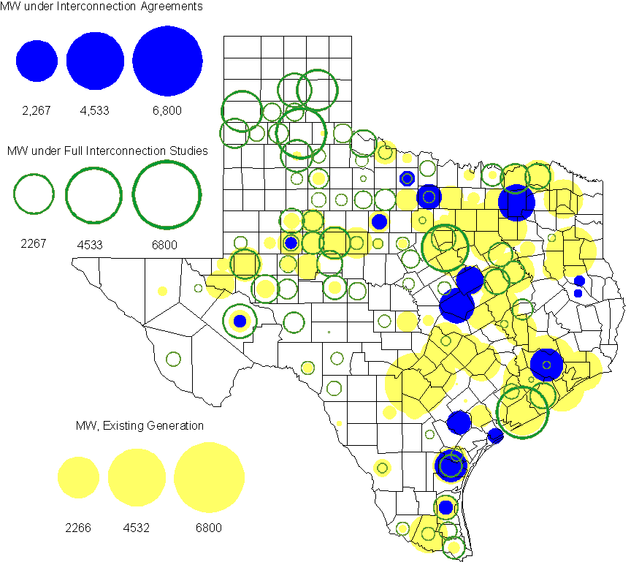

Generation Projects Undergoing Full Interconnection Studies (not otherwise public)
INR | County | Capacity | COD | Fuel |  | INR | County | Capacity | COD | Fuel
09INR0061 | Kent | 258 | TBD | Wind |  | 09INR0054 | Stonewall | 149 | TBD | Wind
10INR0048 | Hardeman | 1,000 | TBD | Wind |  | 10INR0079 | Nolan | 60 | TBD | Wind
10INR0054 | Palo Pinto | 36 | TBD | Wind |  | 10INR0016 | Childress | 150 | TBD | Wind
10INR0029 | Hood | 810 | TBD | Gas |  | 10INR0052a | Knox | 21 | TBD | Wind
10INR0013 | Upton | 400 | TBD | Wind |  | 09INR0074 | Motley | 70 | TBD | Wind
10INR0041 | Floyd | 135 | TBD | Wind |  | 11INR0029 | Throckmorton | 200 | TBD | Wind
10INR0082 | Travis | 30 | TBD | Solar |  | 10INR0080 | Presidio | 144 | TBD | Solar
10INR0077 | Callahan | 101 | TBD | Wind |  | 10INR0060 | Willacy | 401 | TBD | Wind
10INR0056 | Borden | 249 | TBD | Wind |  | 10INR0051 | Brazoria | 200 | TBD | Wind
10INR0042 | Mason | 170 | TBD | Wind |  | 10INR0033 | Armstrong | 399 | TBD | Wind
10INR0032 | Navarro | 775 | TBD | Gas |  | 10INR0019 | Deaf Smith | 609 | TBD | Wind
10INR0008 | Pecos | 500 | TBD | Wind |  | 07INR0035 | Tom Green | 270 | TBD | Wind
07INR0015 | Foard | 180 | TBD | Wind |  | 07INR0013 | Coke | 200 | TBD | Wind
11INR0076 | Archer | 94 | Jan-11 | Wind |  | 11INR0088 | Brazos | 45 | Mar-11 | Gas
11INR0082A | Val Verde | 50 | Mar-11 | Wind |  | 11INR0083A | Crockett | 50 | Mar-11 | Wind
11INR0081 | Live Oak | 72 | Mar-11 | Wind |  | 11INR0050 | Crosby | 149 | Mar-11 | Wind
11INR0086 | Travis | 60 | Apr-11 | Solar |  | 11INR0075 | Fort Bend | 15 | Apr-11 | Coal
11INR0071 | Harris | 7 | Apr-11 | Gas |  | 11INR0062 | Nueces | 149 | May-11 | Wind
11INR0058 | Pecos | 135 | May-11 | Solar |  | 11INR0060 | Tom Green | 90 | May-11 | Solar
11INR0061 | Presidio | 90 | May-11 | Solar |  | 11INR0037 | Smith | 50 | May-11 | Biomass
10INR0009 | Castro | 300 | May-11 | Wind |  | 11INR0033a | Cameron | 200 | May-11 | Wind
11INR0033b | Cameron | 200 | May-11 | Wind |  | 11INR0091 | Webb | 92 | Jun-11 | Wind
10INR0089 | Harris | 40 | Jun-11 | Other |  | 11INR0065 | Nueces | 240 | Jun-11 | Wind
11INR0057 | Cameron | 165 | Jun-11 | Wind |  | 11INR0054 | San Patricio | 161 | Jun-11 | Wind
10INR0057 | Taylor | 200 | Jun-11 | Wind |  | 11INR0019 | Upton | 200 | Jun-11 | Wind
10INR0023 | Haskell | 386 | Jun-11 | Wind |  | 09INR0050 | Fannin | 1,200 | Jun-11 | Gas
08INR0020 | Eastland | 200 | Jun-11 | Wind |  | 11INR0006 | Lamar | 579 | Jul-11 | Gas
11INR0040 | freestone | 640 | Aug-11 | Gas |  | 11INR0079a | Clay | 200 | Sep-11 | Wind
11INR0047 | Deaf Smith | 600 | Sep-11 | Wind |  | 11INR0039 | Starr | 201 | Sep-11 | Wind
10INR0081b | Clay | 19 | Oct-11 | Wind |  | 10INR0062a | Pecos | 80 | Oct-11 | Wind
07INR0014b | Wilbarger | 70 | Oct-11 | Wind |  | 07INR0014a | Wilbarger | 140 | Oct-11 | Wind
11INR0094 | Kent | 100 | Nov-11 | Solar |  | 11INR0090 | Howard | 60 | Nov-11 | Solar
10INR0021 | Grayson | 646 | Nov-11 | Gas |  | 11INR0089 | Hays | 20 | Dec-11 | Solar
12INR0034 | Borden | 342 | Dec-11 | Wind |  | 11INR0070 | Reeves | 50 | Dec-11 | Solar
11INR0067 | Cameron | 78 | Dec-11 | Wind |  | 11INR0043 | Coke | 300 | Dec-11 | Wind
11INR0025 | Crockett | 400 | Dec-11 | Wind |  | 11INR0013 | Mills | 150 | Dec-11 | Wind
08INR0049 | Clay | 50 | Dec-11 | Wind |  | 11INR0005 | Upton | 500 | Dec-11 | Wind
09INR0075 | Kinney | 248 | Dec-11 | Wind |  | 09INR0048 | Jack | 150 | Dec-11 | Wind
10INR0085 | Ector | 40 | Jan-12 | Solar |  | 12INR0033 | Motley | 150 | Jan-12 | Wind
12INR0021 | Edwards | 165 | Jan-12 | Wind |  | 12INR0042 | Deaf Smith | 400 | Mar-12 | Wind
10INR0018 | Madison | 550 | Mar-12 | Gas |  | 10INR0081a | Clay | 30 | May-12 | Wind
11INR0049 | Wharton | 275 | May-12 | gas |  | 12INR0007 | Lamar | 296 | May-12 | Gas
09INR0031 | Ector | 275 | May-12 | Gas |  | 12INR0053 | Crockett | 615 | Jun-12 | Wind
12INR0006 | Limestone | 875 | Jun-12 | Coal |  | 08INR0031 | Childress | 100 | Jun-12 | Wind
12INR0026 | Randall | 400 | Oct-12 | Wind |  | 08INR0041 | Coke | 200 | Oct-12 | Wind
12INR0035 | Nueces | 249 | Nov-12 | Wind |  | 08INR0044 | Concho | 200 | Nov-12 | Wind
12INR0022 | Hidalgo | 200 | Dec-12 | Wind |  | 12INR0005 | Floyd | 1,100 | Dec-12 | Wind
08INR0054 | Comanche | 401 | Dec-12 | Wind |  | 09INR0025 | Concho | 180 | Dec-12 | Wind
08INR0042 | Coke | 200 | Dec-12 | Wind |  | 12INR0029 | Swisher | 500 | Dec-12 | Wind
12INR0027 | Gray | 200 | Jan-13 | Wind |  | 10INR0024 | Briscoe | 2,940 | Jan-13 | Wind
11INR0082B | Val Verde | 150 | Mar-13 | Wind |  | 11INR0083B | Crockett | 100 | Mar-13 | Wind
09INR0058 | Howard | 250 | Mar-13 | Wind |  | 12INR0018 | Gray | 500 | Apr-13 | Wind
13INR0020a | Glasscock | 200 | May-13 | Wind |  | 10INR0062b | Pecos | 220 | May-13 | Wind
09INR0051 | Borden | 249 | Jun-13 | Wind |  | 09INR0041 | Mitchell | 300 | Jun-13 | Wind
13INR0023 | Ector | 240 | Jul-13 | Gas |  | 13INR0016 | Deaf Smith | 251 | Aug-13 | Wind
13INR0005 | Carson | 600 | Oct-13 | Wind |  | 13INR0004 | Deaf Smith | 500 | Oct-13 | Wind
13INR0028 | Hale | 392 | Nov-13 | Gas |  | 13INR0017 | Childress | 200 | Dec-13 | Wind
13INR0007 | Pecos | 200 | Dec-13 | Wind |  | 09INR0077 | Reagan | 500 | Dec-13 | Wind
12INR0002a | Briscoe | 200 | Dec-13 | Wind |  | 13INR0010 | Parmer | 1,200 | Dec-13 | Wind
09INR0073 | Scurry | 200 | Dec-13 | Wind |  | 13INR0006 | Gray | 750 | Jan-14 | Wind
08INR0019a | Gray | 250 | Jan-14 | Wind |  | 08INR0019b | Gray | 250 | Jan-14 | Wind
08INR0019c | Gray | 250 | Jan-14 | Wind |  | 13INR0020b | Glasscock | 150 | May-14 | Wind
10INR0015 | Mitchell | 350 | May-14 | Wind |  | 14INR0003 | Nolan | 850 | Jun-14 | Coal
13INR0021 | Llano | 600 | Dec-14 | Gas |  | 14INR0001 | Pecos | 500 | Dec-14 | Wind
12INR0002b | Briscoe | 200 | Dec-14 | Wind |  | 12INR0002c | Briscoe | 350 | Dec-15 | Wind
16INR0002 | Brazoria | 700 | Jun-17 | Other

Wind Generation

Wind Capacity Installed by Year

County Location of Installed Capacity and Interconnection Requests (Wind only)

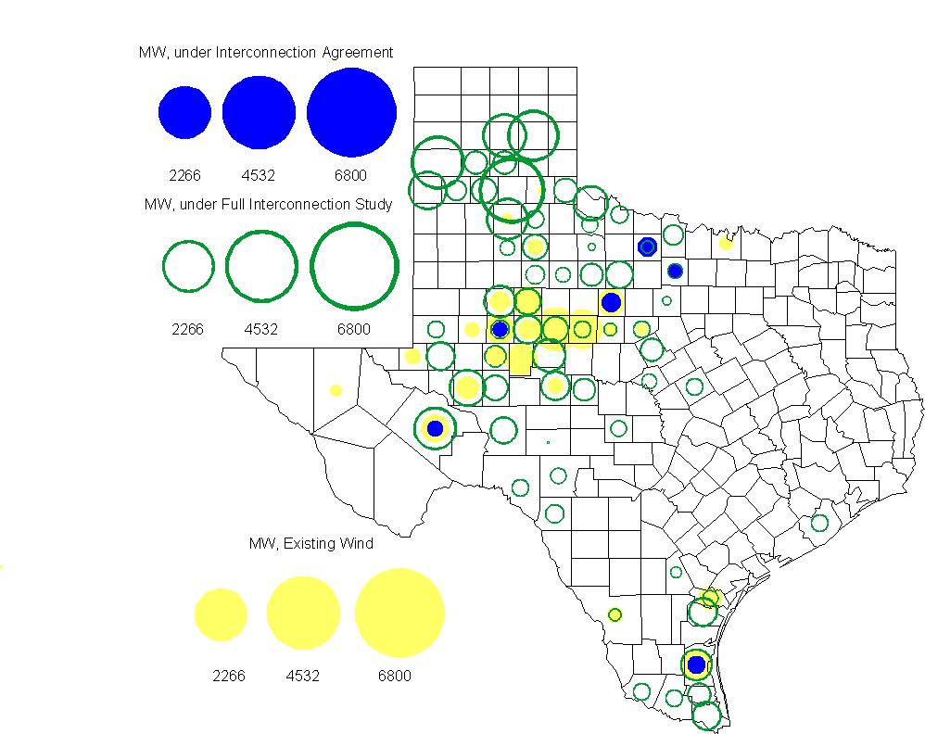

Regional Planning Group Project Reviews
- Oncor submitted a project to relieve congestion related to new wind units in the Lamesa area. The project consists of several 138 kV line upgrades in the Lamesa area and includes the creation of a new 345/ 138 kV substation. The revised cost estimate of this project is $38.4 M. The ERCOT Independent Review of this project has been completed.

- Pattern Energy has submitted a project to construct an HVDC tie with a capacity of up to 3000 MW between ERCOT and SERC. This project has exited Regional Planning Group review at this time and is currently following the revised process for evaluating projects related to asynchronous ties.

- Brazos Electric Cooperative has submitted a project to move some load that is currently being served by the Entergy Texas system into the ERCOT system. The project would involve disconnecting the subject load from the Entergy Texas system, constructing a new 345/ 138 kV substation in ERCOT, upgrading an existing 69 kV line in the ERCOT system and constructing two new 138 kV lines to serve the load from the ERCOT system. The estimated cost of this project is $51.1 M. The project is currently in study mode.

Congestion Costs
Dollars shown in graphs are settlement quality.

OOMC – last 13 months in million$

OOM Down – last 13 months in million$

Local Balancing Energy Down – last 13 months in million$

OOM Up – last 13 months in million$

Local Balancing Energy Up – last 13 months in million$

Replacement Reserve – last 13 months in thousand$

Average MCPE

Binding Constraints & Capacity Shortages– September, 2010
Contingency | Binding Element | Estimated Costs | Transmission Project | Clearance
Roanoke Switch - West Denton - Lewisville Switch 345kV | West Denton - Ft Worth 138kV | $ 1,127,996 | Roanoke Tap to West Denton 345kV CREZ Circuit [10TPIT0133] | High W_N flow
Austrop - Sandow 345kV | Round Rock - Round Rock Northeast 138kV | $ 563,652861 | Hutto Switch - Round Rock NE - Round Rock 138 kV line  [08TPIT0009] | High N-S zonal transfer  Outage: Gabriel-Jarrell East
Santa Anna - Ballinger 138kV | Ballinger - Humble 69kV | $ 450,097 | Ballinger to Steamboat, Rebuild portions of 69 kV line [12TPIT0070] | Outage on Putnam 138 kV, 69 kV operating bus
 | Low Voltage - Valley | $ 235,763 |  | Forced outage on Ajo-Rio Hondo 345kV
Greens Bayou - Gable & Hardy - Crockett 138kV | Garrott - Midtown 138kV | $ 160,897 | Upgrade 138 kV underground Ckt. 90 Garrott to Midtown to Polk [11TPIT0072] | High Load and Insufficient generation in East Houston
Oklaunion - Fisher Road - Bowman 345kV | Bomarton TU - Baylor County Tap 69kV | $ 158,528 |  | Olney - Westover PCAP
Sandow Switch - Austrop 345kV | Hutto - Round Rock Southeast 138kV | $ 132,036 | Hutto Switch - Round Rock NE - Round Rock 138 kV line  [08TPIT0009] | High N-S zonal transfer  Outage: Gabriel-Jarrell East
 | Houston area planned transmission outages | $ 111,894
 | Capacity Shortage | $ 84,824
Graham - Parker 345kV | Leon Switch - Flat Creek 138kV | $ 53,264 |  | Outage: Willow Creek Switch- Parker Switch 345kV & Graham SES - Jacksboro Switching 345KV

Inter-zonal Congestion

Wind Generation as a Percent of Load
One-hour average Settlement quality data shown.

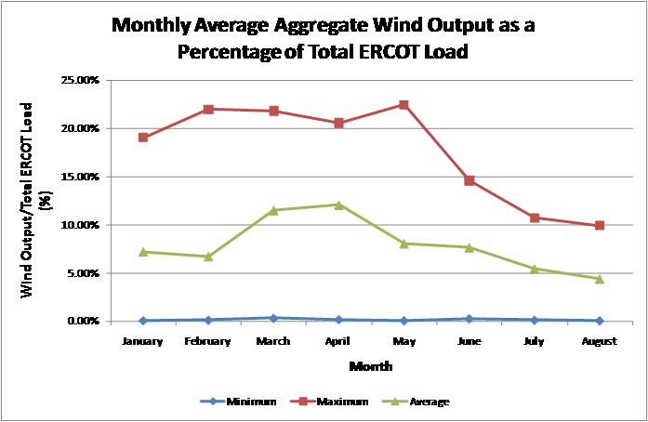

Planning Model Activities
- ERCOT and SSWG continued work to create a 2010 planning case by adding generation, load, and voltage profiles to the Topology Processor output in Model On Demand (MOD). Three passes have been completed for the 2010 case. The case solves if islands are disconnected and generator MVar limits are ignored. TSPs have not completed adding standard PMCRs in MOD that would provide additional reactive capability.
- Work will begin on the 2012 case using PSSE version 32 format starting Dec. 3, 2010. All standard PMCR’s will be applied to this case and the case will be completed using PMCR’s to model transmission projects expected to by complete by July 1, 2012. This case will be compared to the current DSB 2012SUM1 case completed in Nov. 2010. The projected schedule is as follows:
  - Dec. 3 – ERCOT creates Topology Processor case and loads into MOD
  - Dec. 17 – TSPs submit Pass 1 PMCR’s (standard PMCR’s only)
  - Jan. 7 - TSPs submit Pass 2 PMCR’s (standard PMCR’s and future project PMCR’s)
  - Jan. 21 - TSPs submit Pass 3 PMCR’s (standard PMCR’s and future project PMCR’s)

Other Notable Activities
- Work on the 2010 Five-Year Transmission Plan is wrapping up. The set of projects needed to reliably serve load in 2011 through 2015 has been identified and comments have been received. The analysis is currently focused on projects to relieve congestion for 2011 through 2015.

- A draft process for evaluating projects related to new or upgraded asynchronous ties has been completed. This process will be incorporated into the new Planning Guides in 2011.

- ABB has completed the CREZ Reactive Study. This study was conducted to optimize the reactive support equipment required to implement the CREZ plan. A final report will be available to market participants by mid-November.

- Work on the Long-Term System Assessment/DOE Study is ongoing.

- Transient Stability Study for 2011 Winter off-peak conditions: As part of the annual reliability assessment of the network, a transient stability study study is been performed on an ERCOT 2011 Winter off-peak case.

