ERCOT Operations Report
Nov 2010 ROS & OWG

Frequency Control
Time | Freq(Hz) | Duration (s)
11/2/2010 18:46 | 59.889 | 140 | Unit trip with 601 MW
11/3/2010 6:53 | 59.832 | 8 | Unit trip with 525 MW
11/3/2010 10:21 | 59.863 | 92 | Unit trip with 1353 MW and 83 MW
11/3/2010 10:30 | 60.143 | 140 | Due to deployment of LaaRs
11/7/2010 1:57 | 59.829 | 8 | Unit trip with 456 MW
11/8/2010 4:03 | 59.814 | 4 | Unit trip with 580 MW
11/8/2010 5:49 | 60.112 | 68 | Large SCE change
11/8/2010 8:07 | 59.837 | 504 | Incorrect offset calculation
11/8/2010 13:58 | 59.755 | 120 | Unit trip with 700 MW
11/8/2010 14:03 | 60.103 | 8 | Large SCE change
11/9/2010 19:10 | 60.125 | 244 | Out of Down Reg
11/10/2010 7:10 | 59.821 | 80 | Unit trip with 540 MW
11/10/2010 23:44 | 59.863 | 8 | Unit trip with 500 MW
11/11/2010 6:16 | 59.883 | 4 | Unit trip with 375 MW
11/13/2010 1:00 | 59.844 | 8 | Unit trip with 550 MW
11/16/2010 7:06 | 59.897 | 4 | Incorrect offset calculation and out of Up Reg.
11/17/2010 18:07 | 60.125 | 200 | Large ramp and slow system response recalling Up Reg.
11/24/2010 9:40 | 60.113 | 112 | Out of Down Reg
11/25/2010 0:32 | 59.844 | 8 | Unit trip with 480 MW
11/25/2010 4:30 | 60.147 | 828 | Large wind ramp of approximately 1800 MW in 30 minutes and out of Down Reg.
11/28/2010 6:48 | 59.893 | 4 | Unit trip with 400 MW
11/29/2010 20:47 | 59.899 | 8 | Unit trip with 400 MW loss. Out of Down Reg
11/30/2010 10:03 | 59.886 | 4 | Unit trip with 275 MW. Out of Down Reg
Note: Time of frequency excursions outside the range of +/- 0.1 Hz.

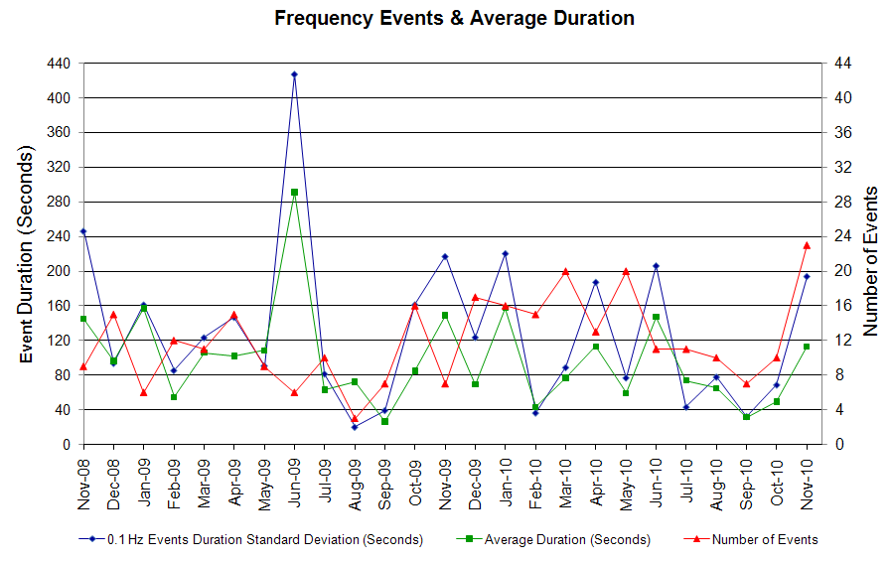

Deployed Responsive (Reported Above)
Time deployed | Stop Time | Duration | Max | Details
11/1/10 12:53:20 | 11/1/10 13:03:15 | 0:09:55 | 325.5 | Unit Trip
11/2/10 7:11:03 | 11/2/10 7:31:37 | 0:20:34 | 368.2
11/2/10 18:16:06 | 11/2/10 19:08:53 | 0:52:47 | 538.9 | Out of Up Reg
11/3/10 6:53:20 | 11/3/10 7:25:55 | 0:32:35 | 736.4
11/3/10 10:21:18 | 11/3/10 10:42:37 | 0:21:19 | 571
11/3/10 18:53:55 | 11/3/10 19:14:35 | 0:20:40 | 304.2 | Out of Up Reg
11/7/10 1:57:52 | 11/7/10 2:32:55 | 0:35:03 | 752.4
11/8/10 4:03:58 | 11/8/10 4:28:59 | 0:25:01 | 832.4
11/8/10 7:58:06 | 11/8/10 8:33:06 | 0:35:00 | 709.7
11/8/10 13:58:36 | 11/8/10 14:46:45 | 0:48:09 | 1147
11/10/10 7:10:20 | 11/10/10 7:30:33 | 0:20:13 | 795.1
11/10/10 23:45:00 | 11/10/10 23:57:41 | 0:12:41 | 571
11/11/10 6:17:00 | 11/11/10 6:27:25 | 0:10:25 | 464.2
11/13/10 1:00:49 | 11/13/10 1:19:19 | 0:18:30 | 672.3
11/16/10 7:03:44 | 11/16/10 7:22:02 | 0:18:18 | 389.5
11/17/10 6:24:00 | 11/17/10 6:46:07 | 0:22:07 | 341.5 | Unit Trip
11/23/10 13:09:57 | 11/23/10 13:18:24 | 0:08:27 | 352.2 | Unit Trip
11/25/10 0:32:45 | 11/25/10 0:47:28 | 0:14:43 | 677.7 | Unit Trip
11/25/10 11:19:45 | 11/25/10 11:28:42 | 0:08:57 | 341.5 | Unit Trip
11/28/10 6:48:05 | 11/28/10 6:58:08 | 0:10:03 | 410.9 | Unit Trip
11/29/10 20:47:52 | 11/29/10 20:54:48 | 0:06:56 | 410.9
11/30/10 0:03:49 | 11/30/10 0:14:24 | 0:10:35 | 357.5
11/30/10 10:03:53 | 11/30/10 10:14:54 | 0:11:01 | 448.2

Day-Ahead OOMC and RPRS Capacity Purchases
Details | OOMC | RPRS S1 | RPRS S2 | RPRS S1+S2 | RMR | Total
Western | 12 | 0 | 0 | 0 | 24 | 36
W RIO | 6 | 0 | 0 | 0 | 0 | 6
E RIO | 4 | 0 | 0 | 0 | 0 | 4
North | 0 | 0 | 0 | 0 | 0 | 0
DFW | 0 | 0 | 0 | 0 | 0 | 0
Corpus | 0 | 0 | 0 | 0 | 0 | 0
Houston | 0 | 0 | 0 | 0 | 0 | 0
Austin | 0 | 0 | 0 | 0 | 0 | 0
Northeast | 0 | 0 | 0 | 0 | 0 | 0
Bryan Area | 0 | 0 | 0 | 0 | 0 | 0
South | 0 | 0 | 0 | 0 | 0 | 0
San Antonio | 0 | 0 | 0 | 0 | 0 | 0
Laredo | 0 | 0 | 0 | 0 | 0 | 0
Total | 22 | 0 | 0 | 0 | 24 | 46

Historical Totals | Nov-10 | Nov-09 | Oct-10
Austin | 0 | 5 | 0
Bryan Area | 0 | 2 | 0
Corpus | 0 | 1 | 0
DFW | 0 | 19 | 0
E RIO | 4 | 4 | 14
Houston | 0 | 10 | 0
Laredo | 0 | 1 | 0
North | 0 | 2 | 1
Northeast | 0 | 0 | 0
San Antonio | 0 | 2 | 0
South | 0 | 3 | 0
W RIO | 6 | 44 | 0
Western | 36 | 9 | 21
Total | 46 | 102 | 36
http://www.ercot.com/mktinfo/services/rprsdr/index.html

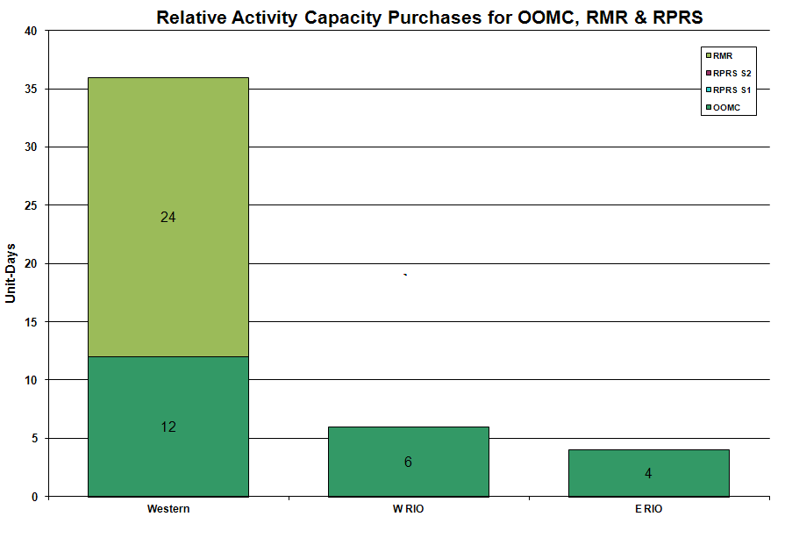

OOME and Congestion Management Activity
Congestion affected by outages Remedial action plan has been developed for the element
Contingency | Overloaded Element | Days
Base Case | Stanton - Midland East 138KV | 21
Base Case | Matador - Paducah 69KV | 16
Austrop - Sandow 345KV | Hutto - Round Rock Southeast 138KV | 13
Hamilton - Sonora 138KV | Sonora - Friess Ranch 69KV | 12
Matador - Paducah Clare Street 69KV | Spur - Girard Tap 69KV | 9
Base Case | Golden Switch - Sun Switch 138KV | 8
Braunig - Toyota and Valley 138KV | Westside CPS - Five Points 138KV | 8
Moss Switch - Holt Switch 138KV | Odessa North 138/69KV Auto | 7
Aspermont - Spur 138KV | Spur 138/69KV AT | 6
Graham SES - Parker Switch 345KV | Graham SES - Bowman Switch 345KV | 5
Midland East - Odessa EHV Switch 345KV | Fort Stockton - Barrilla 69KV | 5
Lon Hill - North Edinburg 345KV | Rio Hondo series Capacitors | 4
Barney Davis - Airline and Rodd Field 138KV | Nelson Sharpe 138KV phase shifting transformer | 4
Base Case | MEC Plainview Tap - Syntex Tap 69KV | 4
Willow Valley Switch – Lamesa 138KV | Ackerly Vealmoor - Ackerly 69KV | 4
Willow Valley Switch - Bluff Creek 138KV | Ackerly Vealmoor Switch - Ackerly 69KV | 4
Crane LCRA - Odessa EHV Switch 138KV | Fort Stockton Plant - Barilla 69KV | 4
Falcon Cal Energy - Morgan Creek 345KV | Forsan Tap - CRMWD7 Tap 138KV | 3
Crane LCRA - Odessa EHV Switch 138KV | Fort Stockton - Barrilla 69KV | 3
Greens Bayou - Gable Street and Hardy - Crockett 138KV | Garrott - Midtown 138KV | 2
Moss Switch 345/138KV AT | Midland East 345/138KV AT | 2
Permian Basin Unit 6 | Fort Stockton - Barrilla 69KV | 2
Base Case | MEC Plainview - WKN Breaker 69KV | 2
Fern Street - Ball Park 138KV | Westside CPS - Five Points 138KV | 2
Firerock - Santa Anna 138KV | Brownwood 138/69KV AT | 2
Richland Chambers - Big Brown 345KV | Forest Grove Switch - Mabank Tap 138KV | 2
Singleton - Tomball and Singleton - Roans Prairie Reit 345KV | Singleton - TH Wharton 345KV. | 2
Singleton - Tomball and Singleton - Roans Prairie Reit 345KV | Garrott - Midtown 138KV | 2
WA Parish - Obrien 345KV | Garrot - Midtown 138KV | 2
Falcon Cal Energy - Midland East 345KV | Fort Stockton Switch - Barrila 69KV | 1
Graham - Long Creek - Cook Field Road Switch 345KV | Paint Creek - Murray TU 138KV | 1
Lobo 345/138KV AT #2 | Freer - San Diego 69KV | 1
Kendall - Hays Energy 345KV | Kendall 345/138KV AT 1 | 1
Aspermont - Spur 138KV | Matador - Paducah REA Tap 69KV | 1
Barney Davis - Airline 138KV | Nelson Sharpe 138KV phase shifting transformer | 1
Cal Energy - Morgan Creek 345KV | Stanton East Switching Station - Midland East 138KV | 1
Calaveras - Ball Park 138KV | Westside CPS - Five Points 138KV | 1
Falcon Cal Energy - Midland East 345KV | Moss Switch 345/138KV AT | 1
Greens Bayou - Gable Street and Hardy - Crockett 138KV | Garrott - Midtown 138KV | 1
Lon Hill - Nelson Sharpe 345KV | Nelson Sharpe - Celanese Bishop | 1
McDonald - Spraberry 138KV | Stanton East Switch - Midland East 138KV | 1
Midland East - Odessa Ector EHV 345KV | Odessa Ector EHV - Big Three Odessa Tap 138KV | 1
North Edinburg - Rio Hondo 345KV | Haine Drive - Harlingen Switch 138KV | 1
Oak Creek - Ballinger 138KV | Abilene South - Cedar Gap 69KV | 1
Temple Creek - Tradinghouse and Temple Switch - Lake Creek 345KV | Lake Creek 345/138KV AT1 | 1
Temple Pecan Creek - Tradinghouse and Temple Switch - Lake Creek 345KV | Waco West 138/69KV AT | 1
West Columbia - West Columbia Main 138KV | West Columbia Main - West Columbia Local 138K | 1

Zonal OC1
CSC | Days
West – North | 27
North – Houston | 6

New RAP, PCAP (Date indicates last update of RAP, PCAP not implementation date.)
None

New Procedures/Forms/Operations Bulletins
Date | Subject | Bulletin No.
11/01/2010 | Nodal Shift Supervisor Desk V1 Rev 0 | 503
11/12/2010 | Nodal Resource Desk V1 Rev 0 | 502
11/01/2010 | Nodal Real Time Desk V1 Rev 0 | 501
11/12/2010 | Nodal Reliability Unit Commitment Desk V1 Rev 0 | 500
11/12/2010 | Nodal Transmission and Security Desk V1 Rev 0 | 499
11/12/2010 | Nodal DC-Tie Desk V1 Rev 0 | 498

Blackout/Load Shed Incidences
None

EEA
None

Major System Voltage Problems
None

Major Computer Problems, Enhancements & Fixes
None

Communication
None

ERCOT peak (Unofficial)
11/01 17:00 40,114 MW

Yearly MTLF Error Comparison
Yearly Mid-Term (Hourly) Load Forecast Error Comparison for the ERCOT Forecast
Month | MAPE for MTLF at 16:00 Day-Ahead
Month | 2007 | 2008 | 2009 | 2010
January | 4.55 | 3.30 | 4.11 | 3.78
February | 3.75 | 3.59 | 3.49 | 3.79
March | 2.70 | 3.29 | 3.24 | 2.24
April | 3.00 | 2.45 | 2.66 | 2.47
May | 3.22 | 3.01 | 2.90 | 2.63
June | 4.46 | 2.81 | 2.89 | 2.84
July | 4.29 | 2.55 | 2.83 | 2.39
August | 3.11 | 3.66 | 3.07 | 2.29
September | 3.78 | 4.99 | 3.68 | 3.14
October | 3.08 | 2.79 | 2.92 | 2.37
November | 2.95 | 2.60 | 1.93 | 3.46
December | 3.74 | 4.54 | 3.70 | NA
Annual Average | 3.55 | 3.29 | 3.11 | 2.85

OCN, Advisory, Watch & Emergency Notices
Capacity
Date | Start | End | Event
11/3/10 | 11:00 | 12:45 | Advisory issued for ARRS below 3000 MW.
11/7/10 | 5:40 | 9:26 | Advisory issued for ARRS below 3000 MW.
11/30/10 | 18:34 | 21:35 | Advisory issued due to ARRS below 2500 MW.
11/30/10 | 13:30 | 15:30 | Watch issued due to time-line deviation for Day Ahead Market.

Transmission Watch
11/10 12:38 ERCOT issued a watch due to the forced outage. The contingency loss of North Edinburgh - Lon Hill 345KV will cause voltage issues in the Valley area. Emergency energy was received from CFE across Railroad Dc-Tie.

Emergency Notice
None

Texas RE Event Analysis
11/02 01:12 Stanton Switch Station SPS #46 activated. ERCOT does not see any evidence that the Stanton East Switching Station SPS #46 SPS failed to operate as designed.

11/02 07:10 Simultaneous wind units ramped back and then successively tripped over a period of 7 minutes, resulting in the loss of approximately 601 MW.

11/03 10:21 Emergency Notice for a NERC Reportable Disturbance Control Standard (DCS) Event for loss of two units at different plants for a total of 1436 MW of generation; however it should be excluded from compliance evaluation as it is larger than the most severe single contingency event, based on NERC Reliability Standard BAL-002. ERCOT ISO system frequency recovered to 60 Hz in approximately 5 minutes and 10 seconds.
11/03 11:42 Stanton Switch Station SPS #46 activated. ERCOT does not see any evidence that the Stanton East Switching Station SPS #46 SPS failed to operate as designed.

11/03 12:30 Stanton Switch Station SPS #46 activated. ERCOT does not see any evidence that the Stanton East Switching Station SPS #46 SPS failed to operate as designed.

11/06 20:00 Stanton Switch Station SPS #46 activated. ERCOT does not see any evidence that the Stanton East Switching Station SPS #46 SPS failed to operate as designed.

11/08 07:48 Stanton Switch Station SPS #46 activated. ERCOT does not see any evidence that the Stanton East Switching Station SPS #46 SPS failed to operate as designed.

11/09 01:31 Stanton Switch Station SPS #46 activated. ERCOT does not see any evidence that the Stanton East Switching Station SPS #46 SPS failed to operate as designed.

11/09 06:55 Stanton Switch Station SPS #46 activated. ERCOT does not see any evidence that the Stanton East Switching Station SPS #46 SPS failed to operate as designed.

11/16 23:59 Stanton Switch Station SPS #46 activated. ERCOT does not see any evidence that the Stanton East Switching Station SPS #46 SPS failed to operate as designed.

11/17 09:24 Stanton Switch Station SPS #46 activated. ERCOT does not see any evidence that the Stanton East Switching Station SPS #46 SPS failed to operate as designed.

11/19 00:17 Stanton Switch Station SPS #46 activated. Still under investigation.

11/25 04:21 The ERCOT BA exceeded the NERC BAAL High trigger limit for 15 consecutive minutes on 11/25/10. The event was the result of a strong storm system moving over a large part of ERCOT Interconnection, where the majority of wind generation is concentrated. The prompt identification of the issues and actions taken were successful in restoring frequency to scheduled values. Still under investigation.

11/25 06:02 Stanton Switch Station SPS #46 activated. Still under investigation.

11/29 00:57 Stanton Switch Station SPS #46 activated. Still under investigation.

11/30 22:53 Stanton Switch Station SPS #46 activated. Still under investigation.

11/30 23:57 Stanton Switch Station SPS #46 activated. Still under investigation.

Others

None

