 |  |  |  | System Planning Division
Monthly Status Report
to
Reliability and Operations Subcommittee
for
October 2010

 |  | Report Highlights
Item
1. | - ERCOT is currently tracking 194 active generation interconnection requests totaling over 65,000 MW. This includes almost 39,000 MW of wind generation.
2. | - ERCOT is currently reviewing proposed transmission improvements with a total cost of $131.9 Million  - Transmission Projects endorsed in 2010 total $230.4 Million  - All projects (in engineering, routing, licensing and construction) total approximately $9.4 Billion  - Transmission Projects energized in 2010 total about $791.7 million

Table of Contents
1. Generation Interconnection 1
1.1 New Generation Registering for Commercial Operations 1
1.2 Publicly Disclosed Generation Interconnection Projects 4
1.3 Generation Projects Undergoing Full Interconnection Studies (not otherwise public) 6
1.4 Wind Generation 7
Wind Capacity Installed by Year 7
2. Regional Planning Group Project Reviews 9
3. Congestion Costs 10
4. Wind Generation as a Percent of Load 16
5. Other Notable Activities 17

1. Generation Interconnection
Additional information regarding detailed generation interconnection and impact studies is contained in the “Generation Project Interconnection Information” folder in the “Operations and System Planning” area on the ERCOT website: http://planning.ercot.com/login/login.

New Generation Registering for Commercial Operations

Cedro Hill Wind (09INR0082) 150 MW in Webb County
The total installed wind capacity is 9,467 MW, of which 7,958 MW (84%) is located within the Western Congestion Management Zone.

New Generation Interconnection Agreements

Archer Young Wind (08INR0062) 250 MW in Archer County

Pondera King Power (10INR0022) 1,380 MW of Combined Cycle Gas in Harris County

Summary of Active Generation Interconnection Requests

GENERATION INTERCONNECTION REQUESTS CURRENTLY BEING PROCESSED
Currently tracking 194 active generation interconnection or change requests
As of October 31, 2010 | North | South | West | Total
Security Screening Study | 0 | 2 | 8 | 10
SSS Completed | 2 | 3 | 11 | 16
Full Interconnect Study | 19 | 14 | 94 | 127
FIS Completed | 4 | 14 | 4 | 21
Interconnect Agreement Completed | 8 | 6 | 5 | 19
Capacity under Interconnection Agreements | 5,192 | 3,742 | 756 | 9,690
Capacity for Grid, MW | 19,200 | 13,144 | 33,244 | 65,588
Wind Capacity, MW | 3,907 | 4,491 | 30,393 | 38,791

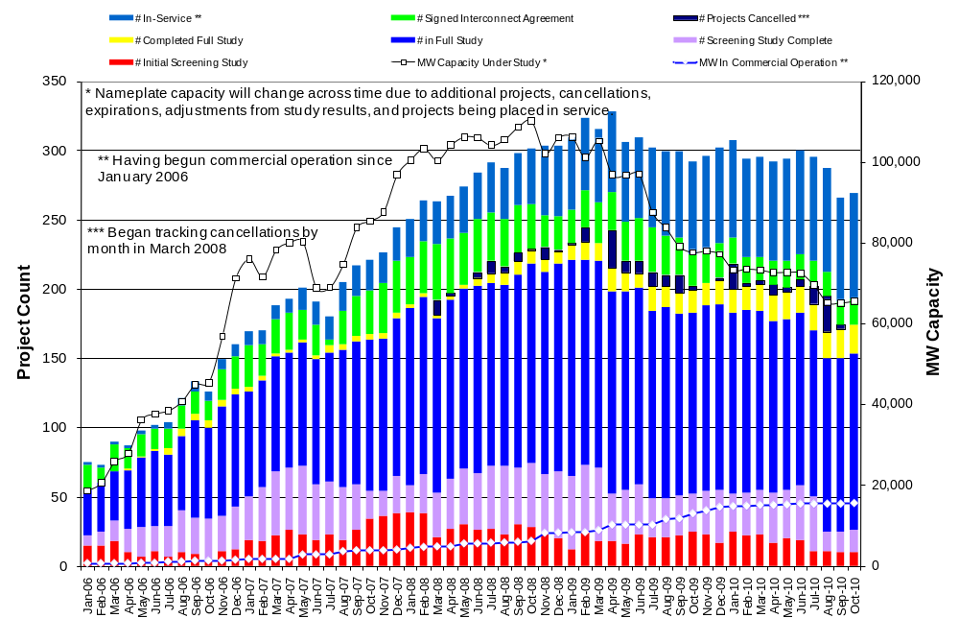

Fuel Type | Confidential Projects (MW) | Projects Under Full Study (MW) | Projects w/ Interconnect Agreement/Public Letter (MW) | Grand Total (MW)
Gas-CC |  |  | 5,352 | 12,054
Gas-CT |  |  |  | 639
Total Gas | 11 | 7,330 | 5,352 | 12,693
Nuclear |  |  | 5,900 | 5,900
Coal |  | 1,740 | 3,210 | 4,950
Wind | 3,245 | 29,493 | 6,053 | 38,791
Solar | 360 | 719 |  | 1,079
Biomass |  | 50 | 145 | 195
Other |  | 740 | 1,240 | 1,980
Grand Total | 3,616 | 40,072 | 21,900 | 65,588

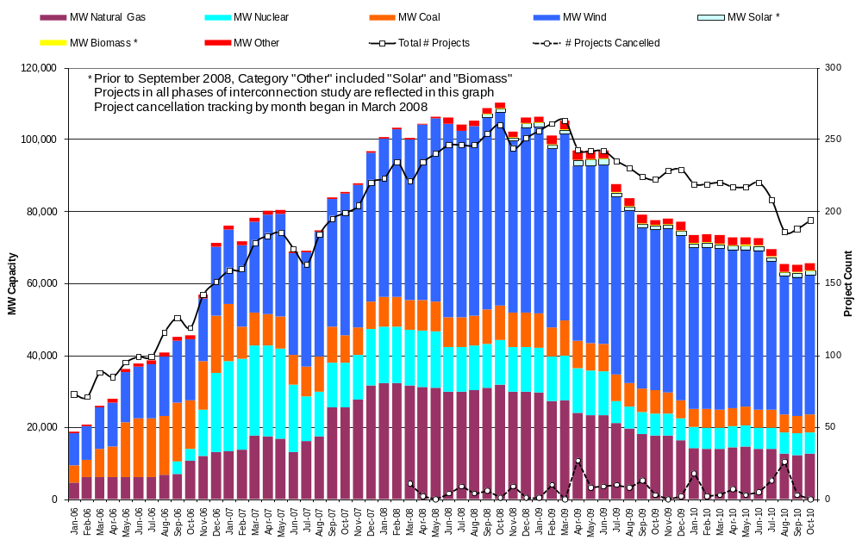

Publicly Disclosed Generation Interconnection Projects
The table below summarizes the publicly disclosed generation projects for the ERCOT region.
(Status: IA=Interconnect Agreement, PL=Public Letter, XX= cancelled)
Generation Interconnections as of October 31, 2010
INR | SiteName | Status | County | Region | COD | Fuel Type |  | MW For Grid | Change from Last Report
08INR0033 | Lufkin | IA | Angelina | North | Dec-10 |  | Biomass | 45
12INR0003 | Throckmorton Wind Farm | PL | Throckmorton | West | Dec-10 |  | Wind | 400
05INR0015b | Gulf Wind 2 | PL | Kenedy | South | Jan-11 |  | Wind | 400
05INR0015c | Gulf Wind 3 | PL | Kenedy | South | Jan-11 |  | Wind | 400
08INR0065 | Buffalo Gap 4 and 5 | PL | Nolan | West | Mar-11 |  | Wind | 465
09INR0029 | CFB Power Plant Units 11&12 | IA | Calhoun | South | Mar-11 |  | Coal | 260
10INR0010 | Jack County 2 | IA | Jack | North | Jun-11 |  | Gas-CC | 620
08INR0011 | Senate Wind Project | IA | Jack | North | Nov-11 |  | Wind | 150
08INR0038 | M Bar Wind | PL | Andrews | West | Dec-11 |  | Wind | 194
09INR0034 | Gatesville Wind Farm | PL | Coryell | North | Dec-11 |  | Wind | 200
08INR0025 | Pistol Hill Energy Center | PL | Ector | West | Dec-11 |  | Wind | 300
06INR0012b | Sherbino Mesa Wind Farm 2 | IA | Pecos | West | Jan-12 |  | Wind | 150
09INR0001 | Sandy Creek 1 | IA | McLennan | North | Feb-12 |  | Coal | 925
08INR0062 | Archer-Young | IA | Young | West | Mar-12 |  | Wind | 250 | New
11INR0084 | 2W Whatley Phase 1 | PL | Ector | West | Mar-12 |  | Wind | 45
09INR0007 | Nacogdoches Project | IA | Nacogdoches | North | Apr-12 |  | Biomass | 100
07INR0004 | Pampa Energy Center | PL | Gray | West | May-12 |  | Coal | 165
09INR0024 | B&B Panhandle Wind | PL | Carson | West | Jun-12 |  | Wind | 1001
09INR0037 | Scurry County Wind III | PL | Scurry | West | Jun-12 |  | Wind | 350
12INR0004 | Fort Concho Wind Farm | PL | Tom Green | West | Jul-12 |  | Wind | 400
12INR0043 | 2W Whatley Phase 2 | PL | Ector | West | Aug-12 |  | Wind | 290
09INR0036 | McAdoo Energy Center II | PL | Dickens | West | Dec-12 |  | Wind | 500
08INR0018 | Gunsight Mountain | IA | Howard | West | Dec-12 |  | Wind | 120
06INR0022c | Penascal Wind Farm 3 | IA | Kenedy | South | Dec-12 |  | Wind | 202
10INR0020a | Panda Temple Power | IA | Bell | North | May-13 |  | Gas-CC | 780
06INR0006 | Cobisa-Greenville | IA | Hunt | North | May-14 |  | Gas-CC | 1792 | Date
10INR0022 | Pondera King Power Project | IA | Harris | South | Jun-14 |  | Gas-CC | 1380 | New
04INR0011b | Cedar Elm | IA | Shackelford | West | Jun-14 |  | Wind | 136
04INR0011c | Cottonwood Wind | IA | Shackelford | West | Jun-14 |  | Wind | 100
14INR0005 | White Stallion Energy Center | PL | Matagorda | South | Jul-14 |  | Coal | 1200
14INR0002 | Coleto Creek Unit 2 | IA | Goliad | South | Nov-14 |  | Coal | 660
10INR0020b | Panda Temple Power | IA | Bell | North | Dec-14 |  | Gas-CC | 780
12INR0016a | Las Brisas Energy Center | IA | Nueces | South | Jun-15 |  | Other | 620 | Date,Capacity
12INR0016b | Las Brisas Energy Center | IA | Nueces | South | Jun-16 |  | Other | 620 | Date,Capacity
15INR0008 | STP 3 and 4 | PL | Matagorda | South | Jun-16 |  | Nuclear | 2700
15INR0002 | Comanche Peak 3 and 4 | PL | Somervel | North | Dec-18 |  | Nuclear | 3200
 |  |  |  |  |  |  | TOTAL | 21,900

County Location of Installed Generation and Interconnection Requests (all fuels)

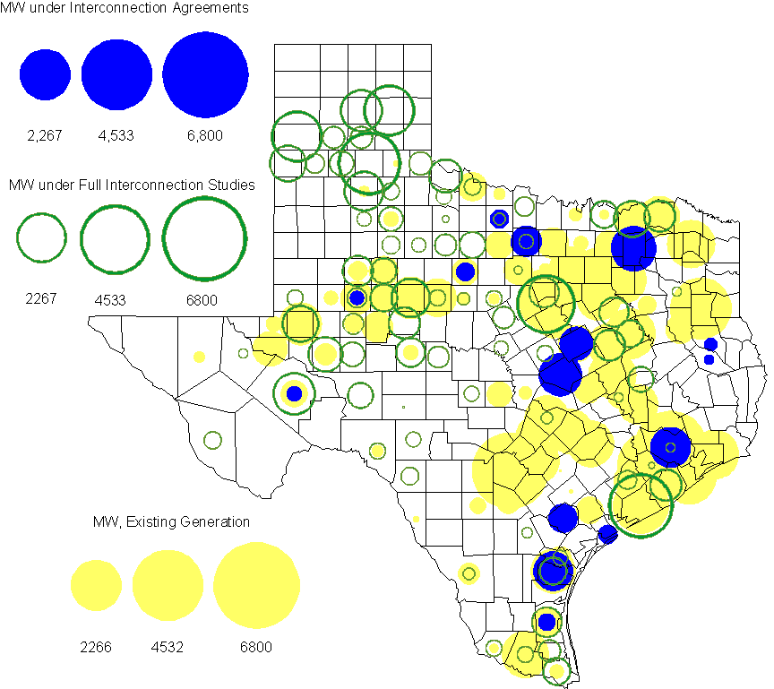

Generation Projects Undergoing Full Interconnection Studies (not otherwise public)
INR | County | Capacity | COD | Fuel |  | INR | County | Capacity | COD | Fuel
09INR0054 | Stonewall | 149 | TBD | Wind |  | 09INR0061 | Kent | 258 | TBD | Wind
10INR0048 | Hardeman | 1,000 | TBD | Wind |  | 10INR0016 | Childress | 150 | TBD | Wind
10INR0054 | Palo Pinto | 36 | TBD | Wind |  | 10INR0079 | Nolan | 60 | TBD | Wind
10INR0029 | Hood | 810 | TBD | Gas |  | 10INR0013 | Upton | 400 | TBD | Wind
10INR0052a | Knox | 21 | TBD | Wind |  | 09INR0074 | Motley | 70 | TBD | Wind
10INR0041 | Floyd | 135 | TBD | Wind |  | 11INR0029 | Throckmorton | 200 | TBD | Wind
07INR0013 | Coke | 200 | Dec-10 | Wind |  | 07INR0015 | Foard | 180 | Dec-10 | Wind
07INR0035 | Tom Green | 270 | Dec-10 | Wind |  | 10INR0008 | Pecos | 500 | Dec-10 | Wind
10INR0019 | Deaf Smith | 609 | Dec-10 | Wind |  | 10INR0032 | Navarro | 775 | Dec-10 | Gas
10INR0033 | Armstrong | 399 | Dec-10 | Wind |  | 10INR0042 | Mason | 170 | Dec-10 | Wind
10INR0051 | Brazoria | 200 | Dec-10 | Wind |  | 10INR0056 | Borden | 249 | Dec-10 | Wind
10INR0060 | Willacy | 401 | Dec-10 | Wind |  | 10INR0077 | Callahan | 101 | Dec-10 | Wind
10INR0080 | Presidio | 144 | Dec-10 | Solar |  | 10INR0082 | Travis | 30 | Dec-10 | Solar
11INR0076 | Archer | 94 | Jan-11 | Wind |  | 11INR0050 | Crosby | 149 | Mar-11 | Wind
11INR0081 | Live Oak | 72 | Mar-11 | Wind |  | 11INR0082A | Val Verde | 50 | Mar-11 | Wind
11INR0083A | Crockett | 50 | Mar-11 | Wind |  | 11INR0088 | Brazos | 45 | Mar-11 | Gas
11INR0071 | Harris | 7 | Apr-11 | Gas |  | 11INR0075 | Fort Bend | 15 | Apr-11 | Coal
11INR0086 | Travis | 60 | Apr-11 | Solar |  | 10INR0009 | Castro | 300 | May-11 | Wind
11INR0037 | Smith | 50 | May-11 | Biomass |  | 11INR0058 | Pecos | 135 | May-11 | Solar
11INR0060 | Tom Green | 90 | May-11 | Solar |  | 11INR0061 | Presidio | 90 | May-11 | Solar
11INR0062 | Nueces | 149 | May-11 | Wind |  | 11INR0033a | Cameron | 200 | May-11 | Wind
11INR0033b | Cameron | 200 | May-11 | Wind |  | 08INR0020 | Eastland | 200 | Jun-11 | Wind
09INR0050 | Fannin | 1,200 | Jun-11 | Gas |  | 10INR0023 | Haskell | 386 | Jun-11 | Wind
10INR0057 | Taylor | 200 | Jun-11 | Wind |  | 10INR0089 | Harris | 40 | Jun-11 | Other
11INR0019 | Upton | 200 | Jun-11 | Wind |  | 11INR0054 | San Patricio | 161 | Jun-11 | Wind
11INR0057 | Cameron | 165 | Jun-11 | Wind |  | 11INR0065 | Nueces | 240 | Jun-11 | Wind
11INR0091 | Webb | 92 | Jun-11 | Wind |  | 11INR0006 | Lamar | 579 | Jul-11 | Gas
11INR0040 | Freestone | 640 | Aug-11 | Gas |  | 11INR0039 | Starr | 201 | Sep-11 | Wind
11INR0047 | Deaf Smith | 600 | Sep-11 | Wind |  | 11INR0079a | Clay | 200 | Sep-11 | Wind
07INR0014a | Wilbarger | 140 | Oct-11 | Wind |  | 07INR0014b | Wilbarger | 70 | Oct-11 | Wind
10INR0062a | Pecos | 80 | Oct-11 | Wind |  | 10INR0081b | Clay | 19 | Oct-11 | Wind
10INR0021 | Grayson | 646 | Nov-11 | Gas |  | 11INR0090 | Howard | 60 | Nov-11 | Solar
08INR0049 | Clay | 50 | Dec-11 | Wind |  | 11INR0005 | Upton | 500 | Dec-11 | Wind
11INR0013 | Mills | 150 | Dec-11 | Wind |  | 11INR0025 | Crockett | 400 | Dec-11 | Wind
11INR0043 | Coke | 300 | Dec-11 | Wind |  | 11INR0067 | Cameron | 78 | Dec-11 | Wind
11INR0070 | Reeves | 50 | Dec-11 | Solar |  | 11INR0089 | Hays | 20 | Dec-11 | Solar
12INR0034 | Borden | 342 | Dec-11 | Wind |  | 09INR0048 | Jack | 150 | Dec-11 | Wind
09INR0075 | Kinney | 248 | Dec-11 | Wind |  | 10INR0085 | Ector | 40 | Jan-12 | Solar
12INR0021 | Edwards | 165 | Jan-12 | Wind |  | 12INR0033 | Motley | 150 | Jan-12 | Wind
10INR0018 | Madison | 550 | Mar-12 | Gas |  | 12INR0042 | Deaf Smith | 400 | Mar-12 | Wind
09INR0031 | Ector | 275 | May-12 | Gas |  | 10INR0081a | Clay | 30 | May-12 | Wind
11INR0049 | Wharton | 275 | May-12 | Gas |  | 12INR0007 | Lamar | 296 | May-12 | Gas
08INR0031 | Childress | 100 | Jun-12 | Wind |  | 12INR0006 | Limestone | 875 | Jun-12 | Coal
12INR0053 | Crockett | 615 | Jun-12 | Wind |  | 08INR0041 | Coke | 200 | Oct-12 | Wind
12INR0026 | Randall | 400 | Oct-12 | Wind |  | 08INR0044 | Concho | 200 | Nov-12 | Wind
12INR0035 | Nueces | 249 | Nov-12 | Wind |  | 08INR0042 | Coke | 200 | Dec-12 | Wind
08INR0054 | Comanche | 401 | Dec-12 | Wind |  | 09INR0025 | Concho | 180 | Dec-12 | Wind
12INR0005 | Floyd | 1,100 | Dec-12 | Wind |  | 12INR0022 | Hidalgo | 200 | Dec-12 | Wind
12INR0029 | Swisher | 500 | Dec-12 | Wind |  | 10INR0024 | Briscoe | 2,940 | Jan-13 | Wind
12INR0027 | Gray | 200 | Jan-13 | Wind |  | 09INR0058 | Howard | 250 | Mar-13 | Wind
11INR0082B | Val Verde | 150 | Mar-13 | Wind |  | 11INR0083B | Crockett | 100 | Mar-13 | Wind
12INR0018 | Gray | 500 | Apr-13 | Wind |  | 10INR0062b | Pecos | 220 | May-13 | Wind
13INR0020a | Glasscock | 200 | May-13 | Wind |  | 09INR0041 | Mitchell | 300 | Jun-13 | Wind
09INR0051 | Borden | 249 | Jun-13 | Wind |  | 13INR0023 | Ector | 240 | Jul-13 | Gas
13INR0016 | Deaf Smith | 251 | Aug-13 | Wind |  | 13INR0004 | Deaf Smith | 500 | Oct-13 | Wind
13INR0005 | Carson | 600 | Oct-13 | Wind |  | 13INR0028 | Hale | 392 | Nov-13 | Gas
08INR0022 | Floyd | 100 | Dec-13 | Wind |  | 08INR0023 | Floyd | 100 | Dec-13 | Wind
09INR0077 | Reagan | 500 | Dec-13 | Wind |  | 12INR0002a | Briscoe | 200 | Dec-13 | Wind
13INR0007 | Pecos | 200 | Dec-13 | Wind |  | 13INR0017 | Childress | 200 | Dec-13 | Wind
09INR0073 | Scurry | 200 | Dec-13 | Wind |  | 13INR0010 | Parmer | 1,200 | Dec-13 | Wind
08INR0019a | Gray | 250 | Jan-14 | Wind |  | 08INR0019b | Gray | 250 | Jan-14 | Wind
08INR0019c | Gray | 250 | Jan-14 | Wind |  | 13INR0006 | Gray | 750 | Jan-14 | Wind
10INR0015 | Mitchell | 350 | May-14 | Wind |  | 13INR0020b | Glasscock | 150 | May-14 | Wind
14INR0003 | Nolan | 850 | Jun-14 | Coal |  | 12INR0002b | Briscoe | 200 | Dec-14 | Wind
13INR0021 | Llano | 600 | Dec-14 | Gas |  | 14INR0001 | Pecos | 500 | Dec-14 | Wind
12INR0002c | Briscoe | 350 | Dec-15 | Wind |  | 16INR0002 | Brazoria | 700 | Jun-17 | Other

Wind Generation

Wind Capacity Installed by Year

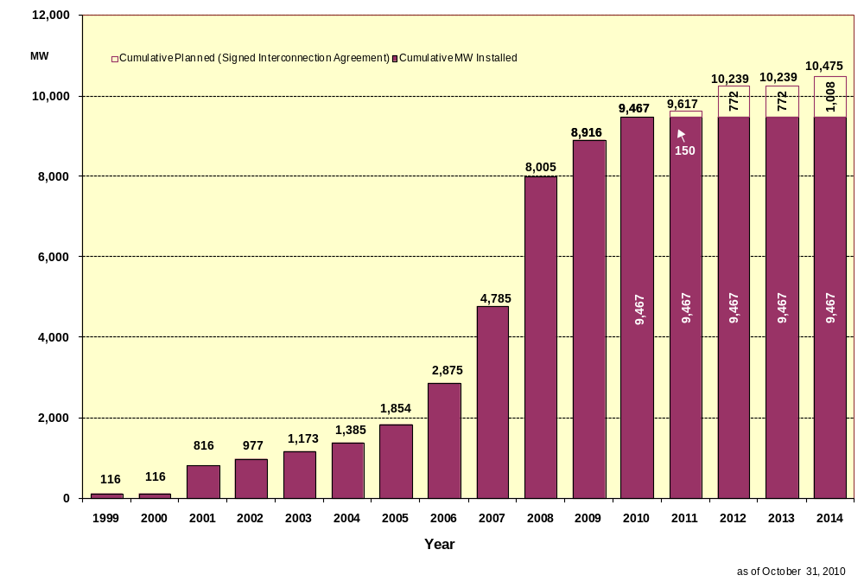

County Location of Installed Capacity and Interconnection Requests (Wind only)

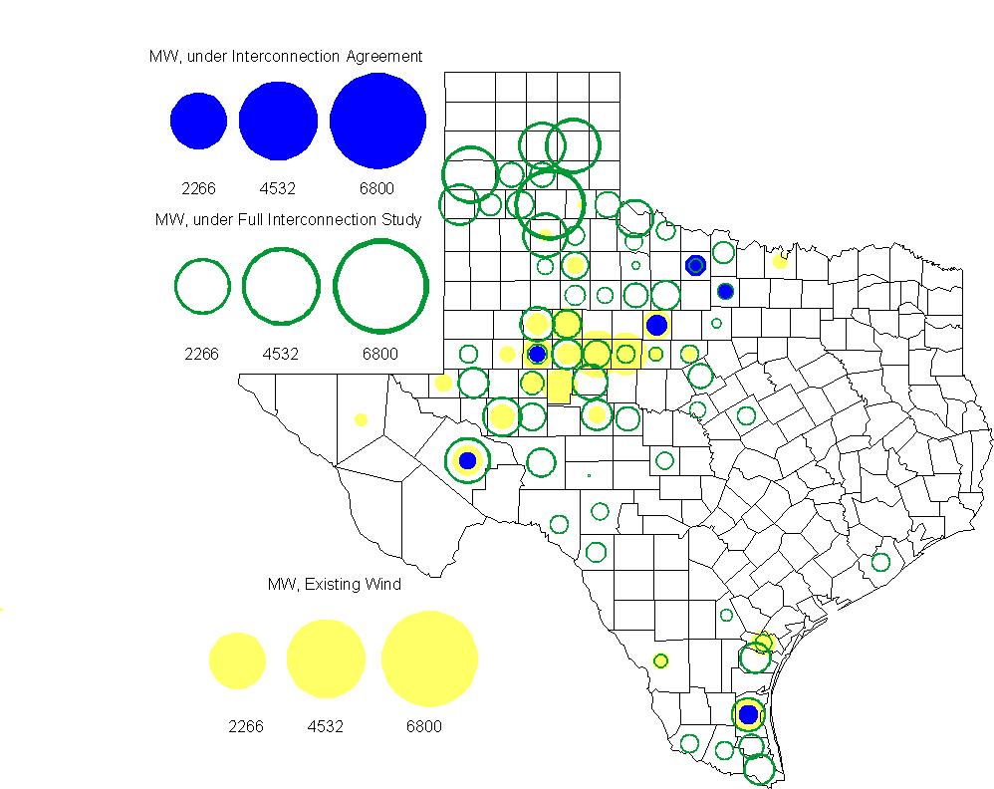

Regional Planning Group Project Reviews
- Oncor submitted a project to relieve congestion related to new wind units in the Lamesa area. The project will upgrade the Lamesa to Bluff Creek 138 kV line, rebuild the Bluff Creek to China Grove 138 kV line, rebuild the Lamesa to Ackerly Vealmoor 69 kV line to 138/69 kV double circuit, rebuild the Lamesa 138 kV switching station, build a new 138 kV Ackerly Vealmoor station, add second circuits to all rebuilt lines and include station upgrades at China Grove and Big Spring. The cost of this project is $ 80.8 M. This project will be reviewed to ensure that the improvements fit into the likely CREZ transmission solution for the area. This project is in ERCOT Independent Review.

- Pattern Energy has submitted a project to construct an HVDC tie with a capacity of up to 3000 MW between ERCOT and SERC. This project is in study mode. ERCOT is currently developing a process for evaluating asynchronous ties with other grids.

- Brazos Electric Cooperative has submitted a project to move some load that is currently being served by the Entergy Texas system into the ERCOT system. The project would involve disconnecting the subject load from the Entergy Texas system, constructing a new 345/ 138 kV substation in ERCOT, upgrading an existing 69 kV line in the ERCOT system and constructing two new 138 kV lines to serve the load from the ERCOT system. The estimated cost of this project is $51.1 M. The project is currently in study mode.

Congestion Costs
Dollars shown in graphs are settlement quality.

OOMC – last 13 months in million$
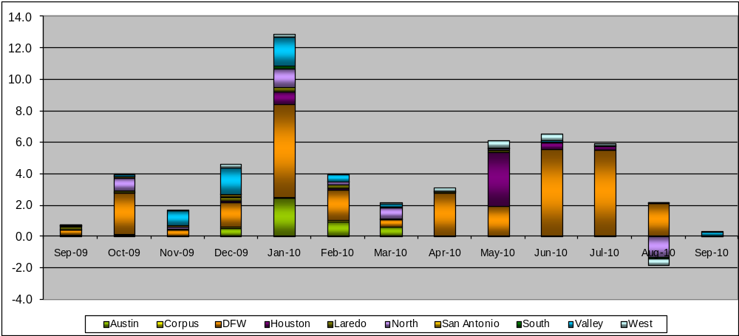

OOM Down – last 13 months in million$
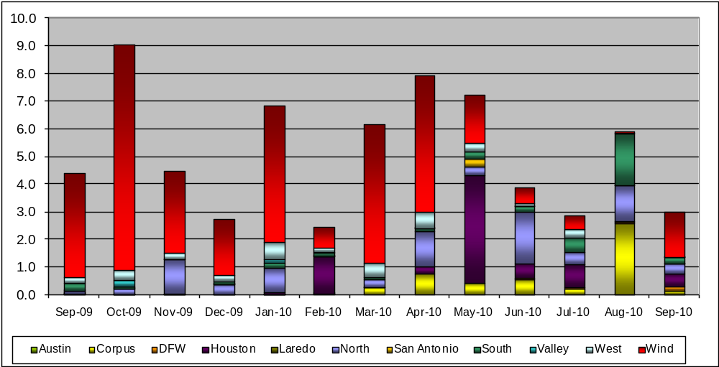

Local Balancing Energy Down – last 13 months in million$
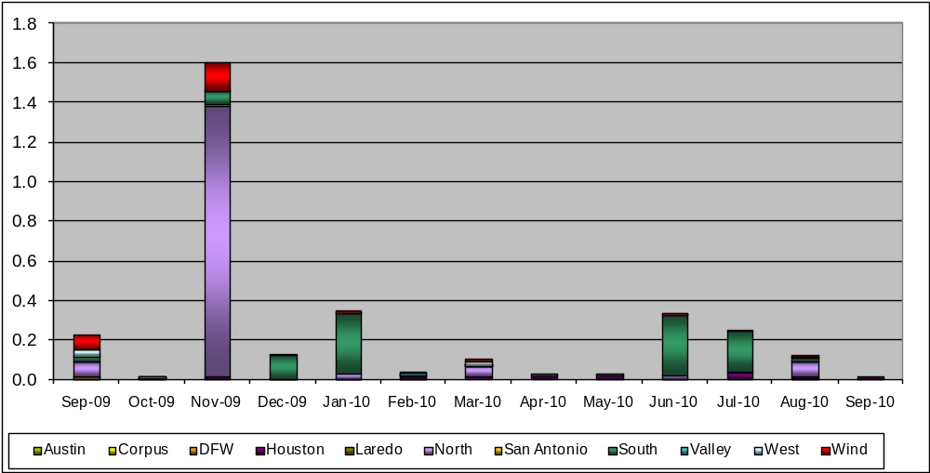

OOM Up – last 13 months in million$
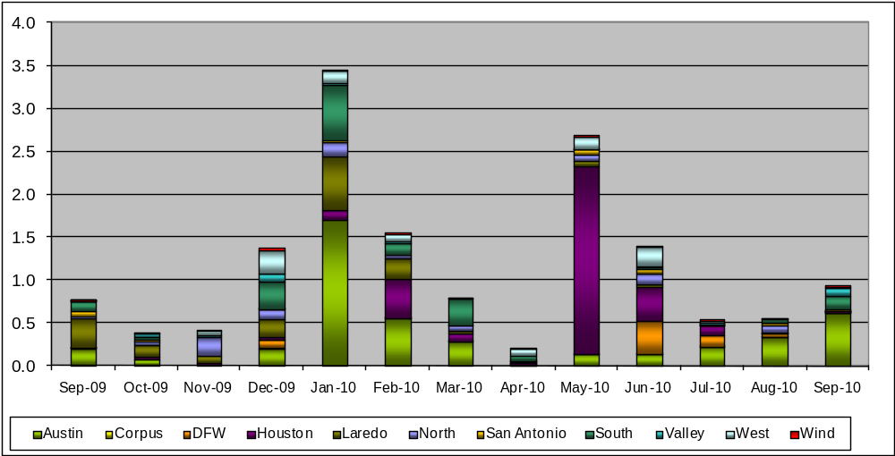

Local Balancing Energy Up – last 13 months in million$
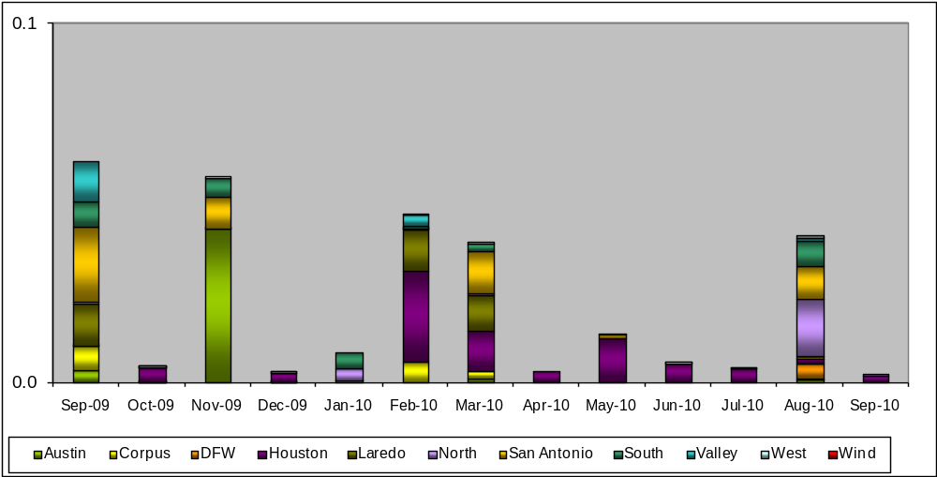

Replacement Reserve – last 13 months in thousand$
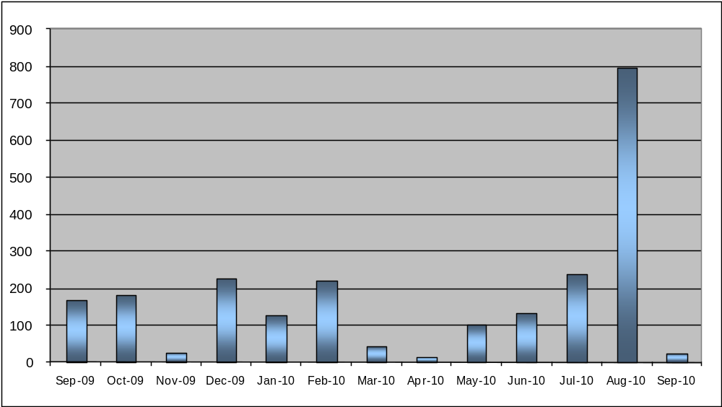

Average MCPE
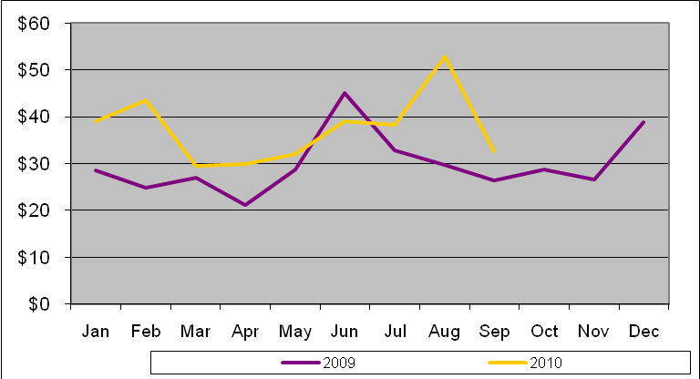

Binding Constraints & Capacity Shortages– September, 2010
Contingency | Binding Element | Estimated Costs | Transmission Project | Clearance
Roanoke Switch - West Denton - Lewisville Switch 345kV | West Denton - Ft Worth 138kV | $ 1,127,996 | Roanoke Tap to West Denton 345kV CREZ Circuit [10TPIT0133] | High W_N flow
Austrop - Sandow 345kV | Round Rock - Round Rock Northeast 138kV | $ 563,652861 | Hutto Switch - Round Rock NE - Round Rock 138 kV line  [08TPIT0009] | High N-S zonal transfer  Outage: Gabriel-Jarrell East
Santa Anna - Ballinger 138kV | Ballinger - Humble 69kV | $ 450,097 | Ballinger to Steamboat, Rebuild portions of 69 kV line [12TPIT0070] | Outage on Putnam 138 kV, 69 kV operating bus
 | Low Voltage - Valley | $ 235,763 |  | Forced outage on Ajo-Rio Hondo 345kV
Greens Bayou - Gable & Hardy - Crockett 138kV | Garrott - Midtown 138kV | $ 160,897 | Upgrade 138 kV underground Ckt. 90 Garrott to Midtown to Polk [11TPIT0072] | High Load and Insufficient generation in East Houston
Oklaunion - Fisher Road - Bowman 345kV | Bomarton TU - Baylor County Tap 69kV | $ 158,528 |  | Olney - Westover PCAP
Sandow Switch - Austrop 345kV | Hutto - Round Rock Southeast 138kV | $ 132,036 | Hutto Switch - Round Rock NE - Round Rock 138 kV line  [08TPIT0009] | High N-S zonal transfer  Outage: Gabriel-Jarrell East
 | Houston area planned transmission outages | $ 111,894
 | Capacity Shortage | $ 84,824
Graham - Parker 345kV | Leon Switch - Flat Creek 138kV | $ 53,264 |  | Outage: Willow Creek Switch- Parker Switch 345kV & Graham SES - Jacksboro Switching 345KV

Inter-zonal Congestion

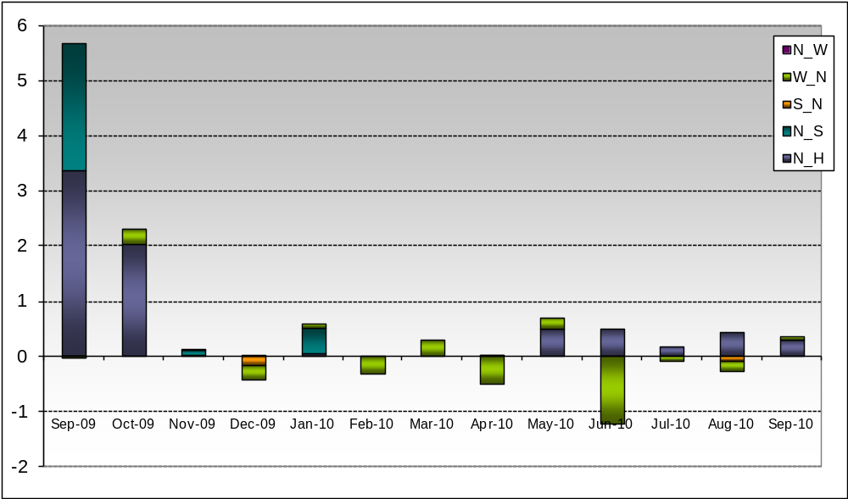

Wind Generation as a Percent of Load
One-hour average Settlement quality data shown.
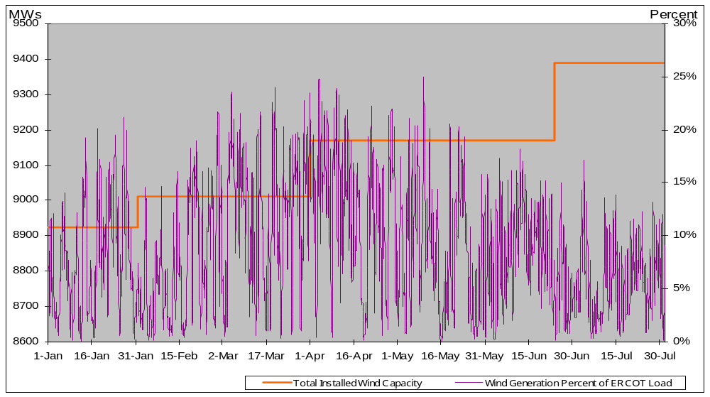

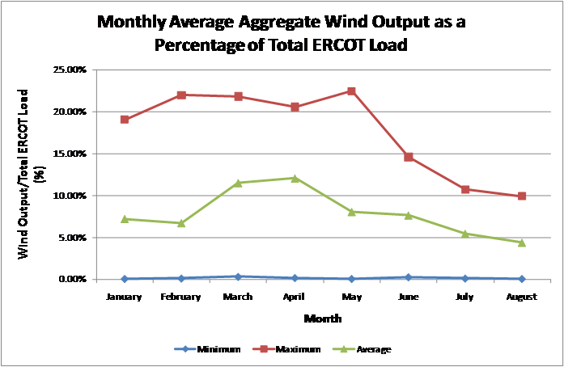

Other Notable Activities
- Work on the 2010 Five-Year Transmission Plan is wrapping up. The set of projects needed to reliably serve load in 2011 through 2015 has been identified and comments have been received. The analysis is currently focused on projects to relieve congestion for 2011 through 2015.

- Nodal Network Model Management System Topology Processor base case building modernization work continues with bi-weekly meetings calls with SSWG. ERCOT topology processor output will continue with monthly outputs.

- ERCOT and SSWG continue work to create a 2010 planning case by adding generation, load, and voltage profiles to the Topology Processor output in Model On Demand (MOD). The 2010 case will have one more pass completed to try to get a solvable case but will not be completed. Work will then begin on the 2012 case. The main reason to move to the 2012 instead of finishing the 2010 is that we will also use version PSSE 32 in MOD whereas the 2010 case is using PSSE version 30.

- ERCOT created a spreadsheet in September showing impedance and branch ratings differences that need to be reconciled between the current 2010 Fall Peak SSWG case and Topology Processor output case with a November build date. The purpose of this comparison is to confirm that impedances and ratings in the NMMS have been crosschecked against the SSWG database.

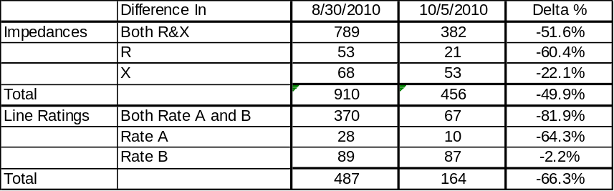

- Studies to determine the ERCOT System Voltage Profile have been completed..

- Blackstart testing has been completed.

- ABB has completed the CREZ Reactive Study. This study was conducted to optimize the reactive support equipment required to implement the CREZ plan. A final report will be available to market participants by mid-November.

- Work on the Long-Term System Assessment/DOE Study is ongoing.

- Transient Stability Study for 2011 Winter off-peak conditions: As part of the annual reliability assessment of the network, a transient stability study study is been performed on an ERCOT 2011 Winter off-peak case.

