ERCOT Operations Report
Oct 2010 ROS & OWG

Frequency Control
Time | Freq(Hz) | Duration (s)
10/2/2010 4:42 | 59.886 | 4 | Unit trip with 1060 MW
10/16/2010 4:00 | 59.831 | 8 | Unit trip with 550 MW
10/23/2010 10:12 | 59.848 | 12 | Unit trip with 530 MW
10/23/2010 10:49 | 60.115 | 240 | SCE +630 MW in 5 mins, out of DRS
10/23/2010 11:50 | 60.115 | 48 | Out of DRS, SCE +600 MW in 10 mins
10/25/2010 12:39 | 59.823 | 44 | Unit trip with 820 MW
10/26/2010 0:09 | 60.109 | 48 | SCE +400 in 5 mins, out of DRS.
10/29/2010 13:30 | 59.888 | 32 | Unit trip with 435 MW
10/31/2010 0:11 | 59.830 | 16 | Unit trip with 640 MW
10/31/2010 0:36 | 60.110 | 44 | Out of DRS, SCE +500 MW in 10 mins.
Note: Time of frequency excursions outside the range of +/- 0.1 Hz.

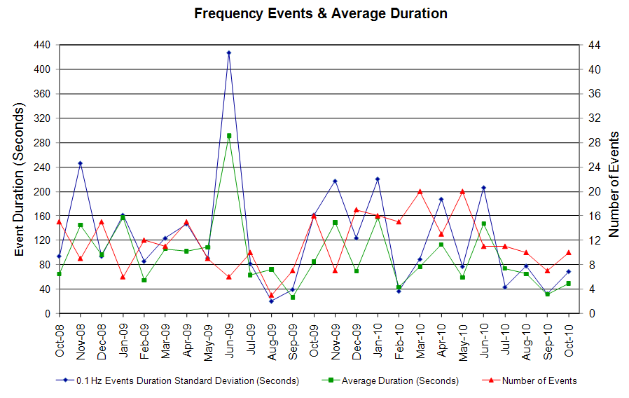

Deployed Responsive (Reported Above)
Time deployed | Stop Time | Duration | Max | Details
10/2/10 0:00:23 | 10/2/10 0:21:48 | 0:21:25 | 362.9 | Incorrect offset calculation
10/2/10 4:42:27 | 10/2/10 5:02:40 | 0:20:13 | 448.2
10/7/10 12:08:49 | 10/7/10 12:29:12 | 0:20:23 | 336.2 | Out of Up Reg
10/8/10 22:22:39 | 10/8/10 22:30:56 | 0:08:17 | 330.8 | Unit Trip
10/16/10 4:00:09 | 10/16/10 4:24:14 | 0:24:05 | 741.7
10/17/10 22:17:23 | 10/17/10 22:27:10 | 0:09:47 | 373.5 | Unit runback
10/22/10 7:06:02 | 10/22/10 7:34:50 | 0:28:48 | 309.5 | Out of Up Reg
10/23/10 10:12:17 | 10/23/10 10:28:08 | 0:15:51 | 651.0
10/25/10 8:46:42 | 10/25/10 8:53:52 | 0:07:10 | 325.5 | Unit runback
10/25/10 12:39:07 | 10/25/10 13:28:29 | 0:49:22 | 784.4
10/27/10 4:44:14 | 10/27/10 4:57:04 | 0:12:50 | 373.5 | Unit Trip
10/29/10 13:30:45 | 10/29/10 13:45:50 | 0:15:05 | 437.56
10/31/10 0:11:00 | 10/31/10 0:24:33 | 0:13:33 | 747.04

Day-Ahead OOMC and RPRS Capacity Purchases
Details | OOMC | RPRS S1 | RPRS S2 | RPRS S1+S2 | RMR | Total
Western | 0 | 0 | 0 | 0 | 21 | 21
E RIO | 14 | 0 | 0 | 0 | 0 | 14
North | 0 | 1 | 0 | 1 | 0 | 1
DFW | 0 | 0 | 1 | 1 | 0 | 1
W RIO | 0 | 0 | 0 | 0 | 0 | 0
Corpus | 0 | 0 | 0 | 0 | 0 | 0
Houston | 0 | 0 | 0 | 0 | 0 | 0
Austin | 0 | 0 | 0 | 0 | 0 | 0
Northeast | 0 | 0 | 0 | 0 | 0 | 0
Bryan Area | 0 | 0 | 0 | 0 | 0 | 0
South | 0 | 0 | 0 | 0 | 0 | 0
San Antonio | 0 | 0 | 0 | 0 | 0 | 0
Laredo | 0 | 0 | 0 | 0 | 0 | 0
Total | 14 | 1 | 1 | 2 | 21 | 37

Historical Totals | Oct-10 | Oct-09 | Sep-10
Austin | 0 | 5 | 0
Bryan Area | 0 | 2 | 0
Corpus | 0 | 3 | 3
DFW | 0 | 95 | 0
E RIO | 14 | 9 | 13
Houston | 0 | 10 | 1
Laredo | 0 | 1 | 0
North | 1 | 2 | 1
Northeast | 0 | 5 | 0
San Antonio | 0 | 6 | 0
South | 0 | 3 | 0
W RIO | 0 | 4 | 9
Western | 21 | 9 | 21
Total | 36 | 154 | 48
http://www.ercot.com/mktinfo/services/rprsdr/index.html

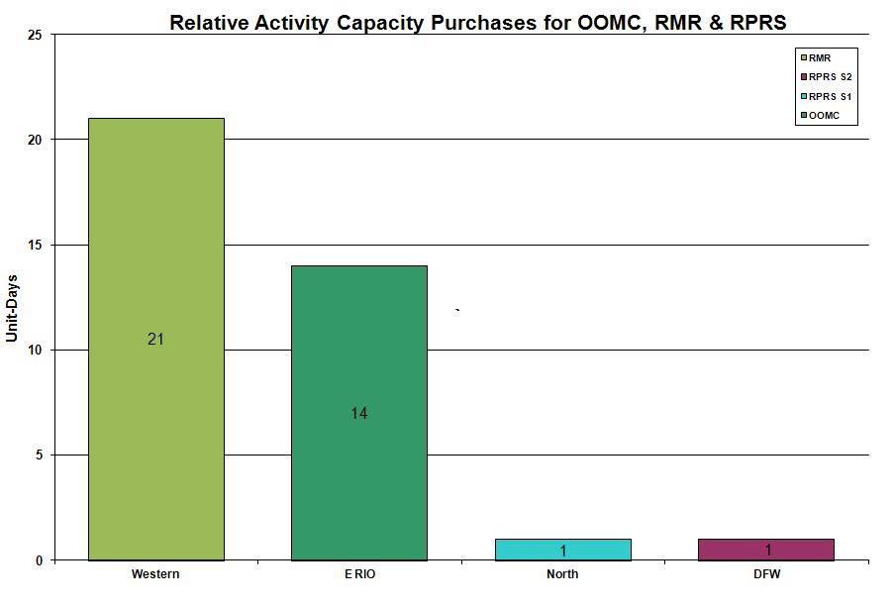
OOME and Congestion Management Activity
Congestion affected by outages Remedial action plan has been developed for the element
Contingency | Overloaded Element | Days
Austrop - Sandow 345KV | Hutto - Round Rock Southeast 138KV | 13
Midland East - Odessa Ector EHV 345KV | Odessa Ector EHV - Big Three Odessa Tap 138KV | 13
Base Case | Matador - Paducah 69KV | 11
Base Case | Stanton - Midland East 138KV | 9
Greens Bayou - Gable Street and Hardy - Crocket 138kV | Garrott - Midtown 138KV | 9
Hamilton - Sonora 138KV | Sonora - Friess Ranch 69KV | 9
Base Case | Golden Switch - Sun Switch 138KV | 7
Graham SES - Parker SW 345KV | Roanoke Switch - West Denton 345KV | 6
Tricorner - Tyler Grande & Martin Lake SES - Elkton 345KV | Tyler Northwest - Tyler West 138KV | 6
Barney Davis - Airline 138KV | Nelson Sharpe 138KV phase shifting transformer | 5
Singleton - Tomball - Roans Prairie 345KV | Garrott - Midtown 138KV | 4
Santa Anna - Ballinger 138KV | Ballinger - Humble Ballinger 69KV | 4
Marion - Zorn and Clear Springs 345KV | Comal - Henne 138KV -115% of 208 MVA rating. | 3
Willow Valley Switch - Bluff Creek 138KV | Ackerly Vealmoor Switch - Ackerly 69KV | 3
Aspermont - Spur 138KV | Spur 138/69KV AT | 2
East Bernard - Dyann 138KV | Blessing - Lane City 138KV | 2
Barrilla - Fort Stockton Plant 138KV | Barrilla - Fort Stockton Switch 69KV | 2
Base Case | Ennis West - Waxahachie 138KV | 2
Base Case | MEC Plainview - WKN Breaker 69KV | 2
Divide Switchyard - Gasconades Creek 345KV | Sterling County - Sterling City 69KV | 2
Firerock - Santa Anna 138KV | Brownwood 138/69KV AT | 2
Golden Switch - Bluff Creek 138KV | Sun Switch - Sacroc 138KV | 2
Jack County - Wise County 138KV | Jack County - Bridgeport 138KV | 2
Marion - Zorn & Clear Springs 345KV | Clear Springs 345/138KV AT | 2
Midland East - Spraberry 138KV | Windwood - Midland West 138KV | 2
Oasis - Meadow 345KV | Garrott - Midtown 138KV | 2
Singleton - Tomball & Roans Prairie 345KV | Singleton - TH Wharton 345KV. | 2
Sun Switch - Scurry Switch 138KV | Aspermont - Aspermont Continental 69KV | 2
Twin Butte - San Angelo Red Creek 345KV | Twin Butte 345/138KV AT | 2
Dyann - South Lane City 138KV | Sealy - Peters Reit 138KV | 1
Graham SES - Parker Switch 345KV | Wichita Falls - Henrietta West 69KV | 1
Hiway 9 T1 138/69KV AT | Koch Upriver 138/69KV AT A1 | 1
Holly - Barney Davis 138KV | Naval Base - North Padre 69KV | 1
Fisher Road Switch T1 345/138KV AT | Bowman Switch T1 345/138KV AT | 1
Barney Davis - Airline 138KV | Alazan - Barney Davis 138KV | 1
Base Case | Bellaire - San Felipe 138KV | 1
Calaveras - Ball Park and Laredo Street 138KV | VH Braunig - Streich Road 138KV | 1
Cedar Bayou - Center 345KV | Garrott - Midtown 138KV | 1
Dupont Switch Ingleside - Dupont PP1 Ingleside 138KV | Oxychem Corpus Christi - Air Liquide Switch 138KV | 1
Lobo 345/138KV AT | Pleasanton to Jourdanton 69 kV | 1
Marion - Zorn and Clear Springs 345KV | Seguin - Seguin West 138KV | 1
McDonald - Spraberry 138KV | Stanton East Switch - Midland East 138KV | 1
Pawnee - Coleto Creek 345KV | Coleto Creek - Victoria 138KV | 1
Roanoke Switch - West Denton & Lewisville SW 345KV | West Denton - Fort Worth Sub 138KV | 1
Sandow 345/138KV AT #1 | Sandow 345/138KV AT #2 | 1
Tricorner - Trinidad 345KV | Forest Grove Switch - Mabank Tap 138KV | 1
Twin Buttes - San Angelo 345KV | Twin Buttes 345/138KV AT | 1
Westside - Airline 138KV | Naval Base - North Padre - Mustang Island 69KV | 1

Zonal OC1
CSC | Days
West – North | 19
North – Houston | 13

New RAP, PCAP (Date indicates last update of RAP, PCAP not implementation date.)
None

New Procedures/Forms/Operations Bulletins
None

Blackout/Load Shed Incidences
None

EEA
None

Major System Voltage Problems
None

Major Computer Problems, Enhancements & Fixes
10/27 08:45 Held Real-time Balancing deployments for IE 08:45, resumed with IE 09:30.

Communication
None

ERCOT peak (Unofficial)
10/25 17:00 45,107 MW

Yearly MTLF Error Comparison
Yearly Mid-Term (Hourly) Load Forecast Error Comparison for the ERCOT Forecast
Month | MAPE for MTLF at 16:00 Day-Ahead
Month | 2007 | 2008 | 2009 | 2010
January | 4.55 | 3.30 | 4.11 | 3.78
February | 3.75 | 3.59 | 3.49 | 3.79
March | 2.70 | 3.29 | 3.24 | 2.24
April | 3.00 | 2.45 | 2.66 | 2.47
May | 3.22 | 3.01 | 2.90 | 2.63
June | 4.46 | 2.81 | 2.89 | 2.84
July | 4.29 | 2.55 | 2.83 | 2.39
August | 3.11 | 3.66 | 3.07 | 2.29
September | 3.78 | 4.99 | 3.68 | 3.14
October | 3.08 | 2.79 | 2.92 | 2.37
November | 2.95 | 2.60 | 1.93 | NA
December | 3.74 | 4.54 | 3.70 | NA
Annual Average | 3.55 | 3.29 | 3.11 | 2.79
OCN, Advisory, Watch & Emergency Notices
Capacity
Date | Start | End | Event
10/2/10 | 9:38 | 11:20 | Advisory issued due to ARRS below 3000 MW.
10/7/10 | 15:38 | 18:54 | Advisory issued due to ARRS below 3000 MW.
10/9/10 | 16:12 | 17:54 | Advisory issued due to ARRS below 3000 MW.
10/11/10 | 9:07 | 10:49 | Advisory issued due to ARRS below 3000 MW.
10/11/10 | 14:34 | 17:45 | Advisory issued due to ARRS below 3000 MW.
10/19/10 | 13:45 | 17:00 | Advisory issued due to ARRS below 3000 MW.
10/27/10 | 15:35 | 17:55 | Advisory issued due to ARRS below 3000 MW.

Transmission Watch
None

Emergency Notice
None

Texas RE Event Analysis
10/09 22:05 Stanton Switch Station SPS #46 activated. ERCOT does not see any evidence that the Stanton East Switching Station SPS #46 SPS failed to operate as designed.

10/17 22:04 Stanton Switch Station SPS #46 activated. ERCOT does not see any evidence that the Stanton East Switching Station SPS #46 SPS failed to operate as designed.

10/23 22:59 Stanton Switch Station SPS #46 activated. ERCOT does not see any evidence that the Stanton East Switching Station SPS #46 SPS failed to operate as designed.
Others
10/2 00:15 Held Real- time Energy Balancing deployments for interval ending 00:15 and 00:30 due to operator offset input error. Resumed with interval ending 00:45.

10/3 00:15 Held Real-time Energy Balancing deployments for interval ending 00:15 due to operator offset input error. Resumed with interval ending 00:30.

