

2010 ERCOT Target Reserve Margin Study

November 1, 2010
Table of Contents
1. INTRODUCTION 1
1.1. Reliability Indices 1
1.2. Report Outline 2
2. RESOURCES AND DEMAND 3
2.1. Simulation Process 3
2.2. NERC Terms 3
2.3. Resources 5
2.3.1. Conventional Resources 5
2.3.2. Private Network Units 6
2.3.3. Wind Energy 6
2.4. Demand 6
3. STUDY METHODOLOGY 8
3.1. System Model 8
3.1.1. Conventional Generation Modeling 8
3.1.2. Wind Modeling 10
3.2. Simulation 11
3.3. Stopping Criteria 12
3.4. Estimation of ELCC 13
4. RESULTS AND CONCLUSION 15
4.1. Study Output 15
4.2. Comparison with the 2007 study by Global Energy Decisions 18

EXECUTIVE SUMMARY

ERCOT 2010 Target Reserve Margin Study is an analysis to quantify the impact of system volatility on reserve levels and reliability. This analysis is performed on a biennial basis to review the appropriateness, given changes to the ERCOT system, of the target reserve margin level used to evaluate resource adequacy in ERCOT. System volatilities such as generator outages and derating, load forecast uncertainties and intermittent nature of wind were studied. Reliability indices such as Loss of Load Events, Loss of Load Hours and Expected Unserved Energy for various levels of reserve margins were obtained
Generator outages were modeled sequentially using random draws from two exponential distributions. Mean Time to Failure and Mean Time to Repair for each of generators were used to build sequences of generator availability and unavailability respectively. For each scenario, the simulation was iterated sufficiently to achieve established stopping criteria.
Load forecast uncertainties due to weather were studied by running Monte Carlo simulation for five different load scenarios – extreme summer, warmer than average, average, cooler than average and much cooler than average. Each of these scenarios was assigned a probability of occurrence. All load scenarios were developed using Moody’s base economic forecast.
Due to the inherent variability of wind powered generation on the ERCOT System, the availability of wind power generation needed to be treated differently than the availability of conventional generators in reserve margin calculations. The Effective Load Carrying Capability (ELCC) concept for variable resources like wind was introduced for this purpose in the past studies. ELCC indicates the percentage of the total nameplate capacity of wind that can be counted towards the calculation of the reserve margin. ELCC was evaluated by comparing the relative reliability of the installed or planned wind generation to the reliability of the planned 2012 fleet on an annual basis. Wind profiles developed by AWS Truewind for ERCOT CREZ study were used in this analysis.
The ELCC of wind resources was calculated to be 12.2%. The ERCOT target reserve margin, based on a 0.1 Loss of Load Events metric that is equivalent to the “one day in ten years” metric that has traditionally been used in the industry, was found to be 13.75%.

INTRODUCTION
The ERCOT 2010 Target Reserve Margin Study is an analysis to evaluate the impact of system volatility on the relationship between generation reserve levels and system reliability. A power system, in general, is volatile from a resource adequacy perspective due to several primary: the forced outage and de-rating of generating facilities; the load forecast uncertainty related to weather; and, the intermittent nature of wind power. At the same time a power system needs to maintain an adequate level of reliability. To cope with system volatility while maintaining adequate reliability, an appropriate level of generation reserves needs to be maintained in the planning timeframe.
Historically, reserve levels have been quantified in terms of a reserve margin. The reserve margin has been defined as the difference between nameplate installed capacity and annual peak load as a percentage of the annual peak load. This reserve margin calculation is used as a proxy to assess the level of reserves necessary to meet an adequately reliable level of resource adequacy over the course of a year. The scope of this study is to assess what the appropriate (target) reserve margin level is for the ERCOT system for year 2012.
The ERCOT system has a considerable amount of wind power resources. Due to the variation of wind power availability these resources need to be treated differently than conventional generators in reserve margin calculations. The concept of Effective Load Carrying Capability (ELCC) of wind was introduced in past studies. ELCC indicates the percentage of the total nameplate capacity of wind that can be counted towards the calculation of the reserve margin and forms the basis for the level of wind generation that currently counts towards planning reserves in ERCOT. Estimating a value of the ELCC is a part of this study and is discussed in detail.

Reliability Indices

Reliability is the probability of a device or system performing its function adequately, for the period of time intended, under the operating conditions intended. The reliability of a power system pertains to its ability to satisfy its demand under the specified operating conditions and supporting policies. For the purpose of quantifying the reliability of a power system, the following metrics apply:
Loss of Load Events (LOLEV): The number of times in a year that available generation was incapable of meeting demand. LOLEV provides information about the frequency of events and is measured in events/year.
Loss of Load Hours (LOLH): The number of hours in a year that available generation was incapable of meeting demand. LOLH provides information about the duration of events and is measured in hrs/year.
Expected Unserved Energy (EUE): The total amount of energy demand that could not be met by available generation in a year. EUE provides information about the severity of events and is measured in MWh/year.
Loss of Load Probability (LOLP): The probability that in any given hour the available capacity will be less than the demand. This index, being a probability measure, is dimensionless.
Loss of Load Expectation (LOLE): The expected number of days per year (hours per year) for which available generating capacity is insufficient to serve the daily peak demand (the hourly demand)^{[1]}. The convention is that when given in days/year, LOLE represents a comparison between daily peak values and available generation. When given in hours/year, it represents a comparison of hourly demand to available generation in which case it is equivalent to LOLH.
A power system is considered to be adequate when it satisfies a certain reliability level. The electric power industry has generally adopted the criteria of 1 loss of load event every 10 years (a 0.1 LOLEV value) as this level, and this level has also been used historically for the ERCOT System.

Report Outline

This report is organized as follows: Chapter I briefly describes the goal of the reserve margin analysis, various reliability concepts and resource adequacy. Chapter II discusses details about the input data – resources and demand. In Chapter III, the study methodology and modeling issues are presented. Chapter IV summarizes the results obtained.

RESOURCES AND DEMAND

Simulation Process

Power system reliability indices can be calculated using a variety of methods. The two main approaches are analytical and simulation. Monte Carlo simulation is utilized in this study because it allows for a more comprehensive modeling of system behavior and provides a more informative set of system reliability indices. Specifically, the sequential approach of Monte Carlo simulation is used in this study. This approach examines each basic interval of time of the simulated period in chronological order.
The basic interval of time is selected according to the type of system under study, as well as the length of the period to be simulated in order to ensure a certain level of confidence in the estimated indices. In this study, one hour is the interval of time. The stopping criteria for the estimated indices in the simulation are discussed in detail in the following chapter.
In order to model and simulate the system for reliability evaluation and hence calculate the reserve margin, model inputs such as generation data, load data and wind data were required. As mentioned previously, the transmission network is not modeled and hence transmission line data is not required. In this analysis, the main focus in on resource adequacy.

NERC Terms

The following parameters were utilized to simulate hourly generator capacity profiles:
- Net Maximum Capacity (NMC)
- Service Hours (SH)
- Forced Outage Hours (FOH)
- Equivalent Forced Derated Hours (EFDH)
- Reserve Shutdown Hours (RSH)
- Equivalent Forced Derated Hours during Reserve Shutdown (EFDHRS)
- # of FO occurrences (# FO)
- # of unit attempted starts
- # of unit actual starts
- Planned Outage Hours (POH)
- Maintenance Outage Hours (MOH)
- Scheduled Outage Hours (SOH) [Note:- SOH = POH + MOH]
- # of SO occurrences.

These parameters are used in the calculation of the following indices.
- EFORd – Equivalent Demand Forced Outage Rate
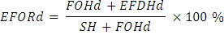
Where,
FOHd = f x FOH
EFDHd = EFDH – EFDHRS, if reserve shutdown events reported.
= fp x EFDH, if no reserve shutdown events reported (approximation).
fp = 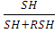
f = 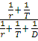
r = , Average FO deration.
D = 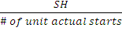 , Average demand time.
T = 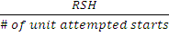 , Average reserve shutdown time.
- MTTR – Mean Time To Repair
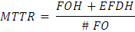
- MTTF – Mean Time To Failure
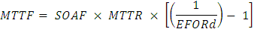
Where,
, Scheduled Outage Adjustment Factor.
N is the number of days in the year considered {i.e. N = 8760 for a normal year and N = 8784 for a leap year}.

The following chapter will explain in detail how the above-mentioned indices are used in the Monte Carlo simulation. The reason why SOAF is used in MTTF calculation will be explained in detail in the next chapter.

Resources

Conventional (thermal) resources, Private-Use-Network resources (PUNs), and Wind energy are the resource categories used in this study.

Conventional Resources

Appendix A provides a list of the generation units that were included in this analysis. Information such as the unit name, net capacity (in MW), unit type (based on EIA definitions/acronyms) and fuel type are presented.
There are several underlying assumptions related to resource input data, as follows:
- All existing generation units, as well as future resources with a signed interconnection agreement that are expected to be in service in year 2012, are considered. This also includes units under reliability must – run (RMR) review.
- The import capacity of the DC ties is not taken into account.
- Planned maintenance outage schedules used in the simulation are the same for every iteration. These schedules were developed as part of this analysis and are based on average weather conditions. Planned outages are not scheduled in summer months (June, July and August).
- Forced outages are modeled in accordance with available NERC GADS data.
- Hydro units are not considered in this study.
- Monthly capacity multipliers are applied in order to model the seasonal capacity ratings of thermal units.
Seasonal capacity values for thermal generators are obtained from each generator’s RARF (Resource Asset Registration Form) and used to determine the monthly capacity multipliers for each of the conventional generators. The monthly values in the RARF are categorized by season as follows,
- December, January and February months are winter.
- March, April and May months are spring.
- June, July and August months are summer.
- September, October and November months are fall.

The resources listed in Appendix – A have a total installed capacity of 70,853 MW.

Private Network Units

Private Network Units (PUNs) contribute a total capacity of 4,803 MW.

Wind Energy

A total nameplate capacity of 10,992 MW of wind generation is included in this study.
Representative hourly wind energy availability profiles for a typical year for each wind plant were used for the analysis. These profiles are based on the wind generation assessment report prepared for ERCOT by AWS Truewind as part of the analysis of Competitive Renewable Energy Zones (CREZ). These profiles contain typical inter-hour volatility and typical diversity between the different 100MW sites used for the CREZ analysis.
Since the transmission network is not being considered, the wind-farm-specific hourly profiles are aggregated. Forced outages of individual wind turbines are not being modeled in this study.

Demand

Five load scenarios were adopted in order to capture weather related uncertainty. For each scenario an hourly chronological load pattern was developed by ERCOT. The five load scenarios and their associated probability of occurrence are:
- Extreme summer weather (10% probability of occurrence),
- Warmer than average (23% probability),
- Average weather (34% probability),
- Cooler than average (23% probability),
- Much cooler than average (10% probability).

All five scenarios were developed using the economic growth assumptions in the concurrent Moody’s base economic forecast.
Actual weather data was used for 1996 through 2009. For each year, an average summer temperature was calculated based on the average of the monthly temperatures for June, July, and August. Each year was then ranked based on its average summer temperature from the lowest temperature to the highest temperature. Four representative years were selected based on their percentile rank (the selected percentile ranks were 10th, 25th, 50th, and 75th) for the various scenarios (2007 was used for the 10th percentile, 2003 was used for the 25th percentile, 1999 was used as the 50th percentile, 2000 was used as the 75th percentile). In order to create the extreme weather scenario, actual weather data for the winter of 2010 (January through March) was combined with summer weather data from 2010 (June through August).
Probabilities for each load scenario were assigned based on data from the Climate Prediction Center. Using average temperature ranges based on monthly average temperatures, each selected year was assigned to the corresponding temperature range and assumed to be representative of years contained within the range. The ranges used were the highest 10% (extreme scenario), lowest 10% (much cooler than average scenario), warmer than average scenario (warmest 33% excluding the highest 10%), cooler than average scenario (coolest 33% excluding the lowest 10%), and the average scenario (median scenario +- 16.5%).
The average weather scenario is the same as the median scenario. This scenario was also used for scheduling planned generation maintenance outages. The probabilities of occurrence of each of the scenarios were incorporated into the calculation of reliability indices using the following formula:

The data described in this chapter were used as input to the system model which was developed using MATLAB. System modeling is described in detail in the next chapter. The results of this study will appear in the last chapter.

STUDY METHODOLOGY

System Model

In this study, the entire ERCOT system is modeled as being connected at a single node. As a result, the transmission network is not considered while modeling (i.e., none of the transmission limit constraints are binding). Conventional generation, wind and load are modeled such that they are all attached to this one node.

Conventional Generation Modeling

To simulate the system, hourly generator capacity profiles are required. The net available hourly generator capacity is obtained by applying a capacity multiplier, scheduled outages and forced outages to the installed capacity of each generator. Each generator is initially assumed to be available in all the hours of the year, with the capacity for each hour set to the appropriate seasonal capacity rating for the unit. A capacity multiplier, initially set to 1.0, is applied to all units and hours. The hourly profile for a unit is then adjusted based on the scheduled outages for the unit.
For this type of reliability study, forced outages of a generator can be modeled in several ways. Specifically, Two-State and Four-State models were considered in this analysis. In a Two State model, a generator is either in up – state (capacity is fully available) or in down – state (capacity is fully unavailable). In contrast, the states of the Four-State model are shown in Figure 1. While the Two-State model adequately estimates unavailability (defined by Forced Outage Rate, FOR) of base-loaded generation, it does not provide an adequate estimate when a unit’s demand cycle is relatively short, as in the case of a peaking or cycling unit. Non-baseload units operate in more than two states, as depicted in Figure 1.
The most critical period in the operation of a unit is the start-up period, and in comparison with a base load unit, a peaking unit will have fewer operating hours and many more start-ups and shut-downs. These aspects must be included in arriving at an estimate of unit unavailability at some time in the future and are captured in the EFORd calculation using the Four-State model.

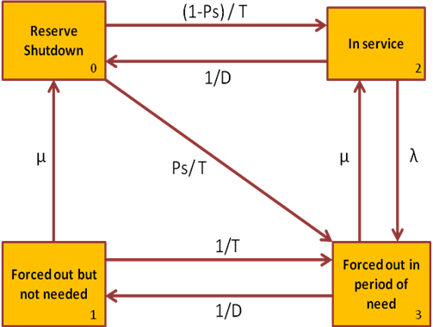

Fig – 1: Four State Model

For each generator and for each of the iterations, a sequence of periods during which the unit is available and unavailable to provide energy is generated. The data required for the EFORd calculation were obtained from NERC GADS. NERC did not allow ERCOT to have access to unit-specific data in the NERC GADS system without obtaining authorization from each generating unit’s owner. ERCOT requested this authorization from all unit owners and obtained access to the unit-specific data for about 50% of the existing generating capacity in ERCOT. The unit-specific data were used, and ERCOT regional averages from the generic NERC GADS data, by unit type and vintage, were used for the remaining units.
The generator forced outage modeling was conducted as follows:
- Forced outages are modeled sequentially, using random draws from two exponential distributions.
- The time on outage for each unit is randomly drawn from an exponential distribution with mean equal to the MTTR.
- The time in service for each unit is randomly drawn from an exponential distribution with mean equal to the MTTF.
- SOAF is applied while calculating MTTF to account for any loss of outage time due to overlap of forced outages with scheduled outages.
The outage modeling described above results in unit unavailability due to forced outage equal to EFORd.
Using these sequences of availability and unavailability, hourly generator capacity profiles are generated, which are aggregated for single node analysis.

Wind Modeling

Hourly wind profiles were derived from wind generation patterns provided by AWS Truewind as part of the ERCOT CREZ studies. Unique wind profiles were assigned to each wind generation facility, by CREZ zone, and were aggregated as all system resources in this analysis are assumed to be connected to a single node.
In order to capture the randomness of wind generation, daily wind profiles in each iteration are generated by randomizing the available daily profiles using MATLAB model. A wind profile for each day was selected at random from a span of fifteen days (+ or – seven days). As an example, the hourly wind profile for the simulated January 30th was randomly selected from the typical daily wind profiles for dates between January 23rd and February 6th.

Simulation

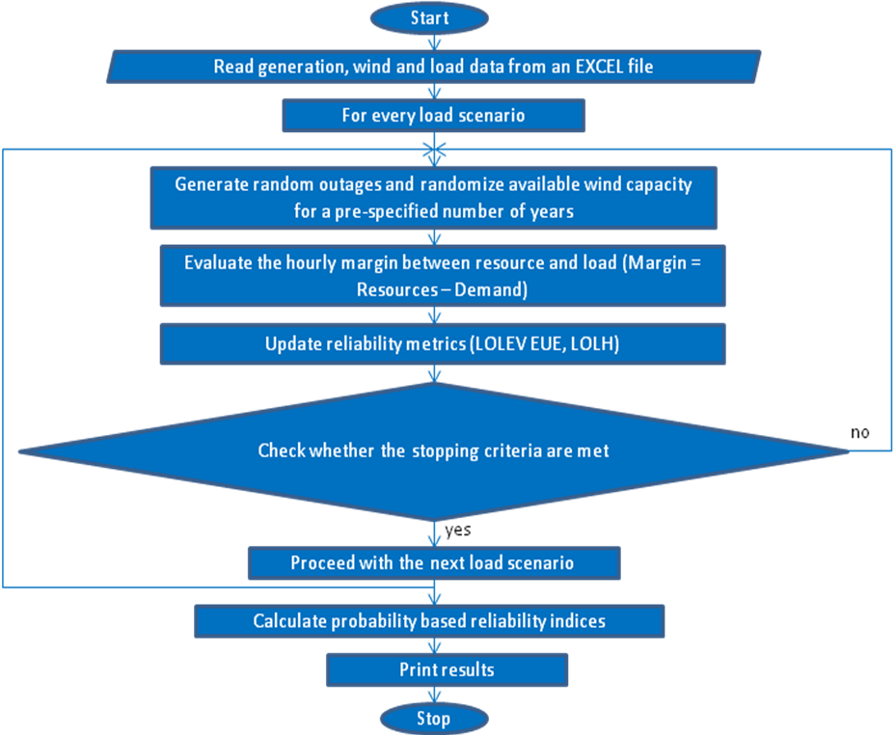
Fig – 2: Flowchart describing the simulation process
The simulation process can be summarized as follows:
- All the input data is stored in an EXCEL file. Using MATLAB, this file is read and all information is stored.
- Each of the load scenarios are separately.
- For every unit, sequences of generator availability and unavailability hours are built using MTTF and MTTR respectively.
- For every day, random daily wind profiles are created. To randomly choose a day’s wind profile, a span of ± seven days is used.
- Hourly resource profiles are generated by summing up the hourly capacity available (wind and conventional resources).
- Hourly margin is then computed (Hourly Margin = Resource Capacity – Demand).
- A negative margin indicates a loss of load hour; this hour’s value indicates the amount of load that could not be served. A sequence of loss of load hours contributes one loss of load event.
- Reliability metrics (LOLEV, EUE and LOLH) are updated based on the hourly margins obtained.
- Once the stopping criteria are met, the procedure is repeated for the next load scenario from step 3. The stopping criteria are described in the next subsection.
- After all the load scenarios are analyzed, the probabilities associated with each of them are used to calculate the reliability indices for the subject reserve margin

Stopping Criteria

Each scenario was iterated for 10,000 iterations, or until the following stopping criteria were achieved:
- A minimum number of iterations (set to 1,000).
- The LOLEV halfwidth for a 95% confidence interval is less than a percentage (set to 5%) of the LOLEV average.
- The total number of loss of load events is greater than a minimum value (set to 1).
These conditions were selected given the tradeoff between accuracy and computational effort. A minimum number of iterations are required so that sufficient samples are considered while computing the reliability indices. The reliability metrics obtained by simulation will converge if a very large number of iterations are used, but the simulation may be ended earlier if a stable result is achieved, in order to be more computationally efficient. An example of output convergence is depicted in Figure 3.

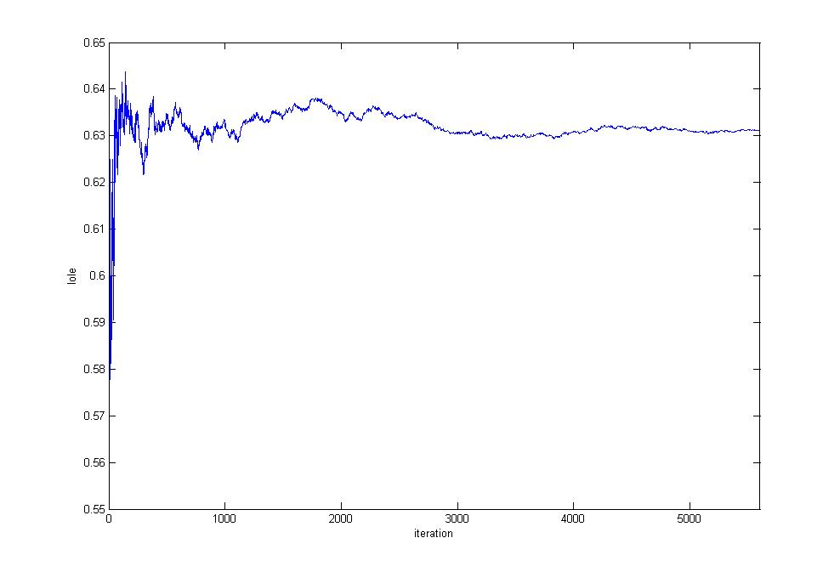
Fig – 3: Variation of LOLEV with the number of iterations

In Fig – 3, the average value of LOLEV varies significantly within the first 1000 iterations for a particular load scenario; with more iterations, the average value becomes more stable. The higher the number of iterations, the more accurate the result will be, at the cost of long computational periods. The high value of the maximum number of iterations and the rigorous stopping criteria applied in this study ensure the statistical significance of the results.

Estimation of ELCC

Due to the inherent variability of wind powered generation on the ERCOT System, it is necessary to equate the availability of wind resources to that of conventional generators using the calculation of an Effective Load Carrying Capability (ELCC). The ELCC indicates the percentage of the total nameplate capacity of wind that is equivalent to a conventional resource in the calculation of the reserve margin.
The methodology to evaluate the ELCC percentage is as follows:

- The probabilistic based reliability metrics are evaluated for a base case scenario (including the existing wind generation resources).
- After the wind units have been completely removed, a capacity adjustment factor is applied to the remaining fleet until the same level of reliability for the selected metric is achieved.
- The ELCC value is equal to the ratio of the capacity of the remaining fleet that was added divided by the total installed capacity of wind, in percent.

RESULTS AND CONCLUSION

Study Output

LOLEV is calculated as follows,
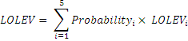
Here the study-wide LOLEV is a probability-based average. The summation of the product of each load scenario probability and LOLEV for the scenario gives the study wide LOLEV. In the above formula, i varies from 1 to 5 as we have five load scenarios.
The reserve margin is calculated by,

Where,

Variations in reserve margin are obtained by applying a capacity adjustment factor, as shown above. This factor is used as a multiplier to alter the fleet capacity, inclusive of wind. Following reliability indices were estimated for various reserve margin levels.
  - The annual Loss Of Load Events (LOLEV).
  - The annual Loss Of Load Hours (LOLH).
  - The annual Expected Unserved Energy (EUE).
Following are the graphs obtained by varying the capacity adjustment factor and hence the reserve margin. The reliability indices are plotted against the Y-axis.

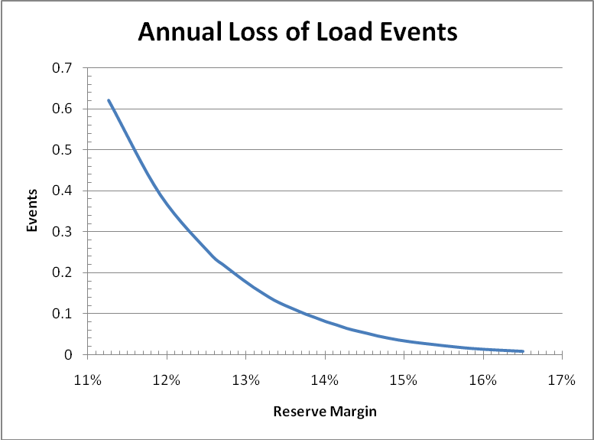

Fig – 4: Annual Loss of Load Events

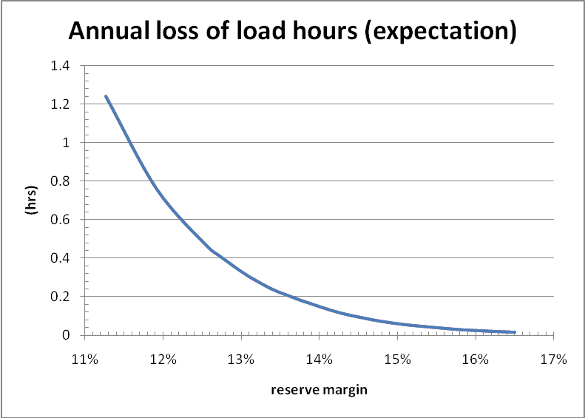

Fig – 5: Annual Loss of Load Hours (expectation)

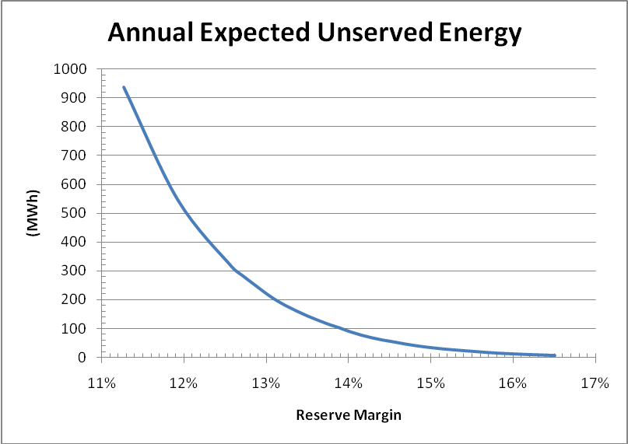

Fig – 6: Annual Expected Unserved Energy

ELCC of wind is calculated based on LOLEV. The ELCC from the study is 12.2%.

The target reserve margin based on the 0.1 LOLEV per year is 13.75%. This is equivalent to one loss of load event in ten years.

Comparison with the 2007 study by Global Energy Decisions

In 2007, Global Energy Decisions conducted the target reserve margin analysis of the ERCOT system. The ERCOT 2010 target reserve margin analysis differs from the 2007 study in the following ways,
  - ERCOT is using a family of load profiles representing different weather conditions.
  - All hours of the year are modeled instead of a representative week from each month.
  - Generator outages are modeled sequentially.
  - Wind volatility is modeled in a more dynamic way.
  - The ELCC of existing wind is compared to the reliability of the existing fleet rather than hypothetical new generation.
  - A much higher number of iterations are performed in order to ensure the statistical significance of the results.
In addition to methodology, there are also some input data differences from the 2007 study as displayed in Table – I.

 | 2007 study |  | 2010 study
 | MW | Capacity Weighted EFOR | MW | Capacity Weighted EFORd
PUNs | 6,498 | 5.98 % | 4,803 | 5.00 %
Mothballed since 2007 study | 2,772 | 4.30 % | N/A | N/A
Retired since 2007 study | 5,358 | 5.01 % | N/A | N/A
New Units (not included in 2007 study) | N/A | N/A | 8,282 | 5.23 %
Operational units (common to both studies) | 61,371 | 5.70 % | 60,808 | 4.32 %
Operational in new study, but not included in 2007 study | N/A | N/A | 1,763 | 3.79 %
Total Thermal | 75,999 | 5.62 % | 75,656 | 4.45 %
Table – I: Comparison of Outage Assumptions – 2007 Study vs. Current Study

For comparison purposes, the forced outage rates of the generic unit compared to wind for the ELCC calculation was a generic coal plant with a FOR of 6%. This value compares to the 4.45% EFORd for the existing fleet that was used to compute the ELCC in the updated study.

APPENDIX - A
ERCOT 2010 Generation Resources - Summer Rating
Generator Name | Net Capacity (Peak; MW) | Unit Type | Fuel Type
A von Rosenberg 1-CT1 | 145 | CT | Natural Gas
A von Rosenberg 1-CT2 | 145 | CT | Natural Gas
A von Rosenberg 1-ST1 | 160 | CA | Natural Gas
AES Deepwater | 138 | ST | Petroleum
Atkins 7 | 20 | GT | Natural Gas
B M Davis 1 | 335 | ST | Natural Gas
B M Davis 2 | 344 | CA | Natural Gas
B M Davis 3 | 190 | CT | Natural Gas
B M Davis 4 | 190 | CT | Natural Gas
Bastrop Energy Center 1 | 152 | CT | Natural Gas
Bastrop Energy Center 2 | 150 | CT | Natural Gas
Bastrop Energy Center 3 | 233 | CA | Natural Gas
Big Brown 1 | 617 | ST | Coal
Big Brown 2 | 615 | ST | Coal
Bosque County Peaking 1 | 153 | GT | Natural Gas
Bosque County Peaking 2 | 153 | GT | Natural Gas
Bosque County Peaking 3 | 154 | CT | Natural Gas
Bosque County Peaking 4 | 83 | CA | Natural Gas
Bosque County Unit 5 | 240 | CA | Natural Gas
Brazos Valley 1 | 163 | CT | Natural Gas
Brazos Valley 2 | 163 | CT | Natural Gas
Brazos Valley 3 | 253 | CA | Natural Gas
Calenergy (Falcon Seaboard) 1 | 75 | CT | Natural Gas
Calenergy (Falcon Seaboard) 2 | 75 | CT | Natural Gas
Calenergy (Falcon Seaboard) 3 | 70 | CA | Natural Gas
Cedar Bayou 1 | 745 | ST | Natural Gas
Cedar Bayou 2 | 749 | ST | Natural Gas
Cedar Bayou 4 | 169 | CT | Natural Gas
Cedar Bayou 5 | 169 | CT | Natural Gas
Cedar Bayou 6 | 180 | CA | Natural Gas
CFB Power Plant Units 11&12 | 263 | ST | Coal
Channel Energy Deepwater | 182 | CT | Natural Gas
Coleto Creek | 632 | ST | Coal
Colorado Bend Energy Center 1 | 77 | CT | Natural Gas
Colorado Bend Energy Center 2 | 77 | CT | Natural Gas
Colorado Bend Energy Center 5 | 105 | CA | Natural Gas
Generator Name | Net Capacity (Peak) | Unit Type | Fuel Type
Colorado Bend Energy Center 3 | 77 | CT | Natural Gas
Colorado Bend Energy Center 4 | 77 | CT | Natural Gas
Colorado Bend Energy Center 6 | 105 | CA | Natural Gas
Comanche Peak 1 | 1209 | NP | Nuclear
Comanche Peak 2 | 1158 | NP | Nuclear
CVC Channelview 1 | 156 | CT | Natural Gas
CVC Channelview 2 | 158 | CT | Natural Gas
CVC Channelview 3 | 160 | CT | Natural Gas
CVC Channelview 5 | 122 | CA | Natural Gas
Dansby 1 | 110 | ST | Natural Gas
Dansby 2 | 48 | GT | Natural Gas
Dansby 3 | 48 | GT | Natural Gas
Decker Creek 1 | 315 | ST | Natural Gas
Decker Creek 2 | 420 | ST | Natural Gas
Decker Creek G1 | 48 | GT | Natural Gas
Decker Creek G2 | 48 | GT | Natural Gas
Decker Creek G3 | 48 | GT | Natural Gas
Decker Creek G4 | 48 | GT | Natural Gas
DeCordova A | 66 | GT | Natural Gas
DeCordova B | 66 | GT | Natural Gas
DeCordova C | 66 | GT | Natural Gas
DeCordova D | 66 | GT | Natural Gas
Deer Park Energy Center 1 | 163 | CT | Natural Gas
Deer Park Energy Center 2 | 157 | CT | Natural Gas
Deer Park Energy Center 3 | 158 | CT | Natural Gas
Deer Park Energy Center 4 | 157 | CT | Natural Gas
Deer Park Energy Center S | 238 | CA | Natural Gas
Ennis Power Station 1 | 116 | CA | Natural Gas
Ennis Power Station 2 | 196 | CT | Natural Gas
ExTex La Porte Power Station (AirPro) 1 | 38 | GT | Natural Gas
ExTex La Porte Power Station (AirPro) 2 | 38 | GT | Natural Gas
ExTex La Porte Power Station (AirPro) 3 | 38 | GT | Natural Gas
ExTex La Porte Power Station (AirPro) 4 | 38 | GT | Natural Gas
Fayette Power Project 1 | 608 | ST | Coal
Fayette Power Project 2 | 608 | ST | Coal
Fayette Power Project 3 | 445 | ST | Coal
Generator Name | Net Capacity (Peak) | Unit Type | Fuel Type
Forney Energy Center GT11 | 165 | CT | Natural Gas
Forney Energy Center GT12 | 165 | CT | Natural Gas
Forney Energy Center GT13 | 165 | CT | Natural Gas
Forney Energy Center STG10 | 415 | CA | Natural Gas
Forney Energy Center GT21 | 165 | CT | Natural Gas
Forney Energy Center GT22 | 165 | CT | Natural Gas
Forney Energy Center GT23 | 165 | CT | Natural Gas
Forney Energy Center STG20 | 415 | CA | Natural Gas
Freestone Energy Center 1 | 152 | CT | Natural Gas
Freestone Energy Center 2 | 152 | CT | Natural Gas
Freestone Energy Center 3 | 175 | CA | Natural Gas
Freestone Energy Center 4 | 152 | CT | Natural Gas
Freestone Energy Center 5 | 152 | CT | Natural Gas
Freestone Energy Center 6 | 175 | CA | Natural Gas
Frontera 1 | 146 | CT | Natural Gas
Frontera 2 | 148 | CT | Natural Gas
Frontera 3 | 173 | CA | Natural Gas
Gibbons Creek 1 | 470 | ST | Coal
Graham 1 | 230 | ST | Natural Gas
Graham 2 | 390 | ST | Natural Gas
Greens Bayou 5 | 406 | ST | Natural Gas
Greens Bayou 73 | 46 | GT | Natural Gas
Greens Bayou 74 | 46 | GT | Natural Gas
Greens Bayou 81 | 46 | GT | Natural Gas
Greens Bayou 82 | 56 | GT | Natural Gas
Greens Bayou 83 | 56 | GT | Natural Gas
Greens Bayou 84 | 56 | GT | Natural Gas
Guadalupe Generating Station 1 | 151 | CT | Natural Gas
Guadalupe Generating Station 2 | 151 | CT | Natural Gas
Guadalupe Generating Station 5 | 170 | CA | Natural Gas
Guadalupe Generating Station 3 | 149 | CT | Natural Gas
Guadalupe Generating Station 4 | 152 | CT | Natural Gas
Guadalupe Generating Station 6 | 169 | CA | Natural Gas
Handley 3 | 395 | ST | Natural Gas
Handley 4 | 435 | ST | Natural Gas
Handley 5 | 435 | ST | Natural Gas
Hays Energy Facility 1 | 216 | CS | Natural Gas
Hays Energy Facility 2 | 216 | CS | Natural Gas
Hays Energy Facility 3 | 225 | CS | Natural Gas
Generator Name | Net Capacity (Peak) | Unit Type | Fuel Type
Hays Energy Facility 4 | 225 | CS | Natural Gas
Hidalgo 1 | 141 | CT | Natural Gas
Hidalgo 2 | 141 | CT | Natural Gas
Hidalgo 3 | 168 | CA | Natural Gas
J K Spruce 1 | 555 | ST | Coal
J K Spruce 2 | 772 | ST | Coal
J T Deely 1 | 440 | ST | Coal
J T Deely 2 | 440 | ST | Coal
Jack County 2 | 620 | GT | Natural Gas
Jack County Generation Facility 1 | 142 | CT | Natural Gas
Jack County Generation Facility 2 | 142 | CT | Natural Gas
Jack County Generation Facility 3 | 281 | CA | Natural Gas
Johnson County Generation Facility 1 | 150 | CT | Natural Gas
Johnson County Generation Facility 2 | 106 | CA | Natural Gas
Kiamichi Energy Facility 1CT101 | 142 | CT | Natural Gas
Kiamichi Energy Facility 1CT201 | 144 | CT | Natural Gas
Kiamichi Energy Facility 1ST | 310 | CA | Natural Gas
Kiamichi Energy Facility 2CT101 | 136 | CT | Natural Gas
Kiamichi Energy Facility 2CT201 | 138 | CT | Natural Gas
Kiamichi Energy Facility 2ST | 303 | CA | Natural Gas
Lake Hubbard 1 | 392 | ST | Natural Gas
Lake Hubbard 2 | 524 | ST | Natural Gas
Lamar Power Project CT11 | 156 | CT | Natural Gas
Lamar Power Project CT12 | 157 | CT | Natural Gas
Lamar Power Project STG1 | 198 | CA | Natural Gas
Lamar Power Project CT21 | 156 | CT | Natural Gas
Lamar Power Project CT22 | 157 | CT | Natural Gas
Lamar Power Project STG2 | 198 | CA | Natural Gas
Laredo Peaking 4 | 94 | ST | Natural Gas
Laredo Peaking 5 | 94 | ST | Natural Gas
Leon Creek 3 | 56 | ST | Natural Gas
Leon Creek 4 | 88 | ST | Natural Gas
Leon Creek Peaking 1 | 45 | GT | Natural Gas
Leon Creek Peaking 2 | 45 | GT | Natural Gas
Leon Creek Peaking 3 | 45 | GT | Natural Gas
Leon Creek Peaking 4 | 45 | GT | Natural Gas
Limestone 1 | 831 | ST | Coal
Limestone 2 | 858 | ST | Coal
Lost Pines 1 | 167 | CT | Natural Gas
Generator Name | Net Capacity (Peak) | Unit Type | Fuel Type
Lost Pines 2 | 164 | CT | Natural Gas
Lost Pines 3 | 184 | CA | Natural Gas
Lufkin | 45 | ST | Biomass
Magic Valley 1 | 166 | CT | Natural Gas
Magic Valley 2 | 166 | CT | Natural Gas
Magic Valley 3 | 204 | CA | Natural Gas
Martin Lake 1 | 800 | ST | Coal
Martin Lake 2 | 800 | ST | Coal
Martin Lake 3 | 818 | ST | Coal
Midlothian 1 | 216 | CS | Natural Gas
Midlothian 2 | 216 | CS | Natural Gas
Midlothian 3 | 216 | CS | Natural Gas
Midlothian 4 | 216 | CS | Natural Gas
Midlothian 5 | 225 | CS | Natural Gas
Midlothian 6 | 225 | CS | Natural Gas
Monticello 1 | 583 | ST | Coal
Monticello 2 | 583 | ST | Coal
Monticello 3 | 765 | ST | Coal
Morgan Creek A | 68 | GT | Natural Gas
Morgan Creek B | 68 | GT | Natural Gas
Morgan Creek C | 68 | GT | Natural Gas
Morgan Creek D | 68 | GT | Natural Gas
Morgan Creek E | 68 | GT | Natural Gas
Morgan Creek F | 68 | GT | Natural Gas
Mountain Creek 6 | 120 | ST | Natural Gas
Mountain Creek 7 | 115 | ST | Natural Gas
Mountain Creek 8 | 565 | ST | Natural Gas
Nacogdoches Project | 100 | ST | Biomass
North Texas 1 | 18 | ST | Natural Gas
North Texas 2 | 18 | ST | Natural Gas
North Texas 3 | 39 | ST | Natural Gas
Nueces Bay 7 | 351 | ST | Natural Gas
Nueces Bay 8 | 175 | ST | Natural Gas
Nueces Bay 9 | 175 | ST | Natural Gas
O W Sommers 1 | 400 | ST | Natural Gas
O W Sommers 2 | 395 | ST | Natural Gas
Oak Grove SES 2 | 855 | ST | Coal
Oak Grove SES Unit 1 | 917 | ST | Coal
Odessa-Ector Generating Station C11 | 146 | CT | Natural Gas
Generator Name | Net Capacity (Peak) | Unit Type | Fuel Type
Odessa-Ector Generating Station C12 | 139 | CT | Natural Gas
Odessa-Ector Generating Station ST1 | 210 | CA | Natural Gas
Odessa-Ector Generating Station C21 | 135 | CT | Natural Gas
Odessa-Ector Generating Station C22 | 153 | CT | Natural Gas
Odessa-Ector Generating Station ST2 | 210 | CA | Natural Gas
Oklaunion 1 | 650 | ST | Coal
Paris Energy Center 1 | 77 | CT | Natural Gas
Paris Energy Center 2 | 80 | CT | Natural Gas
Paris Energy Center 3 | 88 | CA | Natural Gas
Pearsall 1 | 25 | ST | Natural Gas
Pearsall 2 | 25 | ST | Natural Gas
Pearsall 3 | 25 | ST | Natural Gas
Pearsall Engine Plant 1 | 8.4 | IC | Natural Gas
Pearsall Engine Plant 10 | 8.4 | IC | Natural Gas
Pearsall Engine Plant 11 | 8.4 | IC | Natural Gas
Pearsall Engine Plant 12 | 8.4 | IC | Natural Gas
Pearsall Engine Plant 13 | 8.4 | IC | Natural Gas
Pearsall Engine Plant 14 | 8.4 | IC | Natural Gas
Pearsall Engine Plant 15 | 8.4 | IC | Natural Gas
Pearsall Engine Plant 16 | 8.4 | IC | Natural Gas
Pearsall Engine Plant 17 | 8.4 | IC | Natural Gas
Pearsall Engine Plant 18 | 8.4 | IC | Natural Gas
Pearsall Engine Plant 19 | 8.4 | IC | Natural Gas
Pearsall Engine Plant 2 | 8.4 | IC | Natural Gas
Pearsall Engine Plant 20 | 8.4 | IC | Natural Gas
Pearsall Engine Plant 21 | 8.4 | IC | Natural Gas
Pearsall Engine Plant 22 | 8.4 | IC | Natural Gas
Pearsall Engine Plant 23 | 8.4 | IC | Natural Gas
Pearsall Engine Plant 24 | 8.4 | IC | Natural Gas
Pearsall Engine Plant 3 | 8.4 | IC | Natural Gas
Pearsall Engine Plant 4 | 8.4 | IC | Natural Gas
Pearsall Engine Plant 5 | 8.4 | IC | Natural Gas
Pearsall Engine Plant 6 | 8.4 | IC | Natural Gas
Pearsall Engine Plant 7 | 8.4 | IC | Natural Gas
Pearsall Engine Plant 8 | 8.4 | IC | Natural Gas
Pearsall Engine Plant 9 | 8.4 | IC | Natural Gas
Permian Basin A | 68 | GT | Natural Gas
Permian Basin B | 65 | GT | Natural Gas
Permian Basin C | 68 | GT | Natural Gas
Generator Name | Net Capacity (Peak) | Unit Type | Fuel Type
Permian Basin D | 69 | GT | Natural Gas
Permian Basin E | 70 | GT | Natural Gas
Permian Basin Unit 5 | 120 | ST | Natural Gas
Permian Basin Unit 6 | 518 | ST | Natural Gas
Powerlane Plant 1 | 20 | ST | Natural Gas
Powerlane Plant 2 | 26 | ST | Natural Gas
Powerlane Plant 3 | 41 | ST | Natural Gas
Quail Run Energy GT1 | 70 | CT | Natural Gas
Quail Run Energy GT2 | 70 | CT | Natural Gas
Quail Run Energy STG1 | 70 | CA | Natural Gas
Quail Run Energy GT3 | 90 | CT | Natural Gas
Quail Run Energy GT4 | 90 | CT | Natural Gas
Quail Run Energy STG2 | 70 | CA | Natural Gas
R W Miller 1 | 75 | ST | Natural Gas
R W Miller 2 | 120 | ST | Natural Gas
R W Miller 3 | 208 | ST | Natural Gas
R W Miller 4 | 104 | GT | Natural Gas
R W Miller 5 | 104 | GT | Natural Gas
Ray Olinger 1 | 78 | ST | Natural Gas
Ray Olinger 2 | 107 | ST | Natural Gas
Ray Olinger 3 | 146 | ST | Natural Gas
Ray Olinger 4 | 75 | GT | Natural Gas
Rayburn 1 | 11 | GT | Natural Gas
Rayburn 2 | 11 | GT | Natural Gas
Rayburn 3 | 24 | ST | Natural Gas
Rayburn 7 | 50 | CT | Natural Gas
Rayburn 8 | 50 | CT | Natural Gas
Rayburn 9 | 50 | CT | Natural Gas
Rayburn 10 | 40 | CA | Natural Gas
Rio Nogales 1 | 142 | CT | Natural Gas
Rio Nogales 2 | 142 | CT | Natural Gas
Rio Nogales 3 | 142 | CT | Natural Gas
Rio Nogales 4 | 323 | CA | Natural Gas
Sam Bertron 1 | 174 | ST | Natural Gas
Sam Bertron 2 | 174 | ST | Natural Gas
Sam Bertron 3 | 230 | ST | Natural Gas
Sam Bertron 4 | 230 | ST | Natural Gas
San Jacinto SES 1 | 81 | GT | Natural Gas
San Jacinto SES 2 | 81 | GT | Natural Gas
Generator Name | Net Capacity (Peak) | Unit Type | Fuel Type
San Miguel 1 | 391 | ST | Coal
Sand Hill Peakers | 94 | GT | Natural Gas
Sandhill Energy Center 1 | 45 | GT | Natural Gas
Sandhill Energy Center 2 | 46 | GT | Natural Gas
Sandhill Energy Center 3 | 46 | GT | Natural Gas
Sandhill Energy Center 4 | 47 | GT | Natural Gas
Sandhill Energy Center 5A | 155 | CT | Natural Gas
Sandhill Energy Center 5C | 145 | CA | Natural Gas
Sandow 5 | 560 | ST | Coal
Sandy Creek 1 | 925 | ST | Coal
Silas Ray 10 | 48 | GT | Natural Gas
Silas Ray 5 | 10 | ST | Natural Gas
Silas Ray 6 | 20 | CA | Natural Gas
Silas Ray 9 | 38 | CT | Natural Gas
Sim Gideon 1 | 137 | ST | Natural Gas
Sim Gideon 2 | 139 | ST | Natural Gas
Sim Gideon 3 | 335 | ST | Natural Gas
South Texas 1 | 1362 | NP | Nuclear
South Texas 2 | 1362 | NP | Nuclear
Spencer 4 | 61 | ST | Natural Gas
Spencer 5 | 61 | ST | Natural Gas
Stryker Creek 1 | 174 | ST | Natural Gas
Stryker Creek 2 | 502 | ST | Natural Gas
T H Wharton 3 | 104 | CA | Natural Gas
T H Wharton 31 | 57 | CT | Natural Gas
T H Wharton 32 | 57 | CT | Natural Gas
T H Wharton 33 | 57 | CT | Natural Gas
T H Wharton 34 | 57 | CT | Natural Gas
T H Wharton 4 | 104 | CA | Natural Gas
T H Wharton 41 | 57 | CT | Natural Gas
T H Wharton 42 | 57 | CT | Natural Gas
T H Wharton 43 | 57 | CT | Natural Gas
T H Wharton 44 | 57 | CT | Natural Gas
T H Wharton 51 | 58 | GT | Natural Gas
T H Wharton 52 | 58 | GT | Natural Gas
T H Wharton 53 | 58 | GT | Natural Gas
T H Wharton 54 | 58 | GT | Natural Gas
T H Wharton 55 | 58 | GT | Natural Gas
T H Wharton 56 | 58 | GT | Natural Gas
Generator Name | Net Capacity (Peak) | Unit Type | Fuel Type
TECO Central Plant | 50 | ST | Natural Gas
Tenaska-Frontier 1 | 156 | CT | Natural Gas
Tenaska-Frontier 2 | 159 | CT | Natural Gas
Tenaska-Frontier 3 | 158 | CT | Natural Gas
Tenaska-Frontier 4 | 380 | CA | Natural Gas
Tenaska-Gateway 1 | 149 | CT | Natural Gas
Tenaska-Gateway 2 | 128 | CT | Natural Gas
Tenaska-Gateway 3 | 146 | CT | Natural Gas
Tenaska-Gateway 4 | 399 | CA | Natural Gas
Texas City 1 | 100 | CT | Natural Gas
Texas City 2 | 93 | CT | Natural Gas
Texas City 3 | 93 | CT | Natural Gas
Texas City 4 | 128 | CA | Natural Gas
Thomas C Ferguson 1 | 424 | ST | Natural Gas
Tradinghouse 2 | 787 | ST | Natural Gas
Trinidad 6 | 230 | ST | Natural Gas
Twin Oaks 1 | 156 | ST | Coal
Twin Oaks 2 | 156 | ST | Coal
V H Braunig 1 | 215 | ST | Natural Gas
V H Braunig 2 | 220 | ST | Natural Gas
V H Braunig 3 | 397 | ST | Natural Gas
V H Braunig 6 | 185 | GT | Natural Gas
Valley 1 | 174 | ST | Natural Gas
Valley 2 | 520 | ST | Natural Gas
Valley 3 | 375 | ST | Natural Gas
Victoria Power Station 5 | 133 | ST | Natural Gas
Victoria Power Station 6 | 164 | ST | Natural Gas
W A Parish 1 | 174 | ST | Natural Gas
W A Parish 2 | 174 | ST | Natural Gas
W A Parish 3 | 278 | ST | Natural Gas
W A Parish 4 | 552 | ST | Natural Gas
W A Parish 5 | 645 | ST | Coal
W A Parish 6 | 650 | ST | Coal
W A Parish 7 | 565 | ST | Coal
W A Parish 8 | 600 | ST | Coal
Wichita Falls 1 | 20 | CT | Natural Gas
Wichita Falls 2 | 20 | CT | Natural Gas
Wichita Falls 3 | 20 | CT | Natural Gas
Wichita Falls 4 | 17 | CA | Natural Gas
Generator Name | Net Capacity (Peak) | Unit Type | Fuel Type
Winchester Power Park 1 | 45 | CT | Natural Gas
Winchester Power Park 2 | 45 | CT | Natural Gas
Winchester Power Park 3 | 45 | CT | Natural Gas
Winchester Power Park 4 | 45 | CT | Natural Gas
Wise-Tractebel Power Proj. 1 | 212 | CT | Natural Gas
Wise-Tractebel Power Proj. 2 | 212 | CT | Natural Gas
Wise-Tractebel Power Proj. 3 | 241 | CA | Natural Gas
Wolf Hollow Power Proj. 1 | 212 | CT | Natural Gas
Wolf Hollow Power Proj. 2 | 212 | CT | Natural Gas
Wolf Hollow Power Proj. 3 | 280 | CA | Natural Gas
PUN 1 | 35
PUN 2 | 578
PUN 3 | 74
PUN 4 | 590
PUN 5 | 300
PUN 6 | 176
PUN 7 | 18
PUN 8 | 350
PUN 9 | 10
PUN 10 | 269
PUN 11 | 280
PUN 12 | 6
PUN 13 | 80
PUN 14 | 56
PUN 15 | 400
PUN 16 | 110
PUN 17 | 35
PUN 18 | 6
PUN 19 | 485
PUN 20 | 325
PUN 21 | 573
PUN 22 | 3
PUN 23 | 28
PUN 24 | 15
PUN 25 | 1
Total Installed Capacity, in MW | 75655.6
Total Installed Capacity of Wind, in MW | 10992

