DWG met on October 20 to review the 2010 Wind Flat-Start and conduct other business.

The 2010 Wind Flat-Start was approved by the DWG and has been posted on the ERCOT website.

ERCOT made presentations on PRC-006 (NERC standard on under-frequency load shed) and shared preliminary results on the test of ULFS models for compliance with PRC-006, screening studies to assess system stability, and a system frequency response assessment.

Potential ROS concerns:

1. PRC-006

- ERCOT is scheduled to conduct a UFLS assessment in 2011.

- PRC-006 says that each planning coordinator shall identify one or more islands to serve as a basis for designing its UFLS program. The approach and terminology used to satisfy this requirement may need to be coordinated with that used in Black Start. ERCOT will propose language for the Operating/Planning Guides stating that the ERCOT system is not designed to island and that UFLS is designed to preserve the integrity of the ERCOT system.

- Current ERCOT requirements as applied to the NERC modeling curves create step changes that penetrate the NERC boundary envelope and may force generator trip settings to be modeled, unnecessarily complicating modeling and analysis (generator trip settings must be modeled for generators that trip inside the NERC modeling curves). It may simplify modeling and analysis to modify the ERCOT requirements to eliminate step changes and match the sloped changes of the NERC modeling curves. The figure at the end of this report depicts the relationship of ERCOT requirements (green lines) to the NERC modeling curves.

2. PSS/E Version and Generator Dynamic Modeling

- For dynamics analysis migrating to the current PSS/E release requires generators with non-standard dynamic models to provide model updates compatible with the new software version. Dynamics analysis is currently being conducted in PSS/E Version 31 and in PSS/E Version 30. ERCOT will compile a list of models that need to be updated for migration to PSS/E Version 32.

- NERC MOD-012, Dynamic Data for Modeling and Simulation of the Interconnected Transmission System, requires Generator Owners to provide the Regional Reliability Organization with dynamic data, on request, within 30 calendar days.

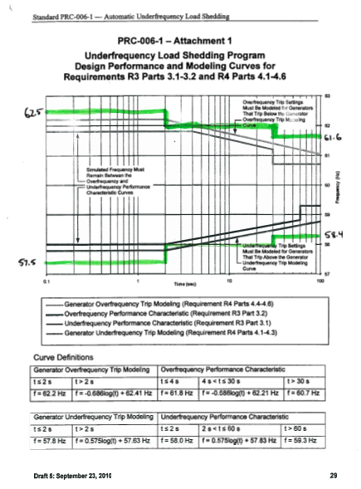

John Moore
STEC
DWG Chair

