 |  |  |  | System Planning Division
Monthly Status Report
to
Reliability and Operations Subcommittee
for
September 2010

 |  | Report Highlights
Item
1. | - ERCOT is currently tracking 188 active generation interconnection requests totaling over 65,000 MW. This includes almost 39,000 MW of wind generation.
2. | - ERCOT is currently reviewing proposed transmission improvements with a total cost of $80.8 Million  - Transmission Projects endorsed in 2010 total $230.4 Million  - All projects (in engineering, routing, licensing and construction) total approximately $9.4 Billion  - Transmission Projects energized in 2010 total about $791.7 million

Table of Contents
1. Generation Interconnection 1
1.1 New Generation Registering for Commercial Operations 1
1.2 Publicly Disclosed Generation Interconnection Projects 4
1.3 Generation Projects Undergoing Full Interconnection Studies (not otherwise public) 6
1.4 Wind Generation 7
Wind Capacity Installed by Year 7
2. Regional Planning Group Project Reviews 9
3. Congestion Costs 10
4. Wind Generation as a Percent of Load 16
5. Other Notable Activities 17

1. Generation Interconnection
Additional information regarding detailed generation interconnection and impact studies is contained in the “Generation Project Interconnection Information” folder in the “Operations and System Planning” area on the ERCOT website: http://planning.ercot.com/login/login.

New Generation Registering for Commercial Operations

Texas Solar (Blue Wing 2) 7 MW of Photovoltaic Solar in Bexar County
The total installed wind capacity remains at 9,317 MW, of which 7,958 MW (85%) is located within the Western Congestion Management Zone.

New Generation Interconnection Agreements - none
Summary of Active Generation Interconnection Requests

GENERATION INTERCONNECTION REQUESTS CURRENTLY BEING PROCESSED
Currently tracking 188 active generation interconnection or change requests
As of September 30, 2010 | North | South | West | Total
Security Screening Study | 1 | 1 | 8 | 10
SSS Completed | 2 | 4 | 9 | 15
Full Interconnect Study | 19 | 13 | 93 | 125
FIS Completed | 3 | 15 | 3 | 21
Interconnect Agreement Completed | 8 | 5 | 4 | 17
Capacity under Interconnection Agreements | 5,192 | 2,575 | 506 | 8,273
Capacity for Grid, MW | 19,325 | 13,347 | 32,454 | 65,126
Wind Capacity, MW | 3,756 | 4,641 | 30,310 | 38,707

Fuel Type | Confidential Projects (MW) | Projects Under Full Study (MW) | Projects w/ Interconnect Agreement/Public Letter (MW) | Grand Total (MW)
Gas-CC |  |  | 3,972 | 12,043
Gas-CT |  |  |  | 247
Total Gas | 600 | 7,718 | 3,972 | 12,290
Nuclear |  |  | 5,900 | 5,900
Coal |  | 1,740 | 3,213 | 4,953
Wind | 3,628 | 29,127 | 5,953 | 38,708
Solar | 340 | 699 |  | 1,039
Biomass |  | 50 | 145 | 195
Other |  | 740 | 1,300 | 2,040
Grand Total | 4,568 | 40,074 | 20,483 | 65,125

Publicly Disclosed Generation Interconnection Projects
The table below summarizes the publicly disclosed generation projects for the ERCOT region.
(Status: IA=Interconnect Agreement, PL=Public Letter, XX= cancelled)
Generation Interconnections as of September 30, 2010
INR | SiteName | Status | County | Region | COD | Fuel Type |  | MW For Grid | Change from Last Report
09INR0082 | Cedro Hill Wind | IA | Webb | South | Oct-10 |  | Wind | 150 | Date
12INR0003 | Throckmorton Wind Farm | PL | Throckmorton | West | Dec-10 |  | Wind | 400
08INR0033 | Lufkin | IA | Angelina | North | Dec-10 |  | Biomass | 45
05INR0015b | Gulf Wind 2 | PL | Kenedy | South | Jan-11 |  | Wind | 400
05INR0015c | Gulf Wind 3 | PL | Kenedy | South | Jan-11 |  | Wind | 400
08INR0065 | Buffalo Gap 4 and 5 | PL | Nolan | West | Mar-11 |  | Wind | 465
09INR0029 | CFB Power Plant Units 11&12 | IA | Calhoun | South | Mar-11 |  | Coal | 263
10INR0010 | Jack County 2 | IA | Jack | North | Jun-11 |  | Gas-CC | 620
08INR0011 | Senate Wind Project | IA | Jack | North | Nov-11 |  | Wind | 150
08INR0038 | M Bar Wind | PL | Andrews | West | Dec-11 |  | Wind | 194
09INR0034 | Gatesville Wind Farm | PL | Coryell | North | Dec-11 |  | Wind | 200
08INR0025 | Pistol Hill Energy Center | PL | Ector | West | Dec-11 |  | Wind | 300
06INR0012b | Sherbino Mesa Wind Farm 2 | IA | Pecos | West | Jan-12 |  | Wind | 150 | Date
09INR0001 | Sandy Creek 1 | IA | McLennan | North | Feb-12 |  | Coal | 925
11INR0084 | 2W Whatley Phase 1 | PL | Ector | West | Mar-12 |  | Wind | 45 | New
09INR0007 | Nacogdoches Project | IA | Nacogdoches | North | Apr-12 |  | Biomass | 100
07INR0004 | Pampa Energy Center | PL | Gray | West | May-12 |  | Coal | 165
09INR0024 | B&B Panhandle Wind | PL | Carson | West | Jun-12 |  | Wind | 1,001
09INR0037 | Scurry County Wind III | PL | Scurry | West | Jun-12 |  | Wind | 350
12INR0004 | Fort Concho Wind Farm | PL | Tom Green | West | Jul-12 |  | Wind | 400
12INR0043 | 2W Whatley Phase 2 | PL | Ector | West | Aug-12 |  | Wind | 290 | New
09INR0036 | McAdoo Energy Center II | PL | Dickens | West | Dec-12 |  | Wind | 500
08INR0018 | Gunsight Mountain | IA | Howard | West | Dec-12 |  | Wind | 120
06INR0022c | Penascal Wind Farm 3 | IA | Kenedy | South | Dec-12 |  | Wind | 202
06INR0006 | Cobisa-Greenville | IA | Hunt | North | May-13 |  | Gas-CC | 1,792
10INR0020a | Panda Temple Power | IA | Bell | North | May-13 |  | Gas-CC | 780
04INR0011b | Cedar Elm | IA | Shackelford | West | Jun-14 |  | Wind | 136
04INR0011c | Cottonwood Wind | IA | Shackelford | West | Jun-14 |  | Wind | 100
14INR0005 | White Stallion Energy Center | PL | Matagorda | South | Jul-14 |  | Coal | 1,200
12INR0016 | Las Brisas Energy Center | IA | Nueces | South | Sep-14 |  | Other | 1,300
14INR0002 | Coleto Creek Unit 2 | IA | Goliad | South | Nov-14 |  | Coal | 660
10INR0020b | Panda Temple Power | IA | Bell | North | Dec-14 |  | Gas-CC | 780
15INR0008 | STP 3 and 4 | PL | Matagorda | South | Jun-16 |  | Nuclear | 2,700
15INR0002 | Comanche Peak 3 and 4 | PL | Somervel | North | Dec-18 |  | Nuclear | 3,200
 |  |  |  |  |  |  | TOTAL | 20,483

County Location of Installed Generation and Interconnection Requests (all fuels)

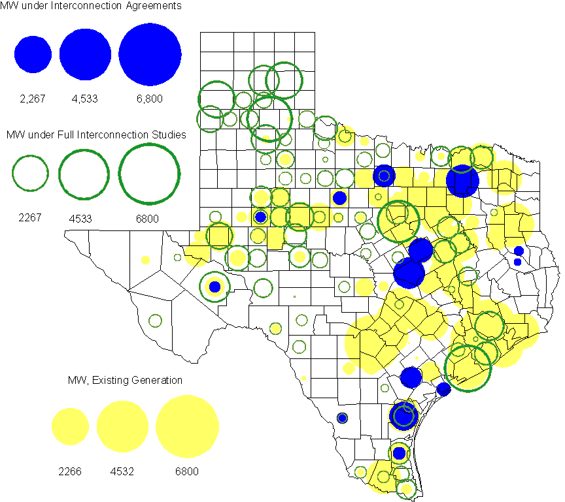

Generation Projects Undergoing Full Interconnection Studies (not otherwise public)
INR | County | Capacity | COD | Fuel |  | INR | County | Capacity | COD | Fuel
09INR0054 | Stonewall | 149 | TBD | Wind |  | 09INR0061 | Kent | 258 | TBD | Wind
10INR0048 | Hardeman | 1,000 | TBD | Wind |  | 10INR0016 | Childress | 150 | TBD | Wind
10INR0054 | Palo Pinto | 36 | TBD | Wind |  | 10INR0079 | Nolan | 60 | TBD | Wind
10INR0029 | Hood | 810 | TBD | Gas |  | 10INR0013 | Upton | 400 | TBD | Wind
10INR0052a | Knox | 21 | TBD | Wind |  | 09INR0074 | Motley | 70 | TBD | Wind
10INR0041 | Floyd | 135 | TBD | Wind |  | 11INR0029 | Throckmorton | 200 | TBD | Wind
07INR0013 | Coke | 200 | Dec-10 | Wind |  | 07INR0015 | Foard | 180 | Dec-10 | Wind
07INR0035 | Tom Green | 270 | Dec-10 | Wind |  | 08INR0062 | Archer | 249 | Dec-10 | Wind
10INR0008 | Pecos | 500 | Dec-10 | Wind |  | 10INR0019 | Deaf Smith | 609 | Dec-10 | Wind
10INR0032 | Navarro | 775 | Dec-10 | Gas |  | 10INR0033 | Armstrong | 399 | Dec-10 | Wind
10INR0042 | Mason | 170 | Dec-10 | Wind |  | 10INR0051 | Brazoria | 200 | Dec-10 | Wind
10INR0056 | Borden | 249 | Dec-10 | Wind |  | 10INR0060 | Willacy | 401 | Dec-10 | Wind
10INR0077 | Callahan | 101 | Dec-10 | Wind |  | 10INR0080 | Presidio | 144 | Dec-10 | Solar
10INR0082 | Travis | 30 | Dec-10 | Solar |  | 11INR0076 | Archer | 94 | Jan-11 | Wind
11INR0050 | Crosby | 149 | Mar-11 | Wind |  | 11INR0081 | Live Oak | 72 | Mar-11 | Wind
11INR0082A | Val Verde | 50 | Mar-11 | Wind |  | 11INR0083A | Crockett | 50 | Mar-11 | Wind
11INR0088 | Brazos | 45 | Mar-11 | Gas |  | 11INR0071 | Harris | 7 | Apr-11 | Gas
11INR0075 | Fort Bend | 15 | Apr-11 | Coal |  | 11INR0086 | Travis | 60 | Apr-11 | Solar
10INR0009 | Castro | 300 | May-11 | Wind |  | 11INR0037 | Smith | 50 | May-11 | Biomass
11INR0058 | Pecos | 135 | May-11 | Solar |  | 11INR0060 | Tom Green | 90 | May-11 | Solar
11INR0061 | Presidio | 90 | May-11 | Solar |  | 11INR0062 | Nueces | 149 | May-11 | Wind
11INR0033a | Cameron | 200 | May-11 | Wind |  | 11INR0033b | Cameron | 200 | May-11 | Wind
08INR0020 | Eastland | 200 | Jun-11 | Wind |  | 09INR0050 | Fannin | 1,200 | Jun-11 | Gas
10INR0023 | Haskell | 386 | Jun-11 | Wind |  | 10INR0057 | Taylor | 200 | Jun-11 | Wind
10INR0089 | Harris | 40 | Jun-11 | Other |  | 11INR0019 | Upton | 200 | Jun-11 | Wind
11INR0054 | San Patricio | 161 | Jun-11 | Wind |  | 11INR0057 | Cameron | 165 | Jun-11 | Wind
11INR0065 | Nueces | 240 | Jun-11 | Wind |  | 11INR0091 | Webb | 92 | Jun-11 | Wind
11INR0006 | Lamar | 579 | Jul-11 | Gas |  | 11INR0040 | Freestone | 640 | Aug-11 | Gas
11INR0039 | Starr | 201 | Sep-11 | Wind |  | 11INR0047 | Deaf Smith | 600 | Sep-11 | Wind
11INR0079a | Clay | 200 | Sep-11 | Wind |  | 07INR0014a | Wilbarger | 140 | Oct-11 | Wind
07INR0014b | Wilbarger | 70 | Oct-11 | Wind |  | 10INR0062a | Pecos | 80 | Oct-11 | Wind
10INR0081b | Clay | 19 | Oct-11 | Wind |  | 10INR0021 | Grayson | 646 | Nov-11 | Gas
11INR0090 | Howard | 60 | Nov-11 | Solar |  | 08INR0049 | Clay | 50 | Dec-11 | Wind
11INR0005 | Upton | 500 | Dec-11 | Wind |  | 11INR0013 | Mills | 150 | Dec-11 | Wind
11INR0025 | Crockett | 400 | Dec-11 | Wind |  | 11INR0043 | Coke | 300 | Dec-11 | Wind
11INR0067 | Cameron | 78 | Dec-11 | Wind |  | 11INR0070 | Reeves | 50 | Dec-11 | Solar
12INR0034 | Borden | 342 | Dec-11 | Wind |  | 09INR0048 | Jack | 150 | Dec-11 | Wind
09INR0075 | Kinney | 248 | Dec-11 | Wind |  | 10INR0085 | Ector | 40 | Jan-12 | Solar
12INR0021 | Edwards | 165 | Jan-12 | Wind |  | 12INR0033 | Motley | 150 | Jan-12 | Wind
10INR0018 | Madison | 550 | Mar-12 | Gas |  | 12INR0042 | Deaf Smith | 400 | Mar-12 | Wind
09INR0031 | Ector | 275 | May-12 | Gas |  | 10INR0081a | Clay | 30 | May-12 | Wind
11INR0049 | Wharton | 275 | May-12 | gas |  | 12INR0007 | Lamar | 296 | May-12 | Gas
08INR0031 | Childress | 100 | Jun-12 | Wind |  | 10INR0022 | Harris | 1,380 | Jun-12 | Gas
12INR0006 | Limestone | 875 | Jun-12 | Coal |  | 08INR0041 | Coke | 200 | Oct-12 | Wind
12INR0026 | Randall | 400 | Oct-12 | Wind |  | 08INR0044 | Concho | 200 | Nov-12 | Wind
12INR0035 | Nueces | 249 | Nov-12 | Wind |  | 08INR0042 | Coke | 200 | Dec-12 | Wind
08INR0054 | Comanche | 401 | Dec-12 | Wind |  | 09INR0025 | Concho | 180 | Dec-12 | Wind
12INR0005 | Floyd | 1,100 | Dec-12 | Wind |  | 12INR0022 | Hidalgo | 200 | Dec-12 | Wind
12INR0029 | Swisher | 500 | Dec-12 | Wind |  | 10INR0024 | Briscoe | 2,940 | Jan-13 | Wind
12INR0027 | Gray | 200 | Jan-13 | Wind |  | 09INR0058 | Howard | 250 | Mar-13 | Wind
11INR0082B | Val Verde | 150 | Mar-13 | Wind |  | 11INR0083B | Crockett | 100 | Mar-13 | Wind
12INR0018 | Gray | 500 | Apr-13 | Wind |  | 10INR0062b | Pecos | 220 | May-13 | Wind
13INR0020 | Glasscock | 350 | May-13 | Wind |  | 09INR0041 | Mitchell | 300 | Jun-13 | Wind
09INR0051 | Borden | 249 | Jun-13 | Wind |  | 13INR0023 | Ector | 240 | Jul-13 | Gas
13INR0016 | Deaf Smith | 251 | Aug-13 | Wind |  | 13INR0004 | Deaf Smith | 500 | Oct-13 | Wind
13INR0005 | Carson | 600 | Oct-13 | Wind |  | 08INR0022 | Floyd | 100 | Dec-13 | Wind
08INR0023 | Floyd | 100 | Dec-13 | Wind |  | 09INR0077 | Reagan | 500 | Dec-13 | Wind
12INR0002a | Briscoe | 200 | Dec-13 | Wind |  | 13INR0007 | Pecos | 200 | Dec-13 | Wind
13INR0017 | Childress | 200 | Dec-13 | Wind |  | 09INR0073 | Scurry | 200 | Dec-13 | Wind
13INR0010 | Parmer | 1,200 | Dec-13 | Wind |  | 08INR0019a | Gray | 250 | Jan-14 | Wind
08INR0019b | Gray | 250 | Jan-14 | Wind |  | 08INR0019c | Gray | 250 | Jan-14 | Wind
13INR0006 | Gray | 750 | Jan-14 | Wind |  | 10INR0015 | Mitchell | 350 | May-14 | Wind
14INR0003 | Nolan | 850 | Jun-14 | Coal |  | 12INR0002b | Briscoe | 200 | Dec-14 | Wind
14INR0001 | Pecos | 500 | Dec-14 | Wind |  | 12INR0002c | Briscoe | 350 | Dec-15 | Wind
16INR0002 | Brazoria | 700 | Jun-17 | Other

Wind Generation

Wind Capacity Installed by Year

County Location of Installed Capacity and Interconnection Requests (Wind only)

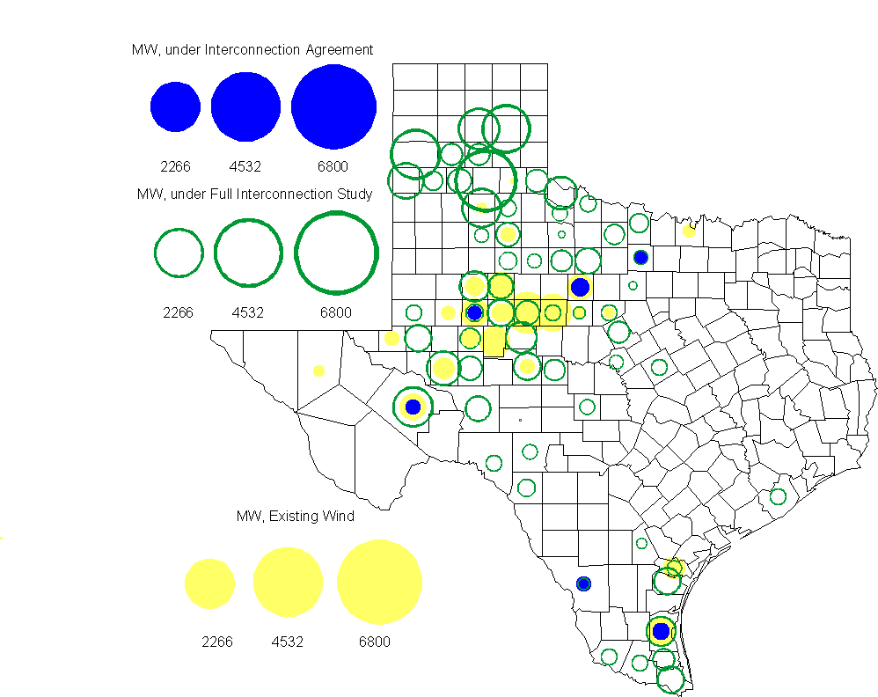

Regional Planning Group Project Reviews
- Oncor submitted a project to relieve congestion related to new wind units in the Lamesa area. The project will upgrade the Lamesa to Bluff Creek 138 kV line, rebuild the Bluff Creek to China Grove 138 kV line, rebuild the Lamesa to Ackerly Vealmoor 69 kV line to 138/69 kV double circuit, rebuild the Lamesa 138 kV switching station, build a new 138 kV Ackerly Vealmoor station, add second circuits to all rebuilt lines and include station upgrades at China Grove and Big Spring. The cost of this project is $ 80.8 M. This project will be reviewed to ensure that the improvements fit into the likely CREZ transmission solution for the area. This project is in ERCOT Independent Review.

- Pattern Energy has submitted a project to construct an HVDC tie with a capacity of up to 3000 MW between ERCOT and SERC. This project is in study mode. ERCOT is currently developing a process for evaluating asynchronous ties with other grids.

Congestion Costs
Dollars shown in graphs are settlement quality.

OOMC – last 13 months in million$
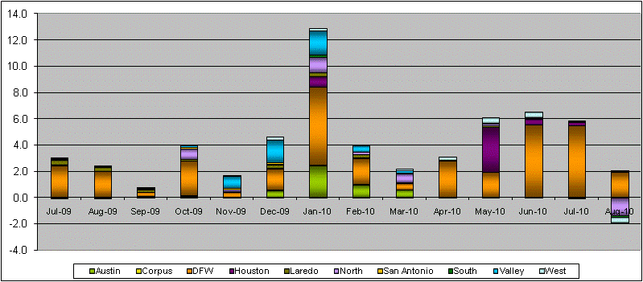

OOM Down – last 13 months in million$
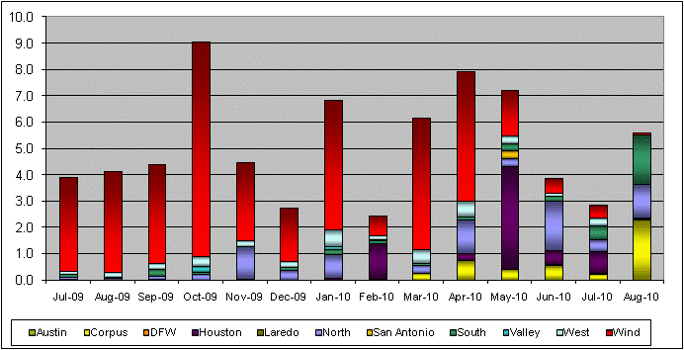

Local Balancing Energy Down – last 13 months in million$
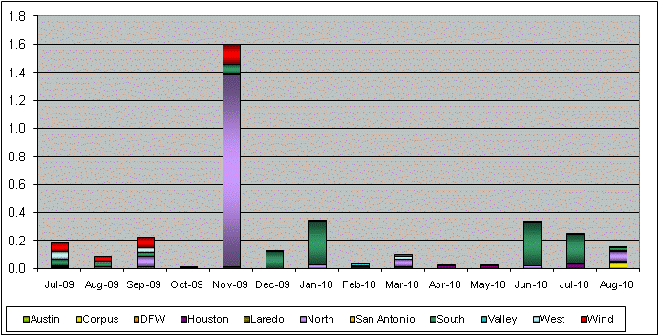

OOM Up – last 13 months in million$
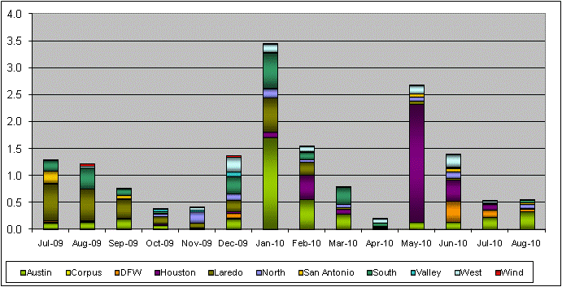

Local Balancing Energy Up – last 13 months in million$
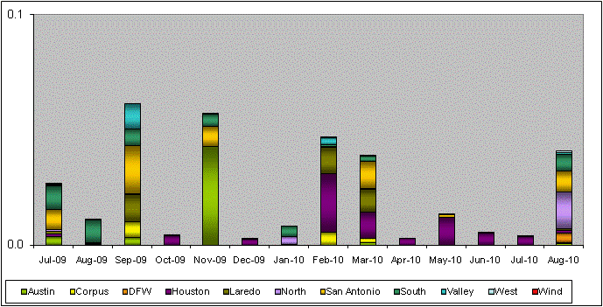

Replacement Reserve – last 13 months in thousand$
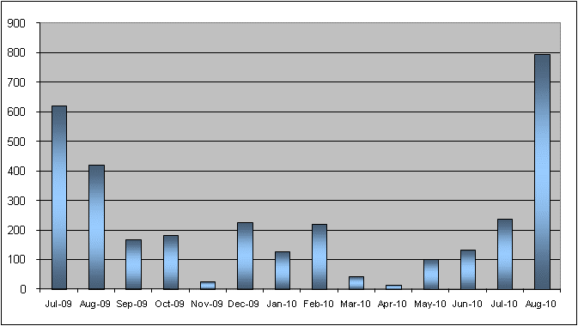

Average MCPE
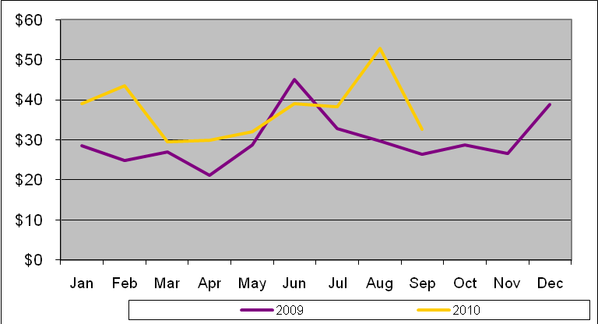

Binding Constraints & Capacity Shortages– August, 2010
Contingency | Binding Element | Estimated Costs | Transmission Project | Clearance
Watermill Switch - West Levee Switch 345kV | Duncanville South - Cedar Hill 138kV | $ 2,555,729 | Cedar Hill Switch second 345/138 kV autotransformer  [13TPIT0062 | Outage on Cedar Hill Switch 345kVAT2
Barney Davis - Holly 138kV  West Side - Airline 138kV | Airline - Cabaniss 138kV | $ 1, 639,144 |  | High generation
Lytton Springs - Zorn & Austrop - Zorn 345kV | Zorn - Pooley 138kV | $ 671,998 | Zorn/Clear Springs-Gilleland Creek-Hutto Switch 345-kV line [08TPIT0020] | High load in the area and S-N flow
Big Brown - Venus 345kV | Richland Chambers - Trinidad 345kV | $ 569,438 | Trinidad - Watermill 345 kV line  [07TPIT0140] | High load in North
Watermill - Limestone 345 kV | Jewett - Rattlesnake Road Switch 345kV | $ 465,102 | Rattlesnake Road Switch - Lake Creek 345 kV line  [09TPIT0150] | High load in North, but units in North having issues. MCSES derated & HLSES tripping/running back.
Austrop - Sandow 345kV | Round Rock - Round Rock Northeast 138kV | $ 357,861 | Hutto Switch - Round Rock NE - Round Rock 138 kV line  [08TPIT0009] | High N-S zonal transfer
RPRS |  | $ 340,696
Lytton Springs - Zorn & Austrop - Zorn 345kV | Victoria - Thomaston - Cuero 138kV | $ 221,167 | Thomaston: Install 138 kV PST, Add 3-28.8 MVAR Cap Banks, Reterminate 138 kV Line  [10TPIT0069] | Line derated per NOMCR 7339_1
Martin Lake SES - Elkton & Tyler Grande | Delek POI - Tyler Northeast 138kV | $ 209,706 |  | High generation
Tricorner - Tyler Grande & Martin Lake SES - Elkton 345kV | Tyler Grande - Elkton 138kV | $ 184,334 | Elkton - Tyler West 138 kV line  [06TPIT0047] | High load in the area

Inter-zonal Congestion

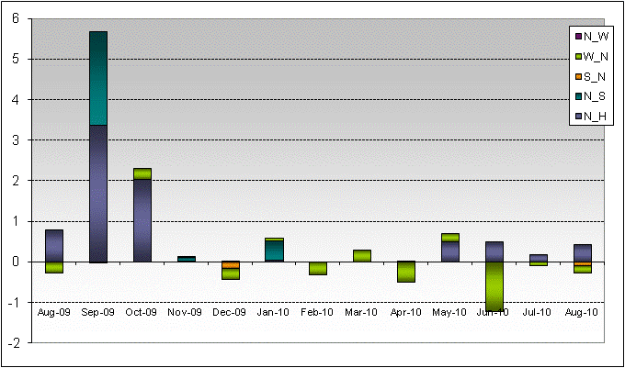

Wind Generation as a Percent of Load
One-hour average Settlement quality data shown.

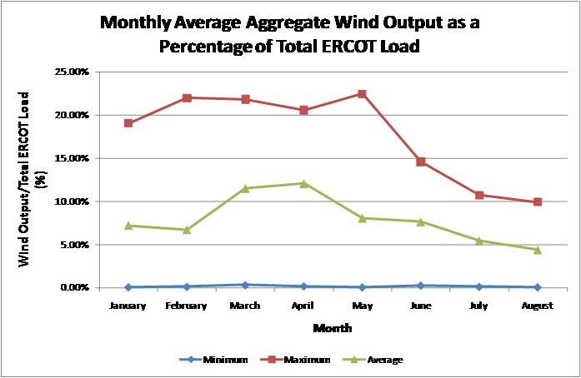

Other Notable Activities
- Work on the 2010 Five-Year Transmission Plan is underway. The set of projects needed to reliably serve load in 2011 through 2015 has been identified and comments have been received. The analysis is currently focused projects to relieve congestion for 2011 through 2015.

- Nodal Network Model Management System Topology Processor base case building modernization work continues with bi-weekly meetings calls with SSWG and weekly ERCOT topology processor output. ERCOT and SSWG have created a planning case by adding generation, load, and voltage profiles to the Topology Processor output in Model On Demand (MOD). This case, once completed, will be compared to the current 2010 Summer Peak case.

- ERCOT created a spreadsheet in September showing impedance and branch ratings differences that need to be reconciled between the current 2010 Fall Peak SSWG case and Topology Processor output case with a November build date. The purpose of this comparison is to confirm that impedances and ratings in the NMMS have been crosschecked against the SSWG database. The deadline for submitting the spreadsheet back to ERCOT and submitting NOMCRs to change the NMMS model was October 1, 2010. ERCOT will create another spreadsheet showing remaining differences and report this metric to ROS at their next meeting.

- Studies to determine the ERCOT System Voltage Profile continue. Market Participants should participate in these to make sure that their interests and unit capabilities are taken into consideration.

- Blackstart testing has begun. ERCOT staff are witnessing the required tests.

- The CREZ Reactive Study, being performed by ABB and led jointly by ERCOT and the CREZ TSPs, to optimize the reactive support equipment required to implement the CREZ plan is nearly complete. Findings from this study will be discussed at the Regional Planning Group meeting on 10/15. A final report will be available in late October.

- Work on the Long-Term System Assessment/DOE Study has begun. A separate subgroup of RPG has been established to focus on this study and is meeting monthly. The current focus is on background information that will be used for developing the scenarios to be studied.

- Transient Stability Study for 2010 Summer on-peak conditions: As part of the annual reliability assessment of the network, a transient stability study study has been performed on an ERCOT 2010 case that included wind modeling. Presentation of results is being prepared for DWG’s Oct. meeting.

- Transient Stability Study for 2013 Summer on-peak conditions: As part of the annual reliability assessment of the network, a transient stability study has been performed on an ERCOT 2013 case that included wind modeling. Presentation of results is being prepared for DWG’s Oct. meeting.

