NPRR Number | 255 | NPRR Title | Resolution of Alignment Item A81 - DRUC Timing and Execution when DAM is Delayed or Aborted
Timeline | Normal | Action |  | Recommended Approval
Date of Decision |  | October 7, 2010
Proposed Effective Date |  | Upon the Nodal Protocol Transition Plan’s Texas Nodal Market Implementation Date as prescribed by zonal Protocol Section 21.12, Process for Transition to Nodal Market Protocol Sections.
Priority and Rank Assigned |  | Not applicable.
Nodal Protocol Sections Requiring Revision |  | 4.1.2, Day-Ahead Process and Timing Deviations  5.2.1, RUC Normal Timeline Summary  5.2.2, RUC Process Timing Deviations (new)  5.2.2.1, Delay of the Day-Ahead Reliability Unit Commitment (new)  5.2.2.2, Aborted Day-Ahead Reliability Unit Commitment (new)
Revision Description |  | This Nodal Protocol Revision Request (NPRR) adds new Section 5.2.2 to describe the process that ERCOT will follow in the event that the Day-Ahead Market (DAM) is delayed or aborted. This NPRR resolves alignment items A81 and A139.
Reason for Revision |  | This change conforms the Nodal Protocols to the as-built ERCOT Nodal System Administrative Controls.  If the DAM is delayed but executes, ERCOT will execute a Day-Ahead Reliability Unit Commitment (DRUC) no sooner than one hour following the completion of the delayed DAM and the sequence of events will be the same as for the normal Reliability Unit Commitment (RUC) timeline.  If the DAM is aborted, ERCOT will not have procured Ancillary Services to meet the needs of the ERCOT Ancillary Service Plan posted prior to the aborted DAM. In this case ERCOT will use the Supplemental Ancillary Services Market (SASM) process described in Section 6.4.8.2, Supplemental Ancillary Services Market, to procure the amount of Ancillary Services not provided as self-arranged by the Qualified Scheduling Entities (QSEs) for the next Operating Day.
Overall Market Benefit |  | Alignment of the Nodal Protocols with the as-built Nodal system implementation and administrative controls. Adds certainty to market processes by clarifying the ERCOT process for RUC and its Settlement that will be executed when the DAM is aborted.
Overall Market Impact |  | Unknown.
Consumer Impact |  | Unknown.
Credit Impacts |  | ERCOT Credit Staff and the Credit Work Group (Credit WG) have reviewed NPRR255 and do not believe that it requires changes to credit monitoring activity or the calculation of liability.
Procedural History |  | - On 7/15/10, NPRR255, a CEO Revision Request Review, and an Impact Analysis were posted.  - On 7/22/10, PRS considered NPRR255.  - On 8/10/10, Nodal Advisory Task Force (NATF) comments were posted.  - On 8/19/10, PRS again considered NPRR255.  - On 8/23/10, Luminant comments were posted.  - On 9/23/10, PRS considered the 8/19/10 PRS Report and Impact Analysis for NPRR255.  - On 9/30/10, ERCOT comments were posted.  - On 10/4/10, PRS again considered the 8/19/10 PRS Report and Impact Analysis for NPRR255.  - On 10/7/10, TAC considered NPRR255.
PRS Decision |  | On 7/22/10, PRS unanimously voted to refer NPRR255 to NATF. All Market Segments were present for the vote.  On 8/19/10, PRS unanimously voted to recommend approval of NPRR255 as submitted. The Independent Power Marketer (IPM) Market Segment was not present for the vote.  On 9/23/10, PRS unanimously voted to table NPRR255 until the next PRS meeting. All Market Segments were present for the vote.  On 10/4/10, PRS voted to endorse and forward the 8/19/10 PRS Report as amended by the 9/30/10 ERCOT comments and Impact Analysis for NPRR255 to TAC. There were two abstentions from the Independent Generator Market Segment. All Market Segments were present for the vote.
Summary of PRS Discussion |  | On 7/22/10, it was requested that NPRR255 be referred to NATF to review the proposed timelines.  On 8/19/10, there was no discussion.  On 9/23/10, ERCOT Staff explained that it was working on modifications to the process proposed in NPRR255, and that ERCOT would submit comments revising the NPRR consistent with the modifications and incorporating Luminant’s comments.  On 10/4/10, it was noted that Luminant would like to consider adopting the approach set forth in NPRR255 for all SASMs, but that this matter was appropriate for a separate future NPRR.
TAC Decision |  | On 10/7/10, TAC unanimously voted to recommend approval of NPRR255 as recommended by PRS in the 10/4/10 PRS Report. All Market Segments were present for the vote.
Summary of TAC Discussion |  | On 10/7/10, there was no discussion.

Quantitative Impacts and Benefits

Assumptions | 1
Assumptions | 2
Assumptions | 3
Assumptions | 4
Market Cost
Market Cost | 1 | Unknown.
Market Cost | 2
Market Cost | 3
Market Cost | 4
Market Benefit
Market Benefit | 1 | Alignment of the Nodal Protocols with the as-built Nodal system implementation and administrative controls.
Market Benefit | 2 | Adds certainty to market processes by clarifying the ERCOT process for RUC and its Settlement that will be executed when the DAM is aborted.
Market Benefit | 3
Market Benefit | 4
Additional Qualitative Information | 1
Additional Qualitative Information | 2
Additional Qualitative Information | 3
Additional Qualitative Information | 4
Other Comments | 1
Other Comments | 2
Other Comments | 3
Other Comments | 4

Sponsor
Name | Matt Mereness
E-mail Address | mmereness@ercot.com
Company | ERCOT
Phone Number | 512-248-3089
Market Segment | Not applicable

Market Rules Staff Contact
Name | Jonathan Levine
E-Mail Address | jlevine@ercot.com
Phone Number | 512-248-6464

Comments Received
Comment Author | Comment Summary
NATF 081010 | Endorsed NPRR255 as submitted.
Luminant 092310 | Expressed general support for NPRR255; proposed revision to add 30 minutes additional advance notice to the Supplemental Ancillary Services Market (SASM) timeline for aborted Day-Ahead processes.
ERCOT 093010 | Proposed an alternative approach for delayed or aborted DAMs.

Proposed Protocol Language Revision

4.1.2 Day-Ahead Process and Timing Deviations
(1) ERCOT may temporarily deviate from the timing of its obligations in this Section but only to the extent necessary to ensure the secure operation of the ERCOT System. In that event, ERCOT shall immediately issue a Watch and notify all Qualified Scheduling Entities (QSEs) of the following:
(a) Details of the affected timing and procedures;
(b) Details of any interim requirements;
(c) An estimate of the period for which the interim requirements apply; and
(d) Reasons for the temporary variation.
(2) If, despite the varying timing or omitting any procedure, ERCOT is unable to execute the Day-Ahead process, ERCOT may abort all or part of the Day-Ahead process and require all schedules and trades to be submitted in the Adjustment Period. In that event, ERCOT shall declare an Emergency Condition and notify all QSEs of the following:
(a) Details of the affected timing and procedures;
(b) Details of any interim requirements, including the requirements described in Section 5.2.2.2, RUC Process Timeline After an Aborted Day-Ahead Market;
(c) An estimate of the period for which the interim requirements apply; and
(d) Reasons for the temporary variation.
(3) If, despite varying timing or omitting steps, ERCOT is unable to operate the Adjustment Period process, then ERCOT may abort the Adjustment Period process and operate under its Operating Period procedures.

5.2 Reliability Unit Commitment Timeline Summary

5.2.1 RUC Normal Timeline Summary
The following Reliability Unit Commitment (RUC) Timeline Summary describes the normal timeline for RUC activities that occur in the Day-Ahead and Adjustment Periods.
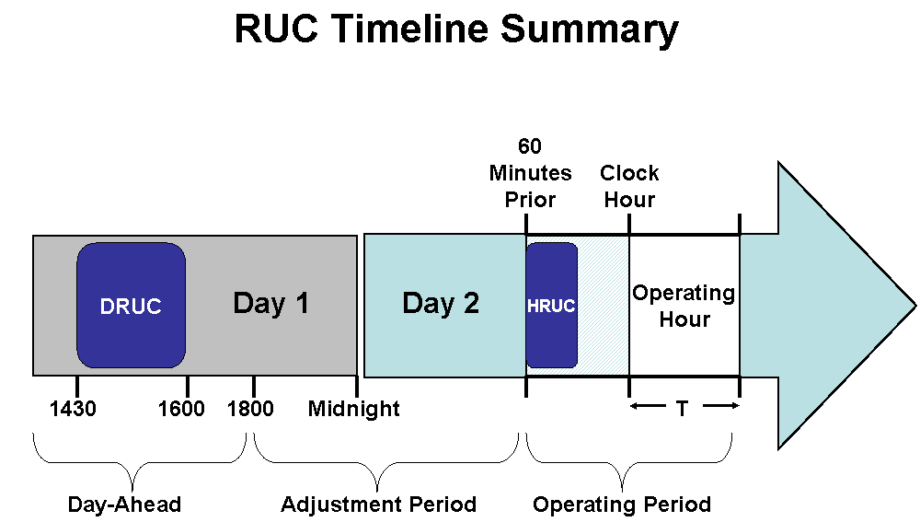

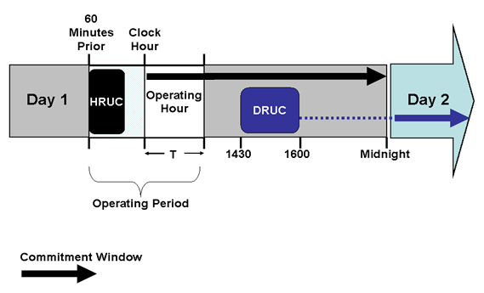

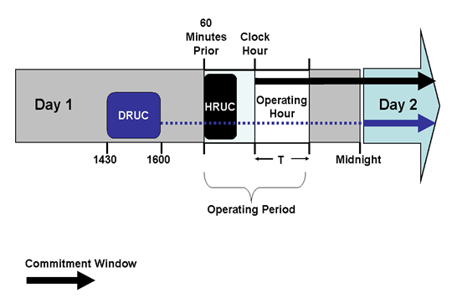

5.2.2 RUC Process Timing Deviations

5.2.2.1 RUC Process Timeline After a Delay of the Day-Ahead Market
If the Day-Ahead Market (DAM) execution is delayed in accordance with Section 4.1.2, Day-Ahead Process and Timing Deviations, ERCOT shall conduct a Day-Ahead Reliability Unit Commitment (DRUC) after 1430 in the Day-Ahead and no earlier than one hour following the posting of DAM awards information on the Market Information System (MIS) Public Area as set forth in Section 4.5.3, Communicating DAM Results. In this event, ERCOT will use the Current Operating Plan (COP) and Trades Snapshot taken just prior to the execution of the DRUC to settle RUC charges.

5.2.2.2 RUC Process Timeline After an Aborted Day-Ahead Market
(1) If ERCOT aborts all or part of the Day Ahead process in accordance with Section 4.1.2, Day-Ahead Process and Timing Deviations, ERCOT shall use the following Supplemental Ancillary Services Market (SASM) process to purchase Ancillary Services for the next Operating Day and the Hourly Reliability Unit Commitment (HRUC) process described in this Section in lieu of the DRUC process.
(2) When the DAM is aborted, ERCOT shall include in the Emergency Condition notice required by paragraph (2) of Section 4.1.2 the time when it intends to conduct the SASM described in this Section 5.2.2.2
to procure the amounts of Ancillary Services necessary to meet the Ancillary Service Plan for the Operating Day affected by the aborted DAM. ERCOT shall allow at least one hour between the issuance of the Emergency Condition notice and the beginning of this SASM.

(3) After the issuance of the Emergency Condition notice described in paragraph (2) above and prior to the beginning of this SASM, a QSE may cancel unexpired Ancillary Service Offers that were submitted for the aborted DAM.
(4) A QSE may submit Ancillary Service Offers for this SASM after the issuance of the Emergency Condition notice described in paragraph (2) above and prior to the beginning of this SASM. For this SASM, these QSE Ancillary Service Offers shall not be subject to the provisions of Section 6.4.8.2.1, Resubmitting Offers for Ancillary Services in the Adjustment Period.
(5) For this SASM, the QSE must submit the Self-Arranged Ancillary Service Quantity for the next Operating Day in accordance with the timeline described in paragraph (8) below. This amount may be different from the self-arrangement amounts previously submitted for the aborted DAM.
(6) The amount of each Ancillary Service to be procured by ERCOT in this SASM is the amount of each Ancillary Service specified in the ERCOT Ancillary Service Plan posted prior to the aborted DAM less the total amount of each Ancillary Service in the QSE submittals for self arranged Ancillary Services for this SASM.
(7) This SASM will settle in accordance with Section 6.7, Real-Time Settlement Calculations for the Ancillary Services.
(8) The SASM process for acquiring Ancillary Services in the event of an aborted Day-Ahead process shall be conducted in accordance with Section 6.4.8.2.2, SASM Clearing Process, but shall use the following activities and timeline with time “X” being the time specified by ERCOT for the beginning of the SASM process in the Emergency Condition notice described above.

SASM Process | QSE Activities: | ERCOT Activities:
Time = X |  | The time specified in the Emergency Condition notice for the SASM to begin.
Time = X plus 30 minutes | Must complete submission of Self-Arranged Ancillary Service Quantities limited to the additional Ancillary Service Obligation of the QSE. | Determine the amount of Ancillary Services to be procured.
Time = X plus 35 minutes |  | Execute SASM.
Time = X plus 45 minutes |  | Notify QSEs with awards of results.  Post the quantities and Market Clearing Prices for Capacity (MCPCs) of Ancillary Services bought in the SASM.
Time = X plus 60 minutes | Submit updated COP with updated Ancillary Service Resource Responsibility. | Validate COPs for Ancillary Service Resource Responsibility.

(9) As soon as practicable, but no later than the time specified above, ERCOT shall notify each QSE of its awarded Ancillary Service Offer quantities, specifying Resource, Ancillary Service type, SASM MCPC, and the first and last hours of the awarded offer.
(10) As soon as practicable, but no later than the time specified above, ERCOT shall post on the MIS Public Area the hourly:
(a) SASM MCPC for each type of Ancillary Service for each hour;
(b) Total Ancillary Service procured in MW by Ancillary Service type for each hour; and
(c) Aggregated Ancillary Service Offer Curve for each ancillary Service for each hour.

(11) No sooner than 1800 in the Day-Ahead and after the completion of the SASM process described in this Section 5.2.2.2, ERCOT shall execute an HRUC process.
(a) The RUC Study Period for this HRUC process is the balance of the current Operating Day plus the next Operating Day. This HRUC process may be a post-1800 HRUC for the current Operating Day.
(b) The COP and Trades Snapshot taken just prior to the execution of the HRUC process described in this Section 5.2.2.2 will be used to settle RUC charges in the Operating Day affected by the aborted DAM.
(c) This HRUC process described in this Section 5.2.2.2 may commit Resources to supply Ancillary Services if the Ancillary Service Offers submitted in the SASM described in this Section 5.2.2.2 are insufficient to meet the requirements of the Ancillary Services Plan in the Operating Day affected by the aborted DAM.

