ERCOT Operations Report
Sep 2010 ROS & OWG

Frequency Control
Time | Freq(Hz) | Duration (s)
9/3/2010 5:24 | 60.10100174 | 4 | Large SCE change +500 MW in 16 minutes. Wind generation increased 630 MW in 20 min.
9/7/2010 18:30 | 59.8390007 | 80 | Unit trip with 760 MW
9/19/2010 6:59 | 59.87900162 | 4 | Unit trip with 580 MW
9/22/2010 23:33 | 59.86600113 | 8 | Unit trip with 520 MW
9/25/2010 20:37 | 59.8390007 | 52 | Unit trip with 760 MW
9/27/2010 15:21 | 59.81900024 | 64 | Unit trip with 760 MW
9/29/2010 7:05 | 59.89500046 | 8 | SCE change -1000MW in 10 minutes
Note: Time of frequency excursions outside the range of +/- 0.1 Hz.

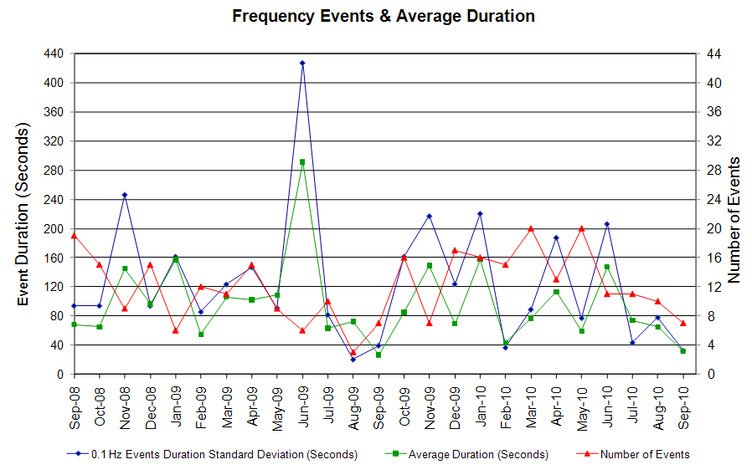

Deployed Responsive (Reported Above)

Time deployed | Stop Time | Duration | Max | Details
9/1/10 12:17:44 | 9/1/10 12:37:25 | 0:19:41 | 378.8514 | Out of up reg.
9/3/10 0:47:20 | 9/3/10 1:09:11 | 0:21:51 | 458.9085 | Out of up reg.
9/3/10 12:30:48 | 9/3/10 12:55:47 | 0:24:59 | 293.4816 | Out of up reg.
9/7/10 18:30:52 | 9/7/10 18:48:59 | 0:18:07 | 699.0189
9/17/10 0:16:14 | 9/17/10 0:37:29 | 0:21:15 | 336.1665 | Unit Trip
9/17/10 8:46:58 | 9/17/10 8:58:05 | 0:11:07 | 373.5183 | Unit Trip
9/17/10 9:07:22 | 9/17/10 9:20:33 | 0:13:11 | 448.2423 | Out of up reg.
9/19/10 6:59:51 | 9/19/10 7:11:28 | 0:11:37 | 485.5738
9/22/10 23:33:59 | 9/22/10 23:50:53 | 0:16:54 | 554.94
9/25/10 20:37:45 | 9/25/10 20:55:49 | 0:18:04 | 699.02
9/27/10 15:21:13 | 9/27/10 15:46:11 | 0:24:58 | 805.74
9/29/10 7:04:55 | 9/29/10 7:22:11 | 0:17:16 | 400.20
9/29/10 21:59:22 | 9/29/10 22:11:21 | 0:11:59 | 330.83 | SCE change -1100MW in 10 minutes

Day-Ahead OOMC and RPRS Capacity Purchases

Details | OOMC | RPRS S1 | RPRS S2 | RPRS S1+S2 | RMR | Total
Western | 0 | 1 | 3 | 4 | 20 | 24
E RIO | 9 | 4 | 0 | 4 | 0 | 13
W RIO | 7 | 2 | 0 | 2 | 0 | 9
Corpus | 1 | 2 | 0 | 2 | 0 | 3
DFW | 0 | 0 | 3 | 3 | 0 | 3
North | 0 | 1 | 1 | 2 | 0 | 2
Houston | 0 | 1 | 1 | 2 | 0 | 2
Austin | 0 | 0 | 1 | 1 | 0 | 1
Northeast | 0 | 0 | 0 | 0 | 0 | 0
Bryan Area | 0 | 0 | 0 | 0 | 0 | 0
South | 0 | 0 | 0 | 0 | 0 | 0
San Antonio | 0 | 0 | 0 | 0 | 0 | 0
Laredo | 0 | 0 | 0 | 0 | 0 | 0
Total | 17 | 11 | 9 | 20 | 20 | 57

Historical Totals | Sep-10 | Sep-09 | Aug-10
Austin | 0 | 1 | 17
Bryan Area | 0 | 0 | 15
Corpus | 3 | 0 | 0
DFW | 0 | 7 | 122
E RIO | 13 | 1 | 1
Houston | 1 | 3 | 0
Laredo | 0 | 2 | 0
North | 1 | 12 | 75
Northeast | 0 | 0 | 23
San Antonio | 0 | 1 | 0
South | 0 | 1 | 8
W RIO | 9 | 0 | 0
Western | 21 | 11 | 60
Total | 48 | 39 | 321

http://www.ercot.com/mktinfo/services/rprsdr/index.html

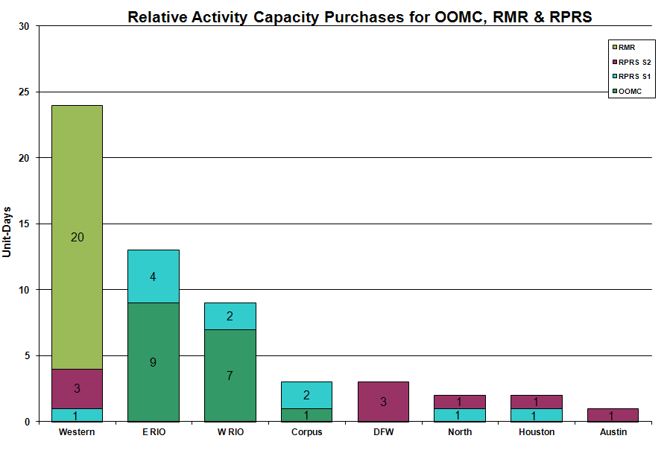

OOME and Congestion Management Activity Congestion affected by outages
Remedial action plan has been developed for the element
Contingency | Overloaded Element | Days
Matador - Paducah Clare Street 69KV | Spur - Girard Tap 69KV | 23
Comanche Peak Units | Cuero - Thomaston138KV | 14
Golden Switch - Bluff Creek Switch 138KV | Sun Switch - Sacroc 138KV | 9
Hamilton - Sonora 138KV | Sonora - Friess Ranch 69KV | 9
Sandow Switch - Austrop 345KV | Hutto - Round Rock Southeast 138KV | 8
Green Bayou - Gable & Hardy - Crockett 138KV | Garrott - Midtown 138KV | 6
Heights - Freeway 138KV | Heights - PH Robinson 138KV | 5
Moss Switch - Holt Switch 138KV | Odessa North 138/69KV AT | 5
Sandow Switch - Austrop 345KV | Round Rock Northeast - Round Rock 138KV | 5
Dyann - East Bernard 138KV | Blessing - Lane City 138KV | 4
Odessa EHV 345/138Kv Auto #2 | Odessa EHV 345/138Kv Auto #1 | 4
Olney - Westover 69KV | Elbert Switch - Seymour 69kV | 4
Lamesa - Willow Valley Switch 138 kV | Ackerly Vealmoor Switch - Ackerly 69 kV | 3
Santa Anna - Ballinger 138KV | Ballinger - Humble 69KV | 3
La Palma - Military Highway 138KV | La Palma - Los Fresnos138KV | 2
Austrop 345/138 kV Auto | Round Rock Northeast - Round Rock 138KV | 2
Barney Davis - Airline - Rodd Field Road 138KV | Airline - Cabaniss 138KV | 2
Cagnon 345/138 kV Auto #3 | Cagnon 345/138 kV Auto #4 | 2
Fisher Road - Oklaunion and Bowman Switch 345KV | Bomarton - Baylor County 69KV | 2
Golden Switch - Bluff Creek Switch 138KV | Sun Switch - Scurry Switch 138KV | 2
Graham - Parker 345KV | Leon Switch - Flat Creek 138KV | 2
Graham - Parker Switch 345KV | Barton Switch - Oran TU 138KV | 2
North Edinburg - Lon Hill 345KV | Low Voltage | 2
Roanoke Switch - West Denton - Lewisville Switch 345KV | West Denton - Ft Worth 138KV | 2
Sandow Switch - Austrop 345KV | Round Rock - Round Rock East 138KV | 2
Snyder - China Grove 138KV | Snyder - Amoco Tap 69KV | 2
Batesville 138/69KV AT | Asherton - Carrizo 69KV | 1
Ingleside Cogen - Whitepoint 138KV | Rincon - Whitepoint 138KV | 1
La Palma - Loma Alta 138KV | La Palma - Villa Cavazos 138KV | 1
Lon Hill - Nelson Sharpe 345KV | Nelson Sharpe - Celanese Bishop 138KV | 1
Fort Bend - East Bernard 138KV | Peters - Sealy 138KV | 1
Graham - Parker Switch 345KV | Graham - Graham East 138KV | 1
Barton Switch - Oran TU 138KV | Graham - Graham Switch 69KV | 1
Basecase | La Palma - Military Highway 138 kV | 1
Basecase | Elbert - Olney 69kV | 1
Calavers JTD #1 | Marbach Road - Cagnon 138KV | 1
Comanche Peak - Decordova & Wolf Hollow - Rocky Creek 345KV | Comanche Peak - Parker Switch 345KV | 1
Dyann - East Bernard 138KV | Altair - Stafford Hill 69KV | 1
Freeway Park - League City 138KV | North Alvin - Hastings 138KV | 1
GAF Substation - Greenbelt 138KV | Freeway Park Sub - PH Robinson 138KV | 1
Graham SES - Long Creek and Graham SES - Cook Field Road Switch 345KV | Brownwood 138/69KV autotransformer | 1
La Palma - Military Highway 138KV | MVEC - Rio Hondo 138KV | 1
McDonald - Spraberry 138 kV | Stanton East - Midland East 138 kV | 1
Parker Switch - Eagle Mountain - Roanoke 345KV | Carrollton Northwest - Lake Point 138KV | 1
San Miguel - Lobo 345KV | Lobo 345/138KV AT | 1
San Miguel 138/69KV AT | Pearsall 138/69KV AT 4 | 1
Snyder - Sun Switch 138 kV | Golden Switch - Brand TU 138 kV | 1
Tricorner - Tyler Grande & Martin Lake SES - Elkton 345KV | Tyler Bullard Road - Tyler South 138KV | 1
Trinidad - Mount Enterprise - Stryker Creek 345KV | Stryker Creek - Cherokee 138KV | 1
Twin Butte - San Angelo 345KV | Twin Butte 345/138KV autotransformer 1 | 1
WB Tuttle - Austin Road 138KV | Fern - Parsons Street 138KV | 1
Wells Branch - Round Rock 138KV | Butter Cup - Whitestone 138KV | 1
West Levee - 800/900 Network 138 kV | East Levee - Reagan Street 138 kV | 1
Willow Valley - Lamesa 138 kV | Ackerly Switch - Ackerly 69 kV | 1

Zonal OC1
CSC | Days
West – North | 15
North – Houston | 8

New RAP, PCAP (Date indicates last update of RAP, PCAP not implementation date.)
None

New Procedures/Forms/Operations Bulletins
Date | Subject | Bulletin No.
09/22/2010 | Transmission and Security Desk V4 Rev 19 | 497
09/22/2010 | Shift Supervisor Desk V4 Rev 18 | 496
09/22/2010 | Operating Period Desk V3 Rev 12 | 495
09/22/2010 | Frequency Control Desk V4 Rev 18 | 494
09/22/2010 | Day-Ahead Desk V4 Rev 15 | 493
09/09/2010 | Transmission and Security Desk V4 Rev 18 | 492
09/09/2010 | Frequency Control Desk V4 Rev 17 | 491

Blackout/Load Shed Incidences
9/07 10:42 17 MW of firm load was shed due to a real-time overload in the Brownsville area. Transmission Watch issued for the Brownsville area due to Tropical Storm Hermine related transmission outages.

EEA
None

Major System Voltage Problems
None

Major Computer Problems, Enhancements & Fixes
None

Communication
None

ERCOT peak (Unofficial)
09/14 17:00 58,137 MW

Yearly MTLF Error Comparison
Yearly Mid-Term (Hourly) Load Forecast Error Comparison for the ERCOT Forecast
Month | MAPE for MTLF at 16:00 Day-Ahead
Month | 2007 | 2008 | 2009 | 2010
January | 4.55 | 3.30 | 4.11 | 3.78
February | 3.75 | 3.59 | 3.49 | 3.79
March | 2.70 | 3.29 | 3.24 | 2.24
April | 3.00 | 2.45 | 2.66 | 2.47
May | 3.22 | 3.01 | 2.90 | 2.63
June | 4.46 | 2.81 | 2.89 | 2.84
July | 4.29 | 2.55 | 2.83 | 2.39
August | 3.11 | 3.66 | 3.07 | 2.29
September | 3.78 | 4.99 | 3.68 | 3.14
October | 3.08 | 2.79 | 2.92 | NA
November | 2.95 | 2.60 | 1.93 | NA
December | 3.74 | 4.54 | 3.70 | NA
Annual Average | 3.55 | 3.29 | 3.11 | 2.84

OCN, Advisory, Watch & Emergency Notices
Capacity
Date | Start | End | Event
9/7/10 | 7:31 | 9:18 | Advisory issued due to ARRS below 3000 MW.
9/9/10 | 13:50 | 18:46 | Advisory issued due to ARRS below 3000 MW.
9/10/10 | 15:35 | 18:00 | Advisory issued due to ARRS below 3000 MW.
9/11/10 | 15:15 | 18:11 | Advisory issued due to ARRS below 3000 MW.
9/12/10 | 14:50 | 18:11 | Advisory issued due to ARRS below 3000 MW.
9/13/10 | 14:52 | 18:15 | Advisory issued due to ARRS below 3000 MW.
9/23/10 | 1:30 | 10:00 | OCN issued for a projected Reserve capacity shortage for HE 1600 - 2100.
9/28/10 | 16:39 | 19:00 | Advisory issued for ARRS below 3000 MW.

Transmission Watch
9/01 18:24 Watch issued for the Lamesa area due to a forced outage. Block Load Transfer from ERCOT to SPP was implemented up to 3 MW.

9/02 00:15 ERCOT issued a Watch for the Lamesa area due to a forced outage.

9/02 17:39 ERCOT issued a Watch for the Laredo area due to area voltage support.

9/07 07:00 Transmission Watch issued for the Brownsville area due to Tropical Storm Hermine related transmission outages. 17 MW of firm load was shed due to a real-time overload in the Brownsville area.

9/08-10 00:15 Transmission Watch issued for the Brownsville area due to Tropical Storm Hermine related transmission outages.

9/19 09:30 Transmission Watch issued for Valley Area due to forced 345kV transmission outage.

Emergency Notice
None

Texas RE Event Analysis
9/05 01:22 Stanton Switch Station SPS #46 activated. ERCOT does not see any evidence that the Stanton East Switching Station SPS #46 SPS failed to operate as designed.

9/05 22:53 Stanton Switch Station SPS #46 activated. ERCOT does not see any evidence that the Stanton East Switching Station SPS #46 SPS failed to operate as designed.

9/06 22:00 Loss of seven 138kV lines, seven 69kV lines, one 138/69kV Autotransformer and one 138kV Statcom in the Brownsville area. Effects of Tropical Storm Hermine being experienced in the area at the time.

9/07 12:18 QSE experienced a power outage at their backup data center due to Tropical Storm Hermine.

9/16 23:29 Stanton Switch Station SPS #46 activated. ERCOT does not see any evidence that the Stanton East Switching Station SPS #46 SPS failed to operate as designed.

9/19 16:00 Market Emergency Notice due to ERCOT not meeting the 16:00 time line regarding scheduling issues with RPRS.

9/21 18:00 Market Emergency Notice issued for RPRS market delay.

Others
None

