NPRR Number | 279 | NPRR Title | Resolution of Alignment Item A144 - Clarify Posting of MCPC for DAM and SASM
Date |  | October 4, 2010
Submitter’s Information
Name |  | Steve Reedy
E-mail Address |  | sreedy@ercot.com
Company |  | ERCOT
Phone Number |  | 512-248-4515
Cell Number
Market Segment |  | Not applicable

Comments

Comments filed by Luminant, Reliant, and PSEG expressed three separate concerns.
We will address these concerns in order of ease.
Reliant has expressed that there should be a “statute of limitations” on price changes made by the ERCOT Board. This could be achieved with little or no system impact.
Luminant proposed (and PSEG and Reliant endorsed this proposal) that the notification timeline in the original protocol language was too late and should instead be moved to 0600 of the operating day (for the Day-Ahead Market) or 0600 of the day following the operating day (for the Real-Time market).
ERCOT understands the concerns expressed in those comments. ERCOT will communicate any price changes as quickly as possible. However, ERCOT would like to note that the price validation group has been staffed to be a business hours unit. ERCOT is concerned that with the notification deadline proposed by Luminant that it is not clear how ERCOT notifies the market if it makes a price correction in between the notification deadline and price finalization.
PSEG expressed concerns about the price correction process in general, which ERCOT would like to address. First, let’s explore the general process of price corrections, and then we will answer the specific questions posed in PSEG’s comments.
ERCOT will endeavor its best to make sure that bad prices do not get published for any market. We have developed a price validation tool and set of quality of solution checks and are working daily to better those tools and processes. However, certain price issues may go undetected, and ERCOT would like to be clear that if we should find that we have published incorrect prices before the price finalization as described in the protocols, we will correct those prices and notify the market that the prices have been corrected. The drawing below illustrates (for the Day-Ahead Market) the different significant events and time frames in the price publication and use life cycle and the ERCOT actions that would be taken should the price need to be corrected in the different time frames.
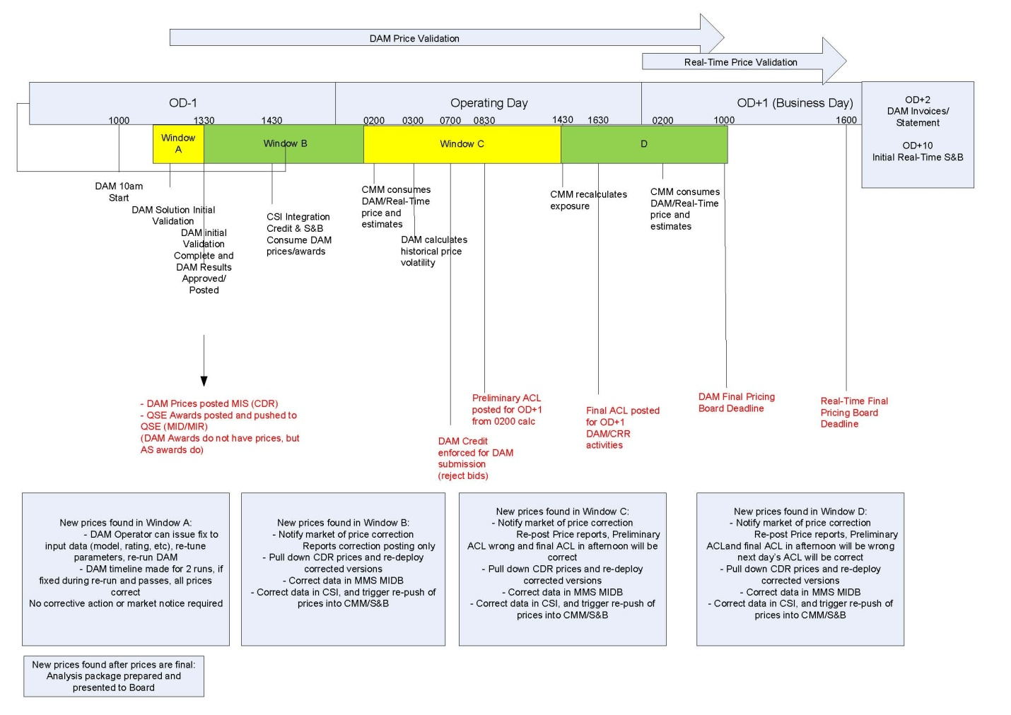Note that the illustration ends at 1000 on Operating Day + 1 bus day when the prices become final. At this time, the process changes significantly. If prices are deemed to be suspect, but we are unable to establish to an extremely high degree of certainty what the correct prices should be, ERCOT will then prepare an analysis for the ERCOT Board. ERCOT will prepare an analysis and recommendation which will include
- Description of the data/software/process error that caused the need for price correction (e.g. QSE X telemetered 0 HSL for several units that were currently generating 3000MW)
- Detailed description of the prices that will be changed (location, interval, price) and what they will change to.
- Description of how ERCOT calculated the new prices.
This analysis will be published as an item on the agenda and a key document for the appropriate ERCOT Board meeting.
There were also specific questions in the PSEG comments that ERCOT would like to answer. Our answers are in green.
(1) How ERCOT will develop the prices that will be used instead of the prices that it proposes to change?
(a) Is it envisioned that prices will be substituted or that markets will be “rerun” with the correct information?
Prices will be substituted; however, markets may need to be rerun in study mode to produce the new prices that will be substituted. The method used to produce the new prices will be highly dependent upon the type of software, data, or process error that produced the pricing error.
(b) Changing one Locational Marginal Price (LMP) (if the rest of the solution is modified to reflect this corrected price) could result in changing all LMPs. Is this the intent or does ERCOT intend to change single prices without respect to the potential impact on the rest of the solution for that interval
ERCOT’s intent is to change all the prices that were affected by the software, data, or process error that necessitated the price correction. Whether that is a single price or all prices will be entirely dependent upon the given circumstance.
(2) What process will be used to gain input from the ERCOT Board on potential price changes?
(a) Will a special ERCOT Board meeting be called?
Special ERCOT Board meetings are not planned for price correction approval
(b) How will Market Participants be informed of these ERCOT Board actions?
ERCOT will prepare an analysis and recommendation which will include
(1) Description of the data/software/process error that caused the need for price correction (e.g. QSE X telemetered 0 HSL for several units that were currently generating 3000MW)
(2) Detailed description of the prices that will be changed (location, interval, price) and what they will change to; and
(3) Description of how ERCOT calculated the new prices.
This analysis will be published as an item on the agenda and a key document for the appropriate ERCOT Board meeting.
(c) How long is the process with the input from the ERCOT Board expected to take and what are the implications on the credit calculations in the interim? (See also question 3)
If the prices become final before ERCOT can correct them, ERCOT will use the final prices for all calculations until they are corrected by the Board. However, if ERCOT can correct the prices prior to price finalization, ERCOT will use the correct prices as soon as possible.
(d) What requirements should be placed on the timeframe for price correction? It seems like prices should be final within a couple of Business Days.
Prices are final according to the timeline in the protocols (Per Section 4.5.3, Communicating DAM Results, DAM prices become final at 1000 of the next Business Day after the Operating Day. Per Section 6.3, Adjustment Period and Real-Time Operations Timeline, Real-Time and SASM prices become final at 1600 of the next Business Day after the Operating Day). If ERCOT deems it necessary to correct prices it will try to do so as quickly as possible and certainly before the prices become final to minimize market impact. Should the prices become final before ERCOT can reach the high degree of certainty needed for a price correction, it is ERCOT’s full intent to prepare the previously discussed analysis packages for the ERCOT Board as soon as possible, but it is difficult to commit to a specific timeline as the effort involved will be strongly dependent upon the circumstances; however, ERCOT would try its best to have a Board analysis package within two weeks. Under current Protocols, the ERCOT Board has the right to change final prices for an indefinite period.
(3) What value will be used to calculate the credit requirements in the interim while the questionable price is under review?
If the prices become final before ERCOT can correct them, ERCOT will use the final prices for all calculations until they are corrected by the ERCOT Board. However, if ERCOT can correct the prices prior to price finalization, ERCOT will use the correct prices as soon as possible.
(4) How do the timelines for dispute change if a price modification occurs? The dispute timeline for a price that has been changed should not “kick off” until the price is final.
Once DAM and RTM LMPs are considered final in accordance with the applicable Protocol sections, the ERCOT Board is the only body authorized to make price modifications. Disagreement related to the ERCOT Board’s decision on price modifications would be subject to the review of ERCOT conduct procedure under P.U.C. Proc. R. 22.251.

Revised Proposed Protocol Language
4.5.3 Communicating DAM Results
(1) As soon as practicable, but no later than 1330 in the Day-Ahead, ERCOT shall notify the parties to each cleared DAM transaction (e.g., the buyer and the seller) of the results of the DAM as follows:
(a) Awarded Ancillary Service Offers, specifying Resource, MW, Ancillary Service type, and price, for each hour of the awarded offer;
(b) Awarded energy offers from Three-Part Supply Offers and from DAM Energy-Only Offers, specifying Resource (except for DAM Energy-Only Offers), MWh, Settlement Point, and Settlement Point Price, for each hour of the awarded offer;
(c) Awarded DAM Energy Bids, specifying MWh, Settlement Point, and Settlement Point Price for each hour of the awarded bid;
(d) Awarded CRR Offers (PTP Options and PTP Options with Refund), specifying CRR identifier(s), number of CRRs in MW, source and sink Settlement Points, and price, for each Settlement Interval of the awarded offer; and
(e) Awarded PTP Obligation bids, number of PTP Obligations in MW, source and sink Settlement Points, and price for each Settlement Interval of the awarded bid.
(2) As soon as practicable, but no later than 1330, ERCOT shall post on the Market Information System (MIS) Public Area the hourly:
(a) Day-Ahead MCPC for each type of Ancillary Service for each hour of the Operating Day;
(b) Day-Ahead Settlement Point Prices for each Settlement Point for each hour of the Operating Day;
(c) Day-Ahead hourly Locational Marginal Prices (LMPs) for each Electrical Bus for each hour of the Operating Day;
(d) Shadow Prices for every binding constraint for each hour of the Operating Day;
(e) Quantity of total Ancillary Service Offers received in the DAM, in MW by Ancillary Service type for each hour of the Operating Day;
(f) Total quantity of energy (in MWh) bought in DAM at each Settlement Point for each hour of the Operating Day;
(g) Total quantity of energy (in MWh) sold in the DAM at each Settlement Point for each hour of the Operating Day; and
(h) Aggregated Ancillary Service Offer Curve of all Ancillary Service Offers for each type of Ancillary Service for each hour of the Operating Day.
(3) ERCOT shall monitor Day-Ahead MCPCs and Day-Ahead hourly LMPs for errors and if there are conditions that cause the price to be questionable, ERCOT shall notify Market Participants that the prices are under investigation prior to 1000 of the next Business Day after the Operating Day.
(4) All DAM LMPs, MCPCs, and Settlement Point Prices are final at 1000 of the next Business Day after the Operating Day. After DAM LMPs, MCPCs, and Settlement Point Prices are final, if ERCOT determines that prices are in need of correction, it shall notify Market Participants and describe the need for such correction. DAM LMPs, MCPCs, and Settlement Point Prices cannot be changed unless the ERCOT Board finds that the DAM LMPs, MCPCs, or Settlement Point Prices are significantly affected by a software or data error.

6.3 Adjustment Period and Real-Time Operations Timeline
(1) The figure below highlights the major activities that occur in the Adjustment Period and Real-Time operations:

(2) Activities for the Adjustment Period begin at 1800 in the Day-Ahead and end one full hour before the start of the Operating Hour. The figure above is intended to be only a general guide and not controlling language, and any conflict between this figure and another section of the Protocols is controlled by the other section.
(3) ERCOT shall monitor Real-Time Locational Marginal Prices (LMPs), Supplemental Ancillary Services Market (SASM) Market Clearing Prices for Capacity (MCPCs), and Real-Time Settlement Point Prices for errors and if there are conditions that cause the price to be questionable, ERCOT shall notify Market Participants that the prices are under investigation prior to 1600 of the next Business Day after the Operating Day.
(4) All Real-Time LMPs, SASM MCPCs, and Real-Time Settlement Point Prices are final at 1600 of the next Business Day after the Operating Day. After Real-Time LMPs, SASM MCPCs, and Real-Time Settlement Point Prices are final, if ERCOT determines that prices are in need of correction, it shall notify Market Participants and describe the need for such correction. Real-Time LMPs, SASM MCPCs, and Real-Time Settlement Point Prices cannot be changed unless the ERCOT Board finds that the Real-Time LMPs, SASM MCPCs, or Real-Time Settlement Point Prices are significantly affected by a software or data error.

6.4.8.2.3 Communication of SASM Results
(1) As soon as practicable, but no later than the time specified in Section 6.4.8.2, Supplemental Ancillary Services Market, ERCOT shall notify each QSE of its awarded Ancillary Service Offer quantities in each SASM, specifying Resource, Ancillary Service type, SASM MCPC, and first and last hours of the awarded offer.
(2) As soon as practicable, but no later than the time specified in Section 6.4.8.2, ERCOT shall post on the MIS Public Area the hourly:
(a) SASM MCPC for each type of Ancillary Service for each hour;
(b) Total Ancillary Service procured in MW by Ancillary Service type for each hour; and
(c) Aggregated Ancillary Service Offer Curve for each Ancillary Service for each hour.

