NPRR Number | 255 | NPRR Title | Resolution of Alignment Item A81 - DRUC Timing and Execution when DAM is Delayed or Aborted
Date |  | September 30, 2010
Submitter’s Information
Name |  | Matt Mereness
E-mail Address |  | mmereness@ercot.com
Company |  | ERCOT
Phone Number |  | 512-248-3089
Cell Number
Market Segment |  | Not applicable

Comments

ERCOT provides the following modified proposal for the processes to be followed in the event that the Day-Ahead Market (DAM) is delayed or aborted. Below is a revised version of the “Additional NPRR Description” contained in the original NPRR submission.

ERCOT Revised Additional NPRR Description

In the event that the DAM is delayed or aborted, this Nodal Protocol Revision Request (NPRR), as modified, describes the process to be used by ERCOT to purchase Ancillary Services and identifies the Current Operating Plan (COP) and Trades Snapshot used to settle Reliability Unit commitment (RUC) charges for the Operating Day affected by the aborted DAM. This modified proposal includes Luminant’s request to allow at least one hour for a Qualified Scheduling Entity (QSE) to cancel and/or submit new Ancillary Service offers before the beginning of the Supplemental Ancillary Services Market (SASM) process described in this NPRR.

In the event that the DAM is delayed, ERCOT will execute a Day-Ahead RUC (DRUC) no sooner than one hour following the completion of the delayed DAM and the sequence of events will be the same as for the normal RUC timeline.

In the event that the DAM is aborted, ERCOT will use the SASM process described in Section 6.4.8.2, Supplemental Ancillary Services Market, to procure the amount of Ancillary Services not provided as self-arranged by the QSEs for the next Operating Day. To allow the use of the existing SASM implementation, without system functional changes, for this SASM auction the following unique provisions apply:
- In the ERCOT Emergency Condition Notice that the DAM has been aborted (reference Section 4.1.2, Day-Ahead Process and Timing Deviations, paragraph (2)), ERCOT will include the time at which it intends to begin the SASM process described in this NPRR.
- After receipt of this Emergency Condition Notice a QSE may cancel unexpired DAM Ancillary Service Offers previously submitted for the aborted DAM. Until the beginning of the SASM auction described in the Emergency Condition Notice, QSEs may submit Ancillary Service Offers for this SASM. QSE Ancillary Service Offers for this SASM auction will not be subject to the provisions of Section 6.4.8.2.1, Resubmitting Offers for Ancillary Services in the Adjustment Period. This provision is included to help assure that sufficient Ancillary Service Offers can be submitted for the SASM to meet the Ancillary Services Plan needs without having to resort to a RUC commitment of Resources to provide Ancillary Services and to facilitate the use of the existing application implementation.
- QSEs must resubmit the amounts of Ancillary Service quantities that the QSE intends to provide in the next Operating Day. ERCOT will procure Ancillary Services in the amount needed to satisfy the Ancillary Service Plan for the aborted DAM less the QSE submitted Self-Arranged Ancillary Service Quantities.
- This SASM will be conducted in accordance with Section 6.4.8.2.2, SASM Clearing Process, and will be settled in accordance with the provisions in Section 6.7, Real-Time Settlement Calculations for the Ancillary Services. Payments and charges associated with this SASM will appear on a Real-Time Settlement Statement. ERCOT is required to meet the posting requirements described in Section 6.4.8.2.3, Communication of SASM Results, subject to the timeline specified in this NPRR.

Upon notification of the SASM awards, the QSE is required to update its COP to reflect the awarded and self-arranged Ancillary Service Resource Responsibilities for the next Operating Day. After 1800 hours in the Day Ahead, and no sooner than one hour following the completion of this SASM, ERCOT will execute an Hourly Reliability Unit Commitment (HRUC) process. This process may be an HRUC process conducted in the Operating Period of the current Operating Day. The COP and Trades Snapshot taken just prior to the execution of this HRUC will serve as the COP and Trades Snapshot to settle RUC charges. The RUC Study Period for this HRUC will be the remaining hours in the current Operating Day and all of the Operating Hours in the next Operating Day. This assures that all QSE-to-QSE Energy and Capacity Trades and Direct Current (DC) Tie imports and exports confirmed as of 1430 hours in the Day-Ahead will be included in the RUC Settlement and that the RUC Study Period will include the hours in the next Operating Day.

In the event that insufficient Ancillary Service Offers are submitted for this SASM, the HRUC may commit Resources to provide Ancillary Services in the amount sufficient to meet the needs of the Ancillary Services Plan.

Revised Proposed Protocol Language
These comments propose revisions to Section 4.1.2, Day-Ahead Process and Timing Deviations, which was not included in the originally submitted NPRR.

4.1.2 Day-Ahead Process and Timing Deviations
(1) ERCOT may temporarily deviate from the timing of its obligations in this Section but only to the extent necessary to ensure the secure operation of the ERCOT System. In that event, ERCOT shall immediately issue a Watch and notify all Qualified Scheduling Entities (QSEs) of the following:
(a) Details of the affected timing and procedures;
(b) Details of any interim requirements;
(c) An estimate of the period for which the interim requirements apply; and
(d) Reasons for the temporary variation.
(2) If, despite the varying timing or omitting any procedure, ERCOT is unable to execute the Day-Ahead process, ERCOT may abort all or part of the Day-Ahead process and require all schedules and trades to be submitted in the Adjustment Period. In that event, ERCOT shall declare an Emergency Condition and notify all QSEs of the following:
(a) Details of the affected timing and procedures;
(b) Details of any interim requirements, including the requirements described in Section 5.2.2.2, RUC Process Timeline After an Aborted Day-Ahead Market;
(c) An estimate of the period for which the interim requirements apply; and
(d) Reasons for the temporary variation.
(3) If, despite varying timing or omitting steps, ERCOT is unable to operate the Adjustment Period process, then ERCOT may abort the Adjustment Period process and operate under its Operating Period procedures.

5.2 Reliability Unit Commitment Timeline Summary

5.2.1 RUC Normal Timeline Summary
The following Reliability Unit Commitment (RUC) Timeline Summary describes the normal timeline for RUC activities that occur in the Day-Ahead and Adjustment Periods.
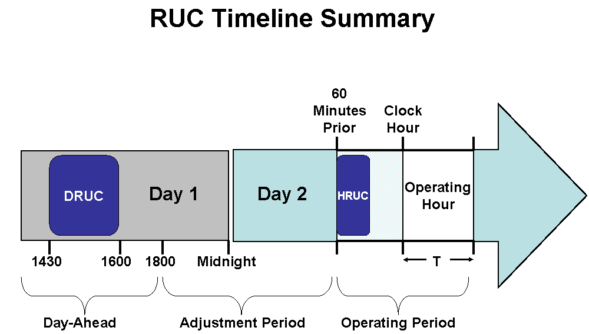

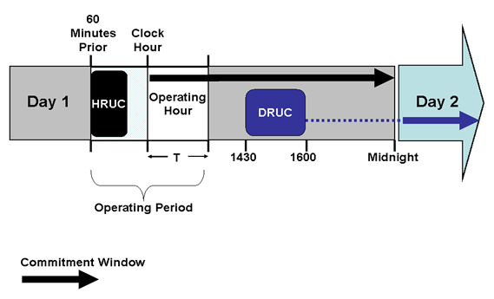

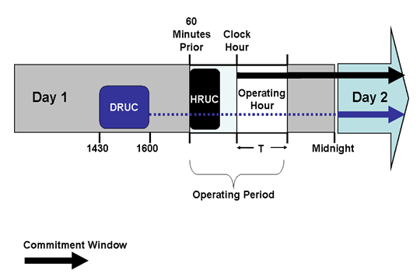

5.2.2 RUC Process Timing Deviations

5.2.2.1 RUC Process Timeline After a Delay of the Day-Ahead Market
If the Day-Ahead Market (DAM) execution is delayed in accordance with Section 4.1.2, Day-Ahead Process and Timing Deviations, ERCOT shall conduct a Day-Ahead Reliability Unit Commitment (DRUC) after 1430 in the Day-Ahead and no earlier than one hour following the posting of DAM awards information on the Market Information System (MIS) Public Area as set forth in Section 4.5.3, Communicating DAM Results. In this event, ERCOT will use the Current Operating Plan (COP) and Trades Snapshot taken just prior to the execution of the DRUC to settle RUC charges.

5.2.2.2 RUC Process Timeline After an Aborted Day-Ahead Market
(1) If ERCOT aborts all or part of the Day Ahead process in accordance with Section 4.1.2, Day-Ahead Process and Timing Deviations, ERCOT shall use the following Supplemental Ancillary Services Market (SASM) process to purchase Ancillary Services for the next Operating Day and the Hourly Reliability Unit Commitment (HRUC) process described in this Section in lieu of the DRUC process.
(2) When the DAM is aborted, ERCOT shall include in the Emergency Condition notice required by paragraph (2) of Section 4.1.2 the time when it intends to conduct the SASM described in this Section 5.2.2.2
to procure the amounts of Ancillary Services necessary to meet the Ancillary Service Plan for the Operating Day affected by the aborted DAM. ERCOT shall allow at least one hour between the issuance of the Emergency Condition notice and the beginning of this SASM.

(3) After the issuance of the Emergency Condition notice described in paragraph (2) above and prior to the beginning of this SASM, a QSE may cancel unexpired Ancillary Service Offers that were submitted for the aborted DAM.
(4) A QSE may submit Ancillary Service Offers for this SASM after the issuance of the Emergency Condition notice described in paragraph (2) above and prior to the beginning of this SASM. For this SASM, these QSE Ancillary Service Offers shall not be subject to the provisions of Section 6.4.8.2.1, Resubmitting Offers for Ancillary Services in the Adjustment Period.
(5) For this SASM, the QSE must submit the Self-Arranged Ancillary Service Quantity for the next Operating Day in accordance with the timeline described in paragraph (8) below. This amount may be different from the self-arrangement amounts previously submitted for the aborted DAM.
(6) The amount of each Ancillary Service to be procured by ERCOT in this SASM is the amount of each Ancillary Service specified in the ERCOT Ancillary Service Plan posted prior to the aborted DAM less the total amount of each Ancillary Service in the QSE submittals for self arranged Ancillary Services for this SASM.
(7) This SASM will settle in accordance with Section 6.7, Real-Time Settlement Calculations for the Ancillary Services.
(8) The SASM process for acquiring Ancillary Services in the event of an aborted Day-Ahead process shall be conducted in accordance with Section 6.4.8.2.2, SASM Clearing Process, but shall use the following activities and timeline with time “X” being the time specified by ERCOT for the beginning of the SASM process in the Emergency Condition notice described above.

SASM Process | QSE Activities: | ERCOT Activities:
Time = X |  | The time specified in the Emergency Condition notice for the SASM to begin.
Time = X plus 30 minutes | Must complete submission of Self-Arranged Ancillary Service Quantities limited to the additional Ancillary Service Obligation of the QSE. | Determine the amount of Ancillary Services to be procured.
Time = X plus 35 minutes |  | Execute SASM.
Time = X plus 45 minutes |  | Notify QSEs with awards of results.  Post the quantities and Market Clearing Prices for Capacity (MCPCs) of Ancillary Services bought in the SASM.
Time = X plus 60 minutes | Submit updated COP with updated Ancillary Service Resource Responsibility. | Validate COPs for Ancillary Service Resource Responsibility.

(9) As soon as practicable, but no later than the time specified above, ERCOT shall notify each QSE of its awarded Ancillary Service Offer quantities, specifying Resource, Ancillary Service type, SASM MCPC, and the first and last hours of the awarded offer.
(10) As soon as practicable, but no later than the time specified above, ERCOT shall post on the MIS Public Area the hourly:
(a) SASM MCPC for each type of Ancillary Service for each hour;
(b) Total Ancillary Service procured in MW by Ancillary Service type for each hour; and
(c) Aggregated Ancillary Service Offer Curve for each ancillary Service for each hour.

(11) No sooner than 1800 in the Day-Ahead and after the completion of the SASM process described in this Section 5.2.2.2, ERCOT shall execute an HRUC process.
(a) The RUC Study Period for this HRUC process is the balance of the current Operating Day plus the next Operating Day. This HRUC process may be a post-1800 HRUC for the current Operating Day.
(b) The COP and Trades Snapshot taken just prior to the execution of the HRUC process described in this Section 5.2.2.2 will be used to settle RUC charges in the Operating Day affected by the aborted DAM.
(c) This HRUC process described in this Section 5.2.2.2 may commit Resources to supply Ancillary Services if the Ancillary Service Offers submitted in the SASM described in this Section 5.2.2.2 are insufficient to meet the requirements of the Ancillary Services Plan in the Operating Day affected by the aborted DAM.

