Market Trials
168 Hour Test Report and Summary

V1.1

September 20, 2010

Revision History
Document Revisions
Date | Version | Description | Author(s)
09/15/2010 | .1 | Initial internal draft | Scott Middleton  Kenneth Ragsdale
09/16/2010 | 1.0 | Edits provided by ERCOT Management and SME team | ERCOT
09/20/2010 | 1.1 | Incorporated NATF feedback | NATF

Approvals
Approved by | Date | Version | Description
J. Mickey
D. Day
J. Dumas
C. Yager
A Smallwood

Table of Contents

1 Introduction 4
2 168-Hour Test Activity Review 4
3 168-Hour Test Participation Review 5
3.1 Congestion Revenue Rights 5
3.2 Outage Scheduling 5
3.3 Day Ahead Market 5
3.4 Reliability Unit Commitment 6
3.5 Real Time Market / LFC 8
4 168-Hour Test Exit Criteria 9
4.1 Issues and Employed Workarounds 9
4.2 ERCOT Disposition on 168-Hour Test exit criteria 11
5 168-Hour Test Evaluation Criteria 11
6 Remaining Market Trials Activities 14
7 Appendix 14
7.1 Daily Reports Provided to the Market during the 168-Hour Test 14

- Introduction
This document details the activities completed comprising the 168-Hour Test. The intent of this document is to demonstrate that ERCOT and the Market have met the overall Exit Criteria as well as provide a review and disposition on the Evaluation Criteria as agreed on by the NATF and TAC forums.

Specific items to be covered in this document are as follows:

- 168-Hour Test Activity Review – recap activities completed during the 168-Hour Test

- 168-Hour Test Participation Review – High level overview of participation from the Market during the 168-Hour Test

  - Congestion Revenue Rights
  - Day Ahead
  - Reliability Unit Commitment
  - Real Time Market
  - Load Frequency Control

- 168-Hour Test Exit Criteria – Review of issues, work-arounds and follow-up actions
  - Review of all technical and business issues encountered during the 168-Hour Test
  - Work-arounds and resolutions to issues encountered during the 168-Hour Test
  - ERCOT disposition of the 168-Hour Test

- 168-Hour Evaluation Criteria – Market and ERCOT defined evaluation criteria to be discussed in the NATF and TAC forums

Note that the upcoming sections of this review will cover high level statistics in each of the areas identified. Additionally, this document includes the daily reports that ERCOT provided to the Market which cover a greater level of detail. These reports can be found in the Appendix section.

168-Hour Test Activity Review
ERCOT has performed the following activities as part of the 168-Hour Test:

- Congestion Revenue Rights monthly Auction for September
- Outage Scheduler synchronization and verification for outages effective during the month of September
- Day Ahead Market and DRUC for the following operational dates:
  - 09/09/2010
  - 09/10/2010
  - 09/11/2010
  - 09/12/2010
  - 09/13/2010
  - 09/14/2010
  - 09/15/2010
- HRUC run 24x7 from 9/8/2010 1800 until 9/15/2010 1800
- SCED run 24x7 from 9/8/2010 1800 until 9/15/2010 1800
- Credit produced ACLs and applied limits to all downstream systems from 9/8/2010 until 9/15/2010
- Settlements continued to publish statements based on the Settlements calendar and will continue to post initial statements through 9/27/2010 for operational dates during the 168-Hour Test
- LFC / Full System Test from 9/12/2010 2:00 PM until 9/14/2010 2:00 PM

168-Hour Test Participation Review

Congestion Revenue Rights
The Congestion Revenue Rights September Monthly Auction results were posted on 8/27/2010. The following details the participation metrics for that auction:
- 9759 total bids
- 3218 Awards
- 42 Account Holders Bidding
- 52 Counterparties submitted Credit
- $8,989,008 Total auction Transaction amount
- Min bid price was $.25 in Off-peak
- Max bid price was $1000 in all three TOU

ERCOT disposition is that this bidding profile is indicative of previous Market Trials on this voluntary market.

Outage Scheduling
In support of the 168-Hour test, QSEs and TSPs were required to synchronize and validate all outages entered in the Zonal system that were effective during the month of September were also entered in the Nodal Outage Scheduler. The deadline for this activity was 8/30/2010. Following are the statistics of the participation in this requirement:
- 41 QSEs submitted ~ 858 resource outages for September
- QSE outages not entered into the Nodal system (existing in Zonal Outage Scheduler)
  - 12 QSEs had outages in the Zonal system that were not entered into the Nodal
  - 16 outages were represented by these QSEs
- 17 TSPs submitted ~ 4012 Transmission outages for September
- TSP outages not entered into Nodal (existing in Zonal Outage Scheduler)
  - 6 TSPs had outages in the Zonal system that were not entered into the Nodal system effective for the month of September
  - 23 outages were represented by these TSPs

Day Ahead Market
As previously mentioned, the Day Ahead Market was executed 7 consecutive days during the 168-Hours Test. The following details the participation of these tests.

High Level Participation for Day Ahead Market
QSEs with Resources (81 total)
- 69/81 participated (97% generation)
- 12/81 Opted Out (1.7% generation)

QSEs without Resources (158 total)
- 114/158 participated (72% of the QSEs without Resources)
- 36 / 158 had < 25% participation
- 8 had >= 25% and < 50% participation
- 27 opted out

Quality of Participation
DAM submission participation during 168-hour test
- An average of 194 QSEs participated
- Net energy transactions submitted were above the load forecast (below is an example day OD 9/15)
- Limiting factor for DAM clearing from a submission standpoint was the demand side
- Large quantity of bilateral trading – snapshot of total confirmed energy trades from Hour 17, OD 9/15 shows ~99,000 MW traded
  - 730 / 1460 submitted across 72 QSEs
- QSE activity appeared to resemble a more post Go-Live trend (e.g. no “stress test” level activity).

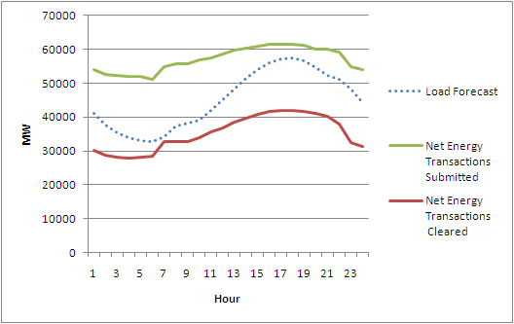

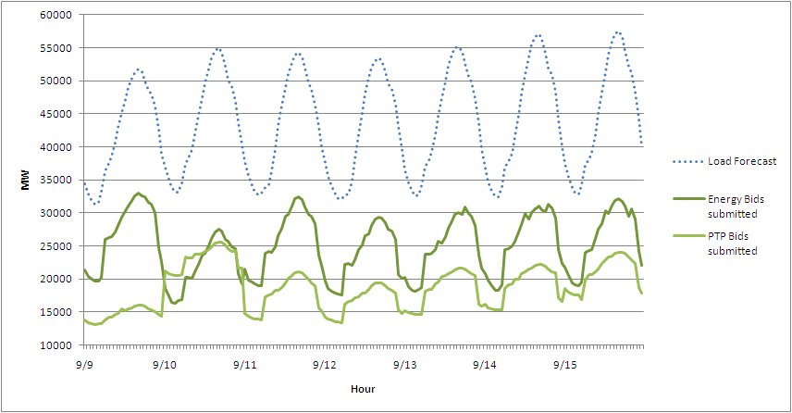

ERCOT disposition is that there was adequate participation and sufficient knowledge demonstrated by the Market in their bidding behavior

Reliability Unit Commitment
High Level Participation Review for the Reliability Unit Commitment
Note that all de-commitments were a result of isolation issues (model discrepancies such as incorrect breaker statuses) or inconsistent / incorrect COPs.

Following are a summary of commitments made across the duration of the 168-Hour Test following each HRUC and DRUC:

HRUC SUMMARY
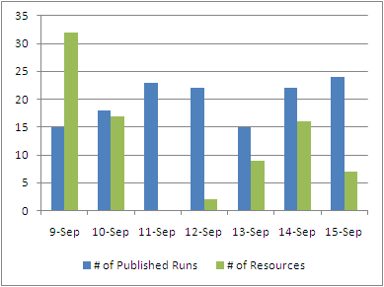
Note that # of published runs includes those that had no approved commitments.
HRUC published runs that are less than all 24 hours are due to HRUC running over allocated times. Issues are detailed in the section covering issues discovered during the 168-Hour test.

DRUC SUMMARY
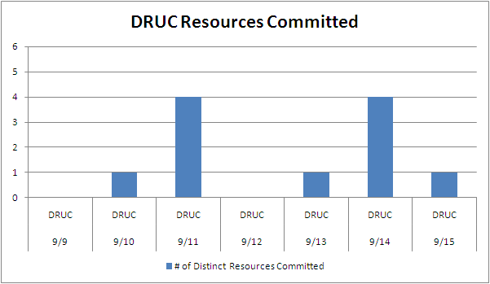
Note that # of Distinct Resources Committed is also impacted by de-selecting resources with shorter lead (start-up) times in order to evaluate the need in HRUC closer to the Operating Hour.

Quality of Participation
Initially DRUC / HRUC processing returned high level of resource commitments due to COPs that were inconsistent with resource’s actual operating status. For example, resources that were OFF (offline and available) were committed despite unit already planned to be online.

Towards the end of the test, ERCOT operators were “de-selecting” fewer units due to improved COPs.

Real Time Market / LFC

High Level Participation Review for the Real Time Market
Daily percentage of expected transactions supporting the Real Time Market

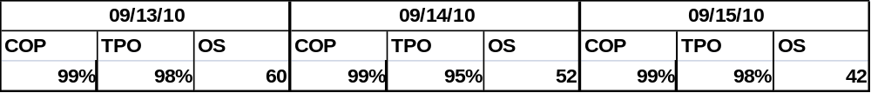

Quality of Participation
Quality of participation largely is accounted for in price spikes resulting from invalid telemetry and/or invalid or lack of offer curves. The following statistics outline the price spikes that would have been prevented had these issues not have been present during the 168-Hour Test.

The 168-Hour Test experienced 14 price spikes during the 7 day testing period:
- 5 of these price spikes would not have occurred if HSL > MW telemetry errors were not present
- The remaining 9 would have lasted a much shorter period of time
- 8 of these 14 price spikes would have cleared much lower had Energy Offer Curves covered full resource capability. This is without the telemetry corrections.

ERCOT disposition is that prices were reasonable and frequency was controlled within acceptable limits throughout the test. Largely, prices are dependent on the quality (and quantity) of Energy Offer Curves coupled with valid telemetry. All prices were explainable given the Market inputs.

168-Hour Test Exit Criteria

- 168 hours of continuous Nodal systems testing have been completed without encountering any major system issues that would prevent the Nodal Market from going live while maintaining system security and reliability as required by the ERCOT Protocols, Operating Guides, other binding documents, and NERC Reliability Standards.
- ERCOT provides a test summary report to TAC and the Board outlining the successful testing processes.

Issues and Employed Workarounds
The following are issues discovered and addressed during the 168-Hour test. These do not include those issues discovered and / or resolved prior to the test start. Those issues are managed and updated on the Market Trials Known Issues List.

MMS Server Issues
Description: Issue with MMS servers memory and file management software were causing the servers to fail-over to the secondary node periodically.
Resolution: Received software patch from vendor. Although the patch impacted memory allocated to MMS, once the memory was upgraded, the systems performed as expected
Net Impact: The following systems were impacted by this issue:
SCED – Incidents impacted SCED completing. The following intervals were missed as a result:
Wed September 8 19:50 CDT 2010
Thu September 9 11:00 CDT 2010
Thu September 9 11:50 CDT 2010
Thu September 9 13:15 CDT 2010
Thu September 9 13:20 CDT 2010
Fri September 10 12:10 CDT 2010
Fri September 10 12:30 CDT 2010
Fri September 10 12:50 CDT 2010
Fri September 10 12:55 CDT 2010

MMS - Execution took longer which caused the results to be published late by 8 minutes on Fri September 10, 2010
HRUC - Various delays during HE 1 and HE 2

Description: Defect found in MMS CIM Importer causing contingencies impacting series devices to be incorrect in MMS
Resolution: ERCOT will manually correct this data after each Network Model Load. Permanent fix will be implemented with MMS Patch 10.
Net Impact: 121 contingencies incorrect in MMS impacting DAM and RUC (SCED unaffected).

Description: 4 contingencies disabled pending further investigation
Resolution: These will remain disabled until final investigation is completed and the definition is verified as correct.
Net Impact: 4 disabled contingencies (out of 2,500 total) in DAM and RUC until resolved. Contingency names:
- SMILMIL8
- XSCS58
- Xod2e58
- Xode58

Description: Benefits of Phase Shifter Transformers not reflected in DAM or RUC
Resolution: Daily operational study performed to determine tap settings for DAM. 22 transmission elements related to phase-shifting equipment were set to monitored rather than secure.
Net Impact: Invalid constraints in the DAM and RUC solutions until noted resolution in place.

Description: Notification “race conditions” caused notification(s) to be incorrectly routed (User Interface only) in rare circumstances.
Resolution: Emergency code fix implemented
Net Impact: 1 QSE received a notification intended for another QSE (no confidential data was divulged)

Description: DRUC initially failed due to configuration / parameter data missing
Resolution: Data was populated and DRUC ran as expected within allocated timelines. This is believed to be an isolated incident related to the fail over from the previous weekend.
Net Impact: No market facing impact

Description: ERCOT Operator HRUC / DRUC de-selection process not appropriately eliminating units from solution consistently
Resolution: Ultimately, an emergency code fix was put into place to resolve the issue. In the interim, a work-around was enacted to manually de-select these units from the database prior to approving the RUC solution.
Net Impact: No Market Facing impact

Description: HRUC maximizing or not completing in allocated timeframe.
Resolution: Network model correction (see phase shifter issue above) and configuration setting in HRUC resolved many of the performance issues. Remaining issues are related to COPs that are not accurately reflecting intra-day changes to resources operating statuses.
Net Impact: HRUC was not published for impacted hours while operators investigated the issue(s).

Description: RUC is misinterpreting NULL minimum start-up and minimum energy as $0.00 on the Three Part Supply Offer.
Resolution: Defect has been created with vendor. Work around in place to review impacted resources during approval process of RUC solutions. These resources (once confirmed) will be de-selected from the solution.
Net Impact: Misinterpretation of the null values prevented a more appropriate resource from being recommended by the RUC process.

Description: Duplicate DAM invoices for Operating Day 9/10/2010.
Resolution: Root cause was human error. Processes will be reviewed to prevent going forward.
Net Impact: Duplicate statements received by MPs for 1 operating day.

ERCOT Disposition on 168-Hour Test exit criteria
The preceding section details issues encountered during the 168-Hour Test and the applicable processes and resolutions ERCOT employed to work around these issues. Of the issues encountered, none were of a severity level to stop or restart the 168-Hour test.

168-Hour Test Evaluation Criteria

- Validate ERCOT and Market Participants have the proper resources and expertise to manage a Nodal system for 7 days. This will be measured by the successful adherence to internal ERCOT procedures during the 168-Hour test to be validated by the ERCOT Training Department during the test and evidenced to the market within a report. Market Participant’s Nodal Accountable Executive will self attest to their criterion.

In the beginning of the 168 hour test, some of the HRUC executions were completed only moments before the deadline for approval. In trying to meet the approval deadline several were approved without complete review. This was soon corrected and approvals were made only after a complete review. ERCOT requests that the attestations be sent to MarketTrials@ERCOT.com by COB Monday 9-30-10

- Credit – monitor credit exposures, create credit reports and accurately reflect each market participant’s credit position based on their activity during the 168-Hour test.

All were completed as required.

- Validate data model accuracy between all systems including integration of the upstream NMMS system with downstream systems (e.g. DAM, MMS, EMS and CRR). This will be measured by existing ERCOT procedures. All issues observed regarding inaccurate modeling during the 168-Hour test will be reported on by ERCOT to the ERCOT Board, Independent Market Monitor, and the related Market Participant forums (NATF and TAC) as to the problem found, root cause of the error in the first place, and what process changes are being implemented to ensure that similar model accuracy issues do not reoccur going forward. ERCOT shall attest to the data model accuracy in and between all systems as a result of TSP and Resource Entity data passing the ERCOT validation rules.

  - Contingencies that do not consider re-closers
Known impacted contingencies have been sent to TSPs to confirm contingency definition. Target date for resolution = 10-15-10
  - MMS CIM importer issue with contingencies with series devices.
This impacted 121 of 2500 contingencies. They were manually fixed within 2 days. Long term fix from vendor, but manual workaround in place.
  - Consideration of Phase Shifter Transformers in DAM and RUC
Phase Shifting Transformers have limitation of 1 setting per day. Shortly after the start of the 168 hour test a manual workaround was put in place for testing to set “monitor-only” impacted equipment to limit constraint impacts.
  - Binding constraints on Generation Step Up transformers are under review.

- Execute DAM, DRUC, HRUC and WRUC for 7 days within timelines set by Nodal Protocols. If any activities fall outside of expected timelines, procedures for handling such incident must be executed by ERCOT personnel in adherence with Nodal Protocols and internal ERCOT procedures.

All DAM publishing were within Protocol timelines except for one which was 8 minutes late. The one that was late was due to MMS server issues (see issues review sections in this document). All DRUC executions were completed on time. WRUC was run several times but for a study period less than 7 days (due to COP issues). HRUC performance at times had issues. These issues included low quality COP issues. Additionally there were issues with MMS Server that impacted HRUC completion times.

- Verify RT Operators can maintain system frequency to scheduled frequency, maintain ancillary obligations and resolve constraints during the period in which ERCOT will be performing Full System Market and Reliability tests during the 168-Hour Test.

NERC standards were exceeded and ERCOT expectations were met.

- Validate ERCOT can effectively and accurately manage all constraints in both DAM and RT (i.e. not constrain on invalid contingencies or inaccurate line ratings) and system will utilize full list of competitive constraints.

Per protocols, the zonal CSCs and CREs were used as the competitive constraints and posted. There were no inaccurate line ratings discovered during the test. In DAM, 121 contingencies were removed as discussed above.

- Validate that ERCOT can execute and manage all SPS, RAPs, PCAPs, MPs, and TOAPs to control congestion in the DAM, DRUC, HRUC, and RT as appropriate.

During the 168 hour test the generic constraint studies did not predict activation of PCAPs MPs and TOAPs. ERCOT is reviewing its procedures to determine why the PCAPs which appeared in RT were not predicted two days ahead.

- Validate that ERCOT is accurately reflecting all congestion mitigation measures (SPS, RAPs) in DAM.

SPS’s and RAPs were properly modeled and managed.

- The rolling CPS1 one minute average score must equal or exceed 100% during the Full System Market and Reliability test period. The target minimum is 125.
  - Note that the CPS1 average will not take into account the two one-hour periods when ERCOT is transitioning to Nodal and then back to Zonal and any periods in which ERCOT must deploy RRS in response to system contingencies.

The hourly averaged CPS1 score ranged from 103 to 193. The average for all hours with Resources on full Nodal control was 156.

- Zonal Commercially Significant Constraints (CSCs) and Closely Related Elements (CREs). managed below thermal limits.

All were managed below thermal limits.

- Local Congestion managed below thermal limits.

ERCOT manages congestion dispatching generation to resolve post contingency overloads, i.e. remain N-1 secure. ERCOT does not remain under N-1 flow limits 100% of the time. During the 48 hour LFC test ERCOT managed 17 unique contingency-overload constraints. During the 48 hour LFC test ERCOT managed congestion below thermal limits with the exception of one period during which one constraint remained over its post-contingency flow limit due to insufficient generation dispatch room. This occurred over peak hours and remained until a forced outage was restored.

- Stability limits managed below transfer limits.

Yes.

- No NERC Disturbance Control Standard (DCS) failure if applicable.

There were no NERC DCS failures.

- No LFC-SCED system issues that result in termination of the test.

There were no LFC-SCED system issues that terminated the test.

- The 168-Hour test will provide adequate data to set the GREDP/CLREDP performance. criteria variables X, Y, and Z. ERCOT shall produce appropriate reports that can be used to set these variables.

ERCOT is in the process of preparing this analysis and plans to provide the information at the October TAC meeting.

- Bilateral trades are processed and flow through the market systems with results returned to MPS.

No issues have been reported.

- Outputs from the Day Ahead Market, Reliability Unit Commitment, and Real Time Market can be reasonably explained based on the inputs.

Yes with the exception of the RUC handling of minimum energy and minimum start-up cost in the Three Part Supply Offer. This issue is being treated as an emergency patch to be available by the 36-hour test.

Remaining Market Trials Activities
In addition to the 168-Hour test, the following activities will resume through the month of September:
- Congestion Revenue Rights Allocation and Monthly Auction for October
- RTM Telemetry and Market submissions
- Day Ahead Market
- Settlements and Credit
- Report Delivery and MIS availability
Additional Full System Market and Reliability / LFC Test
- September 28, 2010 through September 30, 2010 → 36-Hour Test
- October 27, 2010 through October 28, 2010 → 24-Hour Test

Appendix

Daily Reports Provided to the Market during the 168-Hour Test



