NPRR Number | 255 | NPRR Title | Resolution of Alignment Item A81 - DRUC Timing and Execution when DAM is Delayed or Aborted
Timeline | Normal | Action |  | Tabled
Date of Decision |  | September 23, 2010
Proposed Effective Date |  | To be determined.
Priority and Rank Assigned |  | To be determined.
Nodal Protocol Sections Requiring Revision |  | 5.2.1, RUC Normal Timeline Summary  5.2.2, RUC Process Timing Deviations (new)  5.2.2.1, Delay of the Day-Ahead Reliability Unit Commitment (new)  5.2.2.2, Aborted Day-Ahead Reliability Unit Commitment (new)
Revision Description |  | This Nodal Protocol Revision Request (NPRR) adds new Section 5.2.2 to describe the process that ERCOT will follow in the event that the Day-Ahead Market (DAM) is delayed or aborted. This NPRR resolves alignment items A81 and A139.
Reason for Revision |  | This change conforms the Nodal Protocols to the as-built ERCOT Nodal System Administrative Controls.  If the DAM is delayed but executes, ERCOT will delay the start of the Day-Ahead Reliability Unit Commitment (DRUC) process to at least one hour after the DAM awards are noticed to the market to allow Qualified Scheduling Entities (QSEs) the opportunity to update their Current Operating Plans (COPs).  If the DAM is aborted, ERCOT will not have procured Ancillary Services to meet the needs of the ERCOT Ancillary Service Plan posted prior to the aborted DAM. In this case ERCOT will abort the DRUC and execute the described process to satisfy the needs identified in the Ancillary Service Plan and to settle Reliability Unit Commitment (RUC) payments and charges.
Overall Market Benefit |  | Alignment of the Nodal Protocols with the as-built Nodal system implementation and administrative controls. Adds certainty to market processes by clarifying the ERCOT process for RUC and its Settlement that will be executed when the DAM is aborted.
Overall Market Impact |  | Unknown.
Consumer Impact |  | Unknown.
Credit Impacts |  | To be determined.
Procedural History |  | - On 7/15/10, NPRR255, a CEO Revision Request Review, and an Impact Analysis were posted.  - On 7/22/10, PRS considered NPRR255.  - On 8/10/10, Nodal Advisory Task Force (NATF) comments were posted.  - On 8/19/10, PRS again considered NPRR255.  - On 8/23/10, Luminant comments were posted.  - On 9/23/10, PRS considered the 8/19/10 PRS Report and Impact Analysis for NPRR255.
PRS Decision |  | On 7/22/10, PRS unanimously voted to refer NPRR255 to NATF. All Market Segments were present for the vote.  On 8/19/10, PRS unanimously voted to recommend approval of NPRR255 as submitted. The Independent Power Marketer (IPM) Market Segment was not present for the vote.  On 9/23/10, PRS unanimously voted to table NPRR255 until the next PRS meeting. All Market Segments were present for the vote.
Summary of PRS Discussion |  | On 7/22/10, it was requested that NPRR255 be referred to NATF to review the proposed timelines.  On 8/19/10, there was no discussion.  On 9/23/10, ERCOT Staff explained that it was working on modifications to the process proposed in NPRR255, and that ERCOT would submit comments revising the NPRR consistent with the modifications and incorporating Luminant’s comments.

Quantitative Impacts and Benefits

Assumptions | 1
Assumptions | 2
Assumptions | 3
Assumptions | 4
Market Cost
Market Cost | 1 | Unknown.
Market Cost | 2
Market Cost | 3
Market Cost | 4
Market Benefit
Market Benefit | 1 | Alignment of the Nodal Protocols with the as-built Nodal system implementation and administrative controls.
Market Benefit | 2 | Adds certainty to market processes by clarifying the ERCOT process for RUC and its Settlement that will be executed when the DAM is aborted.
Market Benefit | 3
Market Benefit | 4
Additional Qualitative Information | 1
Additional Qualitative Information | 2
Additional Qualitative Information | 3
Additional Qualitative Information | 4
Other Comments | 1
Other Comments | 2
Other Comments | 3
Other Comments | 4

Sponsor
Name | Matt Mereness
E-mail Address | mmereness@ercot.com
Company | ERCOT
Phone Number | 512-248-3089
Market Segment | Not applicable

Market Rules Staff Contact
Name | Jonathan Levine
E-Mail Address | jlevine@ercot.com
Phone Number | 512-248-6464

Comments Received
Comment Author | Comment Summary
NATF 081010 | Endorsed NPRR255 as submitted.
Luminant 092310 | Expressed general support for NPRR255; proposed revision to add 30 minutes additional advance notice to the Supplemental Ancillary Services Market (SASM) timeline for aborted Day-Ahead processes.

Proposed Protocol Language Revision
5.2 Reliability Unit Commitment Timeline Summary
5.2.1 RUC Normal Timeline Summary
The following Reliability Unit Commitment (RUC) Timeline Summary describes the normal timeline for RUC activities that occur in the Day-Ahead and Adjustment Periods.

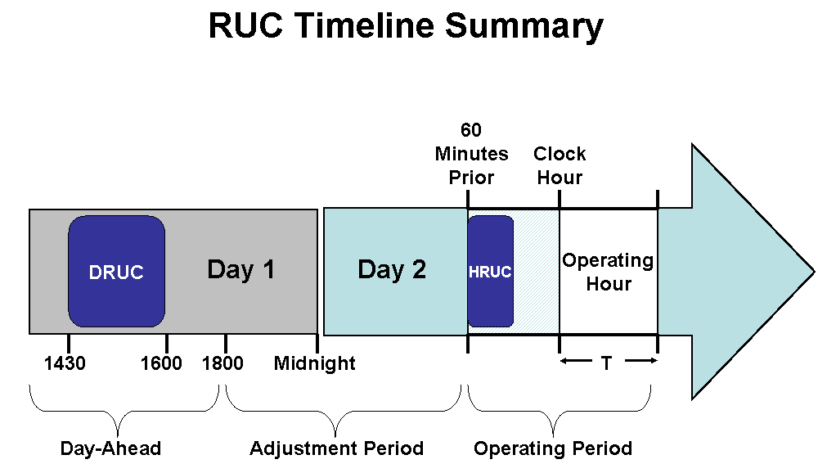

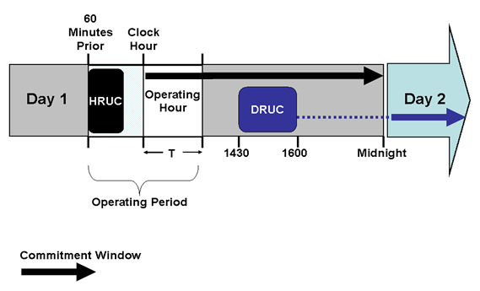

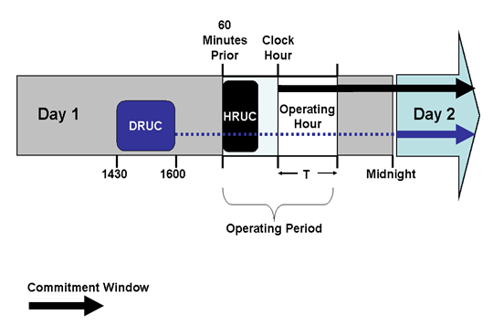
5.2.2 RUC Process Timing Deviations
5.2.2.1 Delay of the Day-Ahead Reliability Unit Commitment
If the Day-Ahead Market (DAM) execution is delayed in accordance with Section 4.1.2, Day-Ahead Process and Timing Deviations, ERCOT shall conduct a Day-Ahead Reliability Unit Commitment (DRUC) after 1430 in the Day-Ahead and no earlier than one hour following the posting of DAM awards information on the Market Information System (MIS) Public Area as set forth in Section 4.5.3, Communicating DAM Results. In this event, ERCOT will use the Current Operating Plan (COP) and Trades Snapshot taken just prior to the execution of the DRUC to settle RUC charges.
5.2.2.2 Aborted Day-Ahead Reliability Unit Commitment
(1) If ERCOT aborts all or part of the Day Ahead process in accordance with Section 4.1.2, Day-Ahead Process and Timing Deviations, ERCOT shall also abort the DRUC process described in this Section 5, Transmission Security Analysis and Reliability Unit Commitment (RUC). In lieu of the DRUC processes described in this Section 5, ERCOT shall use the Hourly Reliability Unit Commitment (HRUC) process described in this Section 5.2.2.2.
(2) When the DRUC is aborted, ERCOT shall notify all QSEs of the following:
(a) ERCOT will execute a Supplemental Ancillary Services Market (SASM) in accordance with Section 6.4.8.2, Supplemental Ancillary Services Market, to procure the amounts of Ancillary Services necessary to meet the Ancillary Service Plan for the Operating Day affected by the aborted DAM.
(b) For this SASM, the QSE may not change the amount of self-arranged Ancillary Services from the amount submitted for the aborted DAM.
(c) The amount of each Ancillary Service to be procured by ERCOT in this SASM is the amount of each Ancillary Service specified in the ERCOT Ancillary Service Plan posted prior to the aborted DAM less the total amount of each Ancillary Service in the QSE DAM submittals for self arranged Ancillary Services.
(d) This SASM will settle in accordance with Section 6.7, Real-Time Settlement Calculations for the Ancillary Services.
(3) Following the SASM notice described in paragraph (2) above, a QSE may expire Ancillary Service Offers that are inclusive with a Three-Part Supply Offer that was submitted for the aborted DAM.
(4) A QSE may submit Ancillary Service Offers for this SASM following the SASM notice described in paragraph (2) above. For this SASM, these QSE Ancillary Service Offers shall not be subject to the provisions of Section 6.4.8.2.1, Resubmitting Offers for Ancillary Services in the Adjustment Period.
(5) Upon completion of the SASM and notification of Ancillary Service awards, the QSE shall update its COP to report the self-arranged and awarded Ancillary Service Resource Responsibilities.
(6) After 1600 in the Day-Ahead and no sooner than one hour following the completion of the SASM, ERCOT shall execute an HRUC process.
(a) The RUC Study Period for this HRUC process is the balance of the current Operating Day plus the next Operating Day.
(b) The COP and Trades Snapshot taken just prior to the execution of this HRUC process will be used to settle RUC charges.
(c) This HRUC process may commit Resources to supply Ancillary Services if the Ancillary Service Offers submitted in the SASM are insufficient to meet the requirements of the Ancillary Services Plan.

