- Commercial System Model

  - Overview
The Commercial System Model is comprised of many Entities whose business interactions are depicted in the graphic below.
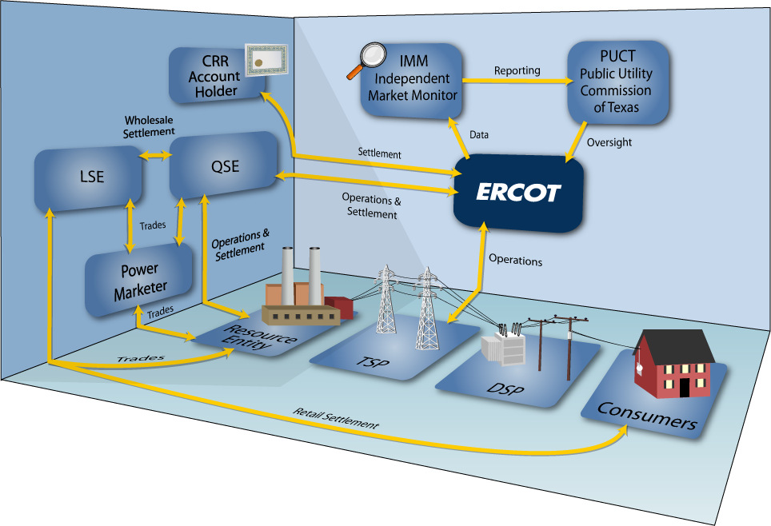
  - Registration Process
- Registration Requirements

Proper registration is required by Market Participants in order to participate in the ERCOT market. For registration materials and additional information, refer to the ERCOT website for Registration and Qualification: http://www.ercot.com/services/rq/.

Market Participants will find registration materials for:
- Load Serving Entities (LSE)
- Qualified Scheduling Entities (QSE)
- Resource Entities (RE)
- Transmission/Distribution Service Providers (TDSP)
- Congestion Revenue Rights Account Holders (CRR)

Each Market Participant who wishes to participate in the ERCOT market shall complete an application form for each role in which it plans to participate. If a Market Participant wishes to function as a QSE and CRR Account Holder, that Market Participant would complete registration application forms for each role.

Once registered, Market Participants are required per Protocol Section 16 to submit a “Notice of Change of Information” request to ERCOT to update registration records already on file, such as updating contacts, bank information, etc.
For registration details, refer to Section 16, Registration and Qualification of Market Participants in the Nodal protocols on the ERCOT website.

  - Market Participant Responsibilities in the Commercial Process

- Overview of Market Participants
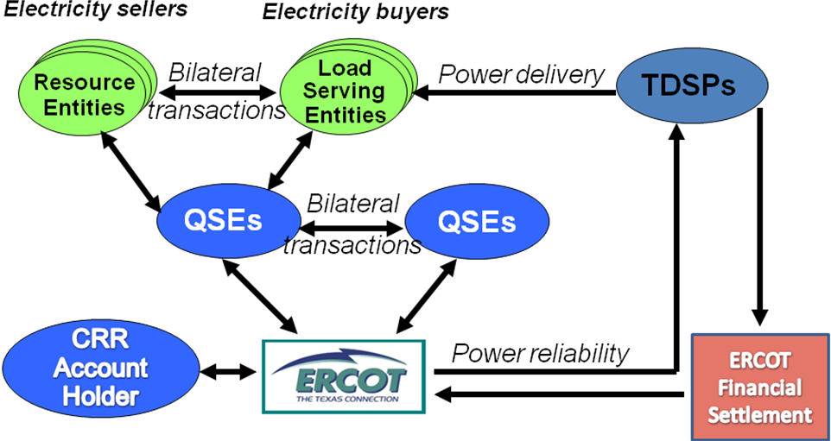

- ERCOT Settlements
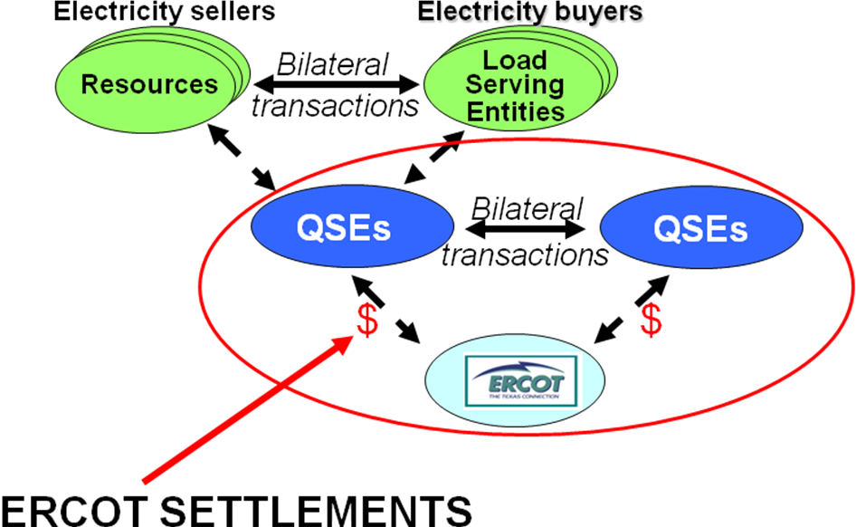

    - Counterparty

ERCOT establishes a Counterparty (CP) so that the entire financial relationship between ERCOT and a Market Participant is under one contract rather than multiple contracts. The Qualified Scheduling Entity (QSE), Sub-QSE, and Congestion Revenue Right (CRR) activity is combined under one contract.
A Counterparty in the ERCOT Nodal market is a single Entity that is a QSE and/or a CRR Account Holder (CRRAH). A Counter-Party includes all registrations as a QSE, all subordinate QSEs, and all CRRAHs by the same Entity.

    - Market Participant Responsibilities

      - ERCOT Responsibilities
ERCOT’s responsibilities include but are not limited to:

        - Ensuring system reliability
        - Running a competitive wholesale market
        - Facilitate retail registration, wholesale transactions, CRR transactions, and energy trades
        - Maintain Data Warehouse to store registration and transaction information
        - Maintaining network models
        - Facilitating dispute resolution
      - QSE Responsibilities
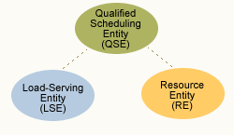
Qualified Scheduling Entities (QSEs) work directly with ERCOT Operations on behalf of resource entities (REs). QSEs represent load serving entities (LSEs) such as Retail Electric Providers (REPs) in Day Ahead Markets and Real-time market activities. QSEs also establish credit and settle financial payments with ERCOT.
Typical functions include but are not limited to:

- Offer and bid load and generation into the Day-Ahead Market (DAM)
- Offer Ancillary Services into the Day-Ahead market
- Provide Ancillary services
- Perform real-time operations for Generation resources, including submitting Three-Part Supply Offers, Current Operating Plans (COPs) and Energy Schedules
- Maintain/submit Outage Schedules
- Establish Credit and settle financial payments with ERCOT

      - CRR Account Holder Responsibilities

The Congestion Revenue Rights (CRR) is a financial instrument that entitles the CRR owner to be charged or to receive compensation for congestion rents that arise when the ERCOT transmission grid is congested in the Day-Ahead Market (DAM) or in the Real-Time Market. A CRR does not represent a right to receive, or obligation to deliver, physical energy.

A CRR Account Holder is an Entity that is registered and qualified to become the owner of record of CRRs in the Nodal market.

Typical functions include but are not limited to:
- Offer and bid CRRs
- Trade CRRs
- Settle CRRs
- Nominate for Pre-assigned Congestion Revenue Rights (PCRRs) - Applies to Non Opt-In Entities (NOIEs) only

      - LSE Responsibilities

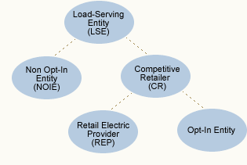
Load serving entities (LSEs) provide electric service to end-use customers and wholesale customers. LSEs include the competitive retailers (CRs) that sell electricity at retail in the competitive market. A CR, who must be certified by ERCOT, may be:

        - A Retail Electric Provider (REP), which contracts with Qualified Scheduling Entities (QSE) to provide scheduling services for their load customers and is certified by the Public Utility Commission of Texas (PUCT), or
        - A Municipally Owned Utility (MOU) or Co-Operative that opts to offer customer choice (an opt-in entity).

LSEs also include NOIEs, which are Electric Co-Operatives and MOUs, which do not operate as CRs and do not plan to offer customer choice.

      - TDSP Responsibilities
Transmission/Distribution Service Providers (TDSPs) own or operate for compensation the equipment or facilities to transmit and/or distribute electricity in Texas. TDSPs are regulated by the Public Utility Commission of Texas (PUCT) and are required to provide non-discriminatory access to the grid.
Each Entity that operates as a Transmission Service Provider (TSP) or Distribution Service Provider (DSP) within the ERCOT region, including municipally owned utilities (MOUs) and Electric Cooperatives, shall register with ERCOT as a TSP, DSP or both, as applicable.
      - Resource Entity Responsibilities
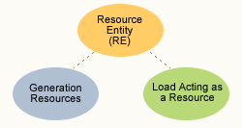
Resource Entities (REs) either own or control a generation resource that generates electricity to serve the ERCOT system load and/or provide Ancillary Services. Resource entities include Loads Acting as a Resource (LaaRs) that can comply with ERCOT instructions to reduce electricity usage or provide Ancillary Services.
Intermittent Renewable Resources are a subset of Generation Resources. Typical Intermittent Renewable Resources include Wind Generators and Run-of-the-River Hydroelectric Generators.
Refer to Protocol Section 16, Registration and Qualification for more information concerning Resource Entities.

  - ERCOT Unique Identifiers, Short Names and DUNS Numbers
ERCOT systems utilize Unique Identifiers, Short names and DUNS Numbers to reference Entities and Resources in the ERCOT Market.
Lists of Unique Identifiers can be found in the Public Reference Data Extract (PRDE) on the ERCOT MIS (under the Settlements Reports and Extracts portlet). A list of short names and DUNS numbers are provided on the ERCOT.com website (under Committees & Groups/Market Participants).
  - QSE
- QSE short names & unique identifiers are assigned by ERCOT and do not change.
- Short name is used in the Market Management System assigned by ERCOT at time of registration.
- Unique identifier (3-digit maximum) is assigned by ERCOT at time of registration and used to identify billing determinants.
- QSE DUNS number is used during registration and updating Notice of Change of Information (NCI) forms, and routing electronic commerce transactions between the QSE and ERCOT.
  - LSE

- LSE unique identifiers are assigned by ERCOT and do not change.
- LSE unique identifier (3-digit maximum) is assigned by ERCOT at time of registration and used to identify billing determinants.
- LSE DUNS number is used during registration and updating NCI forms, and routing electronic commerce transactions between the LSE and TDSPs.

  - TDSP
- TDSP unique identifiers are assigned by ERCOT and do not change.
- TDSP unique identifier (3-digit maximum) is included??
- The TDSP DUNS number is used during registration and updating NCI forms and Retail EDI transactions between LSE, TDSP and ERCOT.

  - CRR Account Holder

- CRRAH unique identifiers are assigned by ERCOT and do not change.
- CRRAH unique identifiers are used on the Day-Ahead Market billing determinants, and on the Real-time Market billing determinants when ERCOT fails to execute the Day-Ahead Market.

  - ESI ID (Electric Service Identifier ID)

- Unique Identifier assigned to each Service Delivery Point used in the Registration and Settlement systems managed by ERCOT. ESI IDs are assigned by the TDSP upon request from a LSE or end-use customer for service to a new premise.
- Refer to the Retail Market Guide posted on the ERCOT website for more information on ESI IDs.

  - Settlement Points - Resource Nodes, Load Zones and Hubs
Unique Identifiers for Settlement Points (Resource Nodes, Load Zones and Hubs) are posted on the ERCOT.com website. Reference the ERCOT Market Information List (EMIL) for the exact file location.

  - Station ID
Unique Identifier that is assigned to an ESI ID by the TDSP to inform ERCOT the sub-station for the ESI ID. Depending on which sub-station assignment the TDSP provides, ERCOT puts the ESI ID in the corresponding Load Zone.

Station ID-to-Load Zone mapping is available on the ERCOT.com website. Reference the ERCOT Market Information List (EMIL) for the exact file location.

  - Weather Zones
A Weather Zone is applied to each Electric Service Identifiers (ESI IDs) located within the geographic boundaries of a Weather Zone. Zone Improvement Plan (ZIP) codes are mapped to Weather Zones and are shown in the “ZipToZone” tab in the Load Profiling Guide Appendix D: Profile Decision Tree.
For additional details regarding Weather Zones, refer to the Load Profiling Guide Section 13.2.1.

