ERCOT Operations Report
Aug 2010 ROS & OWG

Frequency Control
Time | Freq(Hz) | Duration (s)
8/2/2010 14:59 | 59.869 | 90 | Unit trip with 730 MW
8/11/2010 20:34 | 59.866 | 12 | Unit trip with 700 MW
8/16/2010 13:14 | 59.892 | 4 | Unit trip with 685 MW
8/20/2010 5:08 | 60.158 | 237 | QSE telemetered erroneous HSLs during nodal 24 Hour Full System Market & Reliability Test
8/20/2010 15:25 | 59.825 | 112 | Unit trip with 1320 MW
8/21/2010 8:28 | 59.891 | 18 | Unit trip with 720 MW
8/22/2010 14:38 | 59.845 | 140 | Unit trip with 780 MW
8/25/2010 5:57 | 59.870 | 18 | Unit trip with 730 MWs
8/30/2010 18:19 | 59.898 | 8 | DC East tripped with -593 MW
8/31/2010 20:34 | 59.859 | 12 | Unit trip with 795 MW
Note: Time of frequency excursions outside the range of +/- 0.1 Hz.

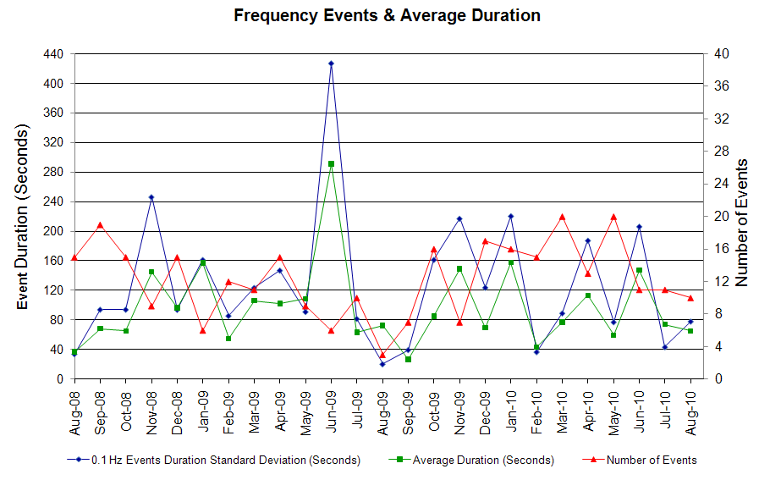

Deployed Responsive (Reported Above)
Time deployed | Stop Time | Duration | Max | Details
8/2/10 14:59:07 | 8/2/10 15:20:29 | 0:21:22 | 538.945
8/9/10 11:20:32 | 8/9/10 11:28:36 | 0:08:04 | 266.80 | SCE change -700 MW in 13 min and out of up reg.
8/10/10 6:21:45 | 8/10/10 6:43:07 | 0:21:22 | 309.48 | SCE change -450 MW in 13 min and ran out of up reg.
8/11/10 8:38:49 | 8/11/10 8:49:06 | 0:10:17 | 336.17 | SCE change -500 MW in 5 min and ran out of up reg.
8/11/10 20:34:10 | 8/11/10 20:48:53 | 0:14:43 | 554.94
8/15/10 19:18:32 | 8/15/10 19:33:36 | 0:15:04 | 272.13 | Out of up reg.
8/16/10 13:14:09 | 8/16/10 13:24:51 | 0:10:42 | 416.22
8/17/10 6:21:09 | 8/17/10 6:31:50 | 0:10:41 | 266.80 | Out of up reg.
8/20/10 15:25:48 | 8/20/10 15:51:05 | 0:25:17 | 1150.00
8/21/10 8:28:36 | 8/21/10 8:41:07 | 0:12:31 | 421.56
8/22/10 14:38:22 | 8/22/10 15:03:21 | 0:24:59 | 859.11
8/22/10 16:30:08 | 8/22/10 16:39:05 | 0:08:57 | 288.149 | Out of up reg.
8/24/10 14:32:10 | 8/24/10 14:50:59 | 0:18:49 | 688.352 | Unit Trip
8/24/10 17:49:24 | 8/24/10 18:19:51 | 0:30:27 | 336.167 | Out of up reg.
8/25/10 5:57:12 | 8/25/10 6:21:33 | 0:24:21 | 533.612
8/29/10 20:00:50 | 8/29/10 20:24:49 | 0:23:59 | 416.203 | Out of up reg.
8/30/10 5:41:38 | 8/30/10 6:26:07 | 0:44:29 | 378.851 | Out of up reg.
8/30/10 18:19:08 | 8/30/10 18:38:37 | 0:19:29 | 389.538
8/30/10 20:06:36 | 8/30/10 20:17:59 | 0:11:23 | 266.816 | Out of up reg.
8/31/10 10:30:14 | 8/31/10 10:40:23 | 0:10:09 | 341.52 | Unit Trip
8/31/10 20:34:32 | 8/31/10 20:47:55 | 0:13:23 | 592.296
8/2/10 14:59:07 | 8/2/10 15:20:29 | 0:21:22 | 538.945 | Unit Trip

Day-Ahead OOMC and RPRS Capacity Purchases
Details | OOMC | RPRS S1 | RPRS S2 | RPRS S1+S2 | RMR | Total
DFW | 51 | 71 | 10 | 81 | 0 | 132
North | 1 | 54 | 3 | 57 | 20 | 78
Western | 1 | 20 | 3 | 23 | 39 | 63
Northeast | 3 | 20 | 1 | 21 | 0 | 24
Bryan Area | 1 | 14 | 2 | 16 | 0 | 17
Austin | 0 | 17 | 0 | 17 | 0 | 17
South | 0 | 8 | 5 | 13 | 0 | 13
Houston | 0 | 0 | 12 | 12 | 0 | 12
E RIO | 0 | 1 | 0 | 1 | 0 | 1
Corpus | 0 | 0 | 0 | 0 | 0 | 0
San Antonio | 0 | 0 | 0 | 0 | 0 | 0
W RIO | 0 | 0 | 0 | 0 | 0 | 0
Laredo | 0 | 0 | 0 | 0 | 0 | 0
Total | 57 | 205 | 36 | 241 | 59 | 357

Historical Totals | Aug-10 | Aug-09 | Jul-10
Austin | 17 | 14 | 0
Bryan Area | 15 | 0 | 0
Corpus | 0 | 0 | 4
DFW | 122 | 40 | 43
E RIO | 1 | 7 | 0
Houston | 0 | 9 | 9
Laredo | 0 | 0 | 0
North | 75 | 42 | 1
Northeast | 23 | 0 | 0
San Antonio | 0 | 5 | 0
South | 8 | 0 | 0
W RIO | 0 | 0 | 0
Western | 60 | 19 | 8
Total | 321 | 136 | 65
http://www.ercot.com/mktinfo/services/rprsdr/index.html

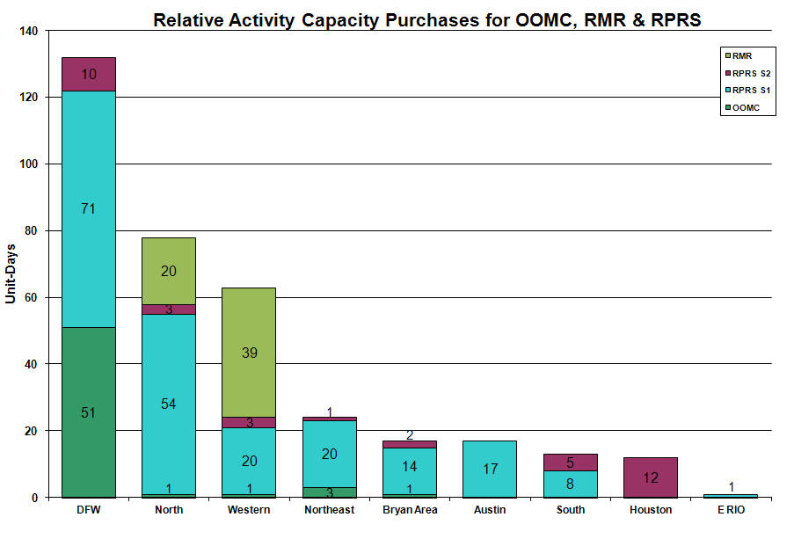

OOME and Congestion Management Activity
Congestion affected by outages Remedial action plan has been developed for the element
Contingency | Overloaded Element | Days
Matador - Paducah Clare Street 69KV | Spur - Girard Tap 69KV | 20
Austrop Switch - Sandow Switch 345KV | Round Rock Northeast - Round Rock 138KV | 16
Holly - Barney Davis 138KV | Airline - Cabaniss 138KV | 11
Lytton Springs - Zorn and Austrop - Zorn 345KV | McCarty Lane - Redwood 138KV | 9
Comanche Peak Unit | Victoria - Thomaston - Cuero 138KV | 8
San Miguel 138/69KV AT | Pearsall 138/69KV AT 4 | 8
Barney Davis - Airline - Rodd Field Road 138KV | Airline - Cabaniss 138KV | 6
Big Brown - Venus 345KV | Trinidad - Richland Chambers 345KV | 6
Cagnon 345/138 kV Auto #3 | Cagnon 345/138 kV Auto #4 | 6
Fisher Road - Oklaunion and Bowman Switch 345KV | Bomarton - Baylor County 69KV | 6
Golden Switch - Bluff Creek Switch 138KV | Sun Switch - Sacroc 138KV | 6
Martin Lake - Elkton - Tyler Grande 345 kV | Troup - Walnut Grove 138KV | 6
Oxychem Corpus - Ingleside 138KV | Dupont PP1 Ingleside - Dupont Switch Ingleside 138KV | 6
Hamilton - Sonora 138KV | Sonora - Friess Ranch 69KV | 5
Lytton Springs - Zorn - Austrop 345KV | Zorn - Pooley 138KV | 5
Lytton Springs - Zorn & Austrop 345KV | Thomaston - Cuero 138KV | 5
Moss Switch - Holt Switch 138KV | Odessa North 138/69KV autotransformer | 5
Odessa EHV 345/138Kv Auto #2 | Odessa EHV 345/138Kv Auto #1 | 5
Odessa EHV - Midland East 345KV | Odessa North - Odessa 138KV | 5
Sandow Switch - Temple Switch 345KV | Hearne 138/69KV AT1 | 5
Trinidad - Watermill - Tricorner 345KV | Trinidad 345/138KV AT | 5
Willow Valley - Bluff Creek 138KV | Ackerly Switch - Ackerly 69KV | 5
Barney Davis - Airline 138KV | Airline - West Cabaniss 138KV | 4
Graham - Parker 345KV | Flat Creek - Leon Switch 138KV | 4
Matador - Paducah Clare Street 69KV | Spur - Aspermont CSW 138KV | 4
San Angelo Red Creek - Comanche Switch 345KV | Flat Creek - Leon Switch 138KV | 4
Trinidad - Richland Chambers 345KV | Big Brown - Venus Switch 345KV | 4
Allen Sw - Renner Sw & Planno Tennyson 345 kV | Plano Alma Sw - Allen Sw 138 kV | 3
George West T1 138/69KV AT | Orange Grove - Orange Grove Switch 69KV | 3
Trinidad - Mt Enterprise & Martin Lake - Stryker Creek 345 kV | Nacogdoches 345/138 kV Auto | 3
Austrop - Daffin & Decker 138KV | Decker - Sprinkle 138KV | 2
Desoto Switch - Cedar Hill TU 138 kV | Desoto Sw - Parkerville Road 138 kV | 2
Golden Switch - Bluff Creek 138KV | Sun Switch - SACROC 138KV | 2
Green Bayou - Gable & Hardy - Crockett 138KV | Garrott - Midtown 138KV | 2
Marion - Zorn and Clear Spring 345KV | Seguin - Seguin West 138kV | 2
Meadow - PH Robinson 345KV | Alvin - North Alvin 138KV | 2
Moore - Pearsall 138KV | Pearsall 138/69KV AT4 | 2
Oasis - Meadow 345KV | Bellaire - Brays 138KV | 2
Olinger - Ben Davis - Elm Grove 138 kV | Olinger - Firewheel 138 kV | 2
Olney - Westover 69 KV | Elbert Switch to Seymour. | 2
San Miguel - Lobo 345 kV | Freer - San Diego 69 kV | 2
Singleton - Tomball & Roanes Prairie 345KV | Singleton - TH Warton 345KV. | 2
Tricorner - Tyler Grande & Martin Lake SES - Elkton 345KV | Tyler Bullard Road - Tyler South 138KV | 2
Trinidad - Mount Enterprise & Stryker Creek 345 kV | Stryker Creek - Stryker Cherokee POI 138 kV | 2
Watermill Switch - Limestone 345KV | Jewett - Rattlesnake Road Switch 345KV | 2
West Levee 345/138KV AT 2 | West Levee 345/138KV AT1 | 2
Abilene Mulberry Creek - Bitter Creek & Long Creek Sw - Sweetwater 345KV | Eskota Switch - McElmurray Tap 138KV | 1
Austrop - Garfield & Zorn 345 kV | Garfield Auto #1 | 1
Austrop - Lost Pines 345 kV | Fayette Auto | 1
Base case | Kosse - Peteway 69KV | 1
Base case | Ballinger - Paint Rock 69KV | 1
Coleto - Pawnee 345KV | Victoria - Thomaston - Cuero 138KV | 1
Decker - Techridge 138 kV | Decker - Sprinkle 138 kV | 1
Decker - McNeil - Sprinkle 138 kV | Burleson - Pedernales 138 kV | 1
Euless - Ligget 138KV | DFW B East - Hackberry 138KV | 1
Euless - Ligget Sw 138 kV | Hackberry - Valley Ranch 138 kV | 1
Euless - Ligget Sw 138 kV line | DFW B-East - Hackberry 138 kV | 1
Garrott - Thermal Energy 138 kV | Garrott - Midtown 138 kV | 1
Graham SES - Parker Switch 345KV | Parker Switch - Willow Creek Switch 345KV | 1
Hearne T1 138/69KV AT | Highland Lakes 138/69KV AT | 1
Howard Lane - Avery Ranch 138KV | Marshall Ford - Balcones LCRA 138KV | 1
Jewett - Rattlesnake Road Switch - Twin Oak 345KV | Hearne 138/69 KV At | 1
Lewisville Swith - Lake Pointe 138 kV | Lewisville West - Lewisville Highlands Tap | 1
Live Oak - Sonora 138 kV | Eldorado - Live Oak 69 kV | 1
Lon Hill - Coleto Creek 345 kV | Kenedy Swith - Kenedy 69 kV | 1
Lytton Springs - Austrop - Zorn 345KV | Victoria - Thomaston - Cuero 138KV | 1
Martin Lake - Elkton - Tyler Grande 345kV | Delek POI - Tyler Northeast 138 kV | 1
Midland East - Odessa 345KV | Odessa - South Foster Amoco 138KV | 1
Morgan - Quail Switch & Longshore Switch 345KV | Stanton East Switch - Big Spring Switch 138KV | 1
Moss Switch - Holt Switch 138KV | Odessa North - North Cowden 69 kV | 1
Mountain Creek - Cedar Hill Switch 138KV | Sherry Switch - Park Row 138KV | 1
Odessa Basin Sw - Odessa North 69 kV | Ector Shell - Holt Sw 69 kV | 1
Oklaunion Unit1 | Flat Creek - Leon Switch 138 kV | 1
Pearsall - San Miguel 138KV | Pearsall 138/69KV AT4 | 1
PH Robinson - South Shore 138KV | Dickinson - League City 138KV | 1
PH Robinson 345/138 kV Auto #2 | PH Robinson 345/138 kV Auto #1 | 1
Putnam - 138/69 kV Auto | Leon Switch - Cisco 69 kV | 1
Renner Auto #2 | Ben Davis - Allen Sw 138 kV | 1
Roanoke Sw - West Denton 345 kV | West Denton - Forth Worth 138 kV | 1
Salem 345/138 kV Auto | Fayetteville 345/138 kV Auto | 1
Sandow - Temple Switch 345 kV | Austrop 345/138 kV Auto #2 | 1
Snyder - China Grove 138 kV | Golden Sw - Brand TU 138 kV | 1
Tricorner - Tyler Grande & Martin Lake - Elkton 345KV | Tyler Grande - Elkton 138KV | 1
Trinidad - Watermill - Tricorner 345 kV | Big Brown - Venus Switch 345 kV | 1
Twin Buttes - San Angelo 345 kV | Twin Buttes 345/138 kV Auto #1 | 1
Venus Sw - Liggett Sw 345 kV | Handley SES - White 1 Tap 138 kV | 1
Victoria 138/69 kV Auto | Green Lake - Weaver 69 kV | 1
Watermill - West Levee 345KV | Duncanville South - Cedar Hill Switch 138KV | 1
West Levee - 800/900 Network 138 kV | East Levee Sw - Reagan Street 138 kV | 1
West Side - Airline 138KV | Airline - Cabaniss 138KV | 1
Willow Valley - Lamesa 138 kV | Ackerly Switch - Ackerly 69 kV | 1
Zorn - Hayes Energy 345KV | Kendall 1HH 345/138KV At | 1
Zorn - Marion & Clear Springs 345 kV | Clear Spring 345/138 kV | 1
Zorn - Marion & Clear Springs 345 kV | Comal - Henne 138 kV | 1

Zonal OC1
CSC | Days
West – North | 14
North – Houston | 4
South – North | 2

New RAP, PCAP (Date indicates last update of RAP, PCAP not implementation date.)
8/03 Cuero – Thomaston 138 kV

New Procedures/Forms/Operations Bulletins
Date | Subject | Bulletin No.
08/30/2010 | Transmission and Security Desk V4 Rev 17 | 490
08/30/2010 | Shift Supervisor Desk V4 Rev 17 | 489
08/30/2010 | Operating Period Desk V3 Rev 11 | 488
08/30/2010 | Frequency Control Desk V4 Rev 16 | 487
08/30/2010 | Day-Ahead Desk V4 Rev 14 | 486
08/09/2010 | Transmission and Security Desk V4 Rev 16 | 485
08/09/2010 | Shift Supervisor Desk V4 Rev 16 | 484
08/09/2010 | Operating Period Desk V3 Rev 10 | 483
08/09/2010 | Frequency Control Desk V4 Rev 15 | 482

Blackout/Load Shed Incidences
None

EEA
8/20 15:25 ERCOT declared EEA 1 for Adjusted Responsive Reserve below 2300MW.

Major System Voltage Problems
None

Major Computer Problems, Enhancements & Fixes
None

Communication
None

ERCOT peak (Unofficial)
08/23 17:00 65,716 MW

Yearly MTLF Error Comparison
Yearly Mid-Term (Hourly) Load Forecast Error Comparison for the ERCOT Forecast
Month | MAPE for MTLF at 16:00 Day-Ahead
Month | 2007 | 2008 | 2009 | 2010
January | 4.55 | 3.30 | 4.11 | 3.78
February | 3.75 | 3.59 | 3.49 | 3.79
March | 2.70 | 3.29 | 3.24 | 2.24
April | 3.00 | 2.45 | 2.66 | 2.47
May | 3.22 | 3.01 | 2.90 | 2.63
June | 4.46 | 2.81 | 2.89 | 2.84
July | 4.29 | 2.55 | 2.83 | 2.39
August | 3.11 | 3.66 | 3.07 | 2.29
September | 3.78 | 4.99 | 3.68 | NA
October | 3.08 | 2.79 | 2.92 | NA
November | 2.95 | 2.60 | 1.93 | NA
December | 3.74 | 4.54 | 3.70 | NA
Annual Average | 3.55 | 3.29 | 3.11 | 2.80

OCN, Advisory, Watch & Emergency Notices
Capacity
Date | Start | End | Event
8/4/10 | 16:29 | 18:30 | Advisory issued for ARRS below 3000 MW.
8/10/10 | 16:08 | 18:50 | Advisory issued due to ARRS below 3000 MW.
8/11/10 | 11:30 | 13:00 | OCN issued due to a projected Reserve Capacity shortage for HE 1500 and HE1600 and a projected shortage of Up Balancing Energy bids for HE 1500 - HE 1800.
8/20/10 | 15:33 | 18:19 | ERCOT issued a Watch due to ARRS below 2500 MW.
8/21/10 | 14:57 | 18:23 | Advisory issued ARRS below 3000 MW.
8/22/10 | 13:45 | 19:42 | Advisory issued for ARRS below 3000 MW.
8/22/10 | 12:25 | 19:42 | OCN issued for a projected capacity reserve shortage for hours ending 1600 - 1800.
8/22/10 | 13:10 | 19:42 | Watch issued for a projected capacity reserve shortage for hours ending 1600 - 1800.
8/23/10 | 13:42 | 18:21 | Advisory issued due to ARRS below 3000 MW.
8/23/10 | 4:35 | 18:21 | Issued OCN for projected Reserve capacity shortage for hours ending 1600 - 1800.

Transmission Watch
None

Emergency Notice
None

Texas RE Event Analysis
8/20 15:25 ERCOT declared EEA 1 for Adjusted Responsive Reserve below 2300MW.

Others
None

