From: Blevins, Bill [mailto:bblevins@ercot.com]
Sent: Thursday, September 02, 2010 10:19 AM
To: 'Floyd Trefny'; Trefny, Floyd; Frosch, Colleen; Mickey, Joel
Cc: Raina, Gokal
Subject: RE: SCED Up and SCED Down Reserves

Thanks for the input we are going to move forward with this as the solution.

From: Floyd Trefny [mailto:ftrefny@dishmail.net]
Sent: Wednesday, September 01, 2010 3:55 PM
To: Blevins, Bill; Trefny, Floyd; Frosch, Colleen; Mickey, Joel
Cc: Raina, Gokal
Subject: RE: SCED Up and SCED Down Reserves

Bill, I think this is the correct decision. When we did the RT Telemetry paper for the MPs (attached) to better understand what to telemeter under various generation and load resources operations (start-up, shut-down, ramping), we included the Non-Spin Deployment procedure that TAC approved back in 2007 with a few minor updates to reflect the current implementation. This procedure also references this quality as a value the ERCOT operator should watch to determine if the system is getting short of capacity in SCED and may need to deploy Non-Spin to add reserves to SCED (see excerpt below). If you are deploying Non-Spin you are concerned not to run out of SCED Up Reserve 30 minutes from now. You may want to review all these processes in the paper too and advise if you agree with its language.

Bill Hellinghausen brought this subject up at NATF yesterday afternoon. After discussion NATF wanted both numbers too and Bill was going to write a change request to get the right numbers too. In ERCOT training and at the PUC a while back when discussing wind, I referred to the HASL- netGen as the SCED Up Reserve and netGen-LASL as the SCED Down Reserve so if you hear of these terms you may know what they are saying. I am not sure I care what you call it. Note that the sum of Base Points should almost always be the same as the sum of generation at the time of the SCED run, but in between SCED executions, LFC is going to move Gen that that is also of interest to this calculation and why it needs to run every 10 seconds. So you are right the cal must use net gen and not Base Points.

Please send me your comments on the attached by Friday or early next week if possible.

Here is the slide Bill used at NATF which is a version from some of my presentation a while back:

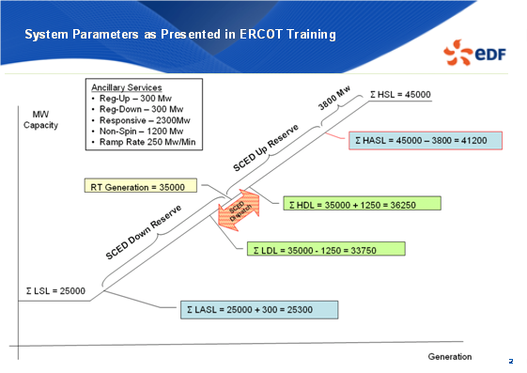

Excerpt from ERCOT Business Practices QSE telmetry practices in the operating hour:
Deployment to cover shortage of energy available to SCED
The deployment procedure will be the same as described above except it will be triggered based on the Real-Time Ancillary Services Capacity Monitor that executes every 10 seconds. Since SCED failing to converge initiates an Emergency state, Emergency processes may govern the deployment of Non-Spin during such conditions.

Floyd

Floyd Trefny
7988 Ranch Road 2828
Bandera, Texas 78003
830-796-3182
ftrefny@dishmail.net
From: Blevins, Bill [mailto:bblevins@ercot.com]
Sent: Wednesday, September 01, 2010 1:03 PM
To: 'Floyd Trefny'; Trefny, Floyd; Frosch, Colleen; Mickey, Joel
Cc: Raina, Gokal
Subject: RE: SCED Up and SCED Down Reserves

I met with EMS development and we decided to add in some new logic. We will keep the current HDL based info but will change this to use the current Gen to calculate the capcity. This will be the 5 Minute SCED capacity since it is based on the HDL and LDL.

So that will be

HDL-Gen = SCED 5 minute up (Both of these values include units with and without offer curves. )
Gen-LDL= SCED 5 minute down (Both of these values include units with and without offer curves. )

We will add in

HASL-Gen = SCED up (Both of these values include units with and without offer curves. )
Gen-LASL= SCED down (Both of these values include units with and without offer curves. )

That will be provided to the ERCOT operator on the area status display so the operator can see their Total SCED Up/Down Room and then their SCED 5 minute Up/Down room. We will also rename the points so Operators easily understand what the values are.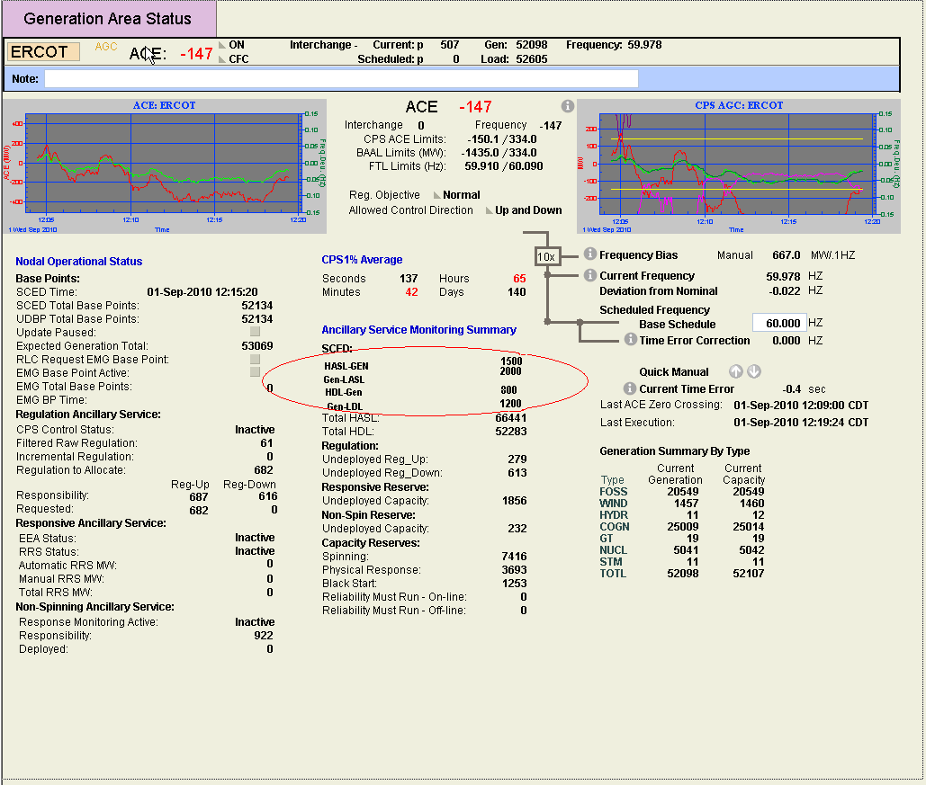

Since Protocols require ERCOT to post out the SCED Up Room that has energy offer curves and that without energy offer curves we will switch the points being sent to be those that are against the HASL and LASL as shown below.

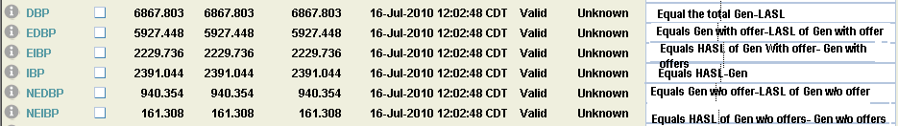

This should correct what the Market sees to be the total SCED room and still be in line with protocols as far as the info needed to include offer curves.

The following displays will need to add in the values calculated against the HASL and LASL since the current fields shown only are based on HDL and LDL. The bottom 3 may be deferred since they are improvements and will valuable may not be required for go live. The first two changes above need to be done regardless of the enhancements below. If this work is capable of being done at the same time then it should be considered.

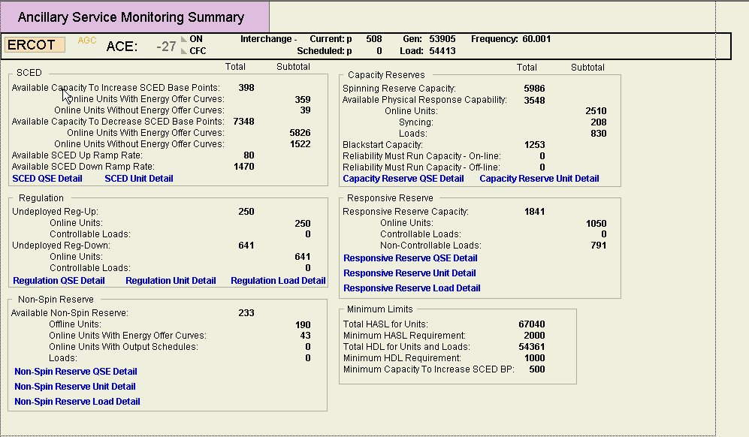

Add in two more columns to show the SCED total up and Down based on the HASL and LASL. Also keep current columns since they are OK for HDL and LDL.
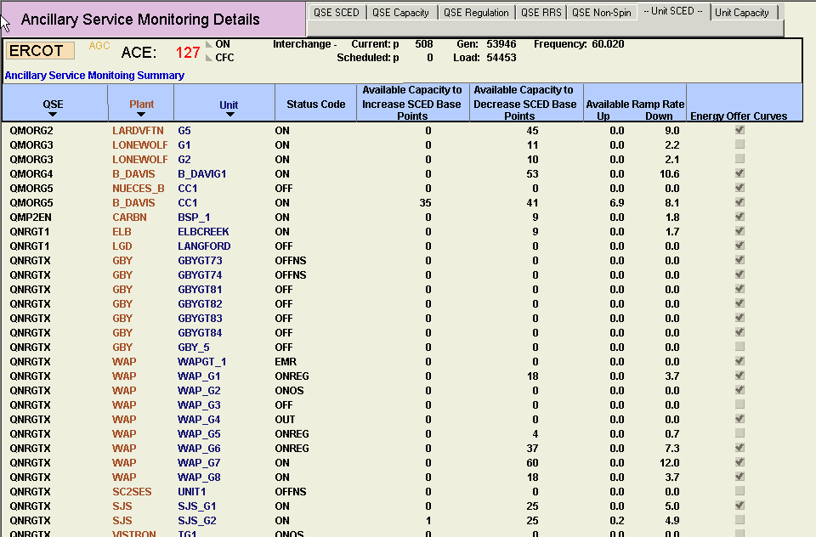

Add in two more columns to show the SCED total up and Down based on the HASL and LASL. Also keep current columns since they are OK for HDL and LDL.

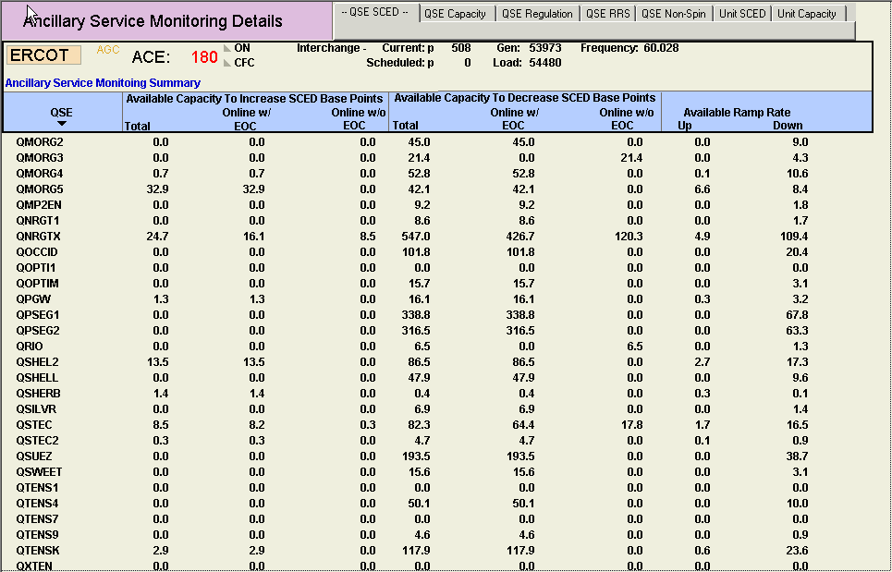

From: Blevins, Bill [mailto:bblevins@ercot.com]
Sent: Friday, July 16, 2010 12:17 PM
To: Trefny, Floyd; Frosch, Colleen; 'Floyd Trefny'; Mickey, Joel
Cc: Raina, Gokal
Subject: RE: SCED Up and SCED Down Reserves

We need to add this to the SPR Sivram has for correcting the HASL value.

Based on speaking to Floyd when we correct the HASL calculation we should just put the calculation in instead of the words. Cap to Increase Base Points should change to sum(HASL- act gen) and Cap to decrease Base points should be sum(act gen -LASL). I also want the operators to have a value of sum(HDL- act gen) and sum(act gen- LDL). This give operators both the current 5 minute up room which is more like the current situation and then Floyds suggestion gives them their future situation. With both those then I think Operators will know as much as possible.

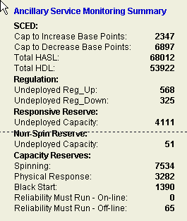

Lastly the Market needs to receive the value Floyds talking about. That means the sum(HDL- act gen) is needed to be sent via SCADA to IBP below and the sum(act gen -LASL) would be written to the DPB SCADA point. This would show the Market when we are running out of room as Floyd mentions.

