2705 West Lake Drive
Taylor, Texas 76574

Network Operations Modeling Expectations for TSPs, REs, and QSEs.

Version 5.1

D.W. Rickerson
8/31/2010

Revision History

Revision | Comments | Date | Author
1.0 | Initial Version | 5/6/2010 | D.W. Rickerson
1.1 | Trefny, Thompson, Hoover comments included | 5/10/2010 | D.W. Rickerson
1.11 | Incorporated additional Trefny comments | 5/11/2010 | D.W. Rickerson
1.12 | Incorporated Rasberry comments | 5/24/2010 | D.W. Rickerson
1.13 | Interim Update definition update | 6/3/2010 | D.W. Rickerson
2.0 | Interim Update process definitions | 7/8/2010 | D.W. Rickerson
2.1 | Outage Coordination edits | 7/9/2010 | D.W. Rickerson
2.12 | SPS and RAP edits | 7/23/2010 | Chad Thompson
2.13 | Approval to Energize Additions | 7/23/2010 | Bill Blevins
3.0 | Supplemental database load and pseudo equipment edits | 7/26/2010 | D.W. Rickerson
4.0 | Consideration and incorporation of Market Participant Comments from 8/4/2010 | 8/8/2010 | D.W. Rickerson
4.1 | Revision of Approval to Energize Section | 8/13/2010 | Bill Blevins
4.11 | Revision of the Approval to Energize Section | 8/13/2010 | D.W. Rickerson
5.0 | Revisions from 8-17 NDSGW meeting and subsequent discussions about the A2E process and modeling examples | 8/27/2010 | D.W. Rickerson
5.1 | Revision from 8/31 NATF Meeting to include “and ROS” | 8/31/2010 | D.W. Rickerson

Network Operations Modeling Expectations for TSPs, REs, and QSEs. 1
I. Overview 6
II. Data Submission Guidelines for Network Model Changes 6
A. NOMCR submissions 6
1. Timeline for RARF submissions 6
B. Interim Updates 7
1. Guideline Definition 8
2. Data Submissions not Subject to the Interim Update rules include: 11
C. Ownership 12
D. Operatorship 12
III. Model loads 13
A. Frequency 13
B. Model load Types 13
1. Scheduled Loads 13
2. Supplemental Loads 13
3. Emergency Loads 13
C. Model load Content 14
D. Scheduled Model Load Time-of-Day 14
E. ERCOT discretion for Emergency Loads 14
1. Emergency Loads due to Unintentional Modeling Errors 14
2. Emergency Loads due to Safety or System Restoration Conditions 15
3. Emergency Loads Necessary to Manage Recurring Congestion 15
IV. NOMCR and Model Validation Process 16
A. NOMCR Integration into Models 16
V. Approval to Energize Process 18
VI. Modeling Equipment Prior to Field-Energize Date 21
A. Use of the ERCOT Outage Scheduler 21
1. Planned outages 21
2. Forced outages 22
3. Coordinating Model and Outage Scheduler Entries 22
VII. Retiring Equipment 22
VIII. General Modeling Principles for Submitters 24
A. Pseudo Device Modeling 24
B. Modeling Examples 24
IX. Contingencies 34
A. Double Element Contingencies 34
B. Single Element Contingencies 35
Appendix A Model Request Classifications 36

Overview
ERCOT Protocols broadly delineate modeling requirements for different segments of the ERCOT market. The information in this document is intended to more clearly define the expectations ERCOT has for market participants as they help to maintain the accuracy of the ERCOT Network Operations Model through the submission of model and outage data.
Modifications to this document by ERCOT will be documented and discussed with NDSWG and ROS prior to being finalized or implemented in ERCOT business processes.

Data Submission Guidelines for Network Model Changes

NOMCR submissions
Changes to ERCOT’s Network Model Management System (NMMS) database will be made using Network Operations Model Change Requests (NOMCRs). Transmission Service Providers (TSPs) will submit changes directly into the NMMS using NOMCRs. Resource Entities (REs) will make submit their model changes in the Resource Asset Registration Form (RARF). ERCOT will convert RARF submissions into NOMCRs. Qualified Scheduling Entities (QSEs) will submit telemetry changes for the model using service requests (SRs) in Siebel. ERCOT will convert the SRs into NOMCRs.

Timeline for RARF submissions
RARF submissions by REs are subject to the same Protocol mandated deadlines as directly submitted TSP NOMCRs. RE RARF submissions may be considered Interim Updates if they fail to pass RARF validation prior to the normal timeline for data submission described in Protocols for NOMCRs. RARF submissions failing to pass RARF validation will be rejected as “Needing Additional Data” and sent back to the RE.
Successful RARF submissions will be converted by ERCOT into NOMCRs and processed as part of the model update process and schedule required in the protocols. REs will receive status updates for the NOMCRs representing their RARF data submissions. If the RARF-NOMCR has significant problems passing the validation rules within the NMMS system it can be rejected even though it passed the validation for submission in the RARF hub. In this event, the RE will be notified and required to submit a new RARF. It is likely that this RARF resubmittal will not be able to meet the normal Protocol timeline for data submission. REs wishing to avoid having data submissions potentially identified as Interim Updates should submit RARF information with enough notice to avoid this conflict.

Interim Updates
ERCOT expects requests to modify the Network Model to meet the Protocol timelines for Network Model changes. NOMCRs that are submitted outside of the normal timelines will be classified as Interim Updates and included in the Network Model if they are needed to correct unintentional modeling inconsistencies, are required for system restoration after a storm, are a correction to previously submitted impedances or ratings. Interim Updates will be reported to the Public Utility Commission of Texas (PUCT) Staff and the Independent Market Monitor (IMM).

Per Nodal Protocols, Interim Updates will be incorporated in the Network Model at the discretion of ERCOT. Many considerations will be made in determining the overall impact of the Interim update to the Network Operations model. ERCOT has outlined a guideline that will be applied to every requested interim update to consistently assess a level of risk and raise transparency to criteria by which interim updates are evaluated.

ERCOT will also critically evaluate other risk items such as system conditions, staffing, volume of requested changes, potential Protocol obligations, etc. prior to determining if the interim update will be accepted.

Section II.B.2 contains information about data submissions not subject to Interim Updates.

Guideline Definition
The type and timing of the update will be considered when evaluating Interim Update requests. In some cases, requestors may be required to change the NOMCR energization date (model ready date – see discussion in Section V) of the request so that the submittal falls within normal data submission guidelines. In these cases the update would no longer be classified as an Interim Update.

In order to evaluate the impact an Interim Update will have on the Network Operations model, the request will first be classified according to when it was submitted. This classification quantifies how much notice is provided for each request. An Interim Update request that requires an Emergency Database Load will be more difficult to grant than a request that is only a few days past the normal submittal deadline. Each interim request will be evaluated in light of risk items such as system conditions, staffing, volume of change requests, and potential Protocol obligations. ERCOT will classify Interim Updates into four periods of time as illustrated below.

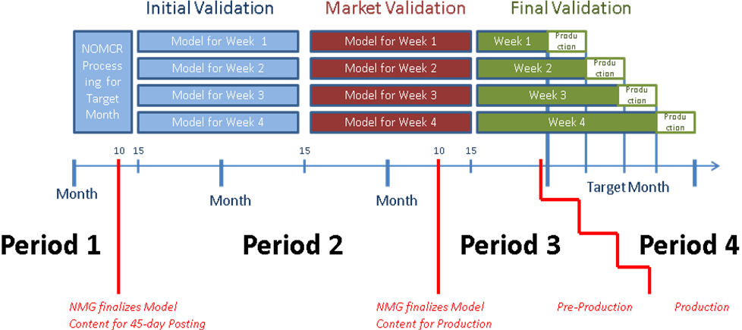

Each Period is applicable to the submission timeline for the Target Month as defined in the Nodal Protocols Section 3.10.4.

Period 1 requests would be submissions that miss the normal deadline by ten days or less. At this point in the validation process ERCOT is still processing the NOMCRs for the Target Month and has not completed the models that will be used in production.

Period 2 immediately follows Period 1 and ends on the tenth of the month prior to the Target Month. During Period 2, the Operational Models undergo Initial Validation and are posted. In addition, the information needed to build the CRR models is exported.

Period 3 immediately follows Period 2 and ends two days before the affected model goes into production. At this point in the validation process the final production models have been completed and are being validated for use in production. Period 3 will vary in length depending on when the affected model goes into production.

Period 4 immediately follows Period 3, beginning two days before the affected model is scheduled to be loaded into production. Interim Updates allowed during Period 4 will require an Emergency Data Base load.

In addition to classifying updates by the period in which they are submitted, Interim Update requests will also be categorized by class. The classes represent the impact the model change will have on both the market and reliability. ERCOT will use four classifications to categorize Interim Update requests. Appendix A contains examples of modeling request categories and how they might be classified. The classes are described below.

Class 1 Interim Update requests will have no impact to market or reliability after implementation.

Class 2 Interim Update requests will have an impact to market or reliability that can be mitigated in real-time with changes to data in downstream systems that can be managed by ERCOT. In some cases ERCOT may request assistance from the Interim Update requestor in mitigating the effects of the change.

Class 3 Interim Update requests will have an impact to market or reliability that cannot be mitigated in real-time with changes to data in downstream systems.

Class 4 Interim Update requests are those that if not incorporated in the model at the requested time will have a severe impact to either the market or reliability. Class 4 updates should always be a result of circumstances that could not be reasonably anticipated.

ERCOT will classify both the Period and Class of each Interim Update. These classifications will be included in the comment section of the NOMCR. ERCOT will use the following chart as a basis for including the Interim Update into the model at the model ready time requested by the data submitter.

ERCOT will consult with data submitters to reschedule or modify all interim updates that cannot be implemented as submitted. In some cases in may be necessary for data submitters to modify some part of the interim update. Rejection of the interim update will be considered a last step and be used only if other coordination efforts fail.

Data Submissions not Subject to the Interim Update rules include:

ICCP data object names.
Changes to an existing NOMCR that modify only Inter-Control Center Communication Protocol (ICCP) data object names may be submitted outside the normal timeline for NOMCRS. This includes SRs submitted into Siebel by QSEs to add or modify ICCP data names. NOMCR modifications containing modifications to the ICCP data object names can be made up to the 15th day of the month prior to the month in which the equipment associated with the ICCP name is energized in the field without incurring Interim Update status for the ICCP update. Modification of ICCP data object names may include their deletion from the model.

Dynamic rating changes for new and existing lines
TSPs and REs will be able to dynamically rate a statically rated line or adjust previously submitted dynamic ratings in production within 48 hours. ERCOT is given 24-hours to accept or reject the dynamic rating change request and then another 24-hours to implement the change into production. Model changes that dynamically rate lines will not be subject to Interim Update status.

Remedial Action Plans
Remedial Action Plans are able to be updated and implemented in the EMS immediately upon approval when necessary; therefore, modeling them in NMMS shall be allowed outside the normal timeline for NOMCRs. When a Remedial Action Plan is approved by ERCOT, ERCOT shall create a NOMCR to build the Remedial Action Plan into NMMS per its procedures. Note that any changes to the Remedial Action Plan database will not be reflected in the MMS system until the next model load.

Special Protection Systems
Special Protection Systems modeling shall follow the process indicated in the Procedure for Approval and Distribution of RAP, MP, and SPS procedure which is posted on the MIS Secure Area. When an SPS proposal is approved by ERCOT, the TSP shall submit a SAMR, attaching to it the approved SPS documentation. Upon receipt of the SAMR, ERCOT shall create a NOMCR to build the Special Protection Systems into NMMS. Once the NOMCR has been accepted, the TSP shall submit a second NOMCR associating the ICCP data object names to the Special Protection Systems definition in the database. Implementing the Special Protection Systems in the EMS can be done on the fly, similar to Remedial Action Plans, however a model load is necessary to tie in any telemetry to the Special Protection Systems. As with Remedial Action Plans, a model load is required to reflect any Special Protection Systems modeling modifications in the MMS system.

Ownership
Typically, ownership of equipment in the NMMS system refers to the physical owner of the equipment. Equipment may have multiple owners. In some circumstances, ERCOT may be shown as the owner of equipment.

Operatorship
Typically, operatorship of equipment in the NMMS system refers to the entity that is responsible for the physical operation of that piece of equipment. Equipment may have multiple operators. REs and Private Use Networks (PUNs) owning transmission equipment must identify in the RARF the connecting TSP as an operator. The TSP designation will be used by ERCOT to enable TSPs to enter outages on behalf of the RE for RE-owned transmission equipment.

Model loads

Frequency
ERCOT will publish a schedule for model loads at least one year prior to the date for each load on a rolling twelve month basis. The normal periodicity for a new load will be weekly. There will also be a load on the first of every month (unless the first falls on a weekend). The normal weekly load schedule will be adjusted to accommodate this first-of-the-month load. If ERCOT needs to perform additional model loads, (see III.B.2 Supplemental Loads) ERCOT will update the schedule so that the additional dates are included.
It is expected that TSPs and REs will, to the degree practical, coordinate the modeling of new and retiring equipment to correspond with scheduled model load dates.

Model load Types

Scheduled Loads
Model loads are listed in the published model load schedule found on the MIS. These loads will normally correspond with the weekly load periodicity. First-of-the-month load will also be incorporated into the schedule.

Supplemental Loads
Supplement Loads are model loads that ERCOT, in-conjunction TSPs, REs, and QSEs, deems necessary in order to represent Network Model changes that cannot be modeled using a model load periodicity of one week. TSPs or REs submitting changes that may require a Supplemental load will coordinate this need with ERCOT at the time of the data submission by indicating the need for a Supplemental load in the information field of the affected NOMCR(s). ERCOT will contact the data submitter for further details by phone or email. Supplemental Loads will be at the sole discretion of ERCOT and will not be scheduled for data submissions that are outside of the normal data submission deadlines. When a Supplement Load date is agreed upon ERCOT will include that load in the published list of scheduled loads so that it can be used by other data submitters.

Emergency Loads
Emergency Loads are loads requiring modifications to the Network Model that are determined to be necessary after the model has been placed into production. Emergency Loads will be scheduled at the discretion of ERCOT. It is expected that some Emergency Loads will be necessary to correct unintentional modeling inconsistencies or to model system restoration configurations after a storm or hurricane that cannot be replicated with outages. Interim Updates requiring Emergency Loads will be reported to the PUCT and IMM. If approved by ERCOT management, Emergency Loads may be scheduled to facilitate modeling requests from REs or TSPs that require additional loads of the network model. These Emergency Loads will be at the discretion of ERCOT.

Model load Content
In general, the model for each period will be “back-loaded”. This means that the last day of the database load period will be used for the snapshot of what is included in the model for the entire period.
For example, if model loads are scheduled for April 1st and April 8th then the model that is loaded on April 1st would normally include all model additions between April 1st and the end-of-day on April 7th that have been scheduled in NMMS. A new piece of equipment that is scheduled to be energized on April 5th would be included in the April 1st model and be associated with an outage recorded in the Outage Scheduler that is scheduled to end on April 5th.
Changes to the model that are both introduced and retired within the life cycle of a single model will not be captured. In these circumstances data submitters should coordinate with ERCOT for a Supplemental Load or modeling of pseudo devices.
It is expected that TSPs and REs will use the published list of Scheduled Loads to coordinate the modeling necessary to accurately represent expected construction schedules in the field. However, if there are circumstances in which new equipment or configuration changes cannot be handled with planned outages a Supplemental Model load may be scheduled. Supplemental Model Loads will not be allowed to input new or revised transmission system connectivity that was not provided to ERCOT according to the submittal schedule required in the Protocols. Pseudo modeling techniques may also be used in these circumstances. It is expected that TSPs and REs will coordinate with ERCOT in order to find a feasible and efficient solution.

Scheduled Model Load Time-of-Day
Scheduled Model loads will normally occur at 12:00 AM (0000) on Tuesday, Wednesday or Thursday. The day of the week for first-of-the-month loads will vary. All Scheduled Model loads will occur at 12:00 AM (0000) on the scheduled date for the load

ERCOT discretion for Emergency Loads
ERCOT may implement an emergency model load into the production environment if significant errors are uncovered after the model is loaded into production. It will be at ERCOT’s discretion to determine if an Emergency Load is necessary.

Emergency Loads due to Unintentional Modeling Errors
Errors in the model may be found at any point in the model validation process. ERCOT will coordinate with TSPs and REs in order to correct errors through the submission of revised data in NOMCRs. A NOMCR update may be required even if an Emergency Load is not made in the production environment. Any NOMCR submission not meeting the normal submission timeline will be reported to the PUCT and IMM as an Interim Update.

Emergency Loads due to Safety or System Restoration Conditions
Emergency Loads may be used to represent the system during emergency conditions. In most cases, outages can be used to represent these conditions using the existing model. However, ERCOT will coordinate with TSPs and REs in order to modify the model used in the production environment when necessary so that conditions in the field can be represented. Adherence to the normal timelines for NOMCR submittal will still be required. Any NOMCR submission not meeting this timeline will be reported to the PUCT and IMM as an interim update.

Emergency Loads Necessary to Manage Recurring Congestion
Emergency Loads may be used to implement additional operational intervention or system monitoring (e.g. SPS, RAP, PCAP) to manage recurring congestion due to a recurring cause. Any NOMCR submission associated with this type of issue will be reported to the PUCT and IMM as an Interim Update Describing the situation.

NOMCR and Model Validation Process

NOMCR Integration into Models
The modeling year is divided into ten periods in Protocols. Each non-summer month represents one period with the summer months (June, July, and August) representing another period. Each period will be divided into weekly models. There are three stages of validation that each model completes. The overall model validation process is illustrated below for a hypothetical month of April.
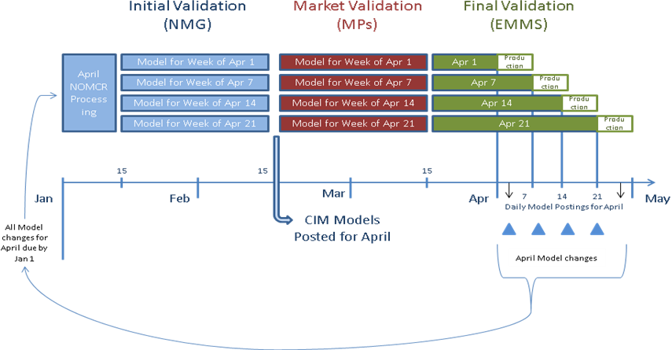
Individual NOMCRs are integrated into the appropriate model based on the model-ready date of each NOMCR. ERCOT has 15 days from the receipt of the NOMCR to either approve or reject the submission. It is during and prior to this NOMCR processing period that the first four levels of validation occur. ERCOT may request additional data be submitted during this 15-day period.
Level 1 Validation- The Level 1 Validation is performed automatically by the NMMS system whenever a NOMCR is submitted or resubmitted. The system will not accept submissions unless they pass the Level 1 Validation criteria. The Market Information System (MIS) Secure postings required by Nodal Protocols are achieved when the NOMCR is submitted.

Level 2 Validation-The Level 2 Validation is performed by the ERCOT Model Coordinator as a visual inspection to ensure that all data in a NOMCR has been provided in a coherent manner.

Level 3 Validation-The Level 3 Validation is performed by the ERCOT Model Tester, who will generate a test network model, transfer it to the Transmission Networks Application (TNA) test bed, and validate that the NOMCR under test will pass a Power Flow and will not corrupt any other portion of the model.

Level 4 Validation-The Level 4 Validation is performed by the ERCOT Model Tester, who will generate a test network model, transfer it to the TNA test bed, and validate that the NOMCR under test, when compiled with other NOMCRs that have the same Model-ready date will pass a Siemens® Power Flow and not corrupt any other portion of the model.

After the NOMCR processing period, models are exported from the NMMS system according to the schedule for Scheduled and Supplemental database loads published on the MIS. These models are then subjected to the Initial Validation that is performed by ERCOT’s Network Modeling Group. Errors found during this validation period will require the submission of NOMCRs outside the normal timelines. Responses to these types of requests will be categorized as Interim Updates. It is during this validation period that ERCOT will apply level 5 Validation to the weekly models.

Level 5 Validation-The Level 5 Validation is performed by the ERCOT Model Tester in the same manner as the Level 4 Validation but using a copy of the Areva Energy Management System (EMS) software that will include State Estimator testing. A price validation on the model will also be conducted using the Market Management System (MMS) software.

ERCOT has approximately forty-five days from the NOMCR submission deadline until the validated models that will be used for the target month Network Operations Model are posted. A period of Market Validation follows the public posting and is scheduled for approximately thirty days. The CRR Auction corresponds with the completion of the Market Validation.
The final phase of validation is facilitated by ERCOT’s Energy and Market Management System (EMMS) group. This is a final check before the model is placed into the production environment. It will be necessary for this set of models to include all final ICCP object name changes. Validation of new or changes to ICCP telemetry are re-verified with the requestor in a point-to-point data check. Failure to provide final ICCP data status could result in Emergency Model loads and notification to the PUCT and IMM.

Approval to Energize Process

In order to describe the “Approval to Energize Process” two concepts must be defined.
The first concept is the model-ready date which is found in the NMMS database and corresponds with the energization date associated with a NOMCR. The model-ready date is the date that the new piece of equipment first appears in the ERCOT production environment. The model-ready date should correspond with a Scheduled or Supplemental Model load date. The model-ready date will also correspond with the date that new piece of equipment can initially be outaged in the ERCOT Outage Scheduler.
The second term is the date that corresponds with the field-energization of a piece of new equipment. The field-energization date is the date the new equipment is energized in the field and is ready for normal service.
The energization of new equipment in the production environment will be preceded by two conditions. First, the equipment must be included in the production model in its normal state prior to energization. Secondly, a Planned Outage whose end time corresponds with the energization of the new equipment must be entered in the Outage Scheduler. Below is an example of how to use the outage scheduler to coordinate New Equipment Energization.
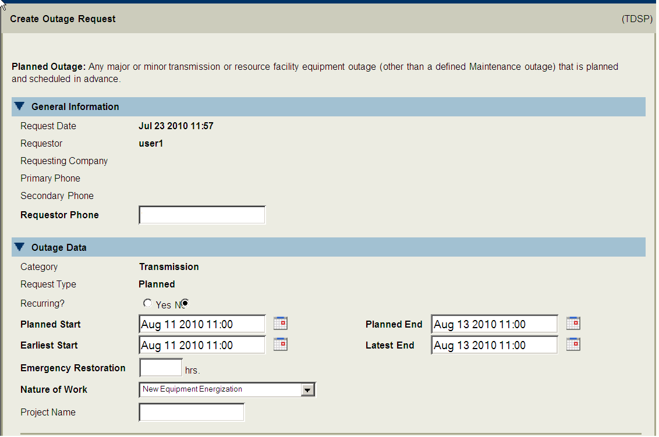
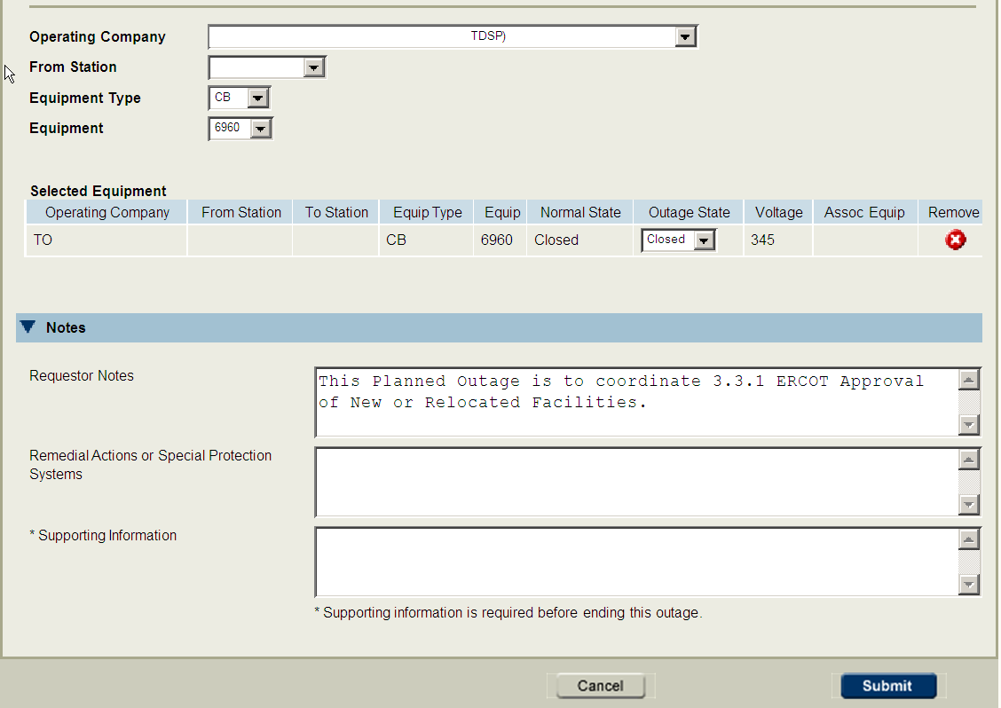

To begin the Approval to Energize process ERCOT Operations will check the Outage Scheduler on a daily basis for equipment that is to be energized in seven days. Equipment that is reported as ready for energization in seven days will be investigated in the current production model. If no problems are anticipated, ERCOT will send an email to the owner of the equipment stating that the Approval to Energize is expected to occur and that no problems are anticipated. If upon investigation of the current production model problems are found, then the email sent to the owner of the equipment will detail the problems and state that the Approval to Energize could be delayed if the problems are not fixed prior to the requested energization date. Market Participants are required to contact ERCOT Operations when the problems are corrected.
In some cases the equipment that is to be energized may not be found in the current production model. The operator will receive a notice stating the equipment to be energized in seven days is not in the current model and that the Approval to Energize may be delayed. In these circumstances, the operator of the equipment is required to call ERCOT Operations provide details as to when the equipment is expected to be loaded into the production environment. With the appropriate communication, the energization date for the new equipment will not be delayed.
Once there are no problems anticipated, ERCOT Operations will contact the ERCOT Shift Supervisor and notify them of the expected energization dates and any other recommended actions. Market Participants are required to request approval from the ERCOT Shift Supervisor for the activation of any new equipment or a relocated transmission facility that is connected to the ERCOT Transmission Grid, according to ERCOT Protocols Section 3.3.1. The request notification shall be by phone from the Market Participant to the ERCOT Shift Supervisor or designee on the day of the energization. If the ERCOT Shift Supervisor or his designee and ERCOT Operations are in agreement, then he/she will allow the equipment to be energized.
Below is an example of the Approval to Energize process.

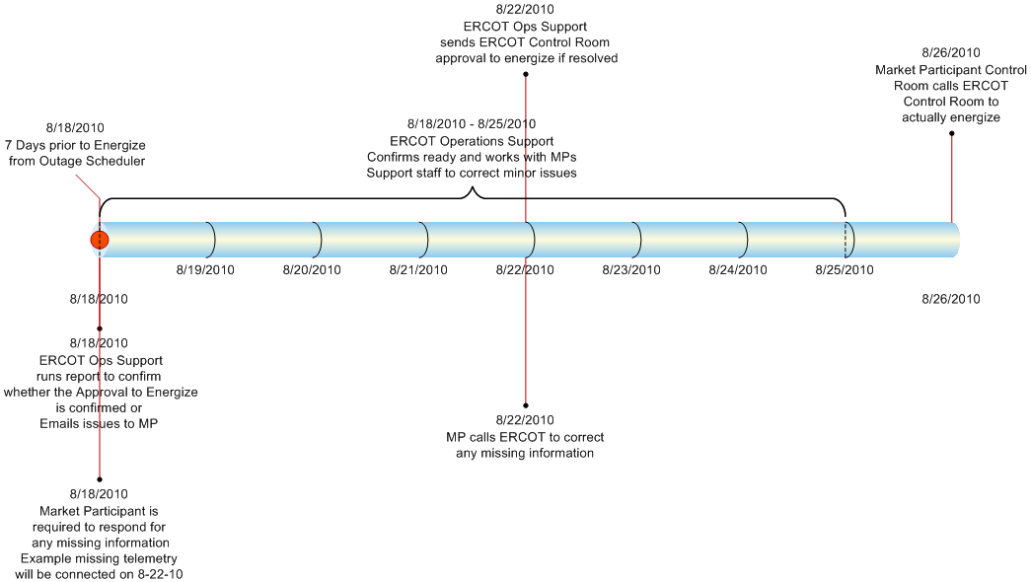

Modeling Equipment Prior to Field-Energize Date
ERCOT expects the model-ready date to precede the field-energization date in all circumstances. New equipment must be entered into the Network Operations Model in its normal operating state. For example, a normally-closed breaker will be initially modeled as normally closed.

Use of the ERCOT Outage Scheduler
The ERCOT Outage Scheduler will be used to coordinate the energization of all new equipment in the Production Environment.

Planned outages
TSPs and REs should remember that Planned Outages on new pieces of equipment will be possible only after the new piece of equipment is modeled in NMMS. Future equipment will be available in the Outage Scheduler seven calendar days after the NOMCR is submitted. The model-ready date for a piece of equipment is the earliest planned start date that can be entered for an outage on that same piece of equipment in the Outage Scheduler.

Forced outages
The ERCOT Forced Outage Detector will notify operator anytime the telemetered status of a piece of equipment differs from the modeled state for more than two hours.

Coordinating Model and Outage Scheduler Entries

Protocols require data submitters to use Planned Outages to coordinate model-ready and field-energization dates for new equipment. The use of Planned Outages is essential in evaluating security in all study cases preceding real-time. In addition, the lack of Planned Outages in association with new equipment energization may result in the increased withdrawal of approval for previously approved outages.

Retiring Equipment
Similar to the energization process, two terms need to be defined in order to describe the retirement process for existing equipment.
The first is the model-retirement date and the second is the field-retirement date. The model-retirement date is the date that an existing piece of equipment is retired or removed from the NMMS model. This date is governed by the submission of a NOMCR. The field-retirement date is the date that the equipment is de-energized in the field in order to be permanently removed from service and is controlled by entries in the Outage Scheduler. In general, NOMCRs that retire equipment from the model should be separate from those that make other changes.
The field-retirement date should precede the model-retirement date. In addition, the model-retirement date should be associated with a Scheduled or Supplemental model load date. If a TSP mistakenly enters a model-retirement date for an existing piece of equipment that does not match a model load date, ERCOT will contact the data submitter with a suggested correction. Without the correction that piece of equipment may not be included in that model (models are back-loaded with data).
For example, assume a model is to be loaded on April 1st and then a subsequent model will be loaded on April 8th. A breaker is to be field-retired on April 6th. If the TSP retires the equipment on April 6th from the model, that equipment will not be included in the April 1st model load. The April 1st model load only includes what is in service on April 8th (this is the backloading mentioned earlier). See illustration below.

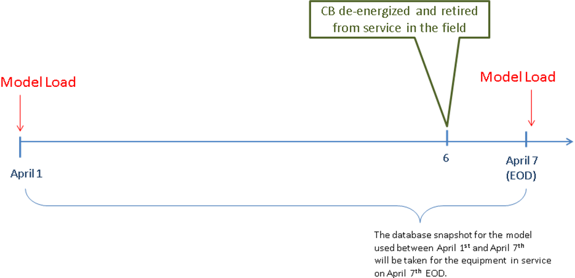

In this example, ERCOT expects the model-retirement date will be scheduled for April 8th. A planned outage will be entered for April 6th until April 8th in order to represent the fact that the equipment has been retired from service. Similar to outages associated with model-energization dates the outages associated with model-retirement dates need to be entered well in advance in order to facilitate any analysis done before real-time. If the CB that is field-retired on April 6th is also model-retired on that date it will not be included in the model used for April 1st to April 7th resulting in an energized breaker not being represented in the model for six days.

General Modeling Principles for Submitters
Scheduled Model load dates should be utilized for all topology changes, the energization of new equipment, the retirement of existing equipment, and changes to ICCP data telemetry. ERCOT will work with data submitters to schedule Supplemental Loads if possible to simplify the modeling demands for data submitters provided the protocol required data submittal timelines are met.
In cases where topology changes or additions cannot be coordinated with scheduled Model Loads, a series of outages and duplicate (pseudo) modeling can be used to accurately represent in the model changes that occur in the field.
Adherence to the following modeling principles will be useful in minimizing the use of pseudo equipment in the Network Model.
- Model-ready dates for new equipment should coincide with a scheduled model load.
- Model-ready dates for new equipment should precede field-energization dates for that same equipment.
- Model-retirement dates should coincide with a scheduled model load
- Field-retirement dates for equipment that is to be retired should precede the model-retirement date for that same equipment.
- The Outage Scheduler will be the primary tool to coordinate the difference between the model-ready dates and field-energization dates (as well as model-retirement dates and field-retirement dates). In general, unforeseen changes in construction schedules should be accounted for by modification of outages in the Outage Scheduler.
- ERCOT suggests that the model-ready date precede the field-energization date by approximately two weeks in order to give the NOMCR submitter flexibility to bring the new equipment into service earlier than anticipated.
- ERCOT suggests that the field-retirement date precede the model-retirement date by approximately two weeks in order to give the NOMCR submitter flexibility to keep a piece of equipment in service past the expected field-retirement date.

Pseudo Device Modeling
ERCOT expects to be able to minimize the use of Pseudo Device Modeling by publishing well in advance a list of Scheduled Model Loads and working with data submitters to add Supplemental Model Loads when feasible. Data submitters may model pseudo transmission elements if they find it is advantageous. The proper use of pseudo modeling will not impede the energization of new equipment.

Modeling Examples
Included below are several examples of common additions and changes to the ERCOT Network Model. For each of these examples a model load schedule of April 1st, April 7th, April 14th, and April 21st will be used.

New Line Termination

Line terminates in a different station on April 10th and requires a 5-day construction outage

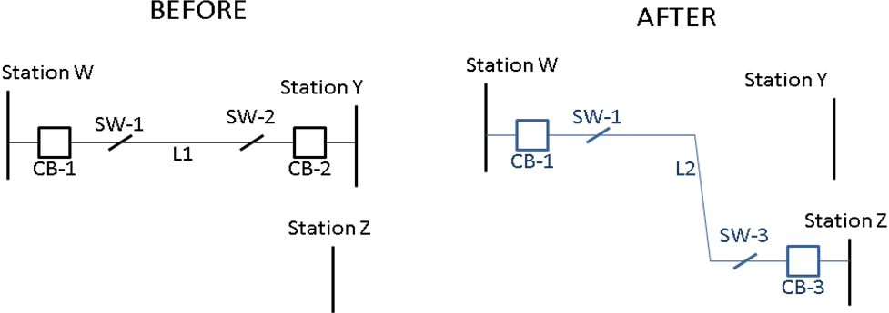

The sequence of events would be as follows:
- Before January 1st, a NOMCR should be submitted with a model-ready date of April 7th for L2, SW-3, and CB-3.
- Before January 1st, a NOMCR should be submitted to retire L1, SW-2, CB-2 with a model-retirement date of April 7th
- Outages should be submitted on CB-1, SW-1, L1, SW-2, and CB-2 starting date on April 5th. These outages will de-energize the existing equipment from the model. The TSP has the flexibility to enter the outages earlier than expected. However the new line cannot be energized until after the model load on April 7th. Ideally these outages should be submitted prior to January 15th to facilitate model validation. The outages on SW-2, CB-2, and L1 should end on April 7th (the model load in which this equipment is retired from the model).
- A second outage should be entered on L2, SW-3, and CB-3. These outages should begin on April 7st (model load date in which the new equipment first appears in production) and end on April 10th (field-energization date for the new equipment).
- On April 10th, the Approval to Energize process is followed to energize the new equipment.
The following illustration shows the sequence of outages and modeling needed to represent this change in topology in the field.
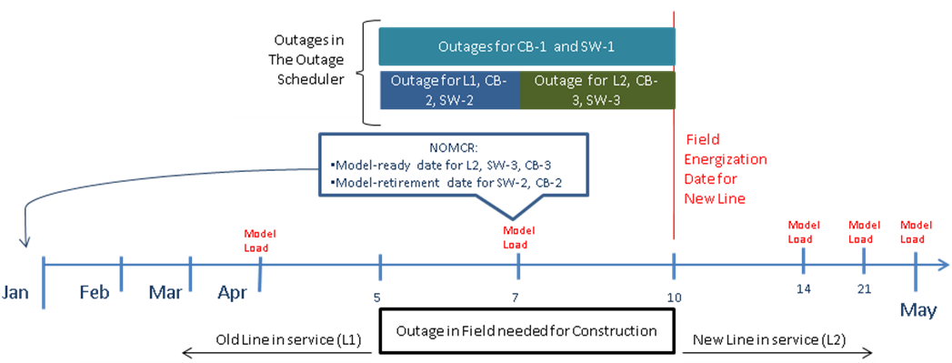

IMPORTANT NOTE: The sequence of outages and NOMCRs illustrated above gives the TSP to ability move the beginning of the construction outages as early as needed. The TSP also has the flexibility to extend the outages to anytime past April 10th using entries in the Outage Scheduler. Restrictions include the fact that the Field-energization of the new line cannot occur before the model load on April 7th, and the entire process requires a model load to occur during the construction outage.

New Tapped Station

New Station built in the middle of existing line to be energized on April 10th. Construction requires a 9-day outage.

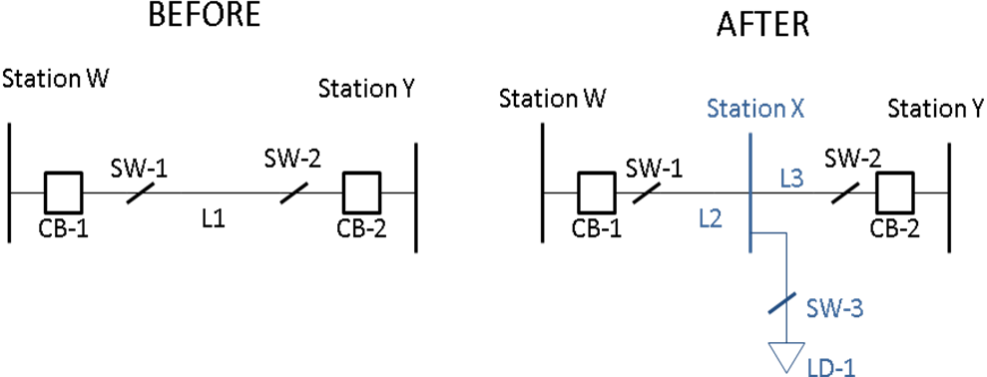
The sequence of events would be as follows:
- Before January 1st, a NOMCR should be submitted with a model-ready date of April 7th for L2, L3, Station X, SW-3, and LD-1
- Before January 1st, a NOMCR should be submitted to retire L1 with a model-retirement date of April 7th
- Outages should be submitted on CB-1, SW-1, L1, SW-2, and CB-2 starting date on April 2nd. These outages will de-energize the existing equipment from the model. Ideally these outages should be submitted prior to January 15th to facilitate model validation. The outage on L1 should end on April 7th (the model load in which this equipment is retired from the model).
- A second group of outages should be submitted on L2, L3, SW-3, and LD-1. These outages should begin on April 7st (model load date in which new equipment first appears in production). The outages should end on April 10th (field-energization date for the new equipment).
- On April 10th, the Approval to Energize process is followed to energize the new equipment.
The following illustration shows the sequence of outages and modeling needed to represent this change in topology in the field.
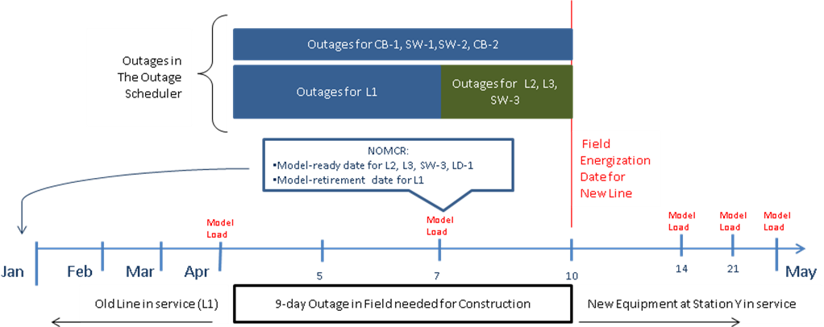

New Line

Line is constructed between existing stations with an field-energization date of April 10th.

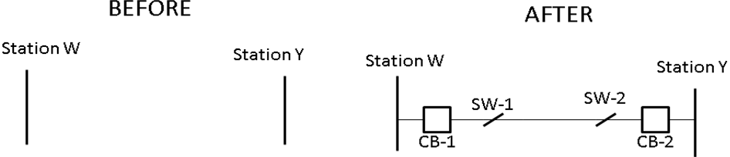
In this example a new line, two breakers, and two disconnect switches are scheduled to be field-energized on April 10th.
- Before January 1st, a NOMCR should be submitted with a model-ready date of April 1st for each piece of new equipment.
- Outages should be submitted for each piece of new equipment that span the time period between the model-ready date and the field-energize date.
- On April 10th, the Approval to Energize process is followed to energize the new equipment.
The following illustration shows the sequence of outages and modeling needed to represent this change in topology in the field.

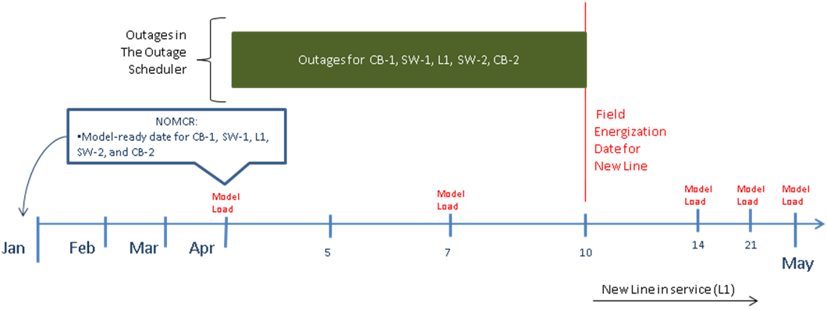

Switching Station

New Switching Station is constructed at the intersection of two existing lines. Station is to be fully energized on April 22rd. Construction requires a series of outages spanning a twenty-one day period with two intermediate configurations.
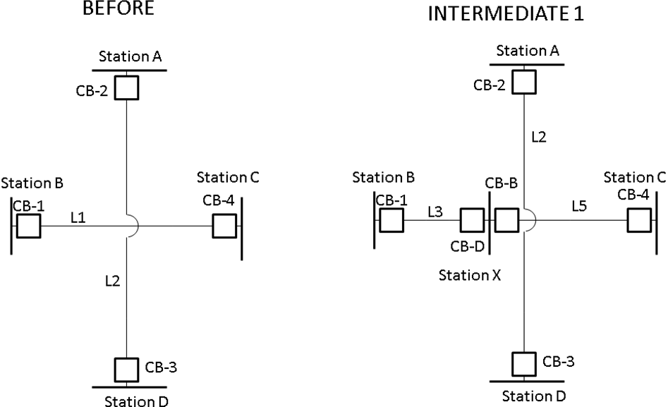
In this example, the first intermediate stage requires a new station to be cut into L1 on April 8th.
- Before January 1st, a NOMCR should be submitted with a model-ready date of April 1st for CB-D, CB-B, L3, and L5.
- Before January 1st, a NOMCR should be submitted with a model-retirement date of April 7th for L1.
- Outage should be submitted for L1 that begins on April 2nd and ends on April 7th (the model-retirement date for L1).
- Outage should be submitted for CB-1 and CB-4 that begins on April 2nd and ends on April 8th (the field-energization date for L3 and L5).
- Outages should be submitted On April 7th, for CB-D, CB-B, L3, and L5. These outages should end on April 8th.

This completes configuration Intermediate 1.
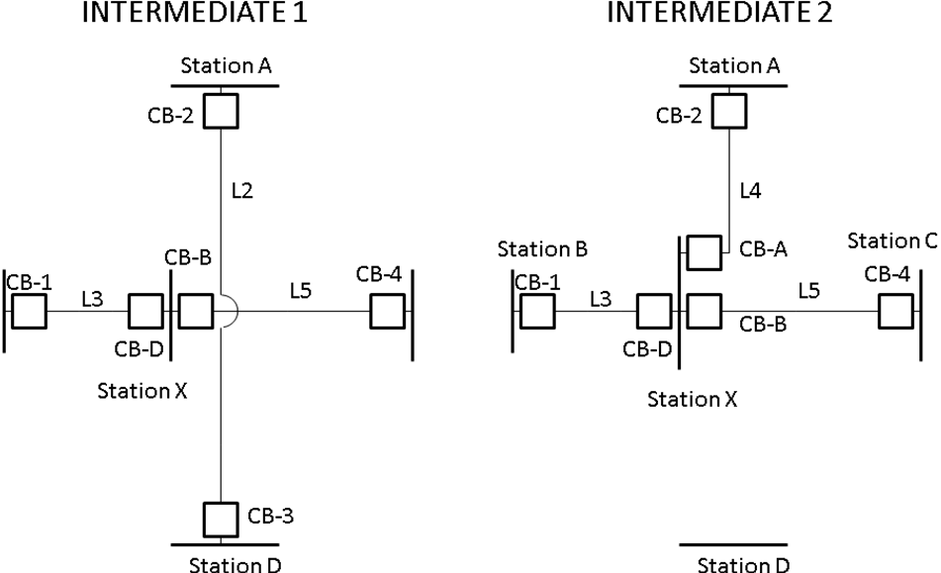
The following needs to take place in order to transition from Intermediate 1 to Intermediate 2. For this stage, L4 is to be field-energized on April 14th (the same day as the Scheduled Model Load).
- Before January 1st, a NOMCR should be submitted with a model-ready date of April 14st for CB-A and L4.
- Before January 1st, a NOMCR should be submitted with a model-retirement date of April 14th for L2.
- Outages should be submitted for L2 and CB-2 that begin on April 11th and end on April 14th (the model-retirement date for L2 and the field-energization date for CB-2).
- Outages should be submitted for CB-A and L4 that start and end on April 14th which is both the model-ready and field-energization date for this equipment. The outages would span the time from the database load (12:00 AM) until the field-energization.

This completes configuration Intermediate 2.

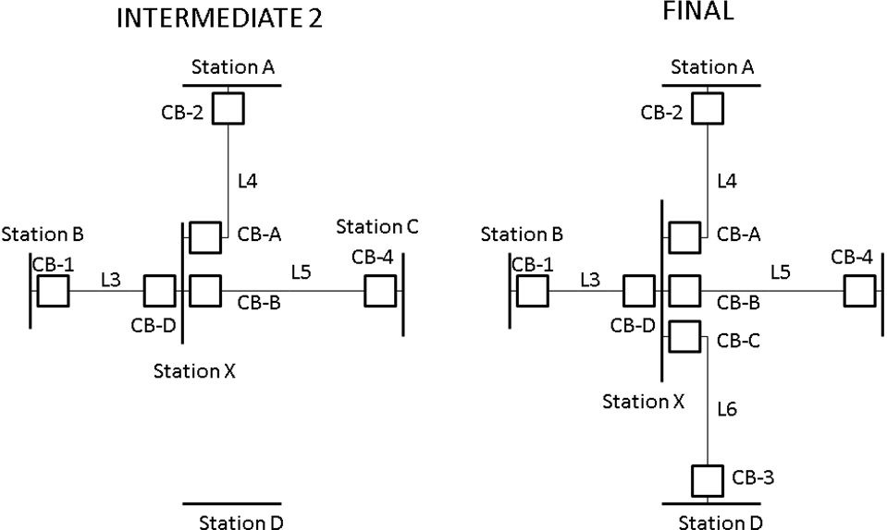

The following needs to take place in order to transition from Intermediate 2 to the final configuration for the new switching station. Line L5 is to be field-energized on April 22nd.
- Before January 1st, a NOMCR should be submitted with a model-ready date of April 22nd L6 and CB-3 (These elements could have been entered on an earlier database load and outaged).
- Outages should be submitted for L6 and CB-3 that begin on April 14th and end on April 22nd (the field-energization date for L2 and CB-B).

This completes the modeling and outage sequence for the new switching station. The overall series of modeling and outage submissions is illustrated in the below diagram.

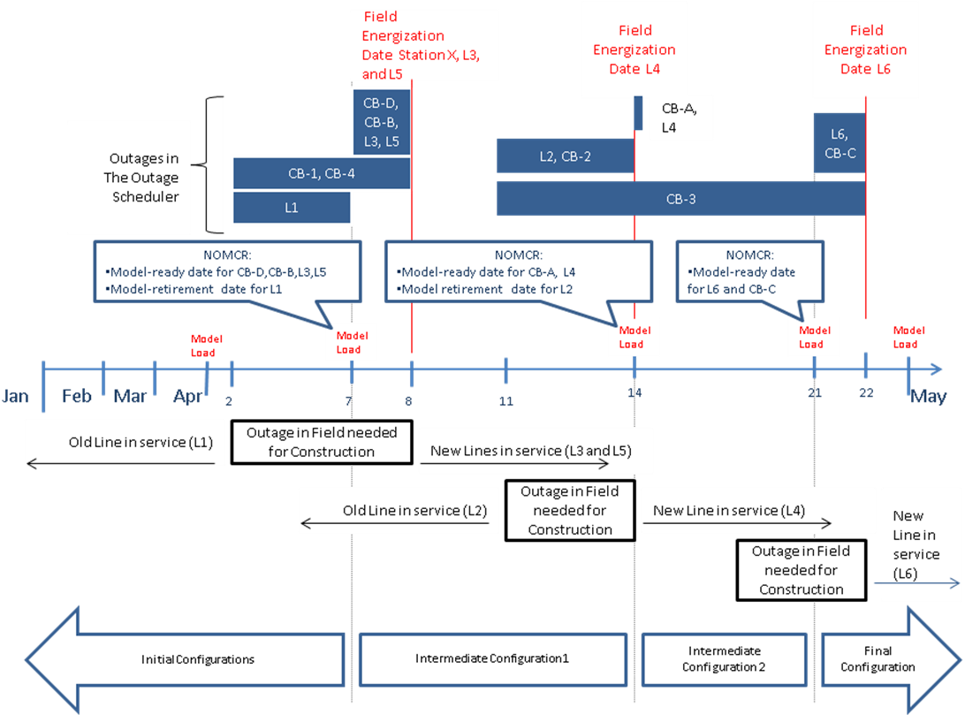

Line Converted to New Voltage (using same name)

An existing 69-kV line is re-insulated and converted to 138-kV. The from and to stations do not change. The new 138-kV line is scheduled to be energized on April 10th. A 5-day construction outage is required in order to move the line to the new voltage (the length of the construction outage is not relevant. However in this example it must span a database load).

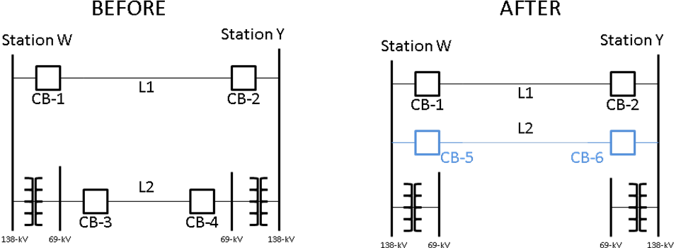

In this example, the following actions will be necessary for the new line to be energized on April 10th following a 5-day outage.
- Before January 1st, a NOMCR should be submitted to rename the 69-kV line to “L2-old” with an energization date of April 1st.
- Before January 1st, a NOMCR should be submitted with a model-retirement date of April 7th to retire CB-3, CB-4 and L2-old.
- Before January 1st, a NOMCR should be submitted with a model-ready date of April 7th for CB-5, CB-6, and L2.
- Outages should be submitted for CB-3, CB-4, and L2-old that start on April 5th and end on April 7th.
- Outages should be submitted for CB-5, CB-6, and L2 that start on April 7th and end on April 10th.
The following illustration shows the sequence of outages and modeling needed to represent this change in topology in the field.
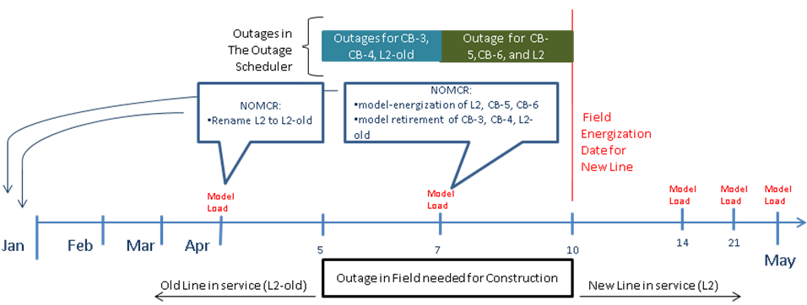

Contingencies

Double Element Contingencies
ERCOT will submit NOMCRs and model double contingencies in NMMS after consulting with the owners of the equipment in the double contingencies. It is expected that equipment owners will proactively communicate to ERCOT which equipment should be included in double-circuit contingencies as identified in ERCOT Operating Guides. For example, any model change that results in the creation (or removal) of one or more new double contingencies should be submitted with the identification of which elements create each of the new double contingencies. That information will be used to update the contingency list in NMMS. An agenda item will be added to the Network Data Support Working Group (NDSWG) meetings to review the current list of double elements and verify that the list is complete. ERCOT will be identified in the model as the owner of the contingencies.

Single Element Contingencies
Single element contingencies will be programmatically generated and appended to each CIM model. Each Network Operations Model could have a unique contingency file. It is expected that equipment owners will work with ERCOT to identify equipment that should not be included in a contingency (i.e. breakers without relaying). Conversely, it is expected that the equipment owners notify ERCOT when equipment that was previously excluded should be re-included in a contingency. ERCOT’s programmatic contingency generator has the capability to exclude contingencies on previously identified equipment. The identification flag for equipment that is to be excluded from the programmatic contingency generation will have ERCOT ownership in the model.

Appendix A Model Request Classifications

This table is not meant to represent all instances of interim updates.

Description | Class 1 | Class 2 | Class 3 | Class 4
Equipment Renames | √ |  | √
Station Renames | √ |  | √
Equipment Rating (static) | √ | √
Breaker or Switch status change | √ | √
Connectivity Changes | √ | √ | √ | √
Telemetry Changes | √ | √ | √ | √
New Equipment Additions | √ |  | √ | √
Equipment Retirements | √ | √
Registration data |  | √ | √ | √
Unit Characteristics | √
Equipment Ownership | √ | √
Equipment Operatorship | √ | √
Zone corrections |  |  | √ | √
SPS, RAP, PCAP, or MP Activation | √ | √ | √ | √

ERCOT Nodal Protocols 3.10.1 (1)
ERCOT Nodal Protocols 3.10.1
ERCOT Nodal Protocols 3.10.4 (5)
ERCOT Nodal Protocols 3.10.4 (5)
ERCOT Nodal Protocols 3.10.1 (6)
ERCOT Nodal Protocols 3.10.8.4 (c),(d)
ERCOT Nodal Protocols 3.10.4 (5)
ERCOT Nodal Protocols 3.10.1
Related to NPRR146
ERCOT Nodal Protocols 3.3.2.1
ERCOT Nodal Protocols 3.3.2.1
ERCOT Nodal Protocols 3.1.5.1 (1)
Double Circuit contingencies are defined in the ERCOT Nodal Operating Guides Section 1 under “Credible Single Contingency”. Two circuits that share the same towers for more than 0.5 miles are considered as a Double Circuit Contingency. Breakers that do not have relaying also need to be brought to the attention of ERCOT as they may require special modeling considerations.

