SCR Number | 759 | SCR Title | acLineSegment Name Length Increase in Information Model Manager
Timeline | Normal | Action |  | Recommended Approval
Date of Decision |  | August 19, 2010
Proposed Effective Date |  | Upon System Implementation - Post Texas Nodal Market Implementation Date.
Priority and Rank Assigned |  | Priority High
Supporting Protocol or Guide Section(s)  (if applicable) |  | Not applicable.
Other Document Reference/Source |  | Not applicable.
System Change Description |  | This System Change Request (SCR) proposes to increase the allowable character size of the acLineSegment type under the Line Equipment Container from two to 14 in the Information Model Manager.
Reason for System Change |  | Multi-section line models have been used by transmission planners in Siemens Power System Simulator for Engineering (PSSE) power flow software for over 20 years as a tool for correctly simulating contingencies on the ERCOT System for planning studies. The Topology Processor enhancement approved by ERCOT in April 2010 to add multi-section line definitions to the raw file output requires all line segments of the multi-section line to be modeled under the same Line Equipment Container in the Network Operations Model. The reason that some Transmission Service Providers (TSPs) are not modeling line segments in this manner in the Information Model Manager is that the acLineSegment name is currently limited to two characters, which is too limiting for many TSPs line segment IDs. To be able to make this change to the Network Operations Model, the acLineSegment name must be increased. If this increased name size is not changed, the multi-section line functionality of the Topology Processor cannot be utilized.
Overall Market Benefit |  | Improved quality of Annual Planning Models in Nodal environment.
Overall Market Impact |  | Project cost to make Information Model Manager system change by ERCOT and/or vendors.
Consumer Impact |  | None.
Relevance to Nodal Market |  | No known market impact. However, this change will facilitate creation of the Annual Planning Models from the Network Model Management System (NMMS) after the Texas Nodal Market Implementation Date.
Procedural History |  | - On 5/27/10, SCR759 and a CEO Revision Request Review were posted.  - On 7/15/10, ROS considered SCR759.  - On 7/27/10, an Impact Analysis was posted.  - On 8/12/10, ROS considered the 7/15/10 ROS Report and Impact Analysis for SCR759.  - On 8/19/10, PRS considered SCR759.
ROS Decision |  | On 7/15/10, ROS unanimously voted to recommend approval of SCR759 as submitted. All Market Segments were present for the vote.  On 8/12/10, ROS unanimously voted to endorse and forward the 7/15/10 ROS Report and Impact Analysis for SCR759 to PRS with a recommended priority of High. All Market Segments were present for the vote.
Summary of ROS Discussion |  | On 7/15/10, participants discussed what the impact would be if SCR759 was not approved. ERCOT Staff explained the ERCOT CEO’s determination that SCR759 is not necessary prior to the Texas Nodal Market Implementation Date. Participants discussed the importance of SCR759 implementation and recommended a priority of High. ERCOT Staff noted that SCR759 would return to ROS next month for a formal recommendation of a priority.  On 8/12/10, there was no discussion.
PRS Decision |  | On 8/19/10, PRS unanimously voted to recommend a priority of High for SCR759. The Independent Power Marketer (IPM) Market Segment was not present for the vote.
Summary of PRS Discussion |  | On 8/19/10, participants discussed whether this SCR has high value for a majority of Market Segments or ERCOT, which is how the “High” priority level is defined.

Quantitative Impacts and Benefits
Assumptions | 1 | Topology Processor enhancements delivered to ERCOT include ability to define multi-section line groups as described in the Siemens March 29, 2010 proposal.
Assumptions | 2
Assumptions | 3
Assumptions | 4
Market Cost |  | Impact Area | Monetary Impact
Market Cost | 1 | Project cost to make Information Model Manager system change by ERCOT and/or vendors | Not known
Market Cost | 2
Market Cost | 3
Market Cost | 4
Market Benefit |  | Impact Area | Monetary Impact
Market Benefit | 1 | Improved quality of Annual Planning Models in Nodal environment | Not known
Market Benefit | 2
Market Benefit | 3
Market Benefit | 4
Additional Qualitative Information | 1 | Annual Planning Models will have multi-section line group records output from the Topology Processor similar to how they are defined in current planning cases.
Additional Qualitative Information | 2 | Seamless transition for planning studies and cases from zonal to Nodal environment.
Additional Qualitative Information | 3 | No work required of TSPs and ERCOT to redefine multi-section lines in planning cases.
Additional Qualitative Information | 4
Other Comments | 1
Other Comments | 2
Other Comments | 3
Other Comments | 4

Sponsor
Name | Wesley Woitt on behalf of the Steady State Working Group (SSWG)
E-mail Address | wesley.woitt@centerpointenergy.com
Company | CenterPoint Energy
Phone Number | 713-207-2760
Cell Number
Market Segment | Investor Owned Utility (IOU)

Market Rules Staff Contact
Name | Jonathan Levine
E-Mail Address | jlevine@ercot.com
Phone Number | 512-248-6464

Comments Received
Comment Author | Comment Summary
None.

Business Case for Proposed System Change
Issue:
Multi-section line models have been used by transmission planners in Siemens PSSE power flow software for over 20 years as a tool for correctly simulating contingencies on the ERCOT System for planning studies. The Topology Processor enhancement approved by ERCOT in April 2010 to add multi-section line definitions to the raw file output requires all line segments of the multi-section line to be modeled under the same Line Equipment Container in the Network Operations Model. The reason that some TSPs are not modeling line segments in this manner in the Information Model Manager is that the acLineSegment name is currently limited to two characters, which is too limiting for many TSPs’ line segment IDs (see Figure 1). To be able to make this change to the Network Operations Model, the acLineSegment name must be increased. If this increased name size is not changed, the multi-section line functionality of the Topology Processor cannot be utilized.
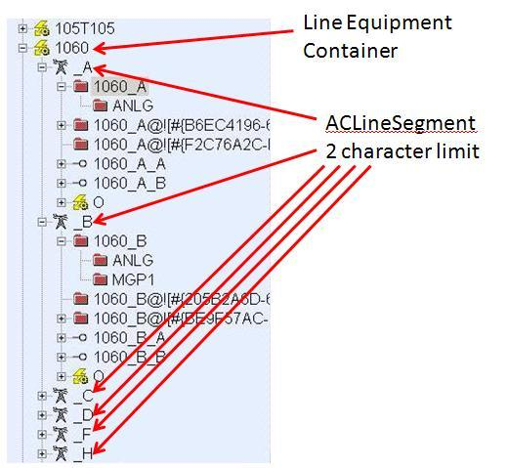
Figure 1.

Example:
Cedar Bayou (CBY) to Warvue (WRN) circuit 84
PSSE branch definitions (From bus, To bus, CKT ID)
40010, 40012, 84
40012, 41700, 84

PSSE multi-section line definition (Bus 1, Bus 2, Multi-section line ID, Bus 3)
40010, 41700, &1, 40012

Current Network Operations Model

Line Segment ID
CBYCD_84: Cedar Bayou to Cedar Bayou tap ckt 84
CD_WRN84: Cedar Bayou tap to Warvue ckt 84

Figure 2 shows the existing Network Operations Model for the two line segments. Note that each line segment exists in its own Line Equipment Container because of the acLineSegment character limitation.

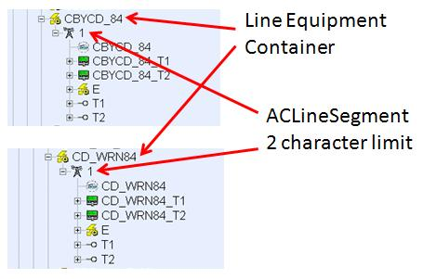
Figure 2.

If the acLineSegment type is expanded from two to 14 characters, then the line could be adjusted as shown in Figure 3, which would also allow the PSSE multi-section line record to be output by the Topology Processor correctly.

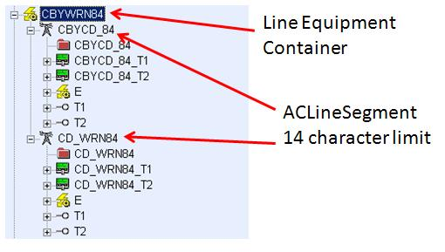
Figure 3. Hypothetical structure of Cedar Bayou to Warvue circuit 84 in the Network Operations Model.
Resolution:
Expand acLineSegment type from two to 14 characters as described above.

