NPRR Number | 255 | NPRR Title | Resolution of Alignment Item A81 - DRUC Timing and Execution when DAM is Delayed or Aborted
Date |  | August 23, 2010
Submitter’s Information
Name |  | Sherry Looney
E-mail Address |  | Sherry.looney@luminant.com
Company |  | Luminant Energy Company, LLC
Phone Number |  | 214-875-9278
Cell Number |  | 469-688-7607
Market Segment |  | Investor-Owned Utility (IOU)

Comments

Luminant Energy Company, LLC (Luminant) supports the ERCOT proposed Protocol revisions which add the provision for ERCOT to execute a Supplemental Ancillary Services Market (SASM) in the event that Day Ahead processes for procuring Ancillary Services are aborted. Luminant believes that the standard 30 minutes allowed for a Market Participant to cancel, re-calculate new offers and re-submit those offers under the normal SASM timeline would not be appropriate under such an unusual market event. Therefore, Luminant proposes the addition of thirty minutes additional advance notice to the SASM timeline for Qualified Scheduling Entities (QSEs) to be able to review, cancel or modify and re-submit their Ancillary Services offers for the SASM.

Proposed Protocol Language Revision
5.2 Reliability Unit Commitment Timeline Summary
5.2.1 RUC Normal Timeline Summary
The following Reliability Unit Commitment (RUC) Timeline Summary describes the normal timeline for RUC activities that occur in the Day-Ahead and Adjustment Periods.

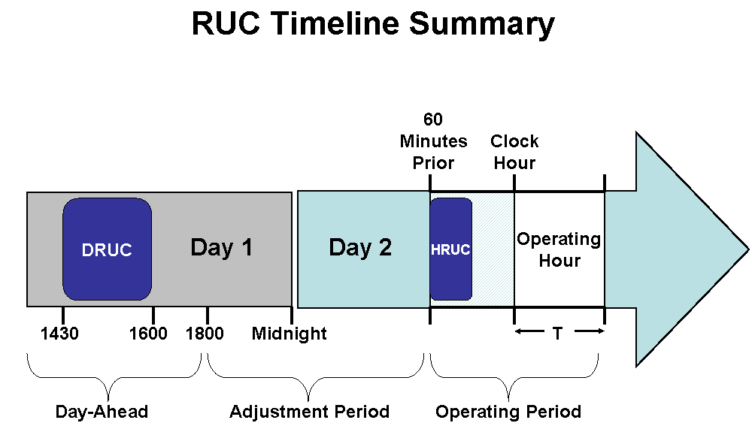

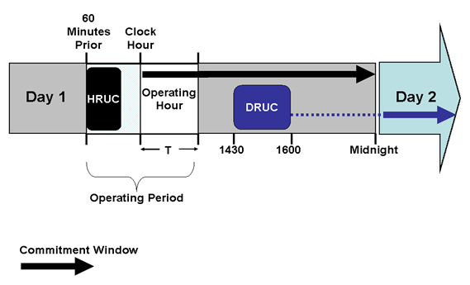

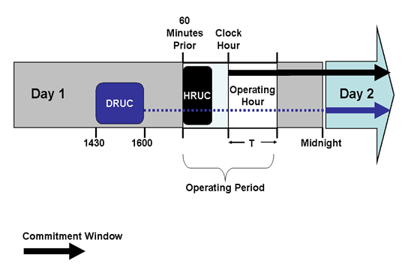
5.2.2 RUC Process Timing Deviations
5.2.2.1 Delay of the Day-Ahead Reliability Unit Commitment
If the Day-Ahead Market (DAM) execution is delayed in accordance with Section 4.1.2, Day-Ahead Process and Timing Deviations, ERCOT shall conduct a Day-Ahead Reliability Unit Commitment (DRUC) after 1430 in the Day-Ahead and no earlier than one hour following the posting of DAM awards information on the Market Information System (MIS) Public Area as set forth in Section 4.5.3, Communicating DAM Results. In this event, ERCOT will use the Current Operating Plan (COP) and Trades Snapshot taken just prior to the execution of the DRUC to settle RUC charges.
5.2.2.2 Aborted Day-Ahead Reliability Unit Commitment
(1) If ERCOT aborts all or part of the Day Ahead process in accordance with Section 4.1.2, Day-Ahead Process and Timing Deviations, ERCOT shall also abort the DRUC process described in this Section 5, Transmission Security Analysis and Reliability Unit Commitment (RUC). In lieu of the DRUC processes described in this Section 5, ERCOT shall use the Hourly Reliability Unit Commitment (HRUC) process described in this Section 5.2.2.2.
(2) When the DRUC is aborted, ERCOT shall notify all QSEs of the following:
(a) ERCOT will execute a Supplemental Ancillary Services Market (SASM) in accordance with Section 6.4.8.2, Supplemental Ancillary Services Market, to procure the amounts of Ancillary Services necessary to meet the Ancillary Service Plan for the Operating Day affected by the aborted DAM.
(b) For this SASM, the QSE may not change the amount of self-arranged Ancillary Services from the amount submitted for the aborted DAM.
(c) The amount of each Ancillary Service to be procured by ERCOT in this SASM is the amount of each Ancillary Service specified in the ERCOT Ancillary Service Plan posted prior to the aborted DAM less the total amount of each Ancillary Service in the QSE DAM submittals for self arranged Ancillary Services.
(d) This SASM will settle in accordance with Section 6.7, Real-Time Settlement Calculations for the Ancillary Services.
(e) The SASM process for acquiring Ancillary Services in the event of aborted Day-Ahead processes shall use the following timelines with time “X” being the time that ERCOT sends notice to all QSEs of the SASM.

SASM Process | QSE Activities: | ERCOT Activities:
Time = X |  | Notify all QSEs of intent to procure additional Ancillary Services.  Notify QSEs of any additional Ancillary Service Obligation, allocated to each Load Serving Entity (LSE) and aggregated to the QSE level.
Time = X plus 60 minutes | May submit additional Self-Arranged Ancillary Service Quantities limited to the additional Ancillary Services Obligation of the QSE. | Determine the amount of Ancillary Services to be procured.
Time = X plus 65 minutes |  | Execute SASM.
Time = X plus 75 minutes |  | Notify QSEs with awards of results.  Post the quantities and Market Clearing Prices for Capacity (MCPCs) of Ancillary Services bought in the SASM.
Time = X plus 90 minutes | Submit updated COP with updated Ancillary Service Resource Responsibility. | Validate COPs for Ancillary Service Resource Responsibility.

(3) Following the SASM notice described in paragraph (2) above, a QSE may expire Ancillary Service Offers that are inclusive with a Three-Part Supply Offer that was submitted for the aborted DAM.
(4) A QSE may submit Ancillary Service Offers for this SASM following the SASM notice described in paragraph (2) above. For this SASM, these QSE Ancillary Service Offers shall not be subject to the provisions of Section 6.4.8.2.1, Resubmitting Offers for Ancillary Services in the Adjustment Period.
(5) Upon completion of the SASM and notification of Ancillary Service awards, the QSE shall update its COP to report the self-arranged and awarded Ancillary Service Resource Responsibilities.
(6) After 1600 in the Day-Ahead and no sooner than one hour following the completion of the SASM, ERCOT shall execute an HRUC process.
(a) The RUC Study Period for this HRUC process is the balance of the current Operating Day plus the next Operating Day.
(b) The COP and Trades Snapshot taken just prior to the execution of this HRUC process will be used to settle RUC charges.
(c) This HRUC process may commit Resources to supply Ancillary Services if the Ancillary Service Offers submitted in the SASM are insufficient to meet the requirements of the Ancillary Services Plan.

