4.5 Day to Day Issues – Projects (AMS LSE Missing/Dispute Interval Data) Interim Process

4.5.1 Required Fields for Projects (AMS LSE Missing/Dispute Interval Data)

Assignee

4.5.2 Definition of Projects
4.5.2.1 Examples of Projects

    - System issues
    - Project related issues

(4.5.3?) Submitting a Projects MarkeTrak issue for missing/dispute of interval data
A CR or a TDSP can submit this sub type.

The Projects sub-type has been designated as the appropriate method by which market participants should resolve issues related to missing or disputed interval data.

Several fields not required to submit a normal issue within this sub-type must be populated for the issue to be considered valid. If any field which is required for submission of an issue under this process is incomplete or not populated, this is considered a valid reject reason and the TDSP may unexecute the issue.

Issues should only be submitted for this purpose when the CR has validated an AMS profile exists for the ESIID and the “origin” is “C”.

4.5.3.1 Examples for Projects submitted by CR to TDSP
- The CR selects the Submit tab (Fig 4.5a)
- From the Submit Tree, select Projects

Fig 4.5a
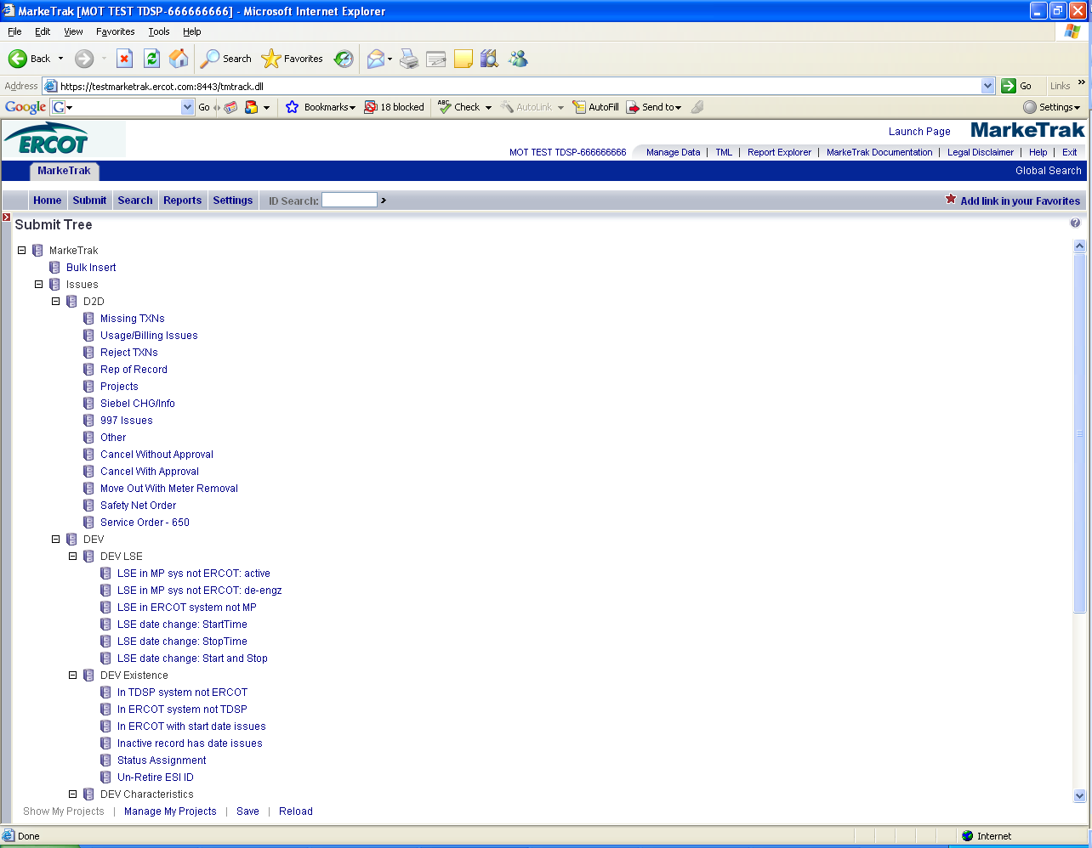

- The following fields must be populated for successful submission of Day to Day issue sub type Projects : (Fig 4.5b)
(For this example, the submitter selects TDSP.)
Assignee
Type in the DUNS or company name of the correct TDSP, and select Find. A dropdown will appear with names that match the entry. Select the appropriate TDSP.
ISA - For the issue to be considered valid, this field must be populated with one of the two following numbers:
“1234” for missing
“12345” for dispute
ESIID
StartTime
Must be formatted as mm/dd/yyyy hh:mm:ss, using military time
Comments (Indicate exact Start and Stop time(s) for missing interval including: month, date, year, hour and minutes)
NOTE: Start AND Stop time are required in comments regardless of number of intervals requested. Use exact format below (StartTime-StopTime using 24 hour clock). Use of incorrect format is a valid unexecutable reason.

mm/dd/yyyy hh:mm:ss-mm/dd/yyyy hh:mm:ss (military time)

If the user is requesting data ranging from Start time to “current”, the following format should be used:

mm/dd/yyyy hh:mm:ss-12/31/2037

(screen shot using p.m. time in military format)

NOTE: The, Original Tran ID, Tran Type, TXN Date, and GS Number, are all optional fields. Please include any additional information relevant to resolving this issue in the comments section.

- Select OK.

Fig 4.5b
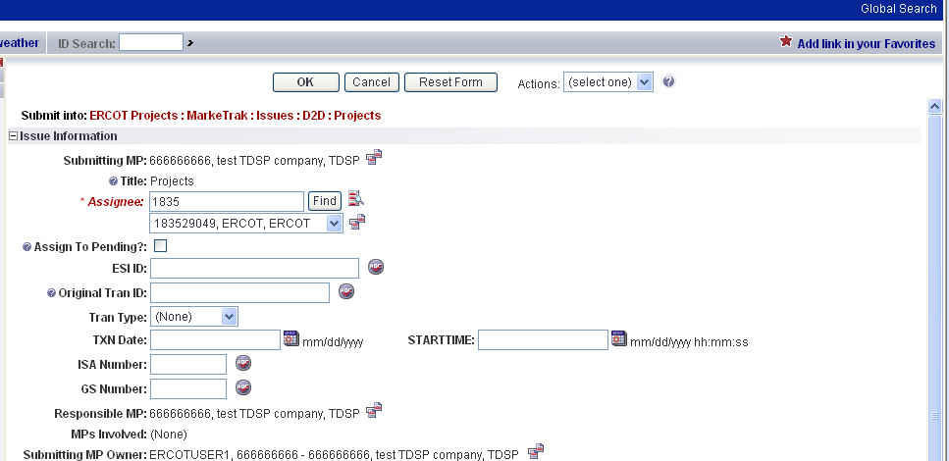

- The issue enters TDSP’s queue in a state of New and is visible only by the Submitting CR and TDSP.
- The Submitting CR can Withdraw the issue at this point by selecting the Withdraw transition within the MT issue. (Fig 4.5c)

Fig 4.5c
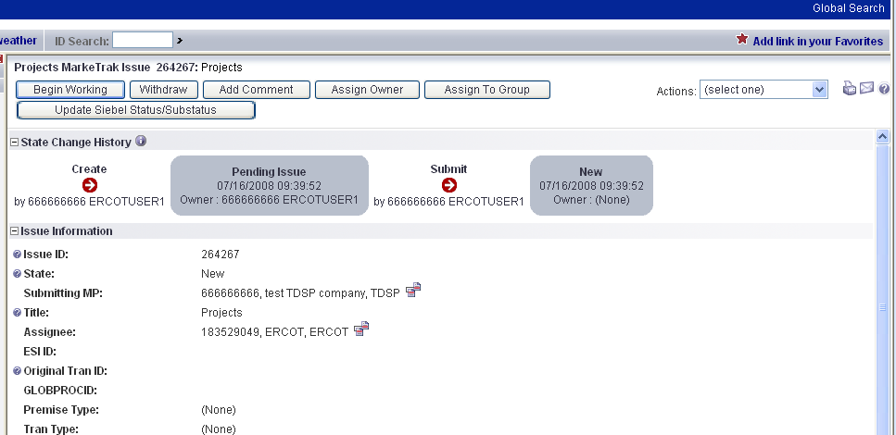

- TDSP selects Begin Working and the issue is transitioned to the state of In Progress (Assignee). (Fig 4.5d)
- At this point, the Submitting CR can no longer Withdraw the issue.

Fig 4.5d
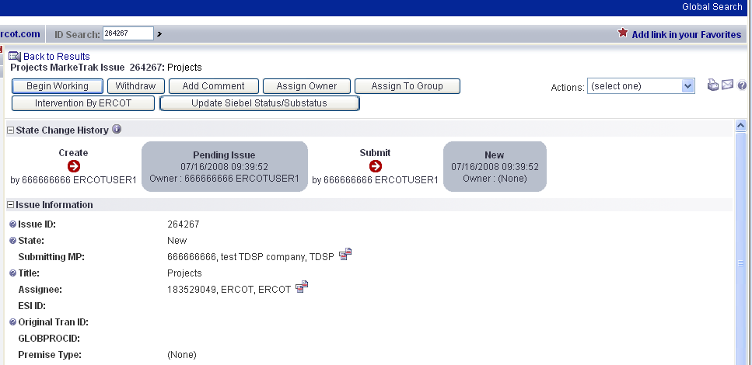

Note: After the initial “Begin Working” is selected and the “Withdraw” is not available or the issue is not in a “Complete” state, if the submitting MP feels a resolution is no longer needed, the “Close” button can be selected. Comments will be required with this transition.
All work will stop on the issue at this point.

- TDSP reviews the issue and has the options: (Fig 4.3e)
      - Unexecutable, which results in state Unexecutable- Pending Complete – comments required.
Other valid reject reasons include:
    - invalid Start and/or Stop time
    - entry of a Start and/or Stop time where the submitting CR was not REP of Record
    - existence of an open issue for the same Start and Stop time, under the same request (missing, dispute)
ESIID does not belong to TDSP, or is not a valid ESIID

      - Complete, which transitions to a state of Pending Complete. The Submitter has the option to close the issue by selecting Complete or the issue will be auto closed in 14 calendar days.

Fig 4.5e
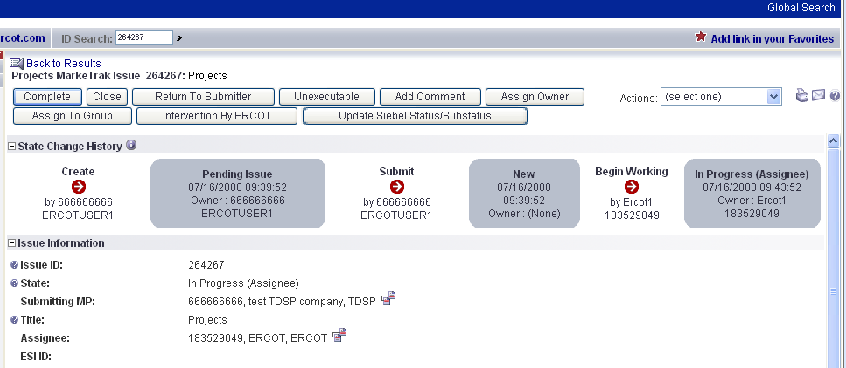

- In this example, if after researching the information provided, TDSP provided the necessary information to the CR within the comments section, TDSP would select Complete, and the issue would be transitioned back to the Submitter in the state of Pending Complete. (Fig 4.5f)

Fig 4.5f
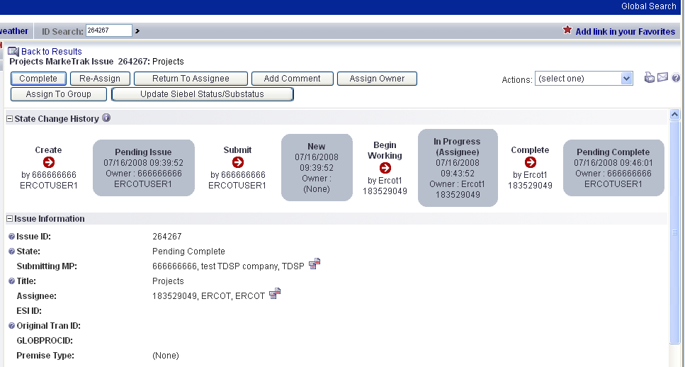

- The Submitting CR has the option to close the issue by selecting Complete or the issue will be Auto Closed in 14 Calendar days. (Fig 4.5g)

Fig 4.5g
