ERCOT Operations Report
Jul 2010 ROS & OWG

Frequency Control
Time | Freq(Hz) | Duration (s)
07/02/2010 01:44:48 | 59.816 | 79 | Unit trip with 674 MW
07/06/2010 20:30:08 | 59.817 | 103 | Unit trip with 796 MW
07/10/2010 04:10:53 | 59.850 | 34 | Unit trip with 626 MW
07/12/2010 13:17:12 | 59.838 | 84 | Unit trip with 795 MW
07/12/2010 13:54:41 | 59.827 | 143 | Unit trip with 630 MW
07/14/2010 14:08:08 | 59.898 | 7 | Unit trip with 192 MW. Out of Up Reg
07/20/2010 07:25:04 | 59.805 | 122 | Unit trip with 810 MW
07/26/2010 04:55:32 | 59.877 | 8 | Unit trip with 740 MW
07/26/2010 05:09:44 | 59.800 | 84 | Unit trip with 783 MW
07/27/2010 15:56:01 | 59.834 | 60 | Unit trip with 690 MW
07/30/2010 14:31:16 | 59.836 | 88 | Unit trip with 770 MW
Note: Time of frequency excursions outside the range of +/- 0.1 Hz.

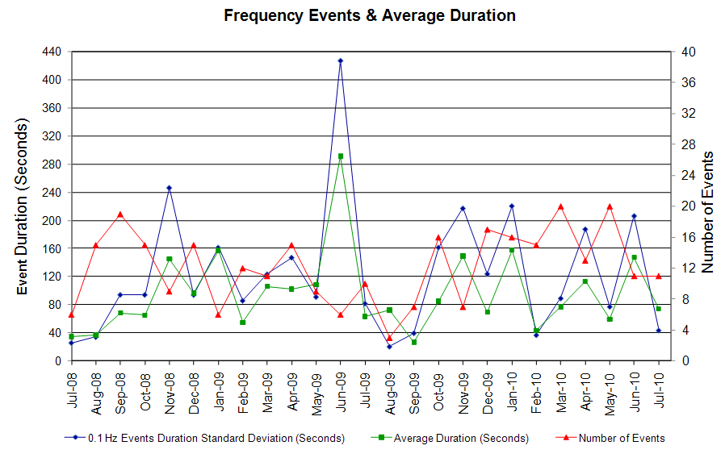

Deployed Responsive (Reported Above)
Time deployed | Stop Time | Duration | Max | Details
7/2/10 1:44:47 | 7/2/10 2:08:34 | 0:23:47 | 821.7
7/5/10 11:07:57 | 7/5/10 11:18:10 | 0:10:13 | 346.85 | Large SCE change
7/6/10 20:30:11 | 7/6/10 20:49:18 | 0:19:07 | 816.41
7/10/10 4:10:55 | 7/10/10 4:27:26 | 0:16:31 | 640.33
7/11/10 1:01:27 | 7/11/10 1:11:02 | 0:09:35 | 352.19 | Unit Trip
7/12/10 1:47:22 | 7/12/10 2:03:50 | 0:16:28 | 341.52 | Out of Up Reg.
7/12/10 13:17:15 | 7/12/10 13:36:38 | 0:19:23 | 704.35
7/12/10 13:54:39 | 7/12/10 14:17:46 | 0:23:07 | 768.39
7/14/10 14:08:07 | 7/14/10 14:34:01 | 0:25:54 | 384.20
7/20/10 7:25:02 | 7/20/10 7:48:53 | 0:23:51 | 880.44
7/26/10 4:55:29 | 7/26/10 5:07:36 | 0:12:07 | 496.26
7/26/10 5:09:45 | 7/26/10 5:41:51 | 0:32:06 | 907.1
7/27/10 15:56:03 | 7/27/10 16:27:14 | 0:31:11 | 725.7
7/27/10 18:27:05 | 7/27/10 18:34:54 | 0:07:49 | 352.2 | Unit Trip
7/27/10 22:35:12 | 7/27/10 22:52:02 | 0:16:50 | 330.8 | Out of Up Reg
7/30/10 14:31:15 | 7/30/10 14:56:51 | 0:25:36 | 715

Day-Ahead OOMC and RPRS Capacity Purchases
Details | OOMC | RPRS S1 | RPRS S2 | RPRS S1+S2 | RMR | Total
DFW | 39 | 4 | 8 | 12 | 0 | 51
Houston | 1 | 8 | 2 | 10 | 0 | 11
Western | 0 | 2 | 3 | 5 | 6 | 11
Corpus | 1 | 3 | 0 | 3 | 0 | 4
Northeast | 0 | 0 | 4 | 4 | 0 | 4
North | 0 | 0 | 1 | 1 | 1 | 2
Austin | 0 | 0 | 1 | 1 | 0 | 1
E RIO | 0 | 0 | 0 | 0 | 0 | 0
San Antonio | 0 | 0 | 0 | 0 | 0 | 0
W RIO | 0 | 0 | 0 | 0 | 0 | 0
South | 0 | 0 | 0 | 0 | 0 | 0
Bryan Area | 0 | 0 | 0 | 0 | 0 | 0
Laredo | 0 | 0 | 0 | 0 | 0 | 0
Total | 41 | 17 | 19 | 36 | 7 | 84

Historical Totals | Jul-10 | Jul-09 | Jun-10
Austin | 0 | 5 | 0
Bryan Area | 0 | 0 | 0
Corpus | 4 | 0 | 0
DFW | 43 | 28 | 64
E RIO | 0 | 9 | 4
Houston | 9 | 37 | 6
Laredo | 0 | 0 | 0
North | 1 | 46 | 9
Northeast | 0 | 2 | 0
San Antonio | 0 | 14 | 2
South | 0 | 13 | 0
W RIO | 0 | 0 | 0
Western | 8 | 19 | 18
Total | 65 | 173 | 103
http://www.ercot.com/mktinfo/services/rprsdr/index.html

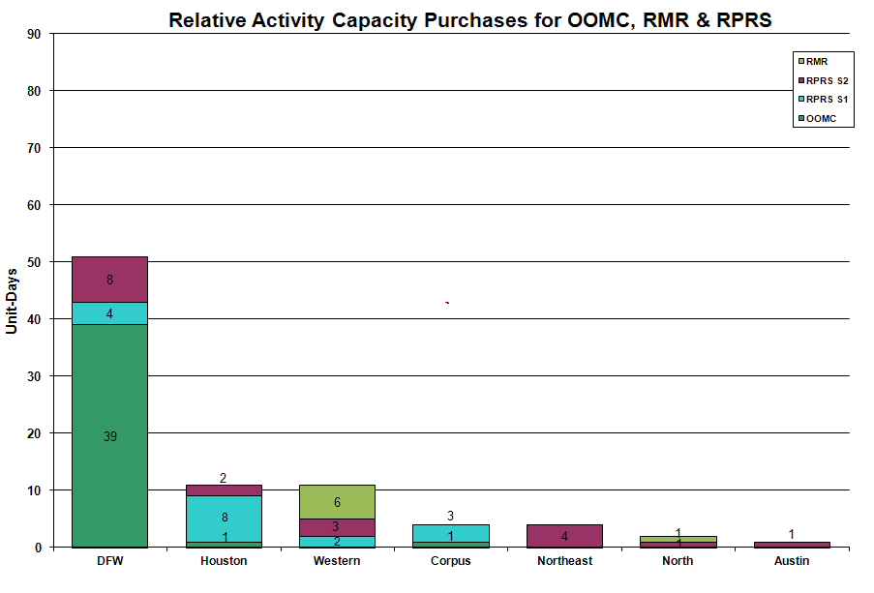

OOME and Congestion Management Activity
Congestion affected by outages Remedial action plan has been developed for the element
Contingency | Overloaded Element | Days
Matador - Paducah Claire St. 69KV | Aspermont - Spur 138KV | 21
Watermill - West Levee - Sargent Road 345KV | Duncanville South - Cedar Hill 138KV | 10
Green Bayou - Gable & Hardy - Crockett 138KV | Garrott - Midtown 138KV | 9
Meadow - PH Robinson 345 KV | North Alvin - Hastings 138KV | 9
Sandow Switch - Austrop 345KV | Round Rock - Round Rock Northeast 138KV | 9
Graham - Parker 345KV | Leon Switch - Flat Creek 138KV | 5
Zorn - Marion - Clear Springs 345KV | Clear Springs 345/138KV T1 AT | 4
Hamilton - Sonora 138KV | Sonora - Friess Ranch 69KV | 4
Jack County - Reno 138KV | Bridgeport TU - Wise County 138KV | 4
Olney - Westover 69 KV | Elbert Switch to Seymour. | 4
Zorn - Lytton Springs & Austrop 345KV | McCarty Lane - Redwood 138KV | 4
Fort Bend - East Bernard 138KV | Flewellen - Peters 138KV | 3
Ingleside Cogen Switch - Oxychem Corpus Christi 138KV | Ingleside - DuPont PP2 138KV | 3
Odessa EHV 345/138Kv Auto #2 | Odessa EHV 345/138Kv Auto #1 | 3
Sherry Switch - Hanley SES - Executive Parkway 138KV | Sherry Switch - Park Row 138KV | 3
Holly - Barney Davis 138KV | Airline - Cabaniss 138KV | 2
Hutto - Gilleland Creek 138KV | Round Rock - Round Rock Northeast 138KV | 2
Desoto Switch - Cedar Hill TU 138KV | Desoto Switch - Parkerville Road 138KV | 2
McDonald - Spraberry SW138KV | Stanton East - Midland East 138KV | 1
Jack County - Reno 138KV | Bridgeport TU - Bridgeport Tap 138KV | 1
Greens Bayou 345/138KV At #1 | Greens Bayou 345/138KV At #2 | 1
Marion - Skyline - Elm Creek 345KV | Schertz - Parkway 138KV | 1
Midland East - Odessa EHV 345KV | Odessa EHV 345/138KV AT #1 | 1
Roanoke Switch - Euless - Saginaw Switch 138KV | Roanoke Switch - Roanoke West 138KV | 1
Sandow Switch - Temple Switch 345KV | Hearne 138/69KV AT | 1
Snyder - Sun Switch 138KV | Morgan Creek - Sun Switch 138KV | 1

Zonal OC1
CSC | Days
West – North | 11
North – Houston | 6

New RAP, PCAP (Date indicates last update of RAP, PCAP not implementation date.)
None

New Procedures/Forms/Operations Bulletins
Date | Subject | Bulletin No.
07/01/2010 | Transmission and Security Desk V4 Rev15 | 480
07/01/2010 | Shift Supervisor Desk V4 Rev 15 | 479
07/01/2010 | Frequency Control Desk V4 Rev 14 | 478
07/01/2010 | Day-Ahead Desk V4 Rev 12 | 477

Blackout/Load Shed Incidences
None

EEA
None

Major System Voltage Problems
None

Major Computer Problems, Enhancements & Fixes
None

Communication
None

ERCOT peak (Unofficial)
07/16 17:00 60,425 MW

Yearly MTLF Error Comparison
Yearly Mid-Term (Hourly) Load Forecast Error Comparison for the ERCOT Forecast
Month | MAPE for MTLF at 16:00 Day-Ahead
Month | 2007 | 2008 | 2009 | 2010
January | 4.55 | 3.30 | 4.11 | 3.78
February | 3.75 | 3.59 | 3.49 | 3.79
March | 2.70 | 3.29 | 3.24 | 2.24
April | 3.00 | 2.45 | 2.66 | 2.47
May | 3.22 | 3.01 | 2.90 | 2.63
June | 4.46 | 2.81 | 2.89 | 2.84
July | 4.29 | 2.55 | 2.83 | 2.39
August | 3.11 | 3.66 | 3.07 | NA
September | 3.78 | 4.99 | 3.68 | NA
October | 3.08 | 2.79 | 2.92 | NA
November | 2.95 | 2.60 | 1.93 | NA
December | 3.74 | 4.54 | 3.70 | NA
Annual Average | 3.55 | 3.29 | 3.11 | 2.88

OCN, Advisory, Watch & Emergency Notices
Capacity
Date | Start | End | Event
7/1/10 | 0:15 | 8:00 | Advisory issued for Hurricane Alex.
7/5/10 | 16:05 | 19:00 | Advisory issued due to ARRS below 3000 MW.
7/17/10 | 15:50 | 18:15 | Advisory issued for ARRS below 3000 MW.
7/19/10 | 16:08 | 19:11 | Advisory issued for ARRS below 3000 MW.
7/21/10 | 7:28 | 10:50 | OCN issued for a projected reserve capacity shortage for hours ending 14:00 - 18:00
7/30/10 | 15:00 | 19:35 | Advisory issued due to ARRS below 3000 MW.

Transmission Watch

7/06 09:30 Transmission Watch issued due to forced outage at Gails substation. Implemented Block Load Transfer up to 2 MW from ERCOT (Gails substation) to SPP (Draw substation).

7/07 00:15 Transmission Watch issued due to forced outage at Gails substation. Implemented Block Load Transfer up to 2 MW from ERCOT (Gails substation) to SPP (Draw substation).

Emergency Notice
7/01 18:00 Issued a Market Emergency Notice. Replacement Reserve Service (RPRS) did not meet the time requirement for operating day 07/02/2010.

Texas RE Event Analysis
7/01 18:00 Market Emergency Notice issued for RPRS market delay.

Others
None

