 |  |  |  | System Planning Division
Monthly Status Report
to
Reliability and Operations Subcommittee
for
July 2010

 |  | Report Highlights
Item
1. | - ERCOT is currently tracking 208 active generation interconnection requests totaling over 69,000 MW. This includes over 41,000 MW of wind generation.
2. | - Mid-Term Planning is currently reviewing proposed transmission improvements with a total cost of $255.8 Million  - Transmission Projects approved in 2010 total $55.4 Million  - All projects (in engineering, routing, licensing and construction) total approximately $9.6 Billion  - Transmission Projects energized in 2010 total about $435 million

Table of Contents
1. Generation Interconnection 1
1.1 New Generation Registering for Commercial Operations 1
1.2 Publicly Disclosed Generation Interconnection Projects 4
1.3 Generation Projects Undergoing Full Interconnection Studies (not otherwise public) 6
1.4 Wind Generation 7
Wind Capacity Installed by Year 7
2. Regional Planning Group Project Reviews 9
3. Congestion Costs 10
4. Wind Generation as a Percent of Load 15
5. Other Notable Activities 16

1. Generation Interconnection
Additional information regarding detailed generation interconnection and impact studies is contained in the “Generation Project Interconnection Information” folder in the “Operations and System Planning” area on the ERCOT website: http://planning.ercot.com/login/login.

New Generation Registering for Commercial Operations
The total installed wind capacity has remains at 9,317 MW, of which 7,958 MW (85%) is located within the Western Congestion Management Zone.

New Generation Interconnection Agreements - none
Summary of Active Generation Interconnection Requests

GENERATION INTERCONNECTION REQUESTS CURRENTLY BEING PROCESSED
Currently tracking 208 active generation interconnection or change requests
As of July 31, 2010 | North | South | West | Total
Security Screening Study | 1 | 3 | 7 | 11
SSS Completed | 10 | 13 | 16 | 39
Full Interconnect Study | 22 | 14 | 84 | 120
FIS Completed | 3 | 14 | 2 | 19
Interconnect Agreement Completed | 8 | 5 | 5 | 18
Capacity under Interconnection Agreements | 5,192 | 2,575 | 626 | 8,393
Capacity for Grid, MW | 20,339 | 17,277 | 31,926 | 69,542
Wind Capacity, MW | 4,867 | 6,995 | 29,491 | 41,353

Fuel Type | Confidential Projects (MW) | Projects Under Full Study (MW) | Projects w/ Interconnect Agreement/Public Letter (MW) | Grand Total (MW)
Gas-CC | - | - | 3,972 | 13,417
Gas-CT | - | - | 0 | 547
Total Gas | 2,169 | 7,823 | 3,972 | 13,964
Nuclear | 0 | 0 | 5,900 | 5,900
Coal | 0 | 1,771 | 3,213 | 4,984
Wind | 6,647 | 28,968 | 5,738 | 41,353
Solar | 409 | 639 | 0 | 1,048
Biomass | 58 | 50 | 145 | 253
Other | 0 | 740 | 1,300 | 2,040
Grand Total | 9,283 | 39,991 | 20,268 | 69,542

Publicly Disclosed Generation Interconnection Projects
The table below summarizes the publicly disclosed generation projects for the ERCOT region.
(Status: IA=Interconnect Agreement, PL=Public Letter, XX= cancelled)
Generation Interconnections as of July 31, 2010
INR | SiteName | Status | County | Region | COD | Fuel Type |  | MW For Grid | Change from Last Report
05INR0015c | Gulf Wind 3 | PL | Kenedy | South | Sep-10 |  | Wind | 400
09INR0082 | Cedro Hill Wind | IA | Webb | South | Sep-10 |  | Wind | 150
05INR0015b | Gulf Wind 2 | PL | Kenedy | South | Oct-10 |  | Wind | 400
08INR0033 | Lufkin | IA | Angelina | North | Dec-10 |  | Biomass | 45
12INR0003 | Throckmorton Wind Farm | PL | Throckmorton | West | Dec-10 |  | Wind | 400
08INR0065 | Buffalo Gap 4 and 5 | PL | Nolan | West | Mar-11 |  | Wind | 465
09INR0029 | CFB Power Plant Units 11&12 | IA | Calhoun | South | Mar-11 |  | Coal | 263
10INR0010 | Jack County 2 | IA | Jack | North | Jun-11 |  | Gas-CC | 620
08INR0011 | Senate Wind Project | IA | Jack | North | Nov-11 |  | Wind | 150
08INR0038 | M Bar Wind | PL | Andrews | West | Dec-11 |  | Wind | 194
09INR0034 | Gatesville Wind Farm | PL | Coryell | North | Dec-11 |  | Wind | 200
08INR0025 | Pistol Hill Energy Center | PL | Ector | West | Dec-11 |  | Wind | 300
09INR0001 | Sandy Creek 1 | IA | McLennan | North | Feb-12 |  | Coal | 925
09INR0007 | Nacogdoches Project | IA | Nacogdoches | North | Apr-12 |  | Biomass | 100
07INR0004 | Pampa Energy Center | PL | Gray | West | May-12 |  | Coal | 165
09INR0024 | B&B Panhandle Wind | PL | Carson | West | Jun-12 |  | Wind | 1,001
09INR0037 | Scurry County Wind III | PL | Scurry | West | Jun-12 |  | Wind | 350
12INR0004 | Fort Concho Wind Farm | PL | Tom Green | West | Jul-12 |  | Wind | 400
06INR0012b | Sherbino Mesa Wind Farm 2 | IA | Pecos | West | Jul-12 |  | Wind | 150
09INR0036 | McAdoo Energy Center II | PL | Dickens | West | Dec-12 |  | Wind | 500
08INR0018 | Gunsight Mountain | IA | Howard | West | Dec-12 |  | Wind | 120
06INR0022c | Penascal Wind Farm 3 | IA | Kenedy | South | Dec-12 |  | Wind | 202
06INR0026 | Wild Horse Mountain | IA | Howard | West | Dec-12 |  | Wind | 120
06INR0006 | Cobisa-Greenville | IA | Hunt | North | May-13 |  | Gas-CC | 1,792
10INR0020a | Panda Temple Power | IA | Bell | North | May-13 |  | Gas-CC | 780
04INR0011c | Cottonwood Wind | IA | Shackelford | West | Jun-14 |  | Wind | 100
04INR0011b | Cedar Elm | IA | Shackelford | West | Jun-14 |  | Wind | 136
14INR0005 | White Stallion Energy Center | PL | Matagorda | South | Jul-14 |  | Coal | 1,200
12INR0016 | Las Brisas Energy Center | IA | Nueces | South | Sep-14 |  | Other | 1,300
14INR0002 | Coleto Creek Unit 2 | IA | Goliad | South | Nov-14 |  | Coal | 660
10INR0020b | Panda Temple Power | IA | Bell | North | Dec-14 |  | Gas-CC | 780
15INR0002 | Comanche Peak 3 and 4 | PL | Somervel | North | Jan-15 |  | Nuclear | 3,200
15INR0008 | STP 3 and 4 | PL | Matagorda | South | Jan-15 |  | Nuclear | 2,700
 |  |  |  |  |  |  | Total | 20,268

County Location of Installed Generation and Interconnection Requests (all fuels)

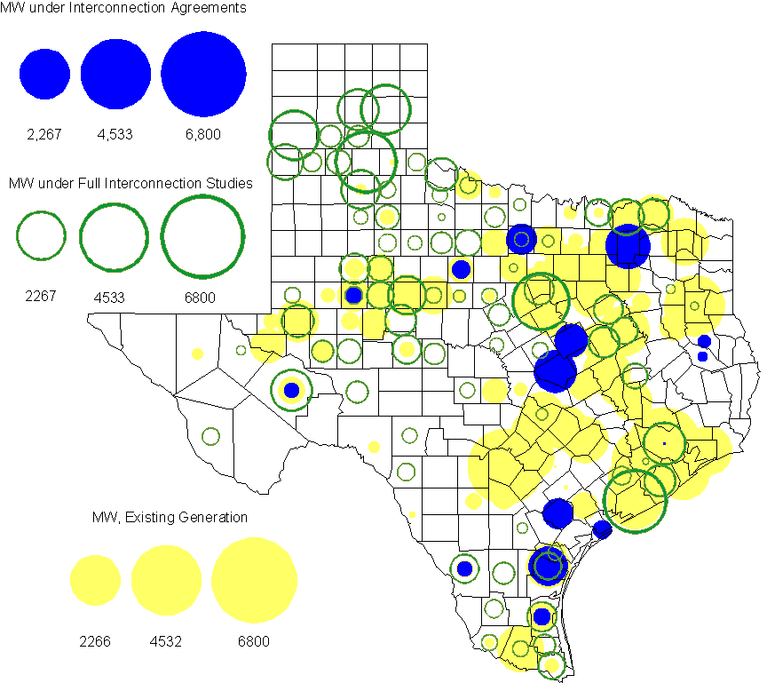

Generation Projects Undergoing Full Interconnection Studies (not otherwise public)
INR | County | Capacity | COD | Fuel |  | INR | County | Capacity | COD | Fuel
08INR0049 | Clay | 50 | TBD | Wind |  | 09INR0054 | Stonewall | 149 | TBD | Wind
09INR0061 | Kent | 258 | TBD | Wind |  | 10INR0048 | Hardeman | 1000 | TBD | Wind
10INR0046 | Jim Hogg | 264 | TBD | Wind |  | 10INR0045 | Webb | 734 | TBD | Wind
10INR0016 | Childress | 150 | TBD | Wind |  | 10INR0054 | Palo Pinto | 36 | TBD | Wind
10INR0079 | Nolan | 60 | TBD | Wind |  | 10INR0069 | Rusk | 13 | TBD | Coal
10INR0029 | Hood | 810 | TBD | Gas |  | 09INR0081 | Rusk | 18 | TBD | Coal
10INR0013 | Upton | 400 | TBD | Wind |  | 10INR0052a | Knox | 21 | TBD | Wind
10INR0057 | Taylor | 200 | TBD | Wind |  | 10INR0015 | Mitchell | 350 | Oct-10 | Wind
10INR0041 | Floyd | 135 | Oct-10 | Wind |  | 09INR0074 | Motley | 70 | Oct-10 | Wind
10INR0081a | Clay | 30 | Oct-10 | Wind |  | 10INR0089 | Harris | 40 | Oct-10 | Other
11INR0029 | Throckmorton | 200 | Nov-10 | Wind |  | 07INR0013 | Coke | 200 | Dec-10 | Wind
07INR0015 | Foard | 180 | Dec-10 | Wind |  | 07INR0035 | Tom Green | 270 | Dec-10 | Wind
10INR0008 | Pecos | 500 | Dec-10 | Wind |  | 08INR0062 | Archer | 249 | Dec-10 | Wind
10INR0019 | Deaf Smith | 609 | Dec-10 | Wind |  | 11INR0012 | Duval | 400 | Dec-10 | Wind
10INR0032 | Navarro | 775 | Dec-10 | Gas |  | 10INR0033 | Armstrong | 399 | Dec-10 | Wind
10INR0042 | Mason | 170 | Dec-10 | Wind |  | 10INR0051 | Brazoria | 200 | Dec-10 | Wind
10INR0056 | Borden | 249 | Dec-10 | Wind |  | 10INR0060 | Willacy | 401 | Dec-10 | Wind
10INR0077 | Callahan | 101 | Dec-10 | Wind |  | 10INR0080 | Presidio | 144 | Dec-10 | Solar
10INR0082 | Travis | 30 | Dec-10 | Solar |  | 11INR0076 | Archer | 94 | Jan-11 | Wind
11INR0050 | Crosby | 149 | Mar-11 | Wind |  | 11INR0081 | Live Oak | 72 | Mar-11 | Wind
11INR0071 | Harris | 7 | Apr-11 | Gas |  | 11INR0075 | Fort Bend | 15 | Apr-11 | Coal
11INR0084 | Ector | 45 | Apr-11 | Wind |  | 11INR0086 | Travis | 60 | Apr-11 | Solar
10INR0009 | Castro | 300 | May-11 | Wind |  | 11INR0037 | Smith | 50 | May-11 | Biomass
11INR0048 | Harris | 300 | May-11 | Gas |  | 11INR0061 | Presidio | 90 | May-11 | Solar
11INR0060 | Tom Green | 90 | May-11 | Solar |  | 11INR0058 | Pecos | 135 | May-11 | Solar
11INR0062 | Nueces | 149 | May-11 | Wind |  | 11INR0087 | Wise | 90 | May-11 | Gas
11INR0033b | Cameron | 200 | May-11 | Wind |  | 11INR0033a | Cameron | 200 | May-11 | Wind
08INR0020 | Eastland | 200 | Jun-11 | Wind |  | 09INR0050 | Fannin | 1200 | Jun-11 | Gas
10INR0023 | Haskell | 386 | Jun-11 | Wind |  | 11INR0054 | San Patricio | 161 | Jun-11 | Wind
11INR0057 | Cameron | 165 | Jun-11 | Wind |  | 11INR0065 | Nueces | 240 | Jun-11 | Wind
11INR0006 | Lamar | 579 | Jul-11 | Gas |  | 11INR0040 | freestone | 640 | Aug-11 | Gas
11INR0039 | Starr | 201 | Sep-11 | Wind |  | 11INR0047 | Deaf Smith | 600 | Sep-11 | Wind
07INR0014a | Wilbarger | 140 | Oct-11 | Wind |  | 07INR0014b | Wilbarger | 70 | Oct-11 | Wind
10INR0062a | Pecos | 80 | Oct-11 | Wind |  | 10INR0081b | Clay | 19 | Oct-11 | Wind
10INR0021 | Grayson | 646 | Nov-11 | Gas |  | 11INR0013 | Mills | 150 | Dec-11 | Wind
11INR0025 | Crockett | 400 | Dec-11 | Wind |  | 11INR0043 | Coke | 300 | Dec-11 | Wind
11INR0067 | Cameron | 78 | Dec-11 | Wind |  | 11INR0070 | Reeves | 50 | Dec-11 | Solar
12INR0034 | Borden | 342 | Dec-11 | Wind |  | 09INR0048 | Jack | 150 | Dec-11 | Wind
09INR0075 | Kinney | 248 | Dec-11 | Wind |  | 12INR0021 | Edwards | 165 | Jan-12 | Wind
12INR0033 | Motley | 150 | Jan-12 | Wind |  | 10INR0085 | Ector | 40 | Jan-12 | Solar
10INR0018 | Madison | 550 | Mar-12 | Gas |  | 12INR0042 | Deaf Smith | 400 | Mar-12 | Wind
09INR0031 | Ector | 275 | May-12 | Gas |  | 12INR0007 | Lamar | 296 | May-12 | Gas
11INR0049 | Wharton | 275 | May-12 | Gas |  | 08INR0031 | Childress | 100 | Jun-12 | Wind
12INR0006 | Limestone | 875 | Jun-12 | Coal |  | 10INR0022 | Harris | 1380 | Jun-12 | Gas
08INR0041 | Coke | 200 | Oct-12 | Wind |  | 12INR0026 | Randall | 400 | Oct-12 | Wind
08INR0044 | Concho | 200 | Nov-12 | Wind |  | 12INR0035 | Nueces | 249 | Nov-12 | Wind
12INR0043 | Ector | 290 | Nov-12 | Wind |  | 08INR0042 | Coke | 200 | Dec-12 | Wind
09INR0025 | Concho | 180 | Dec-12 | Wind |  | 08INR0054 | Comanche | 401 | Dec-12 | Wind
12INR0005 | Floyd | 1100 | Dec-12 | Wind |  | 12INR0022 | Hidalgo | 200 | Dec-12 | Wind
12INR0029 | Swisher | 500 | Dec-12 | Wind |  | 10INR0024 | Briscoe | 2940 | Jan-13 | Wind
12INR0027 | Gray | 200 | Jan-13 | Wind |  | 09INR0058 | Howard | 250 | Mar-13 | Wind
12INR0018 | Gray | 500 | Apr-13 | Wind |  | 10INR0062b | Pecos | 220 | May-13 | Wind
09INR0041 | Mitchell | 300 | Jun-13 | Wind |  | 09INR0051 | Borden | 249 | Jun-13 | Wind
13INR0016 | Deaf Smith | 251 | Aug-13 | Wind |  | 13INR0004 | Deaf Smith | 500 | Oct-13 | Wind
13INR0005 | Carson | 600 | Oct-13 | Wind |  | 08INR0023 | Floyd | 100 | Dec-13 | Wind
08INR0022 | Floyd | 100 | Dec-13 | Wind |  | 12INR0002a | Briscoe | 200 | Dec-13 | Wind
09INR0077 | Reagan | 500 | Dec-13 | Wind |  | 13INR0007 | Pecos | 200 | Dec-13 | Wind
09INR0073 | Scurry | 200 | Dec-13 | Wind |  | 13INR0010 | Parmer | 1200 | Dec-13 | Wind
08INR0019c | Gray | 250 | Jan-14 | Wind |  | 08INR0019b | Gray | 250 | Jan-14 | Wind
08INR0019a | Gray | 250 | Jan-14 | Wind |  | 13INR0006 | Gray | 750 | Jan-14 | Wind
14INR0003 | Nolan | 850 | Jun-14 | Coal |  | 12INR0002b | Briscoe | 200 | Dec-14 | Wind
14INR0001 | Pecos | 500 | Dec-14 | Wind |  | 12INR0002c | Briscoe | 350 | Dec-15 | Wind
16INR0002 | Brazoria | 700 | Jun-17 | Other

Wind Generation

Wind Capacity Installed by Year

County Location of Installed Capacity and Interconnection Requests (Wind only)

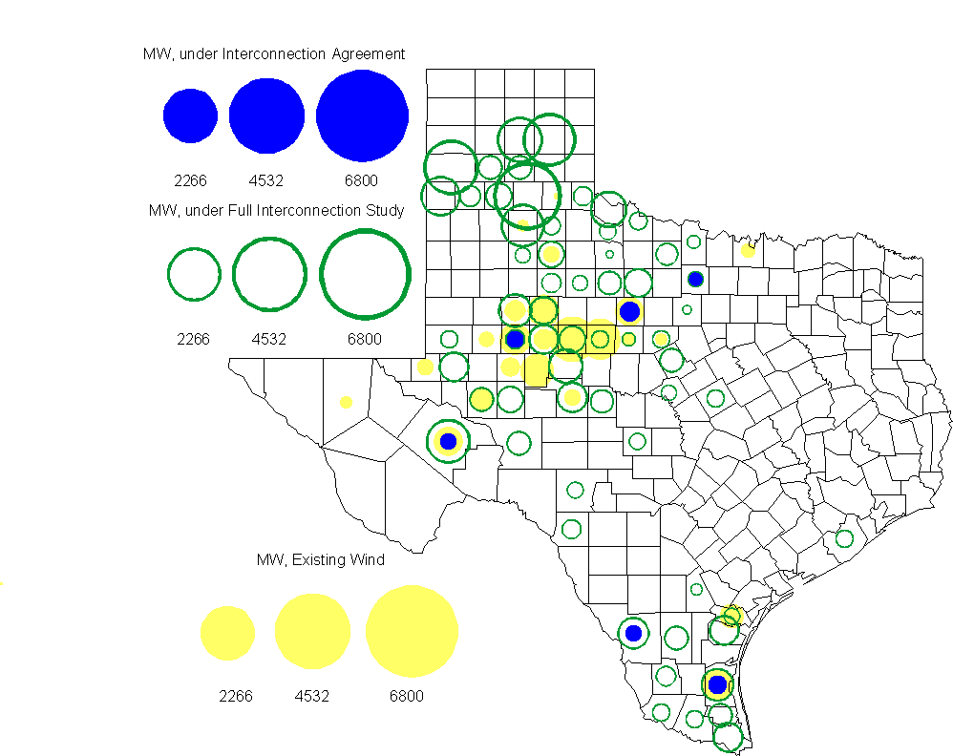

Regional Planning Group Project Reviews
- Oncor submitted a project to relieve congestion related to new wind units in the Lamesa area. The project will upgrade the Lamesa to Bluff Creek 138 kV line, rebuild the Bluff Creek to China Grove 138 kV line, rebuild the Lamesa to Ackerly Vealmoor 69 kV line to 138/69 kV double circuit, rebuild the Lamesa 138 kV switching station, build a new 138 kV Ackerly Vealmoor station, add second circuits to all rebuilt lines and include station upgrades at China Grove and Big Spring. The cost of this project is $ 80.8 M. This project will be reviewed to ensure that the improvements fit into the likely CREZ transmission solution for the area. This project is in ERCOT Independent Review.
- Sharyland Utilities submitted a project to construct and operate the ERCOT Southeast Loop facilities consisting of a 345 kV double circuit from Lufkin to Canal 345 kV substation on the northeast side of Houston. This project will cost $359 M with an estimated completion date of summer 2013. The ERCOT Independent Review of this project has been completed and it will not be recommended.
- Centerpoint Energy has submitted a project to construct a new 345 kV double circuit line to allow greater power imports into the Houston area. The project involves expanding the Fayetteville and Zenith substations and constructing a new 345 kV double circuit from Fayetteville to Zenith. The proposal also includes looping the Fayette Power Project to Salem 345 kV circuit into Fayetteville and upgrading the Fayette Power Project to Fayetteville 345 kV double circuit line. The project is estimated to cost $175 M. The ERCOT Independent Review of this project has been completed. ERCOT Staff will present it to the ERCOT Board of Directors for endorsement in August.

Congestion Costs
Dollars shown in graphs are settlement quality.

OOMC – last 13 months in million$

OOM Down – last 13 months in million$

Local Balancing Energy Down – last 13 months in million$

OOM Up – last 13 months in million$

Local Balancing Energy Up – last 13 months in million$

Replacement Reserve – last 13 months in thousand$

Binding Constraints & Capacity Shortages– June, 2010
Contingency | Binding Element | Estimated Costs | Transmission Project | Clearance
Watermill Switch - West Levee Switch & Sargent Road 345kV | Duncanville South - Cedar Hill 138kV | $ 5,610,488 | Cedar Hill Switch second 345/138 kV autotransformer  [13TPIT0062] | Outage on Cedar Hill Switch 345kVAT2
Comanche Peak - Johnson Switch 345kV | Wolf Hollow - Rocky Creek 345kV | $ 981,010 |  | Outage on Comanche Peak SES-Decordova SES 345kV
Meadow - PH Robinson 345kV | North Alvin - Hastings 138kV | $ 751,603 | Upgrade North Alvin-Hastings [14TPIT0018] | Outage on Oasis-WA Parish 345kV
Capacity |  | $ 479,575
Everman Switch 138kV Outage  Military Hwy Outage | Planned Outages | $ 288,745
Oklaunion - Fisher Road Switch - Bowman 345kV | Bomarton TU - Baylor County Tap 69kV | $ 231,811
Lon Hill - White Point 345kV | Alazan - Barney Davis 138kV | $ 227,446 | Barney Davis to Nelson Sharpe 138 kV line rebuild [12TPIT0069]
Moss Switch - Holt Switch 138kV | Odessa North 138/69KV Autotransformer 1 | $ 204,961 | Odessa EHV Switch #2 [11TPIT0059] | Outage on Ector Harper- Moss Switch 138kV
Graham SES - Parker Switch 345kV | Flat Creek - Leon Switch 138kV | $ 184,483 | Leon - Flat Creek 138 kV line rebuild [08TPIT0107] | Outage on Jacksboro Switching to Willow Creek 345kV
West Levee 345/138KV T1 Autotransformer | West Levee 345/138KV T2 Autotransformer | $ 173,165 |  | High Load in Dallas area

Inter-zonal Congestion

Wind Generation as a Percent of Load
One-hour average Settlement quality data shown.

Other Notable Activities
- Work on the 2010 Five-Year Transmission Plan is underway. The initial set of projects needed to reliably serve load in 2015 has been identified and comments have been received. The analysis is currently focused on finding reliability projects for the years 2011-2014 and projects to relieve congestion for 2015.

- Nodal Network Model Management System Topology Processor base case building modernization work continues with bi-weekly meetings/calls with SSWG and weekly ERCOT topology processor output. ERCOT has produced and distributed a spreadsheet that will be used for Phase II updates. Most TSP have returned the spreadsheet on-time.

- Studies to determine the ERCOT System Voltage Profile will begin shortly. Market Participants should participate in these to make sure that their interests and unit capabilities are taken into consideration.

- Blackstart testing will begin soon. ERCOT staff are being assembled to witness the required tests.

- Initial determinations of “not required to support ERCOT System reliability” were made for Greens Bayou 5 and SR Bertron 2.

- The CREZ Reactive Study, being performed by ABB and led jointly by ERCOT and the CREZ TSPs, to optimize the reactive support equipment required to implement the CREZ plan is ongoing. This study will define the size, type and location of the equipment as well as study any associated subsynchronous issues.

- Work on the Long-Term System Assessment/DOE Study has begun. A separate subgroup of RPG has been established to focus on this study and is meeting monthly. The current focus is on background information that will be used for developing the scenarios to be studied. The next meeting is July 23rd.

