Texas Renewables Integration Plan
Quarterly Update for the Period Ending June 30, 2010

Prepared by the Renewable Technologies Working Group of the ERCOT Technical Advisory Committee

July 2010
Status of Renewable Generation Resources in Texas

At the end of June 2010, the total new renewable capacity in Texas as of June 30, 2010, is approximately 10,073.5 MW which exceeds the 5,000 MW goal specified in the Public Utility Commission of Texas (PUCT) Substantive Rule 25.173 – Goal for Renewable Energy and it exceeds the January 1, 2025 “target” of 10,000 MW. The specific amounts of new renewable capacity in Texas as of June 30, 2010 are shown in Figure 1 below:

Technology | MW
Biomass | 40.3
Hydro | 33.1
Landfill Gas | 80.3
Solar | 5.2
Wind | 9,914.6
Total | 10,073.5

Figure 1 – New Renewable Generation Capacity in Texas

Status of Wind Generation in ERCOT

At the end of June, 2010, ERCOT had 9,317 MW of new wind generation capacity in operation. For the three months ending June 30, 2010, the following new renewable resources became operational in ERCOT:

- Papalote Creek Phase 2 (San Patricio County) – 200 MW

Wind generation has provided 8.7% of the total energy produced in ERCOT from January 1, 2010 through June 30, 2010. The monthly amount of wind energy production as a percentage of total monthly energy production in ERCOT is shown below in Figure 2.

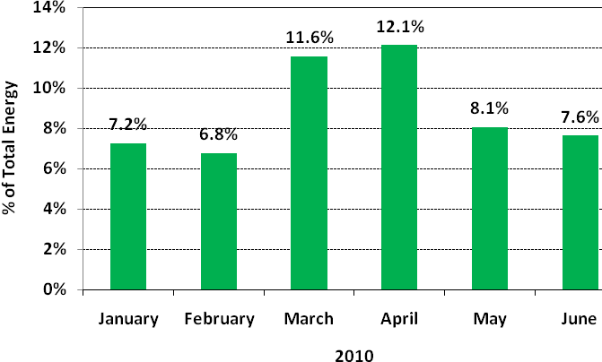
Figure 2 – Monthly Energy from Wind as a Percentage of Total ERCOT Energy Production

The monthly ERCOT generation fuel mix is available at:

http://planning.ercot.com/reports/demand-energy/

Furthermore, the amount of energy (i.e., MWh) produced by wind generation in ERCOT continues to increase. Figure 3 below shows the monthly cumulative amounts of wind generation since 2008.

Figure 3 – Cumulative Energy from Wind in ERCOT

In addition to wind generation capacity that is installed and operating, there are a substantial number of renewable generation projects in various stages of study by ERCOT as part of the Generation Interconnection Process as shown in Figure 4 below.

 | Capacity (MW)
Project Description | Wind | Solar | Biomass
Projects with Interconnect Agreement/Public Letter | 5,738 | 0 | 145
Projects Under Full Interconnect Study | 27,110 | 639 | 50
Confidential Projects | 11,457 | 459 | 58
Total | 44,305 | 1,098 | 253

Figure 4 – New Renewable Generation Capacity Under Study in ERCOT

There are 7 wind generation projects and 2 biomass projects with Interconnect Agreements or public letters. In addition, there are 86 wind generation projects undergoing full interconnect studies. There are 7 solar projects and 1biomass project undergoing full interconnect studies.

For the 3-month period ending June 30, 2010, no renewable resources signed Generation Interconnection Agreements.

The annual actual and forecast ERCOT installed wind generating capacities are shown in Figure 5 below.

Figure 5 – ERCOT Installed Wind Generating Capacity (End of Year)

Note: “New” in Figure 5 above represents wind generators with a Signed Generation Interconnect Agreement and a planned in-service date in the year shown.

Significant Events

On April 13, 2010, a storage workshop was hosted by ERCOT that included presentations from various vendors on several storage technologies, including flywheels, compressed air energy storage (CAES), and batteries. In addition, there was a round table discussion related to potential use of storage in the ERCOT market and changes that need to be made in order to facilitate the integration of storage technologies in the ERCOT market. The workshop was well-attended.

On April 20, 2010, ERCOT presented results of a review of the impact of wind generation on ancillary services to the ERCOT Board of Directors. The preliminary analysis of this review concluded that wind generation does increase the amount of non-spinning reserves and regulation reserves required, and both can be measured and allocated. ERCOT also noted that wind generation ramping events may require a new 10 minute type ancillary service product in the future.

In the Texas Renewable Energy Credit (REC) Program Annual Report filed with the Public Utility Commission of Texas on May 14, 2010, ERCOT reported that Texas retired nearly 15 million RECs in 2009 and posted a record increase in voluntary participation to support environmental initiatives. In 2009, the state’s 150 competitive retail electricity providers retired 6.79 million RECs to satisfy the state renewable portfolio standard’s annual mandate. An additional 8.14 million RECs were retired in the voluntary market to substantiate “green energy” purchases, surpassing 2008’s record of 6.77 million voluntary REC retirements.

At 10:58 pm on June 12, 2010, wind generation in ERCOT produced a new record of 7,016 MW, which represented 15.8% of the system load at that time. The previous record was 6,272 MW on March 5, 2010, which represented 19% of the load at that time.

(Are there other Significant Events during the period April – June, 2010?)

Completed Issues

During the 3-month period ending June 30, 2010, the following Issues were completed by the RTWG:

- WT 7- Storage Workshop I
- MD 8 - Reactive and Voltage Requirements Applicable to Wind Generators

For a detailed list of all Issues and their current status, see the Appendix.

In addition, the following zonal Protocol Revision Requests (PRRs) and Nodal Protocol Revision Requests (NPRRs) impacting renewable resources in the ERCOT market were approved and/or became effective during the second quarter of 2010:

- PRR 833 - Primary Frequency Response Requirement from Existing WGRs
- PRR 841 - Revise Total ERCOT Wind Power Forecast (TEWPF)
- NPRR 210 - Wind Forecasting Change to P50, Synchronization with PRR841
- NPRR 214 - Wind-powered Generation Resource (WGR) High Sustained Limit (HSL) Update Process

New Issues

During the 3-month period ending June 30, 2010, the RTWG began consideration of the following new issues related to the integration of renewable resources into the ERCOT market:

SP 10 - DOE Long-Term Planning Study
Long-term transmission planning study and increased participation with state agencies, Non-governmental organizations and other interested parties.

SP 11- Sub-Synchronous Interactions
Evaluate impact of series-compensated transmission lines which can result in interactions with generators at very low frequencies that can be damaging to the generators.

WT 8 - Ancillary Services Evaluation Workshop
Post Nodal Implementation Date (4-6 months) focusing on the effectiveness of ancillary service products in the nodal market design. Discussion of whether additional services or ancillary products are desirable or necessary.

WT 9 - Storage Workshop II
Workshop to focus on storage technologies issues.

Appendix

