 Nodal Program Cutover Sign-Off Document
________________________________________________________________________

TARGET DATE: 9/01/10
MILESTONE: Begin Network Modeling Timelines Cutover

PURPOSE
This document outlines the Program Readiness Criteria for transitioning Nodal Systems for Go-Live. The Readiness Criteria and supporting information have been evaluated based on the target of starting the Nodal Modeling Timelines rather than Production Ready. The expectation is that the Systems, Processes, and People readiness will continue to be evaluated through the final Go-Live decision for Nodal.

Section I: Program Milestones
Section II: Network Modeling System Readiness Criteria
Section III: Network Modeling Process Readiness Criteria
Section IV: Network Modeling People Readiness Criteria
Section V: Network Modeling Readiness Review and Approval
Section VI: Appendix – Supporting Information

SIGNOFF
ERCOT Management signoff represents acknowledgement of the completion of the Readiness Criteria for continuing transition into Nodal Production Operations targeted for December 1, 2010.
ERCOT Management Area | Business Owner Name /  Technical Owner Name (If Tech Verification only) | Signature  (Not required – Email will count as electronic signature) | Date
Manager Network Modeling | Woody Rickerson
VP Grid Operations and System Planning | Kent Saathoff
Nodal Program  Sr VP Chief Technology Officer | Mike Cleary

Program Timelines, Project Milestones:
The Nodal Program continues to achieve critical milestones and remain on track for Go-Live. The Timeline and dashboard below outline the key tracking milestones for the Program. Based on the overall progress of the Program and identified cutover activities for transitioning into Production, September 1st the Nodal Network Modeling Timelines and Protocol requirements will be enacted.

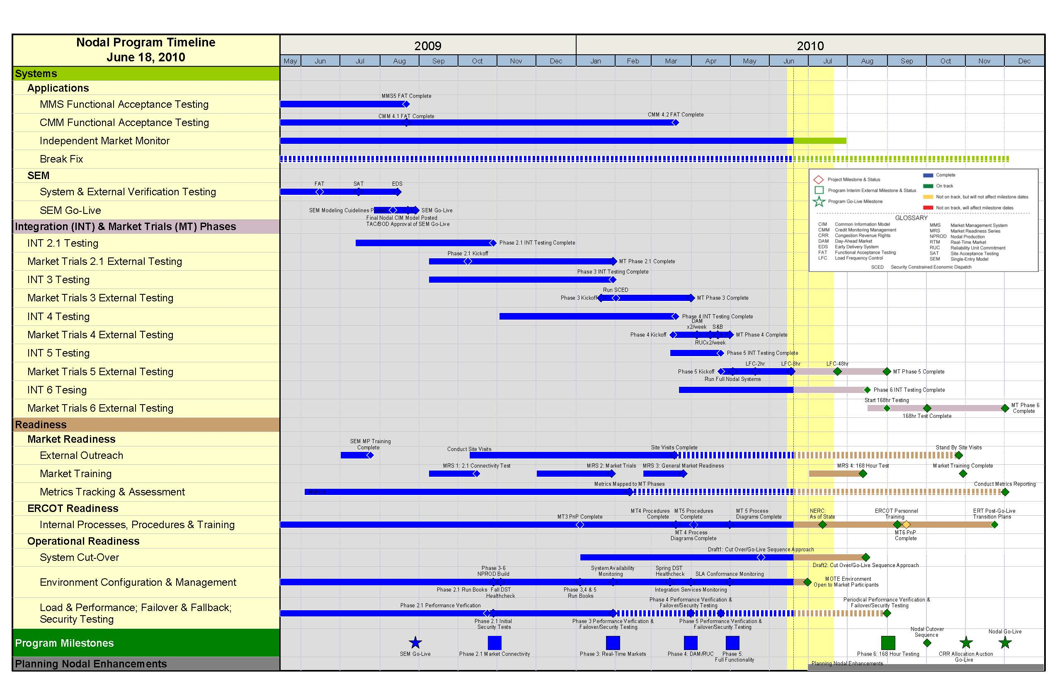

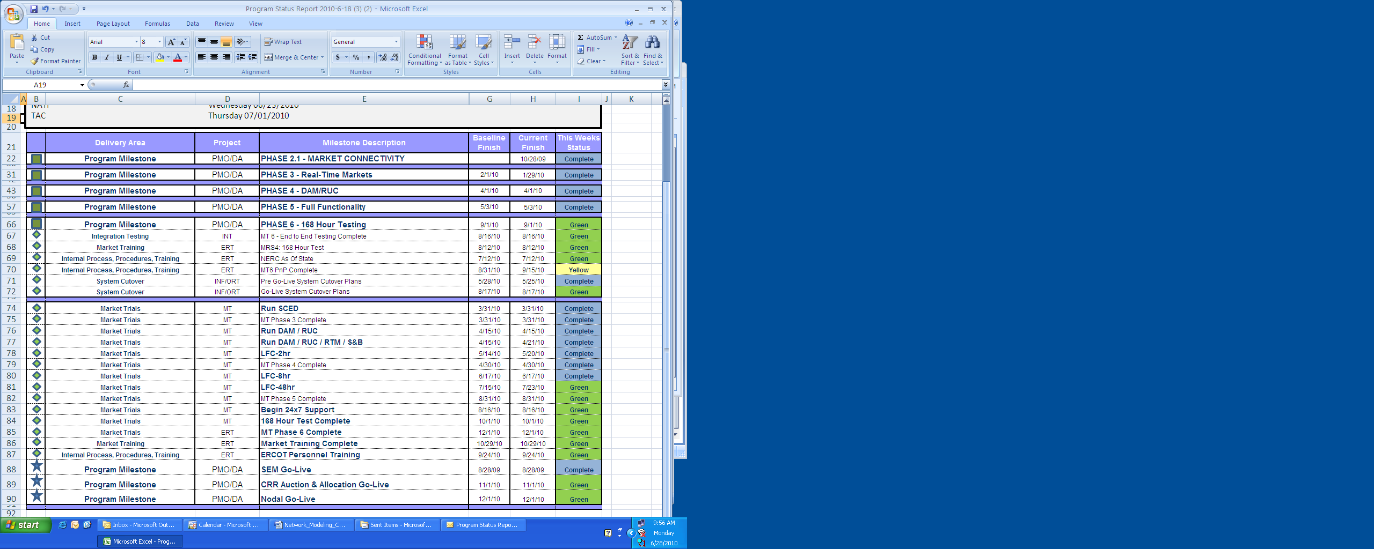

Network Modeling System Readiness Criteria

The following table outlines the System Readiness Criteria for the Network Model Management System.

Criteria | Planned Completion | Status
Single Entry Model Go-Live | 8/31/09 | - Complete  - System will have been in Production for 1 year when the Timelines and Protocols Go-Live
TSP Model Validation (MP14C) | 4/30/10 | - Readiness Metric completed
Model Change Requests Tools Support Market Updates | Ongoing | - NOMCR’s have been used for updating Nodal and to Zonal since SEM Go-Live
Regular Model Loads into Market Trials Systems | Ongoing | - Network Models sourced from NMMS continue to be used to Support Market Testing. Data Set Version (DSV) 20 is currently being processed for a Mid July Model Release.
8 Hour LFC Test Executed w/ Network Model for NMMS | 6/17/10 | - The ERCOT Nodal Program used the EMS system loaded from a NMMS Model to control Frequency during the 8 Hour LFC test.
III. Network Modeling Process Readiness Criteria:

The following table outlines the System Readiness Criteria for the Network Model Management System.

Criteria | Planned Completion | Status
Network Operations Change Request Timeline Transition Plan Established | 6/03/10 | - Presented to NDWSG and TAC  - Network Modeling team worked with Market Participants to compromise on transition timelines and approach  - Interim Update evaluation rules for Production still in process  - All Interim Updates will be allowed during the transition period
Network Modeling Procedures Ready | 8/01/10 | - Initial drafts of identified Network Modeling Procedures documented  - End to End Network Modeling process continues to be improved and is expected to be ready to support Production Updates on 8/01/10
Market Rules – Protocol Transition Plan identified | 7/23/10 | - Market Rules has worked with Network Modeling and Wholesale Client Services teams to identify applicable Nodal Protocol sections that will be enacted on 9/01/10.

IV. Network Modeling People Readiness
The following table outlines the System Readiness Criteria for the Network Model Management System.

Criteria | Planned Completion | Status
ERCOT Staff Supporting Market Trials | Ongoing | - The Network Modeling Process continues to be executed in support of Market Trials  - Key Network Modeling and Information Technology personnel continue to support this process.
ERCOT Staff Trained on System and Processes | 6/22/10 | - Key Network Modeling and Information Technology personnel are ready to support the System and Model update processes.  - Weekly Model loads are still the target for Production Models
Market Participant Training Delivered | 7/29/09 | - Market Participant training was delivered prior to SEM Go-Live  - The Network Modeling team continues to support any Market Participant questions

V. Readiness Review and Approval
The following table outlines the System Readiness Criteria for the Network Model Management System.

Review | Planned Completion | Status
NATF Review | 6/23/10 | - Complete  - The Market expressed concerns on system stability and readiness, the ERCOT team is pulling together the ERCOT responses and applicable mitigation plans for communication at TAC
ERCOT Management Approval | 6/30/10 | - Signoff of this document
TAC Approval | 7/01/10 | - Initial presentation on Readiness Criteria sent with language for a voting motion  - NATF Market concerns and ERCOT responses will be communicated at TAC  - Any TAC concerns will be noted and used to evaluate next steps prior to BOD presentation
Board of Director Approval | 7/20/10
30 Day Market Notice | 7/30/10 | - Market Notice to be drafted pending TAC and Board of Directors feedback

VI. Appendix – Supporting Information
The following table outlines the System Readiness Criteria for the Network Model Management System.

System Readiness

SEM Go-Live
Board of Directors Meeting Presentation 8/18/2009 - (Link)

TSP Validation Metric MP14-C
Reported at Special Nodal Committee – GREEN @ 99.4% - (Link)

Network Model NOMCR submission statistics
NOMCR submission statistics for the last year will be included in the TAC presentation

Regular Model Loads into Market Trials Systems
Data Set Versions generated for to support Market Trials – (Link)

8 Hour LFC Test Executed w/ Network Model for NMMS
Market Notice – (Link)

Process Readiness

Network Operations Change Request Timeline Transition Plan Established
June 3rd TAC Presentation / Document – (Link) / (Link)

Network Modeling Procedures Ready

The table above was consolidated the ERT tracking spreadsheet – (Link)

Notes
1. Pass means that the procedure was tested in Nprod without any issue. “Exercised” means that the procedure was tested, but there were issues.
2. For the two procedures with a status of “exercised,” both are due to the lack of the Outage Extractor tool needed by NMMS to load outages into NMMS so that NOMCRs can be validated before moving into the production operations model.
a. The extractor loads into I-Test 6/30, NProd Target 7/9
3. For the “Summary of NMMS Reports” scheduled for the 168 hour test
a. This is a procedure for a manual process to put report data out of NMMS in the right folder to be picked up by MIR and posted on the MIS
b. It’s scheduled for the 168 hour test because all of the reports are not going to be delivered until then.
4. For the “Hub Bus modification”
a . Have a request out to Jane Cates for more detail on this one.

Market Rules – Protocol Transition Plan identified
June 23rd NATF - DRAFT_090110 Protocol Transition Matrix_062210 (Link)

People Readiness

ERCOT Staff Supporting Market Trials
- Issues tracked in Network Model Data Integrity Work plan

ERCOT Staff Trained on System and Processes
- Woody confirmed that key resources completed initial training on 6/23, ongoing process and procedure improvements will continue during the Transition Plan to final Production timelines

Market Participant Training Delivered
Statistics from June 30, 2009 – June 30, 2010

Overall Readiness

NATF Presentation for Go-Live (Link)

