ERCOT Operations Report
Jun 2010 ROS & OWG

Frequency Control
Time | Freq(Hz) | Duration (s)
06/03/2010 18:55:58 | 59.888 | 7 | Unit trip with 477 MW
06/05/2010 12:57:10 | 60.132 | 444 | Large SCE change +600 MW in 5 minutes. Out of Down Regulation
06/08/2010 09:00:18 | 60.102 | 21 | Large SCE change +553 MW in 9 minutes. Out of Down Regulation. Wind generation increased 1490 MW in 45 min.
06/14/2010 17:58:30 | 59.884 | 8 | Out of Up Regulation. Wind dropped by 300 MW in 1 min due to storms
06/15/2010 16:54:50 | 59.882 | 6 | Unit trip with 560 MW
06/18/2010 19:19:36 | 59.890 | 6 | Unit trip with 585 MW
06/21/2010 07:23:34 | 59.890 | 145 | Incorrect offset calculation and Out of Up Regulation
06/23/2010 15:19:56 | 59.716 | 212 | Unit trip with 733 MW, 157 MW, 157 MW, 168 MW and 38 MW.
06/23/2010 15:50:13 | 60.124 | 615 | Due to deployment of LaaRs. (Related to DCS event)
06/23/2010 18:02:24 | 60.115 | 152 | SCE change +360 MW and Non-conforming load trip of 110 MW
06/29/2010 11:49:21 | 59.881 | 4 | Unit trip with 760 MW
Note: Time of frequency excursions outside the range of +/- 0.1 Hz.

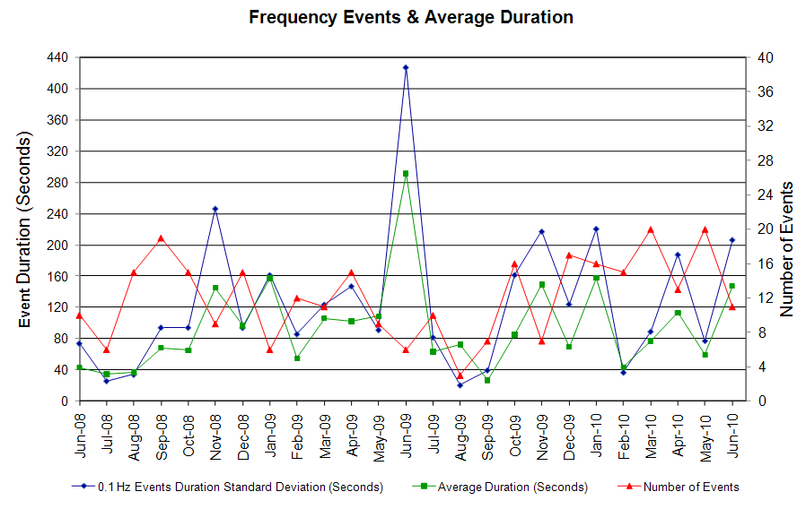

Deployed Responsive (Reported Above)
Time deployed | Stop Time | Duration | Max | Details
6/2/10 0:27:22 | 6/2/10 0:56:44 | 0:29:22 | 352.2 | Large SCE change -1300 MW in 20min.
6/3/10 18:56:01 | 6/3/10 19:05:26 | 0:09:25 | 437.6
6/9/10 7:53:32 | 6/9/10 8:04:52 | 0:11:20 | 368.2 | Unit Trip
6/9/10 9:19:14 | 6/9/10 9:36:28 | 0:17:14 | 325.5 | Large SCE change -600 MW in 9min.
6/10/10 0:04:24 | 6/10/10 0:17:18 | 0:12:54 | 341.5 | Large SCE change -700 MW in 10min and out of up reg
6/14/10 17:58:28 | 6/14/10 18:20:48 | 0:22:20 | 453.7
6/15/10 16:54:51 | 6/15/10 17:05:28 | 0:10:37 | 428.7
6/18/10 19:19:34 | 6/18/10 19:26:14 | 0:06:40 | 426.9
6/19/10 7:28:11 | 6/19/10 7:47:51 | 0:19:40 | 346.9 | Incorrect offset calculation
6/21/10 7:16:58 | 6/21/10 7:49:51 | 0:32:53 | 426.9
6/23/10 15:19:59 | 6/23/10 15:49:21 | 0:29:22 | 1150.0
6/27/10 18:06:55 | 6/27/10 18:19:41 | 0:12:46 | 325.5 | Incorrect offset calculation
6/29/10 11:49:23 | 6/29/10 12:03:23 | 0:14:00 | 474.9

Day-Ahead OOMC and RPRS Capacity Purchases
Details | OOMC | RPRS S1 | RPRS S2 | RPRS S1+S2 | RMR | Total
DFW | 47 | 17 | 5 | 22 | 0 | 69
Western | 0 | 2 | 2 | 4 | 16 | 20
North | 0 | 1 | 1 | 2 | 8 | 10
Houston | 5 | 1 | 2 | 3 | 0 | 8
E RIO | 1 | 3 | 0 | 3 | 0 | 4
Northeast | 0 | 0 | 4 | 4 | 0 | 4
San Antonio | 0 | 2 | 0 | 2 | 0 | 2
Austin | 0 | 0 | 1 | 1 | 0 | 1
W RIO | 0 | 0 | 0 | 0 | 0 | 0
South | 0 | 0 | 0 | 0 | 0 | 0
Corpus | 0 | 0 | 0 | 0 | 0 | 0
Bryan Area | 0 | 0 | 0 | 0 | 0 | 0
Laredo | 0 | 0 | 0 | 0 | 0 | 0
Total | 53 | 26 | 15 | 41 | 24 | 118

Historical Totals | Jun-10 | Jun-09 | May-10
Austin | 0 | 5 | 0
Bryan Area | 0 | 5 | 0
Corpus | 0 | 15 | 0
DFW | 64 | 51 | 87
E RIO | 4 | 31 | 0
Houston | 6 | 2 | 78
Laredo | 0 | 14 | 0
North | 9 | 37 | 18
Northeast | 0 | 0 | 0
San Antonio | 2 | 12 | 0
South | 0 | 11 | 0
W RIO | 0 | 1 | 0
Western | 18 | 14 | 4
Total | 103 | 198 | 187
http://www.ercot.com/mktinfo/services/rprsdr/index.html

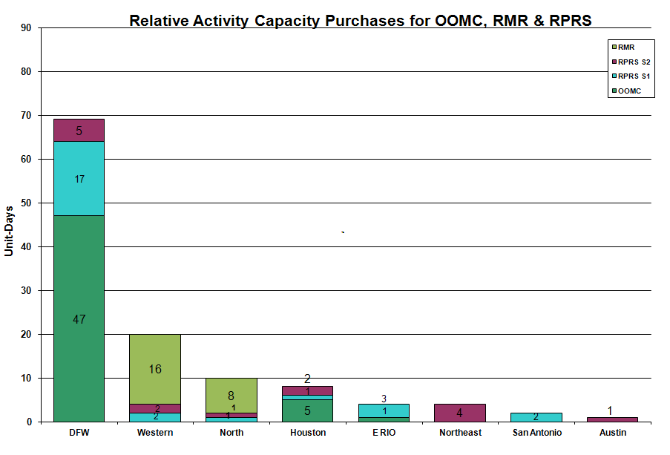

OOME and Congestion Management Activity
Congestion affected by outages Remedial action plan has been developed for the element
Contingency | Overloaded Element | Days
Meadow - PH Robinson 345KV | North Alvin - Hastings 138KV | 16
Matador - Paducah 69KV | Aspermont - Spur 138KV | 13
Graham - Parker 345KV | Barton Switch - Oran 138KV | 13
Watermill Switch - West Levee Switch & Sargent Road 345KV | Duncanville South - Cedar Hill TU 138KV | 12
Graham SES - Parker Switch 345KV | Leon Switch - Flat Creek 138KV | 10
Base Case | Matador - Paducah 69KV | 9
Jack County - Reno 138KV | Rhome TU - Decatur Tap 138KV | 9
Hamilton - Sonora 138KV | Sonora - Friess Ranch 69KV | 8
Comanche Peak SES - Johnson Switch 345KV | Wolf Hollow - Rocky Creek 345KV | 7
Oklaunion - Fisher Road - Bowman 345KV | Bomarton TU - Baylor County Tap 69KV | 5
Barney Davis - Airline and Rodd Field 138KV | Airline CSW - Cabaniss 138KV | 4
Lobo - San Miguel 345KV | Freer - San Diego 69KV | 4
Moss Switch - Holt Switch 138KV | Odessa North - Odessa Basin 69KV | 4
Roanoke Switch - West Denton & Lewisville Switch 345KV | West Denton - Jim Cristal 138KV | 4
Sandow SW - Temple SW 345kV | Hearne 138/69KV AT1 | 4
Roanoke - West Denton & Roanoke - Lewisville 345KV | West Denton - Ft Worth 138KV | 3
Whitepoint - DuPont Switch Ingleside #1 138KV | Rincon - Whitepoint 138KV | 3
Ingleside Cogen Switch - DuPont Switch Ingleside138KV | DuPont Switch Ingleside - DuPont PP1 Ingleside 138KV | 3
Moss Switch - Holt Switch 138KV | Odessa North 138/69KV AT1 | 3
Sherry Switch - Handley & Executive Parkway 138KV | Sherry Switch - Park Row 138KV | 3
Hutto - Gilleland 138KV | Round Rock - Round Rock Northeast 138KV | 2
Willow Valley - Bluff Creek 138KV | Ackerly Vealmoor - Ackerly 69KV | 2
Austrop - Sandow Switch 345KV | Round Rock - Round Rock Northeast 138KV | 2
Base Case | Stanton East Switching Station 138KV - Midland East 138KV | 2
Graham SES - Parker Switch 345KV | Jacksboro switch - Graham SES 345KV | 2
Graham SES - Parker SW 345KV | Graham SES- Jacksboro Switching 345KV | 2
Morgan Creek 2H 345/138KV AT | Morgan Creek 4H 345/138KV AT | 2
Oklaunion Unit | Leon Switch - Flat Creek 138 kV | 2
Olney - Westover 69 KV | Elbert Switch to Seymour. | 2
Wink TNP AT1 138/69KV AT | Wickett TNP - Permian Basin 69KV | 2
Cagnon 345/138KV autotransformer 3 | Cagnon 345/138KV autotransformer 4 | 2
Ferguson - Wirtz - Coronado 138KV | Ferguson - Wirtz 138KV | 2
Fredericksburg - Gillespie LCRA 138KV | Fredericksburg AT2 138/69KV | 1
Sherry - Everman 345KV | Tatte East Tap- Oak Hill 2 Tap 138KV | 1
Base Case | ENA Snyder - WKN Breaker 69KV | 1
Base Case | WKN_BKR - MEC Plainview 69KV | 1
Bellaire 345/138KV AT2 | Bellaire 345/138KV AT4 | 1
Collin - Anna Switch 345KV | Payne Switch - EPCO POI 138KV | 1
Dilley Switch - San Miguel Switch 138KV | Derby Sub - Pearsall Switch 69KV | 1
Fort Bend - East Bernard 138KV | Flewellen - Peters REIT 138KV | 1
La Palma - Rio Hondo 345KV | Raymondville 2 - Raymondville 1 69KV | 1
Renner Switch 345/138KV AT2 | Allen Switch 345/138KV AT1 | 1
Twin Butte - San Angelo Red Creek 345KV | San Angelo Red Creek 345/138KV AT2 | 1
West Levee 345/138KV AT1 | West Levee 345/138KV AT2 | 1

Zonal OC1
CSC | Days
West – North | 19
North – Houston | 11

New RAP, PCAP (Date indicates last update of RAP, PCAP not implementation date.)
Olney – Westover 69 kV PCAP

New Procedures/Forms/Operations Bulletins
None

Blackout/Load Shed Incidences
None

EEA
6/23 15:35 ERCOT declared EEA 1 for Adjusted Responsive Reserve below 2300MW.

Major System Voltage Problems
None

Major Computer Problems, Enhancements & Fixes
None

Communication
None

ERCOT peak (Unofficial)
06/21 17:00 60,698 MW

Yearly MTLF Error Comparison
Yearly Mid-Term (Hourly) Load Forecast Error Comparison for the ERCOT Forecast
Month | MAPE for MTLF at 16:00 Day-Ahead
Month | 2007 | 2008 | 2009 | 2010
January | 4.55 | 3.30 | 4.11 | 3.78
February | 3.75 | 3.59 | 3.49 | 3.79
March | 2.70 | 3.29 | 3.24 | 2.24
April | 3.00 | 2.45 | 2.66 | 2.47
May | 3.22 | 3.01 | 2.90 | 2.63
June | 4.46 | 2.81 | 2.89 | 2.84
July | 4.29 | 2.55 | 2.83 | NA
August | 3.11 | 3.66 | 3.07 | NA
September | 3.78 | 4.99 | 3.68 | NA
October | 3.08 | 2.79 | 2.92 | NA
November | 2.95 | 2.60 | 1.93 | NA
December | 3.74 | 4.54 | 3.70 | NA
Annual Average | 3.55 | 3.29 | 3.11 | 2.96

OCN, Advisory, Watch & Emergency Notices
Capacity
Date | Start | End | Event
6/23/10 | 15:28 | 18:45 | Watch issued for ARRS below 2500 MW.
6/23/10 | 18:45 | 19:15 | Advisory issued for ARRS below 3000 MW.
6/28/10 | 11:30 | 0:00 | Operating Condition Notice (OCN) issued for Tropical Storm Alex in the Gulf of Mexico.
6/29/10 | 0:15 | 11:00 | Operating Condition Notice (OCN) issued for Tropical Storm Alex in the Gulf of Mexico.
6/29/10 | 11:00 | 0:00 | Advisory issued for Tropical Storm Alex in the Gulf of Mexico.
6/30/10 | 0:15 | 0:00 | Advisory issued for Hurricane Alex in the Gulf of Mexico.

Transmission Watch

6/01 00:15 Transmission Watch issued due to forced outage at Gails substation. Implemented Block Load Transfer up to 2 MW from ERCOT (Gails substation) to SPP (Draw substation).

6/15 00:15 Transmission Watch issued due to forced outage on Flomot - Muleta 69KV. BLT implemented for up to 2 MW of ERCOT load to SPP at Estelline.

Emergency Notice
None

Texas RE Event Analysis
6/12 09:39 Stanton Switch Station SPS #46 activated. ERCOT does not see any evidence that the Stanton East Switching Station SPS #46 SPS failed to operate as designed.

6/19 23:04 Stanton Switch Station SPS #46 activated. ERCOT does not see any evidence that the Stanton East Switching Station SPS #46 SPS failed to operate as designed.

6/23 15:19 Emergency Notice for a NERC Reportable Disturbance Control Standard (DCS) Event for loss of 1253 MW of generation. ERCOT declared Level 1 of its Energy Emergency Alert (EEA) due to Adjusted Responsive Reserve dropping below 2300 MW after Loads acting as Resources (LaaRs) were deployed.
6/26 22:18 Stanton Switch Station SPS #46 activated. Investigation is still ongoing.

6/30 12:55 Loss of Military highway bus (jointly owned by AEP and PUB) and four 138kV lines during the storms from hurricane Alex. Investigation is still ongoing.

Others
6/21 06:50 Held the real-time balancing deployments for IE 0700 due to an incorrect offset calculation for IE 0715, resumed with IE 0730.

6/26 00:15 Held real-time balancing energy deployments IE 24:00 on 06-25-10 for IE 00:15 on 06-26-10 due an incorrect offset calculation. Resumed with IE 00:30 deployments.

