COPMGRR Number | 017 | COPMGRR Title | Creating Subsection 8.2, Settlement Statements and Invoices
Timeline | Normal | Action |  | Approved
Date of Decision |  | July 1, 2010
Effective Date |  | Upon Texas Nodal Market implementation.
Priority and Rank Assigned |  | Not applicable.
Commercial Operations Market Guide (COPMG) Section Requiring Revision |  | 8.2, Settlement Statements and Invoices (New)
Revision Description |  | This Commercial Operations Market Guide Revision Request (COPMGRR) creates a new subsection under Section 8, ERCOT Settlement and Invoice Process.
Reason for Revision |  | Provides information concerning the ERCOT Invoicing Process.
Overall Market Benefit |  | Market Participants benefit from being better informed.
Overall Market Impact |  | Improves availability of information concerning the ERCOT Nodal Settlement Statements and Invoices.
Consumer Impact |  | None.
Procedural History |  | - On 12/4/09, COPMGRR017 was posted.  - On 1/29/10, the COPS Communication Working Group (CCWG) considered COPMGRR017.  - On 2/25/10, CCWG again considered COPMGRR017.  - On 3/30/10, CCWG again considered COPMGRR017.  - On 4/9/10, the CEO Revision Request Review was posted.  - On 4/21/10, an Impact Analysis was posted.  - On 4/29/10, CCWG considered the 3/30/10 CCWG Recommendation Report and Impact Analysis.  - On 5/11/10, COPS considered COPMGRR017.  - On 6/3/10, TAC considered COPMGRR017.  - On 6/24/10, ERCOT comments were posted.  - On 7/1/10, TAC again considered COPMGRR017.
CCWG Decision |  | On 1/29/10, CCWG was in consensus to table COPMGRR017 for one month.  On 2/25/10, CCWG was in consensus to table COPMGRR017 for one month.  On 3/30/10, CCWG was in consensus to recommend approval of COPMGRR017 as revised by CCWG.  On 4/29/10, CCWG was in consensus to endorse and forward the 3/30/10 CCWG Recommendation Report as amended by CCWG and the Impact Analysis to COPS.
Summary of CCWG Discussion |  | On 1/29/10, CCWG members agreed to table COPMGRR017 for one month to allow ERCOT additional time to review and provide comments.  On 2/25/10, CCWG members agreed to table COPMGRR017 for one month to allow additional time to clearly define the Settlements Statements and Invoices language for the COPMG.  On 3/30/10, updates to the proposed guide language revision were made to ensure that Market Participants have the most accurate information for Settlements Statements and Invoices.  On 4/29/10, CCWG proposed additional language to COPMGRR017 which included updates for providing more information on retrieving Settlement Statements and Invoices.
COPS Decision |  | On 5/11/10, COPS unanimously voted to recommend approval of COPMGRR017 as recommended by CCWG in the 4/29/10 CCWG Recommendation Report. All Market Segments were present for the vote.
Summary of COPS Discussion |  | On 5/11/10, there was no discussion.
TAC Decision |  | On 6/3/10, TAC unanimously voted to table COPMGRR017. All Market Segments were present for the vote.  On 7/1/10, TAC unanimously voted to approve COPMGRR017 as amended by the 6/24/10 ERCOT comments as revised by TAC. All Market Segments were present for the vote.
Summary of TAC Discussion |  | On 6/3/10, TAC agreed to table COPMGRR017 until NPRR221, Day-Ahead Market and Real-Time Market Default Allocation Changes is approved by the ERCOT Board.  On 7/1/10, it was noted that the timeline diagrams for the Congestion Revenue Right (CRR), Real-Time Market (RTM) and Day-Ahead Market (DAM) statements and Invoices were updated.

Quantitative Impacts and Benefits

Assumptions | 1 | None.
Assumptions | 2
Assumptions | 3
Assumptions | 4
Market Cost |  | Impact Area | Monetary Impact
Market Cost | 1 | None. | None.
Market Cost | 2
Market Cost | 3
Market Cost | 4
Market Benefit |  | Impact Area | Monetary Impact
Market Benefit | 1 | Improve availability of information concerning the ERCOT Nodal Settlement Statements and Invoices. | Time savings in finding information. Relieves ERCOT Client Representatives of some questions.
Market Benefit | 2
Market Benefit | 3
Market Benefit | 4
Additional Qualitative Information | 1
Additional Qualitative Information | 2
Additional Qualitative Information | 3
Additional Qualitative Information | 4
Other Comments | 1 | ERCOT systems will not be impacted.
Other Comments | 2
Other Comments | 3
Other Comments | 4

Sponsor
Name | Michelle Trenary on behalf of the CCWG
E-mail Address | mtrenary@tnsk.com
Company | Tenaska Power Services
Phone Number | 817-303-3613
Cell Number
Market Segment | Independent Power Marketer (IPM)

Market Rules Staff Contact
Name | Sonja B. Mingo
E-Mail Address | smingo@ercot.com
Phone Number | 512-248-6463

Comments Received
Comment Author | Comment Summary
ERCOT 062410 | Proposed revisions to align COPMGRR017 with NPRR221, Day-Ahead Market and Real-Time Market Default Allocation Changes, which was approved by the ERCOT Board on 6/15/10.

Proposed Protocol Language Revision

8.2 Settlement Statements and Invoices
The Real-Time Market (RTM), the Day-Ahead Market (DAM), and the Congestion Revenue Right (CRR) Auction are settled separately. Each type of Settlement has a unique set of statements and/or Invoices and settles according to a different timeline. Settlement Statements and Invoices can apply to a registered CRR Account Holder (CRRAH), a registered Qualified Scheduling Entity (QSE), or both. The table below provides details regarding the various statements and Invoices.
Type | Invoice or Statement | Recipient | Frequency | Post Timing | Payment Due
CRR | CRR Auction Invoice | - CRRAHs | Monthly | 1st Business Day after completion of a CRR Auction (Monthly and Annual CRR Auctions will be invoiced separately) | 3rd Bank Business Day after invoice posts (or next day that is both Business Day and Bank Business Day)
CRR | CRR Auction Revenue Distribution Invoice | - QSEs (with Load) | Monthly | 1st Business Day after RTM Initial Statement posts for the last day of the relevant month  and  1st Business Day after RTM Final Statement posts for the last day of the relevant month | 5th Bank Business Day after invoice posts (or next day that is both Business Day and Bank Business Day)
CRR | CRR Balancing Account Invoice | - CRRAH (due a shortfall refund)  - QSEs (with load) | Monthly | 1st Business Day after RTM Initial Statement posts for the last day of the relevant month | 1st Bank Business Day after the due date of the RTM Invoice that includes the RTM Initial Settlement statement for the last day of the month (or next day that is both Business Day and Bank Business Day)  *Note: Payout to market only
DAM | DAM Statement | - QSEs  - CRRAHs | Daily | 2nd Business after the Operating Day | n/a
DAM | DAM Resettlement Statement | - QSEs  - CRRAHs | Ad-Hoc | Ad-Hoc (on Business Day)  *Note: Notice posted on MIS Public Area | n/a
DAM | DAM Invoice | - QSEs  - CRRAHs | Daily | 2nd Business after the Operating Day | 3rd Bank Business Day after invoice posts (or next day that is both Business Day and Bank Business Day)
DAM | DAM Late Fee Invoice  Charge  Credit | - QSEs  - CRRAHs | Monthly | 10th calendar day after the end of the relevant month (or next Business Day) | 4th Bank Business Day after invoice posts (or next day that is both Business Day and Bank Business Day)
RTM | RTM Initial Settlement Statement | - QSEs  - CRRAHs | Daily | Operating Day + 10 (or next day Business Day) | n/a
RTM | RTM Final Settlement Statement | - QSEs  - CRRAHs | Daily | Operating Day + 59 (or next day Business Day) | n/a
RTM | RTM True-Up Settlement Statement | - QSEs  CRRAHs | Daily | Operating Day + 180 (or next day Business Day) | n/a
RTM | RTM Resettlement Settlement Statement | - QSEs  CRRAHs | Ad-Hoc | Ad-Hoc (on Business Day)  *Note: Notice posted on MIS Public Area | n/a
RTM | RTM Invoice | - QSEs  - CRRAHs | Weekly | Thursdays (or next day Business Day) | 5th Bank Business Day after the invoice posts (or next day that is both Business Day and Bank Business Day)
RTM | Default Uplift Invoice | - QSEs  - CRRAHs | Ad-Hoc | Ad-Hoc (on Business Day)  *Market Notice required | 5th Bank Business Day after the invoice posts, (or next day that is both Business Day and Bank Business Day)
RTM | RTM Late Fee Invoice | - QSEs  - CRRAHs | Monthly | 10th calendar day after the end of the relevant month (or next Business Day) | 4th Business Day after invoice posts (or next day that is both Business Day and Bank Business Day)
 | Miscellaneous Invoice | - QSEs  - CRRAHs | Ad-Hoc | Ad-Hoc (on Business Day)  *Market Notice required | Specified in the Market Notice

Upon approval and posting of Settlement Statements and Invoices, the associated data is sent to the Credit Monitoring & Management (CMM) system for use in credit calculations. Similarly, when payment is made to or from the QSE / CRRAH, the payment data is subsequently sent to the CMM system.
The QSE Settlement Statements and Invoices and the CRR Account Holder Statements and Invoices are available on the Market Information System (MIS) Certified Area. Statements and Invoices are ‘MIS Certified’ meaning they are Market Participant specific and have data proprietary to individual Entities. Therefore, these files are only available to those Entities owning the data and having a matching DUNS number.
Market Participants must have access to the ERCOT MIS and a Digital Certificate with appropriate roles in order to retrieve data via the MIS and/or Application Programmatic Interface (API). This Digital Certificate must be obtained from your Entity’s User Security Administrator (USA) and must contain the role of QSE Extracts (for QSEs) or CRR_Extracts (for CRRs) in order to view and download statements, Invoices and/or related Settlement extracts.

Invoices, statements and extracts are also available via the API. To download the information from the API, utilize the report type IDs as described in the Nodal Settlement and extract user guides, along with the GetReport functionality on the API. For details regarding this option, refer to the External Web Services information posted to the ERCOT website.

In addition to statements and Invoices, the Settlements Calendar which provides statement, Invoice and dispute posting information details is provided as an extract and can be found on both the MIS Public Area and on the ERCOT website. Supporting information for the Settlements Calendar can be found in the Settlements Calendar User Guide and in the Data Definition Language (DDL) and XML Schema Definition (XSD).
Settlement details, including the supporting input, intermediate, and output Settlement billing determinants and other data associated with Settlement Statements and Invoices are found in the appropriate Settlements extracts and reports. When viewing QSE / CRRAH Settlement Statements, a negative amount represents a payment due to the QSE / CRRAH and a positive amount represents a payment due to ERCOT. More information about the available extracts and reports, as well as example statements and Invoices, are available on the MIS Public Area and on the ERCOT website. Descriptions and definitions for the billing determinants can be found on the ERCOT website in the Settlement Charge Matrix and in the relevant Protocol sections. (Also see Section 10, Extracts and Reports).
Information about the Settlements Calendar, statements, and Invoices may be found in Protocol Section 9, Settlement and Billing.
8.2.1 Congestion Revenue Rights (CRR) Settlement Invoices

8.2.1.1 CRR Auction Award Invoices
Refer to Protocol Sections 9.8, CRR Auction Award Invoices, and 9.9, Payment Process for CRR Auction Invoices, for details regarding CRR Auction invoicing. Monthly and Annual CRR Auctions are invoiced separately. Additionally, each year of the two year annual auction will be invoiced separately.
CRR Auction Invoice Timeline

Payment
Due to
ERCOT
CRR
Auction
Results
Posted
CRR
Auction
Day +1*
Invoice
Issued
Payment
Due to
MPs
CRR
Auction
Day +4*
CRR
Auction
Day +3*
Payment
Due to
ERCOT
CRR
Auction
Results
Posted
CRR
Auction
Results
Day +1*
Invoice
Issued
Payment
Due to
MPs
CRR
Auction Invoice Date

Day +4*
CRR
Auction Invoice Date

Day +3*
*Must be a Business Day or move to next Business Day.

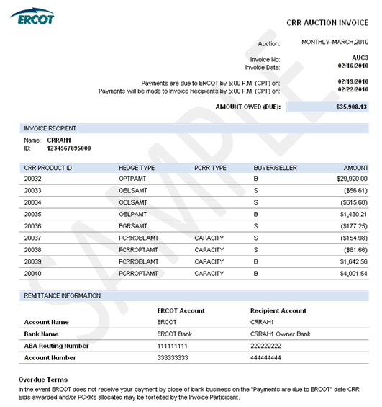
8.2.1.2 CRR Auction Revenue Distribution (CARD) Invoice
Refer to Protocol Sections 9.10, CRR Auction Revenue Distribution Invoices, and 9.11, Payment Process for CRR Auction Revenue Distribution, for details regarding CRR Auction Revenue Distribution (CARD) invoicing. The ‘Time Period’ label on the Invoice indicates the month relevant to the CRR Auction revenue being paid out to QSEs.

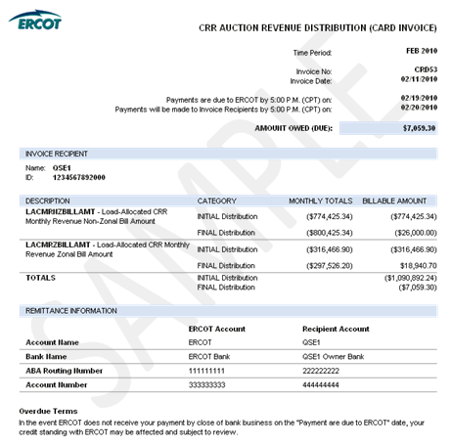

8.2.1.3 CRR Balancing Account (CRRBA) Invoice
Refer to Protocol Sections 9.12, CRR Balancing Account Invoices, and 9.13, Payment Process for CRR Balancing Account, for details regarding CCR Balancing Account (CRRBA) invoicing. The ‘Time Period’ label on the Invoice indicates the month relevant to the balancing account funds being paid out to CRRAHs and/or QSEs.

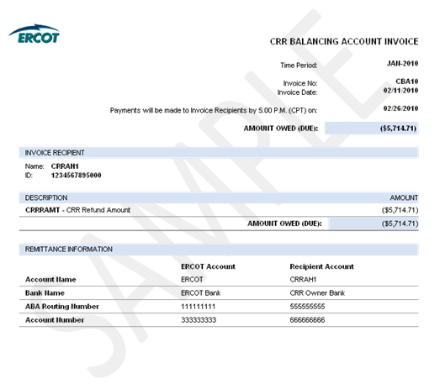

8.2.2 Day-Ahead Market Statements and Invoices
The DAM statements and Invoices for CRR Account Holders and QSEs are issued two days after the Operating Day.
Refer to Protocol Section 9.2, Settlement Statements for the Day-Ahead Market, for details regarding DAM Settlement Statements.
Refer to Protocol Sections 9.3, Settlement Invoices for the DAM, and 9.4, Payment Process for the DAM, for details regarding the DAM invoicing process.

DAM Statement and Invoice Timeline

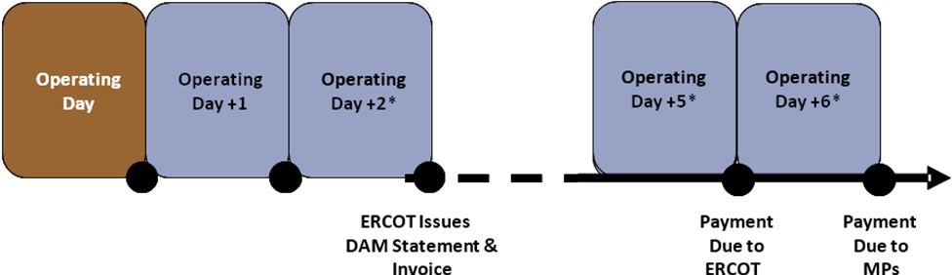
*Must be a Business Day or move to next Business Day.

8.2.2.1 DAM Statement
Refer to Protocol Section 9.2, Settlement Statements for the Day-Ahead Market, for details regarding DAM Settlement Statements. In the case of a “No DAM” scenario, where DAM is not successfully executed for an Operating Day, DAM statements will not be generated or posted for that Operating Day.

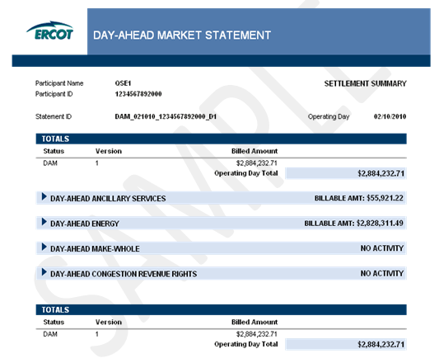
8.2.2.2 DAM Invoice
Refer to Protocol Sections 9.3, Settlement Invoices for the DAM, and 9.4, Payment Process for the DAM, for details regarding DAM invoicing. A DAM Invoice is created separately for each published DAM statement and DAM Resettlement Statement.

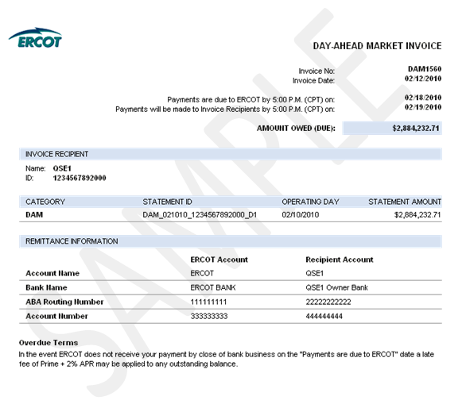

8.2.2.3 DAM Late Fee Invoice
Refer to Protocol Section 9.4.5, Late Fees and Late Fee Invoices for the DAM, for details regarding the DAM late fee invoicing process. To better facilitate verification of relatively small late fee charges and credits, the late fee charge line items have greater precision than the total amount on the Late Fee Invoice.
Late Fee Charge Invoice
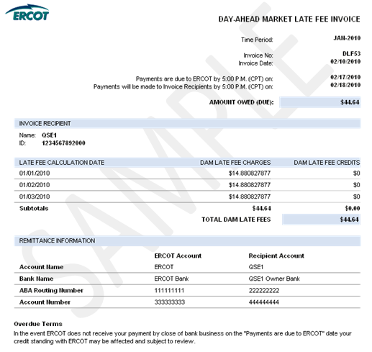

Late Fee Credit Invoice
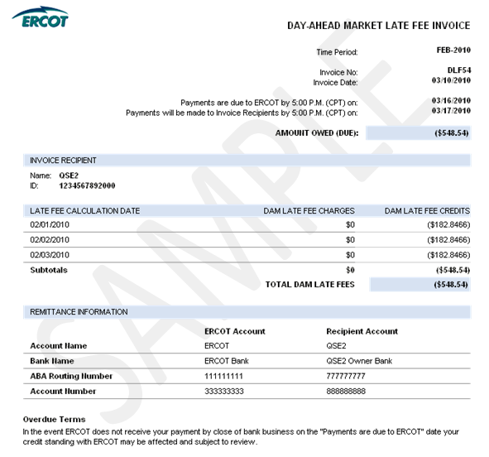
8.2.3 Real-Time Market Statements and Invoices

8.2.3.1 Real-Time Market Statements
Refer to Protocol Section 9.5, Settlement Statements for Real-Time Market, for details regarding RTM Settlement Statements.
There are four types of RTM Settlement Statements: Initial, Final, True-Up and Resettlement.
The figure below illustrates the timing of each statement. Resettlements can occur at any point in accordance with Section 9.5.6, RTM Resettlement Statement.

RTM Statement Timeline

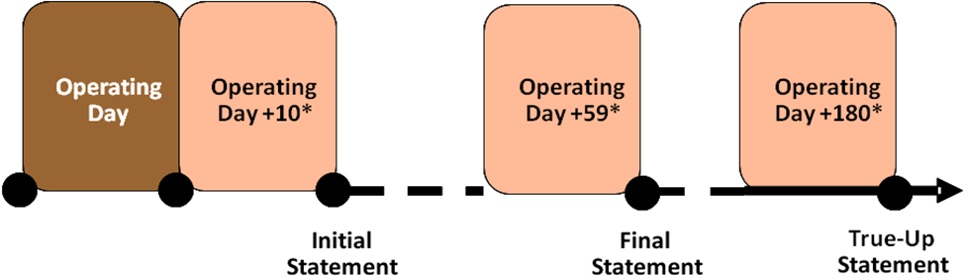
*Must be a Business Day or move to next Business Day.

8.2.3.1.1 RTM Initial Statement

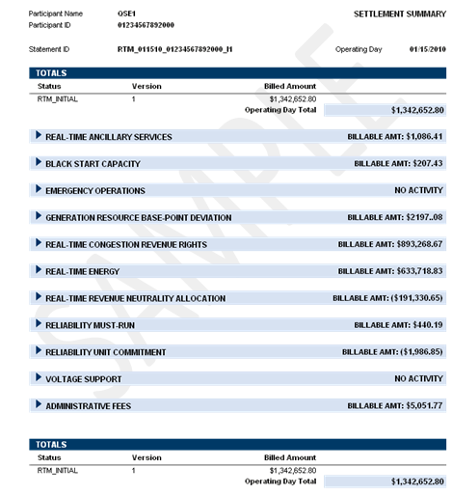

8.2.3.1.2 RTM Final Statement
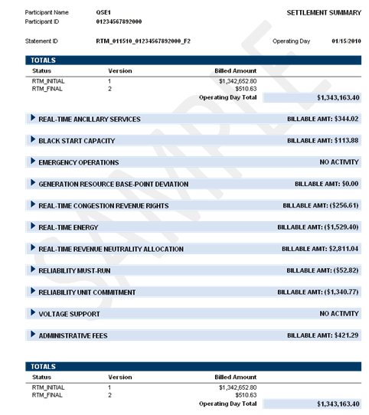

8.2.3.1.3 RTM True-Up Statement

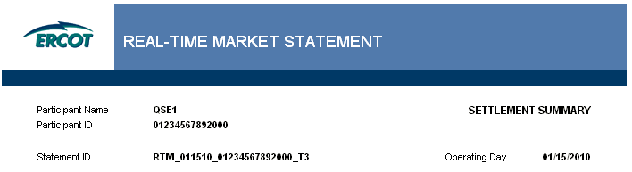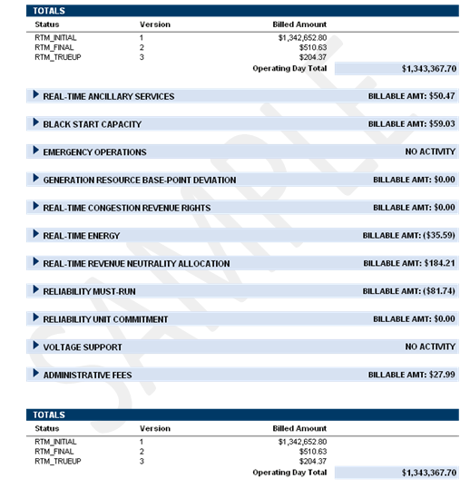
8.2.3.1.4 RTM Resettlement Statement

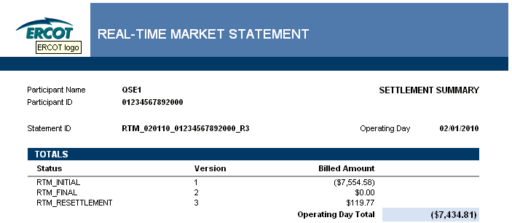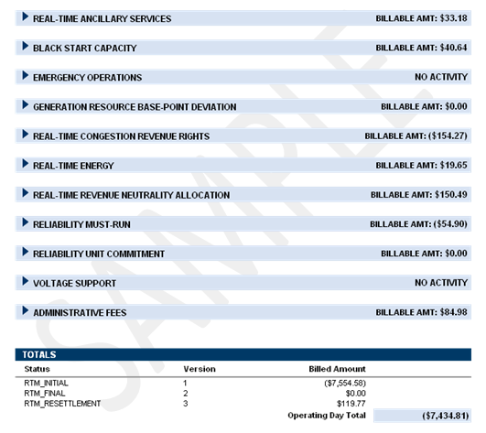

8.2.3.2 Real-Time Market Invoice
Refer to Protocol Section 9.6, Settlement Invoices for the Real-Time Market, for details regarding the RTM invoicing process. Typically, each Thursday the weekly RTM invoicing process finds and includes any RTM Initial, Final, True-Up and/or Resettlement Statements that were generated in the Settlement system from the two Saturdays prior through the previous Friday. (Note: this process is based on the timing of statement generation, not the timing of statement approval/posting.)
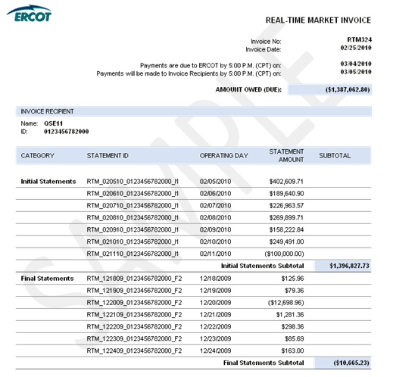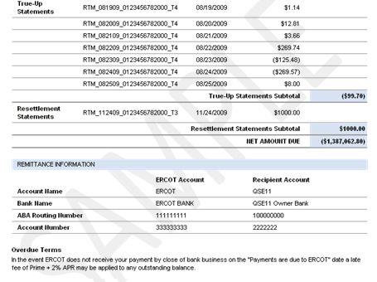

8.2.3.3 Default Uplift Invoice
Refer to Protocol Section 9.19.1, Default Uplift Invoices, and 9.19.2, Payment Process for Default Uplift Invoices, for details regarding the Default Uplift Invoicing Process. The Default Uplift Invoicing process allocates DAM and/or RTM losses to QSEs and CRR Account Holders.
A Default Uplift Invoice will not be available upon the Texas Nodal Market Implementation Date. If it is necessary to uplift DAM or RTM losses prior to the implementation of system changes required for the Default Uplift Invoice, then ERCOT will utilize the Miscellaneous Invoice to render the uplift charges and payments to QSEs and CRRAHs. Please note that while the data will be presented on a different type of invoice (the Miscellaneous Invoice), ERCOT will follow the allocation methodology described in Protocol Section 9.19.1.

8.2.3.4 RTM Late Fee Invoice
Refer to Protocol Section 9.7.5, Late Fees and Late Fee Invoices, for details regarding the RTM late fee invoicing process. To better facilitate verification of relatively small late fee charges and credits, the late fee charge line items have greater precision than the total amount on the Late Fee Invoice.
RTM Late Fee Charge Invoice

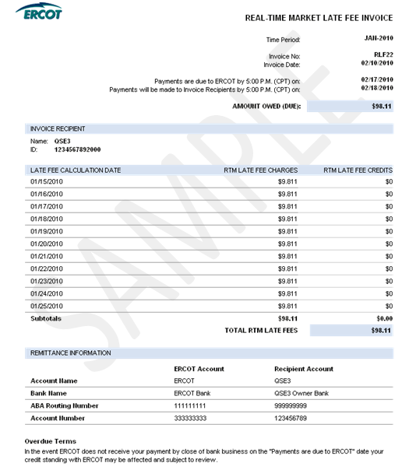

RTM Late Fee Credit Invoice

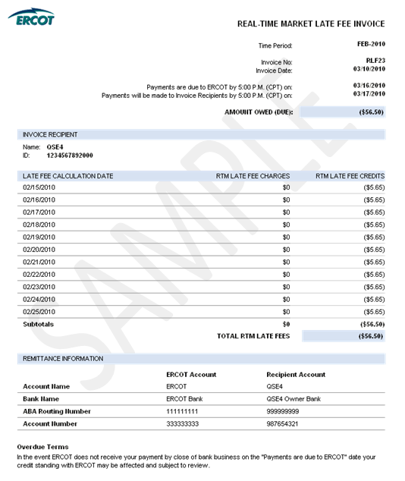
8.2.3.4 Miscellaneous Invoice

In the event that ERCOT cannot reasonably Invoice Market Participants via one of the other Protocol-defined Invoices, ERCOT may utilize the Miscellaneous Invoice. Use of the Miscellaneous Invoice would be noticed to the market and could be in support of any invoicing activity described as “ad-hoc” in Section 8.1, Invoice Process of this document. The Miscellaneous Invoice posts to the same location on MIS as other QSE/CRRAH Invoices. This Invoice is generated out of the Settlements and Billing System using data which is derived and input by analysts. The Invoice format allows for flexibility to communicate descriptive information which varies depending on the nature of the ad-hoc Invoice.
INCLUDEPICTURE "cid:image001.png@01CAC515.8A601C20" \* MERGEFORMATINET INCLUDEPICTURE "cid:image001.png@01CAC515.8A601C20" \* MERGEFORMATINET INCLUDEPICTURE "cid:image001.png@01CAC515.8A601C20" \* MERGEFORMATINET 