4.5 Day to Day Issues – Projects (AMS LSE Missing Interval Data) Interim Process

4.5.1 Required Fields for Projects (AMS LSE Missing Interval Data)

Assignee
ISA (numeric predefined market standard code)
ESIID
StartTime
Comments (Indicate exact Start and Stop time(s) for missing interval including: month, date, year, hour and minutes)

4.5.2 Definition of Projects
4.5.2.1 Examples of Projects

    - System issues
    - Project related issues

4.5.3 Submitting a Projects
A CR or a TDSP can submit this sub type.

4.5.3.1 Examples for Projects submitted by CR to ERCOT
- The CR selects the Submit tab (Fig 4.5a)
- From the Submit Tree, select Projects

Fig 4.5a
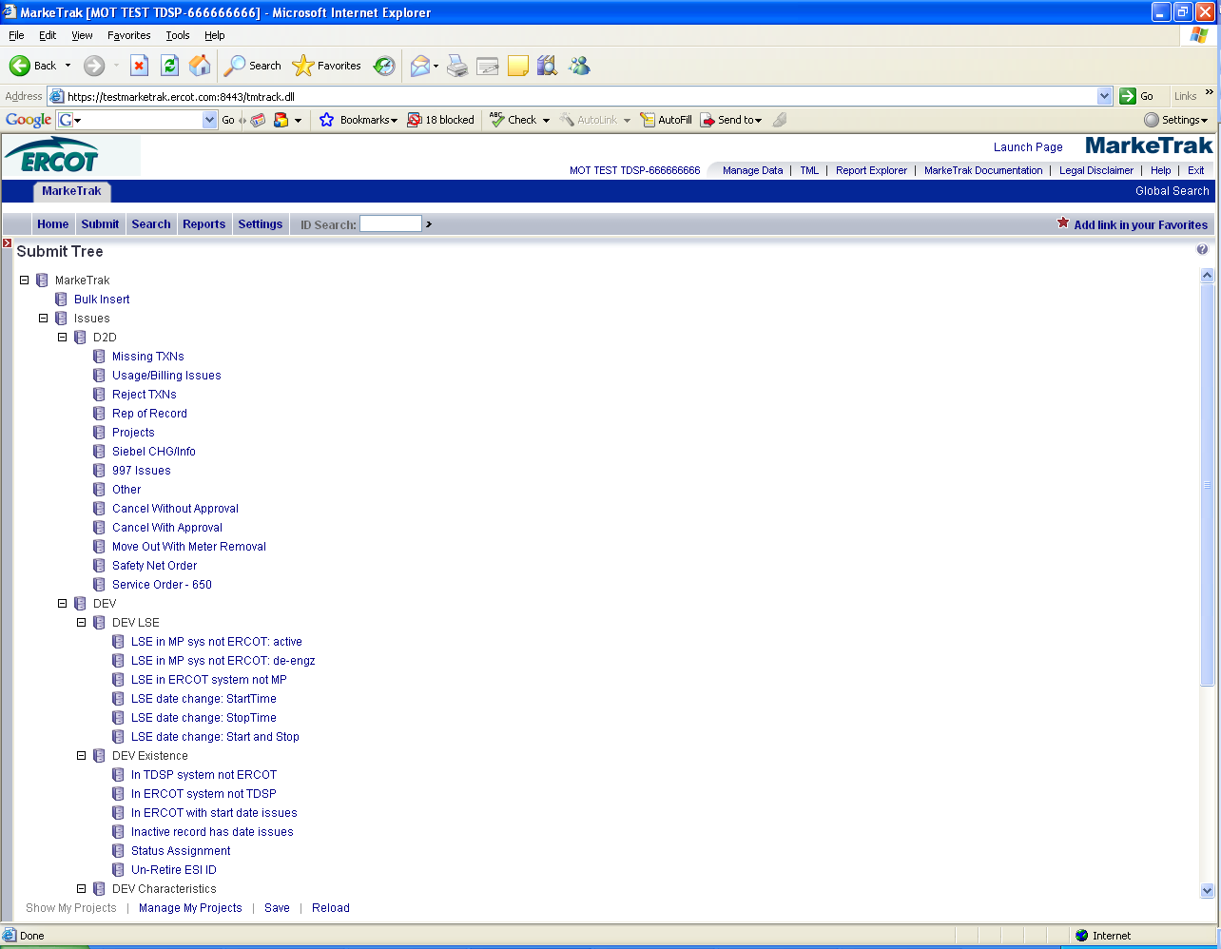

- The following fields must be populated for successful submission of Day to Day issue sub type Projects : (Fig 4.5b)
(For this example, the submitter selects TDSP.)
Assignee

NOTE: The ESI ID, Original Tran ID, Tran Type, TXN Date, GS Number, ISA Number, Start Time and Comments box are all optional fields. Please include any additional information relevant to resolving this issue in the comments section.

- Select OK.

Fig 4.5b
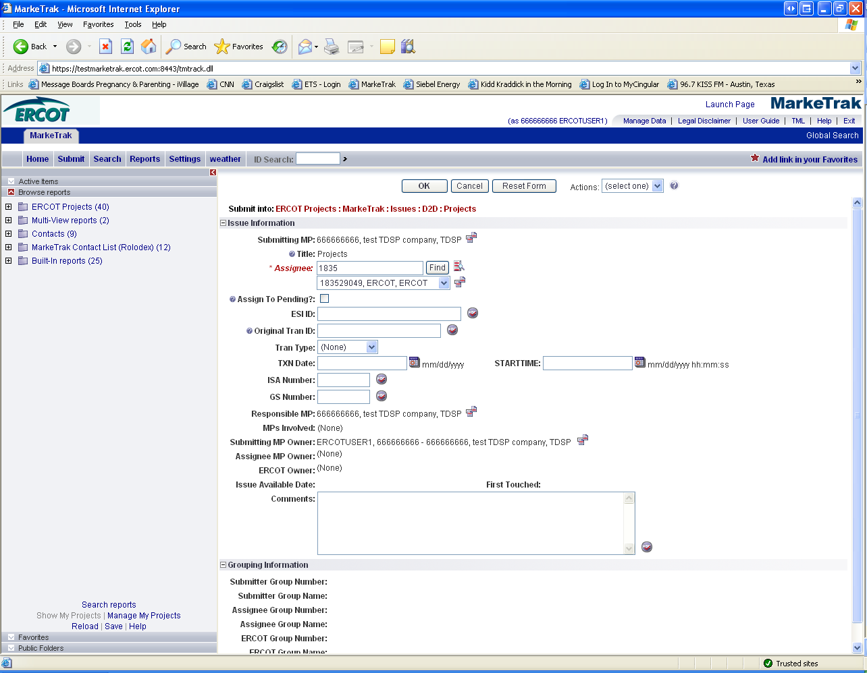

- The issue enters TDSP’s queue in a state of New and is visible only by the Submitting CR and TDSP.
- The Submitting CR can Withdraw the issue at this point by selecting the Withdraw transition within the MT issue. (Fig 4.5c)

Fig 4.5c
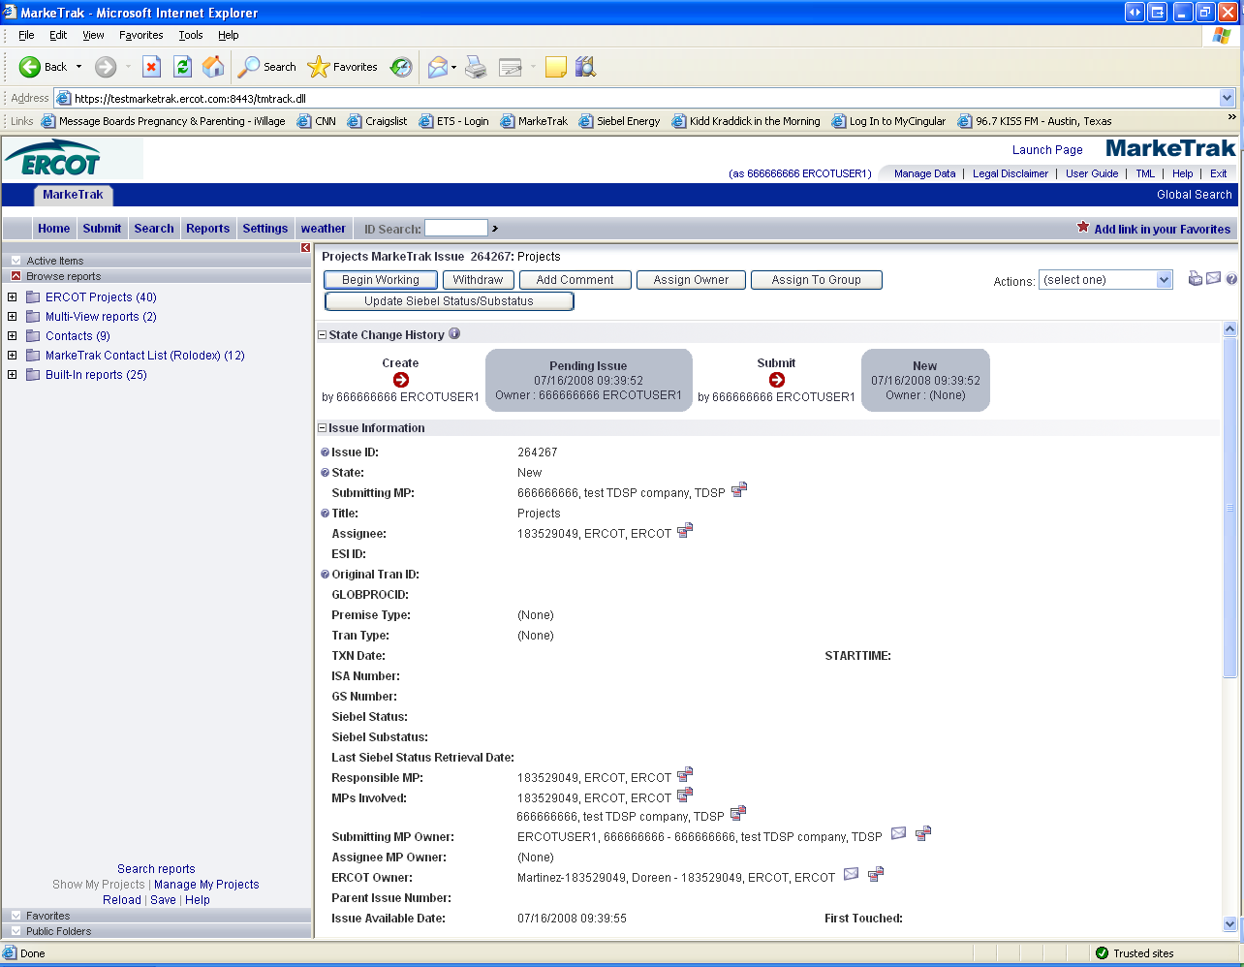

- TDSP selects Begin Working and the issue is transitioned to the state of In Progress (Assignee). (Fig 4.5d)
- At this point, the Submitting CR can no longer Withdraw the issue.

Fig 4.5d
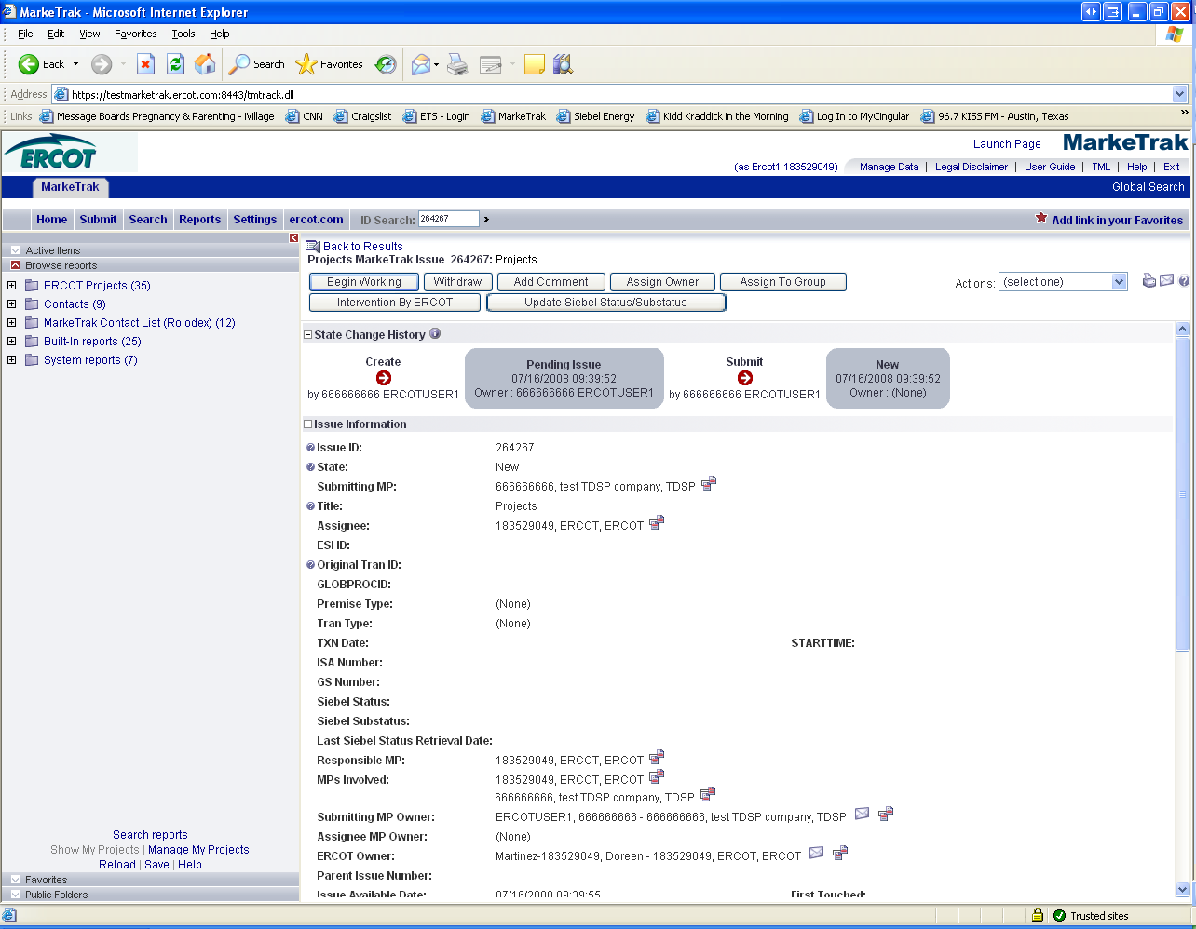

Note: After the initial “Begin Working” is selected and the “Withdraw” is not available or the issue is not in a “Complete” state, if the submitting MP feels a resolution is no longer needed, the “Close” button can be selected. Comments will be required with this transition.
All work will stop on the issue at this point.

- TDSP reviews the issue and has the options: (Fig 4.3e)
      - Unexecutable, which results in state Unexecutable- Pending Complete – comments required.
      - Return to Submitter, which requires comments and then the issue is transitioned back to the Submitter for additional information
      - Complete, which transitions to a state of Pending Complete. The Submitter has the option to close the issue by selecting Complete or the issue will be auto closed in 14 calendar days.

Fig 4.5e
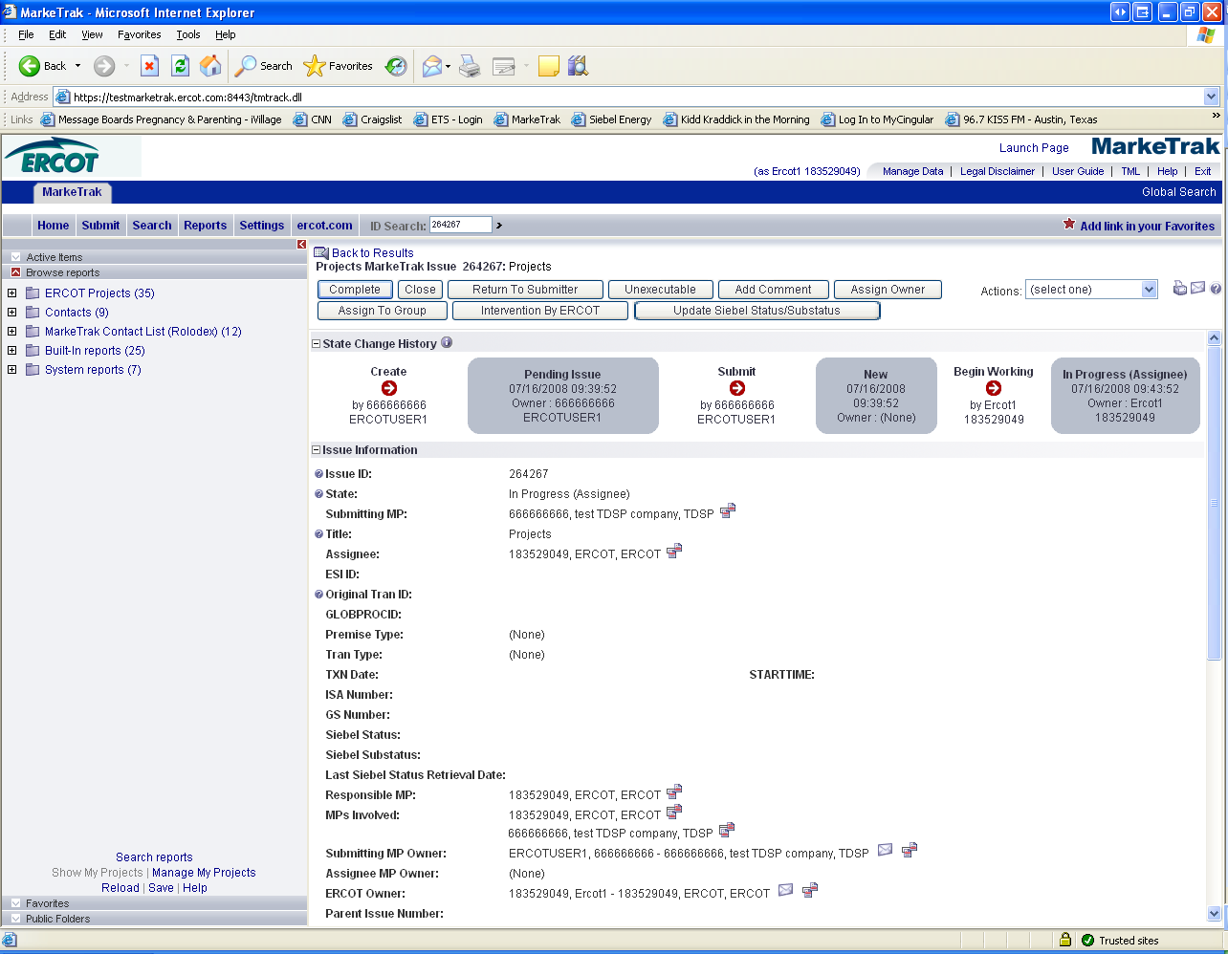

- In this example, if after researching the information provided, TDSP provided the necessary information to the CR within the comments section. TDSP would select Complete, and the issue would be transitioned back to the Submitter in the state of Pending Complete. (Fig 4.5f)

Fig 4.5f
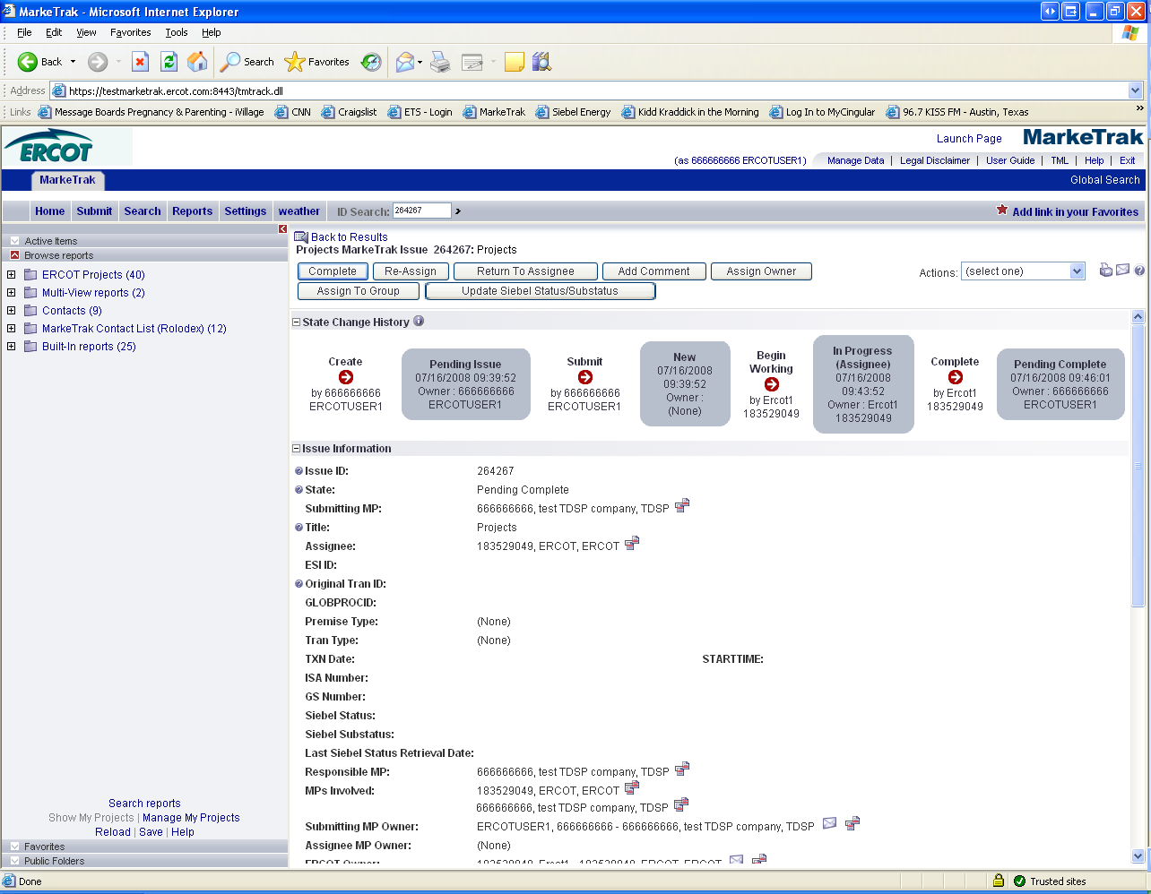

- The Submitting CR has the option to close the issue by selecting Complete or the issue will be Auto Closed in 14 Calendar days. (Fig 4.5g)

Fig 4.5g
