NOGRR Number | 039 | NOGRR Title | Synchronization of Section 1 with Nodal Protocols
Timeline | Normal | Recommended Action |  | Approval
Date of Decision |  | June 16, 2010
Proposed Effective Date |  | To be determined.
Priority and Rank Assigned |  | To be determined.
Guide Sections Requiring Revision |  | 1.1, Document Purpose  1.2, Document Relationship  1.4, Definitions  1.5.1, System Operator Training Objectives  1.5.3, ERCOT Operations Training Seminar
Revision Description |  | This Nodal Operating Guide Revision Request (NOGRR) aligns the Nodal Operating Guides with the Nodal Protocols by adding additional detail to Nodal Operating Guide sections that are referenced in the Nodal Protocols as well as eliminating conflicts and redundancies between the Nodal Operating Guides and Nodal Protocols.  This NOGRR also proposes non-substantive administrative changes, such as correcting acronym and defined term usage. These are shown below with the author “ERCOT Market Rules.”
Reason for Revision |  | This NOGRR supports Nodal Market implementation. This is an effort of the Nodal Operating Guide Review and Revision Task Force (NOGRRTF) to eliminate any conflicts and redundancies between the Nodal Operating Guides and Nodal Protocols.
Overall Market Benefit |  | Support Texas Nodal Market implementation.
Overall Market Impact |  | None expected.
Consumer Impact |  | None.
Procedural History |  | - On 5/10/10, NOGRR039 and the associated CEO Revision Request Review were posted.  - On 06/16/10, the Operations Working Group (OWG) considered NOGRR039.
OWG Decision |  | On 6/16/10, OWG was in consensus to recommend approval of NOGRR039 as amended by OWG.
Summary of OWG Discussion |  | On 6/16/10, there was some concern that the language in Section 1.5.3 places a requirement on Texas Regional Entity (TRE) to conduct the training seminar and whether this language is needed in the Nodal Operating Guides. TRE Staff stated they would review this language and submit comments if needed.

Quantitative Impacts and Benefits
Assumptions | 1 | Aligns the Nodal Operating Guides with the Nodal Protocols.
Assumptions | 2
Assumptions | 3
Assumptions | 4
Market Cost |  | Impact Area | Monetary Impact
Market Cost | 1
Market Cost | 2
Market Cost | 3
Market Cost | 4
Market Benefit |  | Impact Area | Monetary Impact
Market Benefit | 1 | Support Nodal Market implementation.
Market Benefit | 2
Market Benefit | 3
Market Benefit | 4
Additional Qualitative Information | 1
Additional Qualitative Information | 2
Additional Qualitative Information | 3
Additional Qualitative Information | 4
Other Comments | 1
Other Comments | 2
Other Comments | 3
Other Comments | 4

Sponsor
Name | Brad Calhoun on behalf of the NOGRRTF
E-mail Address | Brad.calhoun@centerpointenergy.com
Company | CenterPoint Energy
Phone Number | (713) 207-2744
Cell Number
Market Segment | Investor Owned Utility (IOU)

Market Rules Staff Contact
Name | Yvette M. Landin
E-Mail Address | ylandin@ercot.com
Phone Number | (512) 248-4513

Comments Received
Comment Author | Comment Summary
None

Proposed Guide Language Revision

1.1 Document Purpose
(1) These Operating Guides supplement the Protocols. The Operating Guides provide more detail and establish additional operating requirements for those organizations and Entities operating in, or potentially impacting the reliability of the ERCOT Transmission Grid in the ERCOT Region, as shown below in Figure 1, ERCOT Regional Map.
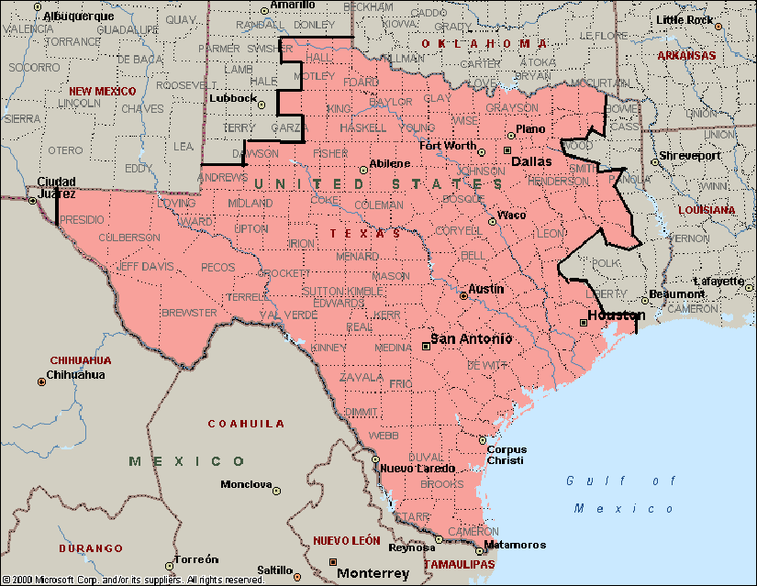
Figure 1 – ERCOT Regional Map
(2) The title “Operating Guide” is not to be construed as presenting merely a recommendation. Organizations and Entities are obligated to comply with the Operating Guides. Specific practices described in the Operating Guides for the ERCOT Region are consistent with North American Electric Reliability Corporation (NERC) Reliability Standards and the Protocols.

1.2 Document Relationship
(1) These Operating Guides are written to be consistent with the Protocols and to implement the North American Electric Reliability Corporation (NERC) Reliability Standards. The Protocols supersede these Operating Guides. The Public Utility Commission of Texas (PUCT) rules contain additional requirements for ERCOT and connected Entities.
(2) For application in the ERCOT Region, some NERC Reliability Standards must be adapted to fit the unique characteristics of ERCOT. Defined terminology for NERC Regional Variances, if any, is detailed in the NERC Reliability Standards.

1.4 Definitions
A primary list of definitions is contained within Protocol Section 2, Definitions and Acronyms. Additional definitions that apply specifically to these Operating Guides are listed below. It is essential to the reliability of the ERCOT Transmission Grid that all appropriate personnel use and understand the same terms in their daily operations. The definitions in this Section are intended to enable ERCOT, Qualified Scheduling Entities (QSEs), and Transmission Operators (TOs) to effectively communicate on an ongoing basis.

Credible Single Contingency
(A) Definition applicable to Operational Planning:
(1) A single facility, comprised of transmission line, auto transformer, or other associated pieces of equipment. This includes multiple equipment Outaged or interrupted during a single fault (single fault multiple element (SFME)).
(2) The Forced Outage of a double-circuit transmission line (DCKT) in excess of 0.5 miles in length will always be considered a credible single contingency for all security constrained unit commitment decisions. The Forced Outage of a DCKT in excess of 0.5 miles in length will only be considered a credible single contingency for energy deployment decisions for any of the following operating conditions characterized by high DCKT Outage probability or consequence:
(a) High Outage Probability:
(i) Severe weather conditions are forecasted by ERCOT in the vicinity of the DCKT.
(ii) During any ERCOT declared Watch or for any operating conditions characterized by high DCKT Outage probability or consequence.
(iii) Weather conditions indicate a high risk of insulator flashover on the DCKT.
(iv) Individual circuits that are part of the DCKT have experienced repeated Forced Outages within the preceding 48 hours possibly indicating unresolved problems.
(v) A high risk of DCKT Outage exists due to fire in progress near the DCKT right-of-way.
(b) High Outage Consequence:
(i) Another Transmission Facility, which significantly increases the impact of an Outage to the DCKT, is out of service.
(ii) Studies affirmatively indicate Outage of the DCKT would result in cascading Outages or voltage collapse.
(iii) Studies affirmatively indicate Outage of the DCKT poses a significant risk of uncontrolled Outages because it would result in equipment overloads, which cannot be eliminated through execution of specific, predefined operating procedures such as Remedial Action Plans (RAPs), which may include the use of energy Dispatch Instructions in time to prevent equipment damage or failure.
(3) Any Generation Resource:
(a) A combined-cycle facility shall be considered a single Generation Resource; or.
(b) Each unit of a combined-cycle facility will be considered a single Generation Resource if the combustion turbine and the steam turbine can operate separately, as stated in the Resource Asset Registration Form on the Market Information System (MIS) Public Area.
(4) With any single Generation Resource unavailable, and with any other generation preemptively redispatched, the contingency loss of a single Transmission Facility (either without a fault or subsequent to a normally-cleared non-three-phase fault) with all other facilities normal should not cause the following:
(a) Cascading or uncontrolled Outages;
(b) Instability of Generation Resources at multiple plant locations; or
(c) Interruption of service to firm demand or generation other than that isolated by the transmission facility, following the execution of all automatic operating actions such as relaying and Special Protection Systems (SPSs).
Furthermore, the loss should result in no damage to or failure of equipment and, following the execution of specific non-automatic predefined operator-directed actions (i.e., RAPs) such as generation schedule changes or curtailment of interruptible Load, should not result in applicable voltage or thermal ratings being exceeded.
(B) Definition applicable to Transmission Planning:
(1) A single facility, comprised of transmission line, auto transformer, or other associated pieces of equipment. This includes multiple equipment Outaged or interrupted during a single fault (SFME).
(2) The Forced Outage of a DCKT in excess of 0.5 miles in length (either without a fault or subsequent to a normally-cleared non-three-phase fault) with all other facilities normal should not cause the following:
(a) Cascading or uncontrolled Outages;
(b) Instability of Generation Resources at multiple plant locations; or
(c) Interruption of service to firm demand or generation other than that isolated by the transmission facility, following the execution of all automatic operating actions such as relaying and Special Protection Systems (SPSs).
Furthermore, the loss should result in no damage to or failure of equipment and, following the execution of specific non-automatic predefined operator-directed actions (i.e., RAPs) such as generation schedule changes or curtailment of interruptible Load, should not result in applicable voltage or thermal ratings being exceeded.
(3) Any Generation Resource:
(a) A combined-cycle facility shall be considered a single Generation Resource; or.
(b) Each unit of a combined-cycle facility will be considered a single Generation Resource if the combustion turbine and the steam turbine can operate separately, as stated in the Resource Registration on the MIS Public Area.
(4) With any single Generation Resource unavailable, and with any other generation preemptively redispatched, the contingency loss of a single Transmission Facility (either without a fault or subsequent to a normally-cleared non-three-phase fault) with all other facilities normal should not cause the following:
(a) Cascading or uncontrolled Outages;
(b) Instability of Generation Resources at multiple plant locations; or
(c) Interruption of service to firm Demand or generation other than that isolated by the transmission facility, following the execution of all automatic operating actions such as relaying and SPSs.
Furthermore, the loss should result in no damage to or failure of equipment and, following the execution of specific non-automatic predefined operator-directed actions (i.e., RAPs) such as generation schedule changes or curtailment of interruptible Load, should not result in applicable voltage or thermal ratings being exceeded.
(5) All normal and contingency conditions outlined in North American Electric Reliability Corporation (NERC) Reliability Standards and any subsequent revisions.

Generator Reactive Power Sign/Direction Terminology
(1) Lagging power factor operating condition is when MVAr flow is out of the Generation Resource (overexcited generator) and is considered to be positive (+) flow, i.e., in the same direction as MW power flow. The generator is producing MVArs.
(2) Leading power factor operating condition is when MVAr flow is into the Generation Resource (underexcited generator) and is considered to be negative (-) flow, i.e., in the opposite direction as MW power flow. The generator is absorbing MVArs.
Interchange
Net Actual Interchange
The algebraic sum of the power flows of the ERCOT System interconnections with other non-ERCOT Systems. Sign convention is that net interchange out of the ERCOT Region is positive (+) while net interchange into the ERCOT area is negative (-).
Net Scheduled Interchange
The mutually prearranged intended net power flow on the ERCOT System’s interconnections with other non-ERCOT Systems. Sign convention is that scheduled interchange out of the ERCOT Region is positive (+) while net interchange into the ERCOT region is negative (-).

Telemetry
The measured quantity or quality (e.g., open/closed, amps, volts, MW, MVAr, MVA) and transmitting the result to a remote location for indication or recording.
Transmission Line Terminal Sign/Direction Terminology
(1) MW or MVAr flow out of the bus is considered to be positive (+) flow.
(2) MW or MVAr flow into the bus is considered to be negative (-) flow.

1.5.1 System Operator Training Objectives
(1) Each operating Entity within the ERCOT System shall train its operators such that they will possess the necessary knowledge, skills and abilities to perform their assigned tasks in directing the operation of the bulk power system. Instruction provided shall be in accordance with North American Electric Reliability Corporation (NERC) Reliability Standards, the Protocols, these Operating Guides, and ERCOT Procedures, as well as individual Entity operating goals, plans and procedures.
(2) Training will prepare operators to:
(a) Maintain the safety of personnel, even during emergency situations involving complex switching and manipulation of control elements;
(b) Protect system components, particularly major power system elements from serious life degradation or harm;
(c) Operate the system in a secure manner to minimize violations of operating limits, avoiding customer Outages where reasonably possible, and avoiding unstable situations that might result in widespread Outages or blackouts;
(d) Operate the system using Good Utility Practices whenever possible within continually changing operating environment; and
(e) Restore the system to its normal operating state as rapidly as practical after a disturbance.

1.5.3 Texas Regional Entity Operations Training Seminar
(1) Texas Regional Entity (TRE) will, at a minimum, annually host a training seminar. The purpose of the training seminar is to provide a forum for system-wide problems to be effectively addressed. The training seminar should present information to maintain the consistency of operators across all of the ERCOT Region.
(2) The seminar provides a forum for QSE, TO, Transmission Service Provider (TSP) or Distribution Service Provider (DSP) and other ERCOT System Operators to meet and analyze common topics and issues as well as participate in formal training sessions.

