ERCOT OPERATIONS REPORT
ON THE EEA EVENT
OF
MAY 15, 2010

Executive Summary 3
Time Line and Description of Significant Events 4
Observations/Data Review 5
Load, Day Ahead-Load Forecast, ARR and RRS 5
Adjusted Responsive Reserve Available, Responsive Reserve Deployed, NSRS and ERCOT Taylor Frequency. 6
High-Speed Frequency Recorder Data 7
SCE and ERCOT Taylor Frequency 8
LaaR response and ERCOT Frequency 9
Action Items and Lessons Learned 10

Executive Summary

At 16:13:49 on May 15th, 2010, Unit A tripped causing the loss of 815 MW. One minute and 18 seconds later, Unit B tripped causing the loss of 745 MW of generation, for a total of 1560 MW.

ERCOT ISO frequency initially dropped to 59.71 Hz immediately after the Unit A trip at 16:13:49. System Frequency recovered to 59.76 Hz before Unit B tripped at 16:15:07. As a result of the trip of Unit B the frequency dropped to 59.69 Hz. This dip below 59.7 Hz caused a total of 1111.8 MW of Responsive Reserve, in the form of Load acting as Resource (LaaR), to be automatically deployed.

In addition to the LaaRs, 1152 MW of Generation Responsive Reserve was deployed from the 3484 MW of Adjusted Responsive Reserve available at the beginning of the event.

ERCOT ISO Operators recognized that this was not a NERC Disturbance Control Standard (DCS) event as the two trips occurred more than 1 minute apart and were considered separate contingencies.

At 16:30 ERCOT implemented Level 1 of its Energy Emergency Alert (EEA). EEA Level 1 was declared due to the ERCOT Adjusted Responsive Reserve (ARR) dropping below 2300 MW. ERCOT deployed 1107 MW of Non-Spin Reserve Service (NSRS) at 16:45. EEA Level 1 was cancelled at 17:00.
The following operations report discusses primary and contributing factors leading up to and during the EEA event and action items that ERCOT has taken in response to the event.

Time Line and Description of Significant Events

5/15

- 16:13:44 ERCOT ISO frequency prior to disturbance was 59.92 Hz.

- 16:13:49 Unit A was operating at 815 MW and tripped to zero.

- 16:13:49 ERCOT ISO frequency initially dropped to 59.71 Hz immediately after the trip.

- 16:13:53 1152 MW of Generation Responsive Reserve was deployed with 3484 MW of ARR available at the beginning of the event.

- 16:14:23 ERCOT deployed approximately 120 MW Load acting as Resource (LaaR) deployment for the initial trip.

- 16:15:05 ERCOT ISO frequency recovered to 59.76 Hz.

- 16:15:07 Unit B was operating at 745 MW and tripped to zero. Units A and B tripped within 1 minute and 18 seconds of each other for a total loss of 1560 MW.

- 16:15:07 As a result of the trip of Unit B the frequency dropped to 59.69 Hz.

- 16:15:23 ERCOT automatically deployed approximately 990 MW LaaR deployment for the second trip due to frequency dipping below 59.7 Hz.

- 16:20 Advisory issued ARR below 3000 MW.

- 16:21 Watch issued ARR below 2500 MW.

- 16:30 EEA 1 declared for Adjusted Responsive Reserve below 2300 MW.

- 16:30 Hot-line calls were made to the Qualified Scheduling Entities (QSE’s) to notify them that ERCOT’s declared EEA 1for Adjusted Responsive Reserve below 2300 MW, STEC repeat back to ensure compliance with three-part communications.

- 16:37 Transmission desk made the hot-line call to the Transmission Operators (TO’s).

- 16:42 ARR returned above 2300 MW.

- 16:45 ERCOT deployed 1107 MW of Non-Spin Reserve Service (NSRS).

- 16:49 Hotline call to all QSE’s to restore LaaRs.

- 17:00 EEA was cancelled.

Observations/Data Review

05/15/2010 15:00 – 18:00 Load, Day Ahead-Load Forecast, ARR and RRS

Figure 1 Load, Day-Ahead Load Forecast, ARR Available and Responsive Reserve Deployed.

05/15/10 16:00 – 17:00 Adjusted Responsive Reserve Available, Responsive Reserve Deployed, NSRS and ERCOT Taylor Frequency.

At 16:13, before the event ARR was 3484 MW. At 16:22, ARR fell to 1988 MW and was back above 2300 at 16:42.

Figure 2 ARR Available, Responsive Reserve Deployed, NSRS Deployed and ERCOT Taylor Frequency.

05/15/10 16:12 – 16:15 High-Speed Frequency Recorder Data

As can be seen in the Figure 3, per ERCOT ISO High-Speed Frequency Recorder Data the frequency initially dropped to 59.709 Hz immediately after the trip at 16:13.09.635. Unit B tripped which further dropped the frequency to 59.685 Hz at 16:14.34.022.

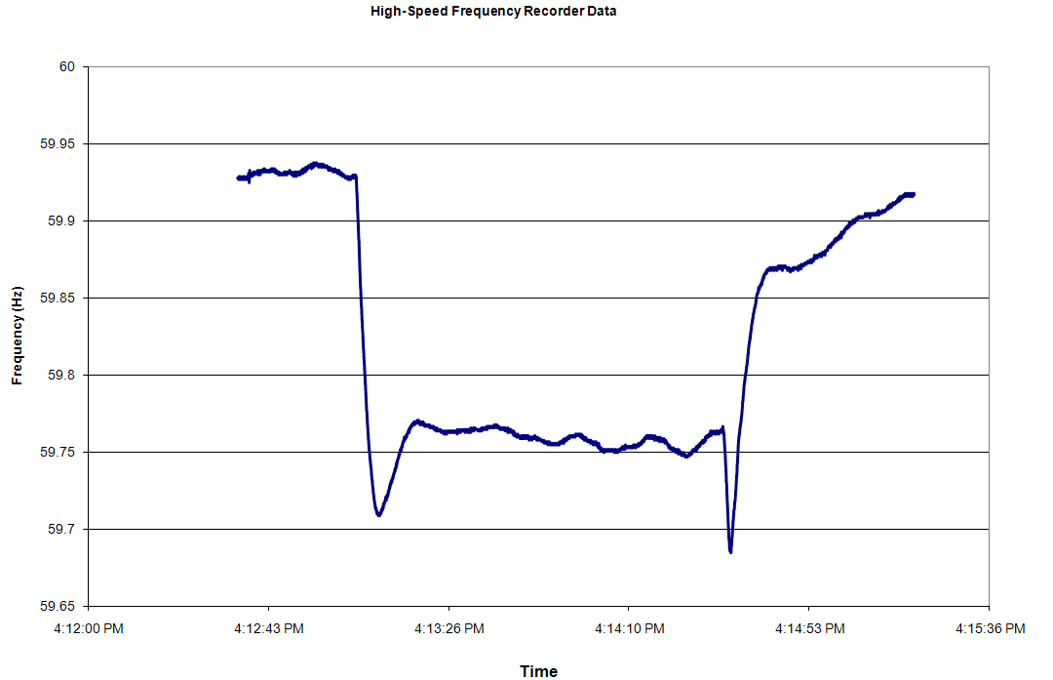
Figure 3 ERCOT High-Speed Frequency Recorder Data on May 15, 2010.

05/15/10 16:00 – 17:00 SCE and ERCOT Taylor Frequency

At 16:11:33, approximately 2 minutes before Unit A tripped, ACE was calculated at -33.357 MW. It dropped to -480 MW in less than 2 minutes due to approximately 169 MW of steel load pickup as well as a -98 MW SCE change.

Figure 4 ACE and ERCOT Taylor Frequency.

05/15/10 16:10 – 16:55 LaaR response and ERCOT Frequency

Figure 4 LaaR Response and ERCOT Frequency

Action Items and Lessons Learned

- ERCOT ISO System Operations investigation confirmed that this was not a NERC DCS event as the two trips occurred more than 1 minute apart and are considered separate contingencies.

- ERCOT ISO System Operations correctly declared Level 1 of its Energy Emergency Alert as required by regional Protocols due to Adjusted Responsive Reserve dropping below 2300 MW. LaaRs were deployed correctly. Adjusted Responsive Reserve was restored after a period of 21 minutes. Operators have procedures in effect to respond to the loss of both units and recover frequency and reserves in timely manner.

- ERCOT System Operations has been told that due to the loss of the “B” Boiler Feed Pump Unit A tripped. Unit B tripped due to the control logic sensing the Main Fuel Trip for Unit A, instead of Unit B. The control logic causing the trip of Unit B has been corrected to prevent future occurrences of a similar nature.

