NPRR Number | 217 | NPRR Title | Resolution of Alignment Item A58 - Use of Different Computational Modules
Timeline | Normal | Action |  | Recommended Approval
Date of Decision |  | June 3, 2010
Proposed Effective Date |  | Upon the Nodal Protocol Transition Plan’s Texas Nodal Market Implementation Date, as prescribed by zonal Protocol Section 21.12, Process for Transition to Nodal Market Protocol Sections.
Priority and Rank Assigned |  | Not applicable.
Nodal Protocol Section Requiring Revision |  | 5.5.1, Security Sequence
Revision Description |  | This Nodal Protocol Revision Request (NPRR) clarifies the Security Sequence since ERCOT does not use the same computational modules to perform both the Real-Time sequence and Day-Ahead and hour-ahead security analysis.
Reason for Revision |  | This change conforms the Nodal Protocols to the as-built Nodal system.
Overall Market Benefit |  | Alignment of the Nodal Protocols with the as-built Nodal system.
Overall Market Impact |  | Unknown.
Consumer Impact |  | Unknown.
Credit Impacts |  | ERCOT Credit Staff and the Credit Work Group (Credit WG) have reviewed NPRR217 and do not believe that it requires changes to credit monitoring activity or the calculation of liability..
Procedural History |  | - On 3/23/10, NPRR217, the CEO Revision Request Review, and Impact Analysis were posted.  - On 4/22/10, PRS considered NPRR217.  - On 5/20/10, PRS considered the 4/22/10 PRS Report and Impact Analysis for NPRR217.  - On 6/3/10, TAC considered NPRR217.
PRS Decision |  | On 4/22/10, PRS unanimously voted to recommend approval of NPRR217 as submitted. All Market Segments were present for the vote.  On 5/20/10 PRS unanimously voted to endorse and forward the 4/22/10 PRS Report and Impact Analysis for NPRR217 to TAC. All Market Segments were present for the vote.
Summary of PRS Discussion |  | On 4/22/10, there was no discussion.  On 5/20/10, there was no discussion.
TAC Decision |  | On 6/3/10, TAC unanimously voted to recommend approval of NPRR217 as recommended by PRS in the 5/20/10 PRS Report. All Market Segments were present for the vote.
Summary of TAC Discussion |  | On 6/3/10, there was no discussion.

Quantitative Impacts and Benefits

Assumptions | 1
Assumptions | 2
Assumptions | 3
Assumptions | 4
Market Cost |  | Impact Area | Monetary Impact
Market Cost | 1 | Unknown.
Market Cost | 2
Market Cost | 3
Market Cost | 4
Market Benefit |  | Impact Area | Monetary Impact
Market Benefit | 1 | Alignment of Nodal Protocols with the Nodal system.
Market Benefit | 2
Market Benefit | 3
Market Benefit | 4
Additional Qualitative Information | 1
Additional Qualitative Information | 2
Additional Qualitative Information | 3
Additional Qualitative Information | 4
Other Comments | 1
Other Comments | 2
Other Comments | 3
Other Comments | 4

Sponsor
Name | Mark Patterson
E-mail Address | mpatterson@ercot.com
Company | ERCOT
Phone Number | 512-248-3912
Cell Number
Market Segment | N/A

Market Rules Staff Contact
Name | Sandra Tindall
E-Mail Address | stindall@ercot.com
Phone Number | 512-248-3867

Comments Received
Comment Author | Comment Summary
None.

Proposed Protocol Language Revision

5.5.1 Security Sequence
(1) The figure below highlights the key computational modules and processes that are used in the Security Sequence:
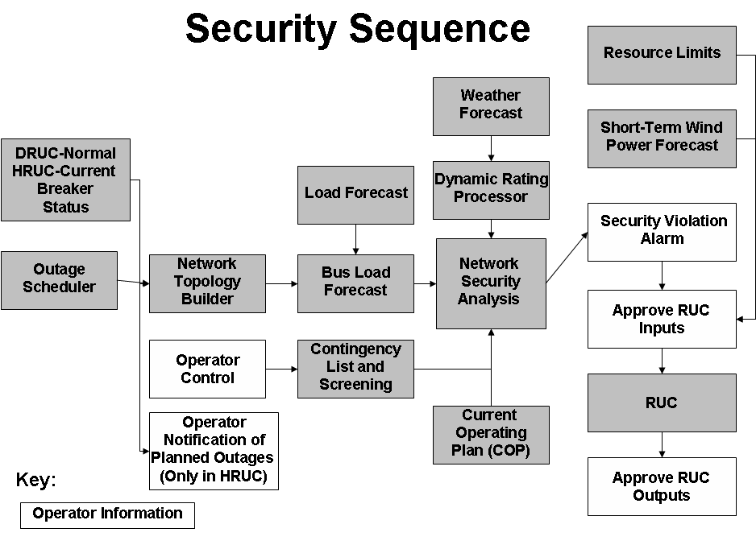
(2) The Security Sequence uses computational modules functionally similar to those used in Real-Time Sequence, however the inputs into the Security Sequence are based on a snapshot of projected hourly system conditions and constraints rather than Real-Time data.
(3) The Security Sequence uses the status of all transmission breakers and switches(current status for Hourly Reliability Unit Commitment (HRUC) and normal status for Day-Ahead Reliability Unit Commitment (DRUC)), updated for approved Planned Outages for equipment out of service and returned to service for building a representation of the ERCOT Transmission Grid for each hour of the Reliability Unit Commitment (RUC) Study Period. The Network Topology Processor constructs a network model for each hour that must be used by the Bus Load Forecast to estimate the hourly Load for each transmission bus.
(4) The weather forecast obtained by ERCOT must be provided to the Dynamic Rating Processor to create weather-adjusted MVA limits for each hour of the RUC Study Period for all transmission lines and transformers that have Dynamic Ratings.
(5) ERCOT shall analyze base configuration, select n-1 contingencies and select n-2 contingencies under the Operating Guides. The Operating Guides must also specify the criteria by which ERCOT may remove contingencies from the list. ERCOT shall post to the Market Information System (MIS) Secure Area the standard contingency list, including identification of changes from previous versions before being used in the Security Sequence. ERCOT shall evaluate the need for Resource-specific deployments during Real-Time operations for management of congestion consistent with the Operating Guides.
(6) ERCOT shall also post to the MIS Secure Area any contingencies temporarily removed from the standard contingency list by ERCOT immediately after successful execution of the Security Sequence. ERCOT shall include the reason for removal of any contingency as soon as practicable but not later than one hour after removal.
(7) As part of the Network Security Analysis, for each hour of the RUC Study Period, ERCOT shall analyze all selected contingencies and perform the following:
(a) Perform full AC analysis of all contingencies;
(b) Monitor element and bus voltage limit violations; and
(c) Monitor transmission line and transformer security violations.
(8) As part of the Network Security Analysis (NSA), if there is an approved Remedial Action Plan (RAP) available, it must be used before considering a Resource commitment.
(9) ERCOT shall review all security violations prior to RUC execution.
(10) ERCOT shall model all approved Special Protection Systems (SPSs) and RAPs in the contingency analysis. The computational modules must enable ERCOT to analyze contingencies, including the effects of all approved automatically deployed SPSs.
(11) ERCOT may deselect certain contingencies known to cause errors or that otherwise result in inconclusive study output in the RUC. On continued de-selection of contingencies, ERCOT shall prepare an analysis to determine the cause of the error. ERCOT may use information from the DAM processes as decision support during the Hour-Ahead processes. ERCOT shall post to the MIS Secure Area any contingencies deselected by ERCOT and must include the reason for removal as soon as practicable, but not later than one hour after deselection.

