ERCOT Operations Report
May 2010 ROS & OWG

Frequency Control
Time | Freq(Hz) | Duration (s)
05/02/2010 19:09:35 | 60.108 | 4 | SCE change +800 MW in 10 min. Out of Down Reg
05/05/2010 03:02:48 | 59.860 | 4 | Unit trip with 500 MW
05/08/2010 07:11:44 | 59.835 | 8 | Unit trip with 510 MW
05/08/2010 11:06:16 | 59.894 | 5 | Unit trip with 270 MW
05/12/2010 14:05:56 | 60.120 | 275 | Wind ramped +500MW in 10 min causing the depletion of Down Reg.
05/12/2010 14:38:04 | 59.898 | 8 | SCE -650 MW in 10 min.
05/13/2010 03:07:28 | 60.112 | 56 | Out of Down Reg
05/14/2010 10:10:32 | 59.881 | 8 | Unit trip with 250 MW
05/15/2010 02:13:20 | 59.872 | 4 | Unit trip with 288 MW and Unit ran back with 140 MW
05/15/2010 04:06:52 | 60.121 | 217 | Wind ramped +500MW in 10 min causing the depletion of Down Reg.
05/15/2010 16:15:08 | 59.692 | 108 | Unit trip with 815 MW & 745 MW
05/15/2010 18:04:01 | 60.103 | 12 | Large SCE change +1700 MW in 10 minutes.
05/16/2010 16:24:44 | 59.864 | 17 | Unit trip with 490 MW
05/17/2010 14:49:44 | 59.856 | 117 | Unit trip with 340 MW. Incorrect offset calculation
05/17/2010 15:07:12 | 59.808 | 120 | Unit trip with 680 MW
05/20/2010 18:24:05 | 59.899 | 3 | Unit trip with 570 MW
05/23/2010 13:38:25 | 59.820 | 107 | Unit trip with 790 MW
05/24/2010 12:18:22 | 60.101 | 3 | Incorrect offset calculation
05/25/2010 20:03:11 | 59.867 | 54 | Unit ran back with 780 MW and trip with 294 MW
05/30/2010 12:01:10 | 59.834 | 58 | Unit trip with 640 MW
Note: Time of frequency excursions outside the range of +/- 0.1 Hz.

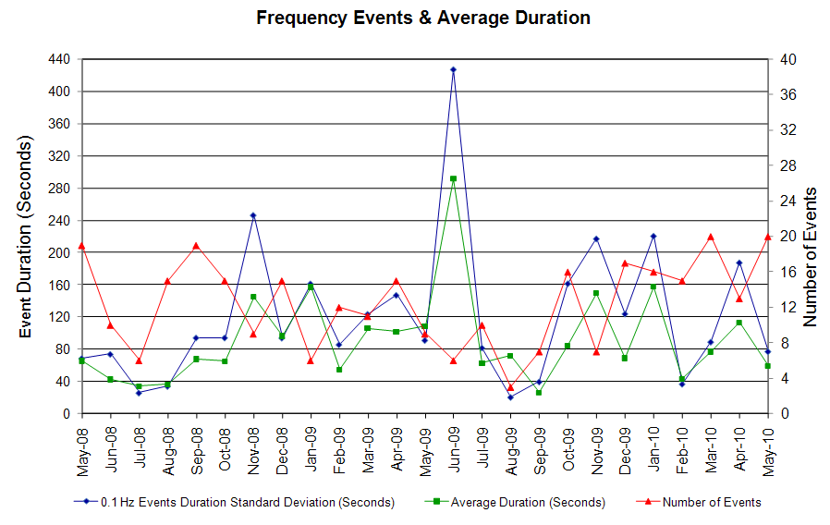

Deployed Responsive (Reported Above)
Time deployed | Stop Time | Duration | Max | Details
5/4/10 21:04:12 | 5/4/10 21:22:56 | 0:18:44 | 357.5 | Offset error
5/5/10 3:02:49 | 5/5/10 3:29:16 | 0:26:27 | 587.0
5/5/10 6:52:56 | 5/5/10 7:00:28 | 0:07:32 | 325.5 | Unit Trip
5/5/10 16:27:21 | 5/5/10 16:50:20 | 0:22:59 | 352.2 | SCE change -420 MW in 6 min.
5/6/10 12:40:01 | 5/6/10 12:48:24 | 0:08:23 | 325.5 | Unit Trip
5/8/10 7:11:46 | 5/8/10 7:29:52 | 0:18:06 | 720.4
5/8/10 11:06:18 | 5/8/10 11:21:01 | 0:14:43 | 405.5 | Unit Trip
5/12/10 14:29:58 | 5/12/10 14:52:56 | 0:22:58 | 384.2 | Large SCE change -650 MW in 10 min
5/13/10 22:06:06 | 5/13/10 22:22:38 | 0:16:32 | 341.5 | Offset error
5/14/10 10:10:32 | 5/14/10 10:26:32 | 0:16:00 | 474.9
5/14/10 21:12:46 | 5/14/10 21:26:42 | 0:13:56 | 352.2 | SCE change -1200 MW in 6 min
5/15/10 2:13:32 | 5/15/10 2:41:06 | 0:27:34 | 432.2
5/15/10 16:13:48 | 5/15/10 16:37:10 | 0:23:22 | 1152.0
5/16/10 16:24:42 | 5/16/10 16:38:48 | 0:14:06 | 565.6
5/17/10 14:45:39 | 5/17/10 15:25:50 | 0:40:11 | 869.8
5/20/10 18:24:07 | 5/20/10 18:29:51 | 0:05:44 | 378.9
5/23/10 13:38:27 | 5/23/10 14:20:45 | 0:42:18 | 800.4
5/24/10 8:16:53 | 5/24/10 8:23:59 | 0:07:06 | 352.2 | Unit Run Back
5/24/10 11:55:25 | 5/24/10 12:05:37 | 0:10:12 | 346.9 | Unit Trip
5/25/10 20:03:09 | 5/25/10 20:20:04 | 0:16:55 | 549.6
5/30/10 12:01:12 | 5/30/10 12:16:28 | 1:16:55 | 725.7

Day-Ahead OOMC and RPRS Capacity Purchases
Details | OOMC | RPRS S1 | RPRS S2 | RPRS S1+S2 | RMR | Total
DFW | 86 | 1 | 1 | 2 | 0 | 88
Houston | 57 | 21 | 0 | 21 | 0 | 78
North | 6 | 0 | 2 | 2 | 12 | 20
Western | 0 | 0 | 0 | 0 | 4 | 4
Austin | 0 | 0 | 3 | 3 | 0 | 3
W RIO | 0 | 0 | 0 | 0 | 0 | 0
San Antonio | 0 | 0 | 0 | 0 | 0 | 0
E RIO | 0 | 0 | 0 | 0 | 0 | 0
South | 0 | 0 | 0 | 0 | 0 | 0
Corpus | 0 | 0 | 0 | 0 | 0 | 0
Bryan Area | 0 | 0 | 0 | 0 | 0 | 0
Laredo | 0 | 0 | 0 | 0 | 0 | 0
Northeast | 0 | 0 | 0 | 0 | 0 | 0
Total | 149 | 22 | 6 | 28 | 16 | 193

Historical Totals | May-10 | May-09 | Apr-10
Austin | 0 | 9 | 0
Bryan Area | 0 | 2 | 0
Corpus | 0 | 10 | 0
DFW | 87 | 18 | 112
E RIO | 0 | 2 | 0
Houston | 78 | 31 | 0
Laredo | 0 | 13 | 0
North | 18 | 19 | 2
Northeast | 0 | 0 | 0
San Antonio | 0 | 10 | 0
South | 0 | 6 | 0
W RIO | 0 | 86 | 0
Western | 4 | 7 | 5
Total | 187 | 213 | 119

http://www.ercot.com/mktinfo/services/rprsdr/index.html

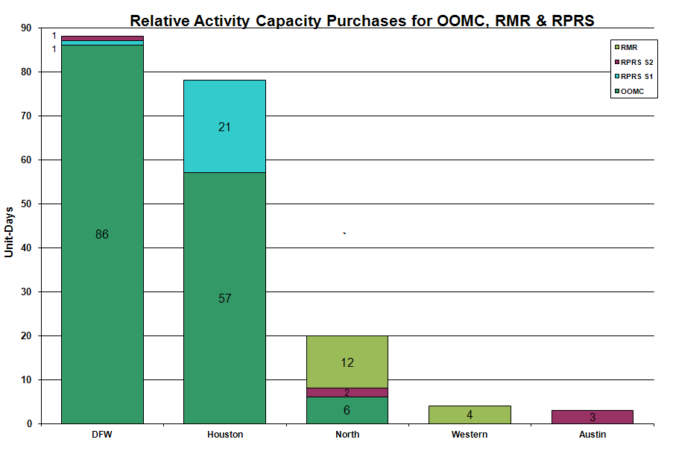

OOME and Congestion Management Activity
Congestion affected by outages Remedial action plan has been developed for the element
Contingency | Overloaded Element | Days
Graham - Parker 345KV | Flat Creek - Leon Switch 138KV | 21
Greens Bayou - Gable & Hardy - Crockett 138KV | Garrott - Midtown 138KV | 16
Matador - Spur 69KV | Matador - Paducah REA Tap 69KV | 16
Bellaire AT#2 | Bellaire AT #4 | 13
Hamilton Road - Sonora 138KV | Sonora - Friess Ranch 69KV | 11
Aspermont - Spur 138KV | Matador - Paducah Rea Tap 69KV | 10
PH Robinson 345/138KV AT2 | PH Robinson 345/138KV AT1 | 10
Graham SES - Parker Switch 345KV | Barton Switch - Oran TU | 9
Crane LCRA - Odessa EHV Switch 138KV | Woodard 2 - 16th Street 138KV | 7
Base Case | Stanton East Switching Station - Midland East 138KV | 7
Moss Switch - Holt Switch 138KV | Odessa North 138/69KV Auto | 4
Base Case | ENA Snyder - WKN Breaker 69KV | 4
Lobo - Laredo VFT North 138KV | Lobo - Laredo VFT North 138KV | 3
Base Case | Matador - Paducah 69KV | 3
Fisher Road Switch - Oklaunion - Bowman 345KV | Abilene Mulberry - Long Creek 345KV | 3
Ingleside Dupont Switch - Ingleside Cogen Switch 138KV | Ingleside Cogen - Dupont 2 138KV | 3
Meadow - PH Robinson 345KV | North Alvin - Hastings 138KV | 3
Moss Switch - Holt Switch 138KV | Odessa North - Odessa Basin Switch 69KV | 3
Watermill - West Levee - Sargent Road 345KV | Cedar Hill - Duncanville South 138KV | 3
Graham - Parker 345KV | Graham SES - Graham East 138KV | 2
Graham SES - Long Creek - Cook Field Road 345KV | Putnam - Leon Switch 138KV | 2
WA Parish - Obrien 345KV | Garrett - Midtown 138KV | 2
Abilene - Eskota 138KV | Merkel - Trent 69KV | 2
Abilene Mulberry Creek - Bitter Creek and Long Creek - Sweetwater 345KV | Santa Anna - Dressey 69KV | 2
Amoco generation | PH Robinson AT1 | 2
Austrop - Sandow 345KV | Killeen Fort Hood West - Killeen Clark Road POI 138KV | 2
Batesville - Pearsall 138KV | Uvalde - Downie1 138KV | 2
Cagnon 345/138KV | Cagnon 345/138KV | 2
Coleto Creek - Victoria #2 138KV | Coleto Creek - Victoria #1 138KV | 2
Collin - Anna Switch 345KV | Payne Switch - Epco POI 138KV | 2
Lobo - San Miguel 345KV | Freer - San Diego 69KV | 2
North Denton - West Denton 138KV | West Denton - Teasley 138KV | 2
North Denton - West Denton 138KV | West Denton - Pockrus 138KV | 2
Odessa Basin - Odessa North 69KV | Holt Switch Ector Shell Tap 69KV | 2
San Miguel 345/138KV | Freer - San Diego 69KV | 2
Sandow Switch - Temple Switch 345KV | Killeen Fort Hood West - Killeen Clark Road 138KV | 2
Willow Valley Switch - Bluff Creek 138KV | Ackerly Vealmoor Switch - Ackerly 69KV | 2
Hamilton - Sonora 138KV | Sonora - Friess Ranch 69KV | 1
Jewett - Singleton 345KV | Twin Oaks - Gibbons Creek 345KV | 1
Marion - Zorn & Clear Spring 345KV | Seguin - Seguin West 138KV | 1
Zorn - Marion & Clear Springs 345KV | Seguin - York Creek 138KV | 1
Holley - Barney Davis 138KV | Airline - Cabaniss 138KV | 1
Austrop - Sandow 345KV | Elgin Switch - Butler 138KV | 1
Hill Country - Marion & Elm Creek 345KV | Schertz - Parkway 138KV | 1
Jack County - Reno 138KV | Bennett Rd Switch - Rhome 138KV | 1
Martin Lake - Tyler Grande & Forney Switch - Elkton 345KV | Elkton 345/138KV 3L autotransformer | 1
Orange Grove - Lon Hill 138KV | Sinton - Skidmore 69KV | 1
PH Robinson - Center - Cedar Bayou 345KV | Garrott - Kirby REIT 138KV | 1
Sandow Switch - Temple Switch 345KV | Copperas Cove TU - Killeen Clark Road 138KV | 1
South Texas Project - Whitepoint 345KV | Blessing - Lolita 138KV | 1
Twin Butte 345/138KV AT #1 | San Angelo Red Creek 345/138KV AT #1 | 1

Zonal OC1
CSC | Days
West – North | 19
North – Houston | 10

New RAP, PCAP (Date indicates last update of RAP, PCAP not implementation date.)
None

New Procedures/Forms/Operations Bulletins
Date | Subject | Bulletin No.
05/12/2010 | Transmission and Security Desk V4 Rev14 | 476
05/12/2010 | Shift Supervisor Desk V4 Rev14 | 475
05/12/2010 | Frequency Control Desk V4 Rev13 | 474

Blackout/Load Shed Incidences
None

EEA
5/15 16:14 ERCOT declared EEA 1 for Adjusted Responsive Reserve below 2300MW. ERCOT deployed all 30 minute NSRS and started quick start units to recover adjusted responsive reserve.

Major System Voltage Problems
None

Major Computer Problems, Enhancements & Fixes
None

Communication
None

ERCOT peak (Unofficial)
05/28 17:00 54,603 MW

Yearly MTLF Error Comparison
Yearly Mid-Term (Hourly) Load Forecast Error Comparison for the ERCOT Forecast
Month | MAPE for MTLF at 16:00 Day-Ahead
Month | 2007 | 2008 | 2009 | 2010
January | 4.55 | 3.30 | 4.11 | 3.78
February | 3.75 | 3.59 | 3.49 | 3.79
March | 2.70 | 3.29 | 3.24 | 2.24
April | 3.00 | 2.45 | 2.66 | 2.47
May | 3.22 | 3.01 | 2.90 | 2.63
June | 4.46 | 2.81 | 2.89 | NA
July | 4.29 | 2.55 | 2.83 | NA
August | 3.11 | 3.66 | 3.07 | NA
September | 3.78 | 4.99 | 3.68 | NA
October | 3.08 | 2.79 | 2.92 | NA
November | 2.95 | 2.60 | 1.93 | NA
December | 3.74 | 4.54 | 3.70 | NA
Annual Average | 3.55 | 3.29 | 3.11 | 2.98

OCN, Advisory, Watch & Emergency Notices
Capacity
Date | Start | End | Event
5/5/10 | 16:31 | 19:11 | Advisory issued for ARRS below 3000 MW.
5/5/10 | 17:30 | 19:00 | Non-Spin Reserve Service (NSRS) was deployed in the North, South and West zones due to the depletion of Up Balancing Energy Service.
5/15/10 | 16:20 | 19:30 | Advisory issued for ARRS below 3000 MW.
5/15/10 | 16:30 | 17:00 | EEA 1 issued for ARRS below 2300 MW.
5/15/10 | 16:21 | 19:30 | Watch issued for ARRS below 2500 MW.
5/15/10 | 16:21 | 19:30 | Non Spin Reserve Service deployed in the West and North zones due to Watch for ARRS below 2500 MW.
5/16/10 | 16:30 | 22:08 | Advisory issued due to ARRS below 3000 MW.
5/16/10 | 17:15 | 0:00 | Deployed NSRS in the West, North and Houston Zones due to depletion of UBES bids.
5/17/10 | 2:00 | 18:00 | OCN issued for a projected reserve capacity shortage for hours 16:00, 17:00 and 18:00.

Transmission Watch
5/1 – 5/31 00:15 Transmission Watch issued due to forced outage at Gail substation. Implemented Block Load Transfer up to 2 MW from ERCOT (Gail substation) to SPP (Draw substation).
5/29 18:33 Transmission Watch issued due to forced outage at Cienega RGEC substation. Implemented Block Load Transfer up to 3 MW from ERCOT (Gonzales substation) to CFE.
Emergency Notice
5/15 16:15 Emergency Notice issued due to ERCOT experiencing a potential NERC Disturbance Control Standard (DCS) event.

5/19 18:00 Market Emergency Notice issued due to Replacement Reserve Service Market did not meet the required time-line.

Texas RE Event Analysis
5/14 19:29 A QSE lost network connectivity for approximately 1 hour 25 minutes.

5/15 02:13 Loss of three units at a plant for a total of 288 MW of generation and one 345kV line.
5/15 16:13 Loss of two units at a plant for a total of 1560 MW of generation. ERCOT ISO System Operations correctly declared Level 1 of its Energy Emergency Alert due to Adjusted Responsive Reserve dropping below 2300 MW.

5/15 16:55 Simultaneous loss of one unit, two auto transformers and one 345 kV line.

5/19 17:00 Market Emergency Notice issued for RPRS market delay.

5/26 04:42 Stanton Switch Station SPS #46 activated.

Others
5/08 22:45 Held IE 22:45 Balancing Energy deployments for IE 23:00 due to an offset calculation error. Resumed with the IE 23:15 deployments.

