2705 West Lake Drive
Taylor, Texas 76574

ERCOT Network Model Data Submission
Transition from Zonal to Nodal

Version 1.0

D.W. Rickerson
05/28/2010

Revision History

Revision | Comments | Date | Author
0.1 | Initial Draft Version | 5/20/2010 | D.W. Rickerson
0.2 | Edits Added | 5/21/2010 | A. Natoli
0.3 | Interim update language added, | 5/26/2010 | D.W. Rickerson
0.4 | Revisions to Interim Updates and Appendix B | 5/27/2010 | D.W. Rickerson
1.0 | Final Revisions | 5/28/2010 | D.W. Rickerson

Contents
I. Overview 4
II. Zonal Timeline for Data Submission 4
III. Nodal Timeline for Data Submission 4
IV. Transition Plan for Data Submittals 6
A. Single Entry Model (SEM) 6
B. Model Validation Timeline 7
C. Cumulative Nature of Temporal modeling in Nodal 7
D. Graduated Approach to the Nodal Timeline 8
E. Interim Updates during the Transition 9
V. Appendix A 10
VI. Appendix B 11

Overview
The purpose of this document is to define the activities and timeline for transitioning from the Zonal to Nodal Network Model update process.

Zonal Timeline for Data Submission
Zonal Protocols require modeling information be submitted to ERCOT with at least 30 days notice before new equipment is energized or placed into service. Network Model Changes for existing data in the Network Model were allowed according to the time table found on the ERCOT website “Operational System Change Schedule”. In general, changes for existing data had three cut-off dates characterized by the type of data being changed.
- Generation Cut-Off: This date is the cut-off for Resource Entities (RE) to have resource registration changes of existing resources for network topology in to insure successful incorporation into the associated EMS database load date. The Generation Cut-Off date below does not apply for new generation.
- Transmission Cut-Off: This date is the ideal date for TSPs to have transmission network topology changes in by to assure successful incorporation into the associated EMS database load date.
- Telemetry Points Cut-Off: ERCOT request that all telemetry point changes be submitted for both resources and transmission elements by this cut-off date in order to assure changes are incorporated in the associated EMS database load date.
These cut-offs are typically follow the guidelines below:
- Generation Cut-Off Date: ~21 days before the scheduled Zonal database load
- Transmission Cut-Off Date: ~14 days before the scheduled Zonal database load
- Telemetry Cut-Off Date: ~3 days before the scheduled Zonal database load
Since 2008, ERCOT Zonal database loads have occurred on a bi-monthly basis (once every two weeks).
The current schedule for Zonal database loads can be found at:
http://www.ercot.com/gridinfo/transmission/opsys-change-schedule

Nodal Timeline for Data Submission
Nodal Protocols require more advance notice be given by Market Participants when changes to the Network Model are required. These new requirements are detailed in Section 3 of the Nodal Protocols and summarized in the following table found in Section 3.10.1.
Deadline to Submit Information to ERCOT  Note 1 | Model Complete and Available for Test  Note 2 | Updated Network Operations Model Testing Complete  Note 3 | Update Network Operations Model Production Environment | Target Physical Equipment In-Service Date  Note 4
Jan 1 | Feb 15 | March 15 | April 1 | Month of April
Feb 1 | March 15 | April 15 | May 1 | Month of May
March 1 | April 15 | May 15 | June 1 | Months of June–August  SUMMER MODEL
June 1 | July 15 | August 15 | September 1 | Month of September
July 1 | August 15 | September 15 | October 1 | Month of October
August 1 | September 15 | October 15 | November 1 | Month of November
September 1 | October 15 | November 15 | December 1 | Month of December
October 1 | November 15 | December 15 | January 1 | Month of January (the next year)
November 1 | December 15 | January 15 | February 1 | Month of February (the next year)
December 1 | January 15 | February 15 | March 1 | Month of March (the next year)

Notes:
1. Transmission and Resource data submissions complete per NOMCR process for inclusion in next update period.
2. Network Operations Model data changes and preliminary fidelity test complete by using the Network Operations Model test facility described in paragraph (3) of Section 3.10.4, ERCOT Responsibilities. A test version of the Redacted Network Operations Model will be posted to the MIS Secure Area for Market Participants and Network Operations Model to the MIS Certified Area for TSPs as described in paragraph (8) of Section 3.10.4, for market review and further testing by Market Participants.
3. Testing of the Redacted Network Operations Model by Market Participants and Network Operations Model by TSPs is complete and ERCOT begins the Energy Management System (EMS) testing prior to placing the new model into the production environment.
4. Updates include changes starting at this date and ending within the same month.

In Nodal, model changes submitted outside these timelines will be included in Network Model at the discretion of ERCOT and will be reported to the Public Utility Commission of Texas (PUCT) and the Independent Market Monitor (IMM) as Interim Updates. Interim Updates will be included in the appropriate Network Model if they are required for reliability or if they have no impact of the market.

Transition Plan for Data Submittals

Single Entry Model (SEM)
In the Zonal Market prior to September 2009, Market Participants submitted Service Requests (SRs) to request changes in the Network Model. Beginning in June of 2009, ERCOT created a Nodal copy of the Zonal model and began copying SRs submitted by MPs into this new Nodal Model. In September 2009 the SEM period was started. During SEM, MPs directly entered their SRs (REs through the RARF) into the NMMS database. ERCOT transferred the modifications submitted in NMMS into the Zonal model in order to keep it up to date. MPs were no longer able to submit SRs for Zonal changes. The Network Operational Model Change Requests (NOMCRs) submitted into the NMMS system became the sole method of affecting change into both the Zonal and Nodal Network Models with the implementation of SEM in September 2009. This transition from SR submission for Zonal changes into the current NOMCR submission for both Zonal and Nodal changes is illustrated below.

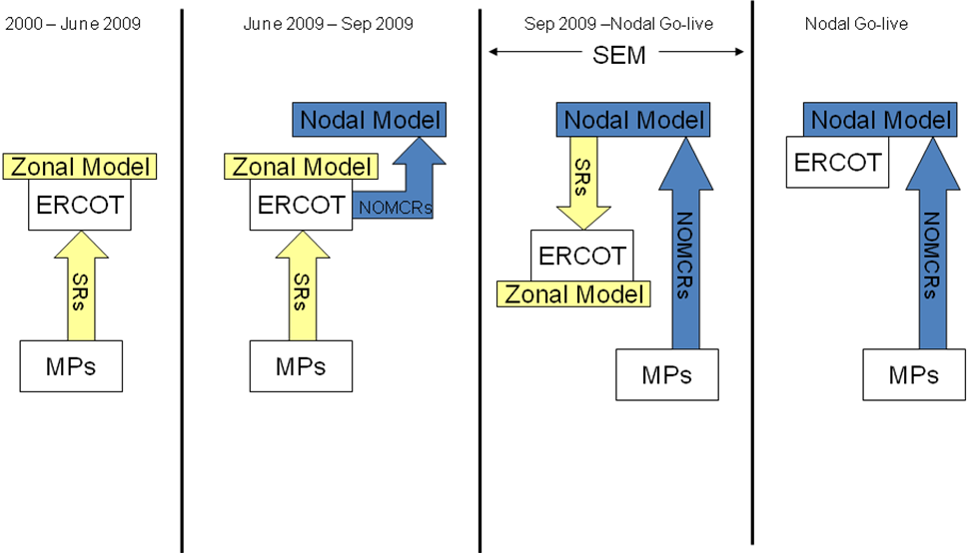
As a result of SEM process, any data timeline transition deadlines put in place for Nodal will also be in effect for Zonal. The SEM process requires data submission timelines to be the same for both models.

Model Validation Timeline
The ERCOT Nodal Protocols require data used in the Network Models in December, 2010 be submitted to ERCOT before September 1, 2010. The 3 month validation sequence is required for all Network Models. To understand the reasons for this timeline it is useful to understand the four-part validation cycle for the models used in December, 2010.
- NOMCR Processing (15 days) – Individual NOMCRs are processed, validated, and included in the NMMS database.
- Initial Validation (1 month) – Models representing specific periods of time in the future are prepared. These models will correspond with published database load schedules. During Initial Validation, the models are tested in downstream applications to verify reasonable results. At the end of the Initial Validation period, the validated models are posted for TSP consumption (redacted models are posted for market use).
- Market Validation (1 month) – The posted models are available for the Market to review and test. The Market Validation time period also precedes the CRR auction and gives Market Participants more information about the models that will be used in production.
- Final Validation (15 - 45 days) – This is the final validation performed by ERCOT before the models are used in production. These models may differ from the models that were used in the Initial Validation if Interim Updates were submitted and accepted. The final models are tested in all downstream applications to verify reasonable results. Point-to-point telemetry checks will be performed for new equipment that is to energized during in each model.
This process is illustrated below for the month of April. The dates are used here are for illustrative purposes only.
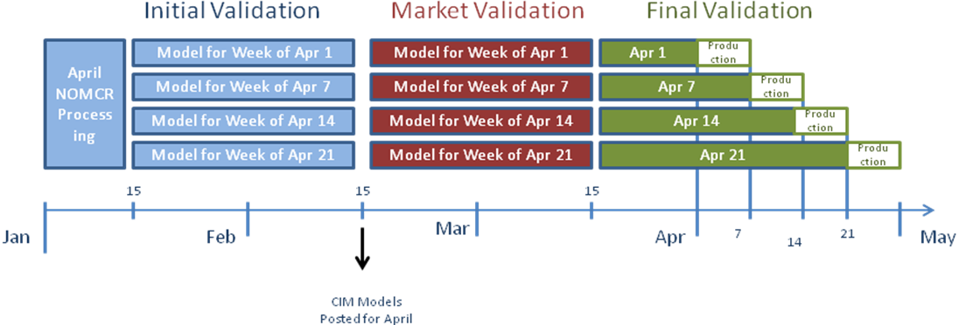

Cumulative Nature of Temporal modeling in Nodal
The Nodal Network Model database differs from the Zonal Network Model database in terms of the ability to model future equipment. The current Zonal Network Model database has a limited ability to model future equipment. A model exported from the Zonal system is intended to be used in the near future. Conversely, the Nodal Network Model database has the ability to export models for any time up to a year into the future. This feature adds a time-dependence to the modeling environment. A change made in the Nodal database four months from now may be dependent on another change just two months in the future. The data found in future models is an accumulation of previous month’s changes. This dependency leads to an important consideration for Nodal modeling and the timelines for data submission. Modelers must take into consideration the fact that Models for time periods in the near future must be finalized before models for subsequent time periods can be developed.

Graduated Approach to the Nodal Timeline
In order to move from the current Zonal data submission timeline into the data submission timeline outlined in Nodal Protocols, a transition period needs to occur. September 1, 2010 has been established in Nodal Protocols as the deadline for data submissions into the Nodal Network Model for December, 2010. December 1, 2010 is the Nodal go-live date. Because of the time-dependency of the data modeling in Nodal it is not possible to move directly into the September 1, 2010 deadline without a transition.
ERCOT is putting forth the following transition plan for the months of July 2010 through the end of November 2010. While this timeline is for the purpose of transitioning into Nodal, it will also be binding for data entry into the Zonal Network Model database (see illustration for SEM).
The table below illustrates the deadlines for the transition plan.
The illustration in Appendix A uses the above deadlines to demonstrate how the validation process will be conducted for each of the Nodal models that will be used in production as well as when the models are scheduled to be posted.

Interim Updates during the Transition
Model change submissions that fall outside the Transition Period timeline will be subject to the Interim Update status as defined by the ERCOT Nodal Protocols.[1] Per protocols Interim Updates are included in the model at the discretion of ERCOT and are reported to the PUCT and IMM. Given that section 3.10 of Nodal Protocols will not be activated until 9/1/2010, the Interim Update reports during the Transition Period will be distributed to the ERCOT Board of Directors for Review. The table below outlines the schedule and effective dates for the Interim Update Report.

Appendix A

Appendix B

ERCOT Protocols 8.8.2.1
ERCOT Nodal Protocols 3.10.4 (5)
[1] ERCOT Nodal Protocols 3.10.4 (5)

