NPRR Number | 235 | NPRR Title | Resolution of Alignment Items A36 and A131 and Clarification of Miscellaneous Requirements
Timeline | Normal | Action |  | Recommended Approval.
Date of Decision |  | May 20, 2010
Proposed Effective Date |  | To be determined.
Priority and Rank Assigned |  | To be determined.
Nodal Protocol Sections Requiring Revision |  | 3.13, Renewable Production Potential Forecasts  3.18, Resource Limits in Providing Ancillary Service  5.5.1, Security Sequence
Revision Description |  | This Nodal Protocol Revision Request (NPRR) resolves Alignment Items A36 and A131 by clarifying Market Information System (MIS) posting requirements and validation of Qualified Scheduling Entity (QSE) telemetry for Ancillary Services Resource Responsibility and clarifies Reliability Unit Commitment (RUC) initialization to data bases.  This NPRR also proposes non-substantive administrative changes, such as correcting acronym and defined term usage. These are shown with the author “ERCOT Market Rules.”
Reason for Revision |  | Alignment of the Nodal Protocols with the as-built Nodal system.
Overall Market Benefit |  | Clarification of Nodal Protocols.
Overall Market Impact |  | Unknown.
Consumer Impact |  | Unknown.
Credit Impacts |  | To be determined.
Procedural History |  | - On 5/13/10, NPRR235, a CEO Revision Request Review, and an Impact Analysis were posted.  - On 5/20/10, PRS considered NPRR235.
PRS Decision |  | On 5/20/10, PRS voted to recommend approval of NPRR235 as submitted. There was one abstention from the Consumer Market Segment. All Market Segments were present for the vote.
Summary of PRS Discussion |  | On 5/20/10, there was no discussion.

Quantitative Impacts and Benefits

Assumptions | 1
Assumptions | 2
Assumptions | 3
Assumptions | 4
Market Cost |  | Impact Area | Monetary Impact
Market Cost | 1 | Unknown.
Market Cost | 2
Market Cost | 3
Market Cost | 4
Market Benefit |  | Impact Area | Monetary Impact
Market Benefit | 1 | Clarification of Nodal Protocols.
Market Benefit | 2
Market Benefit | 3
Market Benefit | 4
Additional Qualitative Information | 1
Additional Qualitative Information | 2
Additional Qualitative Information | 3
Additional Qualitative Information | 4
Other Comments | 1
Other Comments | 2
Other Comments | 3
Other Comments | 4

Sponsor
Name | John Adams
E-mail Address | jadams@ercot.com
Company | ERCOT
Phone Number | 512-248-3130
Cell Number
Market Segment | Not applicable.

Market Rules Staff Contact
Name | Jonathan Levine
E-Mail Address | jlevine@ercot.com
Phone Number | 512.248-6464

Comments Received
Comment Author | Comment Summary
None.

Proposed Protocol Language Revision
3.13 Renewable Production Potential Forecasts
(1) ERCOT shall produce forecasts of Renewable Production Potential (RPP) for Wind-powered Generation Resources (WGR) to be used as an input into the Day-Ahead Reliability Unit Commitment (DRUC) and Hour-Ahead Reliability Unit Commitment (HRUC). ERCOT shall produce the forecasts using information provided by WGR Entities, meteorological information, and Supervisory Control and Data Acquisition (SCADA). WGR Entities shall install telemetry at their WGRs and transmit the ERCOT-specified site-specific meteorological information to ERCOT. WGR Entities shall also provide detailed equipment status at the WGR facility as specified by ERCOT to support the RPP forecast. ERCOT shall post forecasts for each WGR to the Qualified Scheduling Entities (QSEs) representing WGRs on the Market Information System (MIS) Certified Area. QSEs shall use the ERCOT-provided forecasts for WGRs throughout the Day-Ahead and Operating Day for applicable markets and Reliability Unit Commitments (RUCs). Similar requirements for solar power and run-of-the-river hydro must be developed as needed.
(2) WGR Entities shall provide ERCOT and their respective QSEs with Long-Term Wind Power Forecast (LTWPF) profiles for each WGR having an aggregated rating larger than 10 MW at its point of interconnection with the transmission system. The profiles must forecast the daily generation shape by hourly production of wind power Renewable Production Potential and the WGR Entities shall provide the profiles to ERCOT for each month on a rolling 36 month basis.
(3) ERCOT shall develop cost-effective tools or services to forecast energy production from Intermittent Renewable Resources (IRRs) with technical assistance from QSEs scheduling Renewable Resources. ERCOT shall use its best efforts to develop accurate and unbiased forecasts, as limited by the availability of relevant explanatory data. ERCOT shall post on the MIS Secure Area objective criteria and thresholds for unbiased, accurate forecasts within five Business Days of change.
3.18 Resource Limits in Providing Ancillary Service
(1) For both Generation Resources and Load Resources the High Sustained Limit (HSL) must be greater than or equal to the Low Sustained Limit (LSL) and the sum of the Resource-specific designation of capacity to provide Responsive Reserve (RRS), Regulation Up (Reg-Up), Regulation Down (Reg-Down), and Non-Spinning Reserve (Non-Spin).

(2) For Non-Spin, the amount of Non-Spin provided must be less than or equal to the HSL for Off-Line Generation Resources.
(3) For RRS Service:
(a) The amount of RRS provided from a Generation Resource must be less than or equal to 20% of thermal unit HSL for an Ancillary Service Offer and must be less than or equal to ten times the Emergency Ramp Rate;
(b) Hydro-powered Resources operating in the synchronous condenser fast-response mode may provide RRS up to the Resource’s proved 20-second response (which may be 100% of the HSL);
(c) For any hydro-powered Resource with a five percent droop setting operating as a generator, the amount of RRS provided may never be more than 20% of the HSL; and
(d) The amount of RRS provided from a Load Resource must be less than or equal to the HSL minus the sum of the LSL, Reg-Up Resource Responsibility, Reg-Down Resource Responsibility and Non-Spin Resource Responsibility.

5.5.1 Security Sequence
(1) The figure below highlights the key computational modules and processes that are used in the Security Sequence:
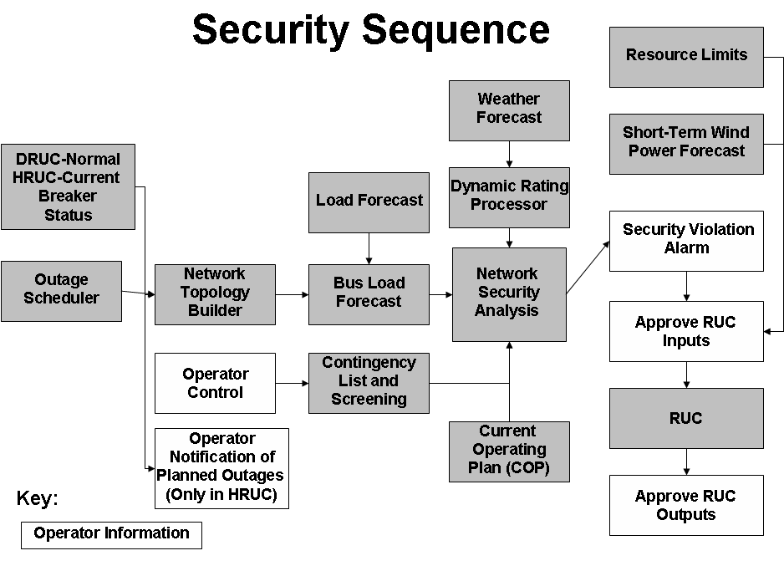
(2) The Security Sequence uses a subset of the computational modules used by the Real-Time Sequence. A more detailed explanation of those computational modules can be found in Section 6.5.7.1, Real-Time Sequence. The main distinction between the two models concerns inputs. The inputs into the Security Sequence are based on a snapshot of projected hourly system conditions and constraints.
(3) The Security Sequence uses the status of all transmission breakers and switches (current status for the first hour and normal status for all other hours of Hourly Reliability Commitment (HRUC) and normal status for all hours of Day-Ahead Reliability Unit Commitment (DRUC), updated for approved Planned Outages for equipment out of service and returned to service for building a representation of the ERCOT Transmission Grid for each hour of the Reliability Unit Commitment (RUC) Study Period. The Network Topology Processor constructs a network model for each hour that must be used by the Bus Load Forecast to estimate the hourly load for each transmission bus.
(4) The weather forecast obtained by ERCOT must be provided to the Dynamic Rating Processor to create weather-adjusted MVA limits for each hour of the RUC Study Period for all transmission lines and transformers that have Dynamic Ratings.
(5) ERCOT shall analyze base configuration, select n-1 contingencies and select n-2 contingencies under the Operating Guides. The Operating Guides must also specify the criteria by which ERCOT may remove contingencies from the list. ERCOT shall post to the Market Information System (MIS) Secure Area the standard contingency list, including identification of changes from previous versions before being used in the Security Sequence. ERCOT shall evaluate the need for Resource-specific deployments during Real-Time operations for management of congestion consistent with the Operating Guides.
(6) ERCOT shall also post to the MIS Secure Area any contingencies temporarily removed from the standard contingency list by ERCOT immediately after successful execution of the Security Sequence. ERCOT shall include the reason for removal of any contingency as soon as practicable but not later than one hour after removal.
(7) As part of the Network Security Analysis (NSA), for each hour of the RUC Study Period, ERCOT shall analyze all selected contingencies and perform the following:
(a) Perform full AC analysis of all contingencies;
(b) Monitor element and bus voltage limit violations; and
(c) Monitor transmission line and transformer security violations.
(8) As part of the NSA, if there is an approved Remedial Action Plan (RAP) available, it must be used before considering a Resource commitment.
(9) ERCOT shall review all security violations prior to RUC execution.
(10) ERCOT shall model all approved Special Protection Systems (SPSs) and RAPs in the contingency analysis. The computational modules must enable ERCOT to analyze contingencies, including the effects of all approved automatically deployed SPSs.
(11) ERCOT may deselect certain contingencies known to cause errors or that otherwise result in inconclusive study output in the RUC. On continued de-selection of contingencies, ERCOT shall prepare an analysis to determine the cause of the error. ERCOT may use information from the Day-Ahead processes as decision support during the Hour-Ahead processes. ERCOT shall post to the MIS Secure Area any contingencies deselected by ERCOT and must include the reason for removal as soon as practicable, but not later than one hour after deselection.

