

Digital Certificate Introduction and Use
For Market Participants
Market Participant Identity Management (MPIM)

Version 3

August 28, 2009

Document Revisions
Date | Version | Description
03/05/2008 | 1.0 | Initial release of the MPIM and Digital Certificate users guide.
03/17/2008 | 1.1 | Updated for Downloading of Report procedures
06/11/2008 | 1.2 | Phase II and incorporation of the Protocol 16.11 document “Digital Certificate Introduction and Use For Market Participants
03/19/2009 | 2 | Revisions and edits
08/28/2009 | 3 | Phase III Siebel and MPIM Integration

Table of Contents
1. Overview of Guide 3
1.1. Document Purpose 3
1.2. Disclaimer 3
1.3. Abbreviations 3
1.4. MP USA Overview 3
1.5. Manage MP USAs 3
1.5.1. Assigning MP USAs 3
1.5.2. Changing MP USAs 3
1.6. Digital Certificate Help 3
1.7. Additional Resources 3
2. Purpose and Role of Digital Certificates 3
2.1. Digital Certificate Summary 3
2.2. What are Digital Certicates? 3
2.3. Why does ERCOT use Digital Certificates? 3
2.4. How is Market System access protected? 3
2.5. Who is VeriSign? 3
3. Getting Started 3
3.1. MP USA Registration 3
3.2. I am the USA, now what? 3
3.3. I received my certificate, now what do I do? 3
3.4. Distribution for End Users 3
3.5. Backing up for Unplanned Issues 3
3.6. Test Certificates 3
3.7. API/Software Certificates 3
4. Market Participant Identity Management Functionality 3
4.1. Assumptions 3
4.2. Accessing MPIM 3
4.3. Create MPIM User Account 3
4.4. Create Application Programming Interface (API) MPIM Account 3
4.5. Certificate Management 3
4.5.1. Creating User Certificate in MPIM 3
4.5.2. User Certificate Retrieval 3
4.5.3. Viewing Certificate Details 3
4.5.4. Lost or Corrupt Certificate 3
4.5.5. Certificate Renewal 3
4.5.6. Troubleshooting Renewal Certificate 3
4.5.7. Revoking User Certificate in MPIM 3
4.6. Modifying a User and API MPIM Account with Roles 3
4.7. Terminating a MPIM User Account 3
4.8. Reporting 3
4.8.1. Report Types and Data 3
4.8.2. Downloading the report 3
5. Supporting Reference Documents 3

- Overview of Guide
  - Document Purpose
This document provides Market Participant (MP) User Security Administrators (USAs) with information regarding the process of receiving their Digital Certificates and serves as a reference tool to navigate through the Market Participant Identity Management (MPIM) features.

  - Disclaimer
This User Guide provides a general overview of the process for obtaining and handling Digital Certificates. If any conflict exists between this User Guide and the ERCOT Protocols, then the ERCOT Protocols shall prevail. Please refer to the ERCOT Protocols “User Security Administrator and Digital Certificates”, Section 16, regarding complete details of USA responsibilities.

  - Abbreviations
- EDC – ERCOT Digital Certificate
- ERCOT – Electric Reliability Council of Texas
- ERCOT USA – ERCOT User Security Administrator
- MP – Market Participant
- MPIM – Market Participant Identity Management
- MP USA – Market Participant User Security Administrator
- NCI – Notice of Change of Information
- TML – Texas Market Link
- USA – User Security Administrator

  - MP USA Overview
Each MP must appoint a MP USA and has the option to register a secondary MP USA. ERCOT encourages the use of a secondary MP USA to prevent the loss of ERCOT system functionality in the event the primary MP USA is unavailable or leaves the company. MP USA registration is part of the initial MP registration process. The MP USA is responsible for managing the entire Digital Certificate process for his/her company. The MP USA is responsible for coordinating Digital Certificate requests and maintaining user roles and access to ERCOT systems.

For assistance registering a new MP USA or changing MP USA contact information, please visit http://www.ercot.com/services/rq/index.html and follow the instructions on the Notice of Change of Information (NCI) form.

  - Manage MP USAs
    - Assigning MP USAs
- Once ERCOT has received management approval of a new Market Participant qualification or a NCI form, ERCOT will begin the process of issuing Digital Certificates for the MP USA. The ERCOT USA will enroll the new MP USA via the MPIM system.
- The MP USA(s) will receive two emails. One will contain a URL and the second will contain a password for that URL.
- The MP USA(s) will contact their ERCOT Account Manager or call ERCOT Client Services at (512) 248-3900 for their Employee ID.
- The Users Guide is available by clicking on Supporting Documents via the MPIM system.

    - Changing MP USAs
- Once ERCOT receives the completed NCI, Client Services will send notification to the ERCOT USA to enroll the new MP USA(s) via the MPIM system.
- The MP USA(s) will receive two emails. One will contain a URL and the second will contain a password for that URL.
- The MP USA(s) will contact their ERCOT Account Manager or call ERCOT Client Services at (512) 248-3900 for their Employee ID.

  - Digital Certificate Help
- To report technical issues or for help on topics not covered in this guide, you may contact the ERCOT Helpdesk at (512) 248-6800.
- For assistance registering a new USA or changing USA contact information, please visit http://www.ercot.com/services/rq/index.html and follow the instructions on the NCI form.
- Any other questions regarding contacts or account information, please contact your ERCOT Account Manager. If you do not know who your Account Manager is, you may call the ERCOT Helpdesk, mentioned above, and press the number 4 to be transferred to the ERCOT Client Services Hotline.

  - Additional Resources
To report technical issues or for help on topics not covered in this guide, you may contact the ERCOT Help Desk at (512) 248-6800.

**NOTE: When contacting ERCOT for assistance, please be prepared to provide:
- Market Participant’s DUNS number
- Employee ID(s) in question,
- Exact name of the digital certificate(s) (if applicable).

- Purpose and Role of Digital Certificates
  - Digital Certificate Summary
A Digital Certificate is an electronic "passport" that establishes your credentials when doing business or other transactions on the Internet. A Digital Certificate is a security measure installed on a user’s computer to identify the person to ERCOT. Digital Certificates are used to access ERCOT systems and ensure that connections are secure. All Digital Certificates ERCOT uses are administered by VeriSign. For more information on VeriSign, please visit their website at http://www.verisign.com.

  - What are Digital Certicates?
- Digital certificates identify each user to ERCOT. Without a digital certificate, ERCOT systems cannot be accessed.
- Digital certificates provide a “digital signature” that tells the recipient, in this case ERCOT, that the information actually came from the sender and has not been forged or tampered with.
- Digital certificates provide access to web sites identified by https://. The “s” in the address identifies the site as a “secured” site.
- Digital certificates are installed on the user’s PC and are utilized by the web browser. A user must use the PC on which the digital certificate is installed to access any secured site at ERCOT.
- (Texas Market Link (TML), also known as the Portal, and MarkeTrak (MT) are examples of secure ERCOT systems.
- Digital certificates ensure that you are accessing the actual ERCOT site to prevent “spoofing.” This means someone could create a false site where companies could enter sensitive and confidential information.

  - Why does ERCOT use Digital Certificates?
- ERCOT uses digital certificates to associate an identity with a user.
- ERCOT uses digital certificates to secure private information from the public. The ERCOT systems are accessible only by MPs, ERCOT, and PUCT users with digital certificates.
- In addition, digital certificates secure private information from other MPs.
- Digital certificates provide a transparent logon to ERCOT systems. No user ID or password is required to enter a transparent site.

  - How is Market System access protected?
      - A digital certificate is intended for use by only one user and is not to be shared among users.
      - Personal computers should be secured appropriately (screensaver passwords, etc.) to prevent improper use.
      - The MP assumes liability if these guidelines are not followed by anyone in the MP’s organization.
      - A yearly audit is conducted to keep ERCOT’s Digital Certificate database information current and accurate. For more information on ERCOT’s annual audit, please see Protocol Section 16.11: “User Security Administrator and Digital Certificates”.

  - Who is VeriSign?
- VeriSign manages digital certificates for all MPs.
- VeriSign’s functionality provides secure internet access, certificate validation, and automated certificate renewal among other functions.
- VeriSign will correspond with MPs via email concerning digital certificates.
- VeriSign’s homepage can be visited at http://www.verisign.com.

- Getting Started
  - MP USA Registration
After a MP completes the registration application in accordance with the ERCOT Protocols, the ERCOT MPIM administrator will enroll the new USA in MPIM. Upon completion of registration and any necessary qualification, the ERCOT Account Manager for that MP will send a request to have the MP USA production digital certificate authorized. ERCOT’s managing staff reviews and approves the request for VeriSign to issue the MP USA production certificate as one of the following types of entities (this includes sub-entities):

- LSE (Load Serving Entity)
- QSE (Qualified Scheduling Entity)
- CRRAH (Congestion Revenue Rights Accountholder)
  - TDSP (Transmission and Distribution Service Provider)
  - TSP (Transmission Service Provider)
  - DSP (Distribution Service Provider)
  - FERC (Federal Energy Regulatory Commission)
  - NERC (National Energy Regulatory Commission)
  - RE (Resource Entity)
  - PUCT (Public Utility Commission of Texas)

The certificate type is based on the DUNS number provided in the application. The account type determines the roles that the MP USA will be able to assign within an entity. For additional information, refer to Section 1.4 MP USA Overview above.

Once a MP USA’s digital certificate is created, email notifications are received by the MP USA with instructions to download the certificate. Refer to the MPIM process defined in this guide.

  - I am the USA, now what?
The USA must assess the requirements for issuing Digital Certificates to meet the security needs of his/her entity. As an example, ERCOT policy requires all users requesting a digital certificate to complete two forms, an “ERCOT Digital Certificate Policy and Agreement Form” and a “Request Form.” The purpose of the first document is to ensure users are held accountable for the security and use of their digital certificate. The Request Form justifies the need for a digital certificate.

  - I received my certificate, now what do I do?
The USA should establish internal policies and procedures for managing certificates, including the USA Digital Certificate. The USA should keep a record of all certificates issued within his/her entity.

**IMPORTANT**: The USA digital certificate should not be shared between different users. If a secondary USA certificate is needed, then contact ERCOT Client Services about submitting an NCI form to establish a secondary USA.

**NOTE**: Each certificate has a one-year lifespan. This means the certificate must be renewed by the anniversary of its issuance to remain valid.

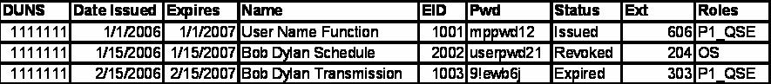
The USA should also determine the best way to document the EDC’s s/he issues. EDC documentation will aid the USA in any troubleshooting and expedite any help that comes from ERCOT. An Excel spreadsheet containing the important user information is a good way to do this. The spreadsheet below is an example of the information necessary to the USA.

  - Distribution for End Users
User EDCs authorized by the USA through the TML/MPIM system are distributed to the end user directly via email notifications from the system, with further instructions to the end user to contact the USA to complete installation. See “Certificate Management” later in this guide for details.

  - Backing up for Unplanned Issues
The USA should define and support a back-up process to minimize the possibility of being without access to the ERCOT systems. As the USA is the single point of entry for all EDCs issued by ERCOT, he/she should ensure that a back-up plan is established.

  - Test Certificates
Requests for EDCs to access the Market Operating Testing Environment (MOTE) are to be made through your ERCOT Account Manager or by sending an email to ClientRelations@ercot.com. For questions regarding the testing environment, please contact your ERCOT Account Manager. The URL for MPs to use after receiving a test EDC is https://testtml.ercot.com. This is the MOTE system.

  - API/Software Certificates
API and software digital certificates are enrolled in a similar manner to regular users. However, the naming convention for API/Software DCs is different than the convention used for individuals. Please refer to the “Naming Convention” section of this guide for further information.

- Market Participant Identity Management Functionality
  - Assumptions
- The MP has been qualified according to ERCOT’s registration process.
- MP USA has a valid EDC for his/her organization.

  - Accessing MPIM
- Navigate to the TML Portal by inserting the following URL in a browser window: https://tml.ercot.com.
- Once prompted, select a certificate corresponding to the entity you are managing, by highlighting the MP USA certificate and click “OK.”

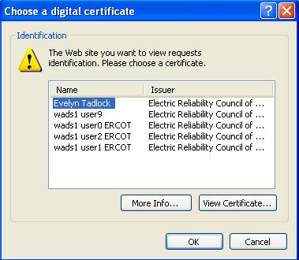

The ERCOT TML Portal will load.

- Click the User Access link located on the bottom left of the ERCOT TML portal home page.

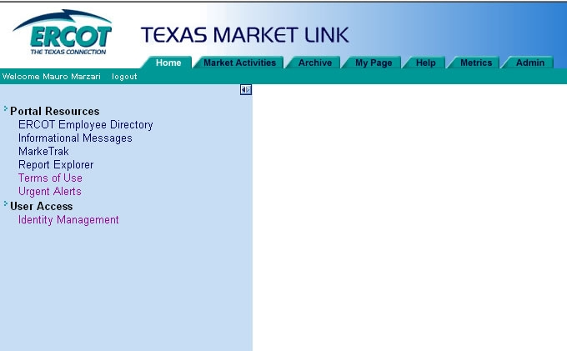

- The MP USA will be presented with the MPIM screen shown below.

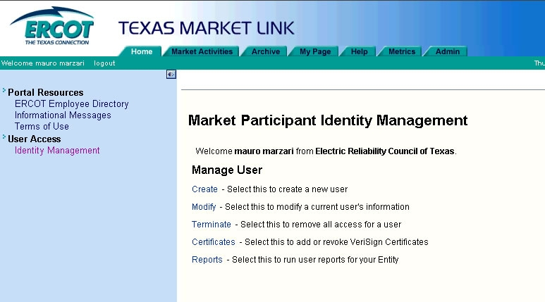

  - Create MPIM User Account
In order to create a user account within the MPIM system, the MP USA must be at the MPIM screen shown above.

- MP USA clicks on the Create link.

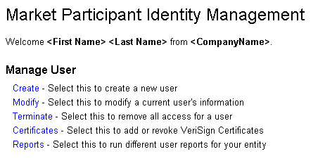

MPIM presents the Create Market Participant User page with the Company Name, DUNS Number and Organization Profile pre-populated.

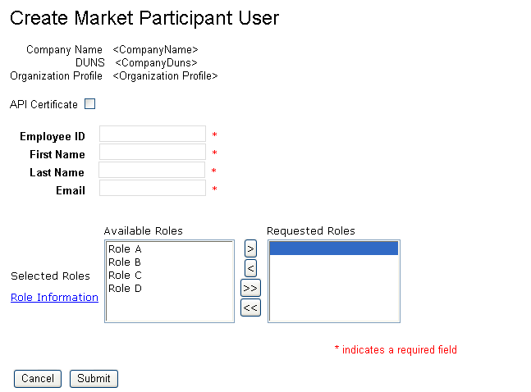

The following table shows the character limits and rules of allowable entries.

Field Name | Length/Type | Validation
Employee ID | 4/min  19/max  Alpha-Numeric | - Unique within the MP entity  - Should not contain any symbols  - Should not contain any spaces
First Name | 30/Alpha-numeric | Should not contain any symbols
Last Name | 30/Alpha-numeric | Should not contain any symbols
Email | 100/Alpha-numeric | Must contain an “@” and “.’

- MP USA fills out the required fields and assigns roles.
- MP USA clicks “Submit” button and the request is processed
- After the user account is successfully created, the following e-mail is sent to the User. The notification is sent to the e-mail address provided during account creation.
- Once the user account is created, and their roles need to be updated, then go to ‘Modified’ and add/remove the roles from the user’s account.

**NOTE**: If the EDC is not retrieved in five days, then the password will expire and the User must contact the MP USA for reissuance.

**See Section 5 for assignment of roles for NMMS, EMS MOTE and SOTE.

Successful User Account Creation Email:
From: helpdesk@ercot.com
Date: 10/01/2007 12:00 PM
To: user@ercot.com
Cc:
Subject: MPIM Notification: User Creation <User First Name User Last Name>

Dear <User (First Name Last Name)>,

Your account has successfully been created. Please contact your User Security Administrator (USA) <Requestor (First name Last Name)>, regarding the information for your account.”

If you have a question related to this email, please contact your USA.

Thank you, MPIM Administrator

The MP USA will be returned to the Market Participant Identity Management screen.

  - Create Application Programming Interface (API) MPIM Account
In order to create an API account within the MPIM system, the MP USA must be at the MPIM home page (shown below).

- MP USA clicks on the Create link.

MPIM presents the Create Market Participant User page with the Company Name, DUNS Number and Organization Profile pre-populated.

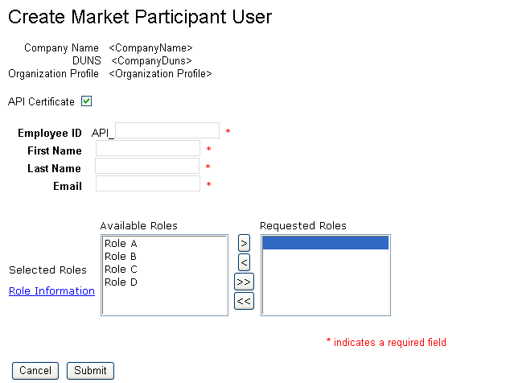

The following table shows the character limits and rules of allowable entries.

Field Name | Length/Type | Validation
Employee ID | 4/min  19/max  Alpha-Numeric | - Unique within the Entity  - Should not contain any symbols  - Should not contain any spaces
First Name | 30/Alpha-numeric | Should not contain any symbols
Last Name | 30/Alpha-numeric | Should not contain any symbols
Email | 100/Alpha-numeric | Must contain an “@” and “.’

- MP USA checks the “API” box, fills out the required fields, assigns roles and clicks on the “Submit” button.
- After the user account is successfully created, the following e-mail is sent to the User. The notification is sent to the e-mail address provided during account creation.

Successful User Account Creation Email:
From: helpdesk@ercot.com
Date: 10/01/2007 12:00 PM
To: user@ercot.com
Cc:
Subject: MPIM Notification: User Creation <User First Name User Last Name>

Dear <User (First Name Last Name)>,

Your account has successfully been created. Please contact your User Security Administrator (USA) <Requestor (First name Last Name)>, regarding the information for your account.”

If you have a question related to this email, please contact your USA.

Thank you, MPIM Administrator

The MP USA will be returned to the Market Participant Identity Management screen.

  - Certificate Management
    - Creating User Certificate in MPIM
In order to create a user certificate within the MPIM system, the MP USA must be at the MPIM home page (shown below).

- MP USA clicks on the Certificates link.

MPIM presents the Certificate Management page with the Company Name, DUNS Number and Organization Profile pre-populated and the “Request Certificate” radio button pre-selected.
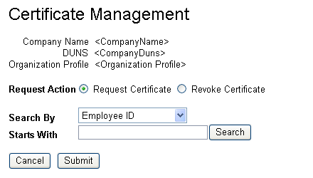

- MP USA enters search parameters for a User (employee id, first name, or last name).
- MP USA clicks the “Search” button.

MPIM returns the search results in table format.

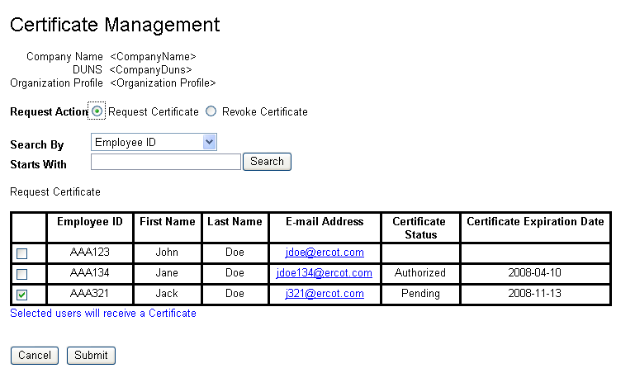

- MP USA checks the boxes of the User(s) for whom certificates should be generated.
- MP USA clicks the “Submit” button.

The selected User(s) receive two e-mails with information on how to retrieve their Digital Certificate. (Please see Section 4.5.2 below for details on this process).

The MP USA is returned to the Market Participant Identity Management home page screen.

    - User Certificate Retrieval
This section assumes the MP USA has completed the steps defined in Section 4.5.1 and expands on the information in step 5 of the EDC request process.

**NOTE**: If the EDC is not retrieved in five days, then the password will expire and the User must contact the MP USA for reissuance.

- Once the “Create Certificate” request is processed, the User will receive the following e-mail with the certificate URL password and certificate download link:

Certificate Password e-mail:

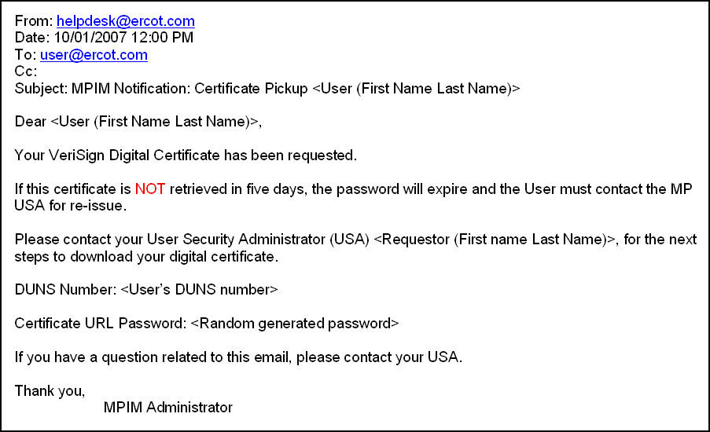

- To download the certificate, the user will click on the link provided in the Certificate URL e-mail (shown below).

Certificate URL e-mail

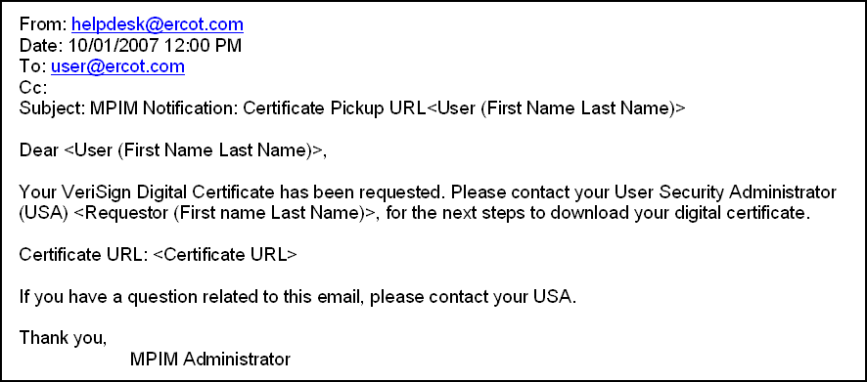

- The user will be prompted to provide an Employee ID, DUNS Number and Password. 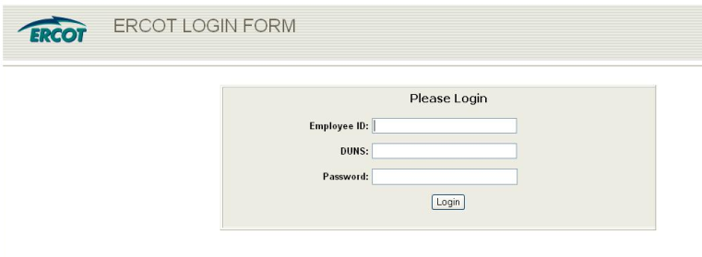

- The user must contact his/her MP USA for the DUNS and Employee ID. The password was provided via e-mail (please see step 2 of this section).
- The EDC site will authenticate the credentials and prompt the User to accept the website and the user will click the “Yes” button.

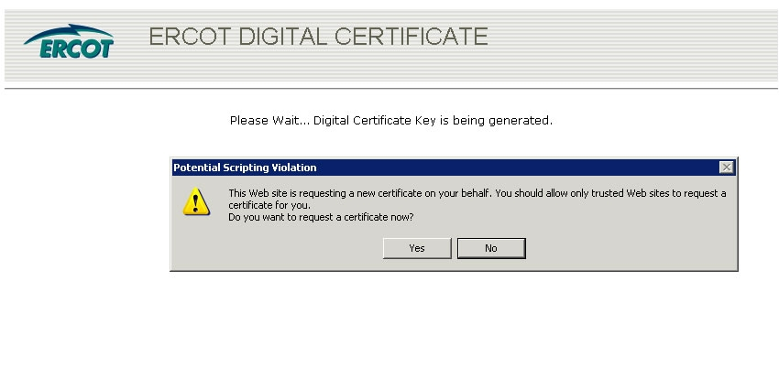
- The User will be prompted by a window asking him/her to accept the creation of the RSA exchange key. the User should click the “OK” button.

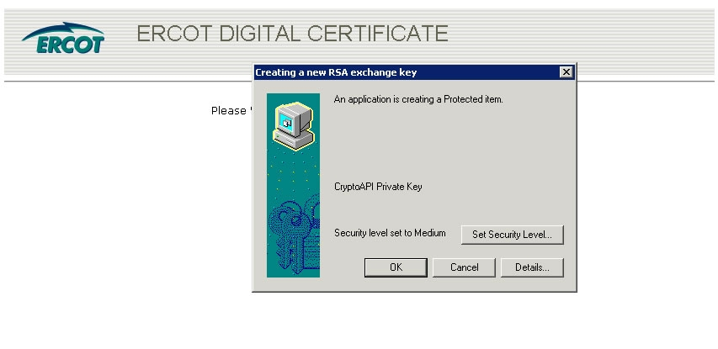

EDC will present the user with a screen stating that the certificate is being issued.

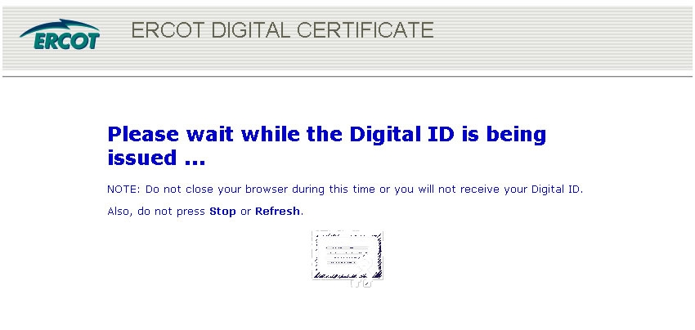

- Once the certificate has been generated, the User will be asked if it is okay to install the EDC on the machine; the User should click the “Yes” button.

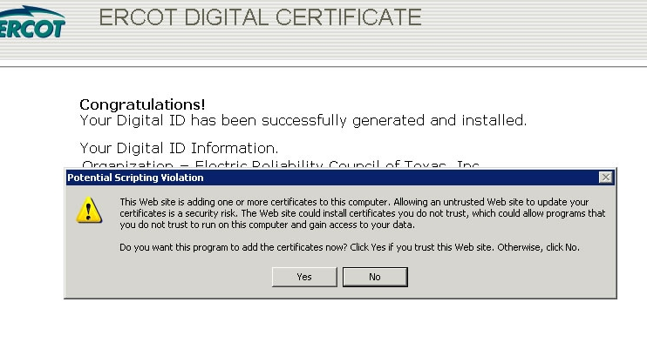

The User will be presented with a final screen with the installed digital certificate information.

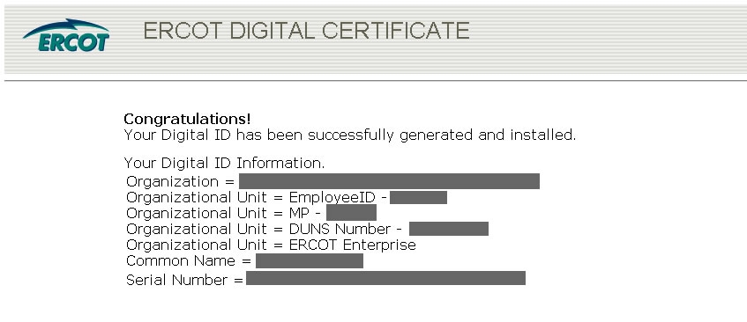

    - Viewing Certificate Details
To view details (Expiration Date, Name of Certificate, EID, and DUNS) of all the EDCs installed on a computer:

1.) Open Internet Explorer
2.) On the taskbar, go to Tools>>Internet Options
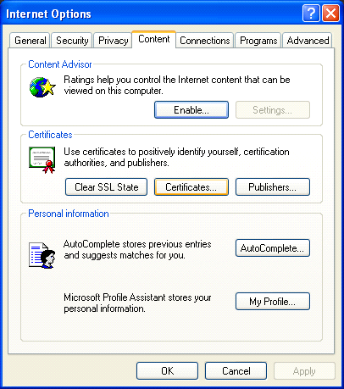
3.) In the window that pops up (shown below) click on the Content tab.

4.) Click on Certificates.
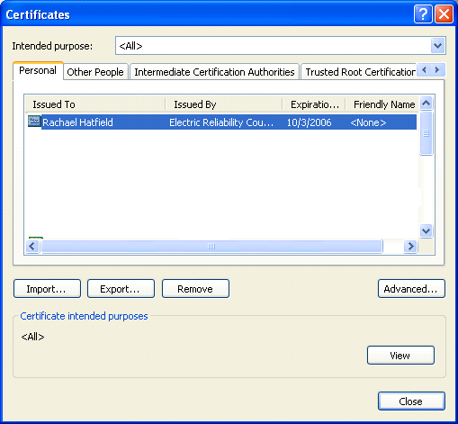
5.) The Certificates window will show all the EDCs you have installed on that computer.

**NOTE**: The expiration date is available on the Certificate window.
6.) Highlight the EDC and click on “View” to see the details.

7.) Click on the “Details” tab within the next window (shown below).
8.) Highlight the subject line. All details for the certificate are available here.
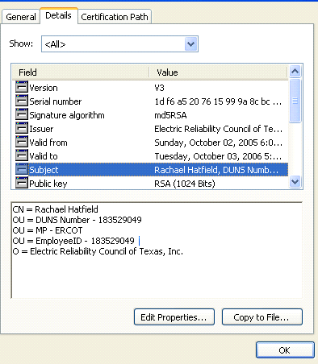

**NOTE**: The details of an EDC should be included in all communications with ERCOT.

    - Lost or Corrupt Certificate
In cases of lost or corrupt MP USA certificates, please contact the ERCOT helpdesk at (512) 248-6800 for EDC reissuance. If a User requires a new EDC, then s/he will need to contact his/her MP USA.

    - Certificate Renewal
A renewal email is sent thirty (30) days prior to the expiration date of the digital certificate. In the event that the digital certificate has not been renewed, then a final email notification will be sent seven (7) days before the expiration date.

- To download the certificate, the user will click on the link provided in the Certificate URL e-mail (shown below).

Certificate URL e-mail
From: lraa
Sent: Tuesday, February 10, 2009 5:52 AM
To: <User (First Name Last Name)>
Subject: Your Digital Certificate is about to expire

Dear <User (First Name Last Name)>

Your VeriSign Digital Certificate will expire on MM/DD/YYYY. Please follow the link below to renew your Verisign Digital Certificate. If you have already renewed your VeriSign Digital Certificate, please ignore this notice.

Failure to renew your VeriSign Digital Certificate before or on the expiration date will require a re-issuance of your Digital Certificate. If you are a USER and have a question related to this email or your certificate has expired, please contact your company’s USA. If you are a USA and have a question related to this email or your certificate has expired, please contact your ERCOT Account Manager.

For Renewal, please visit
https://mistest.ercot.com:8443/edc/client/edcUserRenewMultiple.asp

Thank you,
MPIM Administrator

**NOTE**: Expired Digital Certificates will need to be revoked and reissued by ERCOT USA or MP USA.

2.) Select the appropriate digital certificate and then click ok.

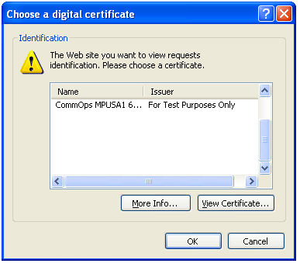

3.) Click Ok again

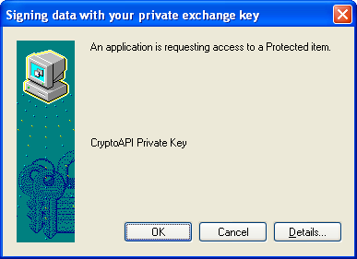

4.) Click on the Renew button to search for the digital certificate in the browser.

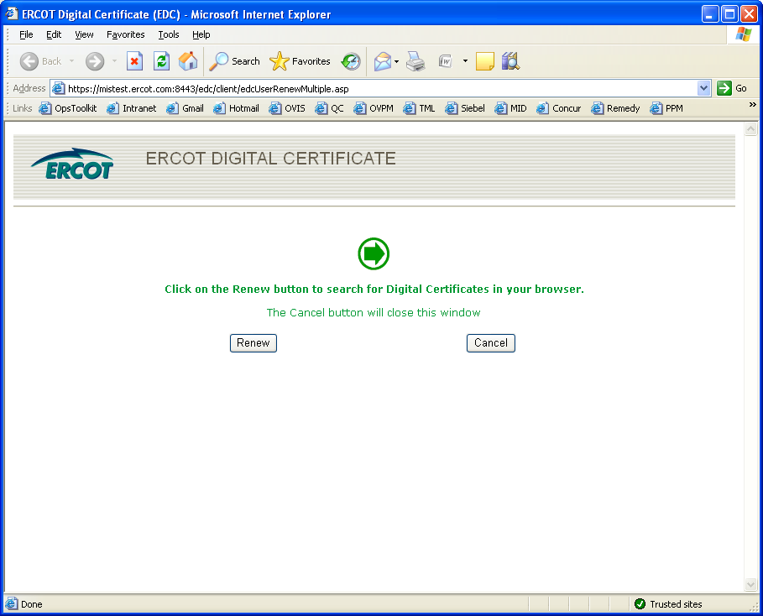

5.) The User will be presented with a final screen with the installed digital certificate information.

    - Troubleshooting Renewal Certificate
Possible issues when renewing a Digital Certificate.

1.) After clicking renewal button Error Message below is displayed.

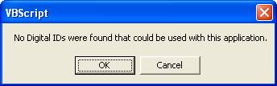

**NOTE**: An older version of a Verisign ActiveX Add-On is being detected in your browser.

1.1) Resolution for Problem 1:

1) Close all Internet Explorer sessions.
2) Open a local Windows Explorer to: C:\WINDOWS\Downloaded Program Files
3) Locate a file named: VSPTA.class.
4) Select it and delete it.
5) Open a browser session to the EDC certificate renewal page.
6) Click on the Renew button.
7) You should see a window with a list of certificates that are about to expire and can be renewed. NOTE: Expired certificates will not show in this window and cannot be renewed.

1.2) Alternate Resolution for Problem 1:

ERCOT’s certificate vendor, VeriSign, has provided an Enterprise Solution that takes the place of the Active-X requirement. This Windows installation file can be downloaded by following the link provided and either installed directly or distributed to the end users for installation.

https://mis.ercot.com/misdocs/idm/OnSiteMSI.msi

Deploy the MSI Packages

There are four methods for deploying the MSI packages:

􀂄 Publish software to a user. When you publish software to a user, you make it available to the user for installation through the Add/Remove Programs utility in the Control Panel the next time the user logs in. The user launches the Add/Remove Program utility, clicks Add New Programs, and chooses to add the published software. This completely installs the software on the user's machine. The user does not need to be a power user or have any special privileges to install published software.
􀂄 Assign software to a user. When you assign software to a user, it is partially installed the next time the user logs in. The installation is completed the first time the user tries to use the software. This feature provides an install-on-demand mode of installation. The user does not need to be a power user or have any special privileges to completely install assigned software.
􀂄 Assign software to a machine. When you assign software to a machine, it is completely installed on the machine when the machine is rebooted. Once installed, the software is available to all users on that machine.
􀂄 Launch the MSI package. By double-clicking the MSI package, a user can install the software contained within the MSI package. However, the user needs to be an administrator on the machine where the installation is being launched in this mode. This mode does not require active directory or group policy support.

The first three methods of deployment, described in this section, require a Windows domain with an Active Directory. The administrator of this domain can specify how the software should be deployed (published to the user or assigned to user/machine) by specifying a group policy. The end-user machine where the software is installed must be one of the following:
􀂄 Windows XP
􀂄 Windows 2000

Publish the OnSiteMSI package to a user

The following steps outline the process for publishing the OnSiteMSI package to a user:

1 In the Active Directory, right-click the OU corresponding to the users to whom the software is to be published.
2 Select Properties.
3 In the Group Policy tab, select the Group Policy that applies to the OU if one exists, or create a new one if it does not.
4 Click Edit. This brings up another window that specifies the group policies.
5 Select User Configuration and expand the tree corresponding to this selection.
6 In the expanded tree, right-click Software Installation, then select New Package.
7 Select the MSI file that contains the software that should be published. A dialog box appears asking if the package should be published or assigned. Select Published.

Assign the OnSiteMSI package to a machine

The following steps outline the process for assigning the OnSiteMSI package to a machine:

1 In the Active Directory, right-click the OU corresponding to the machine to which the software is to be published.
2 Select Properties.
3 In the Group Policy tab, select the Group Policy that applies to the OU if one exists, or create a new one if it does not.
4 Click Edit. This brings up another window that specifies the group policies.
5 Select Computer Configuration and expand the tree corresponding to this selection.
6 In the expanded tree, right-click Software Installation, then select New Package.
7 Select the MSI file that contains the software to be published. A dialog box appears asking if the package should be published or assigned. Select Assigned.

Assign the OnSiteMSI to a user

The following steps outline the process for assigning the MSI package:

1 In the Active Directory, right-click the OU corresponding to the users to whom the software is to be assigned.
2 Select Properties.
3 In the Group Policy tab, select the Group Policy that applies to the OU if one exists, or create a new one if it does not.
4 Click Edit. This brings up another window that specifies the group policies.
5 Select User Configuration and expand the tree corresponding to this selection.
6 In the expanded tree, right-click Software Installation, then select New Package.
7 Select the MSI file that contains the software to be assigned. A dialog box appears asking if the package should be published or assigned. Select Assigned.
- Computer appears idle with no results.

2.1) Resolution for Problem 2: Follow the documentation below for the recommended IE6.x security settings. You must be an Administrator of your computer for these changes to take effect

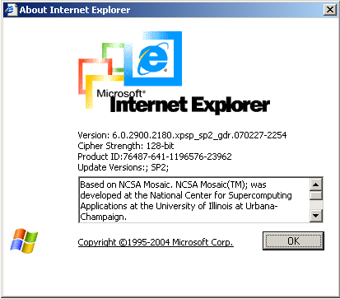

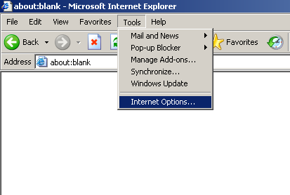

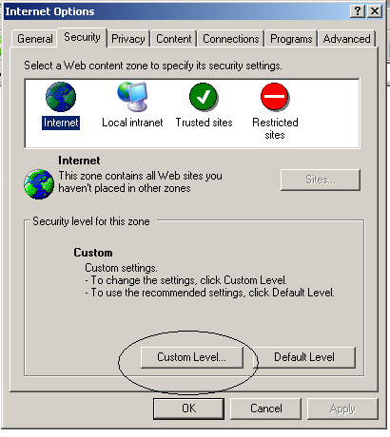

3.) Click on Reset button to reset to default Medium Level and then apply each individual setting as shown below.

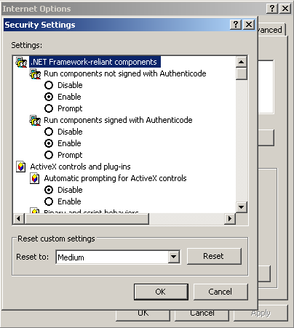

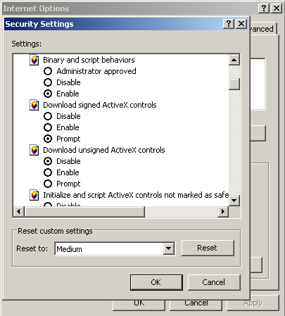

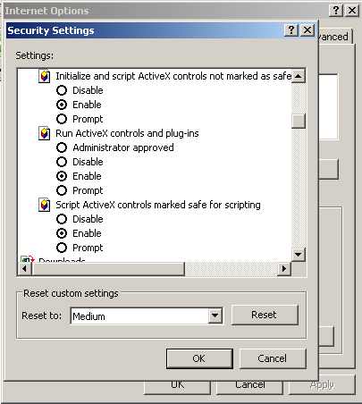

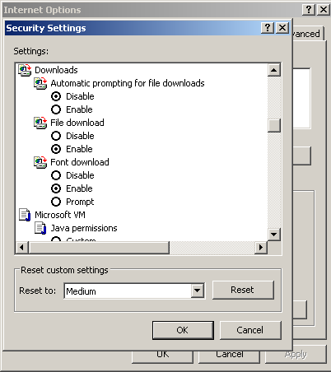

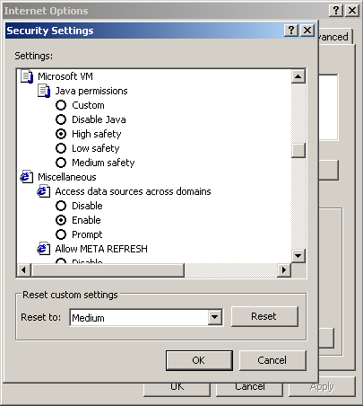

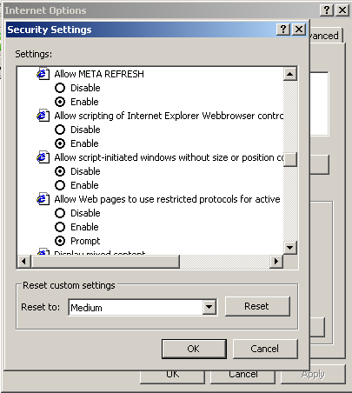

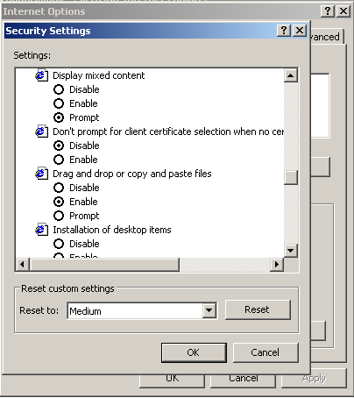

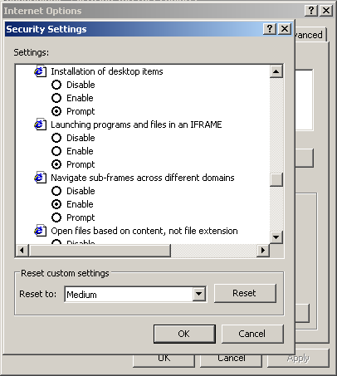

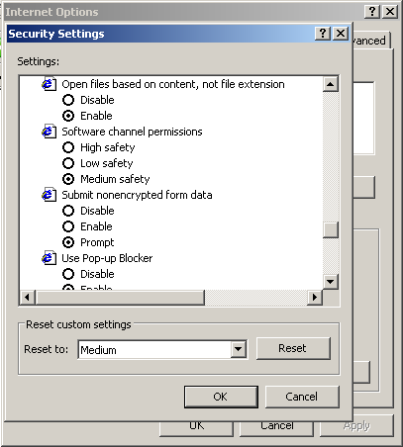

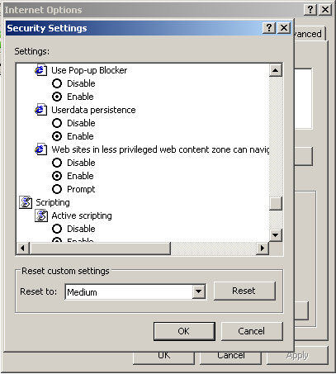

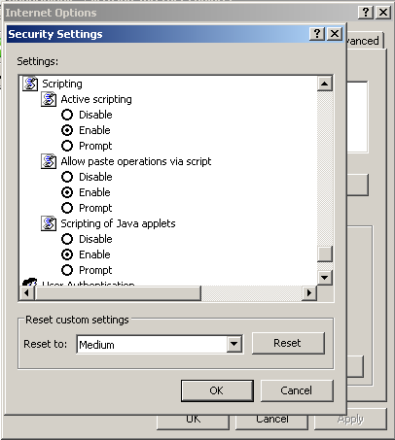

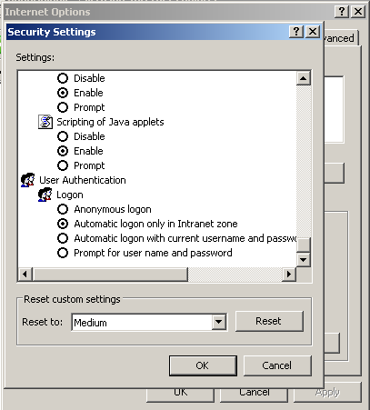

    - Revoking User Certificate in MPIM
**NOTE**: Revoking the certificate does not terminate the User’s MPIM account.

In order to revoke a User EDC, the MP USA must be at the MPIM home page (shown below).

- MP USA clicks on the Certificates link.

MPIM presents the Certificate Management page with the Company Name, DUNS Number and Organization Profile pre-populated and the “Request Certificate” radio button pre-selected.

- MP USA clicks the “Revoke Certificate” radio button.
- MP USA enters the search parameters for a User (employee id, first name, or last name).
- MP USA clicks the “Search” button.

MPIM returns the search results in a table format.
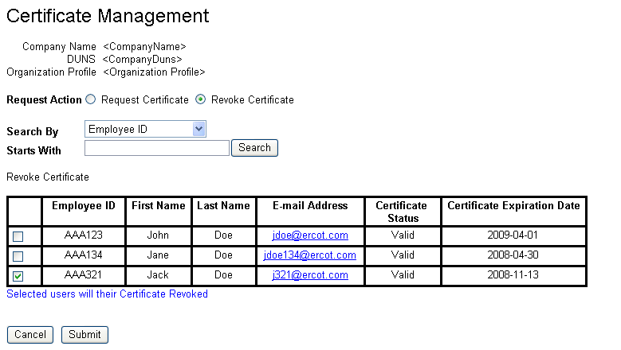

- MP USA checks the boxes of the User(s) for whom EDCs should be revoked.
- MP USA clicks on the “Submit” button.
- A confirmation box will appear with “Are you sure you wish to revoke these certificates?”
- Select Yes or No.

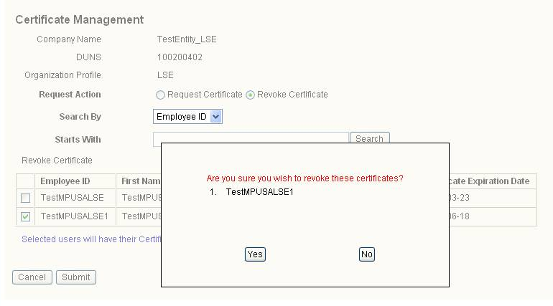

- MPIM revokes the Users’ EDCs.
- Once the EDC revocation request is complete, the MP USA will receive the following email:

Certificate Revoke E-mail:

From: helpdesk@ercot.com
Date: 10/01/2007 12:00 PM
To: Requestor@ercot.com
Cc:
Subject: MPIM Notification: Certificate Revoked <User (First Name Last Name)>

Dear <Requestor (First Name Last Name)>,

The certificate belonging to <User (First Name Last Name)> has successfully been revoked.

If you have a question related to this email, please contact the ERCOT Help Desk at (512) 248-6800 .

The MP USA is returned to the Market Participant Identity Management screen.

  - Modifying a User and API MPIM Account with Roles
In order to modify a User account in the MPIM system, the MP USA must be at the MPIM home page (shown below).

- MP USA clicks on the Modify link.

MPIM presents the Search Market Participant User page with the Company Name, DUNS Number and Organization Profile pre-populated.

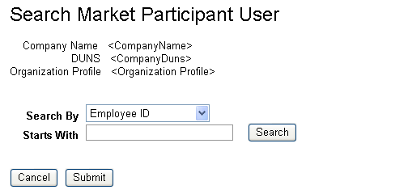

- MP USA enters search parameters for a User (employee id, first name, or last name).
- MP USA clicks the “Search” button.

MPIM generates the search results in a pull down menu.

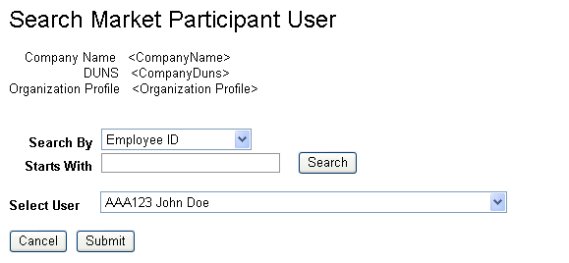

- MP USA selects a User.
- MP USA clicks on the “Submit” button.

MPIM presents the Modify Market Participant User Page with the Company Name, DUNS, Employee ID and Organization Profile pre-populated.

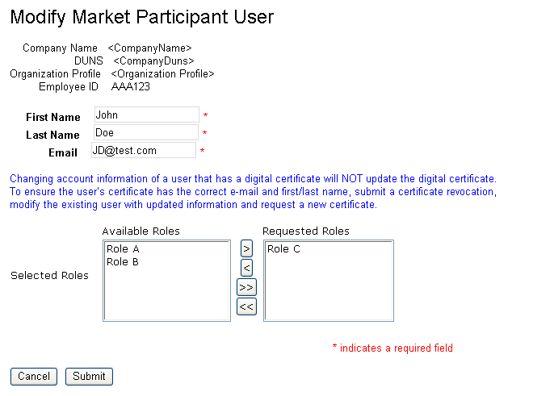
Adds a selected role
Removes a selected role
Adds all roles
Removes all roles

**NOTE**: The Role Information link will provide additional information on the roles.

The following table shows the character limits and restrictions for account modification.

Field Name | Length/Type | Validation
First Name: | 30/Alpha-numeric | First Name
Last Name: | 30/Alpha-numeric | Last Name
Email: | 100/Alpha-numeric | Must contain an “@” and “.’

- MP USA modifies the required fields if needed.
- MP USA modifies roles (see above on role selection and removal).
- MP USA clicks on the “Submit” button.
After the user account is successfully modified, the following e-mail will be sent to the User.

**NOTE**: The assignment of roles may generate additional e-mails.

Successful User Account Modification e-mail:

From: helpdesk@ercot.com
Date: 10/01/2007 12:00 PM
To: user@ercot.com
Cc:
Subject: MPIM Notification: User Modified <User (First Name Last Name)>

Dear <User (First Name Last Name)>,

Your account has successfully been modified. Please contact your User Security Administrator (USA) <Requestor (First name Last Name)>, regarding the information for your account.”

If you have a question related to this email, please contact your USA.

Thank you,
MPIM Administrator

User is taken back to the Market Participant Identity Management Home Page.

  - Terminating a MPIM User Account
**NOTE**: Terminating a User will not only remove the User from the MPIM system, but will also revoke the User’s EDC and roles.

**NOTE**: Once a User is terminated, the account cannot be reactivated. A new account must be created for the User.

In order to terminate a User account within the MPIM system, the MP USA must be at the MPIM home page (shown below).

- MP USA clicks on the Terminate link.

MPIM presents the Terminate Market Participant User page with the Company Name, DUNS Number and Organization Profile pre-populated.

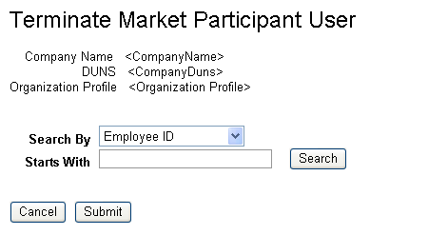

- MP USA enters search parameters for a User (employee id, first name, or last name).
- MP USA clicks the “Search” button.

MPIM returns the search results in table format.
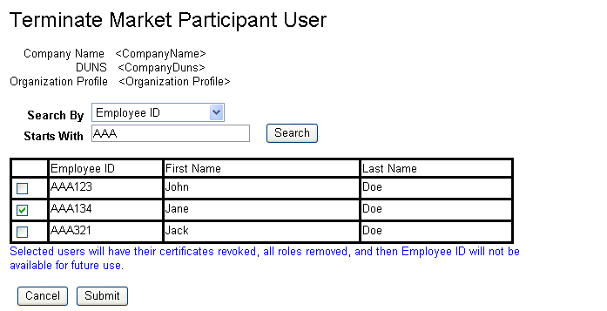

- MP USA checks the boxes of the User(s) to terminate.
- MP USA clicks on the “Submit” button.
- A confirmation box will appear with “Are you sure you wish to terminate these users?”
- Select Yes or No.

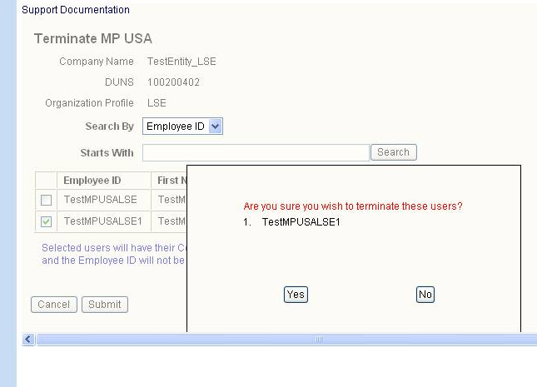

The User’s VeriSign Certificate is revoked, the roles are removed, and the account is disabled in MPIM.

MPIM sends a revoke certificate email. (Please see section 4.5.7 Revoking User Certificate in MPIM for the e-mail text)

MPIM sends a successful notification to the MP USA (an example of the e-mail is below).

User Termination e-mail:

From: helpdesk@ercot.com
Date: 10/01/2007 12:00 PM
To: Requestor@ercot.com
Cc:
Subject: MPIM Notification: User Disabled <User (First Name Last Name)>

Dear <Requestor (First Name Last Name)>,

The account belonging to <User (First Name Last Name)> has successfully been disabled. If the User had any application accounts and/or a certificate, the accounts have been disabled and certificate has been revoked.

If you have a question related to this email, please contact the ERCOT Help Desk at (512) 248-6800 .

Thank you,
MPIM Administrator

  - Reporting
    - Report Types and Data
The MPIM makes the following reports available:
- Current Status Report (all active accounts for a DUNS)
- Full Report (entire history of all accounts and EDCs for a DUNS number)

The Current Status Report lists all valid Users in MPIM for a specific DUNS number.
The Full Report lists all Users for the DUNS number of the MP USA.

The following information will be provided per User in the Current Status and Full reports:
- First Name
- Last Name
- DUNS number
- Employee ID
- E-Mail Address
- Account State
- Roles Assigned
- Admin Role Assigned (This will be blank for most users.)
- Certificate State
- Certificate Expiration Date
- NERC Certification Date (This field will not be populated.)

The MP USA can view the reports in the following formats: on screen (HTML), CSV (viewable in Excel) and a PDF document. Please see Section 4.8.2 for information on how to view the reports.

    - Downloading the report
In order to view a report from the MPIM system, the MP USA must be at the MPIM home screen shown below.

- MP USA clicks on the Reports link.

MPIM presents the Market Participant User Reports page with the Company Name, DUNS Number and Organization Profile pre-populated.

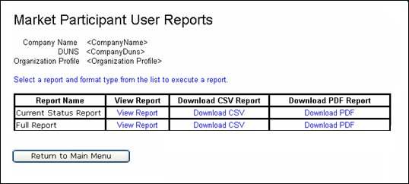

In order to view a report from the MPIM system, the MP USA must be at the MPIM home screen shown below.

- MP USA clicks on the Reports link.

MPIM presents the Market Participant User Reports page with the Company Name, DUNS Number and Organization Profile pre-populated.

- MP USA clicks the link for the desired Report Name.

Note: When downloading a report in CSV format and your organization’s ERCOT registered unique identifier (DUNs number plus four) contains 13 digits, it will appear in scientific notation. Also, the unique identifier begins with a zero; the leading zeros will be cut off. To correct this in the downloaded MPIM reports, please follow the steps below.

  - MP USA right clicks on desired Report type and clicks on “Save Target” to a desired location.
  - Open Excel and click on Data Tab.
  - Select Import External Data.
  - Click on “Import Data”.
  - Go to the desired file to be imported and click Open to import the file.
  - The text import wizard should appear, choose file type as Delimited.

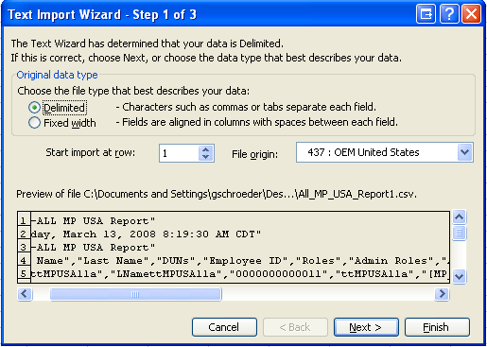

  - Select Delimiters as “Tab” and “Comma” and Click “Next”.

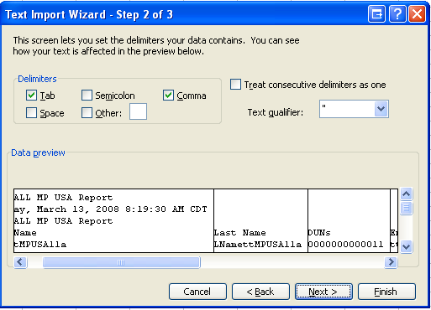

  - In “Data preview” select the third column and in “Column Data Format,” select “Text” and click “Next” and “Finish”.

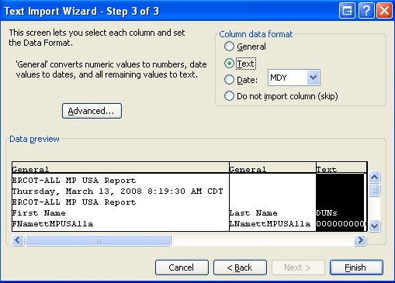

  - Click “OK” to import the data into Excel and the DUNS number should display correctly.

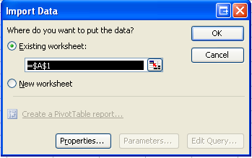

4.8.2.1 Troubleshooting errors with Downloading Reports.
Resolution for Reports Timing Out and Not Downloading:

Follow the documentation below for the recommended IE6.x security settings. You must be an Administrator of your computer for these changes to take effect

Click on the Advanced tab and apply the setting below.

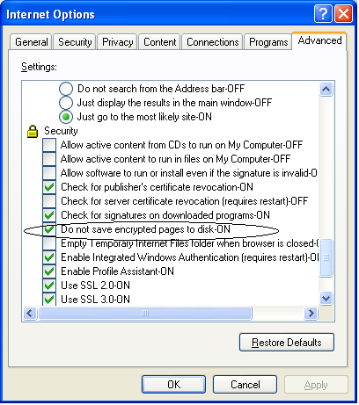

Click OK to save all changes. You now need to close all browsers to make the changes effective.

- TSP GATEWAY
- USA to assign the role for NMMS to remote users

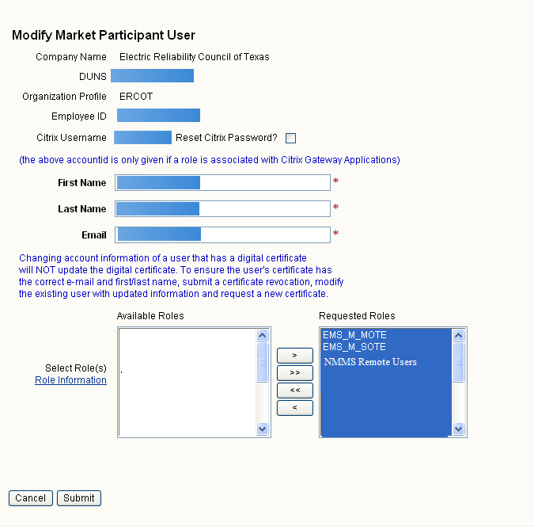
- Email below will be sent to the User notifying them that their account has been modified with the new role.

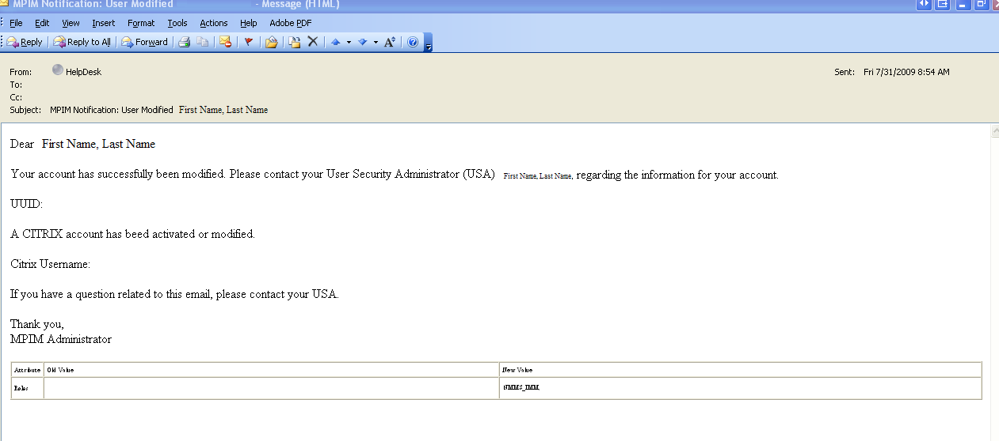

- The Citrix account has been created and an email will be sent with the Citrix Password (see below).

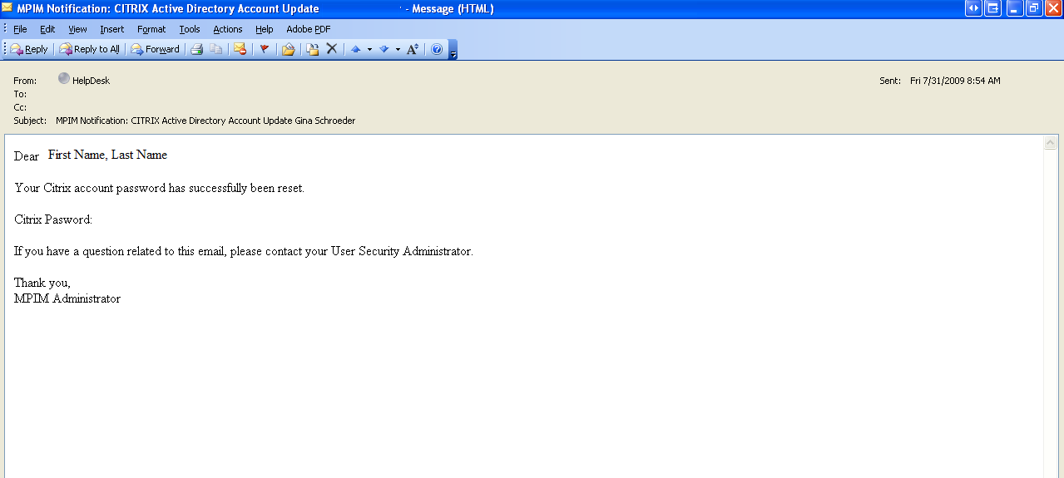

- Once the Citrix account has been created, the following email will be sent to confirm creation.

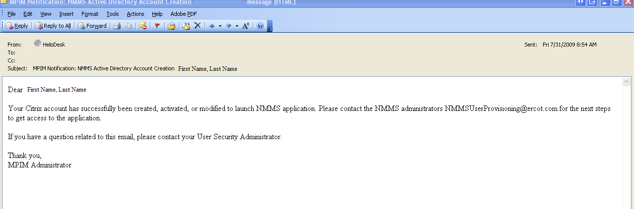
- An email will be sent to the Administrator for an individual User Account to be created to be able to access applicable Database.
    - EMS_M_MOTE
    - EMS_M_SOTE
    - NMMS_REMOTE_USER

- Logging in to Citrix

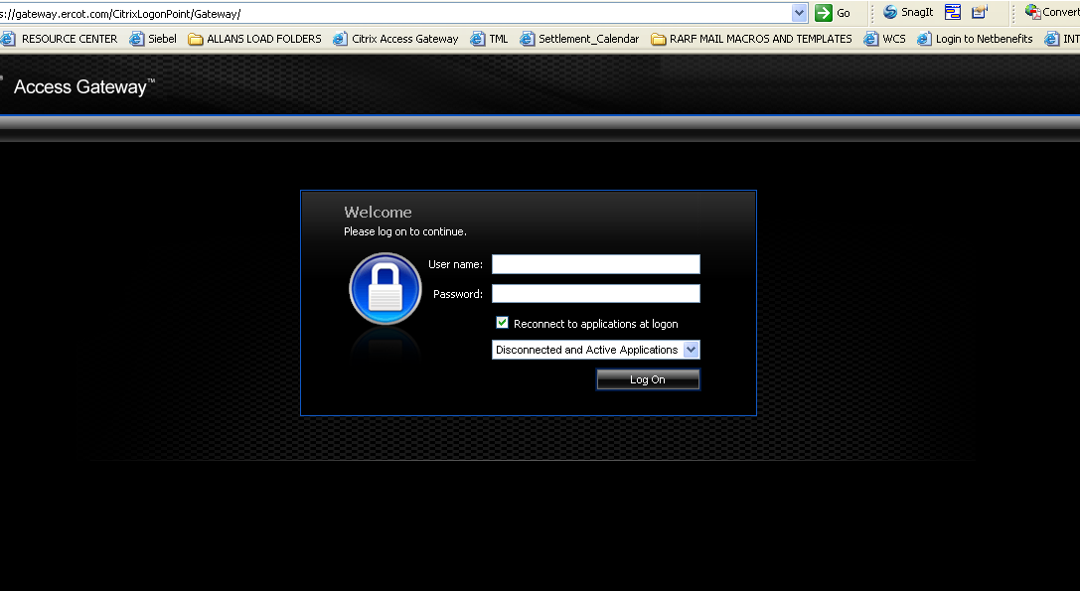
- User is required to change password.

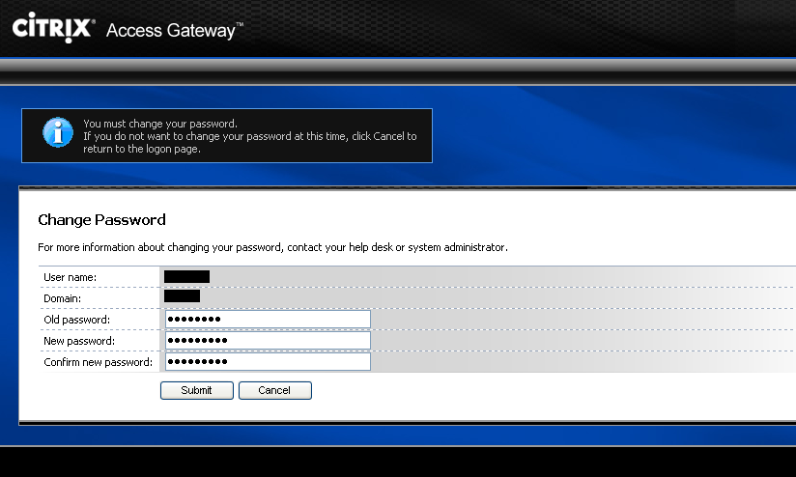

- Access to NMMS and EMS SOTE/MOTE Database

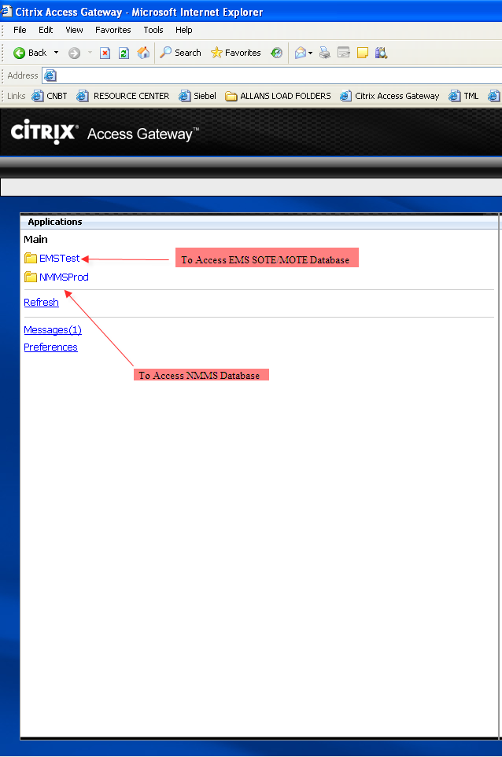

*** Note: Users will NOT be able to login to the NMMS production system until they have received an email from the NMMS team stating that their access has been granted and in no case earlier than SEM Go-Live on August 31, 2009

- Once you have your Citrix account and password, you may login to WEBFG. See the login procedures listed below:

Supporting Reference Documents

The referenced documentation, Protocol Section 16.11 and the NCI form can be found at:

Protocol reference 16.11: User Security Administrator and Digital Certificates:
http://www.ercot.com/mktrules/protocols/current

NCI: http://www.ercot.com/services/rq/

TML Roles: Please call your ERCOT Account Manager to obtain a copy of the TML role definitions and functions.

For updated documentation, contact your ERCOT Account Manager.

