ERCOT Operations Report
April 2010 ROS & OWG

Frequency Control
Time | Freq(Hz) | Duration (s)
4/3/2010 6:24 | 59.723 | 104 | Unit trip with 817 MW
4/4/2010 10:44 | 59.868 | 7 | Unit trip with 417 MW
4/7/2010 0:33 | 59.789 | 160 | Unit trip with 809 MW and 232 MW
4/7/2010 1:31 | 60.104 | 4 | SCE +628 MW in 15 min. Out of Down Regulation. Wind generation increased 2000 MW in 60 min.
4/7/2010 2:06 | 60.152 | 411 | SCE +1105 MW in 15 min. Out of Down Regulation. Wind generation increased 2000 MW in 60 min.
4/8/2010 12:26 | 59.890 | 6 | Unit trip with 345 MW
4/9/2010 21:32 | 59.885 | 3 | Unit trip with 373 MW
4/12/2010 0:35 | 59.844 | 68 | Unit trip with 479 MW
4/12/2010 11:42 | 59.854 | 55 | Unit trip with 455 MW
4/14/2010 7:35 | 59.844 | 32 | Unit trip with 554 MW
4/23/2010 23:59 | 60.104 | 4 | SCE +630 MW in 15 min. Out of Down Regulation. Generation schedules changing after offset calculation.
4/24/2010 0:04 | 60.160 | 612 | SCE +630 MW in 15 min. Out of Down Regulation. Generation schedules changing after offset calculation.
4/28/2010 2:08 | 60.103 | 4 | SCE +330 MW in 15 min. Out of Down Regulation. Load dropped by 225 MW in 15 min.
Note: Time of frequency excursions outside the range of +/- 0.1 Hz.

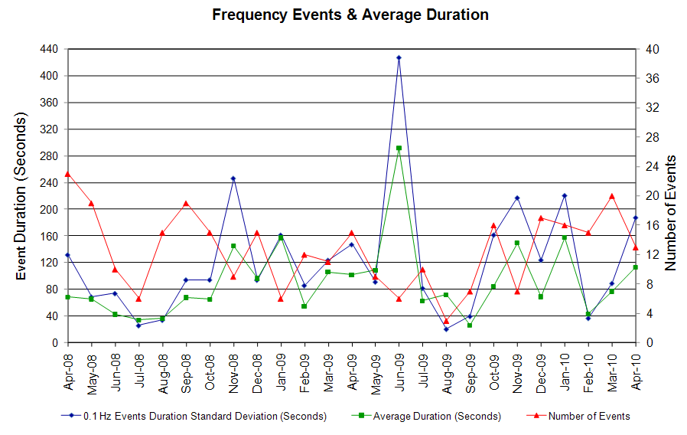
Deployed Responsive (Reported Above)
Time deployed | Stop Time | Duration | Max | Details
4/2/10 6:17:53 | 4/2/10 6:26:54 | 0:09:01 | 341.52 | Unit Trip
4/3/10 6:24:03 | 4/3/10 6:56:54 | 0:32:51 | 1151.00
4/4/10 10:44:39 | 4/4/10 10:58:54 | 0:14:15 | 544.28
4/4/10 21:03:41 | 4/4/10 21:22:40 | 0:18:59 | 357.52 | Incorrect offset calculation
4/5/10 3:19:59 | 4/5/10 3:35:38 | 0:15:39 | 362.85 | DC Tie Trip
4/5/10 13:21:47 | 4/5/10 13:29:12 | 0:07:25 | 325.50 | Unit Trip
4/7/10 0:33:47 | 4/7/10 1:04:06 | 0:26:13 | 965.81
4/7/10 7:16:02 | 4/7/10 7:21:06 | 0:05:04 | 330.83 | Unit Trip
4/7/10 8:20:37 | 4/7/10 8:30:32 | 0:09:55 | 368.19 | Incorrect offset calculation
4/8/10 12:26:47 | 4/8/10 12:42:32 | 0:15:45 | 426.89
4/9/10 21:32:03 | 4/9/10 21:40:18 | 0:08:15 | 453.58
4/11/10 21:18:37 | 4/11/10 21:25:40 | 0:07:03 | 336.17 | Unit Trip
4/12/10 0:35:03 | 4/12/10 0:53:01 | 0:17:58 | 672.33
4/12/10 11:42:23 | 4/12/10 11:56:30 | 0:14:07 | 618.98
4/14/10 7:35:51 | 4/14/10 7:51:56 | 0:16:05 | 672.33
4/14/10 23:48:49 | 4/15/10 0:09:04 | 0:11:11 | 341.52 | Slow unit response
4/17/10 20:49:03 | 4/17/10 20:54:32 | 0:05:29 | 352.19 | Unit Trip
4/23/10 11:08:37 | 4/23/10 11:33:21 | 0:24:44 | 325.5 | Out of up regulation.
4/24/10 21:10:27 | 4/24/10 21:16:48 | 0:06:21 | 325.5 | Unit Trip

Day-Ahead OOMC and RPRS Capacity Purchases
Details | OOMC | RPRS S1 | RPRS S2 | RPRS S1+S2 | RMR | Total
DFW | 112 | 0 | 0 | 0 | 0 | 112
Western | 0 | 3 | 0 | 3 | 2 | 5
North | 2 | 0 | 0 | 0 | 0 | 2
Houston | 0 | 0 | 0 | 0 | 0 | 0
W RIO | 0 | 0 | 0 | 0 | 0 | 0
Austin | 0 | 0 | 0 | 0 | 0 | 0
San Antonio | 0 | 0 | 0 | 0 | 0 | 0
E RIO | 0 | 0 | 0 | 0 | 0 | 0
South | 0 | 0 | 0 | 0 | 0 | 0
Corpus | 0 | 0 | 0 | 0 | 0 | 0
Bryan Area | 0 | 0 | 0 | 0 | 0 | 0
Laredo | 0 | 0 | 0 | 0 | 0 | 0
Northeast | 0 | 0 | 0 | 0 | 0 | 0
Total | 114 | 3 | 0 | 3 | 2 | 119

Historical Totals | Apr-10 | Apr-09 | Mar-10
Austin | 0 | 28 | 7
Bryan Area | 0 | 0 | 0
Corpus | 0 | 8 | 0
DFW | 112 | 11 | 61
E RIO | 0 | 4 | 0
Houston | 0 | 9 | 1
Laredo | 0 | 12 | 0
North | 2 | 12 | 3
Northeast | 0 | 0 | 0
San Antonio | 0 | 0 | 1
South | 0 | 2 | 0
W RIO | 0 | 99 | 10
Western | 5 | 5 | 8
Total | 119 | 190 | 91
http://www.ercot.com/mktinfo/services/rprsdr/index.html

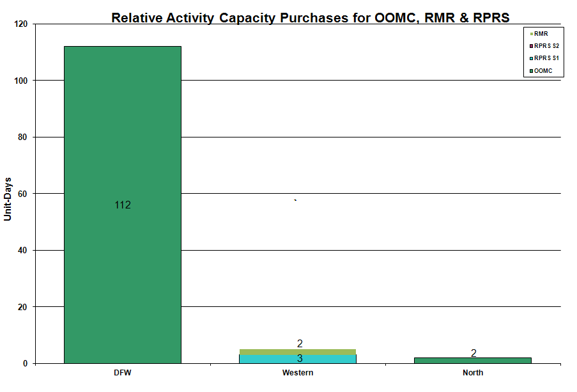

OOME and Congestion Management Activity
Congestion affected by outages Remedial action plan has been developed for the element
Contingency | Overloaded Element | Days
Hamilton Road - Sonora 138KV | Sonora - Friess Ranch 69KV | 20
Base Case | Matador - Paducah 69KV | 19
Fort Mason - Gillespie and Yellow Jacket 138KV | Yellow Jacket - Hext 69KV | 8
Graham SES - Long Creek Switching Station & Cook Field Road Switching Station 345KV | Putnam - Cisco 69KV | 8
Midkiff Switch - Sprayberry 138KV | Midkiff Switch - Reagan Shell Tap 69 KV | 8
Aspermont - Spur 138KV | Spur 138/69 KV AT | 7
Graham SES - Parker Switch 345KV | Barton Switch - Oran TU 138KV | 7
Jack County - Hill Top 138KV | Rhome TU - Decatur Tap 138KV | 6
Graham - Parker 345KV | Flat Creek - Leon Switch 138KV | 6
Pawnee - Lon Hill 345KV | Rincon - Airco CSW 138KV | 6
Abilene Mulberry Creek - Bitter Creek & Long Creek Switching Station - Sweetwater Generating Plant 345KV | Trent - Merkel 69KV | 4
Base Case | ENA Snyder - WKN_Breaker 69KV | 4
Graham SES - Long Creek Switching Station & Cook Field Road Switching Station 345KV | Comanche Switch - Comanche Tap 138KV | 4
Roanoke Switch - West Denton and Lewisville Switch 345KV | West Denton - Airport TMPP 138KV | 3
Base Case | Eskota Switch 138/69KV AT | 3
DuPont Switch - Ingleside Switch 138KV | Ingleside Cogen Switch - Ingelside DuPont 2 138KV | 3
Odessa EHV - Morgan Creek - Quail Switch 345KV | Big Spring Switch - Big Spring West 138KV | 3
Pearsall - San Miguel 138KV | Pearsall 138/69 KV AT | 3
Roanoke Switch - West Denton and Lewisville Switch 345KV | West Denton - Pockrus 138KV | 3
Santa Anna - Ballinger 138KV | Ballinger - Humble Ballinger 69KV | 3
Abilene Mulberry Creek - Bitter Creek and Long Creek - Sweetwater Cogen 345KV | Sterling County - Sterling City 69KV | 2
Batesville - Pearsall 138KV | Uvalde - Downie1 138KV | 2
Paris Switch - Valley and Parker Switch - Valley South 345KV | Paris Switch 345/138KV AT | 2
Farmersville - Monticello 345kV | Allen Switch - Monticello 345KV | 2
Base Case | Stanton Switch - Big Springs 138KV | 2
Hamilton Road - Sonora 138KV | San Angelo Power Station -Santiago 138KV | 2
Midland East - Odessa 345KV | Odessa EHV 345/138KV autotransformer 1 | 2
Morgan Creek SES - Bitter Creek & Sweetwater Generating Plant 345KV | Trent - Scott Rea Tap 69KV | 2
Morgan SES - Quail Switch & Longshore 345KV | Big Spring West - Stanton Switch 138KV | 2
PH Robinson 345/138KV AT2 | PH Robinson 345/138KV AT1 | 2
Asherton - West Batesville 138KV | Batesville 138/69KV AT | 1
Aspermont - Spur 138KV | Spur - Girard Tap 69KV | 1
Austrop - Sandow Switch 345KV | Elgin Switch - Butler 138KV | 1
Roanoke Switch - West Denton and Lewisville Switch 345KV | West Denton - Teasley 138KV | 1
Victoria - Victoria DuPont Switch 138KV | Weaver Road - Green Lake 69KV | 1
Big Brown SES - Venus Switch 345KV | Richland Chambers - Trinidad SES 345K | 1
Dilley Switch - San Miguel Switch 138KV | Derby - Pearsall 69KV | 1
Graham SES - Long Creek Switching Station & Cook Field Road Switching Station 345KV | Putnam - Leon Switch 138KV | 1
Lon Hill - Weil Tract 138KV | Citgo West - Weil Tract 138KV | 1
Lon Hill - Weil Tract 138KV | Westside - McKenzie 138KV | 1
Long Creek - Sweetwater - Abilene Mulberry 345KV | Shiloh BEC - Hasse BEC POD 138KV | 1
Lytton Springs - Zorn and Austrop Zorn 345KV | McCarty Lane - Ranch Road 12 138KV | 1
Nelson Sharpe - Ajo 345KV | North Edinburg - Rachal 138KV | 1
Orange Grove - Lon Hill 138KV | Lon Hill - Smith 69KV | 1
Pawnee - Lon Hill 345KV | Sinton - Skidmore 69KV | 1
Sweetwater Generating Plant - Long Creek Switching Station & Morgan Creek SES - Champion Creek Switching Station 345KV | Abilene Mulberry Creek - Long Creek Switching Station 345KV | 1
Temple Pecan Creek - Tradinghouse & Temple Switch - Lake Creek SES 345KV | Goldthwaite - San Saba Switch 69KV | 1

Zonal OC1
CSC | Days
West – North | 17
North – Houston | 2
North – South | 1

New RAP, PCAP (Date indicates last update of RAP, PCAP not implementation date.)
4/28 Gillespie LCRA – Fort Mason – Yellow Jacket 138 kV (This RAP was proposed by AEP)

New Procedures/Forms/Operations Bulletins
None

Blackout/Load Shed Incidences
None

EEA
None

Major System Voltage Problems
None

Major Computer Problems, Enhancements & Fixes
4/01 10:54 Held IE 1100 Balancing Energy deployments for IE 1115 due to a Market Management System problem. Resumed with the IE 1130 deployments.

4/22 23:30 Held IE 2330 Balancing Energy deployments for IE 2345 due to a Market Management System problem. Resumed with the IE 2400 deployments.

Communication
None

ERCOT peak (Unofficial)
04/23 17:00 40,174 MW

Yearly MTLF Error Comparison
Yearly Mid-Term (Hourly) Load Forecast Error Comparison for the ERCOT Forecast
Month | MAPE for MTLF at 16:00 Day-Ahead
Month | 2007 | 2008 | 2009 | 2010
January | 4.55 | 3.30 | 4.11 | 3.78
February | 3.75 | 3.59 | 3.49 | 3.79
March | 2.70 | 3.29 | 3.24 | 2.24
April | 3.00 | 2.45 | 2.66 | 2.47
May | 3.22 | 3.01 | 2.90 | NA
June | 4.46 | 2.81 | 2.89 | NA
July | 4.29 | 2.55 | 2.83 | NA
August | 3.11 | 3.66 | 3.07 | NA
September | 3.78 | 4.99 | 3.68 | NA
October | 3.08 | 2.79 | 2.92 | NA
November | 2.95 | 2.60 | 1.93 | NA
December | 3.74 | 4.54 | 3.70 | NA
Annual Average | 3.55 | 3.29 | 3.11 | 3.07

OCN, Advisory, Watch & Emergency Notices
Capacity
Date | Start | End | Event
4/2/10 | 9:16 | 10:45 | Advisory for ARRS below 3000 MW.
4/4/10 | 11:00 | 20:50 | OCN issued for projected reserve capacity shortage for HE 19 - 23.
4/12/10 | 11:45 | 16:00 | Advisory issued due to ARRS below 3000 MW.
4/23/10 | 7:12 | 10:30 | Advisory issued for ARRS below 3000 MW.
4/23/10 | 12:54 | 19:17 | Advisory issued for ARRS below 3000 MW.

Transmission Watch
4/1 – 4/30 00:15 Transmission Watch issued due to forced outage at Gail substation. Implemented Block Load Transfer up to 2 MW from ERCOT (Gail substation) to SPP (Draw substation).

Emergency Notice
None

Texas RE Event Analysis
4/07 00:33 Loss of two units in a total of 1041 MW of generation.

4/17 20:48 Sandow Switch 40 SPS activated.

4/18 11:17 QSE loss network connectivity.

4/28 04:42 Eskota Switch SPS activated.

Others
4/27 21:36 Held IE 21:45 Balancing Energy deployments for IE 22:00 due to an offset calculation error. Resumed with the IE 22:15 deployments.

