NPRR Number | 146 | NPRR Title | ICCP Telemetry Information Submittals
Date |  | May 3, 2010
Submitter’s Information
Name |  | Jim Jacoby on behalf of the Network Data Support Working Group (NDSWG)
E-mail Address |  | jwjacoby@aep.com
Company |  | AEP
Phone Number |  | 214-777-1144
Cell Number
Market Segment |  | Investor Owned Utility (IOU)

Comments

While the NDSWG agrees some of the underlying concepts of database load frequency have changed we are still asking that TSPs and QSEs be allowed to make ICCP name changes up to two weeks prior to each weekly database load that ERCOT is now working towards. The NDSWG believes that ERCOT could modify their business process to accommodate that. Instead of freezing all model updates at the beginning of the month prior to handing off to the ERCOT production group, the NDSWG believes it should be possible to allow ICCP naming changes up to two weeks prior to each database load without incurring a interim update, In many cases, the TSPs and QSEs have not completed finalizing telemetry naming and verification prior to this time period. This will allow TSPs and QSEs to provide the most accurate and timely information to ERCOT. These changes do not affect the underlying integrity of the posted models and are not significant until the new models are actually put into production. Additionally, many TSPs have automated processes that generate ICCP names based on their own internal system names. If those internal system names are changing in the last month during RTU checkout, then the automation will break the ICCP names correlation between ERCOT, QSEs and TSPs.

NDSWG Proposed timeline:

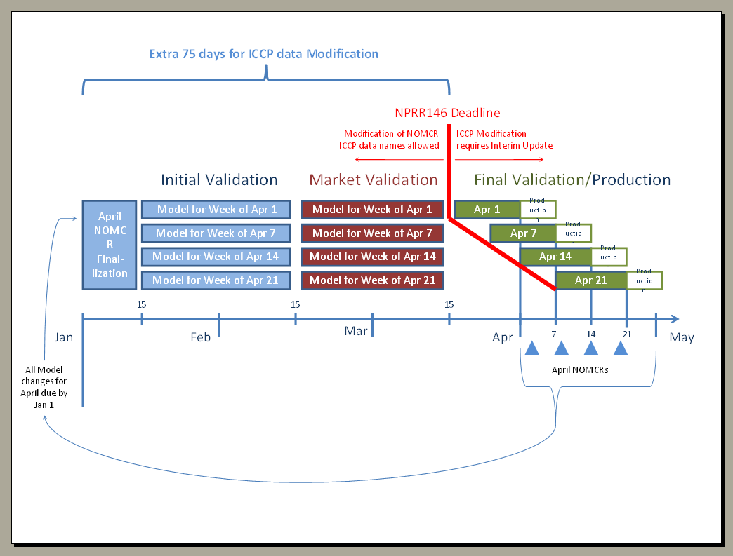

Revised Cover Page Language

Revision Description | This Nodal Protocol Revision Request (NPRR) requires that changes to an existing Network Operations Model Change Request (NOMCR) that modify only Inter-Control Center Communications Protocol (ICCP) data object names be submitted prior to the completion of the testing for the Network Operations Model..

Revised Proposed Protocol Language
3.10.1 Time Line for Network Operations Model Change Requests
(1) ERCOT shall perform periodic updates to the ERCOT Network Operations Model. Market Participants may provide Network Operations Model updates to ERCOT to implement planned transmission and Resource construction one year before the required submittal date below. TSPs and Resource Entities must timely submit Network Operations Model changes pursuant to the schedule in this Section to be included in the updates.
(2) For a facility addition, revision, or deletion to be included in any Network Operations Model update, all technical modeling information must be submitted to ERCOT pursuant to the ERCOT NOMCR process.
(3) TSPs and Resource Entities shall submit Network Operations Model updates at least three months prior to the physical equipment change. ERCOT shall update the Network Operations Model according to the following table:
Deadline to Submit Information to ERCOT  Note 1 | Model Complete and Available for Test  Note 2 | Updated Network Operations Model Testing Complete  Note 3  Note 6 | Update Network Operations Model Production Environment | Target Physical Equipment included in Production Model  Note 4
Jan 1 | Feb 15 | March 15 | April 1 | Month of April
Feb 1 | March 15 | April 15 | May 1 | Month of May
March 1 | April 15 | May 15 | June 1 | Months of June–August  SUMMER MODEL
June 1 | July 15 | August 15 | September 1 | Month of September
July 1 | August 15 | September 15 | October 1 | Month of October
August 1 | September 15 | October 15 | November 1 | Month of November
September 1 | October 15 | November 15 | December 1 | Month of December
October 1 | November 15 | December 15 | January 1 | Month of January (the next year)
November 1 | December 15 | January 15 | February 1 | Month of February (the next year)
December 1 | January 15 | February 15 | March 1 | Month of March (the next year)

Notes:
1. Transmission and Resource data submissions complete per ERCOT NOMCR process for inclusion in next update period.
2. Network Operations Model data changes and preliminary fidelity test complete by using the Network Operations Model test facility described in paragraph (3) of Section 3.10.4, ERCOT Responsibilities. The test version of the Network Operations Model will be available for market review and further testing by Market Participants.
3. Testing of the Network Operations Model by Market Participants is complete and ERCOT begins the Energy Management System testing prior to placing the new model into the production environment.
4. Updates include changes starting at this date and ending within the same month.

(4) ERCOT shall only approve energization requests when the Transmission Element is satisfactorily modeled in the Network Operations Model.
(5) In order to allow for construction schedules, TSPs may use pseudo-breakers and switches to designate future facilities configurations such that the Network Operations Model topology may be correctly implemented as construction of new facilities is accomplished.
(6) Changes to an existing NOMCR that modify only Inter-Control Center Communications Protocol (ICCP) data object names shall be provided 15 days prior to the Network Operations Model load date. NOMCR modifications containing only ICCP data object names shall not be subject to interim update reporting to the Independent Market Monitor (IMM) and Public Utility Commission of Texas (PUCT) (reference paragraph (5) of Section 3.10.4, ERCOT Responsibilities), according to the following:

NOMCR that contains ICCP Data and is submitted … | ERCOT shall … | Subject to IMM & PUC Reporting
Beyond 90 days of the energization date | Allow modification of only ICCP data for an existing NOMCR | No
Between 90 and 15 days prior to the scheduled database load. | Allow modification of only ICCP data for an existing NOMCR | No
Less than 15 days before scheduled database load. | Require a new NOMCR to be submitted containing the ICCP data | Yes

