Load Participation
in the ERCOT Nodal Market

Financial Opportunities for
Reducing Electricity Load

An Introduction to ERCOT’s Load Reduction Programs
for the Texas Nodal Market and the ERCOT Nodal Protocols

Prepared by the Demand-Side Working Group
of the ERCOT Wholesale Market Subcommittee



ELECTRIC RELIABILITY COUNCIL OF TEXAS

Version N1.0

June 11, 2007
Table of Contents

Executive Summary 2
The Value of Load Reductions 2
The Restructured Texas Electricity Market 2
Participation Checklist 5
Load Participation in ERCOT 5
Background 5
The ERCOT Markets 7
Participation as a Demand-Side Resource 8
Voluntary Load Participation 10
Ancillary Services Markets 14
Day Ahead Processes 17
Settlement 20
ERCOT Scheduling Process 20
ERCOT Settlement Process 23
Scheduling and Settlement Example 24
Examples of Potential Payments 26
Frequently Asked Questions 27
An Overview of the Restructured Texas Electricity Market 30
Glossary of Market Participants 31

This document is intended as an introductory guide to the opportunities available to demand-side resources to participate in various ERCOT nodal markets, and should not be treated as a comprehensive resource. The ERCOT Nodal Protocols are continuously subject to change, and therefore may be more current than the information presented here. If there is any variation between the information in this document and that contained in the Nodal Protocols, the Nodal Protocol language takes precedence.
Executive Summary

If you are a business or institution with the ability to curtail your electricity use (i.e., interrupt load), you can be paid for electricity not taken from the grid in the current zonal market and in the future nodal market ERCOT that is currently developing.

To participate, you must be willing to allow your supplier, on short notice, to reduce the amount of electricity being delivered. You can accomplish this by consuming less electricity than was forecasted either by shutting down facilities, by tapping into on-site generation, or relying on alternative fuel capabilities if they are available.

If you have this ability…
Your Load May Have Value — and Profit Potential!

The Value of Load Reductions

Wholesale electricity market prices fluctuate based on simple rules of supply and demand—that is, the relationship between the level of power consumption (demand) being placed on the grid at any time, and the generation resources (supply) available to meet that demand. During periods of peak demand, such as hot summer days, wholesale prices may reach many multiples of their off-peak levels. Even during milder weather when demand is lower, premium prices are often paid for available resources because many generation plants choose these times to shut down temporarily for maintenance.

In the future nodal market, a reduction in load is considered a form of available energy, with a value equivalent to what your supplier pays for energy. Thus, during these periods, payments for load reductions are equal, dollar for dollar, to that which retail suppliers are charged for power.

The New Texas Nodal Electricity Market

The Nodal ERCOT electricity market will have both a “bilateral” market where market participants arrange to meet their anticipated electric energy needs through the use of third party supply contracts and a “power pool” market that allows loads to purchase their supply needs in a Day Ahead or Real Time energy market. In other words, load serving entities including Retail Electric Providers (REPs) can procure enough electrical power through private contracts with suppliers or buy from the ERCOT markets to meet the needs of their customers. ERCOT retail entities have access to a large “pool” of resources from which they can choose to acquire resources and assign a portion of their load responsibilities. This structure makes ERCOT similar to other markets in California, New York, and Pennsylvania-New Jersey-Maryland (PJM). In these markets, a significant amount of wholesale energy is purchased at open auctions where buyers and sellers reach agreements in both day-ahead and same-day environments. As a retail customer, you may also want to purchase a portion of your energy in these markets. For example, by placing a “limit order” in the Day Ahead market, you can control your energy cost by reducing consumption during those times where market prices are higher than your established limit. Thus, by reducing your consumption at certain times and then consuming more when prices are lower, you may be able to save considerably in the new Texas Nodal Markets.

While prices will be set in advance in the Day Ahead market will provide some advance “price signal” to consumers, the market is ultimately settled on the basis of nodal prices set in real-time. Unfortunately, there will be no advance notification of real-time prices, since they will be calculated after each pricing interval. However, a consumer’s may react to real-time prices that are posted from each execution of ERCOT’s Security Constrained Dispatch calculation that is occurring every 5 minutes. Those prices ultimately make up the real time prices. The consumer would have to predict real-time prices based on patterns of pricing observed in prior postings or other factors such as pricing patterns from prior days and similar hours.

Any market—bilateral or pool-type—must be responsive to factors such as transmission line congestion or unplanned variations in available power such as generation plant outages. To ensure system reliability, all markets include mechanisms for acquiring or reallocating generating resources to ensure a stable supply of power. Generating Resources that are acquired in these situations are typically paid a price determined by available supply; thus resulting in a market price. In ERCOT these market prices are established using the market rules described in the ERCOT Nodal protocols and the energy offers which generators provide to ERCOT.

In the ERCOT nodal market, market participants known as Qualified Scheduling Entities (QSEs) have the responsibility for communicating with ERCOT to purchase energy to meet its REP’s load requirements and for selling their generation capabilities at prices set by supply and demand on a daily basis (see Figure 1).

Retail Electric Providers (REPs), must contract with a QSE to provide coordination and settlement services for their load customers. REPs may be the same company as the QSE, and thus contract for energy supply through direct agreements with generators or purchase energy from ERCOT markets. Although prices in bilateral contracts are confidential, the prices paid by market participants for energy in the Day Ahead or Real Time nodal markets are publicly disclosed. As such, information on the value of electricity in the Daily and Real Time markets are available to all parties. Load customers may purchase energy supply on a long term basis or may make their purchases through a combination of long term contracts and through daily and real time purchases. The Texas Nodal Market will offer tremendous flexibility to purchase energy supply for some for load customers who are able to forecast their electricity needs.

In the current ERCOT market, electricity is scheduled and delivered to load zones (there are 4 load zones in ERCOT in 2007; North, South, West, and Houston). Under the Nodal market, power can be delivered to an electrical bus (a generator’s substation location), a hub (a collection of buses), or a load zone. The change from zonal power scheduling by generators to specific prices at each generator’s location is the biggest change in the new Nodal market from the current ERCOT Zonal market.

For loads to participate in ERCOT’s markets and in ERCOT’s Load Reduction Programs, the load must contract through its retail provider or a QSE. QSEs are the only entities permitted to perform settlement services with ERCOT. Participating loads may need to be registered with ERCOT and are subject to testing administered by ERCOT for some of these programs. Any participation in the market must be conducted through a single REP or a QSE under contract with the customer. There is no explicit prohibition in the market rules on a customer purchasing power through one REP and offering a Load Resource’s capacity to an ERCOT market through another QSE. However, a load customer should check its contract with its REP to ensure that there is no prohibition on working with a second QSE. Any payments from ERCOT for load reductions are made to the QSE and, therefore, any customer reimbursement for a load reduction event is subject to the terms of the customer’s contract with its REP. This underscores the importance of an informed working relationship between the retail load customer and its REP and QSE.

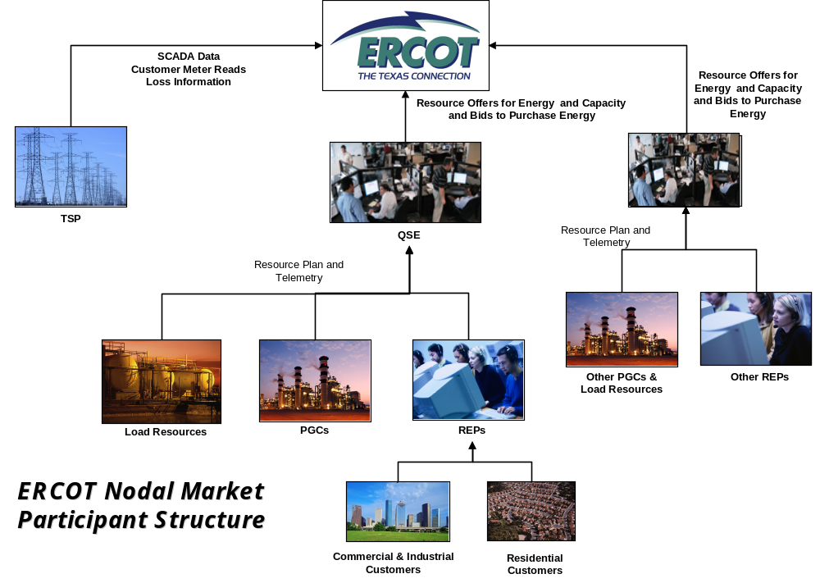

Participation Checklist
Here is a checklist of criteria to help you determine whether participation through your REP is appropriate or advisable for your company or facility:
 Your facility must have some interruptible load or load that can be shifted to other times of the day must be
 Your facility must have Interval Data Recorder metering. For some programs, your facility will also be required to have telemetry—a real-time direct communication from your Load to ERCOT.
 You must have the ability to deliver the load reduction on short notice for some programs or be able to shift your consumption patterns on an hourly basis.
 For some programs, you must register as an available Resource with ERCOT, and your facility must be made available for testing prior to actual participation. For others, you need only contract with your REP to participate in the Day Ahead and Real Time markets.
 You must contract with either your Retail Electric Provider (REP) or a Qualified Scheduling Entity (QSE) to represent your available load to the system. A QSE is the entity with which ERCOT settles. In many cases, your REP and QSE are the same company.
 For some programs, you must be able to maintain the load reduction for at least 15 minutes or an hour, or up to a period determined by your participation, or by the need of the electrical system.

If this sounds like a program your company may desire to participate in, the following pages offer an overview of the ERCOT Nodal Market and additional information about the financial opportunities available to customers for reducing or shifting their loads. A list of detailed Frequently Asked Questions appears at the end of the document. For any prospective load participant, familiarity with the details of the Texas nodal market design and the ERCOT protocols is strongly recommended.

Load Participation in ERCOT

Background
Historically, utilities in the Electric Reliability Council of Texas (ERCOT) relied on over 4,000 megawatts of interruptible and curtailable load, group load curtailment programs, residential direct load control programs, thermal energy storage systems, and other “demand-side resources” to maintain reliability and meet the system’s resource needs. The Public Utility Commission of Texas has established a goal to “ensure not only that the load resources that have historically participated in the markets have reasonable opportunities to continue to participate, but also that a framework is established for even greater participation by load resources in the future.” Participation by loads in the ERCOT Nodal market is viewed as a means of enhancing competition in those markets, mitigating unwarranted price spikes, encouraging the demand side of the market to respond better to wholesale price signals, providing for resource adequacy, and preserving system reliability.

While state mandates and incentives for interruptible tariffs have been discontinued, customers may still negotiate contracts for these special rates with their suppliers. However, new Nodal market-based financial incentives for reducing and shifting load will be available with the implementation of the new Texas Nodal Market. Qualifying customers can not only save money by making themselves available to reduce or shift their load, but also earn money for reducing load when needed. Load customers in the Texas Nodal Market are considered not only a load to be removed from the system and be paid for it, but also a load that could possibly consume energy at different hours of the day when prices are lower resulting in reducing overall costs for the retail load customer.

Providing a demand-side resource can be more complicated than signing up for a REP’s voluntary load interruption energy products or a utility program. Generally, when demand-side resources are offered into the structured ERCOT nodal markets, the load must be tested and registered, and then included in Load Resource plans that are provided to ERCOT. The value of a resource is largely determined by market conditions. Perhaps most importantly, compensation for being interrupted is subject to contractual arrangements between the customer and its Retail Electric Provider (REP). Providing a load into ERCOT’s Nodal market requires knowledge of the Texas electric market structure, settlement processes and the requirements associated with participating in various markets.

The purpose of this document is to provide additional background and supporting data to load entities, who are interested in determining their eligibility for the load reduction programs in the Texas electricity market. This guide will provide an overview of the organization and operation of the ERCOT Nodal market. It provides the basic information necessary for load entities to understand how the ERCOT market operations can affect their daily activities and processes, and provides an overview of the opportunities, rules and risks of actively participating in some of the ERCOT ancillary services markets. This guide is intended only to provide an overview of the ERCOT Nodal Protocols. For additional information, the reader should refer to the Nodal Protocols themselves, which may be found on the ERCOT website at: http://nodal.ercot.com/protocols/index.html.

The ERCOT Nodal Markets

The primary role of ERCOT is to maintain reliability of the ERCOT electricity grid, including operation of the ERCOT system as one control area and has secondary roles in facilitating a Day Ahead energy market where buyers and sellers of capacity and energy may participate. ERCOT serves as the Independent System Operator (“ISO”) and is charged with maintaining a precise balance between load and generation on a second-by-second basis.

To assist market participants in buying and/or selling capacity and energy to meet their energy and ancillary services requirements, ERCOT administers various Day Ahead and Real Time operations markets:

- Ancillary Services (“AS”), defined in the ERCOT Nodal Protocols (Section 2) as “services necessary to support the transmission of energy to Loads while maintaining reliable operation of the Transmission Service Provider’s transmission system using Good Utility Practice.” ERCOT requires REPs to carry a specified level of operating reserves—the ability to call up additional resources, whether load increases or reduces, on varying levels of short notice. These operating reserves serve as "insurance" in case a generating unit goes down, load is higher than anticipated, or another problem emerges. Most such reserves can be self-arranged. If a REP doesn't self-arrange all its reserves, then ERCOT will purchase the necessary reserves on the REP’s behalf by operating a Day Ahead Market for the various Ancillary Services programs. In the Nodal market, there are eleven AS programs in place, four of which are available for participation by loads (more detail is provided in the following pages).

- The Day Ahead Energy Market, an energy market where QSEs may sell or buy energy at any settlement point on the ERCOT Grid. Settlement points exist at each generator’s electrical bus in the transmission system, at trading Hubs and at Load Zones. In the Nodal market, REPs will pay ERCOT for all the energy used by its customers. The price of energy is established every 15 minutes in ERCOT’s Real Time market and is adjusted for any energy purchased in ERCOT’s Day Ahead market. REPs may offer load customers the ability to also purchase all or a portion of their energy in the Day Ahead energy market. Similarly, loads could purchase their supply at a specified trading Hub with additional charges applying to the difference in the Hub price and the Load Zone prices. Such arrangements are virtually unlimited and allow loads to purchase their energy needs in these markets or in combination with traditional bilateral contracts or contracts for differences. Loads may choose to place bids in ERCOT markets to purchase energy only if a certain price limit is maintained. Of course doing so exposes the load to real time prices which could be higher or lower than the limit specified by the purchaser.

- The Real Time Market
When load consumes energy its supplier must pay ERCOT for that energy at prices established by the Real Time market, adjusted for any energy purchased in the Day Ahead market at the same load zone. If a load does not purchase energy in the Day Ahead market, then it is settled at the Real Time market price. A load may participate in the Real Time market by requesting its REP provide pricing equal to the Real Time prices and then adjusting its consumption pattern to consume less energy when prices are high and/or more energy when prices are low. However, the actual real-time prices that are faced by a consumer exposed to the Real Time market will not be known by the consumer until after-the-fact, since they are calculated on a real-time basis.

Demand-Side Participation

The ERCOT Nodal market is explicitly designed with a number of features to reward energy consumers that are willing to curtail or shift load as a way of helping maintain system reliability. These “demand-side resources,” or loads, are encouraged to make their resources available by responding to wholesale price signals. Actual dollar values to be paid for these resources are established in the form of Market Clearing Prices, which in a Nodal market are based on bids and offers in the various ERCOT-operated markets described below. The Market Clearing Price for Capacity (MCPC) expressed in dollars per megawatt per hour represents the price paid for making a capacity resource (load reduction or generation increase) available to the ERCOT Grid. The Locational Marginal Price (LMP) expressed in dollars per megawatt-hour represents the price paid for generation at a specific location on the ERCOT Grid. The same calculation engine that ERCOT uses to dispatch generation also calculates the value of energy at every electrical bus in the Transmission System. The individual bus load weighted average of all the LMP prices in a Load Zone is the price paid by loads who consume the energy from the generation in ERCOT. This price is sometimes referred to as the Load Zone Market Price or LMPZ. Since this price is calculated in real-time, it will not be known to energy consumers in advance but is posted to ERCOT’s web site immediately following each calculation of LMPZ.

There are four basic types of load response or demand-side resources, in the ERCOT market, as summarized in Table 1 and detailed below.

Table 1: Demand-Side Participation in ERCOT

Resource Type | Resource or Service that can be Provided | Requirements
Voluntary Load Response | Curtailment or reduction in response to LMPZ or other factors | - Metering and/or curtailment technology defined in REP contract
Day Ahead Market bids and response | Load may choose to curtail or reduce consumption in response to prices bid in the Day Ahead energy market | - Day Ahead Market Pricing  - Metering and/or curtailment technology defined in REP contract
Real Time Market and passive response to price | Load may choose to curtail or reduce consumption in response to prices in the Real Time energy market | - Real Time Pricing  - Metering and/or curtailment technology
Load Resources | Various ERCOT Ancillary Services (AS) | - IDR meter  - Telemetry  - Qualification

Voluntary Load Response

Voluntary load response refers to a customer’s independent decision to reduce consumption from its anticipated level in response to market price signals. Voluntary response applies to situations where the customer has not formally offered this response to the market as a Load Resource. This practice has also been known as “passive load response” and sometimes as “self-directed load response.” For purposes of this document, these customers will be referred to as “Voluntary Loads.”

Like Load Resources, Voluntary Loads stand to gain financially from the ERCOT markets—over and above the savings they may enjoy on their electric bills from reducing consumption when market prices are high. Also like Load Resources, a Voluntary Load’s ability to receive extra financial compensation depends entirely on its contractual relationship with its REP (and QSE).

Voluntary Loads’ most obvious opportunity would be to benefit financially during periods when the Load Zone Price (LMPZ) is high, based on the dynamics of supply and demand. A load reduction or load shift could allow the customer’s REP to benefit by selling the customer’s anticipated power requirements to another facility willing to pay higher prices to ensure service. There may be other scenarios where a Voluntary Load could find it mutually beneficial to coordinate a response to high prices with its REP. In any of these cases, the customer will receive the full value from its load reduction or load shift only if it has negotiated a favorable REP contract.

While prices will be set in advance in the Day Ahead market will provide some advance “price signal” to consumers, the market is ultimately settled on the basis of nodal prices set in real-time. Unfortunately, there will be no advance notification of real-time prices, since they will be calculated after each pricing interval. However, a consumer’s may react to real-time prices that are posted from each execution of ERCOT’s Security Constrained Dispatch calculation that is occurring every 5 minutes. Those prices ultimately make up the real time prices. The consumer would have to predict real-time prices based on patterns of pricing observed in prior postings or other factors such as pricing patterns from prior days and similar hours.

As discussed in the Market Overview section, loads pay the LMPZ and generators are paid the LMP at their electrical bus. If a QSE’s actual load level turns out to be lower than anticipated during any given 15-minute interval, the QSE pays LMPZ only for the actual load amount. Voluntary Loads can reduce consumption in order to contribute to reducing the QSE’s cost while the associated REPs pay ERCOT for its actual consumption of energy. Depending on its REP contract, this behavior may make the load eligible for financial incentives such as reduced rates, rebates, or pass-through payments. The manner in which any bill credits, payments from the market, or transmission cost savings are shared among responsive customers, their REPs, and their QSEs is a contractual matter among these market participants.

Day Ahead Market Bids

Load customers who have the ability to reduce consumption at certain times of the day or move energy requirements from one hour to another, may be able to take advantage of ERCOT’s Day Ahead energy market. These markets operate using ERCOT systems to match willing buyers and sellers bids and offers for energy for the next day. This is an entirely new market for ERCOT and its participants.

Loads through their REPs and QSEs may submit bids to purchase energy in the Day Ahead for the next day’s energy requirement. Bids could consist of limit orders or pricing tiers, with associated quantities for each hour of the next day. The prices loads are willing to pay in the day ahead are matched with prices generators are willing to accept at various locations throughout ERCOT. ERCOTs computers will calculate the LMPs for all settlement points and post these prices on public web sites. Over time, these historical prices and supply and demand economics will provide loads many new opportunities to reduce their overall costs to serve their electric energy requirements.

Real Time Market - Passive Response to Price
Load customers may request their REP to provide prices equal to the prices ERCOT establishes during Real Time operations. These prices are provided to the public through web postings or directly from the load’s REP to enable the load to adjust its consumption pattern to reduce energy at times of high prices and potentially increase consumption at times of lower prices. Load customers should be careful when structuring contracts with their REPs to be clear if the REP or the Load customer will be responsible for ERCOT charges for any Reliability Unit Commitment Capacity Short Charges. QSEs and their REPs who purposely do not purchase supply prior to the real time market, may be subject to additional charges if ERCOT has to purchase additional generating capacity. These capacity charges may be passed on to the Load customer or may be covered by the REPs contract.

Voluntary Load Reduction and Day Ahead/Real Time Market Summary

For load customers, the primary differences between participating in a voluntary load reduction program or the Day Ahead or Real Time markets and being a Load Resource providing ancillary services to ERCOT are as follows:

- Any advanced metering, communication, or curtailment infrastructure required for the load to participate is purely a contractual matter between the load and its REP, and does not involve ERCOT. Loads do not have to meet all the protocol requirements to be a registered and qualified Load Resource in ERCOT’s systems;
- The QSE (and thus, REP) receive value to the extent they consume less energy at high prices and thus avoid paying ERCOT for load that has been reduced. Any value for the generating capacity the load avoided comes to the load in its avoided energy price and/ or payments/reduced prices from its REP. The QSE (and thus the REP) does not receive capacity payments from the reduced energy consumption from ERCOT as do Load Resources;

As long as a REP or QSE offers the necessary interfaces with ERCOT, any customer can become a Voluntary Load or can participate as part of a voluntary load curtailment group. Likewise, a customer can bid into the Day Ahead Market. A commercial or industrial Voluntary Load would likely possess the technology to receive time-variant electricity prices from its provider, and the technological or human resources to monitor those prices and respond to them in the Day Ahead or Real Time.

Similarly, groups or aggregations of small commercial or residential consumers who are contracted to receive their electricity through variable-rate pricing plans may also participate in Day Ahead and Real Time markets. Managing individual small customer loads can become logistically very difficult, and thus are unlikely to be offered Voluntary Load incentives unless they are part of a group plan administered by a REP or Aggregator.

Voluntary Loads and Day Ahead/Real Time Market Loads may receive price signals from their REPs in the form of time-variant rate offerings. Time-variant pricing reduces or even eliminates the “insurance premium” that most customers pay for the luxury of purchasing power at flat rates 24 hours per day. For some customers, the price paid to ensure a flat rate may be higher than average day ahead or real-time market prices. Savings opportunities from curtailments or load shifts may become evident to many customers only when they are made aware of their detailed consumption patterns (load shape) through access to advanced meter data. Access to such data in turn may also allow customers to negotiate more favorable electricity rates with their suppliers. Some of the more notable types of time-variant pricing plans include:

- Time of Use (TOU) rates, involving set prices during predetermined hours of the day, that reward shifts in consumption away from high-priced peak periods.
- Critical Peak Pricing (CPP), in which everyday rates are lowered in exchange for the customer’s exposure to potentially much higher prices during certain peak periods. These critical peaks are typically accompanied by advance notice, and are often limited to a maximum number of hours per year.
- Real-Time Pricing (RTP) or its variations known as Hourly Variable Pricing or Variable Energy Pricing. Under these rates, customers agree to pay electricity rates that track Day Ahead market or Real Time market prices at all hours.
- Direct Load Control (DLC), typically involving groups of small customers who pay lower rates or obtain rebates in exchange for making themselves available for direct curtailment by the REP or system operator during price spikes
- Rate plans may involve combinations of two or more of the above features.

Over the past several years, a convergence of technology and economics has yielded innovative combinations of pricing plans and software and hardware applications. Matching rate offerings with energy-saving or load curtailment technologies can help loads take advantage of the price incentives in their rate plans, while mitigating the challenges of responding and minimizing disruption of their business operations or lifestyles. Customers through their relationships with their REPs or other independent energy service providers can explore these combinations of rate plans and technologies.

Depending on the type of rate plan and the specific features of its REP contract, a Voluntary Load or Day Ahead/Real Time Market Load may receive changing price information on a regular basis from its REP, or may arrange to monitor market prices itself. In either instance, the customer would make an internal business decisions regarding the factors that must be in place in order for it to be willing to curtail or shift its electricity service. For example, a load’s REP contract may rely exclusively on the real time LMPZ as the sole factor in determining whether to curtail.

Some other elements of Voluntary Load and Day Ahead/Real Time Market response that customers should be aware of:
- Loads (and their QSEs) are not penalized if they fail to follow supply plan unless ERCOT Reliability Unit Commitment program requires additional generation. ERCOT procures additional generation capacity when it determines that market participant supply plans are inadequate to solve a forecasted capacity insufficiency or forecasted Transmission Congestion. In such situations, REPs who are “short” of capacity may be assessed a capacity charge. Such charges may be passed on to certain energy consumers, if a pass-through of such charges is permitted in the contract negotiated between a consumer and its REP.
- A customer’s willingness to participate in Voluntary Load Response or Day Ahead/Real Time markets must take into account any other potentially conflicting features that may be part of its REP rate plan. For example, some REP contracts include “bandwidth” provisions that can penalize customers if their demand drops below a predetermined level.

Load Resource -- Ancillary Services Markets

ERCOT is responsible for developing a daily Ancillary Services (“AS”) Plan with sufficient AS to maintain the security and reliability of the ERCOT System consistent with ERCOT and North American Electric Reliability Council (NERC) standards. As discussed previously, ERCOT determines the amount of AS that each market participant is required to provide. Each market participant may self-provide its AS or may elect to have all or a portion of its AS provided by ERCOT. ERCOT will deploy the AS in order to maintain system reliability.

Customers with interruptible loads that can meet various performance requirements can be qualified to provide operating reserves under ERCOT’s Load Resource program. In the eligible AS markets, the value of having a Load Resource available to reduce load is equal to the value of having a generator available to increase its generation at a generating plant. These providers of operating reserves selected through an ERCOT AS market are eligible for capacity payments, regardless of whether the Resource is actually deployed (or curtailed, in the case of the Load Resource).

ERCOT qualifies Load Resources to be able to provide AS based on the load’s available technology, as follows:

- Responsive Reserve: Requires that an Under Frequency Relay (UFR) be installed that opens the load feeder breaker on automatic detection of an under frequency condition or in the case of a Controllable Load Resource respond similarly to a generator’s response to frequency change. These loads are also required to be manually interrupted within a 10 minute notice. The load, breaker status, and relay status, if applicable, must have real-time telemetry to ERCOT (through the QSE) installed. Loads qualified for the Responsive Reserve market are also automatically qualified for the Non-Spin market
- Non-Spin Reserve: Requires that interruptible loads be manually interrupted (e.g., opening a circuit breaker) within 30 minutes notice. The load must also have real-time telemetry installed.
- Regulation Up and Down Service: Requires that loads through automatic controls respond by changing consumption to signals provided by ERCOT to increase and decrease load while meeting rigorous performance monitoring criteria. The controllable load must also have real-time telemetry installed and be able to receive certain control information from ERCOT every 4 seconds. Loads qualified for Regulation Up and Down service are also qualified to provide Non-Spinning Reserve.

Day Ahead Ancillary Services Procurement

Each QSE may arrange bilaterally for AS or may have ERCOT make the arrangements through a market (i.e., an auction) administered by ERCOT. ERCOT holds auctions on a daily basis for each of the following AS:
  - Regulation Up
  - Regulation Down
  - Responsive Reserve
  - Non-Spinning Reserve

Table 2 summarizes the different Ancillary Services available for participation by loads:

Table 2: Ancillary Services

Type of Service | Down  Reg | Up  Reg | Responsive  Reserve | Non  Spin Reserve
System Response to instruction: | Must be on AGC | Must be on AGC | AGC or in 10 minutes manually or  Relay  Action | Responds w/in 30min
Generation Resources | X | X | X | X
Controllable Load Resources | X | X | X | X
Load with Under frequency relay installed and capable of being deployed within 10 minute notice |  |  | X | X
Load with real time telemetry and that can be deployed within 30 minute notice |  |  |  | X

Loads that agree to be interrupted when directed by ERCOT via their QSE (and that meet other metering and operational requirements as specified in the ERCOT Protocols) may participate in AS market auctions described above. As noted in Table 2, the type of ancillary service that a Load Resource may provide will depend upon the load’s response time and metering system, as well as other requirements described in the Protocols. In the Responsive Reserve and Non-Spin Reserve markets, the QSE will receive capacity payments regardless of whether or not the load was actually interrupted, but the load must be available to be interrupted at any time while providing the Ancillary Service.

Table 3: Demand-Side Participation in ERCOT

Service | Metering | Used by | Participation Basis for Payment | Markets Payment Determination | Time to Curtail/  Interrupt
Regulation Up and Down | Telemetry& IDR settlement metering | ERCOT | Ability to control load consumption to respond to ERCOT signals | Market clearing capacity price in Regulation Up or Down Market and LMPZ for energy when deployed | 4 seconds or less
Responsive Reserves | Telemetry& IDR settlement metering | Market Participant or ERCOT | Being available to be interrupted | Market clearing capacity price in Responsive Reserve Market and LMPZ for energy when deployed | Instantaneously or within 10 minutes if manually deployed  Load Resources providing Responsive Reserve are manually deployed during emergency operations in two steps;
Non-Spinning Reserves | Telemetry& IDR settlement metering | Market Participant or ERCOT | Being available to be interrupted | Market clearing capacity price in Non-Spinning Reserve Market and LMPZ for energy when deployed | Within 30 minutes of Interruption
Day Ahead Market | Contractual with REP | REP | Actual load pattern and Day Ahead prices | LMPZ in the Day Ahead market | Contractual with REP
Real Time Market | Contractual with REP | REP | Actual load pattern and Real Time prices | LMPZ in the Real Time market | Contractual with REP
Voluntary Load Response | Contractual with REP | REP | Actual deployment | LMPZ in the real time market | Contractual with REP

For additional details regarding Ancillary Services, refer to Sections 2, 3, 4, 6 and 8 of the ERCOT Nodal Protocols posted at: http://nodal.ercot.com/protocols/index.html

ERCOT Dispatching Process
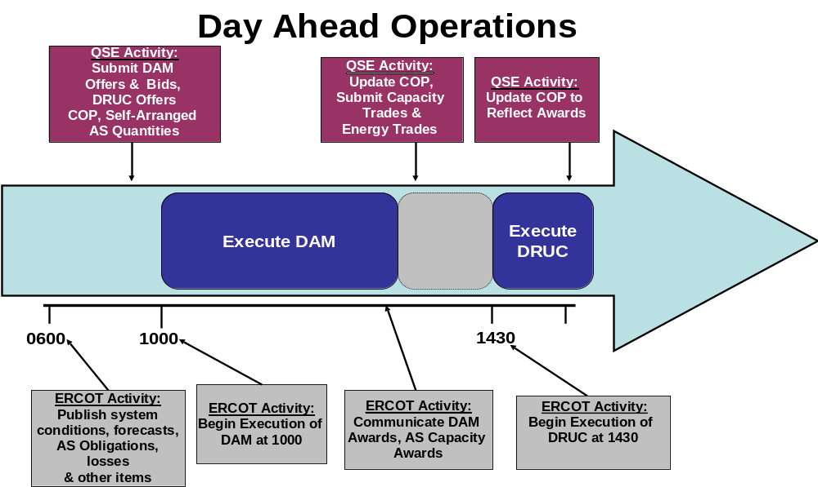
As shown below, the ERCOT divides the day into three different time periods, the Day Ahead Market period, the Adjustment period and the Operating period (Real Time).

The following timeline describes the Day Ahead Market (from a QSE perspective):

06:00 Market Open – data posted by ERCOT will include: updated transmission system information, load forecasts (by weather zone and total ERCOT), AS Plan, AS responsibility for each QSE, and transmission and distribution loss factors.
10:00 Submit Bids and Offers for energy requirements (i.e., load) and 3 part Offers for generating resources.

10:00 Update self-arranged AS provide AS offers for ERCOT AS market.
13:30 QSEs notified of AS procure from resources
14:00 Submit Current Operating Plan with resource-specific information.
14:30 Day Ahead Market closed by ERCOT.

Once the Day Ahead Market is closed, then QSEs may continue to modify Resource Plan and any capacity and energy offers not struck in the DA market during the Adjustment Period as shown below (where T=the start of the Operating Hour):
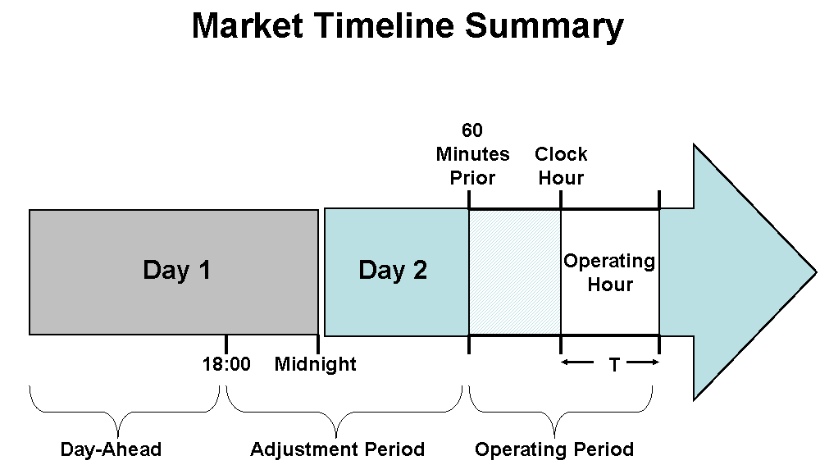

One hour prior to the Operating Hour, no more adjustments are allowed.

For additional information related to scheduling, refer to Section 6 of the ERCOT Nodal Protocols.

ERCOT Settlement Process

The ERCOT Settlement process is used to receive funds and send payments to QSEs who participated in the Day Ahead and Real Time markets during any given settlement interval. The Settlement process takes into account administrative and miscellaneous fees as well as the cost of transmitting the electricity around the state.

ERCOT will produce daily settlement statements reflecting a breakdown of market charges for hourly and other settlement interval (i.e., 15 minute) market services, monthly charges and any annual charges applicable to each Operating Day. The ERCOT Settlement Statement timeline is:

Day 0 Energy Consumed during Operating Day
Day 4 Day Ahead Market Settlement Statement
Day 17 Initial Statement for Day 0 Real Time market is issued by ERCOT.
Day 59 Final Statement for Day 0 Real Time market is issued by ERCOT.
Day 0 + 6 Months True-Up Statement for Day 0 Real Time market is issued by ERCOT.

Any dispute pertaining to settlement information must be raised by the QSE with ERCOT within ten days of the issuance of a Statement for the appropriate Operating Day. If such a dispute is found to be valid by ERCOT, it will issue a Resettlement Statement within 21 business days of the issuance of the True-Up Statement.

For additional information pertaining to settlements and invoicing, please refer to Section 9 of the ERCOT Nodal Protocols.

Settlement Example

In order to better understand the ERCOT settlement processes, consider the following simple example (data shown for a single settlement interval).

G2
G1
R1
R2
175 MW
55 MW
25 MW
45 MW

Here, Retailer 1 (“R1”) buys 25 MW from Generator 1 (“G1”) and 175 MW from Generator 2 (“G2”) in the day ahead market to meet its estimated load of 200 MW (i.e., 200 MW of generation balanced by 200 MW of load). Retailer 2 (“R2”) buys 45 MW from G1 and 55 MW from G2 in the day ahead market to meet its estimated load of 100 MW. ERCOT notifies the market participants of its awards for energy following the Day Ahead market.

Now, in real-time, assume that the following occurred:

Actual production of G1 was 105 MW and G2 was 200 MW (a total of 305 MW of generation during the settlement interval). Actual load requirement of R1 was 195 MW and R2 was 110 MW (a total of 305 MW of load during the settlement interval). The LMPs for the generators were equal to the LMPZ (no congestion in ERCOT) and for both the Day Ahead Market and real time market for the settlement interval was $25/MW. This is a big assumption as prices in the Day Ahead and Real Time are more likely to be different.

Based on the above, the following amounts the QSEs representing the generators and retailers would be settled and invoiced as appropriate:

- R1 pays ERCOT and ERCOT pays G1 for 25 MW and G2 for 175 MW from the day ahead market.
- R2 pays ERCOT and ERCOT pays G1 for 45 MW and G2 for 55 MW from the day ahead market
- In the real time market ERCOT pays R1 $125 (5 MW x $25/MW) because its load was actually 5 MW less than it purchased in the Day Ahead.
- In the real time market ERCOT pays G1 $875 (35 MW x $25/MW) because it generated 35 MW more than the day ahead market.
- ERCOT is paid $250 (10 MW x $25/MW) by R2 because its real time load was 10 MW more than the day ahead
- ERCOT is paid $750 (30 MW x $25/MW) by G2 because it generated 30 MW less than it generated in the Day Ahead Market

Thus, for this settlement interval, the ERCOT payments and charges are balanced ($125 +$875) = $1,000 = ($250 + $750).

Examples of Potential Payments

The following are sample calculations of payments or benefits that a load would receive by adopting some of the “load participation” strategies that are described elsewhere in this guide.

1. Responsive Reserves – (RRS)

Our first example is an energy consumer with a stable demand of 10 MW and armed with an under-frequency relay that offers (on a day-ahead basis for each hour of the day) and is selected to provide responsive reserves through the ERCOT-run day-ahead market at the market-clearing price. During April 12, 2006, a day of relatively high prices, this provider of responsive reserves ancillary services would have received compensation based on the prices depicted in the following graph.

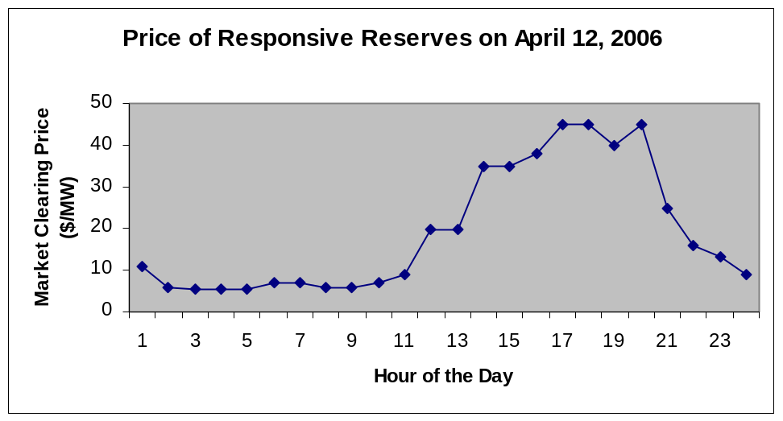

The QSE associated with this energy consumer would receive:

∑^{24 hours} (10 MW x MCPC) = $4,608.70.

The share of this payment that is provided to the energy consumer is a contractual matter between the consumer and the QSE or REP serving the customer. The consumer could receive a payment regardless of whether the consumer’s load is actually curtailed.

Note that even though this example is based on actual historical data on a day prior to the introduction of the nodal market, this example would still be applicable under the forthcoming nodal market.

2. Non-Spinning Reserves – (NSRS)

In this second example, let’s assume that this energy consumer instead opts to provide non-spinning reserves on that same day. On April 12, 2006, non-spin prices followed the pattern depicted on the following graph.

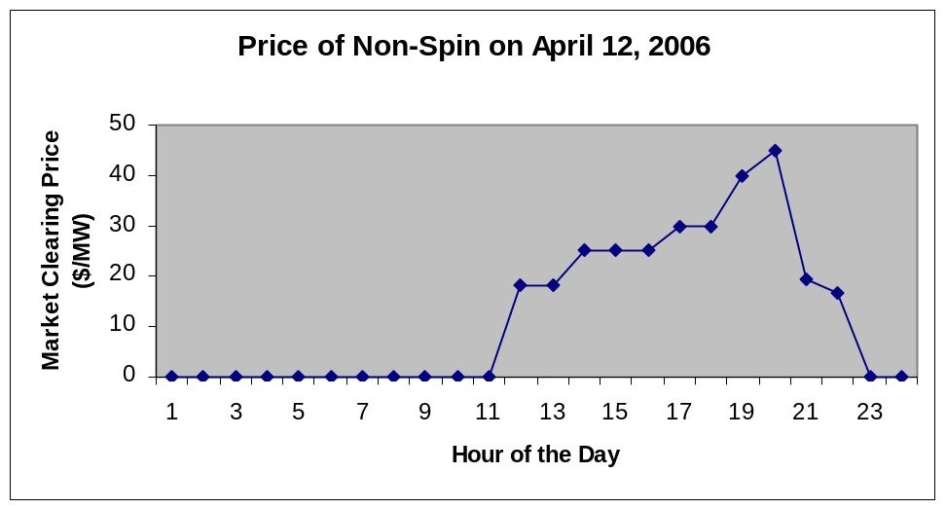

The QSE associated with that consumer would have received:

∑^{24 hours} (10 MW x MCPC) = $2,923.40.

The share of this payment that is provided to the energy consumer is a contractual matter between the consumer and the QSE or REP serving the customer. The consumer could receive a payment regardless of whether the consumer’s load is actually curtailed.

Note that even though this example is based on actual historical data on a day prior to the introduction of the nodal market, this example would still be applicable under the forthcoming nodal market.

3. Day-Ahead Market Purchase

Now let’s consider an energy consumer that can perfectly control and/or predict its usage. It normally consumes 10 MW. It has some flexibility in its operations, it is not already providing an ancillary service such as responsive reserves or non-spinning reserves to the market, and it does not have a long-term commitment to purchase power through a REP. The consumer’s REP agrees to assist the consumer in purchasing power from the day-ahead market. The consumer will curtail its operations whenever the day-ahead price of electricity exceeds $1,000 per MWh.

The consumer, through its REP or QSE, submits a buy limit order for 10 MW at a price no higher than $1,000 per MWh for each hour of the following day. The QSE then enters this order into the day-ahead market. Provided the market price stays below $1,000 per MWh, the consumer purchases the rights to the 10 MW of electricity each hour (2,400 MWh for the day) and pays the market clearing price.

If the market clearing price in the day-ahead auction exceeds $1,000 per MWh for a given hour, then the consumer does not receive the rights to the 10 MW of electricity for that hour. The consumer may then opt to either 1) curtail its operations during the hour of the high day-ahead price or 2) purchase power in the real-time market in hopes that the LMPZ will be lower than $1,000 per MWh.

What if the consumer purchases the rights to 10 MW at a day-ahead price of $30 per MWh, but the LMPZ in the real-time market is $25 per MWh? In this case, the consumer’s QSE would be settled based on a $25 per MWh price by ERCOT. However, the consumer has paid the $30 price.

What if the consumer purchases the rights to 10 MW at a day-ahead price of $30 per MWh, but the LMPZ in the real-time market is $35 per MWh? In this case, the consumer’s QSE would be settled based on a $35 per MWh price by ERCOT. So the consumer has saved $5 per MWh by participating in the day-ahead market.

What if the consumer’s actual consumption of electricity deviates from the 10 MW load level? The customer’s QSE would be charged for any additional amount over the 10 MW planned level based on the real-time LMPZ. From a financial perspective, amounts consumed less than the 10 MW amount would essentially be “re-sold” into the real-time market at the LMPZ, and the amount that the QSE would pay would be based on the price paid in the day-ahead market minus the value of the power “re-sold.”

As usual, how costs and benefits are shared between an energy consumer and a QSE or REP is a contractual matter among those parties. Participation in the day-ahead market may be difficult for consumers that cannot accurately predict or control their next-day hourly consumption or for loads that tend to fluctuate due to weather-sensitivity or the nature of the consumer’s industrial process.

Frequently Asked Questions

Q. How do I register with ERCOT as a Load Resource?
A. To participate as a Load Resource you must register as a Resource entity, and then as a Load Resource asset. To register as a Resource entity you will need to complete the Resource Registration Form and to register the Load Resource asset you must complete the Resource: Load Resource Asset Registration Form.

Q. What level of compensation (dollars times kWh) makes it worthwhile or profitable for me to reduce the load?
A. This is the key business decision you must make internally. Only you know the financial impact of shutting off or shifting electricity to some or all of your operations, and the cost of restarting operations. If you plan to use electricity generated on site to replace power from the grid, you should factor those costs into your decision. Some REPs may offer you the ability to set the minimum price you will accept to have your load interrupted or shifted. The REP may notify you a day in advance what the projected market price will be and whether you are likely to be notified to curtail. Other REPs may offer other variations of products where you receive a discount off your bill for giving your REP the right to count on you to interrupt your load at their request for a specified number of hours and events during the hot summer. Your REP could offer you the ability to decide a day in advance whether to participate. Your interruption or shifting load schedule is something that can be negotiated between you and your REP.

Q. Can I “aggregate” a number of small residential and commercial loads that can be interrupted, and offer this aggregated resource into the market as an ancillary service?
A. Yes, but there are some complications. First, ERCOT will only recognize a resource of at least 1 MW Keep in mind that Load Resource require telemetry, which may be prohibitively expensive for smaller loads.

Q. Can I “directly” offer a demand-side resource to the market?
A. No. Only a QSE can offer a resource to an ERCOT market. (You could become a QSE, but that can be a very expensive proposition.) As noted earlier, your REP already has a QSE. Your success in these load reduction programs will require you to have an informed working relationship with your REP, and the terms of your participation in these programs should be clearly spelled out in your REP contract.

Q. My industrial load can be interrupted. The REP that I’m negotiating with doesn’t have a standard contract to provide interruptible service, but is willing to negotiate with me. What do I need to do?
A. Make sure this REP understands your degree of flexibility or ability to endure interruptions and load shifting and knows how to value these attributes. The manner in which any bill credits, payments from the market, or cost savings are shared among consumers, and their REP, and the QSE scheduling the power is a contractual matter among these parties. Your contract with the REP must clearly describe how any payments or credits will be shared.

Q. My electricity use at my industrial facility may be interrupted once or twice a year, provided I have 30 minutes notice. But I don’t want to endure too many interruptions. Should I participate as a Load Resource?
A. Sure. You might consider offering a non-spinning reserve ancillary service. Your QSE can control the Offer price at which your load would be made available as a capacity resource to ERCOT. The higher the price, the less likely you will be selected to provide the service, and the less likely you will actually be called on to be interrupted. And if there are times when you do not wish to be interrupted, you may notify your QSE and choose not to participate in the market.

Q. How long will the interruption typically last, and how will I know when to restore my load to the grid?
A. The minimum period of interruption is 15 minutes, but there is no “typical” period of interruption. The maximum time is determined by the need of the electric system for the resource you have offered, or the time you have established as your stated availability, whichever is more.

Q. Under what circumstances would I get paid without having to actually interrupt my load?
A. Some of the Ancillary Services programs available to Load Resource offer capacity payments. This means that if your offer for capacity is accepted, you’ll receive some compensation simply for making your load available, even if you are not notified to deliver the actual reduction.

Q. What happens if I can’t deliver the full load reduction I contracted for?
A. This is a contract issue between you and your REP/QSE and a performance issue with the ERCOT compliance group ERCOT compensates QSEs only for the actual resources provided and may disqualify an individual resource if does not provide the services according to performance criteria in the nodal protocols. So, if you under-deliver a load reduction, it could result in severe penalties from the compliance group at ERCOT and your QSE could have to pay into the market to correct the resulting default and also be in violation of the performance standard defined in the protocols.

Q. Do I receive extra payments if I deliver more of a load reduction than I contracted for?
A. No not from ERCOT. However, your QSE may stand to benefit from the market by providing extra resources, so that makes this another contract issue between you and your REP/QSE

Q. Can I use my backup generators to keep my plant running during a Load Resource curtailment?
A. If you are going to use a backup power source (e.g., diesel generators) at any time other than an emergency (blackout or brownout) situation, you must obtain an Air Quality Standard Permit for Electricity Generating Units from the Texas Natural Resource Conservation Commission (TNRCC). For some industrial customers, you may be able to include the increased emissions from your generators in your facility’s overall emissions limits, if you can show reduced emissions from other sources.

Q. How do I determine what value my “interruptibility” has in this new market?
A. The value of an energy consumer’s interpretability depends on at least three factors:
- How quickly you can respond to an interruption request (this determines which services you can provide);
- The cost at which you are willing to interrupt service; and
- The market conditions for that particular service.

Q. I want to make sure I’m getting the best value for my load interruption. How will I know in advance which of the various ERCOT markets will pay the best price?
A. Keeping in mind that the flexibility of your facility dictates which of the markets you can bid into, you can bid simultaneously into different markets. You can only be selected to provide one. Under a new process called “simultaneous combinatorial auction,” QSEs may bid in all day ahead markets and ERCOT will determine where the load resources would have the most value.

An Overview of the Restructured Texas Electricity Market

Familiarity with the following terms and facts will help you to navigate through the new ERCOT programs.

The TEXAS LEGISLATURE restructured the wholesale electric power market in 1995. Four years later, the legislature passed Senate Bill 7 (SB7), which was signed into law by then-Gov. George W. Bush, opening most of the state to retail electricity competition effective Jan. 1, 2002. This law currently affects approximately 70 percent of Texas electricity customers. The exceptions are customers served by the following entities:
- Municipally-owned utilities such as those serving Austin and San Antonio*;
- Electric cooperatives*;
- El Paso Electric, Entergy/Gulf States, Mutual Energy–SWEPCO, and Southwestern Public Service Company (SPS). These are investor-owned utilities with service areas that are not administered by ERCOT.**

*Municipals and co-ops have the ability to “opt in” to competition at any time. Thus far none have opted in.
**Competition in these service areas has been postponed until a future date.

Prior to deregulation, the Public Utility Commission of Texas (PUCT) helped to ensure system reliability by requiring utilities to offer special tariffs to those customers who had “interruptible” loads. In exchange for these reduced rates, interruptible customers agreed to allow their utility to curtail electricity service on short notice during periods of extreme peak demand. In the restructured market, the Load Resource and voluntary load reduction programs operated by ERCOT are replacing these rates. The PUCT retains some regulatory authority over market participants, but no longer has the power to mandate rates or programs designed to achieve peak load reductions.

The Electric Reliability Council of Texas (ERCOT), a non-profit corporation, is the Independent System Operator (ISO) formed to ensure the reliability of the electricity grid. ERCOT’s primary responsibility is to maintain the reliability of the electric grid by ensuring a precise balance between load and generation throughout its service area on a second-by-second basis. In this role, ERCOT administers and facilitates the Texas market rules as set forth in the Protocols and Operating Guides. ERCOT Inc. handles the interface with the North American Reliability Council, reporting, and Operating Authority requirements. ERCOT Inc. does not set market rules, nor does it create or inhibit market opportunities, though it does establish and enforce grid performance associated with reliability issues.

The ERCOT region covers about 85 percent of Texas, including all areas that are open to retail competitive choice. (The El Paso area and portions of the Panhandle and East Texas are not connected to the ERCOT grid).

Glossary of Market Participants

The following terms are used to identify the market participants in ERCOT.

Load Resource is a load that can interrupt in response to a request from ERCOT under various Ancillary Services programs. Load Resources are eligible for capacity payments for making their loads available for curtailment. If they are deployed, they also may receive energy payments for actually delivering the load reduction.

Non-Opt In Entity (“NOIE”) is a municipally owned utility or electric cooperative that has not chosen to offer customer choice.

Power Generation Company (“PGC”) generates electricity that is intended for the wholesale market. A PGC cannot own a transmission or distribution facility other than that essential for interconnection.

Qualified Scheduling Entity (“QSE”) is the entity that coordinates the operation of PGCs and REPs with ERCOT. The QSE also manages Day Ahead Market bids and offers for energy, Ancillary Services offers, including those from the Load Resource program. QSEs are responsible for all financial settlement activities with ERCOT, and must obtain certification demonstrating that they are financially responsible to ERCOT for all bills and payments. A QSE may be a REP, a PGC, a NOIE, a PM, or a combination of several entities. A QSE may represent multiple REPs, and a REP may contract with multiple QSEs to schedule its services.

Retail Electric Provider (“REP”) is a category of market participant registered with the PUCT that sells electric energy to retail customers. A REP may not own or operate generation assets.
Transmission Service Provider (“TSP”) is an Entity under the jurisdiction of the PUCT that owns or operates Transmission Facilities used for the transmission of electricity and provides Transmission Service in the ERCOT Transmission Grid.
Distribution Service Provider (DSP) is an Entity that owns or operates a Distribution System for the delivery of energy from the ERCOT Transmission Grid to Customers.

For additional definitions and a list of acronyms, refer to Section 2 of the ERCOT Protocols.

AGC = Automatic Generation Control.

