 |  |  |  | System Planning Division
Monthly Status Report
to
Reliability and Operations Subcommittee
for
March 2010

 |  | Report Highlights
Item
1. | - ERCOT is currently tracking 220 active generation interconnection requests totaling over 73,000 MW. This includes almost 45,000 MW of wind generation.
2. | - Regional Planning is currently reviewing proposed transmission improvements with a total of $798.0 Million  - Transmission Projects approved in 2010 total $0 Million  - All projects (in engineering, routing, licensing and construction) total approximately $9.6 Billion  - Transmission Projects energized in 2009 total about $762 million  - Transmission Projects energized in 2010 total about $41.3 million

Table of Contents
1. Generation Interconnection 1
1.1 New Generation Beginning Commercial Operations 1
1.2 New Generation Interconnection Agreements 1
1.3 Summary of Active Generation Interconnection Requests 1
1.4 Publicly Disclosed Generation Interconnection Projects 4
1.5 Generation Projects Undergoing Full Interconnection Studies 6
1.6 Wind Generation 8
2. Regional Planning Group Project Reviews 10
3. Other Notable Activities 16

1. Generation Interconnection
Additional information regarding detailed generation interconnection and impact studies is contained in the “Generation Project Interconnection Information” folder in the “Operations and System Planning” area on the ERCOT website: http://planning.ercot.com/login/login.

New Generation Registering for Commercial Operations

Penascal Wind (06INR0022) in Kenedy County for 201 MW

The total installed wind capacity is now 9,117 MW, of which 7,958 MW (87%) is located within the Western Congestion Management Zone.

New Generation Interconnection Agreements - none

Summary of Active Generation Interconnection Requests

GENERATION INTERCONNECTION REQUESTS CURRENTLY BEING PROCESSED
Currently tracking 220 active generation interconnection or change requests
As of March 31, 2010 | North | South | West | Total
Security Screening Study | 3 | 7 | 13 | 23
SSS Completed | 10 | 8 | 14 | 32
Full Interconnect Study | 22 | 22 | 85 | 129
FIS Completed | 5 | 12 | 2 | 19
Interconnect Agreement Completed | 6 | 6 | 5 | 17
Capacity under Interconnection Agreements | 3,632 | 863 | 626 | 5,121
Capacity for Grid, MW | 20,145 | 19,022 | 34,139 | 73,306
Wind Capacity, MW | 4,881 | 8,219 | 31,734 | 44,834

Fuel Type | Confidential Projects (MW) | Projects Under Full Study (MW) | Projects w/ Interconnect Agreement/Public Letter (MW) | Grand Total (MW)
Gas-CC |  |  | 3,554 | 13,575
Gas-CT |  |  | 50 | 350
Total Gas | 1,879 | 8,442 | 3,604 | 13,925
Nuclear |  |  | 5,900 | 5,900
Coal | 15 | 3,712 | 1,353 | 5,080
Wind | 6,915 | 31,983 | 5,936 | 44,834
Solar | 489 | 489 |  | 978
Biomass | 58 | 50 | 145 | 253
Other | 389 | 1,947 |  | 2,336
Grand Total | 9,745 | 46,623 | 16,938 | 73,306

Publicly Disclosed Generation Interconnection Projects
The table below summarizes the publicly disclosed generation projects for the ERCOT region.
(Status: IA=Interconnect Agreement, PL=Public Letter, XX= cancelled)
Generation Interconnections as of March 31, 2010
INR | SiteName | Status | County | Region | COD | Fuel Type | MW For Grid | Change from Last Report
08INR0038 | M Bar Wind | PL | Andrews | West | TBD | Wind | 194
10INR0070 | Greenville Engine Plant | PL | Hunt | North | Jul-10 | Gas-CT | 50
11INR0014 | TECO Central Plant | IA | Harris | South | Jul-10 | Gas-CC | 50 | Date
06INR0012b | Sherbino Mesa Wind Farm 2 | IA | Pecos | West | Jul-10 | Wind | 150
09INR0082 | Cedro Hill Wind | IA | Webb | South | Sep-10 | Wind | 150 | Date
05INR0015c | Gulf Wind 3 | PL | Kenedy | South | Sep-10 | Wind | 400
05INR0015b | Gulf Wind 2 | PL | Kenedy | South | Oct-10 | Wind | 400
08INR0033 | Lufkin | IA | Angelina | North | Dec-10 | Biomass | 45 | Date
12INR0003 | Throckmorton Wind Farm | PL | Throckmorton | West | Dec-10 | Wind | 400
08INR0012b | Papalote Creek Phase 2 | IA | San Patricio | South | Dec-10 | Wind | 198
09INR0029 | CFB Power Plant Units 11&12 | IA | Calhoun | South | Mar-11 | Coal | 263 | Date
08INR0065 | Buffalo Gap 4 and 5 | PL | Nolan | West | Mar-11 | Wind | 465
10INR0020 | Panda Temple Power | PL | Bell | North | May-11 | Gas-CC | 1,092
10INR0010 | Jack County 2 | IA | Jack | North | Jun-11 | Gas-CC | 620
08INR0011 | Senate Wind Project | IA | Jack | North | Nov-11 | Wind | 150
09INR0034 | Gatesville Wind Farm | PL | Coryell | North | Dec-11 | Wind | 200
06INR0026 | Wild Horse Mountain | IA | Howard | West | Dec-11 | Wind | 120
08INR0025 | Pistol Hill Energy Center | PL | Ector | West | Dec-11 | Wind | 300
06INR0022b | Penascal Wind Farm 3 | IA | Kenedy | South | Dec-11 | Wind | 202
09INR0007 | Nacogdoches Project | IA | Nacogdoches | North | Apr-12 | Biomass | 100
07INR0004 | Pampa Energy Center | PL | Gray | West | May-12 | Coal | 165
09INR0001 | Sandy Creek 1 | IA | McLennan | North | Jun-12 | Coal | 925
09INR0037 | Scurry County Wind III | PL | Scurry | West | Jun-12 | Wind | 350
09INR0024 | B&B Panhandle Wind | PL | Carson | West | Jun-12 | Wind | 1,001
12INR0004 | Fort Concho Wind Farm | PL | Tom Green | West | Jul-12 | Wind | 400
09INR0036 | McAdoo Energy Center II | PL | Dickens | West | Dec-12 | Wind | 500
08INR0018 | Gunsight Mountain | IA | Howard | West | Dec-12 | Wind | 120 | Date
06INR0006 | Cobisa-Greenville | IA | Hunt | North | May-13 | Gas-CC | 1,792
04INR0011c | Cottonwood Wind | IA | Shackelford | West | Jun-14 | Wind | 100 | Date
04INR0011b | Cedar Elm | IA | Shackelford | West | Jun-14 | Wind | 136 | Date
15INR0008 | STP 3 and 4 | PL | Matagorda | South | Jan-15 | Nuclear | 2,700
15INR0002 | Comanche Peak 3 and 4 | PL | Somervel | North | Jan-15 | Nuclear | 3,200
 |  |  |  |  |  | TOTAL | 16,938

County Location of Installed Generation and Interconnection Requests (all fuels)

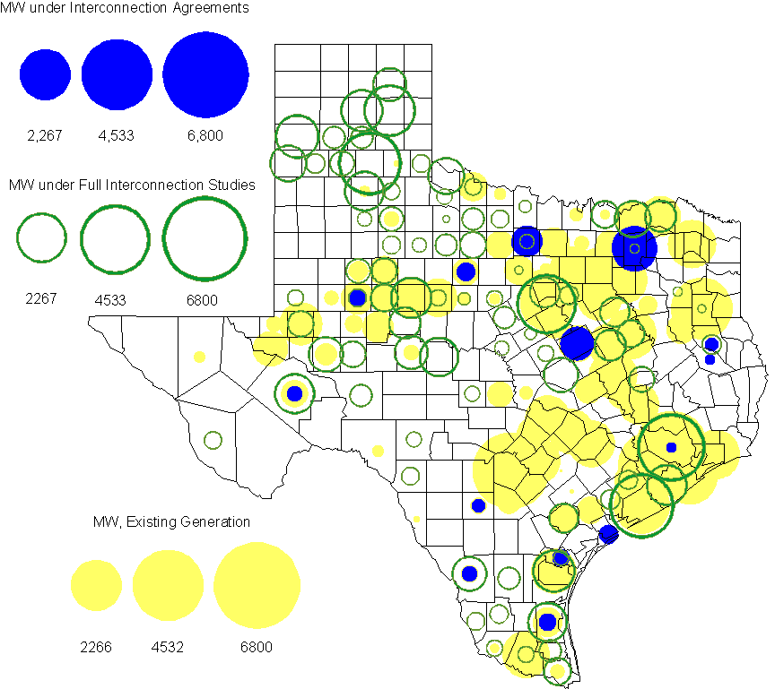

Generation Projects Undergoing Full Interconnection Studies (not otherwise public)
INR | County | Capacity | COD | Fuel |  | INR | County | Capacity | COD | Fuel
08INR0049 | Clay | 50 | TBD | Wind |  | 09INR0073 | Scurry | 200 | TBD | Wind
09INR0065 | Webb | 150 | TBD | Wind |  | 09INR0061 | Kent | 258 | TBD | Wind
09INR0054 | Stonewall | 148.5 | TBD | Wind |  | 09INR0051 | Borden | 249 | TBD | Wind
08INR0039 | Hamilton | 90 | TBD | Wind |  | 08INR0022 | Floyd | 100 | TBD | Wind
08INR0023 | Floyd | 100 | TBD | Wind |  | 10INR0048 | Hardeman | 1000 | TBD | Wind
10INR0046 | Jim Hogg | 264 | TBD | Wind |  | 10INR0045 | Webb | 734 | TBD | Wind
10INR0079 | Nolan | 60 | May-10 | Wind |  | 10INR0062a | Pecos | 49.5 | May-10 | Wind
10INR0054 | Palo Pinto | 36 | May-10 | Wind |  | 09INR0070 | Reagan | 42 | May-10 | Wind
09INR0069 | Reagan | 36 | May-10 | Wind |  | 10INR0023 | Haskell | 386 | May-10 | Wind
10INR0016 | Childress | 150 | May-10 | Wind |  | 09INR0035 | Concho | 750 | May-10 | Wind
09INR0018 | Concho | 249 | May-10 | Wind |  | 10INR0069 | Rusk | 818 | May-10 | Coal
09INR0081 | Rusk | 818 | Jun-10 | Coal |  | 10INR0035 | Harris | 416 | Jun-10 | Gas
10INR0029 | Hood | 810 | Jun-10 | Gas |  | 10INR0012 | Nacogdoches | 300 | Jul-10 | Gas
10INR0057 | Taylor | 200 | Jul-10 | Wind |  | 10INR0052a | Knox | 21 | Jul-10 | Wind
10INR0013 | Upton | 400 | Jul-10 | Wind |  | 10INR0089 | Harris | 40 | Oct-10 | Other
10INR0081a | Clay | 30.4 | Oct-10 | Wind |  | 09INR0074 | Motley | 70 | Oct-10 | Wind
10INR0041 | Floyd | 135 | Oct-10 | Wind |  | 10INR0015 | Mitchell | 350 | Oct-10 | Wind
11INR0029 | Throckmorton | 200 | Nov-10 | Wind |  | 10INR0032 | Navarro | 800 | Dec-10 | Gas
10INR0082 | Travis | 30 | Dec-10 | Solar |  | 10INR0080 | Presidio | 144 | Dec-10 | Solar
10INR0077 | Callahan | 101 | Dec-10 | Wind |  | 10INR0060 | Willacy | 400.5 | Dec-10 | Wind
10INR0056 | Borden | 249 | Dec-10 | Wind |  | 10INR0051 | Brazoria | 200 | Dec-10 | Wind
09INR0076 | Jackson | 300 | Dec-10 | Wind |  | 10INR0042 | Mason | 170 | Dec-10 | Wind
10INR0033 | Armstrong | 420 | Dec-10 | Wind |  | 11INR0012 | Duval | 400 | Dec-10 | Wind
10INR0019 | Deaf Smith | 609 | Dec-10 | Wind |  | 08INR0062 | Archer | 249 | Dec-10 | Wind
08INR0061 | Hardeman | 200 | Dec-10 | Wind |  | 10INR0008 | Pecos | 500 | Dec-10 | Wind
07INR0035 | Tom Green | 270 | Dec-10 | Wind |  | 07INR0015 | Foard | 180 | Dec-10 | Wind
07INR0013 | Coke | 200 | Dec-10 | Wind |  | 09INR0041 | Mitchell | 300 | Dec-10 | Wind
11INR0050 | Crosby | 149 | Mar-11 | Wind |  | 11INR0071 | Harris | 20 | Apr-11 | Gas
11INR0037 | Smith | 55 | May-11 | Biomass |  | 11INR0048 | Harris | 300 | May-11 | Gas
11INR0058 | Pecos | 135 | May-11 | Solar |  | 11INR0060 | Tom Green | 90 | May-11 | Solar
11INR0061 | Presidio | 90 | May-11 | Solar |  | 11INR0062 | Nueces | 149 | May-11 | Wind
10INR0062b | Pecos | 49.5 | May-11 | Wind |  | 10INR0009 | Castro | 300 | May-11 | Wind
11INR0033a | Cameron | 200 | May-11 | Wind |  | 11INR0033b | Cameron | 200 | May-11 | Wind
09INR0050 | Fannin | 1200 | Jun-11 | Gas |  | 11INR0065 | Nueces | 240 | Jun-11 | Wind
11INR0057 | Cameron | 165 | Jun-11 | Wind |  | 11INR0054 | San Patricio | 161 | Jun-11 | Wind
11INR0019 | Upton | 200 | Jun-11 | Wind |  | 08INR0020 | Eastland | 200 | Jun-11 | Wind
11INR0006 | Lamar | 579 | Jul-11 | Gas |  | 11INR0040 | freestone | 749 | Aug-11 | Gas
11INR0047 | Deaf Smith | 600 | Sep-11 | Wind |  | 11INR0039 | Starr | 201 | Sep-11 | Wind
11INR0008a | Roberts | 1000 | Sep-11 | Wind |  | 10INR0081b | Clay | 19.2 | Oct-11 | Wind
07INR0014b | Wilbarger | 70 | Oct-11 | Wind |  | 07INR0014a | Wilbarger | 140 | Oct-11 | Wind
10INR0021 | Grayson | 646 | Nov-11 | Gas |  | 12INR0034 | Borden | 342 | Dec-11 | Wind
11INR0067 | Cameron | 78 | Dec-11 | Wind |  | 11INR0043 | Coke | 300 | Dec-11 | Wind
11INR0025 | Crockett | 400 | Dec-11 | Wind |  | 11INR0013 | Mills | 150 | Dec-11 | Wind
11INR0005 | Upton | 500 | Dec-11 | Wind |  | 06INR0022d | Kenedy | 200 | Dec-11 | Wind
09INR0075 | Kinney | 248 | Dec-11 | Wind |  | 09INR0048 | Jack | 150 | Dec-11 | Wind
12INR0033 | Motley | 150 | Jan-12 | Wind |  | 12INR0021 | Edwards | 165 | Jan-12 | Wind
10INR0018 | Madison | 550 | Mar-12 | Gas |  | 11INR0049 | Wharton | 275 | May-12 | Gas
12INR0007 | Lamar | 296 | May-12 | Gas |  | 09INR0031 | Ector | 275 | May-12 | Gas
10INR0062c | Pecos | 201 | May-12 | Wind |  | 12INR0006 | Limestone | 875 | Jun-12 | Coal
10INR0022 | Harris | 1380 | Jun-12 | Gas |  | 08INR0031 | Childress | 100 | Jun-12 | Wind
12INR0002 | Briscoe | 750 | Jul-12 | Wind |  | 12INR0027 | Gray | 200 | Oct-12 | Wind
12INR0026 | Randall | 400 | Oct-12 | Wind |  | 08INR0041 | Coke | 200 | Oct-12 | Wind
12INR0016 | Nueces | 1200 | Nov-12 | Other |  | 12INR0035 | Nueces | 249 | Nov-12 | Wind
08INR0044 | Concho | 200 | Nov-12 | Wind |  | 08INR0019c | Gray | 250 | Nov-12 | Wind
08INR0019a | Gray | 250 | Nov-12 | Wind |  | 08INR0019b | Gray | 250 | Nov-12 | Wind
12INR0022 | Hidalgo | 200 | Dec-12 | Wind |  | 12INR0018 | Gray | 600 | Dec-12 | Wind
12INR0005 | Floyd | 1100 | Dec-12 | Wind |  | 08INR0056 | Nolan | 149 | Dec-12 | Wind
08INR0054 | Comanche | 401 | Dec-12 | Wind |  | 09INR0025 | Concho | 180 | Dec-12 | Wind
08INR0042 | Coke | 200 | Dec-12 | Wind |  | 06INR0022f | Kenedy | 200 | Dec-12 | Wind
12INR0029 | Swisher | 500 | Dec-12 | Wind |  | 10INR0024 | Briscoe | 3000 | Jan-13 | Wind
09INR0058 | Howard | 250 | Mar-13 | Wind |  | 13INR0005 | Carson | 600 | Oct-13 | Wind
13INR0006 | Gray | 750 | Oct-13 | Wind |  | 13INR0004 | Deaf Smith | 500 | Oct-13 | Wind
09INR0077 | Reagan | 500 | Dec-13 | Wind |  | 06INR0022e | Kenedy | 200 | Dec-13 | Wind
13INR0010 | Parmer | 1200 | Dec-13 | Wind |  | 14INR0002 | Goliad | 756 | Feb-14 | Coal
14INR0003 | Nolan | 850 | Jun-14 | Coal |  | 14INR0005 | Matagorda | 1200 | Jul-14 | Coal
14INR0001 | Pecos | 500 | Dec-14 | Wind |  | 16INR0002 | Brazoria | 1000 | Jun-17 | Other

Wind Generation
Wind Capacity Installed by Year

County Location of Installed Capacity and Interconnection Requests (Wind only)

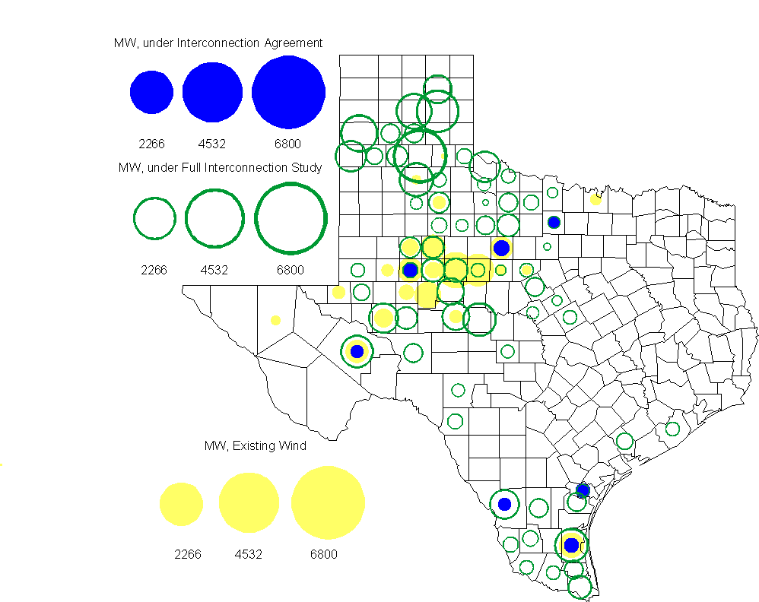

Regional Planning Group Project Reviews

Oncor submitted a project to relieve congestion related to new wind units in the Lamesa area. The project will upgrade the Lamesa to Bluff Creek 138 kV line, rebuild the Bluff Creek to China Grove 138 kV line, rebuild the Lamesa to Ackerly Vealmoor 69 kV line to 138/69 kV double circuit, rebuild the Lamesa 138 kV switching station, build a new 138 kV Ackerly Vealmoor station, add second circuits to all rebuilt lines and include station upgrades at China Grove and Big Spring. The cost of this project is $ 80.8 M. This project will be reviewed to ensure that the improvements fit into the likely CREZ transmission solution for the area. This project is in ERCOT Independent Review.

Oncor submitted a project to add several 345 kV circuits to support the addition of Comanche Peak units 3 and 4 in 2015 at an estimated cost of $ 133 M. These upgrades include a new 345 kV double circuit line with one circuit in place from Comanche to Whitney, a new 345 kV line from Comanche to Johnson Switch, a new circuit on existing structures from Johnson Switch to Everman, a new 345 kV double circuit with one circuit in place from Comanche to DeCordova, and a new 345 kV line on existing structures from Comanche to Parker Switch. This project is in ERCOT Independent Review and will be studied when the 2009 Five-Year Transmission Plan is complete.

Sharyland Utilities submitted a project to construct and operate the ERCOT Southeast Loop facilities consisting of a 345 kV double circuit from Lufkin to Canal 345 kV substation on the northeast side of Houston. This project will cost $359 M with an estimated completion date of summer 2013. This project is in ERCOT Independent Review.

Centerpoint Energy has submitted a project to construct a new 345 kV double circuit line to allow greater power imports into the Houston area. The project involves expanding the Fayetteville and Zenith substations and constructing a new 345 kV double circuit from Fayetteville to Zenith. The proposal also includes looping the Fayette Power Project to Salem 345 kV circuit into Fayetteville and upgrading the Fayette Power Project to Fayetteville 345 kV double circuit lines. The project is estimated to be complete by September 2014 at a cost of $222 M. This project is in ERCOT Independent Review.

Luminant Energy has submitted the Comanche Peak Area Congestion Mitigation Plan project to loop the future Parker to Everman 345 kV CREZ line into the Comanche Peak 345 kV switch station. Luminant Energy’s estimated completion date for this project is April 2010 and the estimated cost is $3 M. The review of this project is complete and an ERCOT recommendation letter is being prepared.

Luminant Energy submitted a proposal to either accelerate the Waco West to Waco Atco 138 kV line rebuild that is currently scheduled to be completed by the fall of 2010 or to open the line in order to prevent congestion. This project has exited the RPG review process with the understanding that Oncor will proceed with construction as rapidly as possible.

Congestion Costs
Dollars shown in graphs are settlement quality.

OOMC – last 13 months in million$

OOM Down – last 13 months in million$

Local Balancing Energy Down – last 13 months in million$

OOM Up – last 13 months in million$

Local Balancing Energy Up – last 13 months in million$

Replacement Reserve – last 13 months in thousand$

Binding Constraints & Capacity Shortages– March, 2010

Contingency | Binding Element | Estimated Costs | Transmission Project | Clearance
Roanoke Switch - West Denton & Lewisville Switch 345kV | West Denton - Teasley 138kV | $ 1,440,860 | West Dention re-route (07TPIT0132) | Outage on Jacksboro Switching to Willow Creek 345KV
Twin Butte - San Angelo Red Creek 345kV | Twin Butte 345/138kV Autotransformer | $ 1,112,663 |  | Outage on Twin Butte - San Angelo Red Creek 345kV
 | Voltage - DFW | $ 933,260
Planned Outage | Horse Hollow 345kV | $ 896,245
Sandow Switch - Austrop 345kV | Taylor West - Taylor 138kV | $ 876,865 | Salado Sw-Cedar Valley Sw (09TPIT0051) | Outage on Salado - Bell County Switching Station 138 KV
Roanoke Switch T1 345/138kV Autotransformer  Morgan Creek Bittercreek - Sweetwater Cogen 345kV | West Denton - Airport TMPP 138kV | $ 319,036 | West Dention re-route (07TPIT0132) | Outage on Jacksboro Switching to Willow Creek 345KV
Sandow Switch - Austrop 345kV | Hutto - Taylor West 138kV | $ 291,677 | Salado Sw-Cedar Valley Sw (09TPIT0051) | Outage on Salado - Bell County Switching Station 138 KV
Abilene Mulberry Creek - Bitter Creek & Long Creek - Sweetwater Cogen 345kV | Anson - Radium 69kV | $ 241,094 |  | Outage on Divide Switchyard - Twin Butte 345kV
Pawnee - Lon Hill 345kV | Sinton - Skidmore 69kV | $ 153,207
 | Voltage Stability - Valley | $ 113,793

Inter-zonal Congestion

Other Notable Activities
Work on the 2010 Five-Year Transmission Plan is underway. The analysis is currently focused on identifying reliability projects needed for 2015.

TPIT worksheet updates for April have been completed and posted on March 31, 2010 at http://planning.ercot.com/reports/tpit/. This marks the end of the one month delay in TPIT to better align with SSWG case building efforts. TPIT will resume its quarterly updates from this point forward. TPIT updates to the base cases are underway and should be completed by April 16, 2010.

Nodal Network Model Management System Topology Processor work continues with bi-weekly meetings/calls with SSWG and weekly ERCOT topology processor output. The most recent topology processor output was the first utilizing the NMMS 8.1 database which allows three winding transformers and facility ratings to be included. ERCOT created and submitted over 60 NOMCRs for SSWG members in response to SSWG changes submitted on an ERCOT created spreadsheet. NOMCR training for planning data is being planned for SSWG members so that they can enter more complicated NOMCRs.

Voltage Ride Through Study Update:
The Phase II effort to develop models for each wind plant is essentially complete. These models have been successfully integrated into the VRT base cases for flat start and dynamic simulation. ERCOT is reviewing the Phase II deliverables and documentation to ensure that the modeling efforts developed by the vendor can be used by ERCOT into the future. Phase III is underway with completion of dynamic flat start base cases and preliminary contingency simulations with (Phase II) wind models using PSSe v.31. The vendor has recommended the use of dynamic motor load models for Phase III simulations. ERCOT has attempted to apply models received from the CREZ reactive study to the VRT study cases, but will likely require additional support from the transmission owners.

Voltage Stability Study for 2015 Summer on-peak conditions:
In preparation for the annual NERC Long-Term Reliability Assessment reporting, a steady-state voltage stability study was performed using the SSWG 2015 year summer on-peak base case to assess the reliability of the network. The study result shows sufficient voltage stability margin for NERC category B and NERC category C contingencies.

