ERCOT Operations Report
March 2010 ROS & OWG

Frequency Control
Time | Freq(Hz) | Duration (s)
3/1/2010 18:26 | 59.852 | 89 | Unit trip with 583 MW & 160 MW
3/2/2010 10:17 | 59.878 | 12 | Unit trip with 650 MW
3/2/2010 11:10 | 60.116 | 44 | SCE +533 MW in 15 min. Out of Down Reg.
3/8/2010 0:07 | 60.132 | 356 | Out of Down Reg. Large schedule change.
3/9/2010 3:39 | 59.756 | 148 | Unit trip with 837 MW
3/9/2010 14:01 | 59.896 | 5 | Unit trip with 330 MW
3/11/2010 5:54 | 60.102 | 4 | SCE +356 MW in 10 min. Out of Down Reg.
3/18/2010 14:51 | 59.881 | 4 | Unit trip with 600 MW
3/18/2010 16:04 | 59.823 | 78 | Unit trip with 560 MW
3/18/2010 17:07 | 60.122 | 228 | SCE +955 MW in 20 min. Out of Down Reg.
3/19/2010 14:04 | 60.122 | 130 | SCE +540 MW in 10 min. Incorrect offset calculation
3/20/2010 10:23 | 59.813 | 129 | Unit trip with 650 MW
3/21/2010 23:02 | 60.107 | 88 | Load dropped by 550 MW in 10 min. Incorrect offset calculation
3/22/2010 16:43 | 59.896 | 4 | Unit trip with 290 MW
3/24/2010 18:21 | 59.852 | 54 | Unit trip with 600 MW
3/25/2010 0:11 | 59.895 | 8 | Unit trip with 500 MW
3/26/2010 2:03 | 59.863 | 76 | Unit trip with 800 MW
3/26/2010 7:09 | 59.893 | 48 | Out of Up Reg. Incorrect offset calculation
3/26/2010 7:40 | 60.106 | 31 | Load dropping with rising Wind. Out of Down Reg
3/29/2010 23:58 | 59.891 | 6 | Unit trip with 250 MW
Note: Time of frequency excursions outside the range of +/- 0.1 Hz.

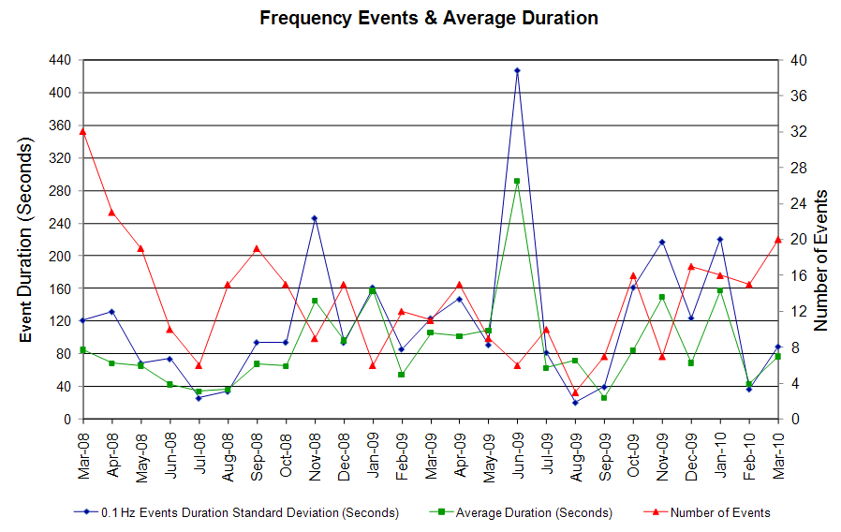

Deployed Responsive (Reported Above)
Time deployed | Stop Time | Duration | Max | Details
3/1 08:05:46 | 3/1 08:29:44 | 0:23:58 | 341.52 | Large SCE change
3/1 18:01:52 | 3/1 18:06:44 | 0:04:52 | 373.52 | Unit Trip
3/1 18:26:14 | 3/1 18:44:12 | 0:17:58 | 629.65
3/2 10:16:01 | 3/2 10:31:48 | 0:15:47 | 490.93
3/5 23:22:09 | 3/5 23:33:11 | 0:11:02 | 330.83 | Out of Up Reg. Incorrect offset calculation due to large STLF deviation
3/8 11:04:02 | 3/8 11:16:57 | 0:12:55 | 336.17 | Out of Up Reg.
3/9 03:39:38 | 3/9 04:15:39 | 0:36:01 | 1141.90
3/9 14:01:59 | 3/9 14:13:01 | 0:11:02 | 394.87 | Unit Trip
3/9 18:54:18 | 3/9 19:02:16 | 0:07:58 | 330.83 | Out of Up Reg. Incorrect offset calculation
3/16 12:46:11 | 3/16 13:08:07 | 0:21:56 | 362.85 | Unit Trip
3/18 14:51:38 | 3/18 15:09:52 | 0:18:14 | 474.91
3/18 16:04:22 | 3/18 16:33:06 | 0:28:44 | 784.39
3/19 13:38:37 | 3/19 13:57:00 | 0:18:23 | 330.83 | Out of Up Reg
3/20 10:23:30 | 3/20 10:45:24 | 0:21:54 | 837.76
3/22 16:43:34 | 3/22 16:55:08 | 0:11:34 | 394.87
3/24 18:21:06 | 3/24 18:36:26 | 0:15:20 | 629.65
3/25 00:11:38 | 3/25 00:24:48 | 0:13:10 | 400.2
3/25 22:15:48 | 3/25 22:28:58 | 0:13:10 | 336.17 | Out of Up Reg.
3/26 02:03:16 | 3/26 02:18:06 | 0:14:50 | 570.96
3/26 06:06:58 | 3/26 06:14:38 | 0:07:40 | 352.19 | Large SCE change
3/26 07:03:26 | 3/26 07:24:01 | 0:20:35 | 410.87
3/26 10:00:44 | 3/26 10:30:12 | 0:29:28 | 50 | Unit Test (Nueces Bay)
3/27 20:11:14 | 3/27 20:33:08 | 0:21:54 | 346.85 | Out of Up Reg.
3/29 23:58:22 | 3/30 00:11:42 | 0:13:20 | 421.56

Day-Ahead OOMC and RPRS Capacity Purchases
Details | OOMC | RPRS S1 | RPRS S2 | RPRS S1+S2 | RMR | Total
DFW | 59 | 2 | 2 | 4 | 0 | 63
W RIO | 10 | 0 | 0 | 0 | 0 | 10
Western | 0 | 8 | 1 | 9 | 0 | 9
Austin | 7 | 0 | 0 | 0 | 0 | 7
North | 2 | 1 | 0 | 1 | 0 | 3
San Antonio | 1 | 0 | 0 | 0 | 0 | 1
Houston | 0 | 1 | 0 | 1 | 0 | 1
E RIO | 0 | 0 | 0 | 0 | 0 | 0
South | 0 | 0 | 0 | 0 | 0 | 0
Corpus | 0 | 0 | 0 | 0 | 0 | 0
Bryan Area | 0 | 0 | 0 | 0 | 0 | 0
Laredo | 0 | 0 | 0 | 0 | 0 | 0
Northeast | 0 | 0 | 0 | 0 | 0 | 0
Total | 79 | 12 | 3 | 15 | 0 | 94

Historical Totals | Mar-10 | Mar-09 | Feb-10
Austin | 7 | 26 | 22
Bryan Area | 0 | 7 | 0
Corpus | 0 | 2 | 0
DFW | 61 | 6 | 30
E RIO | 0 | 1 | 3
Houston | 1 | 2 | 2
Laredo | 0 | 9 | 0
North | 3 | 33 | 14
Northeast | 0 | 0 | 0
San Antonio | 1 | 0 | 0
South | 0 | 2 | 1
W RIO | 10 | 96 | 15
Western | 8 | 1 | 8
Total | 91 | 185 | 95

http://www.ercot.com/mktinfo/services/rprsdr/index.html

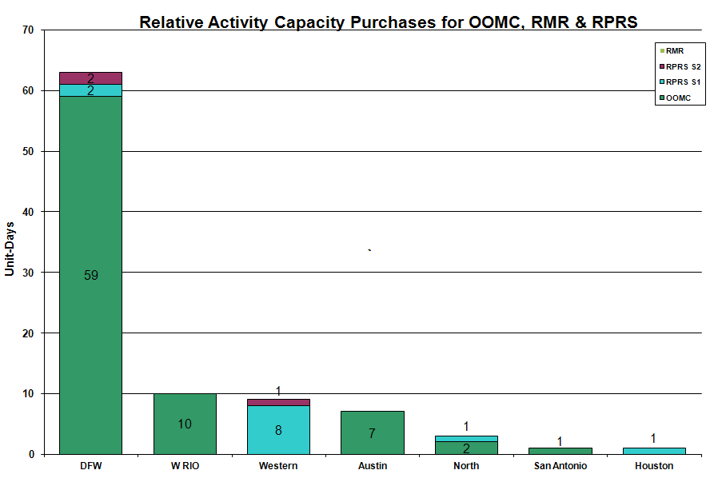

OOME and Congestion Management Activity
Congestion affected by outages Remedial action plan has been developed for the element
Contingency | Overloaded Element | Days
Base Case | Matador - Paducah 69KV | 20
Hamilton Road - Sonora 138KV | Sonora - Friess Ranch 69KV | 11
San Angelo Red Creek - Twin Buttes 345KV | Twin Butte 345/138KV AT | 11
Abilene Mulberry Creek - Bitter Creek and Long Creek - Sweetwater Cogen 345KV | Anson - Radium 69KV | 9
Sandow Switch - Austrop 345KV | Taylor West - Taylor 138KV | 8
Graham - Parker Switch 345KV | Leon Switch - Flat Creek 138KV | 6
Base Case | MEC Plainview Tap - WKN Breaker 69KV | 6
San Miguel - Pearsall 138KV | Pearsall 138/69KV AT | 5
Abilene South - Eskota 138KV | Trent - Scott Rea Tap 69 KV | 5
McDonald - Big Spring 138KV | Forsan Tap - CRMWD7 138KV | 5
Roanoke Switch - West Denton and Lewisville Switch 345KV | West Denton - Airport TMPP 138KV | 4
Aspermont - Spur 138KV | Spur 138/69 KV AT | 4
Abilene Mulberry Creek - Bitter Creek and Long Creek - Sweetwater 345KV | Twin Butte Auto#1 345/138 KV | 3
Graham - Long Creek and Cook Field Road Switch 345KV | Sonora - Cauthorn 138KV | 3
Sandow Switch - Austrop 345KV | Gabriel 138/69KV AT | 3
Abilene Mulberry Creek - Bitter Creek and Long Creek Switching Station - Sweetwater Generating Plant 345KV | Big Lake - North McCamey Switching Station 138KV | 3
Base Case | Notrees - Notrees Switch 138KV | 3
Jack County - Hill Top 138KV | Rhome TU - Decatur Tap 138KV | 3
Roanoke Switch - West Denton and Lewisville Switch 345KV | West Denton - Teasley 138KV | 3
Morgan Creek – Bitter Creek - Sweetwater Generation 345KV | West Denton - Airport TMPP 138KV | 2
Roanoke Switch - West Denton and Lewisville Switch 345KV | West Denton - Pockrus 138KV | 2
Sweetwater Generating Plant- Morgan Creek SES and Long Creek 345KV | Abilene Mulberry Creek - Long Creek 345KV | 2
Temple Elm Creek - Belton 138KV | Temple Southeast - Scott and White 138KV | 2
Abilene Mulberry - Bluff Creek 345KV | Abilene NW - Callahan 138KV | 2
Abilene Mulberry Creek - Bitter Creek and Long Creek - Sweetwater 345KV | Matador - Paducah 69KV | 2
Amoco Oil G1, G2, and S1 138KV generators | PH Robinson 345/138KV AT | 2
Austrop - Sandow 345KV | Robertson - Milano 138KV | 2
Barney Davis - Airline CSW - Rodd Field 138KV | Alazan - Barney Davis 138KV | 2
Base Case | Spur - Girard 69KV | 2
Base Case | Stanton Switch - Big Springs 138KV | 2
Leon Switch - Putnam 138KV | Putnam - Cisco 69KV | 2
Roanoke Switch 345/138 KV T1 AT | West Denton - Pockrus 138 KV | 2
Abilene Mulberry Creek - Bitter Creek and Long Creek - Sweetwater Cogen 345KV | Sterling County - Sterling City 69KV | 1
Crestonio - Falfurrias 138KV | Freer - San Diego 69KV | 1
Dilley Switch - San Miguel 138KV | Derby SW - Pearsall SW 69KV | 1
Dupont Switch Ingleside - Ingleside Cogen Switch 138KV | Dupont Switch Ingleside - Dupont PP1 Ingleside 138KV | 1
Friend Ranch 138/69KV AT | Sonora 138/69KV AT | 1
Garfield - Onion Creek & Hicross AEN 138KV | Lytton Springs 345/138KV AT #1 | 1
Morgan Creek - Quail Switch - Longshore 345KV | Glenhaven – CRMWD8 Tap - 103% | 1
Bluff Creek - San Angelo Red Creek 345KV | San Angelo Red Creek 345/138KV AT | 1
Elm Creek - San Miguel 345KV | Pearsall 138/69KV AT 4 | 1
Abilene South - Eskota 138KV | Trent - Merkel 69KV | 1
Gasconades - Morgan Creek 345KV | Twin Butte 345/138KV AT1 | 1
Graham - Long Creek and Cook Field Road Switch 345KV | Putnam - Cisco 69KV | 1
Hamilton - Sonora 138KV | Uvalde - Downie 138KV | 1
Holly - Barney Davis 138KV | Airline CSW - Cabaniss 138KV | 1
Midland East - Odessa EHV 345KV | Ackerly Vealmoor Switch - Ackerly 69KV | 1
Midland East - Odessa EHV Switch 345KV | Odessa EHV Switch 345/138KV AT 2 | 1
Roanoke Switch T1 345/138KV Auto | West Denton - Airport TMPP | 1
Zorn - Hayes 345KV | Kendall 25AT1 345/138KV AT | 1

Zonal OC1
CSC | Days
West – North | 24

New RAP, PCAP (Date indicates last update of RAP, PCAP not implementation date.)
None

New Procedures/Forms/Operations Bulletins
Date | Subject | Bulletin No.
03/31/2010 | Transmission and Security Desk V4 Rev13 | 473
03/31/2010 | Shift Supervisor Desk V4 Rev13 | 472
03/31/2010 | Operating Period Desk V3 Rev9 | 471
03/31/2010 | Frequency Control Desk V4 Rev12 | 470
03/31/2010 | Day-Ahead Desk V4 Rev11 | 469
03/09/2010 | Transmission and Security Desk V4 Rev12 | 468
03/09/2010 | Frequency Control Desk V4 Rev11 | 467
03/09/2010 | Shift Supervisor Desk V4 Rev12 | 466
03/09/2010 | Operating Period Desk V3 Rev8 | 465
03/09/2010 | Day-Ahead Desk V4 Rev10 | 464

Blackout/Load Shed Incidences
None

EEA
None

Major System Voltage Problems
None

Major Computer Problems, Enhancements & Fixes
None

Communication
None

ERCOT peak (Unofficial)
03/02 08:00 41,416 MW

Yearly MTLF Error Comparison
Yearly Mid-Term (Hourly) Load Forecast Error Comparison for the ERCOT Forecast
Month | MAPE for MTLF at 16:00 Day-Ahead
Month | 2007 | 2008 | 2009 | 2010
January | 4.55 | 3.30 | 4.11 | 3.78
February | 3.75 | 3.59 | 3.49 | 3.79
March | 2.70 | 3.29 | 3.24 | 2.24
April | 3.00 | 2.45 | 2.66 | NA
May | 3.22 | 3.01 | 2.90 | NA
June | 4.46 | 2.81 | 2.89 | NA
July | 4.29 | 2.55 | 2.83 | NA
August | 3.11 | 3.66 | 3.07 | NA
September | 3.78 | 4.99 | 3.68 | NA
October | 3.08 | 2.79 | 2.92 | NA
November | 2.95 | 2.60 | 1.93 | NA
December | 3.74 | 4.54 | 3.70 | NA
Annual Average | 3.55 | 3.29 | 3.11 | 3.27

OCN, Advisory, Watch & Emergency Notices
Capacity
Date | Start | End | Event
3/2/10 | 1:28 | 9:00 | OCN issued for projected reserve capacity shortage for HE 0800 - 1100.
3/6/10 | 4:55 | 13:20 | Advisory issued for ARRS below 3000 MW.
3/2/10 | 6:30 | 9:00 | Watch issued for projected reserve capacity shortage for HE 0800 - 1100.
3/7/10 | 14:55 | 21:30 | Advisory issued for ARRS below 3000 MW.
3/9/10 | 19:05 | 21:38 | Advisory issued for ARRS below 3000 MW.
3/10/10 | 19:22 | 21:15 | Advisory issued for ARRS below 3000 MW.
3/19/10 | 13:49 | 19:20 | Advisory issued for ARRS below 3000 MW.
3/20/10 | 10:43 | 14:30 | Advisory issued for ARRS below 3000 MW.
3/20/10 | 16:30 | 23:55 | OCN issued for projected capacity reserve shortage HE 2100 - 2400.
3/20/10 | 20:00 | 0:00 | Advisory issued for ARRS below 3000 MW.
3/20/10 | 20:30 | 23:55 | OCN issued for projected capacity reserve shortage HE 0100 - 0300 on 03/21/10.
3/21/10 | 0:15 | 2:00 | Advisory issued for ARRS below 3000 MW.
3/21/10 | 4:00 | 11:07 | OCN issued for projected reserve capacity shortage HE 1000 - 1100 and for a projected shortage of Up Balancing bids for HE 0900 - 1300.
3/25/10 | 7:08 | 7:53 | Advisory for ARRS below 3000 MW.
3/26/10 | 7:00 | 9:00 | Advisory for ARRS below 3000 MW.
3/28/10 | 14:45 | 23:00 | OCN issued for a projected reserve capacity shortage for HE 2100 - 2400.
3/28/10 | 19:52 | 23:00 | Advisory for adjusted Responsive Reserve below 3000 MW.

Transmission Watch
3/31 02:57 Transmission Watch issued due to forced outage at Gail substation. Implemented Block Load Transfer up to 2 MW from ERCOT (Gail substation) to SPP (Draw substation).

Emergency Notice
None

Texas RE Event Analysis
3/20 10:23 Simultaneous loss of units, two auto transformers and one 345 kV line.

3/24 18:21 Simultaneous loss of units, two auto transformers and one 345 kV line.

3/31 00:12 Lost connection to the Market Management System (MMS). Held IE 00:30 balancing energy deployment and resumed with IE 01:30 deployments.

Others
3/19 20:15 Held IE 2000 Balancing Energy Service deployments for IE 2015 due to incorrect offset calculation. Resumed with the IE 2030 deployments.

3/20 23:00 Held IE 2300 Balancing Energy Service deployments for IE 2315 due to a system problem that resulted in IE 2315 deployments going out late. Resumed with the IE 2330 deployments.

3/27 20:30 Held IE 2015 Balancing Energy Service deployments for IE 2030 due to incorrect offset calculation. Resumed with the IE 2045 deployments.

3/31 00:45 Held IE 0030 Balancing Energy deployments for IE 0045, 0100, 0115 due to a Market Management System problem. Resumed with the IE 0130 deployments.

